**Jared Cotton – 125 089 185**

**BTP400 NAA – Prof. Reza Khojasteh**

**April 12th, 2020**

**Assignment 3 – Knights Tour Problem**

**Part A: Hand Attempt & Prediction**

Prediction: ¾ of board or 48/64 spaces

Pre-decided picking order:

1. 2 up - 1 right
2. 1 up - 2 right
3. 2 down – 1 left
4. 1 down – 2 left
5. 2 up - 1 left
6. 1 up - 2 left
7. 2 down – 1 right
8. 1 down – 2 right

|  |  |  |  |  |  |  |  |  |
| --- | --- | --- | --- | --- | --- | --- | --- | --- |
|  | **C0** | **C1** | **C2** | **C3** | **C4** | **C5** | **C6** | **C7** |
| **R0** |  |  |  |  |  | 15 | **36** | 3 |
| **R1** |  |  |  | 16 | 35 | 2 | 13 | 28 |
| **R2** |  |  |  |  | 14 | 29 | 4 | 11 |
| **R3** |  |  | 17 | 34 | **1** | 12 | 27 | 6 |
| **R4** |  |  |  | 19 | 30 | 5 | 10 |  |
| **R5** |  | 18 | 33 |  | 21 | 26 | 7 | 24 |
| **R6** |  |  | 20 | 31 |  | 23 |  | 9 |
| **R7** |  | 32 |  | 22 |  | 8 | 25 |  |

Results using this picking order: 36 squares filled starting from H3-V4 (off from estimate by 12)

**Part B: Basic Implementation**

Results:

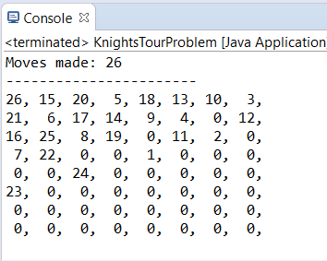

**Part C: Adding Accessibility Heuristic**

Starting from top left corner:

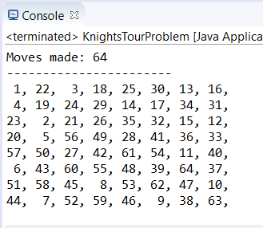

63/64 runs are successful when each possible starting point tested.

Failure is when starting on R4-C3

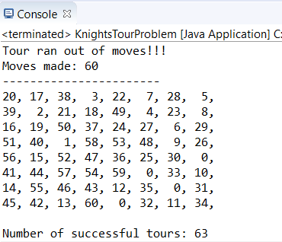

**Part D: Adding ‘Look one step ahead’ when tied**

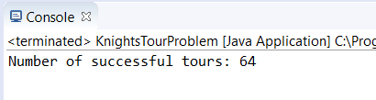

**Part E-1: Single Random Run**

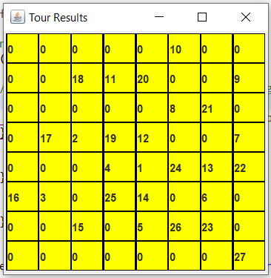

**Part E-2: 1000 Random Run’s**

Tabular results of 1000 runs: (Best result was 59 squares hit)

1000 Random Tours Results:

3 tour(s) touched 6 squares.

2 tour(s) touched 8 squares.

2 tour(s) touched 9 squares.

...

...

18 tour(s) touched 50 squares.

14 tour(s) touched 51 squares.

11 tour(s) touched 52 squares.

5 tour(s) touched 53 squares.

4 tour(s) touched 54 squares.

2 tour(s) touched 55 squares.

1 tour(s) touched 56 squares.

1 tour(s) touched 57 squares.

2 tour(s) touched 58 squares.

1 tour(s) touched 59 squares.

**Part E-1: Random Run’s Until Success (Doing 1000 runs at a time)**

**Which method required more careful study of the problem?**

The heuristic approach took more careful studying of the problem as it required me to implement a logic tree for decision making which required me to understand each possible move’s ‘accessibility’. The brute force method on the other hand only required I check to ensure the knights moves were within the board.

**Which algorithm was more difficult to develop?**

The algorithm for the heuristic approach was harder for me to develop as it required implementing the ‘accessibility’ logic of rating each square by how many other squares it could be reached from.

**Which required more computer power?**

The ‘brute force’ approach required vastly more computer processing power as it was running tests by the 1000 whereas the heuristic approach only ever needed to run 1 test per starting as the results would always be the same using that method and running multiple versions of it would be pointless.

**Could we be certain in advance of obtaining a full tour with either the heuristic approach or the brute force approach?**

Using a heuristic approach, we could only be certain of our ability to reproduce our results as the ‘decision’ making algorithm we designed would act the same every time we used it. These results may not be able to find a solution however as it is based on our logic which may have flaws in it.

Using the brute force method, we could be sure to get a solution if one did exist as it would keep testing until every possible tour of the board had been done. If no solution is found by brute force it would simply mean that no solution exists.

Successful Run:

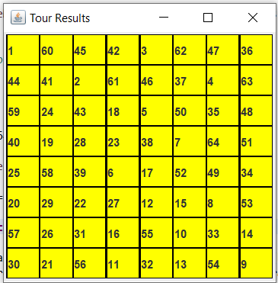

Full Results:

Running... (May take a few minutes)

Random Tours Results:

350 tour(s) touched 4 squares.

351 tour(s) touched 5 squares.

936 tour(s) touched 6 squares.

878 tour(s) touched 7 squares.

1530 tour(s) touched 8 squares.

1548 tour(s) touched 9 squares.

2317 tour(s) touched 10 squares.

2188 tour(s) touched 11 squares.

3167 tour(s) touched 12 squares.

3082 tour(s) touched 13 squares.

4059 tour(s) touched 14 squares.

4110 tour(s) touched 15 squares.

5412 tour(s) touched 16 squares.

5223 tour(s) touched 17 squares.

6769 tour(s) touched 18 squares.

6688 tour(s) touched 19 squares.

8357 tour(s) touched 20 squares.

7915 tour(s) touched 21 squares.

9999 tour(s) touched 22 squares.

9734 tour(s) touched 23 squares.

11925 tour(s) touched 24 squares.

11419 tour(s) touched 25 squares.

13995 tour(s) touched 26 squares.

13527 tour(s) touched 27 squares.

16185 tour(s) touched 28 squares.

15604 tour(s) touched 29 squares.

18334 tour(s) touched 30 squares.

17325 tour(s) touched 31 squares.

20303 tour(s) touched 32 squares.

18703 tour(s) touched 33 squares.

22025 tour(s) touched 34 squares.

20214 tour(s) touched 35 squares.

23037 tour(s) touched 36 squares.

21045 tour(s) touched 37 squares.

23650 tour(s) touched 38 squares.

21057 tour(s) touched 39 squares.

22947 tour(s) touched 40 squares.

20172 tour(s) touched 41 squares.

21963 tour(s) touched 42 squares.

18542 tour(s) touched 43 squares.

19366 tour(s) touched 44 squares.

15951 tour(s) touched 45 squares.

16119 tour(s) touched 46 squares.

12762 tour(s) touched 47 squares.

12107 tour(s) touched 48 squares.

9152 tour(s) touched 49 squares.

8253 tour(s) touched 50 squares.

5744 tour(s) touched 51 squares.

4972 tour(s) touched 52 squares.

3233 tour(s) touched 53 squares.

2517 tour(s) touched 54 squares.

1378 tour(s) touched 55 squares.

982 tour(s) touched 56 squares.

435 tour(s) touched 57 squares.

293 tour(s) touched 58 squares.

82 tour(s) touched 59 squares.

46 tour(s) touched 60 squares.

20 tour(s) touched 61 squares.

2 tour(s) touched 62 squares.

1 tour(s) touched 64 squares.

**Part F: Adding Closed Tour Check**

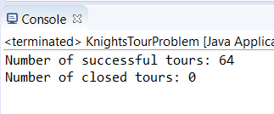

None of my tours fulfill the requirements of a closed tour