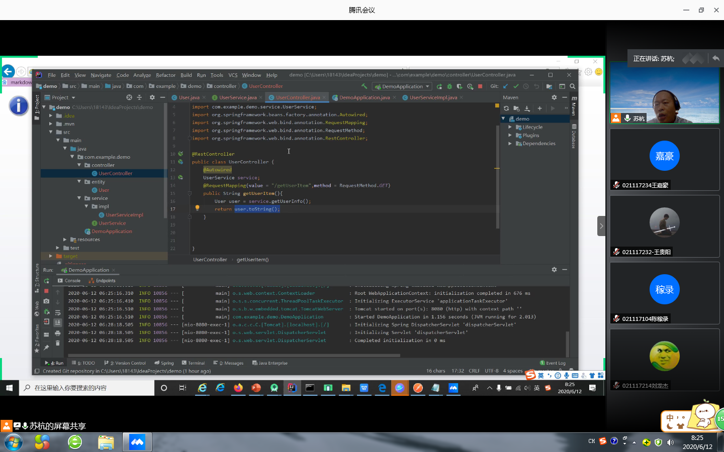

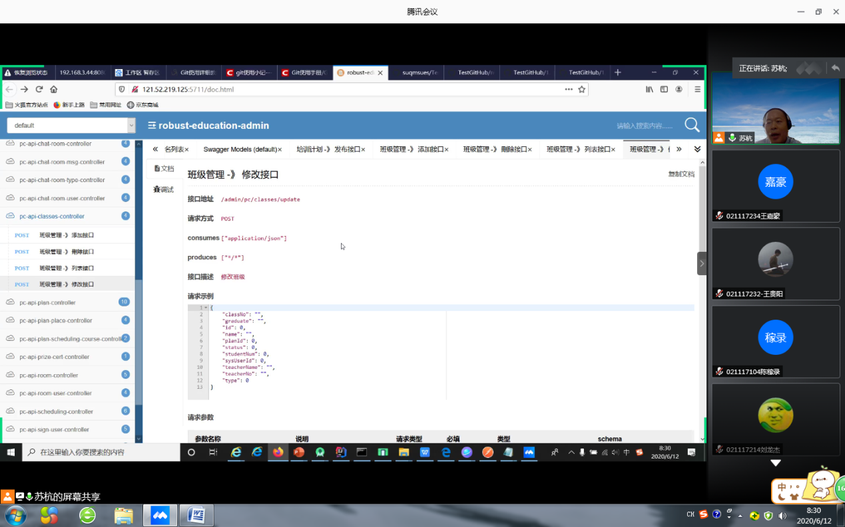

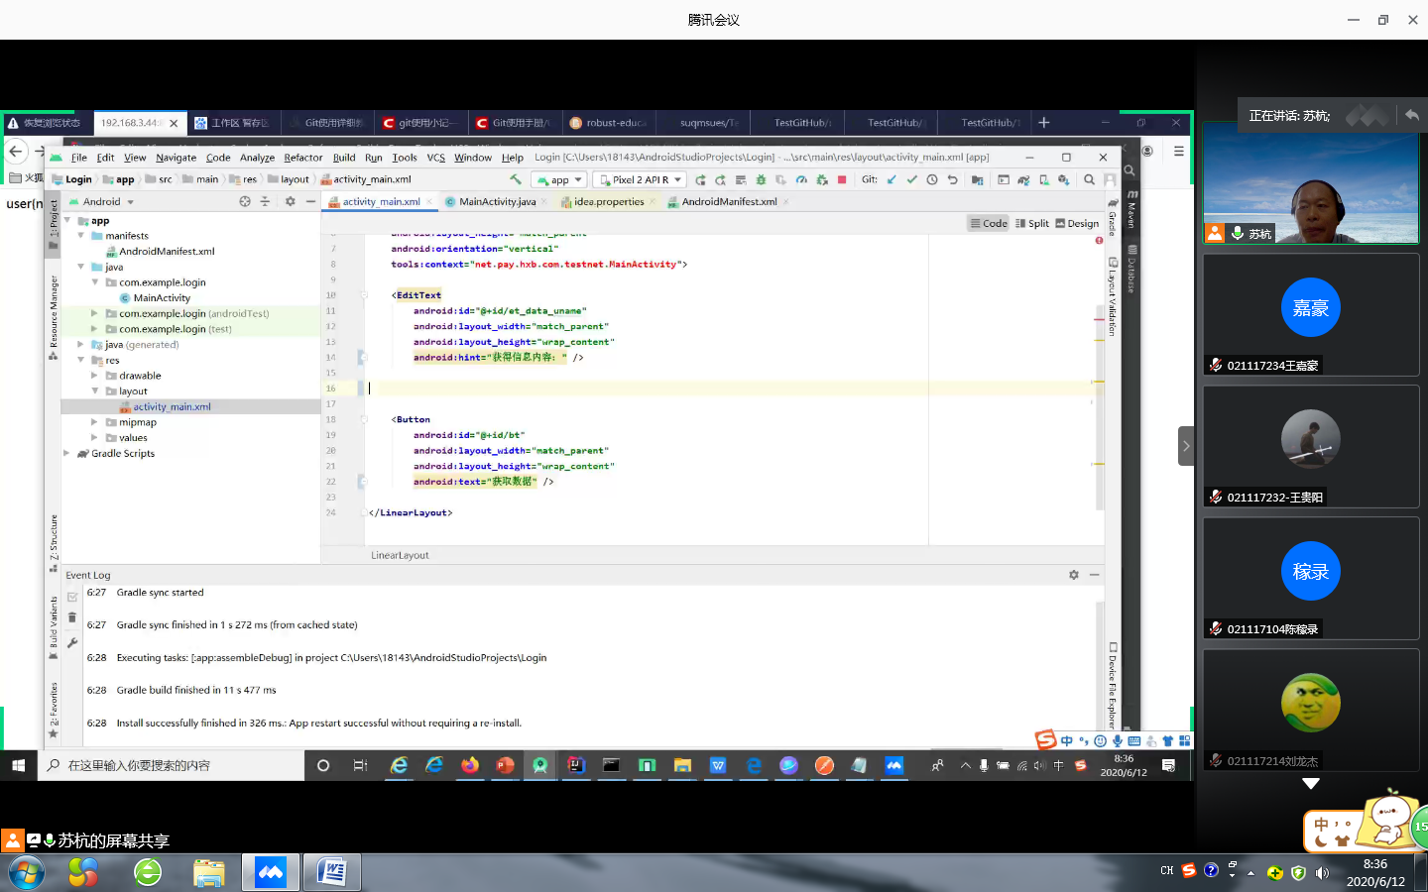

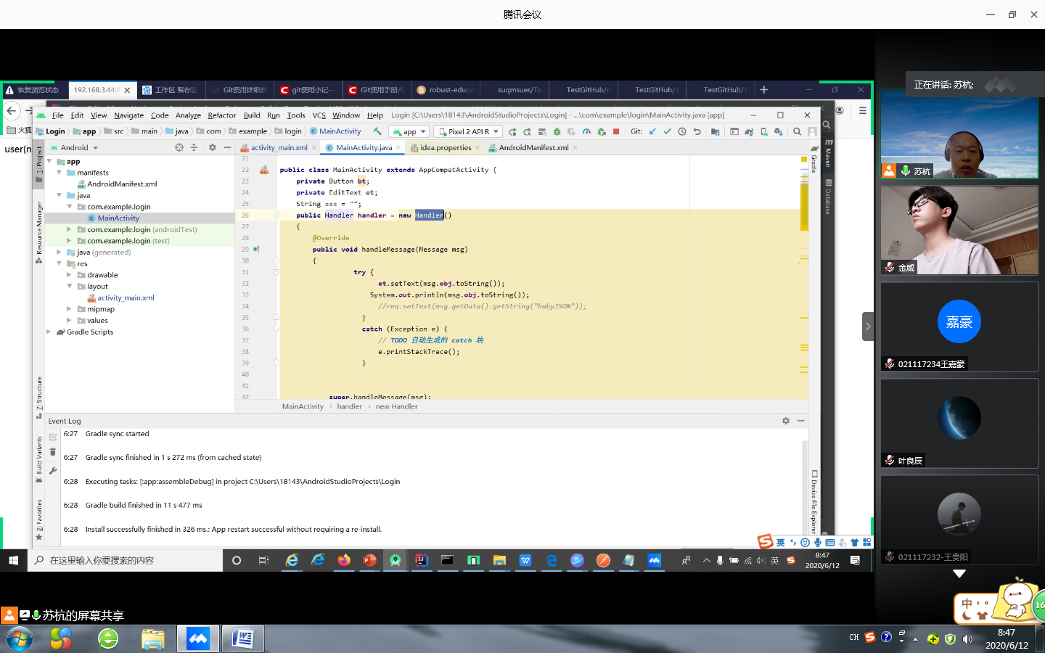

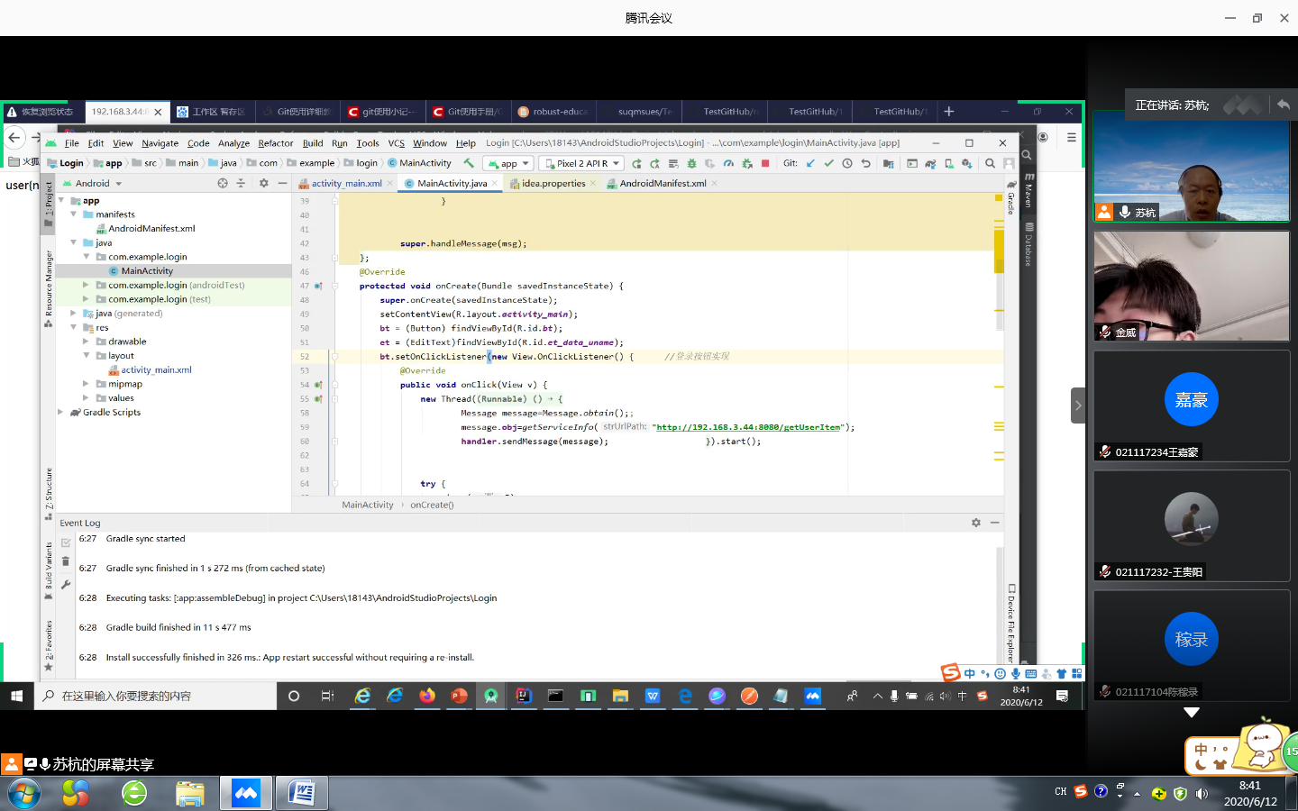

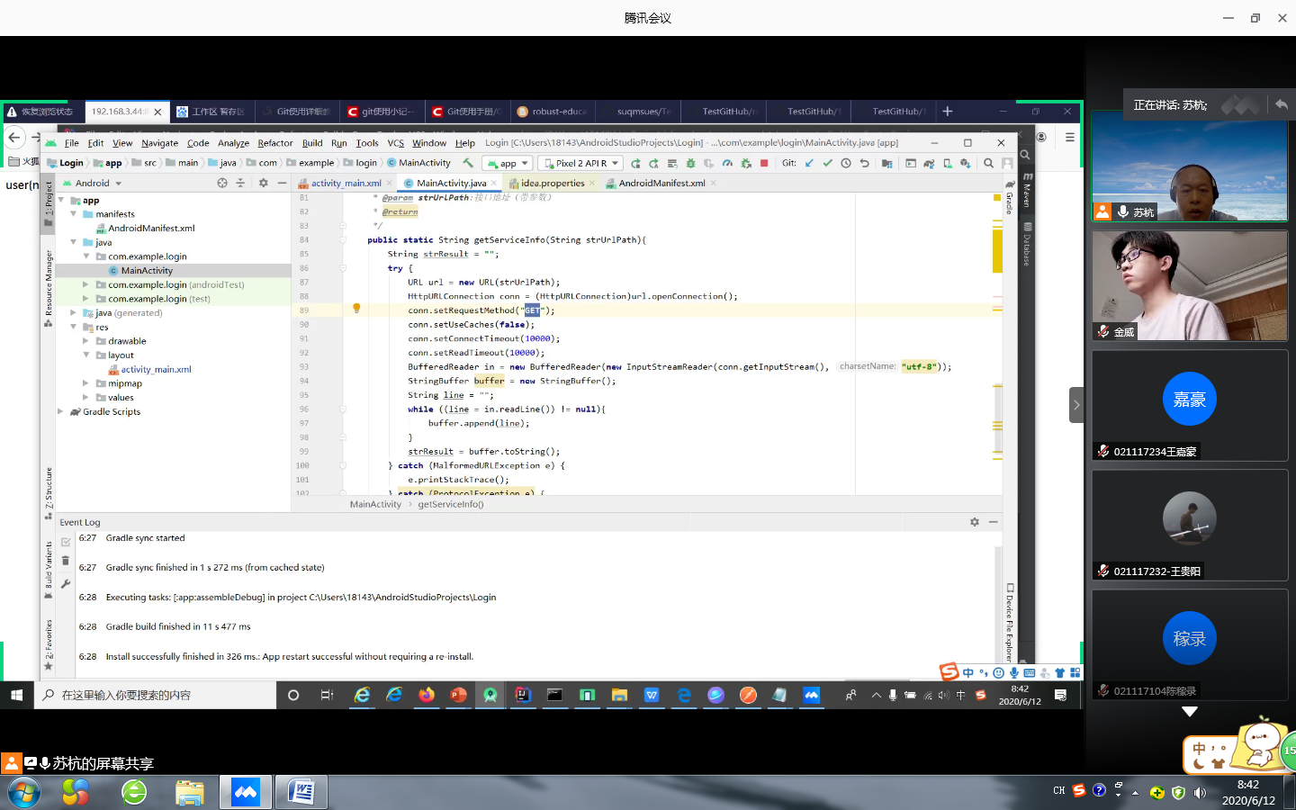

private Button bt;  
private EditText et;  
String sss="";  
public Handler handler=new Handler()  
{  
 @Override  
 public void handleMessage(Message msg)  
 {  
 try{  
 et.setText(msg.obj.toString());  
 }  
 catch(Exception e){  
 e.printStackTrace();  
 }  
 super.handleMessage(msg);  
 }  
};  
 @Override  
 protected void onCreate(Bundle savedInstanceState) {  
 super.onCreate(savedInstanceState);  
 setContentView(R.layout.*activity_main*);  
 Bmob.*initialize*(this,"ff2de1a04952a7dd10c85ede32d7d0a9");  
 bt = (Button) findViewById(R.id.*bt*);  
 et = (EditText) findViewById(R.id.*et_data_uname*);  
 bt.setOnClickListener(new View.OnClickListener() {  
 @Override  
 public void onClick(View v) {  
 new Thread((Runnable) () -> {  
 Message message = Message.*obtain*();  
 message.obj = *getServiceInfo*(strUrlPath:"http://192.168.3.44:8080/getUserItem");  
 handler.sendMessage(message);  
 }).start();  
 try {  
 *sleep*(millis:5);  
 } catch (InterruptedException e) {  
 e.printStackTrace();  
 }  
  
  
 }  
 });  
 }  
 public static String getServiceInfo(String strUrlPath){  
 String strResult="";  
 try{  
 URL url=new URL(strUrlPath);  
 HttpURLConnection conn=(HttpURLConnection)url.openConnection();  
 conn.setRequestMethod("GET");  
 conn.setUseCaches(false);  
 conn.setConnectTimeout(10000);  
 conn.setReadTimeout(10000);  
 BufferedReader in=new BufferedReader(new InputStreamReader(conn.getInputStream(),charsetName:"utf-8"));  
 StringBuffer buffer=new StringBuffer();  
 String line="";  
 while((line=in.readLine())!=null) {  
 buffer.append(line);  
 }  
 strResult=buffer.toString();  
 }catch(MalformedURLException e) {  
 e.printStackTrace();  
 }catch(ProtocolException e){  
 e.printStackTrace();  
 }catch(IOException e){  
 e.printStackTrace();  
 }  
 return strResult;  
 }  
 }