ADAMSON UNIVERSITY
COLLEGE OF SCIENCE
COMPUTER SCIENCE DEPARTMENT
ACADEMIC SERVICE LEARNING

BASKETBALL COURT SCHEDULING SYSTEM
IN COOPERATION WITH
BARANGAY STO. NIÑO, PARAÑAQUE CITY

Submitted by:
Roviklein P. Fabre
Jacob Ethan R. Gabaldon
Peter T. Guo
Zedrick Lonzaga
Benedict Riley D. Quizon
Rhegille Gabriel L. Rodriguez

Course/Subject: [INSERT COURSE/SUBJECT HERE]
Section: [INSERT SECTION HERE]
Professor/ASL Instructor: [INSERT PROFESSOR/ASL INSTRUCTOR HERE]
Semester / School Year: [INSERT SEMESTER AND SCHOOL YEAR HERE]
Date of Submission: [INSERT DATE OF SUBMISSION HERE]

ACKNOWLEDGEMENT
The researchers express their sincere gratitude to Adamson University for giving them the opportunity to take part in Academic Service Learning and to apply computer science knowledge in a community-based setting.
The group also extends its appreciation to the College of Science and the Computer Science Department for guiding students toward projects that respond to practical needs beyond the classroom.
The researchers are grateful to Barangay Sto. Niño, Parañaque City, including its officials and authorized personnel, for serving as the partner community for the Basketball Court Scheduling System. Their cooperation and insights helped shape an offline, barangay-office system that supports organized court reservations, schedule monitoring, and local record keeping.
The group acknowledges the guidance of [INSERT PROFESSOR/ASL INSTRUCTOR NAME HERE], whose instruction and feedback supported the completion of the project and this documentation.
Finally, the researchers thank their families, classmates, friends, and each group member for the support, patience, and cooperation shared throughout the planning, development, testing, and documentation of this Academic Service Learning project.

TABLE OF CONTENTS
ACKNOWLEDGEMENT 2
TABLE OF CONTENTS 3
CHAPTER 1: INTRODUCTION 6
1.1 BACKGROUND OF THE STUDY 6
1.1.1 THE HISTORY OF BARANGAY STO. NIÑO 6
1.1.2 MISSION, GOAL & VISION 6
1.2 ORGANIZATIONAL STRUCTURE 7
1.3 STATEMENT OF THE PROBLEM 7
1.4 OBJECTIVES OF THE STUDY 7
1.5 SCOPE AND LIMITATIONS 7
SCOPE 7
LIMITATIONS 8
CHAPTER 2: DATABASE & PROGRAM STRUCTURE 9
2.1 PROGRAM FLOWCHART 9
2.2 ENTITY RELATIONSHIP NOTATION 15
users 15
residents 16
reservation_statuses 16
time_slots 16
court_settings 17
reservation_reference_sequences 17
reservations 17
schedule_blocks 18
activity_logs 18
2.3 ENTITY RELATIONSHIP DIAGRAM 19
2.4 USER INTERFACE 20
Login Page 20
Dashboard 21
Calendar/Schedule View 22
New Reservation / Reservation Form 23
Reservation Details 24
Reservation Records 25
Account Management 27
Activity Logs 28
Reports 31
Maintenance Block Modal 33
Backup / Maintenance Tools 33
CHAPTER 3: THE FORMS 34
3.1 ASL PLAN OF ACTIVITIES 34
3.2 COLLEGE DEAN REPORT 34
3.3 FACULTY MEMBER REPORT FORM 34
3.4 FACULTY MEMBER EVALUATION FORM 35
3.5 STUDENT REGISTRATION FORM 35
Roviklein P. Fabre 35
Jacob Ethan R. Gabaldon 36
Peter T. Guo 37
Zedrick Lonzaga 38
Benedict Riley D. Quizon 39
Rhegille Gabriel L. Rodriguez 40
3.6 CLASS EVALUATION FORM 40
3.7 STUDENT EVALUATION FORM 40
Roviklein P. Fabre 40
Jacob Ethan R. Gabaldon 42
Peter T. Guo 43
Zedrick Lonzaga 44
Benedict Riley D. Quizon 45
Rhegille Gabriel L. Rodriguez 46
3.8 COMMUNITY/ORGANIZATION EVALUATION FORM 46
3.9 TURNOVER / ACCEPTANCE FORM 46
CHAPTER 4: REFLECTION 48
Roviklein P. Fabre 48
Jacob Ethan R. Gabaldon 49
Peter T. Guo 50
Zedrick Lonzaga 51
Benedict Riley D. Quizon 52
Rhegille Gabriel L. Rodriguez 53
CHAPTER 5: DOCUMENTATION 54
5.1 Barangay Sto. Niño Barangay Hall 54
5.2 First Community Visit / Initial Coordination 54
5.3 Data Gathering / Observation of Current Process 54
5.4 Contract Signing / Approval / Coordination 54
5.5 Program Development 54
5.6 System Testing 55
5.7 ASL Presentation / Defense Preparation 55
5.8 Deployment / Turnover 55
5.9 User Training / Barangay Personnel Briefing 55

Note: This table uses Word heading styles and can be updated by selecting the table of contents and choosing Update Field.

CHAPTER 1: INTRODUCTION

1.1 BACKGROUND OF THE STUDY
The basketball court in Barangay Sto. Niño, Parañaque City serves as a community recreation space where residents, youth groups, and sports teams gather for practice, friendly games, and social interaction. Because the court is a shared barangay facility, its availability affects many residents who depend on it for organized and informal community activities.
The project proposal identifies scheduling conflicts as the main concern. When court use is handled informally, two or more groups may expect to use the same time slot, and barangay personnel may need to manually check whether a requested schedule is available. This can lead to misunderstandings, repeated checking, and difficulty maintaining a clear record of reservations.
To address this need, the Basketball Court Scheduling System was developed as an offline, computer-based scheduling system for the barangay office. Residents do not reserve remotely; they coordinate directly with authorized barangay personnel, who encode reservation details, monitor available and reserved slots, update reservation status, and keep records in the local database.
An organized reservation system supports both barangay personnel and residents. Personnel can check the calendar before approving a request, prevent overlapping reservations, track missed, cancelled, and completed records, and review activity logs. Residents benefit from clearer scheduling and fairer access to the basketball court under barangay policy.
The project is also prepared for ISO/IEC 25010-style evaluation through evidence of functional suitability, reliability, usability, security, maintainability, and portability. The documentation does not assign evaluation scores because no verified score sheet or completed evaluation results were found in the available source files.

1.1.1 THE HISTORY OF BARANGAY STO. NIÑO
[INSERT VERIFIED HISTORY OF BARANGAY STO. NIÑO, PARAÑAQUE CITY HERE]
This section requires verified barangay-provided historical information. No verified history was found in the repository, proposal, slides, or provided ASL reference files.

1.1.2 MISSION, GOAL & VISION
Mission | [INSERT VERIFIED BARANGAY MISSION HERE]
Goal | [INSERT VERIFIED BARANGAY GOAL HERE]
Vision | [INSERT VERIFIED BARANGAY VISION HERE]

1.2 ORGANIZATIONAL STRUCTURE
[INSERT BARANGAY STO. NIÑO ORGANIZATIONAL STRUCTURE HERE]
No official organizational chart or verified list of barangay officials was found in the source files inspected.

1.3 STATEMENT OF THE PROBLEM
The system responds to the need for a clear and centralized method of managing basketball court reservations inside the barangay office.
- Scheduling Conflicts - Informal scheduling can allow multiple groups to expect access to the court at the same time.
- Inefficient Manual Checking - Personnel may need to repeatedly verify whether a date and time are still available.
- Lack of Centralized Reservation Records - Without a system, reservation details, status changes, and requester information can be harder to retrieve and update.
- Difficulty Monitoring Available Time Slots - Barangay personnel need a clear view of reserved, available, missed, cancelled, completed, and blocked periods.
- Limited Access Due to Offline Barangay-Office Setup - The system is intentionally limited to authorized personnel on the installed barangay office computer.

1.4 OBJECTIVES OF THE STUDY
- To provide an organized reservation system for the Barangay Sto. Niño basketball court.
- To prevent scheduling overlaps and double bookings through application validation and database safeguards.
- To maximize facility utilization by giving barangay personnel a clear view of reserved and available court time slots.
- To allow authorized barangay personnel to record, update, and manage reservations efficiently.
- To maintain systematic and updated reservation records in a local MySQL/MariaDB database.
- To support accountability through activity logs for reservation, account, and schedule-related actions where implemented.

1.5 SCOPE AND LIMITATIONS

SCOPE
- Monitoring available basketball court schedules through dashboard and calendar/schedule views.
- Recording reservation requests submitted by residents through authorized barangay personnel.
- Displaying reserved, available, missed, cancelled, completed, maintenance, and public-use blocked slots where applicable.
- Managing reservation records through the administrative staff interface, including reservation details, status changes, filtered lists, print views, and CSV exports.
- Suggesting the nearest available time when the requested schedule is not available, as implemented in the dashboard/API availability logic.
- Marking missed reservations through supported reservation status workflows.
- Managing Admin and Staff accounts, including account creation, activation/deactivation, and password changes.
- Maintaining activity logs for implemented reservation, account, court-policy, and schedule-block actions.
- Providing local backup, restore, readiness, and sign-off tooling through maintenance scripts rather than an in-app backup interface.

LIMITATIONS
- The project is designed for offline deployment based on the barangay preference recorded in the proposal and slides.
- The normal deployment is accessible only on the installed barangay office computer unless the office later configures local-network access.
- Residents cannot reserve remotely; they must coordinate with barangay personnel.
- Scheduling follows Barangay Sto. Niño policies and any policy changes must be confirmed by the barangay.
- Multi-device, public internet, cloud database, online payment, email, and SMS notification features are not included in the current system.
- Actual barangay-office PC setup, physical printer output, signed turnover, and completed evaluation scores remain external items that must be verified on site.

CHAPTER 2: DATABASE & PROGRAM STRUCTURE

2.1 PROGRAM FLOWCHART
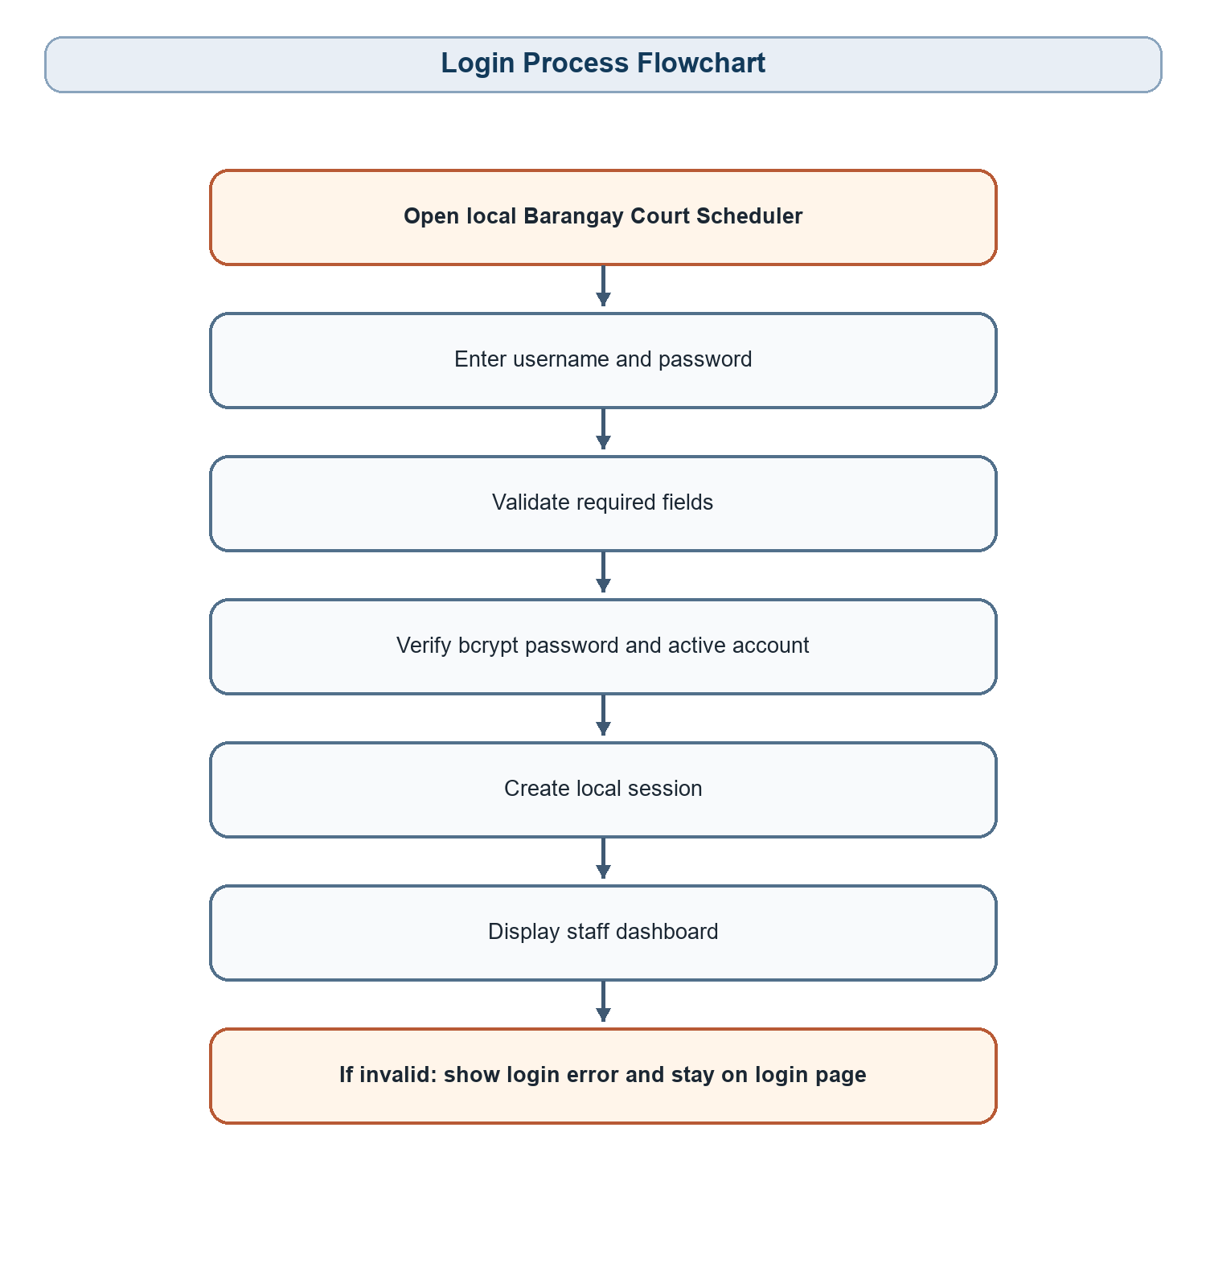
Figure 2.1. Login Process Flowchart
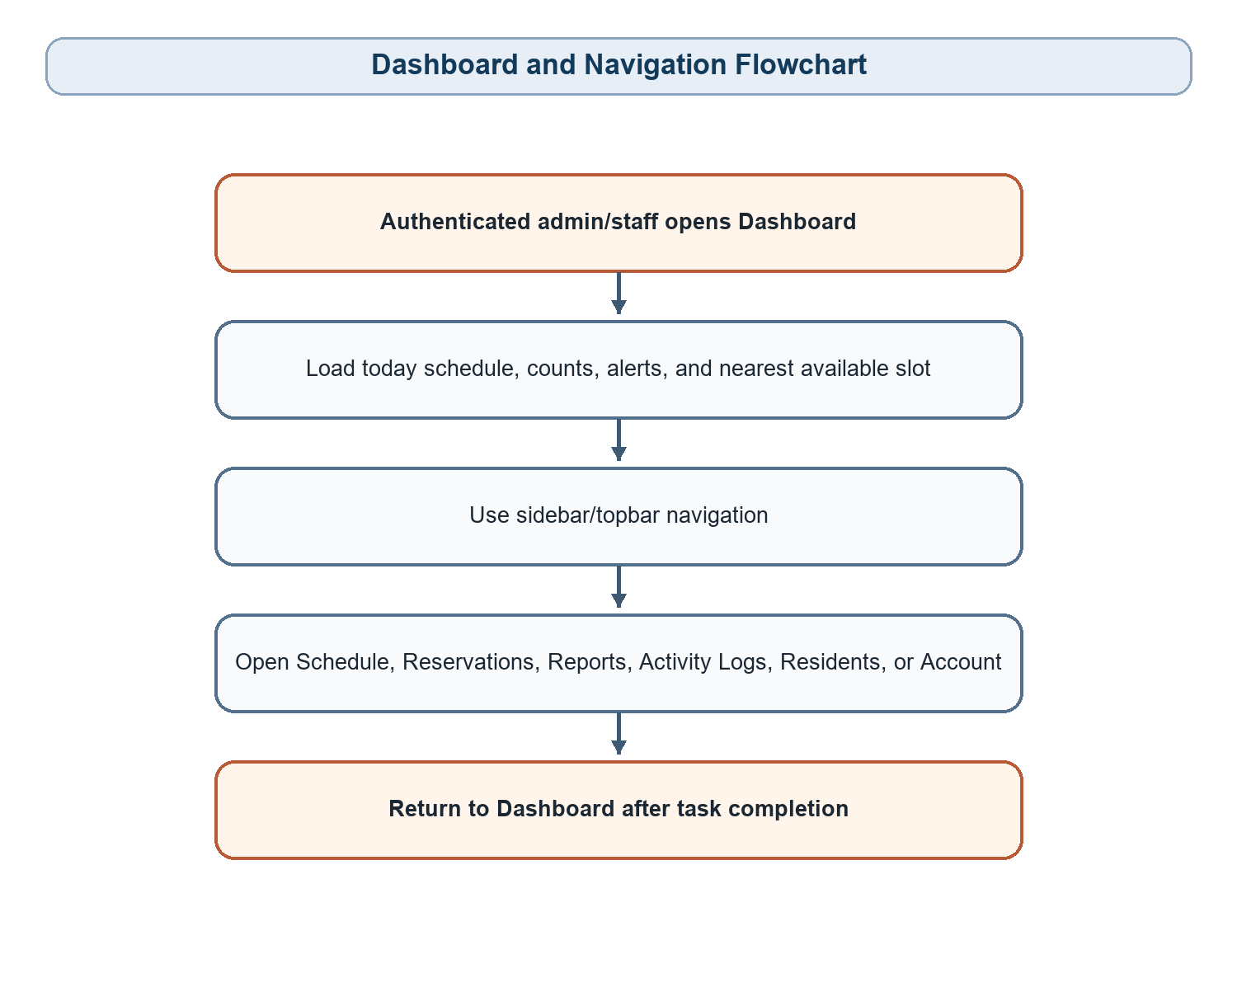
Figure 2.2. Dashboard and Navigation Flowchart
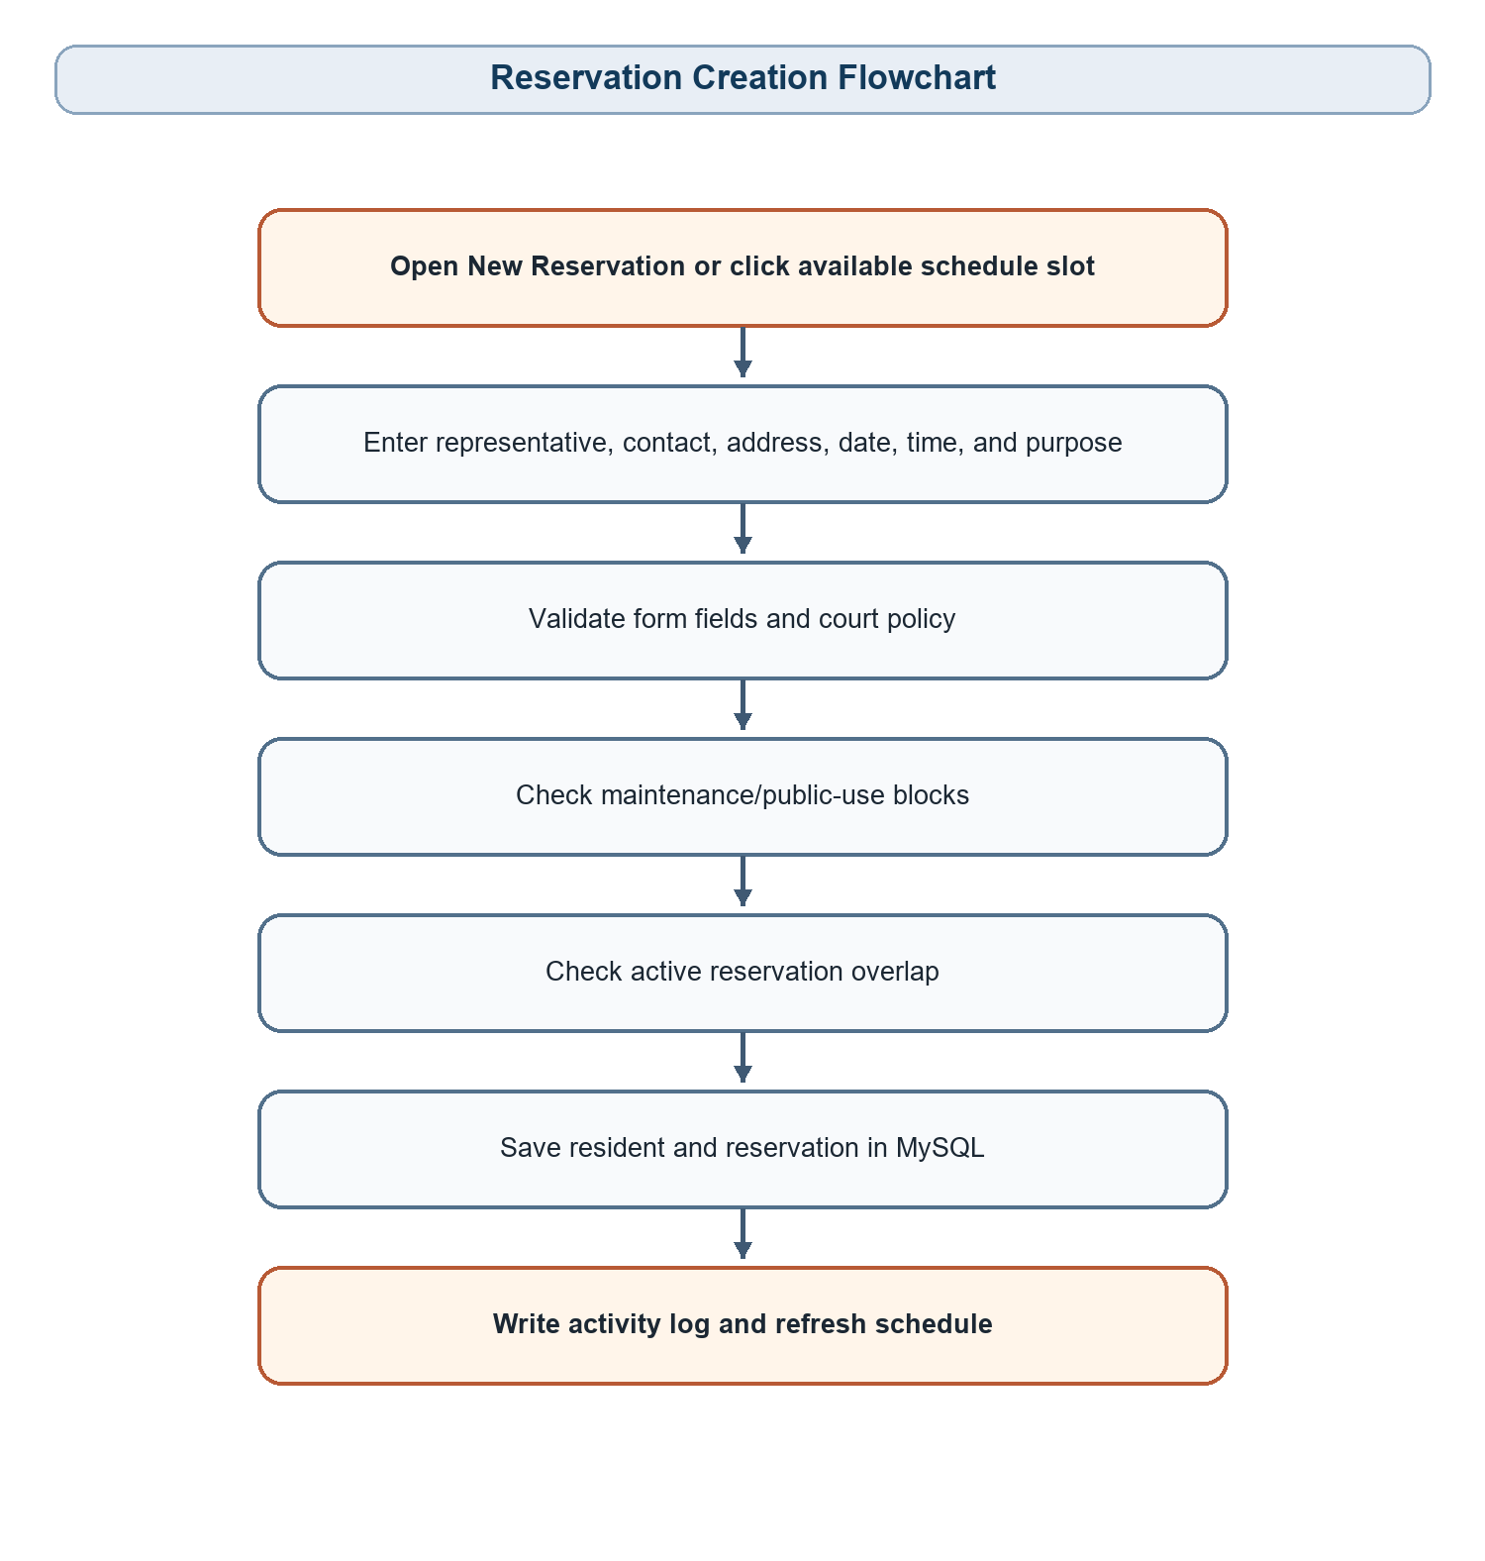
Figure 2.3. Reservation Creation Flowchart
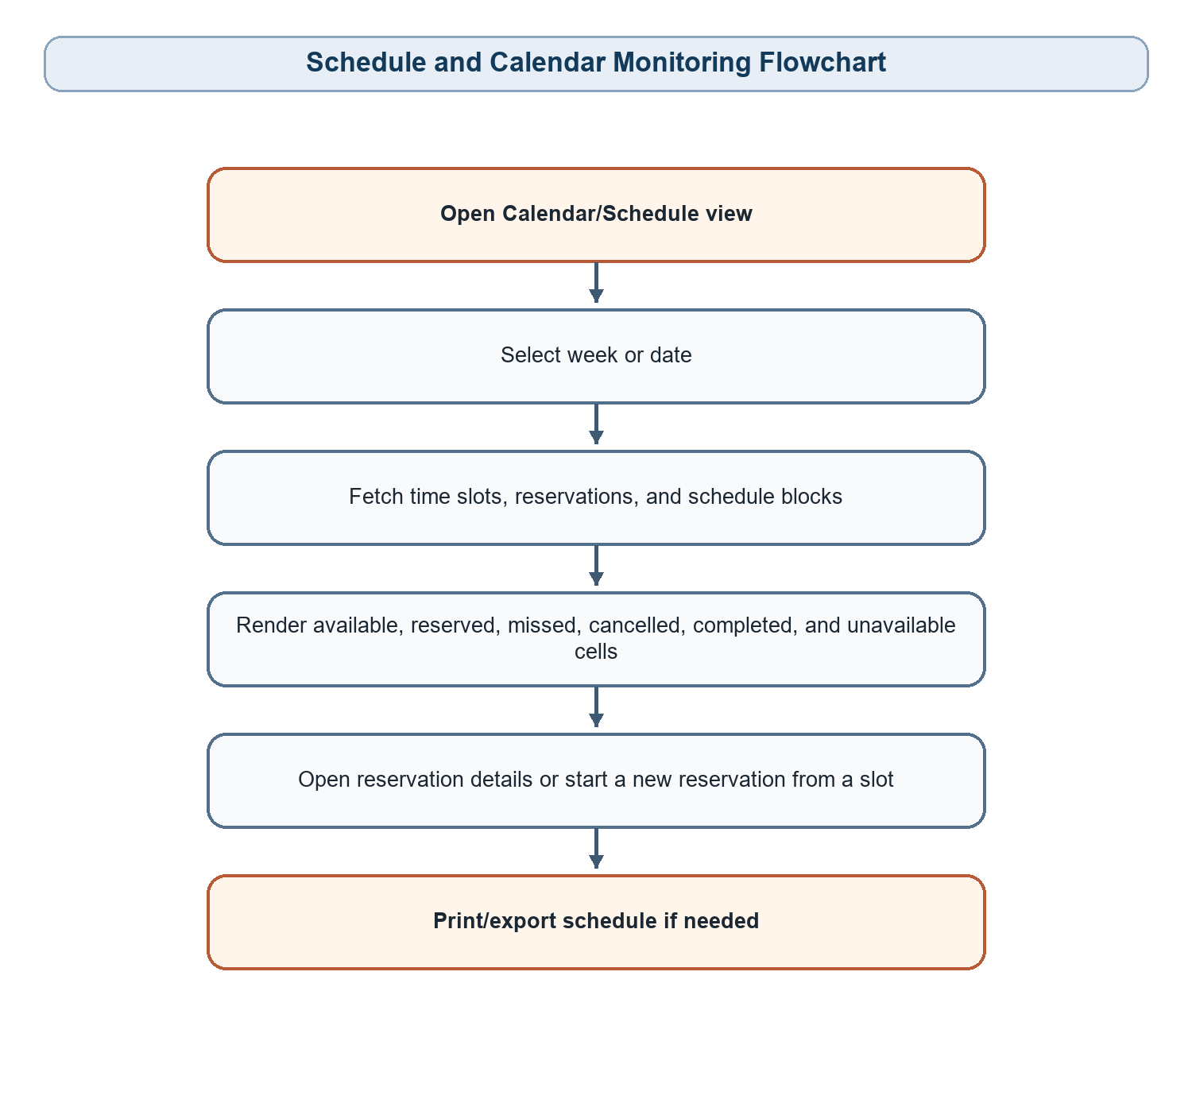
Figure 2.4. Schedule and Calendar Monitoring Flowchart
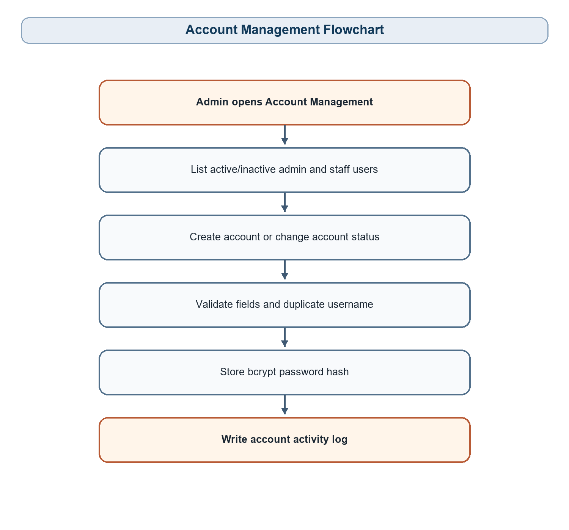
Figure 2.5. Account Management Flowchart
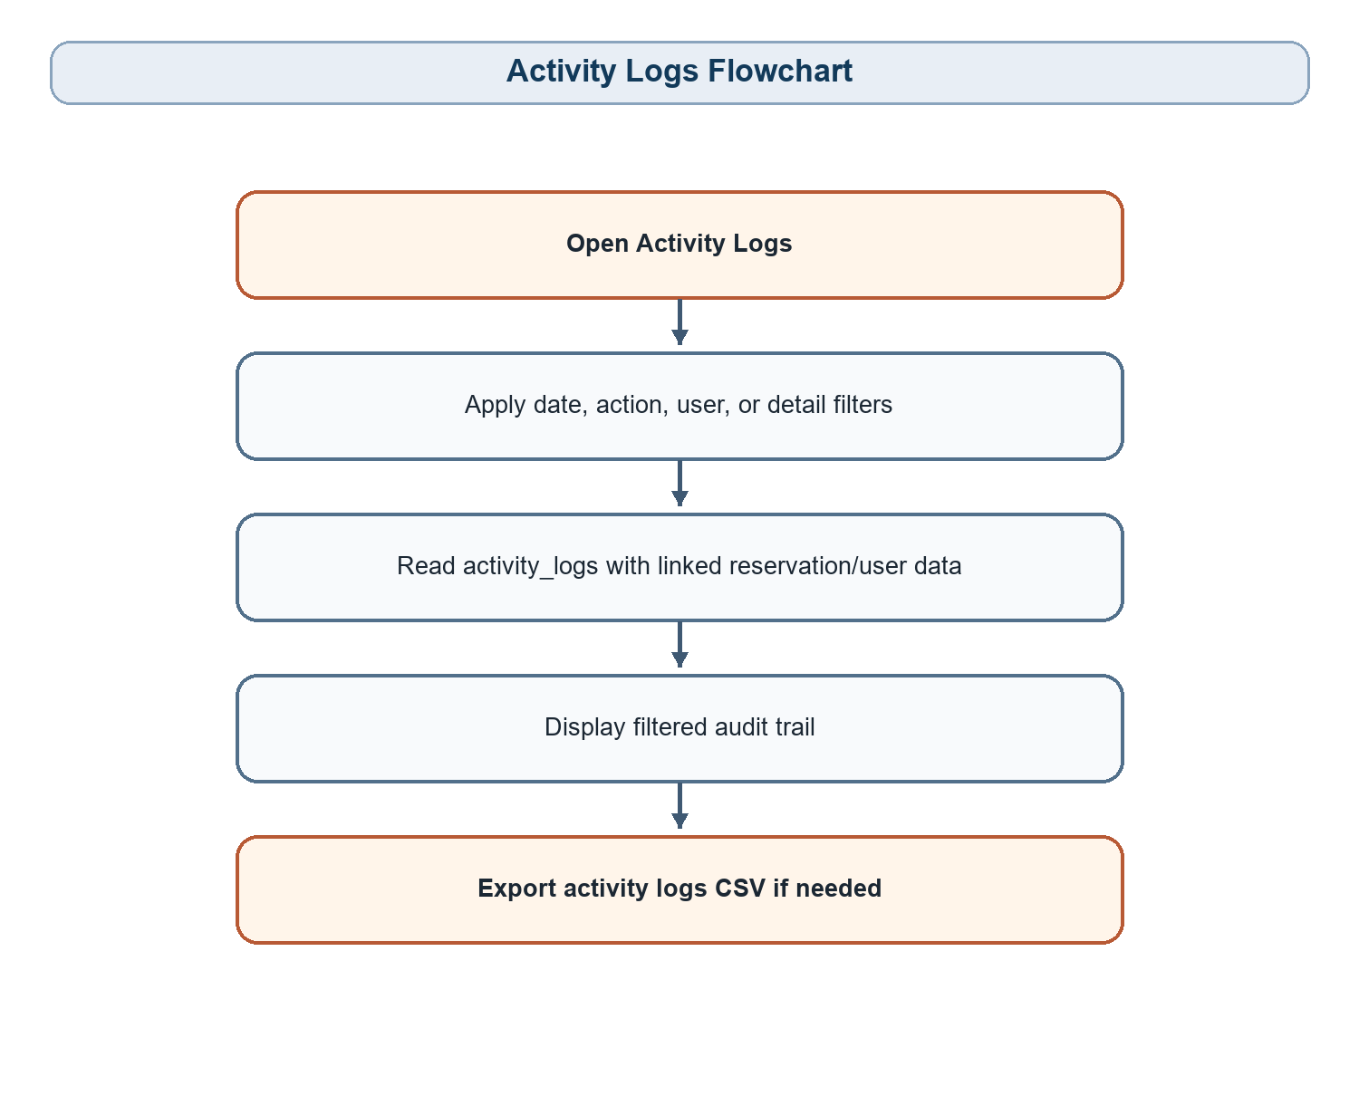
Figure 2.6. Activity Logs Flowchart
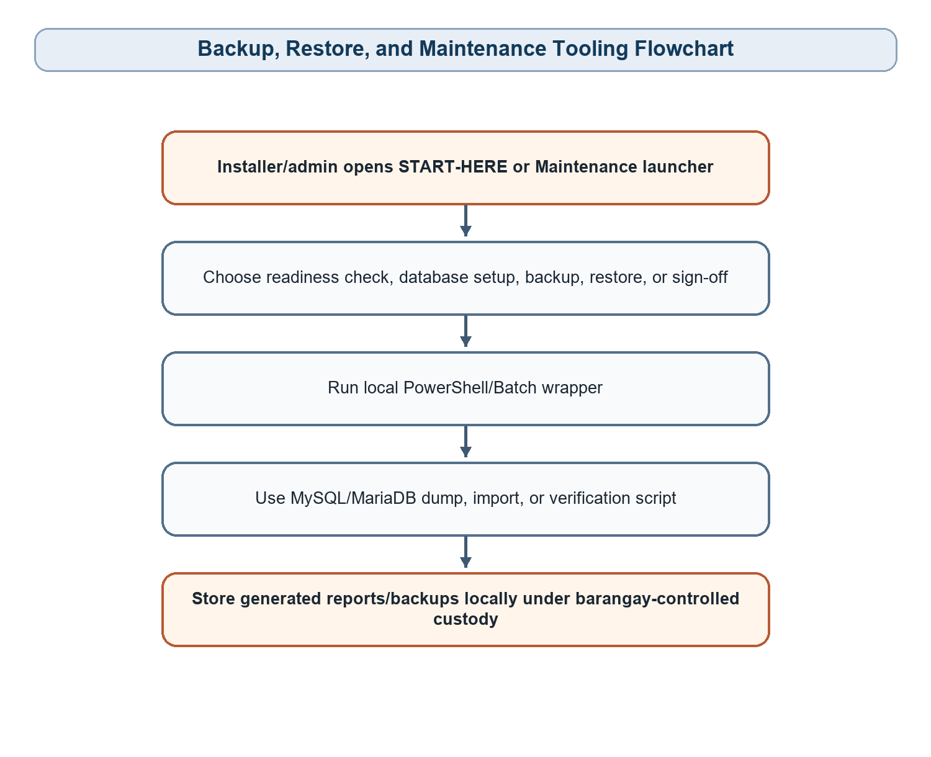
Figure 2.7. Backup, Restore, and Maintenance Tooling Flowchart

2.2 ENTITY RELATIONSHIP NOTATION
The current implementation uses a local MySQL/MariaDB database named barangay_court_scheduler. The schema is defined in database/schema.sql and uses InnoDB tables, utf8mb4/utf8mb4_unicode_ci encoding, foreign keys, indexes, CHECK constraints, reservation reference sequences, schedule blocks, and overlap-prevention triggers.

users
Field Name | Data Type | Key/Constraint | Description
user_id | BIGINT UNSIGNED | PK, AUTO_INCREMENT | Unique user account identifier.
full_name | VARCHAR(120) | NOT NULL | Name of the authorized barangay user.
contact_no | VARCHAR(30) | NULL | Optional staff contact number.
username | VARCHAR(60) | NOT NULL, UNIQUE | Login username.
password_hash | VARCHAR(255) | NOT NULL | Bcrypt password hash; plaintext passwords are not stored.
role | VARCHAR(20) | CHECK ADMIN/STAFF | Role used for permissions.
account_status | VARCHAR(20) | CHECK ACTIVE/INACTIVE | Controls account use.
created_at | TIMESTAMP | DEFAULT CURRENT_TIMESTAMP | Creation timestamp.
updated_at | TIMESTAMP | ON UPDATE CURRENT_TIMESTAMP | Latest update timestamp.

residents
Field Name | Data Type | Key/Constraint | Description
resident_id | BIGINT UNSIGNED | PK, AUTO_INCREMENT | Unique resident/requester identifier.
full_name | VARCHAR(140) | NOT NULL, INDEX | Resident or representative name.
contact_no | VARCHAR(30) | NOT NULL, INDEX | Resident or representative contact number.
address | VARCHAR(255) | NOT NULL | Resident address.
group_name | VARCHAR(140) | NULL | Optional team or group name.
notes | TEXT | NULL | Optional resident notes.
created_at | TIMESTAMP | DEFAULT CURRENT_TIMESTAMP | Record creation timestamp.
updated_at | TIMESTAMP | ON UPDATE CURRENT_TIMESTAMP | Latest update timestamp.

reservation_statuses
Field Name | Data Type | Key/Constraint | Description
status_id | SMALLINT UNSIGNED | PK | Status identifier.
status_code | VARCHAR(30) | NOT NULL, UNIQUE | Machine-readable status.
status_name | VARCHAR(50) | NOT NULL | Display label.
is_blocking | TINYINT(1) | CHECK 0/1 | Whether status blocks new reservations.
display_order | SMALLINT UNSIGNED | NOT NULL | Display order.

time_slots
Field Name | Data Type | Key/Constraint | Description
slot_id | SMALLINT UNSIGNED | PK, AUTO_INCREMENT | Unique slot identifier.
name | VARCHAR(50) | NOT NULL | Display name.
start_time | TIME | NOT NULL, UNIQUE WITH end_time | Slot start time.
end_time | TIME | NOT NULL, CHECK end > start | Slot end time.
display_order | SMALLINT UNSIGNED | NOT NULL | Display order.
is_active | TINYINT(1) | CHECK 0/1 | Whether slot is active.

court_settings
Field Name | Data Type | Key/Constraint | Description
setting_key | VARCHAR(80) | PK | Unique setting key.
setting_value | VARCHAR(255) | NOT NULL | Configured value.
description | VARCHAR(255) | NULL | Setting explanation.
updated_at | TIMESTAMP | ON UPDATE CURRENT_TIMESTAMP | Latest update timestamp.

reservation_reference_sequences
Field Name | Data Type | Key/Constraint | Description
reference_year | SMALLINT UNSIGNED | PK | Year for BCS references.
next_sequence | BIGINT UNSIGNED | NOT NULL | Next reservation number for the year.
updated_at | TIMESTAMP | ON UPDATE CURRENT_TIMESTAMP | Latest update timestamp.

reservations
Field Name | Data Type | Key/Constraint | Description
reservation_id | BIGINT UNSIGNED | PK, AUTO_INCREMENT | Unique reservation identifier.
reference_no | VARCHAR(20) | NOT NULL, UNIQUE | BCS-YYYY-000001 reference.
resident_id | BIGINT UNSIGNED | FK residents | Linked resident/requester.
time_slot_id | SMALLINT UNSIGNED | FK time_slots, NULL | Optional display time-slot reference.
status_id | SMALLINT UNSIGNED | FK reservation_statuses | Current reservation status.
approved_by_user_id | BIGINT UNSIGNED | FK users, NULL | Approving user when applicable.
created_by_user_id | BIGINT UNSIGNED | FK users | User who encoded reservation.
reservation_date | DATE | NOT NULL, INDEX | Date reserved.
start_time | TIME | NOT NULL | Reservation start time.
end_time | TIME | NOT NULL, CHECK end > start | Reservation end time.
purpose | VARCHAR(120) | NOT NULL | Purpose of court use.
remarks | TEXT | NULL | Optional remarks.
created_at | TIMESTAMP | DEFAULT CURRENT_TIMESTAMP | Creation timestamp.
updated_at | TIMESTAMP | ON UPDATE CURRENT_TIMESTAMP | Latest update timestamp.

schedule_blocks
Field Name | Data Type | Key/Constraint | Description
block_id | BIGINT UNSIGNED | PK, AUTO_INCREMENT | Unique unavailable-range identifier.
block_category | VARCHAR(30) | CHECK MAINTENANCE/PUBLIC_USE | Type of unavailable range.
block_type | VARCHAR(40) | NOT NULL | Specific reason category.
mode | VARCHAR(30) | CHECK WHOLE_DAY/TIME_RANGE/FROM_TIME_ONWARD | How time range is applied.
reservation_date | DATE | NOT NULL, INDEX | Date affected.
start_time | TIME | NOT NULL | Block start time.
end_time | TIME | NOT NULL, CHECK end > start | Block end time.
reason | VARCHAR(255) | NOT NULL | Reason entered by personnel.
created_by_user_id | BIGINT UNSIGNED | FK users | User who created block.
deactivated_by_user_id | BIGINT UNSIGNED | FK users, NULL | User who deactivated block.
is_active | TINYINT(1) | CHECK 0/1 | Whether block is active.
created_at | TIMESTAMP | DEFAULT CURRENT_TIMESTAMP | Creation timestamp.
updated_at | TIMESTAMP | ON UPDATE CURRENT_TIMESTAMP | Latest update timestamp.
deactivated_at | TIMESTAMP | NULL | Deactivation timestamp.

activity_logs
Field Name | Data Type | Key/Constraint | Description
log_id | BIGINT UNSIGNED | PK, AUTO_INCREMENT | Unique activity log identifier.
reservation_id | BIGINT UNSIGNED | FK reservations, NULL | Reservation connected to action.
user_id | BIGINT UNSIGNED | FK users, NULL | User connected to action.
action | VARCHAR(80) | NOT NULL, INDEX | Action label.
details | TEXT | NULL | Additional details.
created_at | TIMESTAMP | DEFAULT CURRENT_TIMESTAMP, INDEX | Time action was logged.

Database safeguards include MySQL triggers named prevent_reservation_overlap_before_insert and prevent_reservation_overlap_before_update. These reject overlapping active reservations at the database level when the new or updated status is blocking.

2.3 ENTITY RELATIONSHIP DIAGRAM
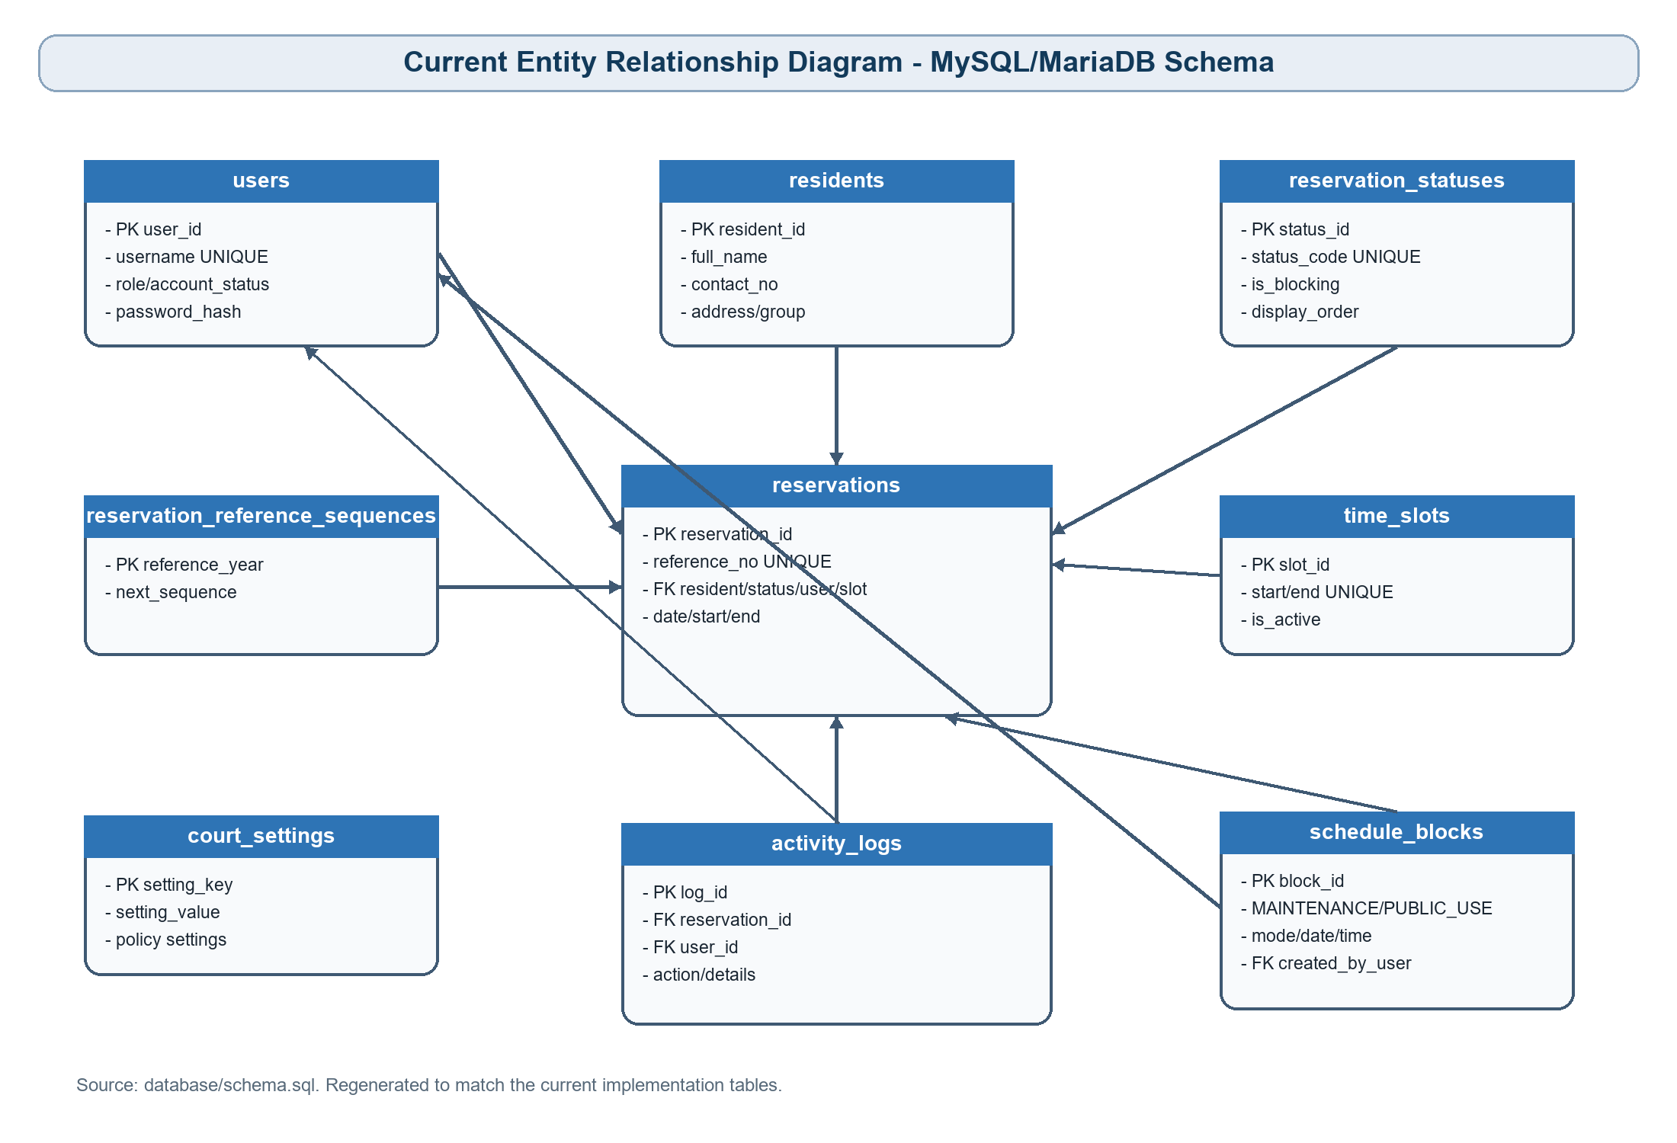
Figure 2.8. Entity Relationship Diagram of the Basketball Court Scheduling System

2.4 USER INTERFACE

Login Page
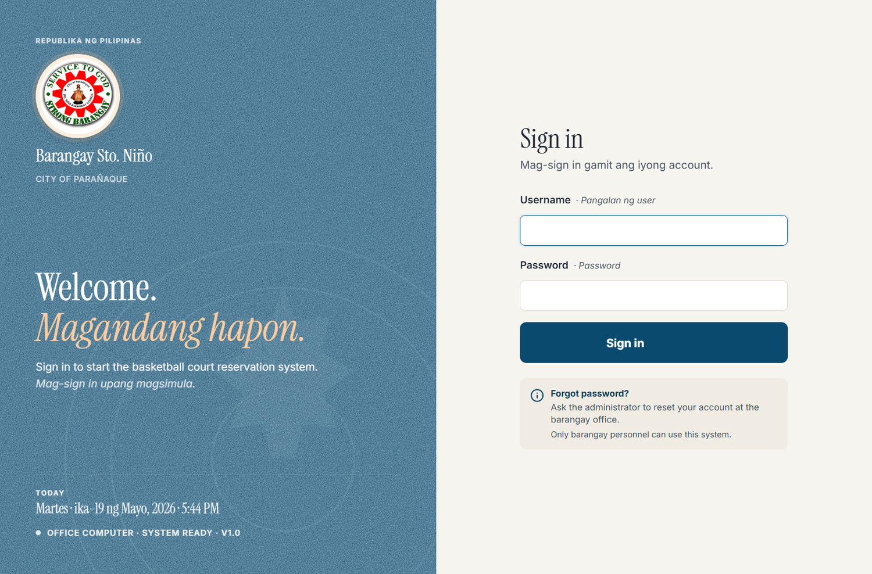
Figure 2.9. Login Page
The login page is used by authorized Admin and Staff accounts before accessing the office system.

Dashboard
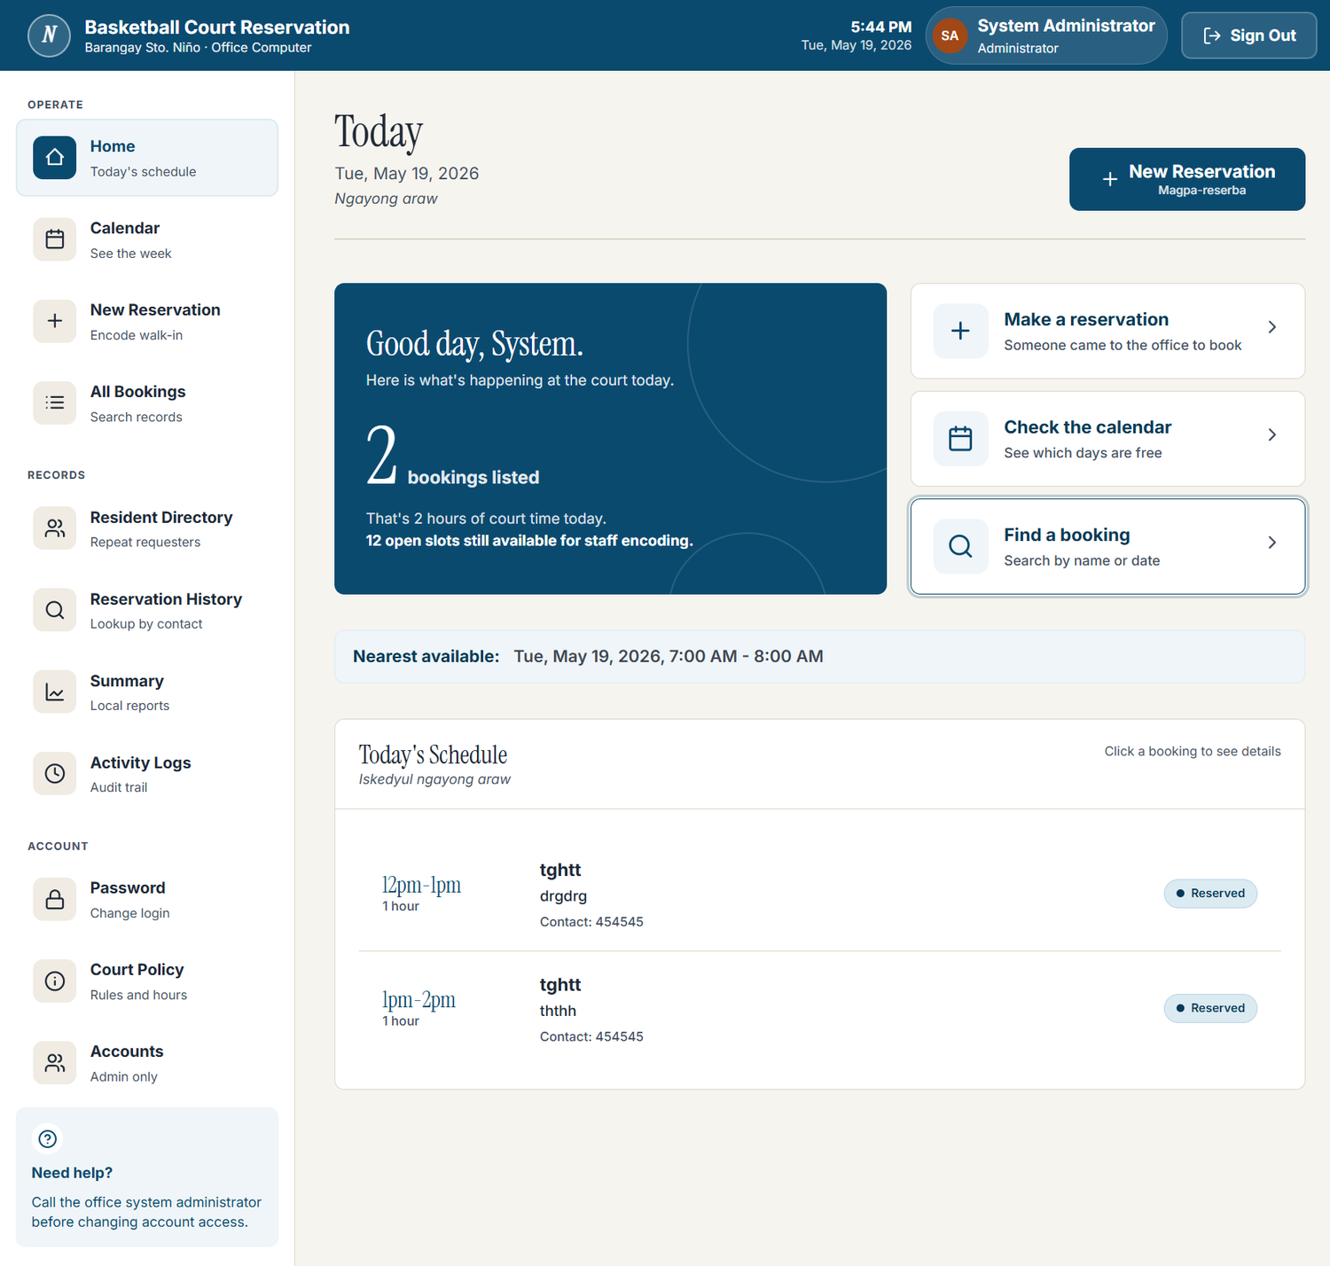
Figure 2.10. Dashboard
The dashboard summarizes today's schedule, alerts, counts, and nearest available slot information for quick office checking.

Calendar/Schedule View
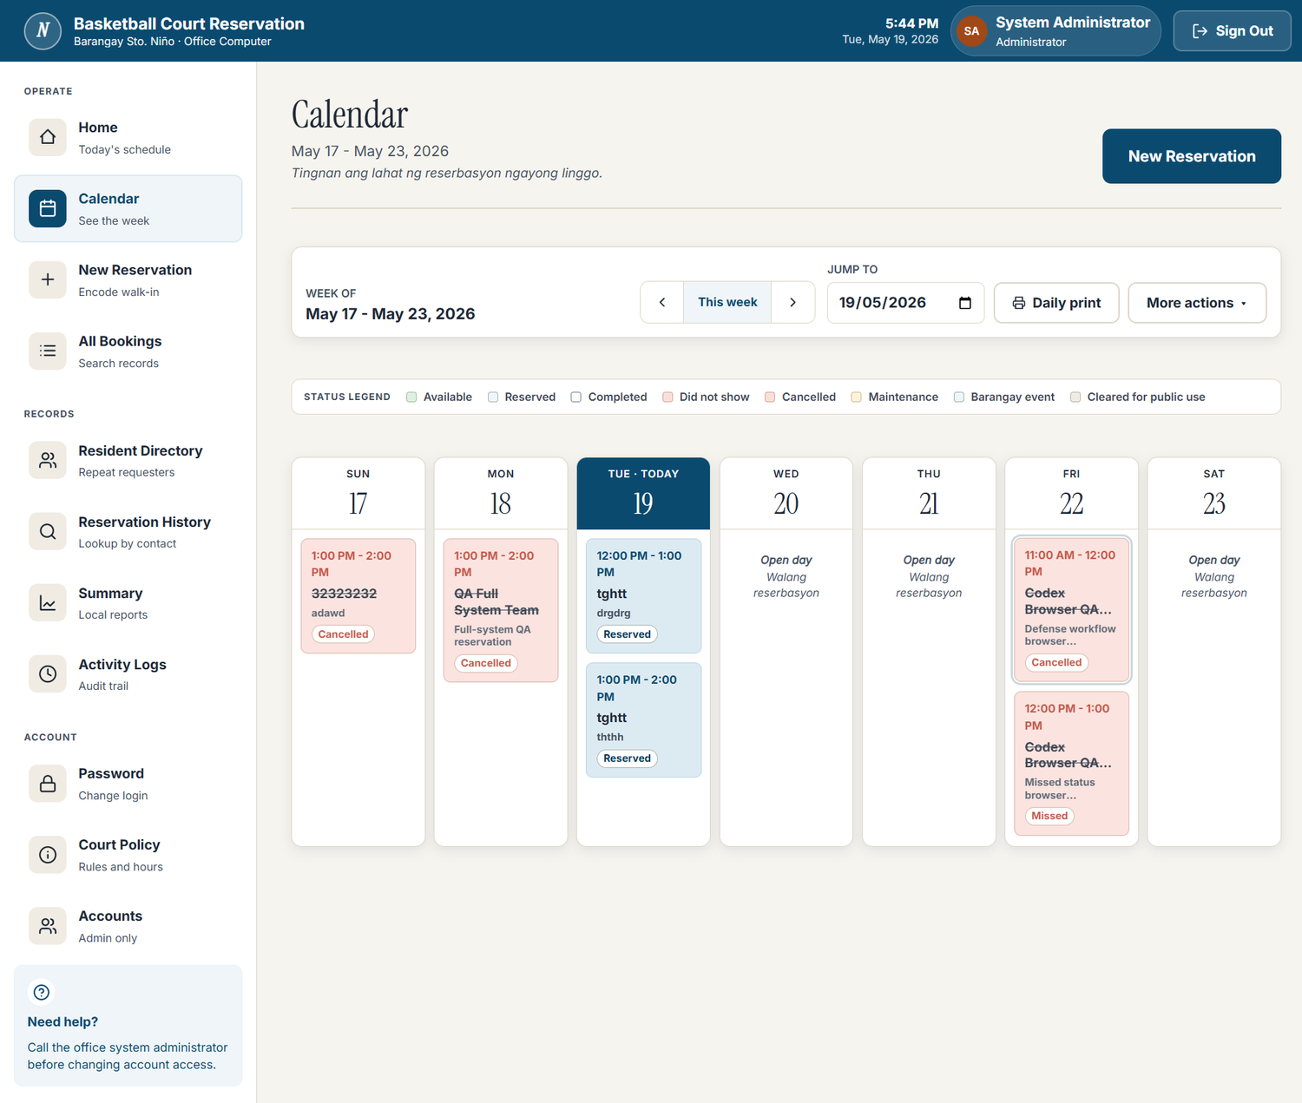
Figure 2.11. Calendar/Schedule View
The schedule view displays available, reserved, missed, cancelled, completed, maintenance, and public-use blocked slots.

New Reservation / Reservation Form
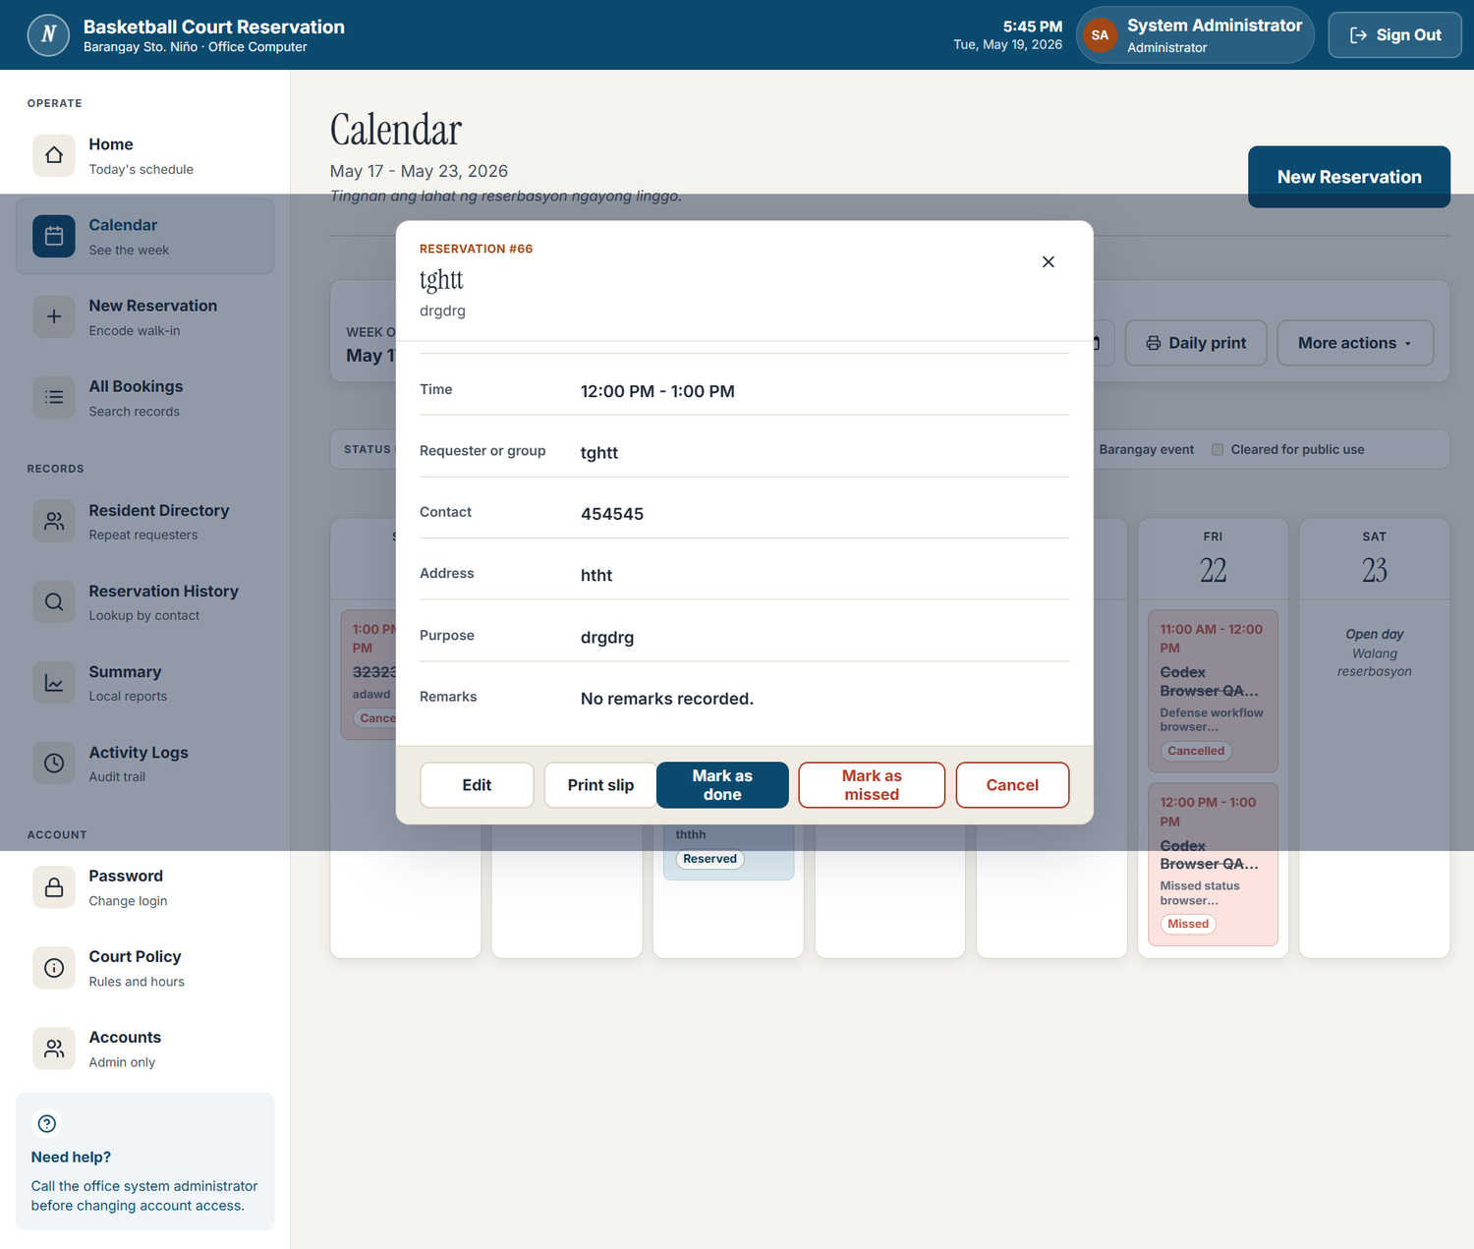
Figure 2.12. New Reservation / Reservation Form
The reservation form is used by barangay personnel to encode resident/requester details, date, time, and purpose.

Reservation Details
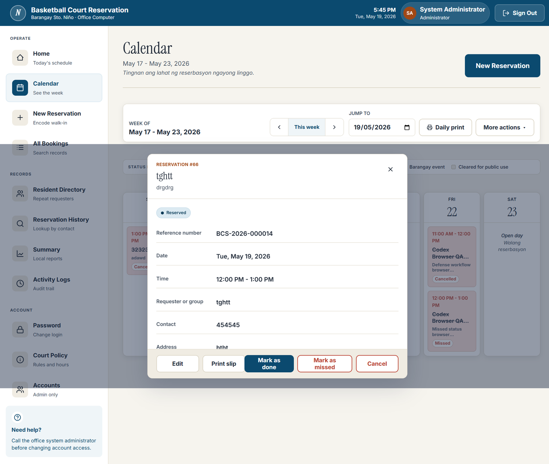
Figure 2.13. Reservation Details
The detail drawer displays reservation reference information, requester data, schedule details, and status actions.

Reservation Records
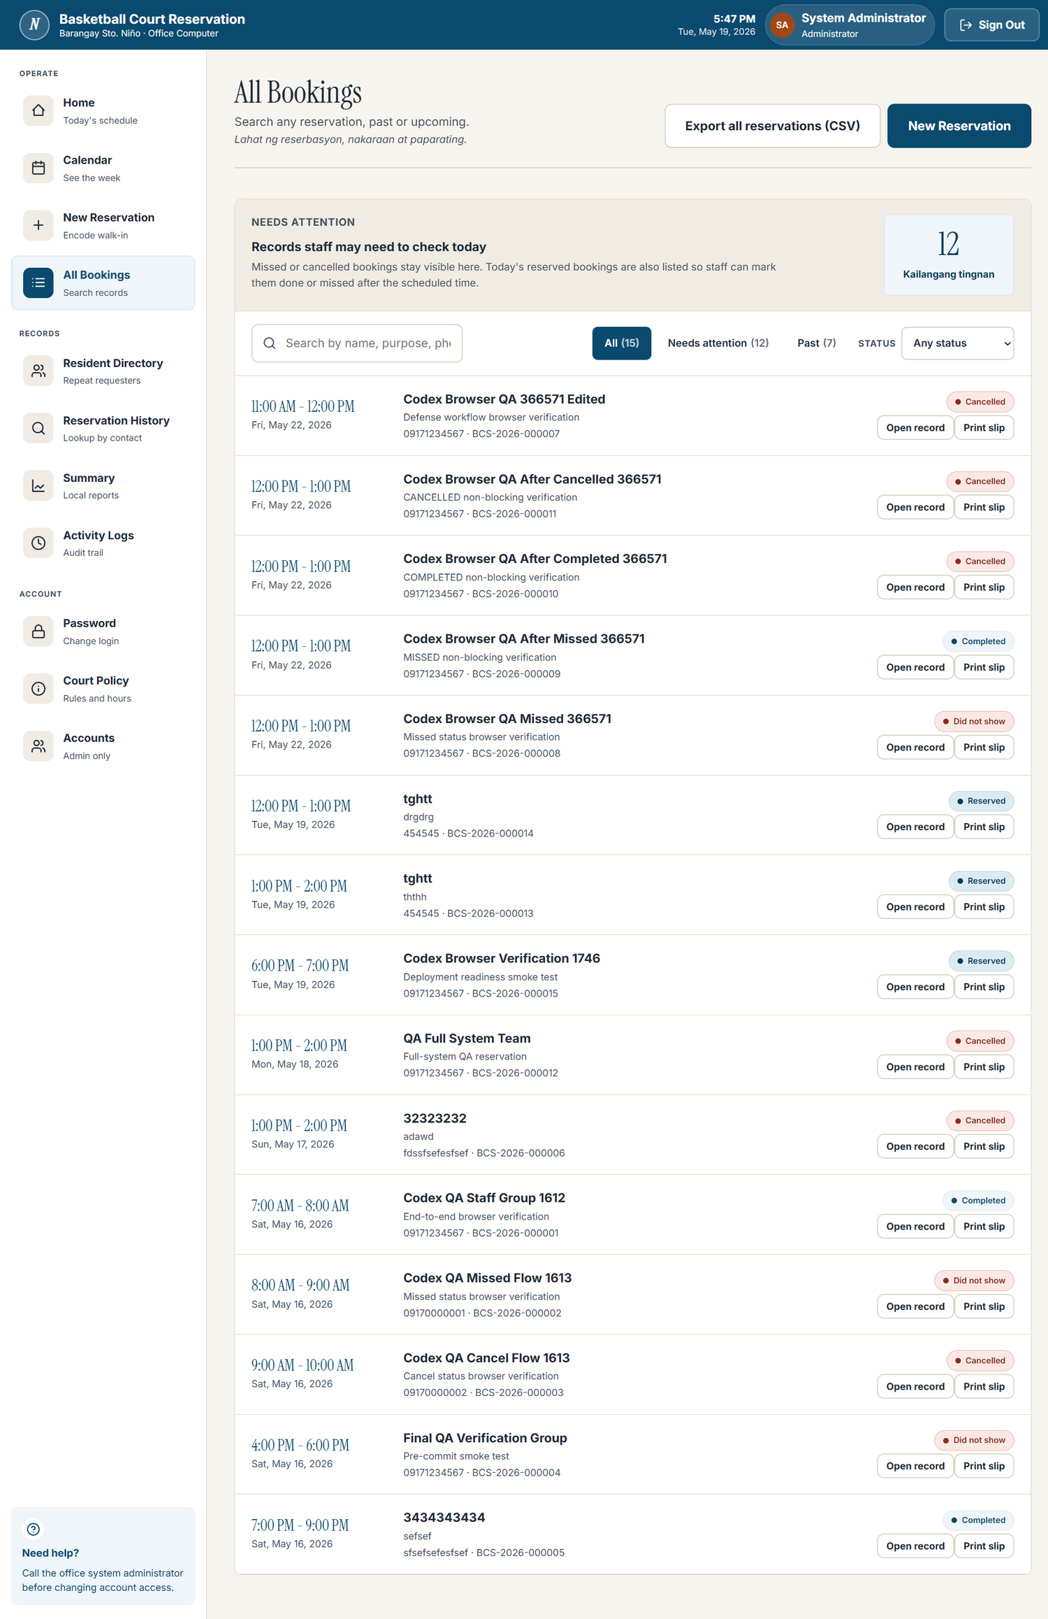
Figure 2.14. Reservation Records
The records page supports searching, filtering, reviewing, printing, and exporting reservation data.

Account Management
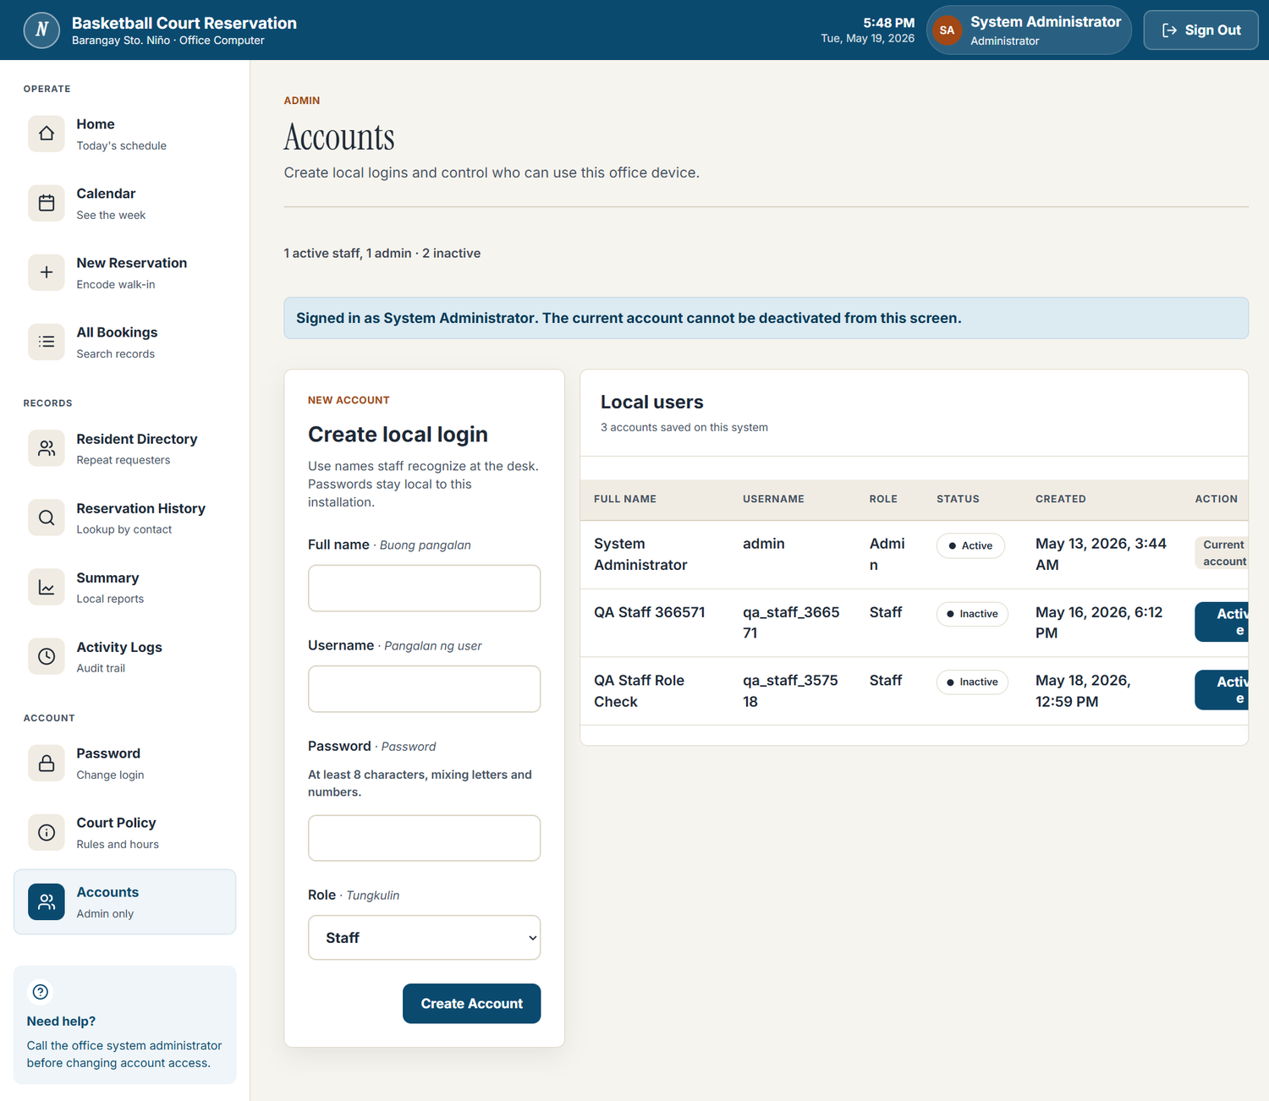
Figure 2.15. Account Management
The account management screen is restricted to Admin users and supports Admin/Staff account handling.

Activity Logs
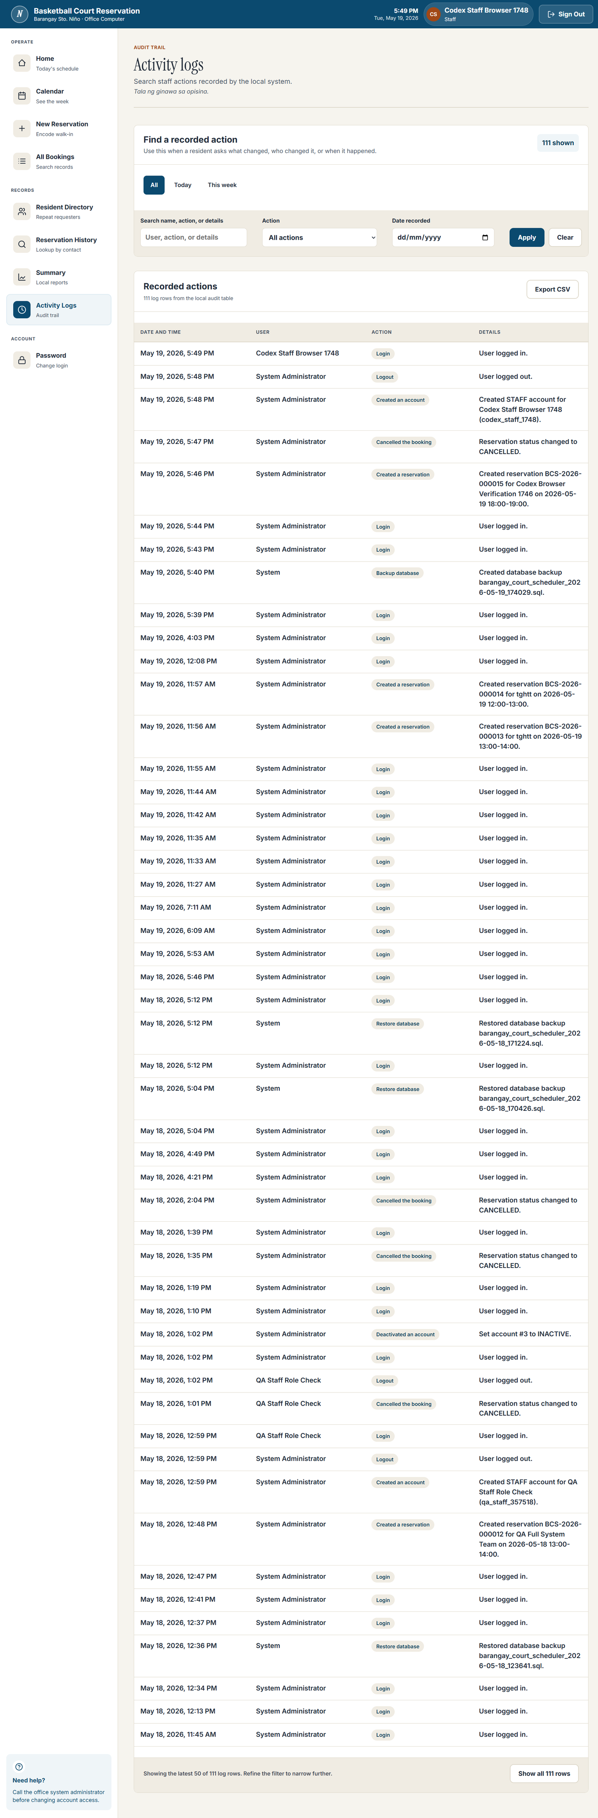
Figure 2.16. Activity Logs
The activity log screen shows the audit trail for reservation, account, court policy, and schedule-related actions.

Reports
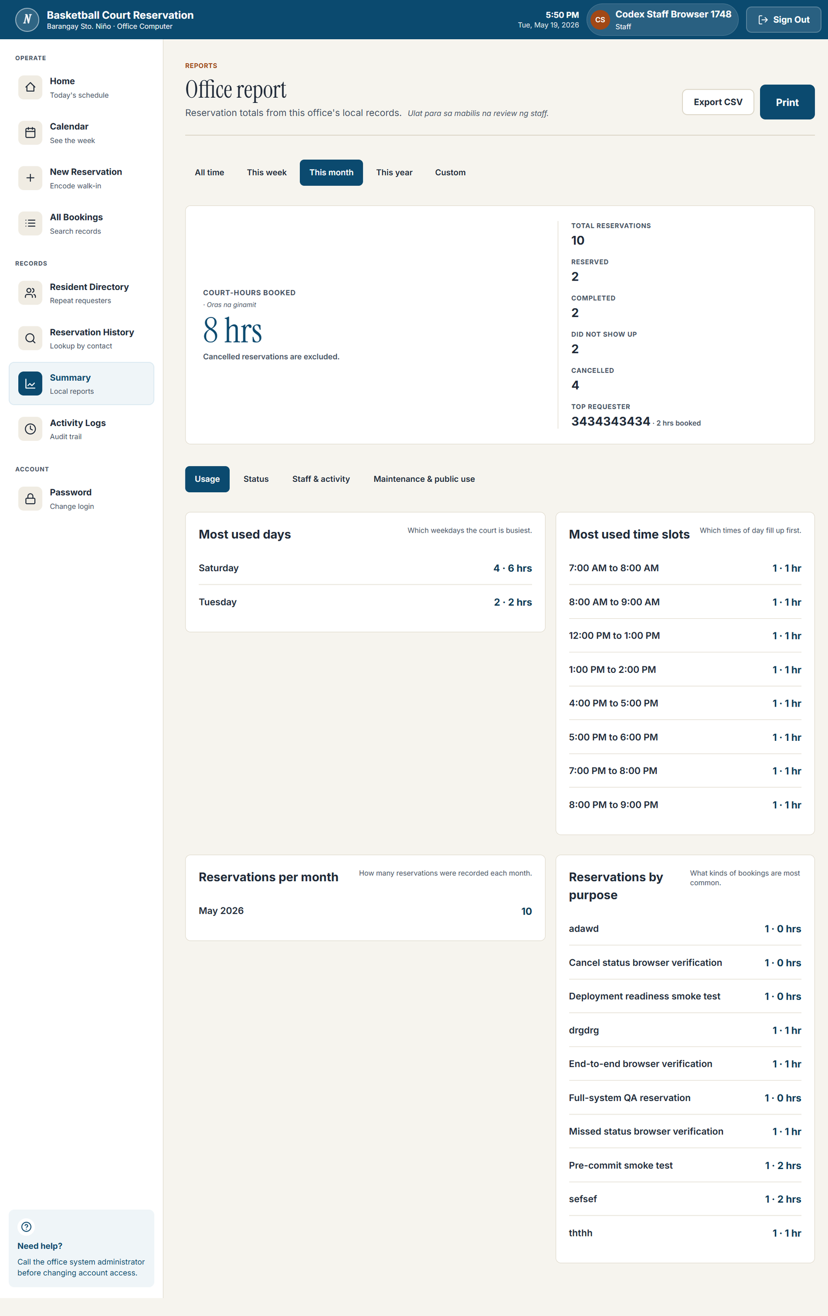
Figure 2.17. Reports
The reports screen summarizes reservation counts, status breakdowns, usage, maintenance/public-use ranges, and exportable report data.

Maintenance Block Modal
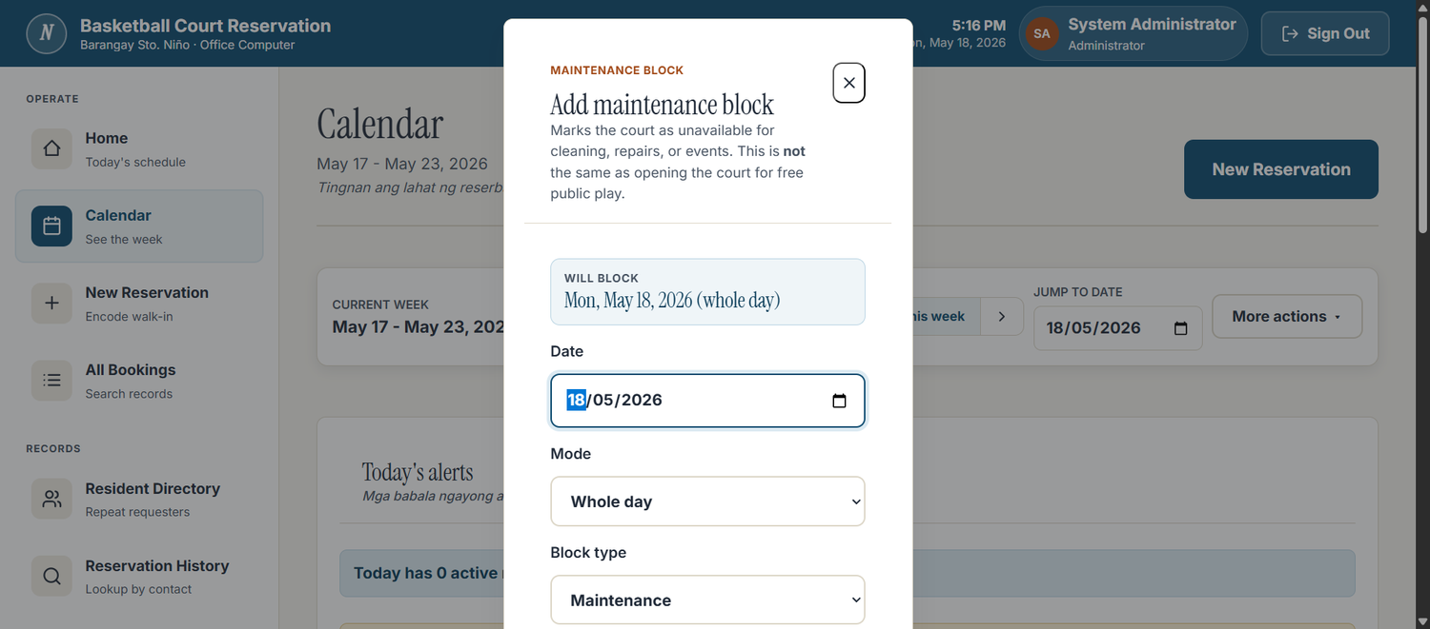
Figure 2.18. Maintenance Block Modal
The maintenance block modal marks unavailable court time; backup and restore are handled through separate Windows maintenance scripts.

Backup / Maintenance Tools
[INSERT SCREENSHOT: Maintenance Tools Launcher / Backup-Restore Tools]
Backup and restore are implemented as local Windows maintenance tools and scripts. No verified screenshot of the launcher was found among the source screenshots.

CHAPTER 3: THE FORMS
The following ASL forms are prepared in placeholder format because no completed signed forms were found in the source files.

3.1 ASL PLAN OF ACTIVITIES
Activity | Date | Objective | Participants | Remarks
Initial coordination with Barangay Sto. Niño | [INSERT DATE] | Confirm community need and project scope. | Group members; barangay personnel | [INSERT REMARKS]
Data gathering and process observation | [INSERT DATE] | Understand current court scheduling process and required details. | Group members; barangay personnel | [INSERT REMARKS]
System design and database planning | [INSERT DATE] | Prepare UI flow, database structure, and offline deployment plan. | Group members | [INSERT REMARKS]
Program development | [INSERT DATE] | Build login, reservation, schedule, account, reporting, and logging features. | Group members | [INSERT REMARKS]
Testing and verification | [INSERT DATE] | Verify overlap prevention, schedule display, UI screens, and offline readiness. | Group members | [INSERT REMARKS]
Presentation / defense preparation | [INSERT DATE] | Prepare ASL presentation, documentation, and evidence. | Group members | [INSERT REMARKS]
Turnover / user briefing | [INSERT DATE] | Brief barangay personnel and prepare acceptance records. | Group members; barangay personnel | [INSERT REMARKS]

3.2 COLLEGE DEAN REPORT
College | College of Science
School Year | [INSERT SCHOOL YEAR]
Semester | [INSERT SEMESTER]
Date | [INSERT DATE]
Project Title | Basketball Court Scheduling System
Community/Organization | Barangay Sto. Niño, Parañaque City
Report/Remarks | [INSERT VERIFIED COLLEGE DEAN REPORT DETAILS HERE]

3.3 FACULTY MEMBER REPORT FORM
Faculty Member | [INSERT FACULTY MEMBER NAME HERE]
Subject/Section | [INSERT SUBJECT AND SECTION HERE]
Community/Organization | Barangay Sto. Niño, Parañaque City
Project Description | Offline barangay-office basketball court scheduling system.
Report/Remarks | [INSERT VERIFIED FACULTY MEMBER REPORT HERE]

3.4 FACULTY MEMBER EVALUATION FORM
Semester | [INSERT SEMESTER]
School Year | [INSERT SCHOOL YEAR]
Name of Professor | [INSERT PROFESSOR NAME HERE]
Name of Community/Organization Served | Barangay Sto. Niño, Parañaque City
Evaluation Scale | 1 = Poor, 2 = Fair, 3 = Good, 4 = Very Good, 5 = Outstanding
Evaluator Name / Signature / Date | [INSERT VERIFIED EVALUATION DETAILS HERE]

3.5 STUDENT REGISTRATION FORM

Roviklein P. Fabre
Name of Student | Roviklein P. Fabre
Student No. | [INSERT STUDENT NUMBER HERE]
Course & Year | [INSERT COURSE AND YEAR LEVEL HERE]
Permanent Address | [INSERT ADDRESS HERE]
Telephone / CP No. | [INSERT CONTACT NUMBER HERE]
Subject with ASL | [INSERT SUBJECT HERE]
Section / Day / Time / Room | [INSERT CLASS DETAILS HERE]
Semester / School Year | [INSERT SEMESTER AND SCHOOL YEAR HERE]
Professor | [INSERT PROFESSOR NAME HERE]
Community / Organization | Barangay Sto. Niño, Parañaque City
Community Address / Contact Person | [INSERT VERIFIED BARANGAY CONTACT DETAILS HERE]

Jacob Ethan R. Gabaldon
Name of Student | Jacob Ethan R. Gabaldon
Student No. | [INSERT STUDENT NUMBER HERE]
Course & Year | [INSERT COURSE AND YEAR LEVEL HERE]
Permanent Address | [INSERT ADDRESS HERE]
Telephone / CP No. | [INSERT CONTACT NUMBER HERE]
Subject with ASL | [INSERT SUBJECT HERE]
Section / Day / Time / Room | [INSERT CLASS DETAILS HERE]
Semester / School Year | [INSERT SEMESTER AND SCHOOL YEAR HERE]
Professor | [INSERT PROFESSOR NAME HERE]
Community / Organization | Barangay Sto. Niño, Parañaque City
Community Address / Contact Person | [INSERT VERIFIED BARANGAY CONTACT DETAILS HERE]

Peter T. Guo
Name of Student | Peter T. Guo
Student No. | [INSERT STUDENT NUMBER HERE]
Course & Year | [INSERT COURSE AND YEAR LEVEL HERE]
Permanent Address | [INSERT ADDRESS HERE]
Telephone / CP No. | [INSERT CONTACT NUMBER HERE]
Subject with ASL | [INSERT SUBJECT HERE]
Section / Day / Time / Room | [INSERT CLASS DETAILS HERE]
Semester / School Year | [INSERT SEMESTER AND SCHOOL YEAR HERE]
Professor | [INSERT PROFESSOR NAME HERE]
Community / Organization | Barangay Sto. Niño, Parañaque City
Community Address / Contact Person | [INSERT VERIFIED BARANGAY CONTACT DETAILS HERE]

Zedrick Lonzaga
Name of Student | Zedrick Lonzaga
Student No. | [INSERT STUDENT NUMBER HERE]
Course & Year | [INSERT COURSE AND YEAR LEVEL HERE]
Permanent Address | [INSERT ADDRESS HERE]
Telephone / CP No. | [INSERT CONTACT NUMBER HERE]
Subject with ASL | [INSERT SUBJECT HERE]
Section / Day / Time / Room | [INSERT CLASS DETAILS HERE]
Semester / School Year | [INSERT SEMESTER AND SCHOOL YEAR HERE]
Professor | [INSERT PROFESSOR NAME HERE]
Community / Organization | Barangay Sto. Niño, Parañaque City
Community Address / Contact Person | [INSERT VERIFIED BARANGAY CONTACT DETAILS HERE]

Benedict Riley D. Quizon
Name of Student | Benedict Riley D. Quizon
Student No. | [INSERT STUDENT NUMBER HERE]
Course & Year | [INSERT COURSE AND YEAR LEVEL HERE]
Permanent Address | [INSERT ADDRESS HERE]
Telephone / CP No. | [INSERT CONTACT NUMBER HERE]
Subject with ASL | [INSERT SUBJECT HERE]
Section / Day / Time / Room | [INSERT CLASS DETAILS HERE]
Semester / School Year | [INSERT SEMESTER AND SCHOOL YEAR HERE]
Professor | [INSERT PROFESSOR NAME HERE]
Community / Organization | Barangay Sto. Niño, Parañaque City
Community Address / Contact Person | [INSERT VERIFIED BARANGAY CONTACT DETAILS HERE]

Rhegille Gabriel L. Rodriguez
Name of Student | Rhegille Gabriel L. Rodriguez
Student No. | [INSERT STUDENT NUMBER HERE]
Course & Year | [INSERT COURSE AND YEAR LEVEL HERE]
Permanent Address | [INSERT ADDRESS HERE]
Telephone / CP No. | [INSERT CONTACT NUMBER HERE]
Subject with ASL | [INSERT SUBJECT HERE]
Section / Day / Time / Room | [INSERT CLASS DETAILS HERE]
Semester / School Year | [INSERT SEMESTER AND SCHOOL YEAR HERE]
Professor | [INSERT PROFESSOR NAME HERE]
Community / Organization | Barangay Sto. Niño, Parañaque City
Community Address / Contact Person | [INSERT VERIFIED BARANGAY CONTACT DETAILS HERE]

3.6 CLASS EVALUATION FORM
Subject | [INSERT SUBJECT HERE]
Name of Professor | [INSERT PROFESSOR NAME HERE]
Department | Computer Science
College | College of Science
Community/Organization Served | Barangay Sto. Niño, Parañaque City
Class Evaluation | [INSERT VERIFIED CLASS EVALUATION FORM HERE]

3.7 STUDENT EVALUATION FORM

Roviklein P. Fabre
Name of Student | Roviklein P. Fabre
Student No. | [INSERT STUDENT NUMBER HERE]
Course / Year Level | [INSERT COURSE AND YEAR LEVEL HERE]
Subject | [INSERT SUBJECT HERE]
Professor | [INSERT PROFESSOR NAME HERE]
Community / Organization Served | Barangay Sto. Niño, Parañaque City
Scale | 1 = Strongly Disagree, 2 = Disagree, 3 = Neither Agree nor Disagree, 4 = Agree, 5 = Strongly Agree
Preparation and Support | 1 2 3 4 5 [INSERT RESPONSES]
Cognitive Learning | 1 2 3 4 5 [INSERT RESPONSES]
Affective Learning | 1 2 3 4 5 [INSERT RESPONSES]
Open-Ended Reflection | [INSERT VERIFIED STUDENT RESPONSE HERE]

Jacob Ethan R. Gabaldon
Name of Student | Jacob Ethan R. Gabaldon
Student No. | [INSERT STUDENT NUMBER HERE]
Course / Year Level | [INSERT COURSE AND YEAR LEVEL HERE]
Subject | [INSERT SUBJECT HERE]
Professor | [INSERT PROFESSOR NAME HERE]
Community / Organization Served | Barangay Sto. Niño, Parañaque City
Scale | 1 = Strongly Disagree, 2 = Disagree, 3 = Neither Agree nor Disagree, 4 = Agree, 5 = Strongly Agree
Preparation and Support | 1 2 3 4 5 [INSERT RESPONSES]
Cognitive Learning | 1 2 3 4 5 [INSERT RESPONSES]
Affective Learning | 1 2 3 4 5 [INSERT RESPONSES]
Open-Ended Reflection | [INSERT VERIFIED STUDENT RESPONSE HERE]

Peter T. Guo
Name of Student | Peter T. Guo
Student No. | [INSERT STUDENT NUMBER HERE]
Course / Year Level | [INSERT COURSE AND YEAR LEVEL HERE]
Subject | [INSERT SUBJECT HERE]
Professor | [INSERT PROFESSOR NAME HERE]
Community / Organization Served | Barangay Sto. Niño, Parañaque City
Scale | 1 = Strongly Disagree, 2 = Disagree, 3 = Neither Agree nor Disagree, 4 = Agree, 5 = Strongly Agree
Preparation and Support | 1 2 3 4 5 [INSERT RESPONSES]
Cognitive Learning | 1 2 3 4 5 [INSERT RESPONSES]
Affective Learning | 1 2 3 4 5 [INSERT RESPONSES]
Open-Ended Reflection | [INSERT VERIFIED STUDENT RESPONSE HERE]

Zedrick Lonzaga
Name of Student | Zedrick Lonzaga
Student No. | [INSERT STUDENT NUMBER HERE]
Course / Year Level | [INSERT COURSE AND YEAR LEVEL HERE]
Subject | [INSERT SUBJECT HERE]
Professor | [INSERT PROFESSOR NAME HERE]
Community / Organization Served | Barangay Sto. Niño, Parañaque City
Scale | 1 = Strongly Disagree, 2 = Disagree, 3 = Neither Agree nor Disagree, 4 = Agree, 5 = Strongly Agree
Preparation and Support | 1 2 3 4 5 [INSERT RESPONSES]
Cognitive Learning | 1 2 3 4 5 [INSERT RESPONSES]
Affective Learning | 1 2 3 4 5 [INSERT RESPONSES]
Open-Ended Reflection | [INSERT VERIFIED STUDENT RESPONSE HERE]

Benedict Riley D. Quizon
Name of Student | Benedict Riley D. Quizon
Student No. | [INSERT STUDENT NUMBER HERE]
Course / Year Level | [INSERT COURSE AND YEAR LEVEL HERE]
Subject | [INSERT SUBJECT HERE]
Professor | [INSERT PROFESSOR NAME HERE]
Community / Organization Served | Barangay Sto. Niño, Parañaque City
Scale | 1 = Strongly Disagree, 2 = Disagree, 3 = Neither Agree nor Disagree, 4 = Agree, 5 = Strongly Agree
Preparation and Support | 1 2 3 4 5 [INSERT RESPONSES]
Cognitive Learning | 1 2 3 4 5 [INSERT RESPONSES]
Affective Learning | 1 2 3 4 5 [INSERT RESPONSES]
Open-Ended Reflection | [INSERT VERIFIED STUDENT RESPONSE HERE]

Rhegille Gabriel L. Rodriguez
Name of Student | Rhegille Gabriel L. Rodriguez
Student No. | [INSERT STUDENT NUMBER HERE]
Course / Year Level | [INSERT COURSE AND YEAR LEVEL HERE]
Subject | [INSERT SUBJECT HERE]
Professor | [INSERT PROFESSOR NAME HERE]
Community / Organization Served | Barangay Sto. Niño, Parañaque City
Scale | 1 = Strongly Disagree, 2 = Disagree, 3 = Neither Agree nor Disagree, 4 = Agree, 5 = Strongly Agree
Preparation and Support | 1 2 3 4 5 [INSERT RESPONSES]
Cognitive Learning | 1 2 3 4 5 [INSERT RESPONSES]
Affective Learning | 1 2 3 4 5 [INSERT RESPONSES]
Open-Ended Reflection | [INSERT VERIFIED STUDENT RESPONSE HERE]

3.8 COMMUNITY/ORGANIZATION EVALUATION FORM
Community / Organization | Barangay Sto. Niño, Parañaque City
Project Title | Basketball Court Scheduling System
Evaluator Name | [INSERT VERIFIED BARANGAY EVALUATOR NAME HERE]
Position | [INSERT VERIFIED POSITION HERE]
Date | [INSERT DATE HERE]
Evaluation / Comments | [INSERT VERIFIED COMMUNITY/ORGANIZATION EVALUATION HERE]
Signature | [INSERT SIGNATURE HERE]

3.9 TURNOVER / ACCEPTANCE FORM
Project Turned Over | Basketball Court Scheduling System
Receiving Community | Barangay Sto. Niño, Parañaque City
Items Turned Over | [INSERT SYSTEM FILES, INSTALLATION MEDIA, USER GUIDE, AND TRAINING MATERIALS HERE]
Receiving Representative | [INSERT VERIFIED NAME AND POSITION HERE]
Date of Turnover | [INSERT DATE HERE]
Remarks | [INSERT TURNOVER REMARKS HERE]
Signatures | [INSERT SIGNATURES HERE]

CHAPTER 4: REFLECTION
Personal reflections must be written or approved by the named students. The placeholders below provide prompts only and should not be treated as completed student reflections.

Roviklein P. Fabre
[INSERT PERSONAL ASL REFLECTION HERE]

Suggested reflection points:
- Experience working with Barangay Sto. Niño.
- What was learned from developing the Basketball Court Scheduling System.
- Challenges during planning, development, documentation, testing, or deployment.
- Technical skills developed in database design, backend/frontend development, verification, or documentation.
- Value of community service and applying computer science to real barangay needs.
- Recommendations for future improvement of the system or ASL process.

Jacob Ethan R. Gabaldon
[INSERT PERSONAL ASL REFLECTION HERE]

Suggested reflection points:
- Experience working with Barangay Sto. Niño.
- What was learned from developing the Basketball Court Scheduling System.
- Challenges during planning, development, documentation, testing, or deployment.
- Technical skills developed in database design, backend/frontend development, verification, or documentation.
- Value of community service and applying computer science to real barangay needs.
- Recommendations for future improvement of the system or ASL process.

Peter T. Guo
[INSERT PERSONAL ASL REFLECTION HERE]

Suggested reflection points:
- Experience working with Barangay Sto. Niño.
- What was learned from developing the Basketball Court Scheduling System.
- Challenges during planning, development, documentation, testing, or deployment.
- Technical skills developed in database design, backend/frontend development, verification, or documentation.
- Value of community service and applying computer science to real barangay needs.
- Recommendations for future improvement of the system or ASL process.

Zedrick Lonzaga
[INSERT PERSONAL ASL REFLECTION HERE]

Suggested reflection points:
- Experience working with Barangay Sto. Niño.
- What was learned from developing the Basketball Court Scheduling System.
- Challenges during planning, development, documentation, testing, or deployment.
- Technical skills developed in database design, backend/frontend development, verification, or documentation.
- Value of community service and applying computer science to real barangay needs.
- Recommendations for future improvement of the system or ASL process.

Benedict Riley D. Quizon
[INSERT PERSONAL ASL REFLECTION HERE]

Suggested reflection points:
- Experience working with Barangay Sto. Niño.
- What was learned from developing the Basketball Court Scheduling System.
- Challenges during planning, development, documentation, testing, or deployment.
- Technical skills developed in database design, backend/frontend development, verification, or documentation.
- Value of community service and applying computer science to real barangay needs.
- Recommendations for future improvement of the system or ASL process.

Rhegille Gabriel L. Rodriguez
[INSERT PERSONAL ASL REFLECTION HERE]

Suggested reflection points:
- Experience working with Barangay Sto. Niño.
- What was learned from developing the Basketball Court Scheduling System.
- Challenges during planning, development, documentation, testing, or deployment.
- Technical skills developed in database design, backend/frontend development, verification, or documentation.
- Value of community service and applying computer science to real barangay needs.
- Recommendations for future improvement of the system or ASL process.

CHAPTER 5: DOCUMENTATION
This chapter is reserved for actual ASL photo documentation. No verified barangay visit, signing, development, testing, deployment, turnover, or training photos were found in the inspected source folders, so clearly labeled placeholders are provided.

5.1 Barangay Sto. Niño Barangay Hall
[INSERT PHOTO: Barangay Hall]
Barangay Sto. Niño barangay hall or official project location.

Barangay Sto. Niño barangay hall or official project location.

5.2 First Community Visit / Initial Coordination
[INSERT PHOTO: First Community Visit]
Initial coordination with barangay personnel regarding the court scheduling need.

Initial coordination with barangay personnel regarding the court scheduling need.

5.3 Data Gathering / Observation of Current Process
[INSERT PHOTO: Data Gathering / Current Process Observation]
Observation of current reservation and schedule-checking process.

Observation of current reservation and schedule-checking process.

5.4 Contract Signing / Approval / Coordination
[INSERT PHOTO: Contract Signing / Approval / Coordination]
Project approval, coordination, or ASL agreement documentation.

Project approval, coordination, or ASL agreement documentation.

5.5 Program Development
[INSERT PHOTO: Program Development]
Development of the offline Basketball Court Scheduling System.

Development of the offline Basketball Court Scheduling System.

5.6 System Testing
[INSERT PHOTO: System Testing]
Testing of reservation creation, schedule monitoring, overlap prevention, accounts, and activity logs.

Testing of reservation creation, schedule monitoring, overlap prevention, accounts, and activity logs.

5.7 ASL Presentation / Defense Preparation
[INSERT PHOTO: ASL Presentation / Defense Preparation]
Preparation of system presentation and ASL documentation.

Preparation of system presentation and ASL documentation.

5.8 Deployment / Turnover
[INSERT PHOTO: Deployment / Turnover]
Installation or turnover of the system to Barangay Sto. Niño personnel.

Installation or turnover of the system to Barangay Sto. Niño personnel.

5.9 User Training / Barangay Personnel Briefing
[INSERT PHOTO: User Training / Barangay Personnel Briefing]
Briefing authorized barangay personnel on how to use the installed system.

Briefing authorized barangay personnel on how to use the installed system.

