Task
Set Identity in Acrobat | - Edit Preferences  Required so will print at top of hard copies | - Edit > Preferences > Identity  Fill in Field - Name  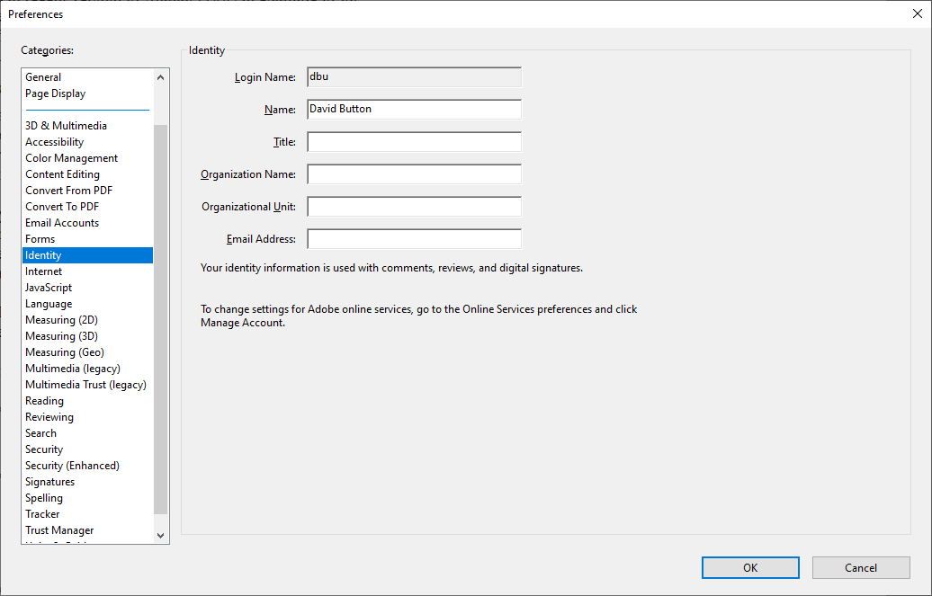
Display Margin Rules | - Toggle Margin Rules ON and OFF | - Ctrl + U  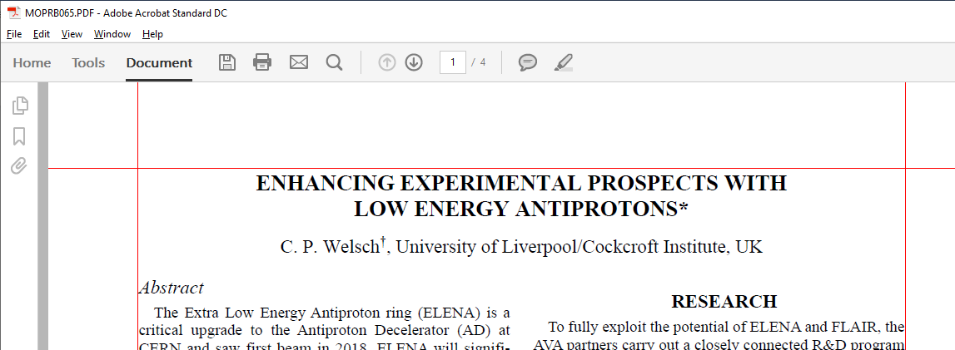
Display Column Guides | - Tuggle ON/OFF Column Guides | - File > Col Guide ON/OFF  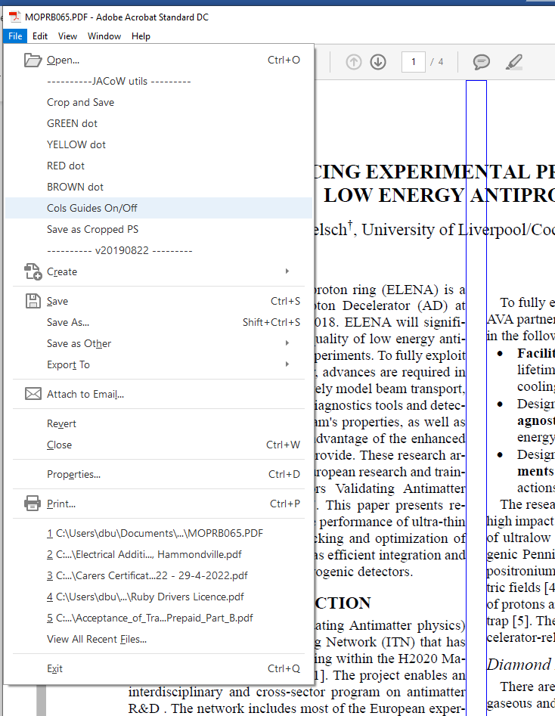

Advanced Search | - Show All Search Results for Key Words  - “[“  - “fig”  - “eq”  - “table”  Etc…  Check order, uniqueness, matching pairs, etc. | - Ctrl + Shift + F  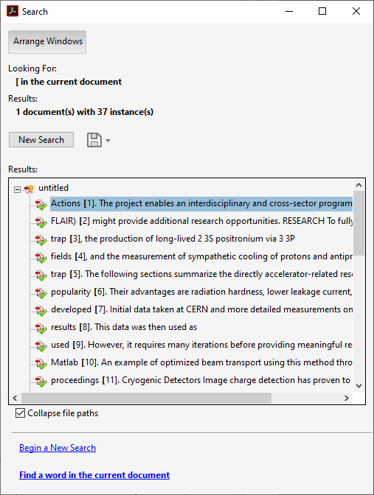
Check Document Properties | - Display Document Properties  - Check ALL fonts Embedded  - Check Page Size  [595.0 x 792.0 pt]  Check Number of Pages within limit | - Ctrl + D  - 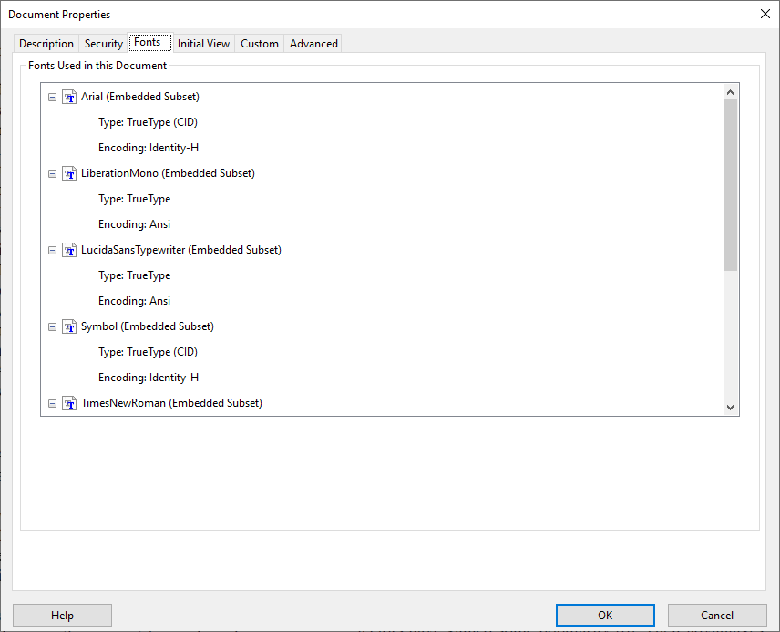  - 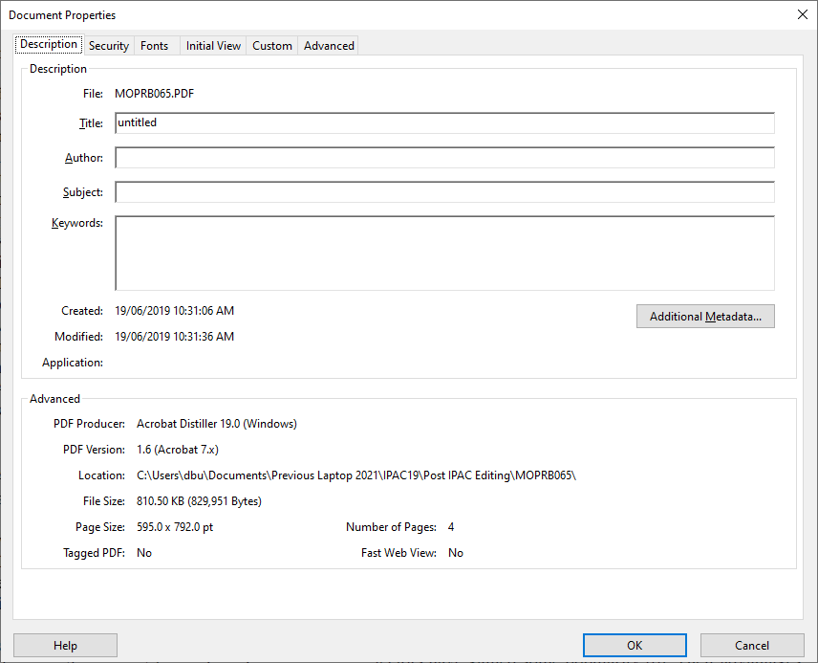
Embed Fonts | - Run Pre-fight  (Need Pro Version) | - Ctrl + Shift + X  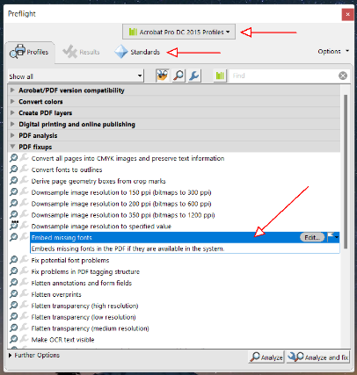  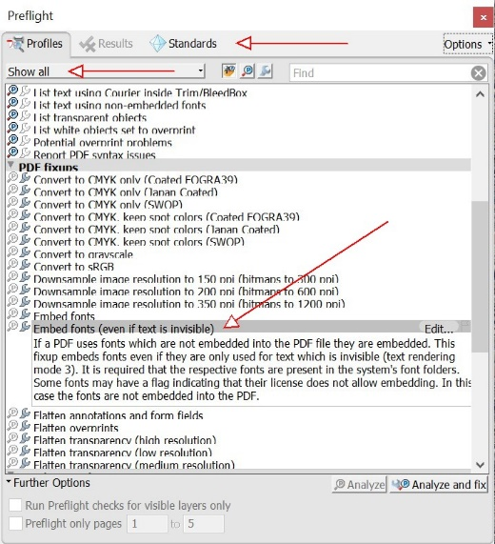
Generating PDF | - Turn Off Column Guides  - Crop & Save File  - Print | - File > Col Guide ON/OFF  - File > Crop and Save  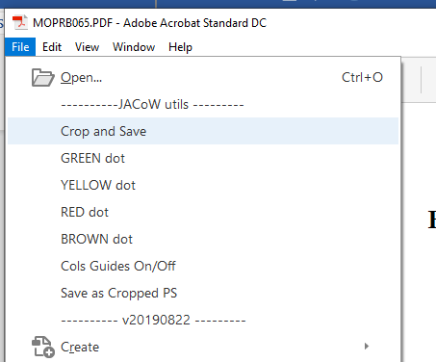  - Ctrl + P  