

JADE ATLAS: WCLL_TBM_1D_31c

# Plot type: Ratio graph

## Tally: Neutron Heating [MeV/cc/n_s]

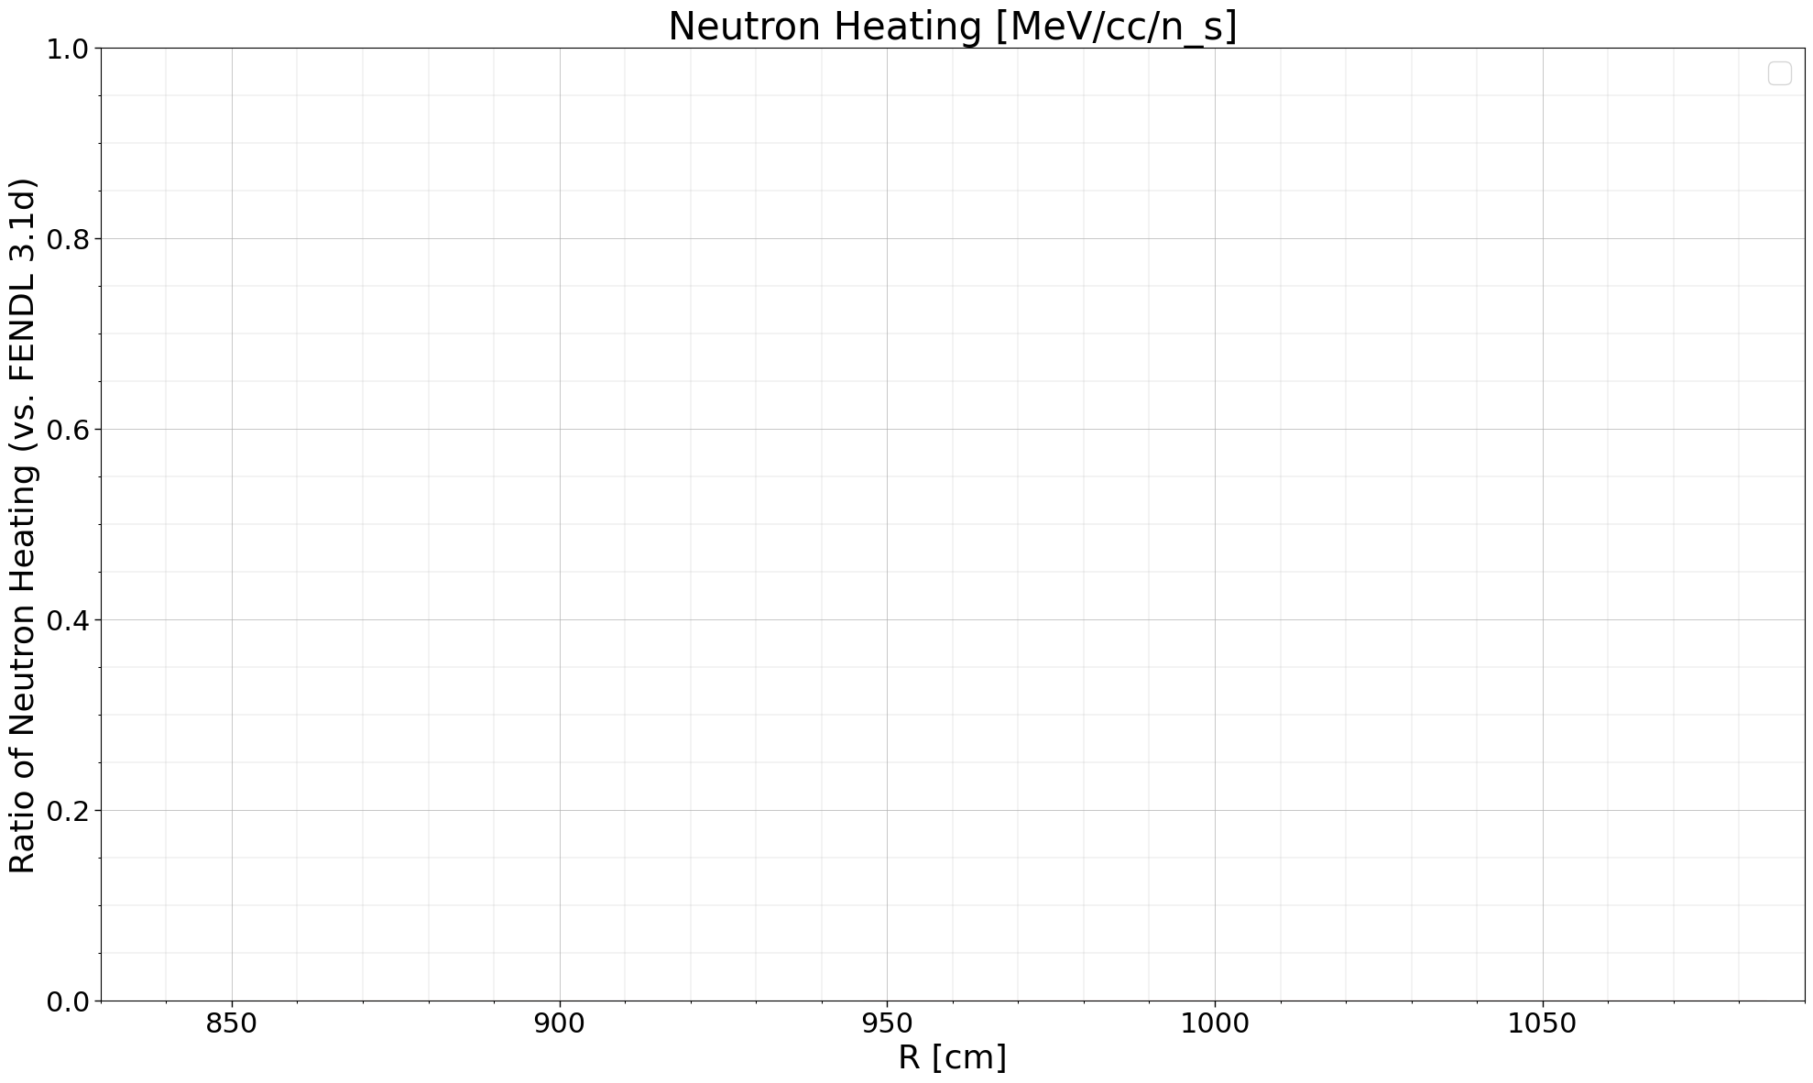

## Tally: Photon Heating [MeV/cc/n_s]

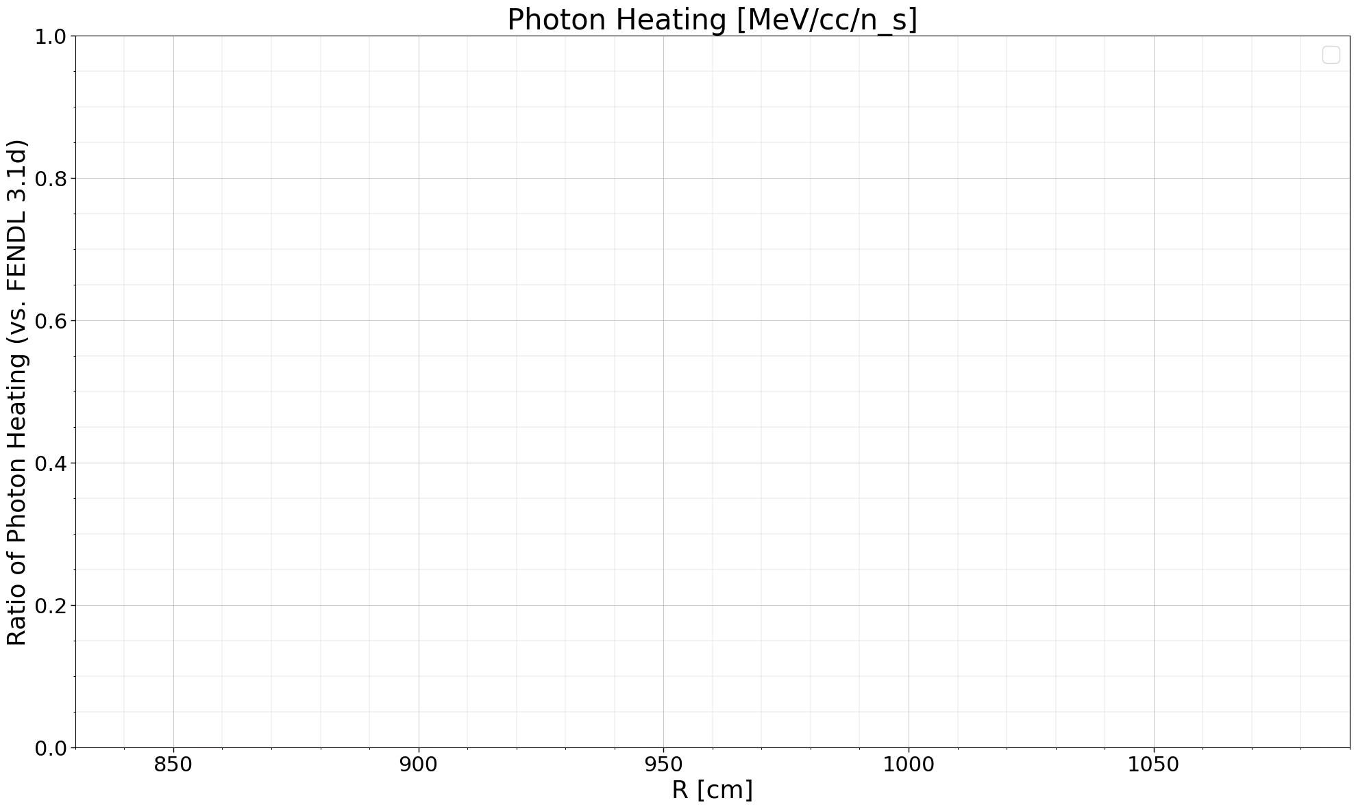

## Tally: Tritium Production [atoms/cc/n_s]

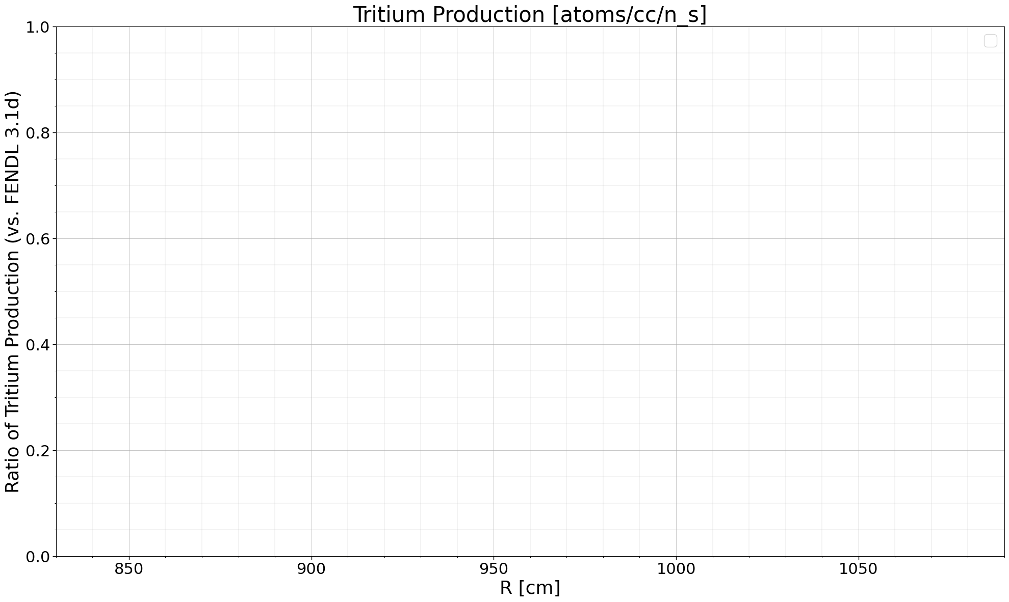

## Tally: Neutron Flux [#/cc/n_s]

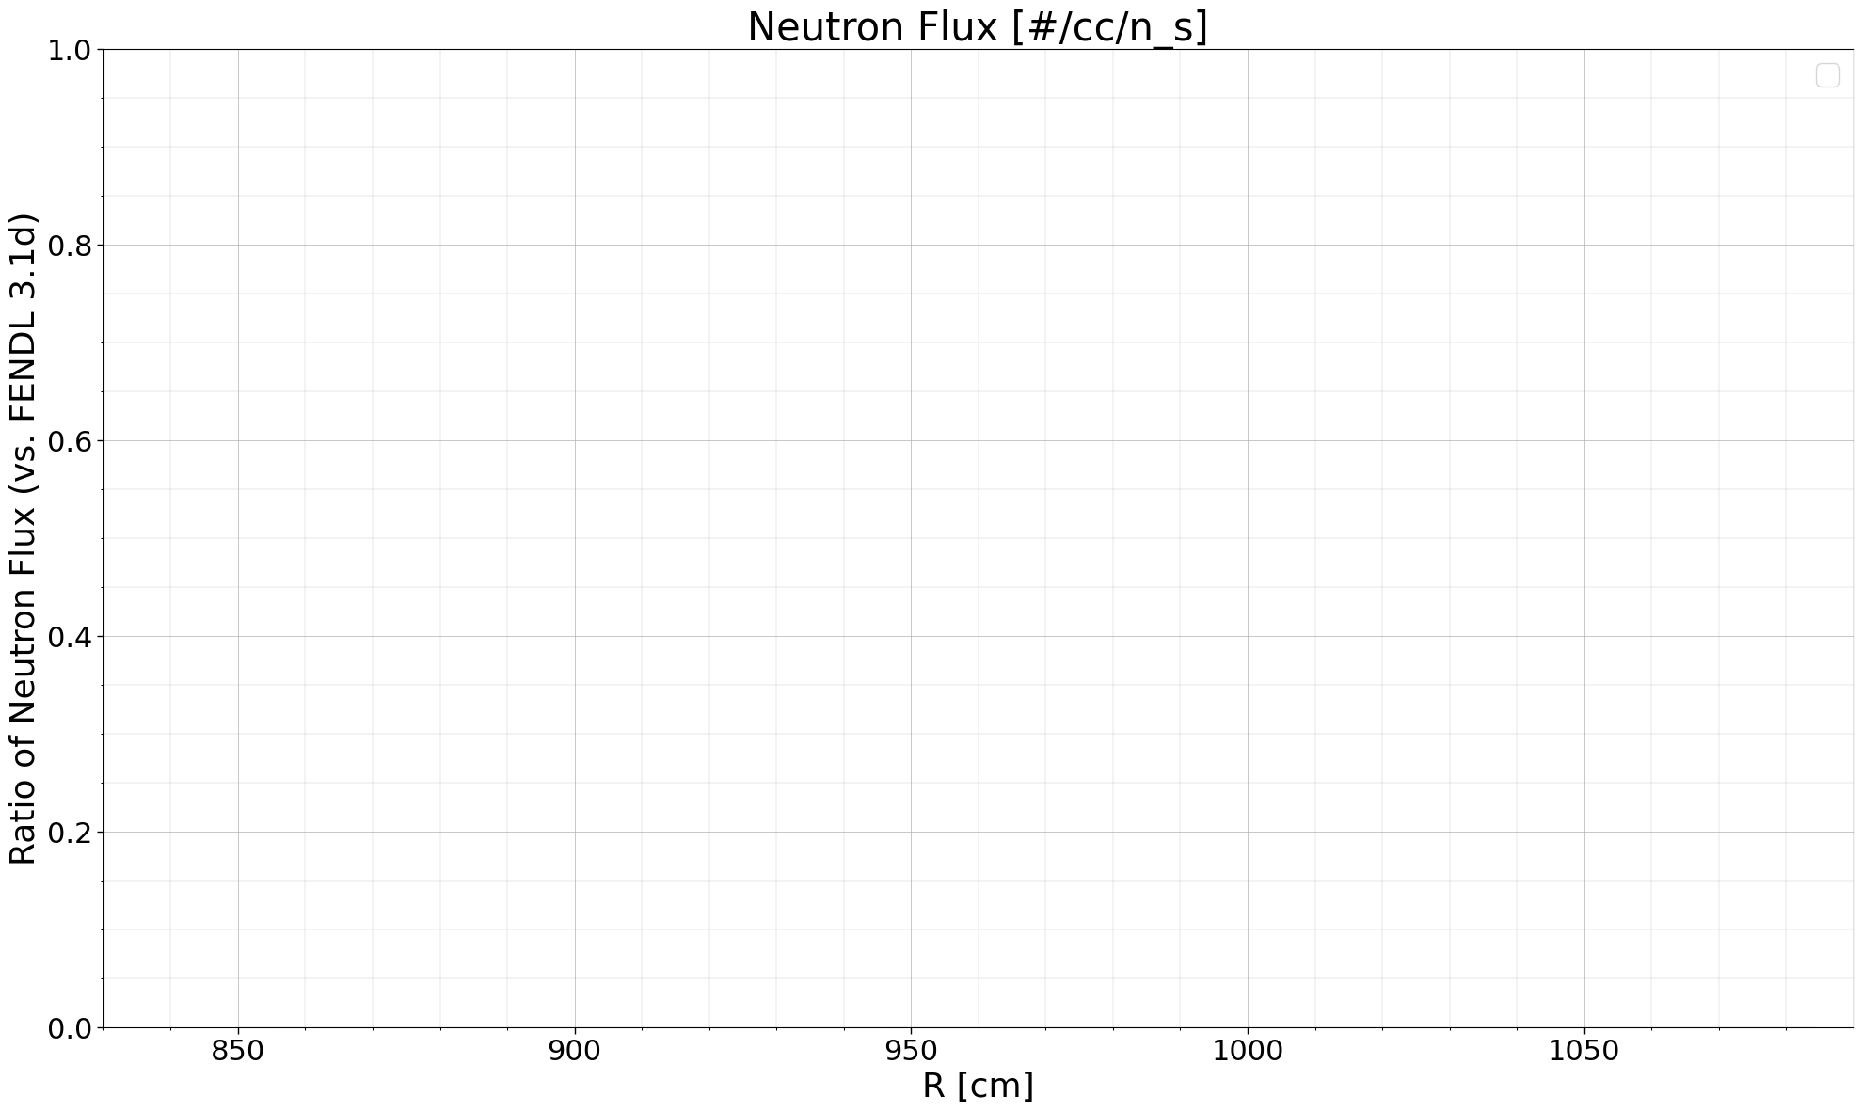

## Tally: Photon Flux [#/cc/n_s]

