# I. Introduction

Bluetooth low energy (BLE) positioning can be achieved by different algorithms. Most popular algorithms are based on triangulation methods where variables like the time, angle or RSSI value of the signal are used to compute the position of a mobile or asset.

Triangulation methods are based on access points (Gateways) which receive data from sensor on the area and send the information elsewhere. At least 3 access points are needed to compute an asset’s position, 4 are desirable.

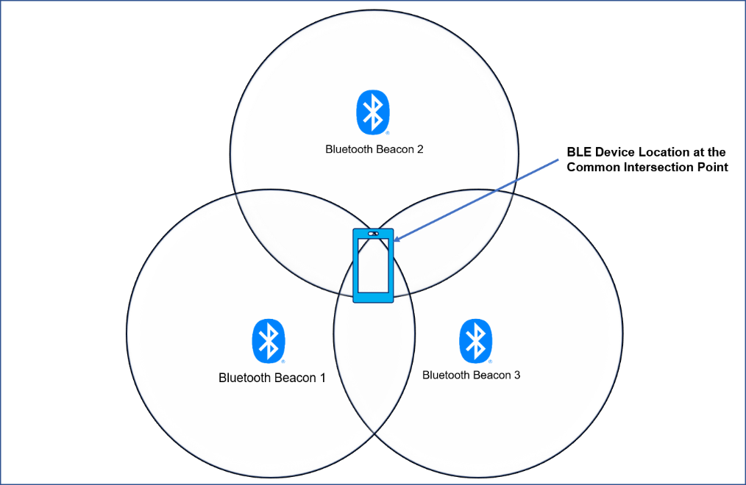

Triangulation algorithm maps RSSI value to the distance between sensor and gateway. A circumference is described with the calculated distance and centered on the access point.

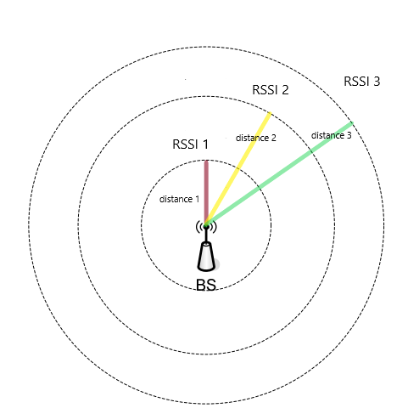

Each gateway’s circumference must be described before computing the position. All circumferences provide information of where is located the asset. When the circumferences are described, intersection points are computed and filter algorithms are used to determine the real asset position. Algorithms like Least Square Estimation (LSE), Three Border Position, and Centroid Computation are used as filter algorithms.

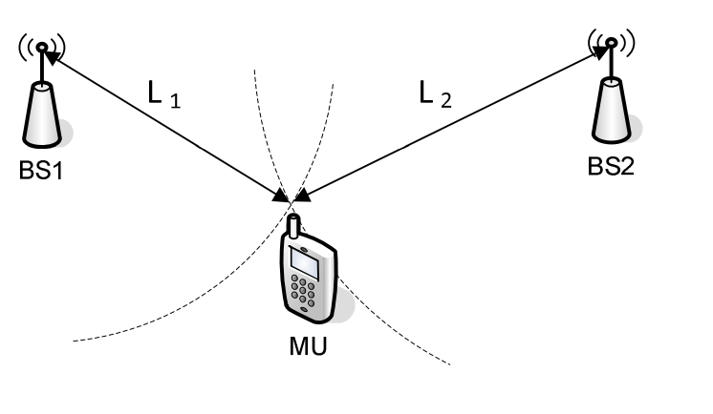

## Distance Algorithm

In order to calculate the distance between two radio devices using RSSI, we must use a proper radio propagation model. The propagation loss due to radio signal absorption and diffraction by obstacles like human body, walls and furniture cannot be ignored. In literature equation (1) is often used for indoor environments and to take into consideration obstacles like the ones previously mentioned.

$$RSSI=10∙n∙\log_{10}{d}+A (1)$$

Where n is the signal transmission constant, and it is relevant to signal transmission environment; A is the RSSI value obtained from a distance of 1 meter from the access point.

Solving *d* in equation (1) we obtain (1.1):

$$d={10}^{(RSSI-A)/(10n)} (1.1)$$

Which for a given RSSI value a distance value in meters is obtained.

# II. Methodology

The objective of the following test is to compare different gateway behaviors for distance computed. We have tested 3 different gateways 2 times, one with obstacles and another without obstacles.

We have placed the gateways in the border of a room and marked distances from the gateway until 5.4 meters. The first 2 meters the distance between marks was of 0.20 meters. From 2 to 5.4 meters the distance between marks is 0.40 meters. The gateways tested were:

* ESP32 With internal antenna
* Vamia Gateway with normal antenna
* Vamia Gateway with directional antenna

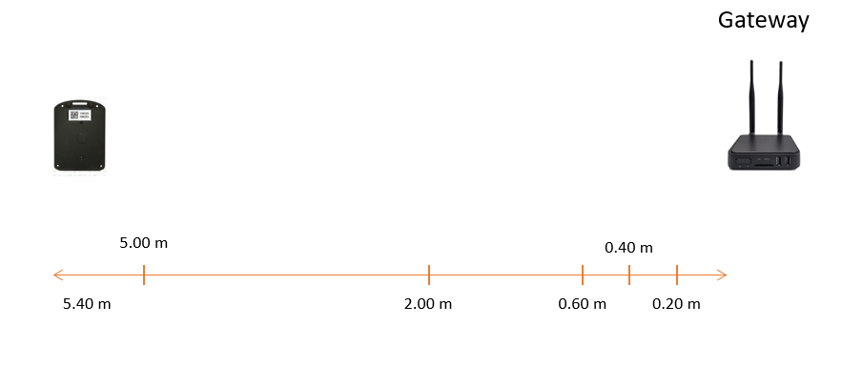

# III. Results

## Gateway: ESP32 with internal antenna

### No obstacles test

The following graph represents the model in equation (1) for ESP32 Gateway without obstacles. The orange curve and the measured RSSI value obtained from gateway in blue.

The following table is the measured distance against the real distance of the model in equation (1.1). The average error of computed distance is 21.39 % which means that the readings have high variance. In this test all data follow the model curve, is just the variance that modify the behavior of measured curve.

|  |  |  |
| --- | --- | --- |
| Distance Measured (cm) | Distance Computed (cm) | Percentual error |
| **20** | 26.25 | 31% |
| **40** | 44.42 | 11% |
| **60** | 78.57 | 31% |
| **80** | 132.99 | 66% |
| **100** | 100.00 | 0% |
| **120** | 102.22 | -15% |
| **140** | 197.35 | 41% |
| **160** | 176.86 | 11% |
| **180** | 206.20 | 15% |
| **200** | 188.88 | -6% |
| **240** | 162.00 | -32% |
| **280** | 356.76 | 27% |
| **320** | 299.36 | -6% |
| **360** | 349.03 | -3% |
| **400** | 506.71 | 27% |
| **440** | 381.02 | -13% |
| **480** | 251.19 | -48% |
| **520** | 517.95 | 0% |
| **560** | 688.80 | 23% |

### Obstacles test

The following graph represents the model in equation (1) for ESP32 Gateway with obstacles. The orange curve and the measured RSSI value obtained from gateway in blue.

The following table is the measured distance against the real distance of the model in equation (1.1). The average error of computed distance is 46.85 % which means that the readings have a greater variance than no obstacles test. This test shows a discrepancy in the start and middle of model. The start does not follow the model curve until 1 meter, which increased the percentual error a lot. The middle is trying to follow the model curve, but did not follow it correctly due by variance.

|  |  |  |
| --- | --- | --- |
| Measured Distance | Computed Distance | Percentual Error |
| 20 | 54.12 | 171% |
| 40 | 116.59 | 191% |
| 60 | 151.69 | 153% |
| 80 | 116.59 | 46% |
| 100 | 106.80 | 7% |
| 120 | 91.60 | -24% |
| 140 | 121.82 | -13% |
| 160 | 162.00 | 1% |
| 180 | 151.69 | -16% |
| 200 | 184.78 | -8% |
| 240 | 372.76 | 55% |
| 280 | 381.02 | 36% |
| 320 | 262.45 | -18% |
| 360 | 245.74 | -32% |
| 400 | 251.19 | -37% |
| 440 | 381.02 | -13% |
| 480 | 364.67 | -24% |
| 520 | 751.95 | 45% |
| 560 | 553.17 | -1% |

## Gateway: Vamia Gateway with normal antenna

### No obstacles test

The following graph represents the model in equation (1) for Vamia Gateway with normal antenna when obstacles are not present. The orange curve and the measured RSSI value obtained from gateway in blue.

The following table is the measured distance against the real distance of the model in equation (1.1). The average error of computed distance is 25.75 % which means that the readings have a high variance. This test shows that the measured distance tends to follow the model curve, but its high variance does not allow it.

|  |  |  |
| --- | --- | --- |
| Measured Distance | Computed Distance | Percentual Error |
| **20** | 13.17067 | -34.15% |
| **40** | 14.67799 | -63.31% |
| **60** | 55.3525 | -7.75% |
| **80** | 100.4525 | 25.57% |
| **100** | 45.79144 | -54.21% |
| **120** | 96.88901 | -19.26% |
| **140** | 111.9488 | -20.04% |
| **160** | 132.9014 | -16.94% |
| **180** | 239.0184 | 32.79% |
| **200** | 352.4186 | 76.21% |
| **240** | 205.0051 | -14.58% |
| **280** | 313.3852 | 11.92% |
| **320** | 327.8584 | 2.46% |
| **360** | 281.2028 | -21.89% |
| **400** | 276.17 | -30.96% |
| **440** | 382.2548 | -13.12% |
| **480** | 358.8409 | -25.24% |
| **520** | 579.0887 | 11.36% |
| **560** | 519.6205 | -7.21% |

### Obstacles test

The following graph represents the model in equation (1) for Vamia Gateway with normal antenna when obstacles are not present. The orange curve and the measured RSSI value obtained from gateway in blue. We can see that the real RSSI was not able to follow the modeled curve in most of the measurements.

The following table is the measured distance against the real distance of the model in equation (1.1). The average error of computed distance is 47.87 % which means that the readings have a high variance. This test shows a discrepancy in the middle of the model. It was not able to follow the tendency of the modeled curve.

|  |  |  |
| --- | --- | --- |
| Measured Distance | Computed Distance | Percentual Error |
| **20** | 30.09 | 50.45% |
| **40** | 15.29 | -61.78% |
| **60** | 48.12 | -19.79% |
| **80** | 35.40 | -55.75% |
| **100** | 125.33 | 25.33% |
| **120** | 100.91 | -15.91% |
| **140** | 67.82 | -51.56% |
| **160** | 104.62 | -34.61% |
| **180** | 107.49 | -40.28% |
| **200** | 104.62 | -47.69% |
| **240** | 112.46 | -53.14% |
| **280** | 92.19 | -67.07% |
| **320** | 84.23 | -73.68% |
| **360** | 85.77 | -76.18% |
| **400** | 140.94 | -64.77% |
| **440** | 279.94 | -36.38% |
| **480** | 195.07 | -59.36% |
| **520** | 126.46 | -75.68% |
| **560** | 561.07 | 0.19% |

## Gateway: Vamia Gateway with directional antenna

### No obstacles test

The following graph represents the model in equation (1) for Vamia Gateway with normal antenna when obstacles are not present. The orange curve and the measured RSSI value obtained from gateway in blue.

The following table is the measured distance against the real distance of the model in equation (1.1). The average error of computed distance is 35.85 % which means that the readings have a high variance.

|  |  |  |
| --- | --- | --- |
| Measured Distance | Computed Distance | Percentual Error |
| **20** | 35.64511 | 78% |
| **40** | 59.70353 | 49% |
| **60** | 48.45441 | -19% |
| **80** | 69.6092 | -13% |
| **100** | 100.6159 | 1% |
| **120** | 102.4865 | -15% |
| **140** | 82.16118 | -41% |
| **160** | 325.0873 | 103% |
| **180** | 198.9146 | 11% |
| **200** | 196.4868 | -2% |
| **240** | 243.594 | 1% |
| **280** | 450.1252 | 61% |
| **320** | 267.0956 | -17% |
| **360** | 185.9231 | -48% |
| **400** | 194.0886 | -51% |
| **440** | 262.2205 | -40% |
| **480** | 343.5579 | -28% |
| **520** | 395.6702 | -24% |
| **560** | 150.8922 | -73% |

### Obstacles test

# IV. Conclusions