Day 1

# Example Text

This document is just to show the following document types:

* .md,
* .Rmd,
* .html,
* .docx, and
* .pdf.

This document also contains an image:

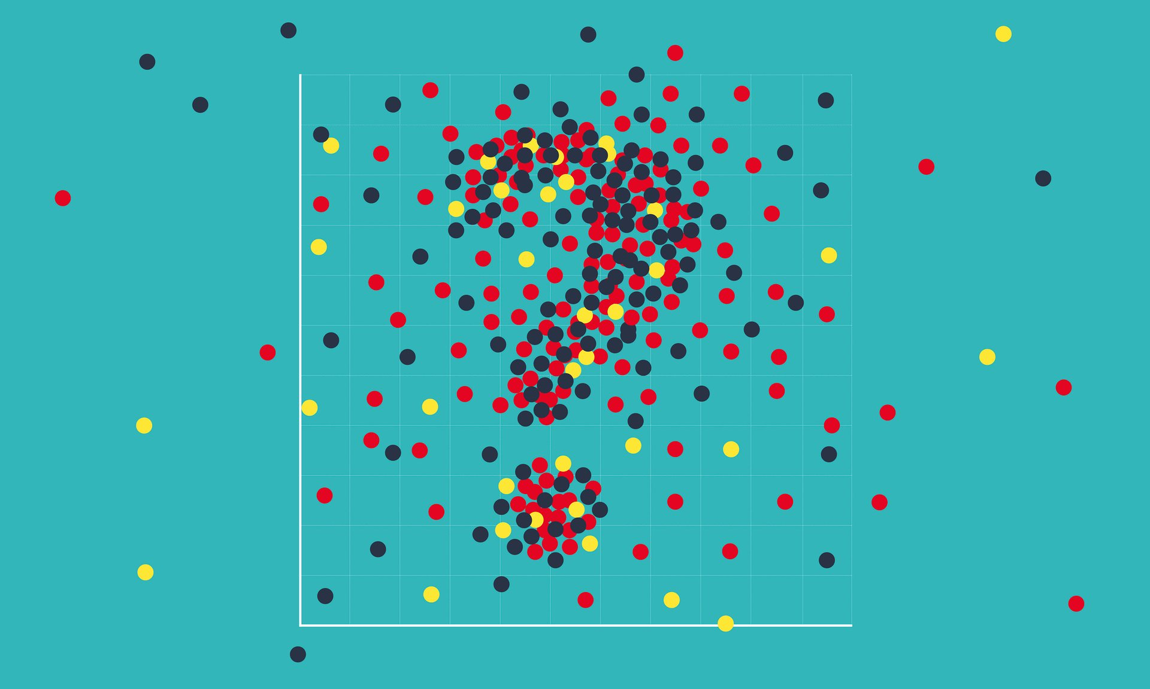

Scatterplot comprised of red, yellow, and black points with a hidden question mark

And code with its output:

2 + 2

## [1] 4