**Navratri- An occasion to bring everything in balance.**

Our religious festivals and rituals are matchless in one or the other way. They are based on logic and certain scientific backgrounds can also be attributed to their origin. They are invariably ingrained and beneficial to the mankind vis-à-vis to the physical, mental, and spiritual aspects of life. Physical, mental, and spiritual growths are inseparable aspects of life requisite for a blissful and pleasant life. This may be the founding stone for our rituals and festivals.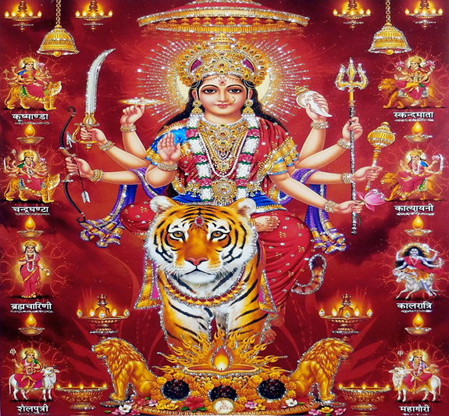

The essence of Hindu festivals is that they all are related to some or the other astronomical events or change of seasons. Navratri is not an exception to this rule. Everyone is acquainted with two Navratri festivals being celebrated in a year all over the world by the Hindus. But there are four Navratri’s in Hindu calendar in a year. Other, two are known as Gupt or secret Navratri. All the four Navratri are associated with the astronomical events known as Equinoxes and Solstices. Equinoxes occurs twice in a year when days and nights are of equal duration i.e March 21 and September 22. This is the period when Vasant and Sharada Navratri’s are observed. The Solstices also occur twice in a year when days and nights are longer, June 21 (longest day) and December 22 (longest night). Vasant (Chaitra) Navratri is observed in March/April during Vernal Equinox – March 21. This year Chaitra Navratri being observed from 2nd April 2022(Dates changed every year in tandem with Hindu Calendar. Variation of up to 14-15 days may occur every y). While Sharadiya Navratri is held during the period of Autumnal Equinox- September 22.

The two Gupt (secret) Navratri, which happen during Solstices, are observed by the householder and spiritual seekers alike. These are largely observed by people who perform Tantrik Vidya or seekers of psychic powers and devotees of Goddess Adi Shakti (Mother Divine Power). They are observed in consonance with two Solstices. Ashadha Navratri falls in June /July during the period of summer solstice June 21, that also marks the beginning of the monsoon season while Pausha/ Magha Navratri falls during December/January, that also signals the change of season. Of the four, the Shardiya Navratri are celebrated with much enthusiasm and religious fervour by devotees. They are also known as Maha Navratri.

These four periods of Navratri are the focal points of changes in our life. They mark the end of what is old, spent, harmful and birth of something new. They may be considered as period of introspection, rejuvenation, and rebirth on all the three planes: Physical, Mental and Spiritual. This is the time to bring everything in balance. Balancing of everything in life is paramount for the existence of human beings.

Seasons on earth change as the planet earth is slightly tilted on its axis while revolving around the Sun. If earth were not tilted on its axis, the Sun would always appear to be directly above the equator and earth receiving fixed amount of light throughout the year. Then, there would have been no seasons. The unmarked equinoxes and Solstices would not be effecting change of seasons. Thus, there would have been no reason to celebrate festivals and the life would have been dull and monotonous in their absence.

**Physical Rejuvenation:**

Equinoxes and the Solstices mark the transition period between the two seasons. During this period bacteria thrive, and viral infections /diseases are at their peak. The body at the same time needs time to adjust to the climatic and environmental changes. Excessive and wrong eating habits, abnormal sleeping patterns and seasonal changes are main factors that leads to low immunity. It also creates imbalance in the body by disturbing the three bio-elements-Vata (Gas), Pitta (Bile) and Kapha (Phlegm). Certainly, the Navratri is the right time to detoxify and revitalize the body, by balancing the three cardinal humors.

To keep the right balance in the body, fasting is very important and is an essential part of the Navratri celebrations. According to age and health parameters of devotees, some people have only one meal a day or would avoid certain food stuffs. People mostly avoid and abstain from certain high energy food stuffs like meat, grain, alcohol, onion, garlic, processed foods etc . Devotees mostly prefer gluten free grain alternatives, fresh fruits, yoghurt etc. as these can be easily digested.

Divine Energy symbolized by the Adi Shakti (Primal Energy) is invoked to help control and cleanse the nine openings (nou dwar) of the physical body. Two Eyes, two ears, two nostrils, one Mouth, one Anus and one urinary opening.

It is said whatever you eat, it is reflected in your thoughts and mind. In Ayurveda, foods have been divided into three categories, depending upon their nature and response they trigger in the body after being consumed. Raajasic Foods, Taamasic Foods and Saatvik Foods, during fasting, people eat Saatvik foods. Apart from religious aspect, there is scientific reason behind it. For instance, Shardiya Navratri falls in the month of October- November, which is the transition period from autumn to the winter season. Due to seasonal change, our immunity tends to decline. Consumption of Saatvik foods during this season gives your digestive some rest and cleanses body of all impurities.

The word Saatvik is derived from the word sattva, which means something that is pure, natural, vital, clean, energetic, and conscious. Saatvik foods include fresh fruits, curd, rock salt, seasonal vegetables and subtle spices like coriander and black pepper. Garlic and onion are not allowed, as they are known as Rajogini; a substance that can make one lose grip over their instincts and one fails to differentiate between desires and priorities.

Raajasic and Taamasic foods are referred to things that are unripe, weak, resentful, and destructive. During Navratri, people are supposed to denounce the worldly pleasure and adopt a pure and simple life for nine days. So, these foods are avoided during this time as these tend to distract your focus.

**Mental Rejuvenation:**

Navratri is also the period of cleansing the mind of the nine evil forces – These are lust, anger, greed, delusion, ego, jealousy, doubt, attachment, and hatred. These evil forces are responsible for downgrade and abasement. Devotees who fast during Navratri also try to have control over these forces so as avoid declination in their life. Denouncing these forces helps to maintain communal harmony, brotherhood, and empathy for all creatures.

Fasting also has psychological benefits including strengthening one’s will power and removing emotional blocks. It also helps devotees to build self-confidence to face the challenges in life and live in harmony with other people. This is the time when one reflects inwards. Self-control and discipline help to rid the mind of its impurities and nurture noble values. This aspect has gained more importance in modern times as, many people suffer from depression. Mental Rejuvenation is more relevant today, as mind and body should be both healthy.

**Spiritual Rejuvenation: Mental control combined with control over physical desires and urges help the devotees to elevate spiritual status. People involve themselves in spiritual practices such as meditation, pranayama, reciting holy scriptures etc. All the forms of Adi Shakti (Primal Energy) are worshipped to help us destroy our basic, gross carnal tendencies and invoke the Divine Power within ourselves. This is the time when devotees recharge their dormant energies and activate their progress to the divine world.**

**Why Nine Nights (Navratri)**

The nine number is considered complete, perfect, and divine number, represents culmination of wisdom and experience. The number of Mala beads for Jaap are 108, the total of which is also 9. Nine forms of Adi Shakti are worshipped during Navratri. Each has been assigned one day of Navratri. Their names are: 1)Shailaputri - Daughter of Mountain.2) Brahmacharini – Mother of devotion and penance 3) Chanderaghanta- Destroyer of demons. 4) Kushamanda- Goddess of cosmic egg. 5) Skanda Mata- Goddess of motherhood and children 6) Katyayani- Goddess of power 7) Kalaratri- Goddess of auspiciousness and courage.8) Mahagauri- Goddess of beauty and women 9) Siddhidhatri- Goddess of supernatural powers.

Navratri is a festival of nine nights. It has a valid reason. Religious scriptures mention that “रात्रि रूपा यतोदेवी, दिवा रूपो महेश्वर ”. Meaning that Shiv represents daytime while Shakti is active during the night-time. Shiv and Shakti are one; so also, a day and night represents one complete day. Shiv is also known as Ardhnarishwar. The day is full of activity; while energies are invoked and recharged in the silence of the night. Hence worshippers of the Feminine Primal force (Adi Shakti) always choose the night-time to worship the Devis — the Goddess. **Physical, Mental and Spiritual rejuvenation change the life of devotees to such an extent, that they lead a blissful life. Energy is essential for all living things. Thus, there is a cardinal rule to recharge and rejuvenate during Navratri to live a delighted, blissful, and prosperous life.**

**Jagdish R Sharma**

**#9419186191** [**sharmajagdish2727@yahoo.com**](mailto:sharmajagdish2727@yahoo.com)