GURU NANAK KHALSA COLLEGE

AUTONOMOUS (UNIVERSITY OF MUMBAI)
MUMBAI-400 019
DEPARTMENT OF COMPUTER SCIENCE

CERTIFICATE


CERTIFIED that the practical’s, assignments duly signed, were performed by Mr/Ms. Tanishq Chavan Roll No:__02__ of MSC.Big Data Analytics Part II for the Computer Science Laboratory of G. N. Khalsa College ,Mumbai during the academic year 2026-2027. He/ She has completed the course of Laboratory assignments in Computer Science as contained in the course prescribed by the University of Mumbai.

Sign of Student Head Dept. of Computer Science
Date _____________________ Date _____________________ Professor-in-charge Sign of Examiner’s
1] ________________________ 1] ________________________
Date _____________________ Date _____________________

2] _____________________ 2] _____________________
Date _____________________ Date ___________________

INDEX

Sr.  No. | Name of Practical | Page No. | Date | Sign
1 | Study of Basic Linux Commands | 3
2 | Shell Programming | 6
3 | Process Creation using fork() – Parent, Child, Orphan and Zombie Processes | 15
4 | CPU Scheduling Algorithms – FCFS, SJF, Priority and Round Robin | 19
5 | Banker's Algorithm for Deadlock Avoidance | 24
6 | Parallel Thread Management using POSIX Threads (pthread) | 27
7 | Dynamic Memory Allocation – First Fit, Best Fit and Worst Fit | 29
8 | Page Replacement Algorithms – FIFO, LRU and Optimal | 32
9 | Type-I and Type-II Hypervisors and VM Setup using a Type-II Hypervisor | 35
10 | Operating System Virtualization – Ubuntu VM using VMware Workstation | 41

Practical No. 1: Study of Basic Linux Commands
Aim: To study and execute basic Linux commands for file management, directory operations, file permissions, system information, and process management.

Theory
Linux is an open-source, Unix-like operating system made up of the kernel, which manages hardware, processes and memory, and the shell, which reads the commands typed in the terminal and passes them to the kernel. Ubuntu uses the bash shell. Every command has the form command [options] [arguments], and help for any command is available through man
<command>.
All files are arranged in a single tree starting at the root directory /. A path starting from / is an absolute path, while a path starting from the current directory is a relative path. Every file has read (r = 4), write (w = 2) and execute (x = 1) permissions for the owner, group and others; for example chmod 755 gives rwx to the owner and r-x to everyone else.

Commands Used

Sr. No. | Command | Purpose | Example
1 | pwd | Display current directory | pwd
2 | ls | List files and directories | ls -l
3 | cd | Change directory | cd OS_Practical
4 | mkdir | Create directory | mkdir OS_Practical
5 | touch | Create file | touch file1.txt
6 | echo | Display/write text into a file | echo "Operating Systems Practical" > file1.txt
7 | cat | Display file contents | cat file1.txt
8 | cp | Copy files | cp file1.txt backup.txt
9 | mv | Move/Rename files | mv backup.txt newfile.txt
10 | rm | Delete files | rm newfile.txt
11 | stat | Display file information | stat file1.txt
12 | chmod | Change file permissions | chmod +x file1.txt
13 | date | Display current date and time | date
14 | whoami | Show current user | whoami
15 | uname | Display system information | uname -a
16 | ps | Display running processes | ps
17 | top | Monitor running processes | top
18 | find | Search files | find . -name "*.txt"
19 | wc | Count lines, words, and characters | wc file1.txt
20 | history | Display command history | history

Procedure
- Open the Terminal (Ctrl + Alt + T).
- Display the current working directory: pwd

- List the files and directories: ls and ls -l
- Create a new directory: mkdir OS_Practical
- Move to the newly created directory: cd OS_Practical
- Create an empty file: touch file1.txt
- Write text into the file: echo "Operating Systems Practical" > file1.txt
- Display the contents of the file: cat file1.txt
- Create a copy of the file: cp file1.txt backup.txt
- Rename the copied file: mv backup.txt newfile.txt
- Delete the renamed file: rm newfile.txt
- Display detailed information of the file: stat file1.txt
- Change the file permission: chmod +x file1.txt and verify using ls -l
- Display the current date and time: date
- Display the current logged-in user: whoami
- Display system information: uname -a
- Display running processes: ps, and monitor them using top (press q to exit)
- Search for all text files: find . -name "*.txt"
- Count the lines, words and characters: wc file1.txt
- Display the command history: history
Result: Successfully studied and executed basic Linux commands for file management, directory operations, file permissions, system information, and process management.
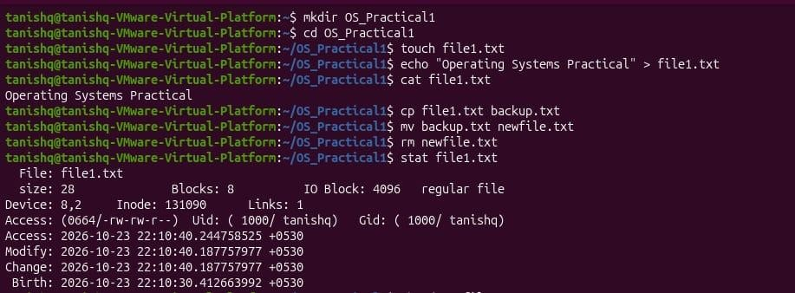
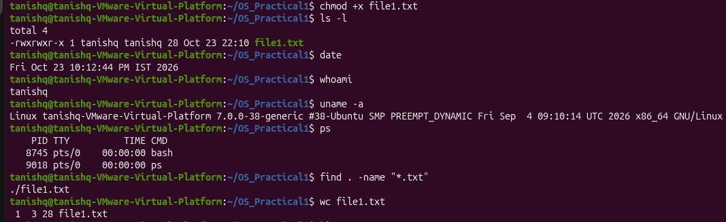

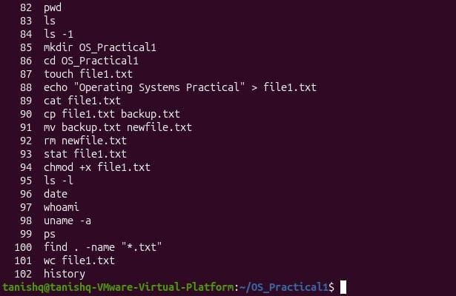

Practical No. 2: Shell Programming
Aim: To write and execute shell scripts using input/output statements, decision-making, looping, and multi-level branching in Linux.

Theory
A shell script is a text file containing a sequence of commands that the shell executes one after another, and is used to automate repetitive tasks. The first line, called the shebang (#!/bin/bash or #!/bin/sh), tells the system which shell should run the script. The script is made executable with chmod +x and run with ./script.sh.
Variables are assigned without spaces (name="PJ") and read using $name. Input is taken with read and output displayed with echo, while arithmetic is done using $(( )). Conditions are written inside [ ] using the operators below, and the program flow is controlled using if-elif-else, case, for and while. Features such as {1..5} and for ((i=1; i<=5; i++)) work only in bash, not in sh.

Operator | Meaning | Operator | Meaning
-eq | Equal to | -ne | Not equal to
-gt | Greater than | -lt | Less than
-ge | Greater than or equal to | -le | Less than or equal to

Commands Used

Sr. No. | Command | Purpose | Example
1 | nano | Create/edit a shell script | nano script.sh
2 | echo | Display output | echo "Hello"
3 | read | Accept user input | read name
4 | if | Execute statements based on a condition | if [ $a -gt $b ]
5 | elif | Check multiple conditions | elif [ $a -eq $b ]
6 | else | Execute alternative statements | else
7 | case | Multi-way branching | case $choice in
8 | for | Execute statements repeatedly | for i in 1 2 3
9 | while | Repeat while a condition is true | while [ $i -le 5 ]
10 | chmod | Make the script executable | chmod +x script.sh
11 | ./script.sh | Execute the shell script | ./script.sh

Procedure
- Open the Terminal and create a script: nano script.sh
- Write the program, save with Ctrl + S and exit with Ctrl + X.
- Give execute permission: chmod +x script.sh
- Execute the script: ./script.sh
- Repeat the steps for each of the following programs.

Simple Shell Program

Program:
#!/bin/bash
echo "Welcome to Shell programming"

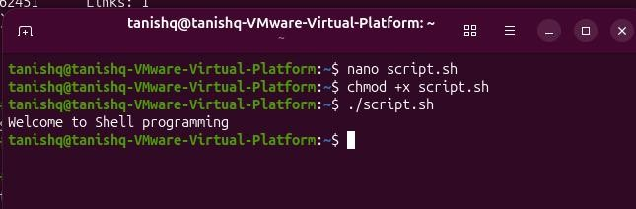
Output:

Input and Output using read

Program:
#!/bin/bash
echo "enter your name" read name
echo "Welcome $name"

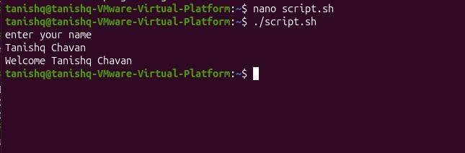
Output:

Check Positive or Negative using if-else

Program:
#!/bin/bash
echo "enter a number :" read num
if [ $num -gt 0 ] then
echo "Positve number" else
echo "Negative number"
fi

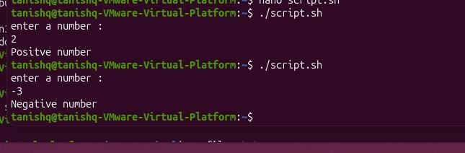
Output:

Check Even or Odd using if-else

Program:
#!/bin/bash
echo "Enter a number:" read n
if [ $((n % 2)) -eq 0 ] then
echo "$n is Even" else
echo "$n is Odd"
fi

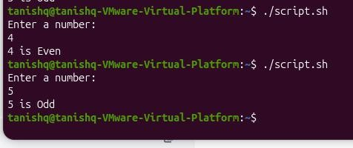
Output:

Login Check using if-else

Program:
#!/bin/bash
echo "Enter username:" read user
echo "Enter password:" read pass
if [ "$user" = "admin" ] && [ "$pass" = "1234" ] then
echo "Login Sucessfull" else
echo "invalid username or password"
fi

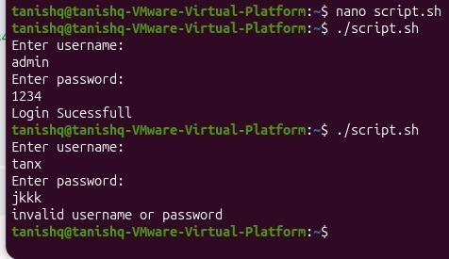
Output:

Looping using for (sh)

Program:
#!/bin/sh
for i in 1 2 3 4 5 do
echo $i done

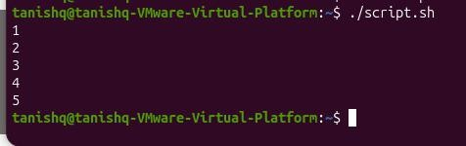
Output:

Looping using for – brace range (bash)

Program:
#!/bin/bash
for i in {1..5} do
echo $i done

Output:

Looping using for – C-style (bash)

Program:
#!/bin/bash
for ((i=1; i<=5; i++)) do
echo $i done

Output:

Check Even or Odd using for

Program:
#!/bin/sh
for i in 1 2 3 4 5 do
if [ $((i % 2)) -eq 0 ] then
echo "$i is Even" else
echo "$i is odd"
fi done

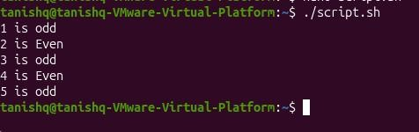
Output:

Print Multiplication Table

Program:
#!/bin/sh
echo "Enter a number:" read n
for i in 1 2 3 4 5 6 7 8 9 10 do
echo "$n x $i = $((n * i))" done

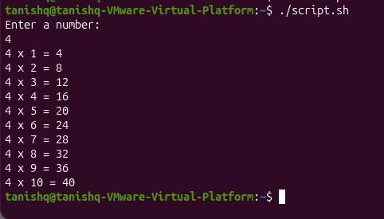
Output:

Looping using while

Program:
#!/bin/bash i=1
while [ $i -le 5 ] do
echo $i i=$((i+1))
done

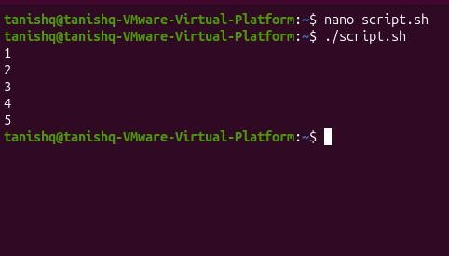
Output:

Fibonacci Series

Program:
#!/bin/sh
echo "Enter the number of terms :" read n
a=0 b=1 i=1
while [ $i -le $n ] do
echo $a c=$((a + b)) a=$b
b=$c
i=$((i + 1)) done

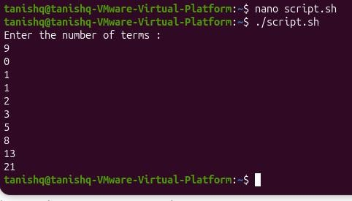
Output:

Sum of First N Numbers

Program:
#!/bin/sh
echo "Enter a number:" read n
i=1 sum=0
while [ $i -le $n ] do
sum=$((sum + i)) i=$((i + 1))
done
echo "Sum = $sum"

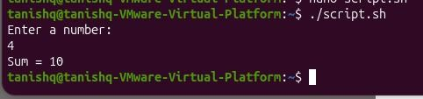
Output:

Factorial of a Number

Program:
#!/bin/sh
echo "Enter a number:" read n
fact=1 i=1
while [ $i -le $n ] do
fact=$((fact * i)) i=$((i + 1))
done
echo "Factorial=$fact"

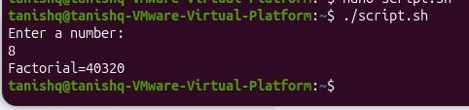
Output:

Multi-Level Branching using Nested if-else

Program:
#!/bin/bash
echo "Enter your marks:" read marks
if [ $marks -ge 90 ] then
echo "Grade: A+" elif [ $marks -ge 80 ] then
echo "Grade: A" elif [ $marks -ge 70 ] then
echo "Grade: B" elif [ $marks -ge 60 ] then
echo "Grade: C" elif [ $marks -ge 40 ] then
echo "Grade: D (Pass)" else
echo "Grade: F (Fail)"
fi

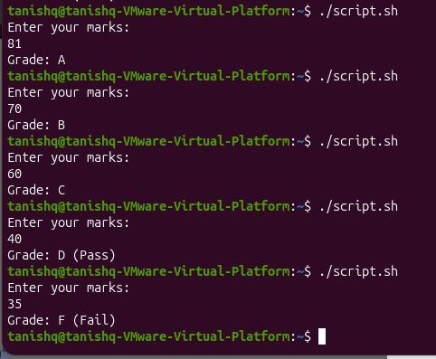
Output:

Multi-Level Branching using case

Program:
#!/bin/bash
echo "Enter your choice (1-3):" read choice
case $choice in
- echo "You selected Option 1";;
- echo "You selected Option 2";;
- echo "You selected Option 3";;
*) echo "Invalid Choice";; esac

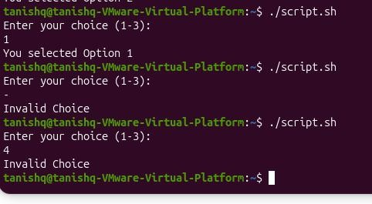
Output:
Result: Shell scripts using input/output statements, decision-making, looping and multi-level branching were written and executed successfully in Linux.

Practical No. 3: Process Creation using fork() – Parent, Child, Orphan and Zombie Processes

Theory
A process is a program in execution. Each process has a unique Process ID (PID) and also stores the ID of the process that created it, the Parent Process ID (PPID). In Linux, a new process is created with the fork() system call, which makes an almost exact copy of the calling process. After fork(), both processes continue from the next statement, and the return value tells them apart: a negative value means creation failed, 0 is returned in the child, and the child’s PID is returned in the parent. getpid() and getppid() give the PID and PPID of the current process.
If the parent finishes before the child, the child becomes an orphan process and is adopted by the init/systemd process (PID 1), so its PPID changes. If the child finishes but the parent has not yet collected its exit status using wait(), the child remains in the process table as a zombie process, shown with state Z (<defunct>) in ps.

Commands Used

Sr. No. | Command | Purpose | Example
1 | nano | Create/edit a C program | nano fork.c
2 | gcc | Compile the C program | gcc fork.c -o fork
3 | ./program | Execute the compiled program | ./fork
4 | ls | Verify the executable file | ls
5 | ps | Display process status | ps -el

Procedure
  - Open Terminal (Ctrl + Alt + T).
  - Update package list: sudo apt update
  - Install GCC: sudo apt install build-essential
  - Verify GCC: gcc --version
  - Create the program: nano fork.c
  - Write the program, save (Ctrl + O, Enter) and exit (Ctrl + X).
  - Compile: gcc fork.c -o fork
  - Run: ./fork

Parent and Child Process
Aim: To study process creation in Linux using the fork() system call and observe the Parent and Child processes.

Program:
#include <stdio.h> #include <unistd.h>

int main()
{
pid_t pid; pid = fork();

if (pid < 0)

{
printf("Process creation failed.\n");
}
else if (pid == 0)
{
printf("\n----- Child Process \n");
printf("Child Process ID (PID): %d\n", getpid()); printf("Parent Process ID (PPID): %d\n", getppid()); printf("Child process is executing \n");
printf("Child process completed.\n");
}
else
{
printf("\n----- Parent Process \n");
printf("Parent Process ID (PID): %d\n", getpid()); printf("Child Process ID: %d\n", pid); printf("Parent process is executing \n");
printf("Parent process completed.\n");
}
return 0;
}

Output:
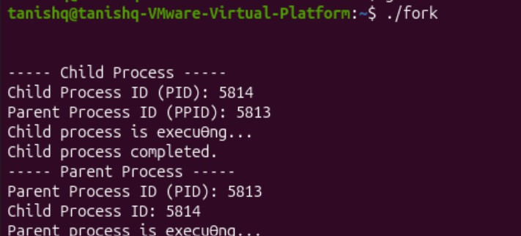

Orphan Process
Aim: To create and observe an Orphan Process using the fork() system call.

Program:
#include <stdio.h> #include <unistd.h> #include <stdlib.h>

int main()
{
pid_t pid = fork();

if (pid < 0)
{
printf("Fork failed.\n");
}
else if (pid == 0)
{
printf("\n----- Child Process \n");
printf("Child PID : %d\n", getpid()); printf("Initial Parent PPID : %d\n", getppid());

sleep(5); // Wait for parent to terminate

printf("\nAfter Parent Terminates...\n"); printf("Child PID : %d\n", getpid()); printf("New Parent PPID : %d\n", getppid()); printf("Child has become an Orphan Process.\n");
}
else
{
printf("\n----- Parent Process \n");
printf("Parent PID : %d\n", getpid()); printf("Child PID : %d\n", pid); printf("Parent is terminating \n");
exit(0);
}
return 0;
}

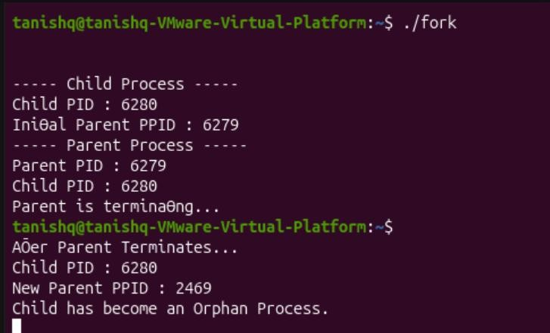
Output:

Zombie Process
Aim: To create and observe a Zombie Process using the fork() system call.
  - Create the file: nano zombie.c and write the program.
  - Compile: gcc zombie.c -o zombie
  - Run: ./zombie
  - Open another terminal and check the zombie process: ps -el | grep Z

Program:
#include <stdio.h> #include <unistd.h> #include <stdlib.h>

int main()
{
pid_t pid; pid = fork();

if (pid < 0)

{
printf("Process creation failed.\n");
}
else if (pid == 0)
{
printf("\n----- Child Process \n");
printf("Child Process ID (PID): %d\n", getpid()); printf("Child process is terminating \n");
exit(0);
}
else
{
printf("\n----- Parent Process \n");
printf("Parent Process ID (PID): %d\n", getpid()); printf("Child Process ID: %d\n", pid); printf("Parent process is sleeping \n");
sleep(15);
printf("Parent process completed.\n");
}
return 0;
}

Output:
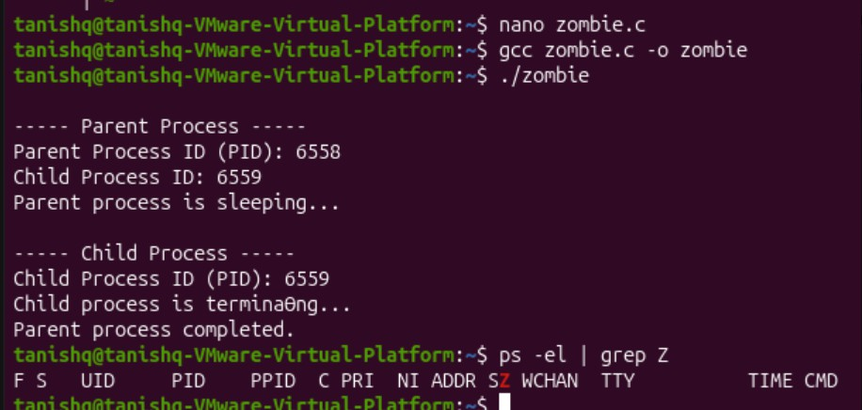
Result: Process creation using fork() was studied, and parent, child, orphan and zombie processes were created and observed successfully.

Practical No. 4: CPU Scheduling Algorithms – FCFS, SJF, Priority and Round Robin

Theory
When several processes are ready to run, the CPU scheduler decides which one gets the CPU next. In non-preemptive scheduling a process keeps the CPU until it finishes, whereas in preemptive scheduling the CPU can be taken away from it. The algorithms are compared using Turnaround Time (TAT = CT − AT) and Waiting Time (WT = TAT − BT), where AT is arrival time, BT is burst time and CT is completion time. A Gantt chart shows which process runs in each time interval.
- FCFS runs processes in the order they arrive. It is simple but short processes may wait behind a long one (convoy effect).
- SJF runs the process with the shortest burst time first and gives the minimum average waiting time, but long processes may starve.
- Priority runs the process with the highest priority first (a smaller number means higher priority here). Starvation is avoided using aging.
- Round Robin gives each process a fixed time quantum in turn and is preemptive and fair, which suits time-sharing systems.

FCFS Scheduling
Aim: Write a program to implement FCFS CPU Scheduling and find the Average Waiting Time and Average Turnaround Time along with the Gantt Chart.

Code:
process = ["P1", "P2", "P3", "P4"]
at = [0, 2, 4, 6] # Arrival Time
bt = [1, 3, 8, 6] # Burst Time n = len(process)

wt = [0] * n tat = [0] * n ct = [0] * n

# First process
ct[0] = at[0] + bt[0]
tat[0] = ct[0] - at[0]
wt[0] = tat[0] - bt[0]

# Remaining processes for i in range(1, n):
if ct[i-1] < at[i]:
ct[i] = at[i] + bt[i] # CPU Idle else:
ct[i] = ct[i-1] + bt[i]
tat[i] = ct[i] - at[i]
wt[i] = tat[i] - bt[i]

# Display Table print("Process\tAT\tBT\tCT\tTAT\tWT") for i in range(n):
print(process[i], "\t", at[i], "\t", bt[i], "\t", ct[i], "\t", tat[i], "\t", wt[i])

print("\nAverage Waiting Time =", sum(wt) / n) print("Average Turnaround Time =", sum(tat) / n)

# Gantt Chart print("\nGantt Chart:") time = 0
print(time, end="") for i in range(n):
if time < at[i]:
print(f" --Idle-- {at[i]}", end="") time = at[i]
print(f" --{process[i]}-- {ct[i]}", end="") time = ct[i]
print()

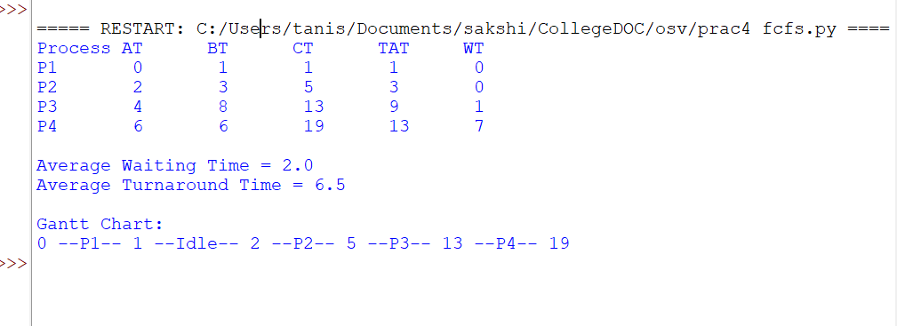
Output:

SJF Scheduling
Aim: Write a program to implement SJF CPU Scheduling and find the Average Waiting Time and Average Turnaround Time along with the Gantt Chart.

Code:
process = ["P1", "P2", "P3", "P4"]
at = [0, 2, 2, 5] # Arrival Time
bt = [2, 4, 1, 2] # Burst Time n = len(process)

wt = [0] * n tat = [0] * n ct = [0] * n
completed = [False] * n time = 0
completed_process = 0 gantt = []

while completed_process < n: shortest = -1
min_bt = 999
for i in range(n):
if at[i] <= time and completed[i] == False: if bt[i] < min_bt:
min_bt = bt[i] shortest = i
if shortest == -1: gantt.append(("Idle", time)) time += 1
continue
time = time + bt[shortest] ct[shortest] = time
tat[shortest] = ct[shortest] - at[shortest]

wt[shortest] = tat[shortest] - bt[shortest] completed[shortest] = True completed_process += 1 gantt.append((process[shortest], time))

print("Process\tAT\tBT\tCT\tTAT\tWT") for i in range(n):
print(process[i], "\t", at[i], "\t", bt[i],
"\t", ct[i], "\t", tat[i], "\t", wt[i])

print("\nAverage Waiting Time =", sum(wt) / n) print("Average Turnaround Time =", sum(tat) / n)

print("\nGantt Chart:") start = 0
print(start, end="")
for p, end_time in gantt:
print(f" --{p}-- {end_time}", end="") print()

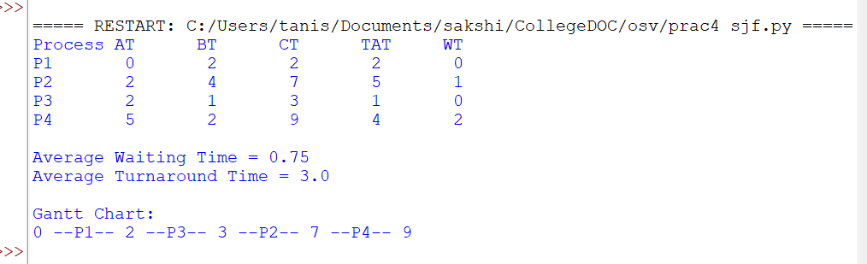
Output:

Priority Scheduling
Aim: Write a program to implement Priority CPU Scheduling and find the Average Waiting Time and Average Turnaround Time along with the Gantt Chart.

Code:
process = ["P1", "P2", "P3", "P4"] at = [0, 2, 3, 5]
bt = [7, 4, 1, 2]
priority = [2, 1, 4, 2] n = len(process)

wt = [0] * n tat = [0] * n ct = [0] * n
completed = [False] * n time = 0
count = 0 gantt = []

while count < n: highest = -1
min_priority = 999 for i in range(n):
if at[i] <= time and completed[i] == False: if priority[i] < min_priority:
min_priority = priority[i] highest = i

if highest == -1: gantt.append(("Idle", time)) time += 1
continue
time += bt[highest] ct[highest] = time
tat[highest] = ct[highest] - at[highest] wt[highest] = tat[highest] - bt[highest] completed[highest] = True
count += 1 gantt.append((process[highest], time))

print("Process\tAT\tBT\tPriority\tCT\tTAT\tWT") for i in range(n):
print(process[i], "\t", at[i], "\t", bt[i], "\t",
priority[i], "\t\t", ct[i], "\t", tat[i], "\t", wt[i])

print("\nAverage Waiting Time =", sum(wt) / n) print("Average Turnaround Time =", sum(tat) / n)

print("\nGantt Chart:") time = 0
print(time, end="")
for p, end_time in gantt:
print(f" --{p}-- {end_time}", end="") print()

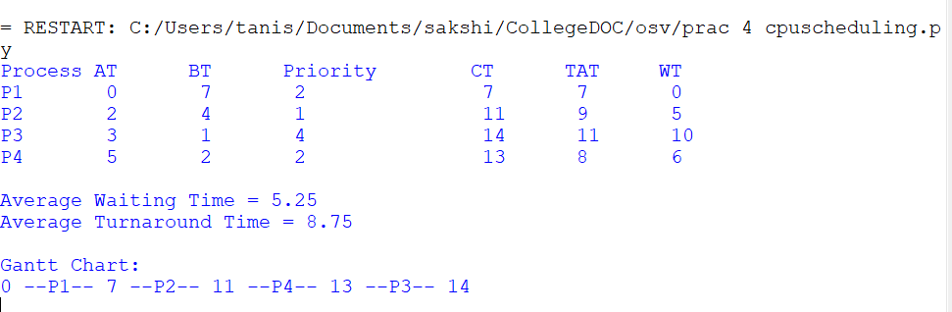
Output:

Round Robin Scheduling
Aim: Write a program to implement Round robin CPU Scheduling and find the Average Waiting Time and Average Turnaround Time along with the Gantt Chart.

Code:
process = ["P1", "P2", "P3", "P4"] at = [0, 1, 3, 5]
bt = [5, 4, 2, 6]
tq = 2
n = len(process)

rt = bt[:] ct = [0] * n
tat = [0] * n wt = [0] * n queue = []
visited = [False] * n time = 0
completed = 0

gantt = []

queue.append(0) visited[0] = True

while completed < n: if len(queue) == 0:
gantt.append(("Idle", time)) time += 1
for i in range(n):
if at[i] <= time and not visited[i]: queue.append(i)
visited[i] = True continue

i = queue.pop(0) if rt[i] > tq:
time += tq rt[i] -= tq
else:
time += rt[i] rt[i] = 0 ct[i] = time completed += 1
gantt.append((process[i], time))

for j in range(n):
if at[j] <= time and not visited[j]: queue.append(j)
visited[j] = True if rt[i] > 0:
queue.append(i)

for i in range(n):
tat[i] = ct[i] - at[i]
wt[i] = tat[i] - bt[i]

print("Process\tAT\tBT\tCT\tTAT\tWT") for i in range(n):
print(process[i], "\t", at[i], "\t", bt[i], "\t",
ct[i], "\t", tat[i], "\t", wt[i])

print("\nAverage WT =", sum(wt) / n) print("Average TAT =", sum(tat) / n)

print("\nGantt Chart:") print("0", end="")
for p, t in gantt:
print(f" --{p}-- {t}", end="") print()

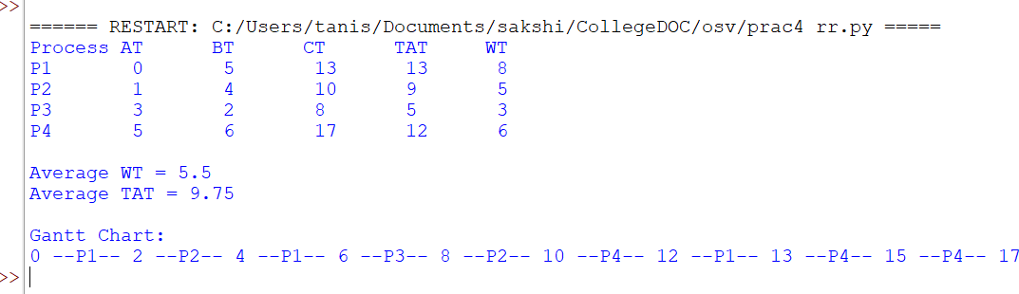
Output:
Result: FCFS, SJF, Priority and Round Robin CPU scheduling algorithms were implemented, and the average waiting time, average turnaround time and Gantt chart were obtained for each.

Practical No. 5: Banker's Algorithm for Deadlock Avoidance
Aim: Simulation of Banker's algorithm to check whether the given system is in a safe state or not. Also check whether an additional resource request can be granted immediately.

Theory
A deadlock occurs when a set of processes wait forever, each holding a resource needed by another. It can happen only when mutual exclusion, hold and wait, no preemption and circular wait all hold together. The Banker’s algorithm avoids deadlock by granting a request only if the system remains in a safe state, that is, if there is at least one order (safe sequence) in which every process can obtain its remaining need and finish.
It uses the Available, Max and Allocation matrices and calculates Need = Max − Allocation. The safety algorithm starts with Work = Available, repeatedly picks an unfinished process whose Need ≤ Work, adds its Allocation back to Work, and marks it finished. If all processes finish, the system is safe. A new request is granted only if Request ≤ Need and Request ≤ Available.

Code:
allocation = [
]

available = [3, 3, 2]

n = 5
m = 3

# Calculate Need Matrix need = []
for i in range(n): row = []
for j in range(m):
row.append(maximum[i][j] - allocation[i][j]) need.append(row)

print("Need Matrix:") for i in range(n):
print("P", i, ":", need[i])

# Safety Algorithm work = available[:] finish = [False] * n safe = []

while len(safe) < n: found = False

 | [0, | 1, | 0],
 | [2, | 0, | 0],
 | [3, | 0, | 2],
 | [2, | 1, | 1],
] | [0, | 0, | 2]
maximum |  | = [
[7, |  | 5, | 3],
[3, |  | 2, | 2],
[9, |  | 0, | 2],
[2, |  | 2, | 2],
[4, |  | 3, | 3]

for i in range(n):
if not finish[i]: possible = True for j in range(m):
if need[i][j] > work[j]: possible = False break
if possible:
for j in range(m):
work[j] += allocation[i][j] finish[i] = True safe.append(i)
found = True if not found:
break

if len(safe) == n:
print("\nSystem is in Safe State") print("Safe Sequence:", end=" ") for p in safe:
print("P" + str(p), end=" ")
else:
print("\nSystem is NOT in Safe State")
#
Additional Resource Request
print("\n\nAdditional Resource Request") process = int(input("Enter Process Number: "))
request = list(map(int, input("Enter Request (3 values): ").split())) grant = True
# Check Request <= Need for i in range(m):
if request[i] > need[process][i]: print("Request exceeds Need.") grant = False
break

# Check Request <= Available if grant:
for i in range(m):
if request[i] > available[i]: print("Resources are not available.") grant = False
break
if grant:
print("Request can be granted immediately.") else:
print("Request cannot be granted.")

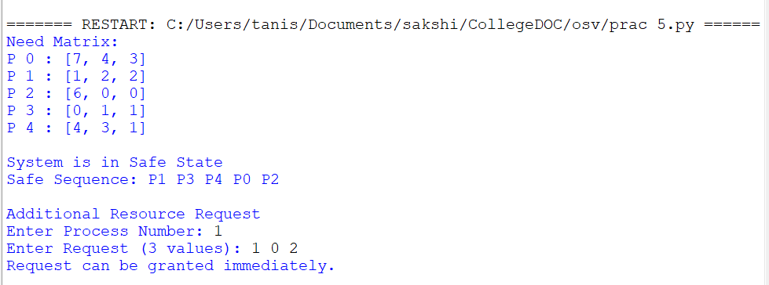
Output:
Result: Banker's algorithm was simulated successfully. The system is in a safe state with safe sequence P1, P3, P4, P0, P2, and the request (1, 0, 2) by P1 can be granted immediately.

Practical No. 6: Parallel Thread Management using POSIX Threads (pthread)
Aim: Parallel Thread Management using the POSIX Thread (pthread) Library (Data Parallelism).

Theory
A thread is a lightweight unit of execution within a process. Threads of the same process share code, global data and open files, but each has its own stack and registers, which makes them faster to create and switch than processes. In data parallelism, the same task is performed on different parts of the data at the same time; here, one thread searches the first half of the array and another searches the second half.
POSIX threads (pthreads) is the standard thread library on Linux, used through <pthread.h> and compiled with the -pthread flag. pthread_create() starts a new thread, pthread_join() makes the main program wait for a thread to finish, and pthread_exit() ends a thread. The order of thread output may vary between runs because it depends on the scheduler.

Commands Used

Sr. No. | Command | Purpose | Example
1 | nano | Create/edit a C program | nano search.c
2 | gcc | Compile the C program with pthread library | gcc search.c -o search -pthread
3 | ./program | Execute the compiled program | ./search
4 | ls | Verify the executable file | ls

Procedure
  - Open the Terminal (Ctrl + Alt + T).
  - Create a C program: nano search.c
  - Type the program and save the file.
  - Compile the program: gcc search.c -o search -pthread
  - Execute the program: ./search

Program:
#include <stdio.h> #include <pthread.h>

int arr[] = {5, 10, 15, 20, 25, 30, 35, 40, 45, 50};
int key = 25;

void *searchFirstHalf(void *arg)
{
for (int i = 0; i < 5; i++)
{
if (arr[i] == key)
{
printf("Thread 1: Element %d found at index %d\n", key, i); pthread_exit(NULL);
}
}
printf("Thread 1: Element not found.\n"); pthread_exit(NULL);

}

void *searchSecondHalf(void *arg)
{
for (int i = 5; i < 10; i++)
{
if (arr[i] == key)
{
printf("Thread 2: Element %d found at index %d\n", key, i); pthread_exit(NULL);
}
}
printf("Thread 2: Element not found.\n"); pthread_exit(NULL);
}

int main()
{
pthread_t t1, t2;

pthread_create(&t1, NULL, searchFirstHalf, NULL); pthread_create(&t2, NULL, searchSecondHalf, NULL);

pthread_join(t1, NULL); pthread_join(t2, NULL);

printf("Search completed.\n"); return 0;
}

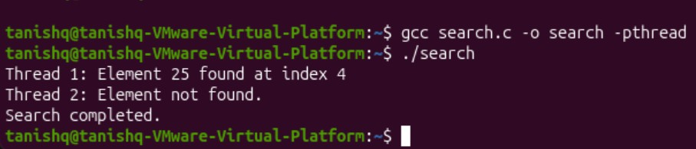
Output:
Result: Parallel searching of an array was implemented using two POSIX threads, and the element 25 was found at index 4 by thread 1.

Practical No. 7: Dynamic Memory Allocation – First Fit, Best Fit and Worst Fit

Theory
In dynamic (variable) partitioning, memory is given to a process according to its size, and the free areas of memory are called holes. When a process requests memory, the operating system chooses a hole using one of three strategies. First Fit uses the first hole that is large enough and is the fastest. Best Fit uses the smallest hole that is large enough, leaving the least space unused. Worst Fit uses the largest hole so that the leftover space is still usable. Repeated allocation leaves small scattered holes, which causes external fragmentation; space left unused inside an allocated block is internal fragmentation.
Memory blocks used: 20, 100, 40, 200, 10. Process sizes: 90, 50, 30, 40.

First Fit
Aim: Demonstrate the First-fit dynamic memory allocation algorithm.

Code:
blocks = [20, 100, 40, 200, 10]
processes = [90, 50, 30, 40]
allocation = [-1] * len(processes) for i in range(len(processes)):
for j in range(len(blocks)):
if blocks[j] >= processes[i]: allocation[i] = j blocks[j] -= processes[i] break

print("Process\tSize\tBlock") for i in range(len(processes)):
if allocation[i] != -1: print(f"P{i+1}\t{processes[i]}\tBlock {allocation[i]+1}")
else:
print(f"P{i+1}\t{processes[i]}\tNot Allocated")

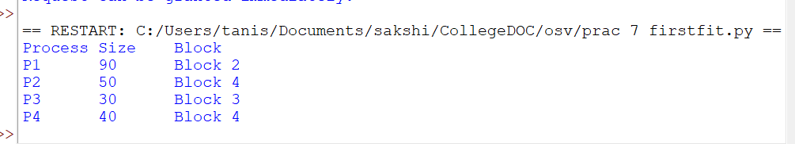
Output:

Best Fit
Aim: Demonstrate the Best-fit dynamic memory allocation algorithm.

Code:
blocks = [20, 100, 40, 200, 10]
processes = [90, 50, 30, 40]
allocation = [-1] * len(processes) for i in range(len(processes)):

best = -1
for j in range(len(blocks)):
if blocks[j] >= processes[i]:
if best == -1 or blocks[j] < blocks[best]: best = j
if best != -1: allocation[i] = best
blocks[best] -= processes[i]

print("Process\tSize\tBlock") for i in range(len(processes)):
if allocation[i] != -1: print(f"P{i+1}\t{processes[i]}\tBlock {allocation[i]+1}")
else:
print(f"P{i+1}\t{processes[i]}\tNot Allocated")

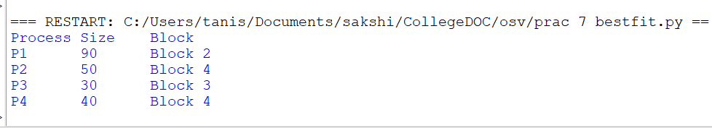
Output:

Worst Fit
Aim: Demonstrate the Worst-fit dynamic memory allocation algorithm.

Code:
blocks = [20, 100, 40, 200, 10]
processes = [90, 50, 30, 40]
allocation = [-1] * len(processes) for i in range(len(processes)):
worst = -1
for j in range(len(blocks)):
if blocks[j] >= processes[i]:
if worst == -1 or blocks[j] > blocks[worst]: worst = j
if worst != -1: allocation[i] = worst
blocks[worst] -= processes[i]

print("Process\tSize\tBlock") for i in range(len(processes)):
if allocation[i] != -1: print(f"P{i+1}\t{processes[i]}\tBlock {allocation[i]+1}")
else:
print(f"P{i+1}\t{processes[i]}\tNot Allocated")

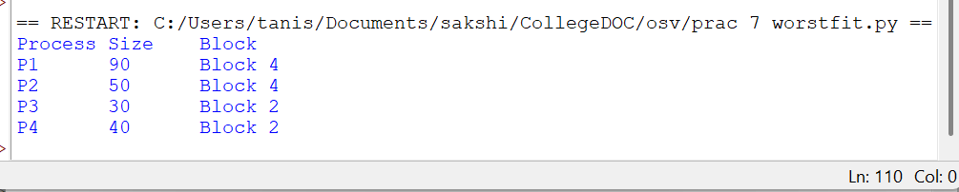
Output:

Result: First Fit, Best Fit and Worst Fit memory allocation algorithms were implemented and the block allocated to each process was displayed.

Practical No. 8: Page Replacement Algorithms – FIFO, LRU and Optimal

Theory
In paging, a process is divided into fixed-size pages that are loaded into memory frames only when needed. When a referenced page is not in memory a page fault occurs, and if all frames are full a page replacement algorithm decides which page to remove. FIFO removes the oldest page in memory and can suffer from Belady’s anomaly, where more frames give more faults. LRU removes the page that has not been used for the longest time. Optimal removes the page that will not be used for the longest time in the future; it gives the fewest page faults but needs future knowledge, so it is used as a benchmark.
Reference string used: 1, 2, 3, 1, 4, 5, 2, 1, 2, 3, 4, 5 with 3 frames.

FIFO Page Replacement
Aim: Demonstrate the FIFO Page Replacement Algorithm.

Code:
pages = [1, 2, 3, 1, 4, 5, 2, 1, 2, 3, 4, 5]
frames = 3 memory = [] page_faults = 0

for page in pages:
if page not in memory: page_faults += 1
if len(memory) < frames: memory.append(page)
else:
memory.pop(0) memory.append(page)
print(page, "->", memory)

print("\nTotal Page Faults:", page_faults)

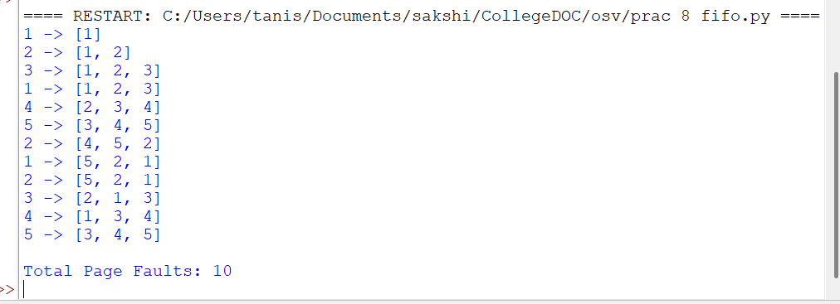
Output:

LRU Page Replacement
Aim: Demonstrate the LRU Page Replacement Algorithm.

Code:
pages = [1, 2, 3, 1, 4, 5, 2, 1, 2, 3, 4, 5]
frames = 3

memory = [] page_faults = 0

for page in pages:
if page not in memory: page_faults += 1
if len(memory) < frames: memory.append(page)
else:
memory.pop(0) memory.append(page)
else:
memory.remove(page) memory.append(page)
print(page, "->", memory)

print("\nTotal Page Faults:", page_faults)

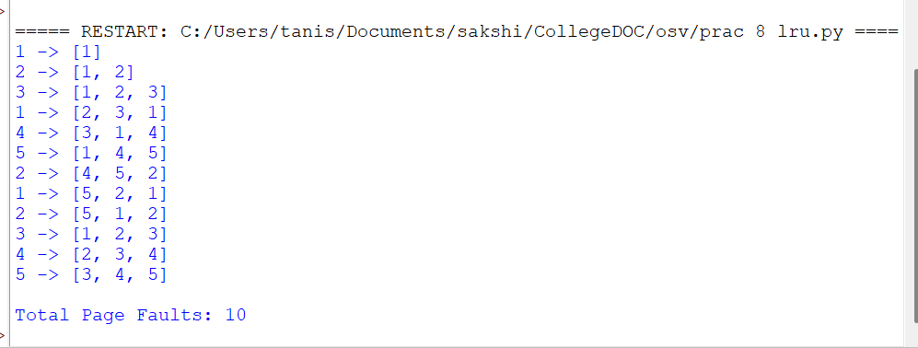
Output:

Optimal Page Replacement
Aim: Demonstrate the Optimal Page Replacement Algorithm.

Code:
pages = [1, 2, 3, 1, 4, 5, 2, 1, 2, 3, 4, 5]
frames = 3 memory = [] page_faults = 0

for i in range(len(pages)): page = pages[i]
if page not in memory: page_faults += 1
if len(memory) < frames: memory.append(page)
else:
future = pages[i + 1:] index = -1
farthest = -1
for j in range(len(memory)):
if memory[j] not in future: index = j
break
position = future.index(memory[j]) if position > farthest:
farthest = position index = j

memory[index] = page print(page, "->", memory)

print("\nTotal Page Faults:", page_faults)

Output:
$ python3 optimal.py
Total Page Faults: 7

1 | -> | [1]
2 | -> | [1, | 2]
3 | -> | [1, | 2, | 3]
1 | -> | [1, | 2, | 3]
4 | -> | [1, | 2, | 4]
5 | -> | [1, | 2, | 5]
2 | -> | [1, | 2, | 5]
1 | -> | [1, | 2, | 5]
2 | -> | [1, | 2, | 5]
3 | -> | [3, | 2, | 5]
4 | -> | [4, | 2, | 5]
5 | -> | [4, | 2, | 5]

Result: FIFO, LRU and Optimal page replacement algorithms were implemented, giving 10, 10 and 7 page faults respectively for the given reference string.

Practical No. 9: Type-I and Type-II Hypervisors and VM Setup using a Type-II Hypervisor
Aim: To study Type-I and Type-II hypervisors and set up a virtual machine using a Type-II hypervisor.

Theory
A hypervisor, also called a Virtual Machine Monitor, is software that creates and manages virtual machines (VMs) by sharing the physical CPU, memory, storage and network among them. There are two main types:
- Type-I Hypervisor (Bare-Metal) runs directly on the physical hardware and does not require a host operating system. It gives better performance and is commonly used in servers and data centers. Examples: VMware ESXi, Microsoft Hyper-V, Xen.
- Type-II Hypervisor (Hosted) runs on top of an existing operating system, which manages the hardware, while the hypervisor creates and manages virtual machines. It is mainly used on desktops for learning and testing. Examples: VMware Workstation, Oracle VirtualBox.
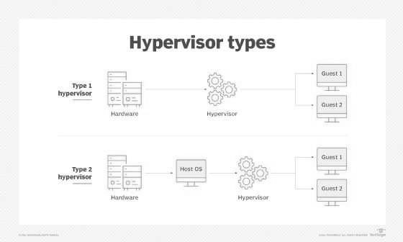
Virtualization support (Intel VT-x / AMD-V) should be enabled in the BIOS of the host machine.

Steps

Step 1: Open VMware Workstation
  - Open VMware Workstation Pro 17.
  - Click Create a New Virtual Machine.

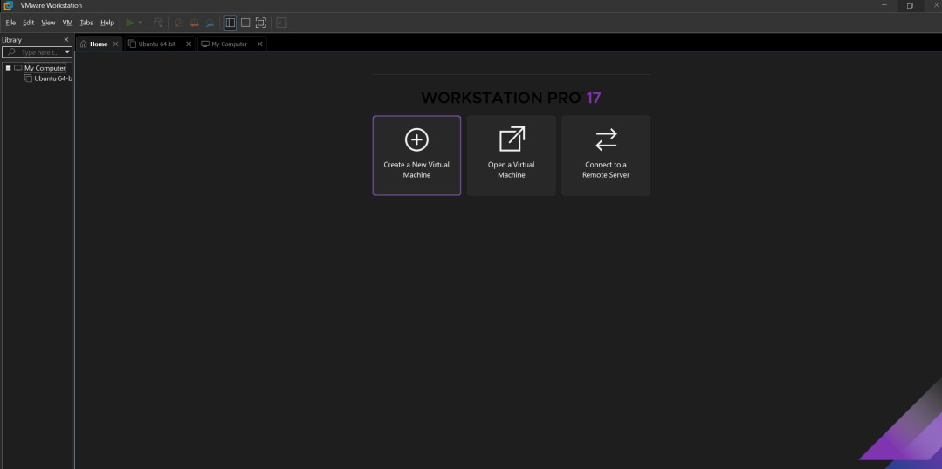

Step 2: Select Ubuntu ISO
- Select Installer disc image file (ISO).
- Browse and select the Ubuntu ISO file.
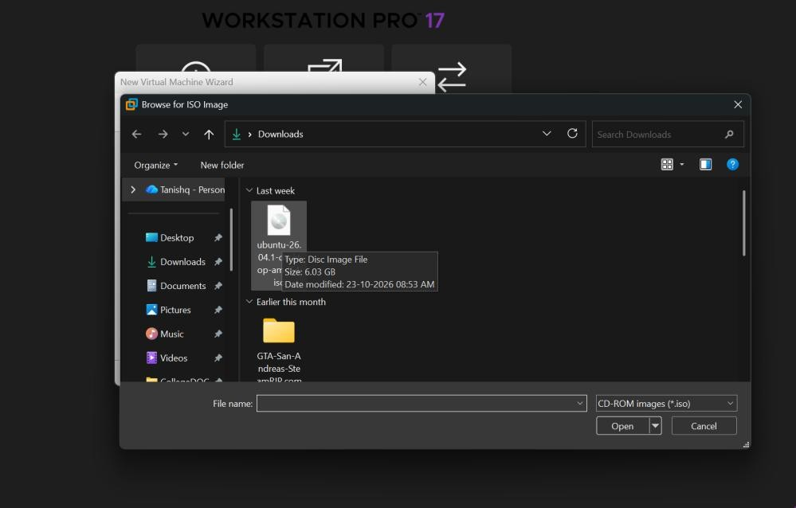
- Click Next.

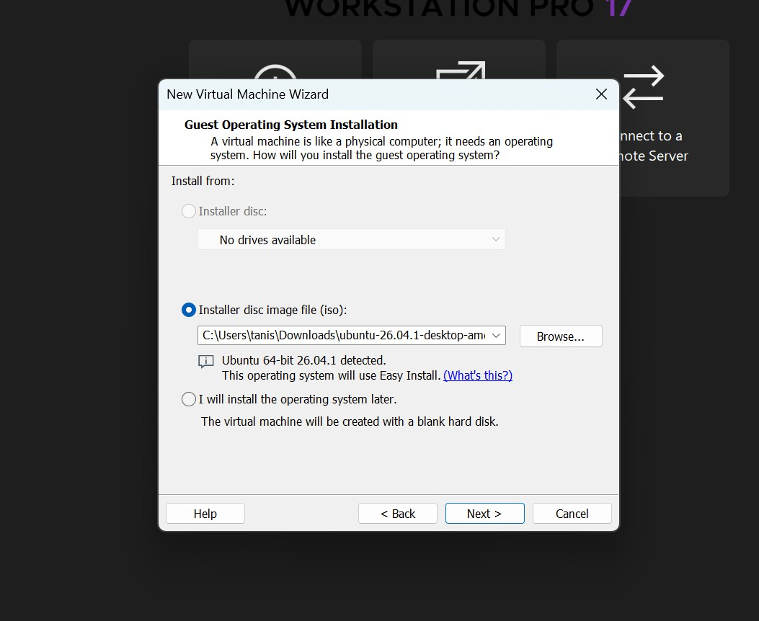

Step 3: Configure the Virtual Machine
- Enter the VM name and location.
- Set the disk size (20 GB).
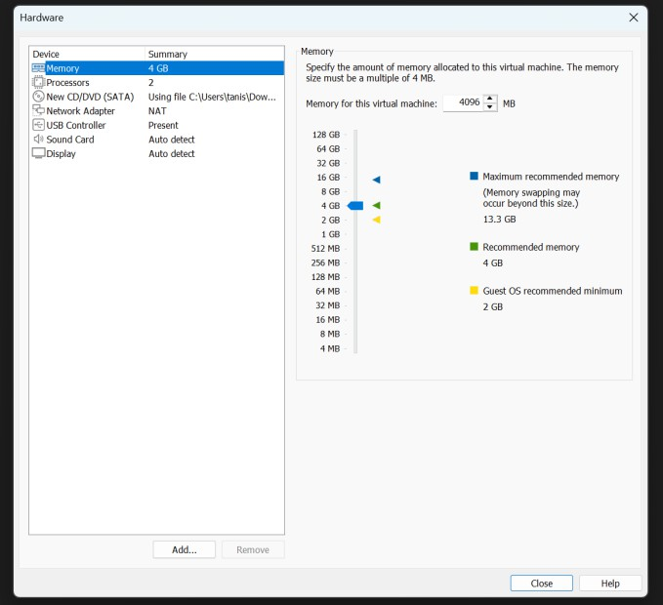
- Use Customize Hardware to set Memory (4 GB), Processors (2) and Network (NAT).

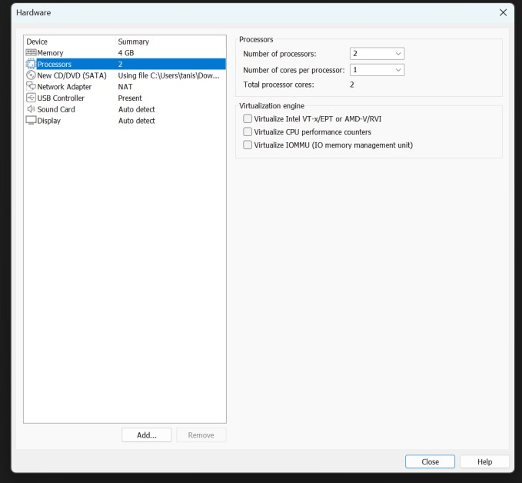
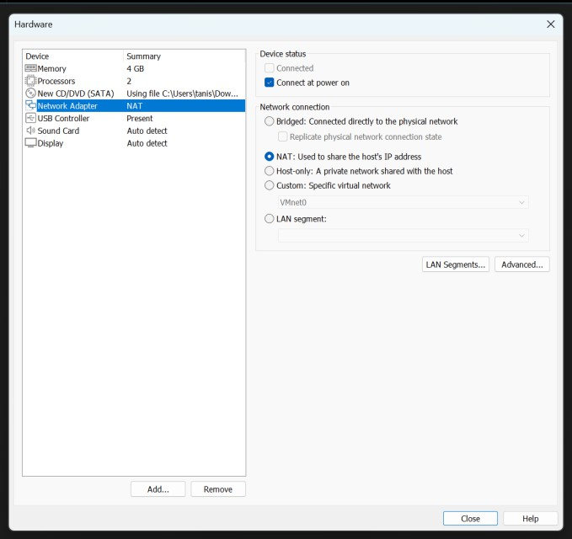

Step 4: Create the Virtual Machine
- Review the configuration.
- Click Finish.
- The Ubuntu virtual machine will be created.

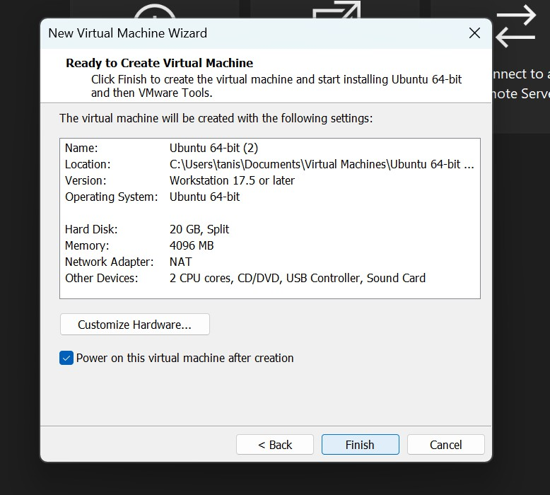

Step 5: Start the Virtual Machine
- Select the Ubuntu VM.
- Click Play Virtual Machine.
- Ubuntu will start from the ISO file.

Step 6: Install Ubuntu
- Select Install Ubuntu.
- Follow the installation instructions.
- Create a username and password.
- Complete the installation.

- Restart the virtual machine when prompted.

Commands for Verification
Open the Ubuntu Terminal and execute:
- lscpu – displays the CPU information available to the virtual machine.

- free -h – displays the total, used and available RAM.
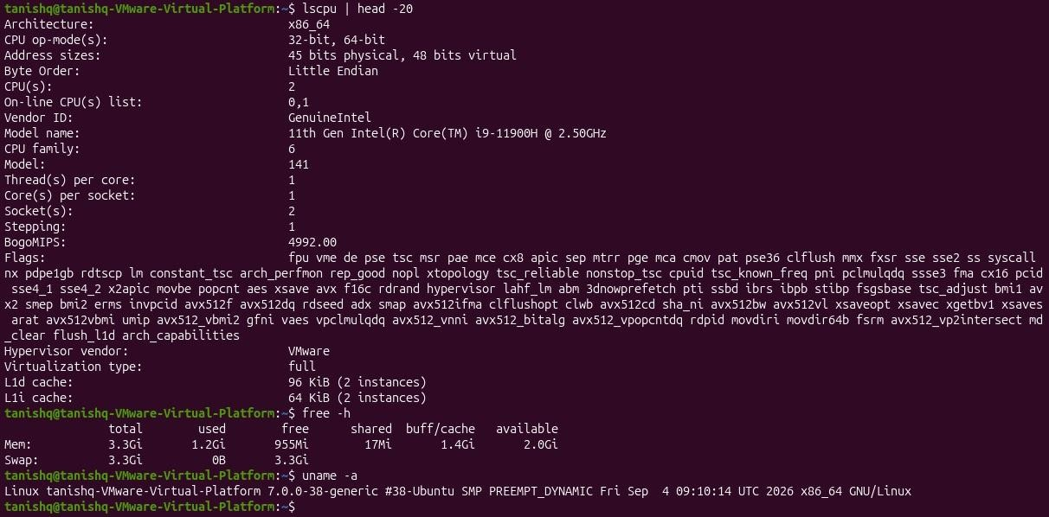
- uname -a – displays information about the Linux kernel and system.
Result: The Type-I and Type-II hypervisors were studied, and a virtual machine was successfully created and executed using the Type-II hypervisor VMware Workstation.

Practical No. 10: Operating System Virtualization – Ubuntu VM using VMware Workstation
Aim: To implement operating system virtualization by creating and running an Ubuntu virtual machine using VMware Workstation.

Theory
Virtualization is a technique that allows multiple virtual computers or operating systems to run on a single physical computer. A Virtual Machine (VM) behaves like an independent computer, with its own virtual CPU, RAM, storage and network resources. The physical machine is called the host and the operating system inside the VM is called the guest. Virtualization reduces hardware cost, keeps each VM isolated, and allows snapshots, so different operating systems can be tested safely. In this practical, VMware Workstation is used to create an Ubuntu virtual machine on a Windows host system.

Steps

Step 1: Open VMware Workstation
- Open VMware Workstation Pro 17.

Step 2: Create a New Virtual Machine
- Click Create a New Virtual Machine.
- Select Installer disc image file (ISO).
- Select the Ubuntu ISO file.
- Click Next.

Step 3: Configure Hardware
- Enter the VM name and allocate disk space (20 GB).
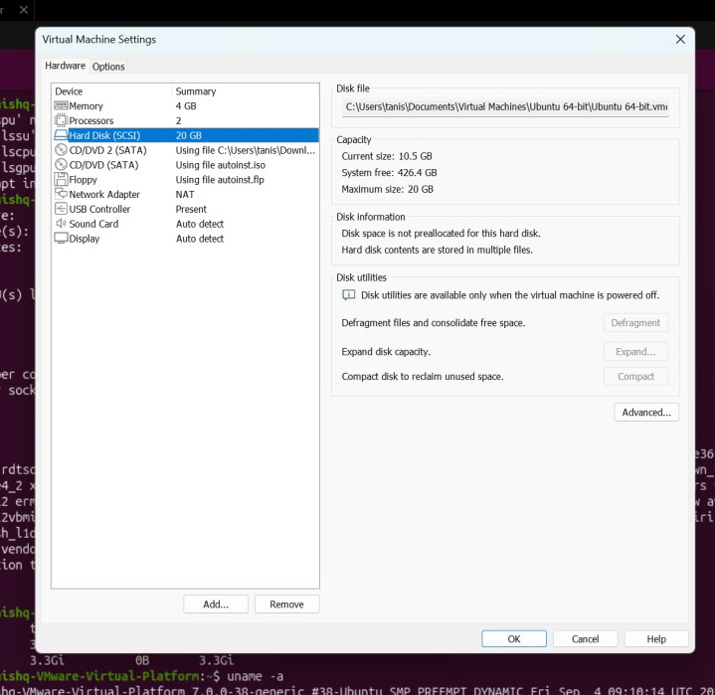
- Use Customize Hardware to allocate Memory (4 GB), Processors (2) and Network (NAT).

Step 4: Create the Virtual Machine
- Review the configuration.
- Click Finish.

- The Ubuntu virtual machine will be created.

Step 5: Start the Virtual Machine
- Select the Ubuntu VM.
- Click Play Virtual Machine.
- Ubuntu will start from the ISO file.

Step 6: Install Ubuntu
- Select Install Ubuntu.
- Follow the installation instructions.
- Create a username and password.
- Complete the installation.
- Restart the virtual machine when prompted.

Commands for Verification
Open the Ubuntu Terminal and execute:
- lscpu – displays the CPU information available to the virtual machine.
- free -h – displays the total, used and available RAM (total, used, free; -h shows values in GiB/MiB).
- uname -a – displays information about the Linux kernel and system.
- df -h – displays the available and used disk space.
- ip addr – displays the network interfaces and IP addresses of the virtual machine.

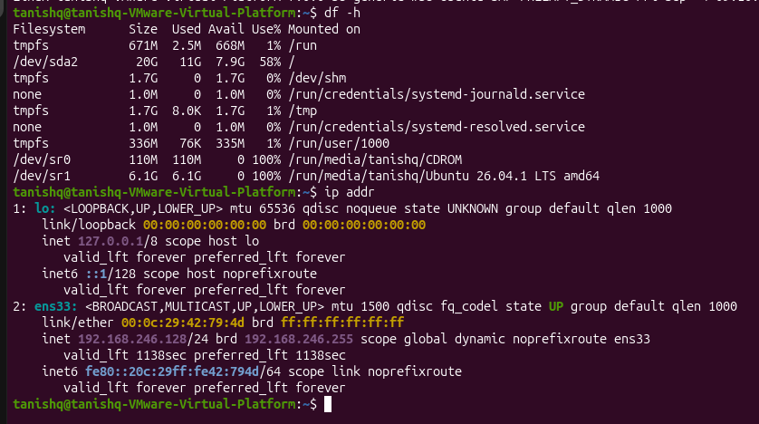
Observation: The Ubuntu operating system runs inside VMware as a virtual machine. The VM receives virtual CPU, RAM, storage and network resources from the host computer.
Result: The Ubuntu operating system was successfully implemented as a virtual machine using VMware Workstation, demonstrating operating system/server virtualization.

