**Project Name : Coaching Management.**

**INTRODUCTION**

**Project Objective**

* To make a easier system for a Teacher and a Student to store his information.
* To upgrade a system from paper-based to computerized system.
* To lessen the risk of losing records.
* To make it simple for Teacher and Student.

**Applications**

* The system use only registered Teacher and Student, but if someone wishes to use it then he/she can get registered.
* The system has only three parts : i) Admin ii)Teacher iii)Student.
* Admin section is the most powerful part because he can add, update or delete any item.
* User friendly registration system for teacher and student.
* Without admin approval any teacher doesn’t take any course. Only admin can choose a teacher for a particular course.
* When the course registration is open then Student can choose his/her particular course and if closed then not. And when the course withdraw is open then Student can withdraw his/her course and if closed then not.
* Teacher can see who register with him.
* After the exam Teacher can add the marks of any particular student.

**LOGIN PAGE**

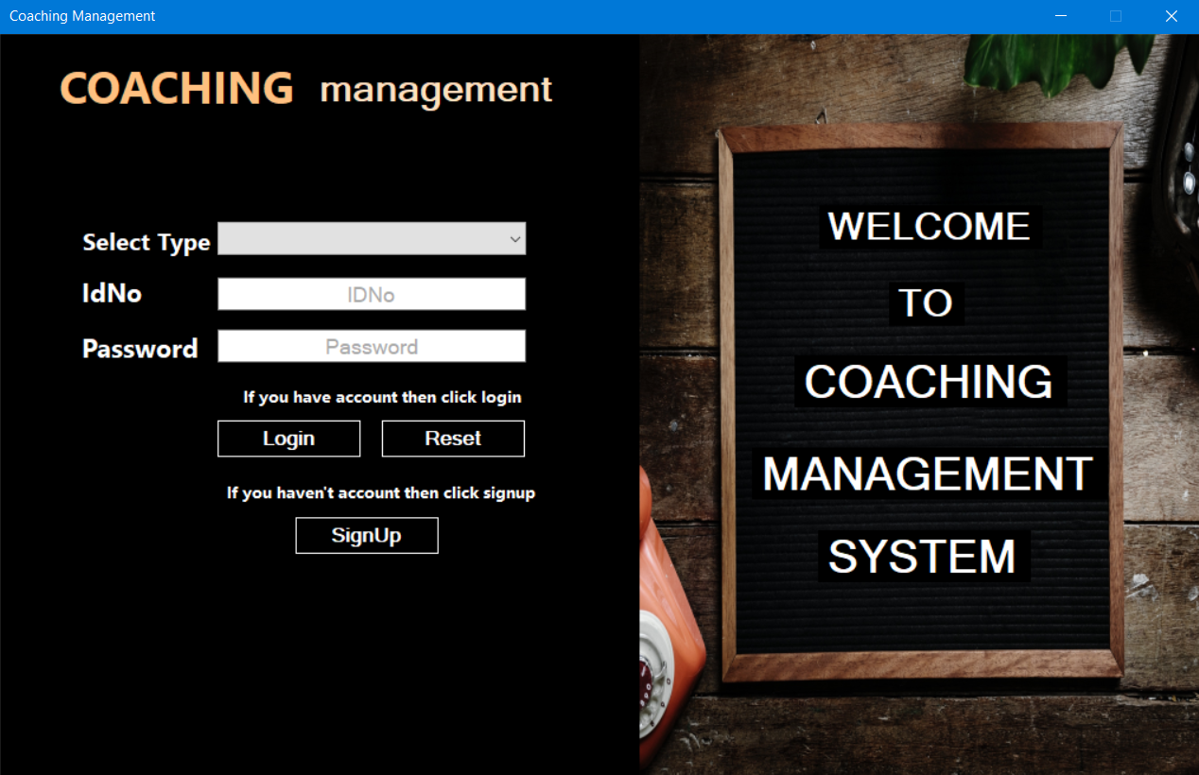

If IdNo and Password

is correct then user

enter into the system

otherwise not.

Student

Teacher

Admin

Reset IdNo

and Password

If the Student or Teacher wishes to get registered

he/she can simply do that by pressing this SignUp

buton, which take them to the registration form.

**SIGNUP FORM**

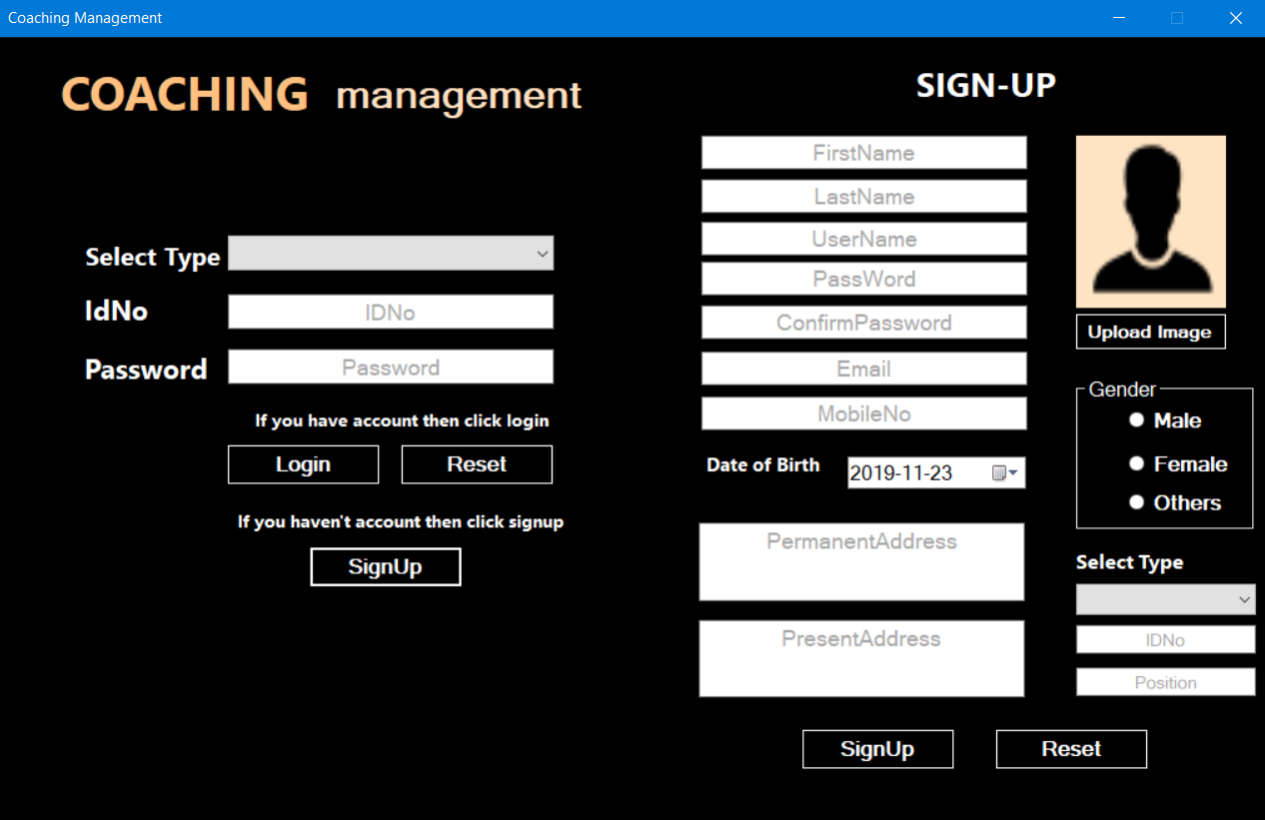

* If user want to get registered

then fill up the form and press

After fill up this form click the signUp button to get registered.

the signUp button.

**ADMIN -> Details**

Select type Student or Teacher to see the details of them.

Click Logout button to go to the Login page.

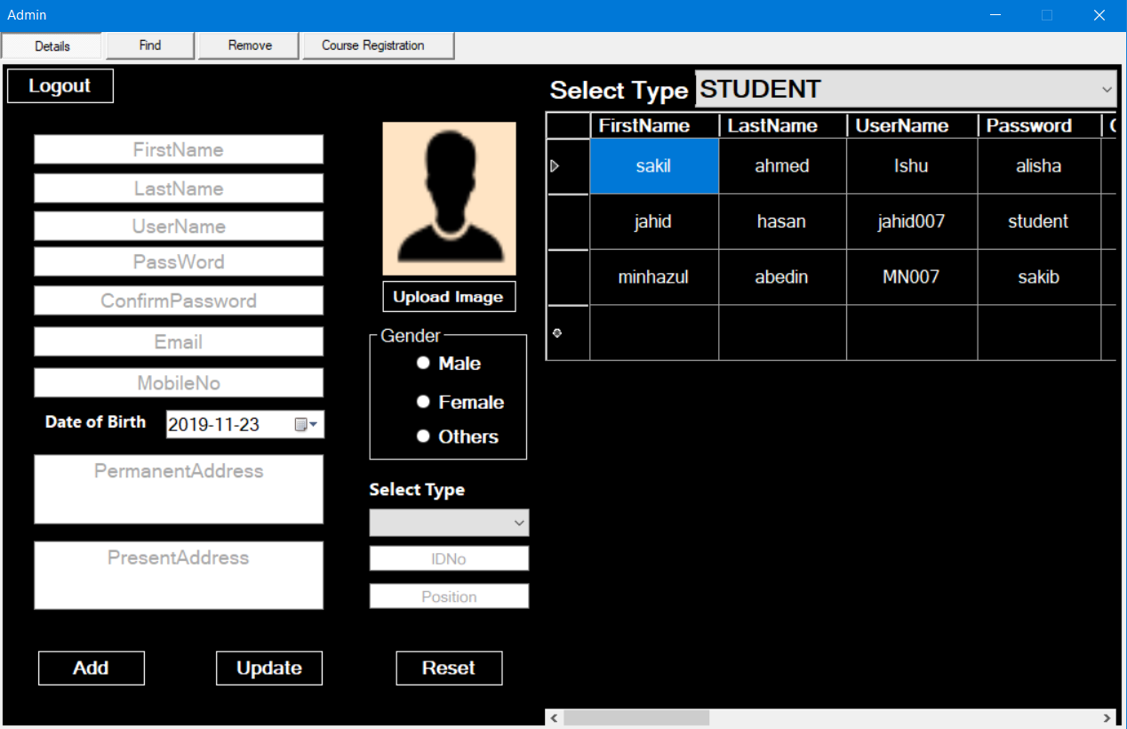

Click Update button to update the student or teacher details from this admin section.

Click Reset button to reset the whole form.

Click Add button to add the new student or teacher from this admin section.

**ADMIN -> Find**

Select search type Student or Teacher to see the details of any student or teacher.

Enter search item

Click search to find the details of any student or teacher.

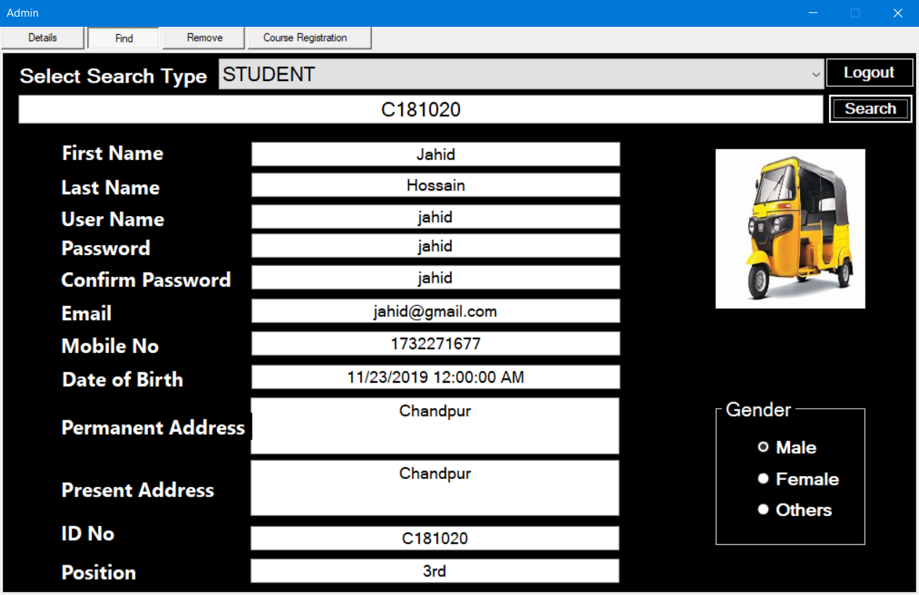

All the details of a user

**ADMIN -> Remove**

Enter search item

Select delete type Student or Teacher to remove the details of any student or teacher.

Click remove to delete the details of any student or teacher.

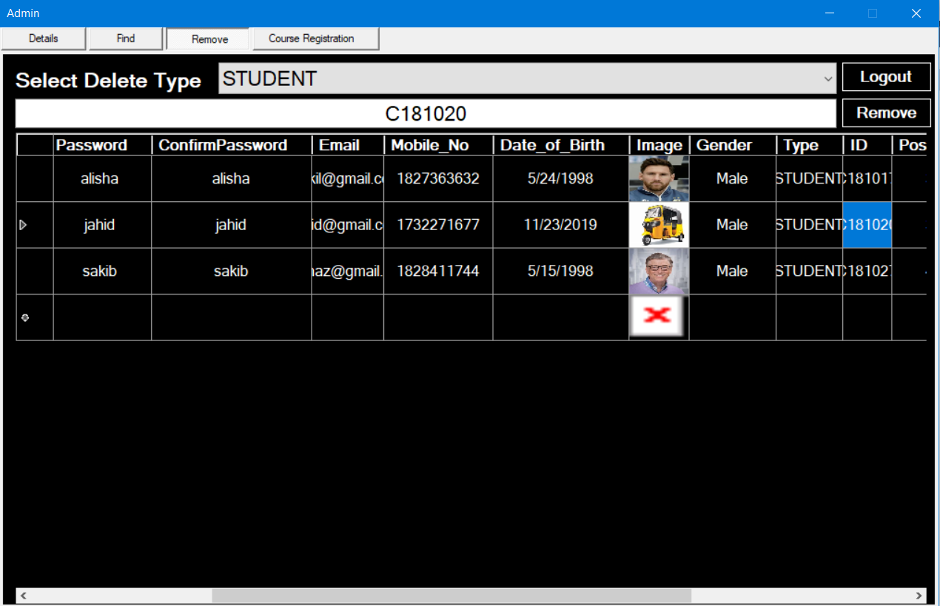

Remove any user

**ADMIN -> Course Registration**

Admin can ADD any course and select a teacher for a particular course.

See all the details of course

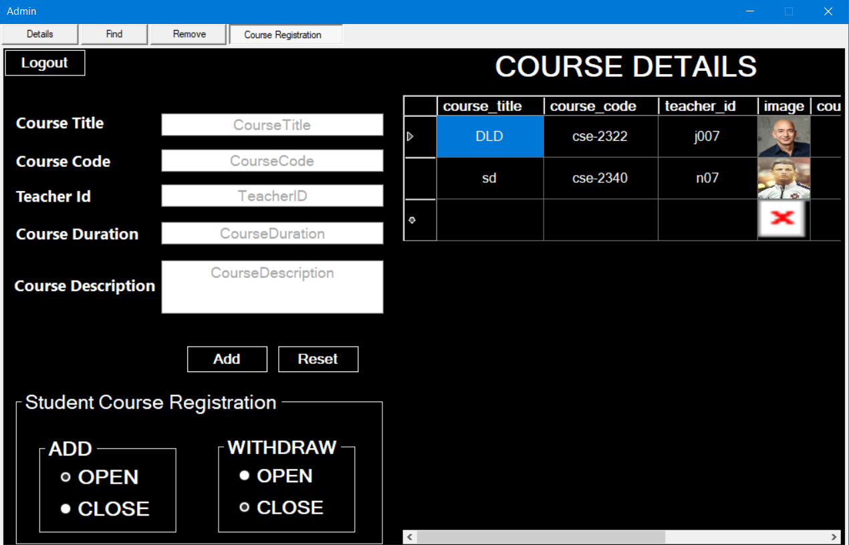

If check open – then student are eligible for witdraw any course from the list of course.

If check close – then student aren’t eligible for withdraw any course from the list of course.

If check open – then student are eligible for taking any course from the list of course.

If check close – then student aren’t eligible for taking any course from the list of course.

**STUDENT -> Profile**

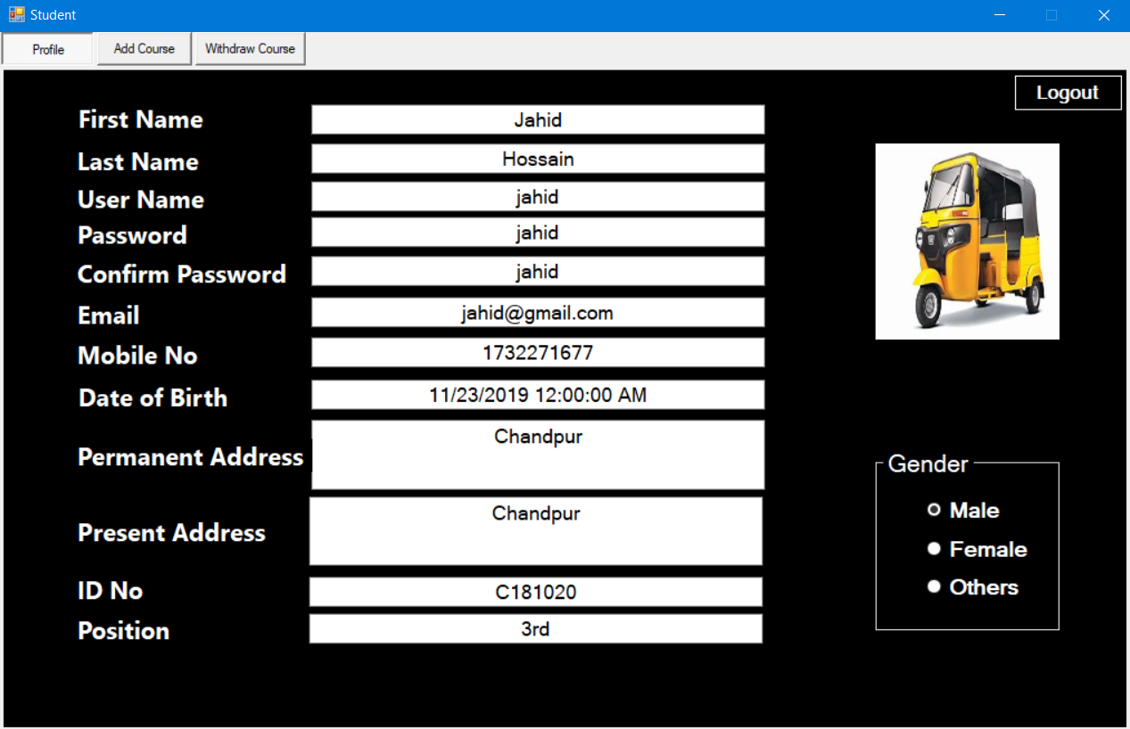

All the details of a student who are login.

**STUDENT -> Add Course(Open)**

Select any course for register.

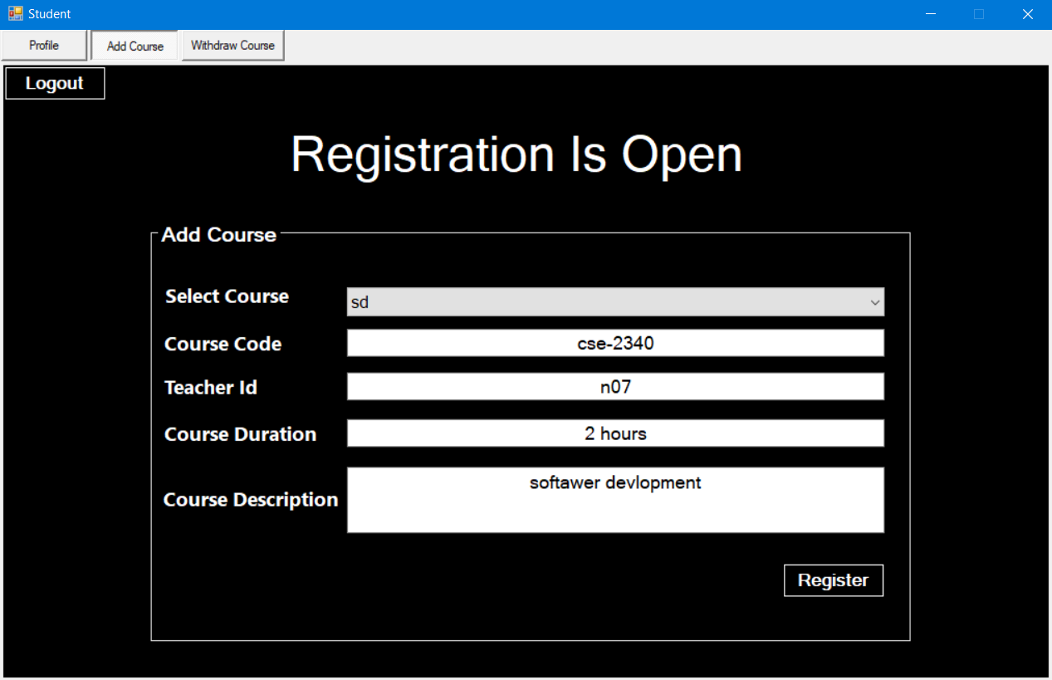

Registration is open for register any course from the list.

After Clicking the register your registration is confirm.

if you already have register then you aren’t eligible for registration.

**STUDENT -> Add Course(Close)**

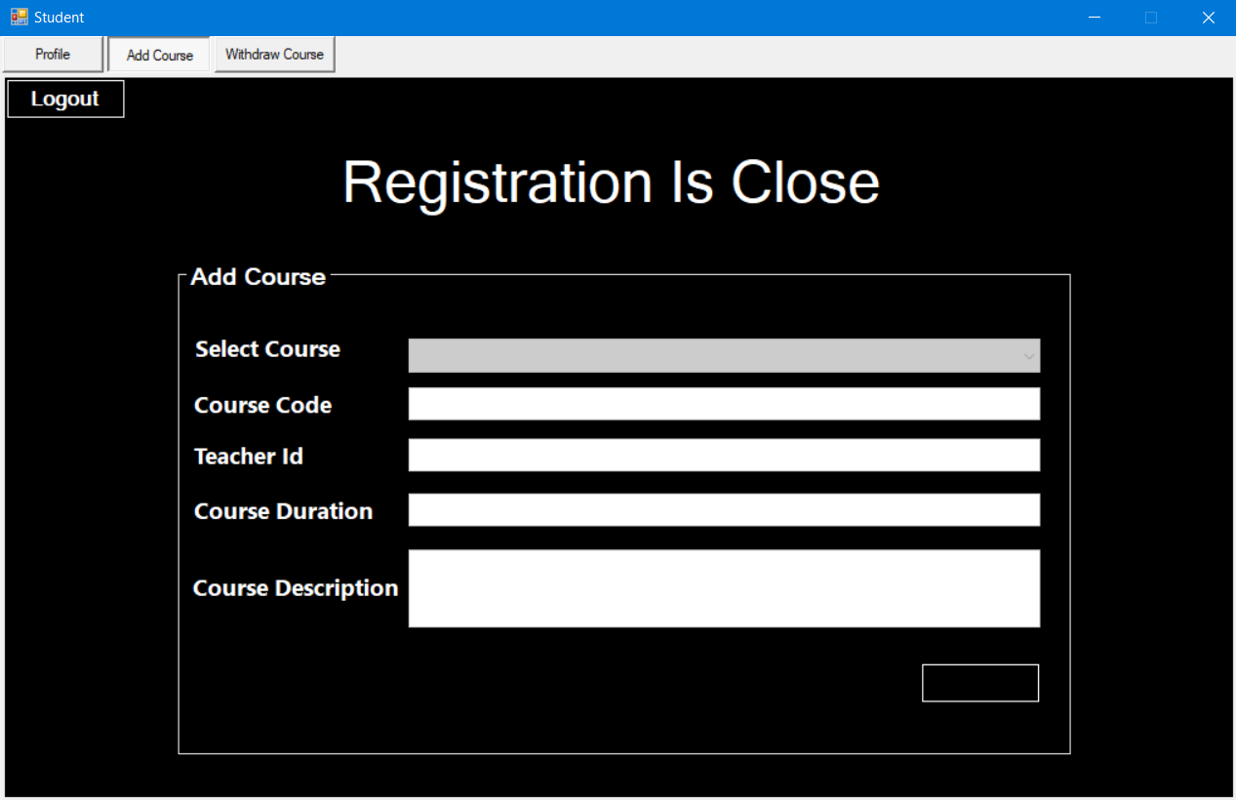

Registration is close so you aren’t eligible for registration.

**STUDENT -> Withdraw Course(Open)**

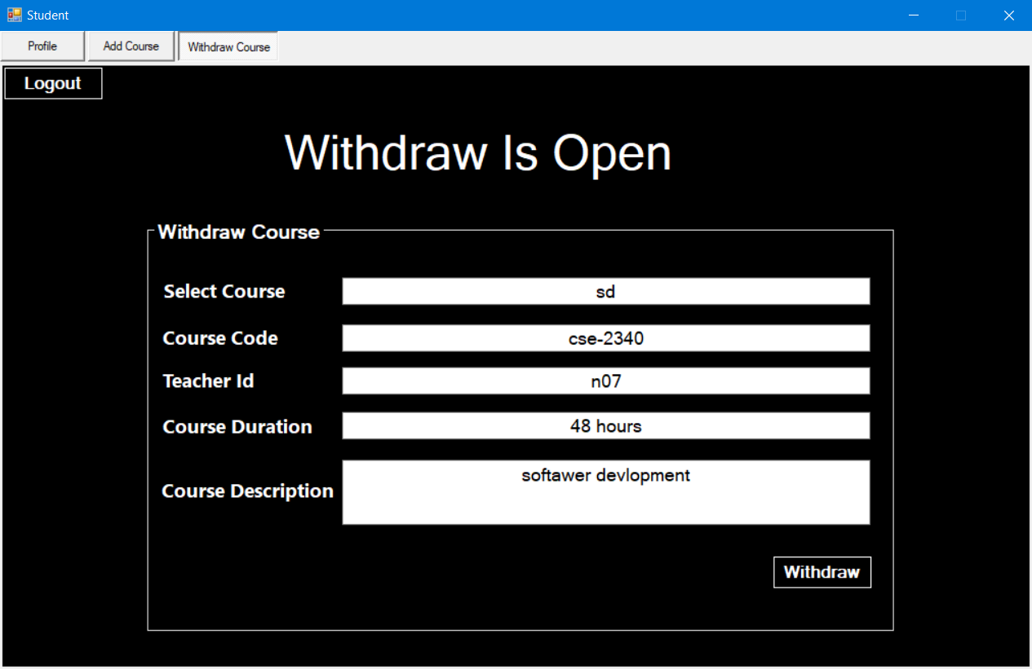

Withdraw is open for withdraw your course from the list.

After Clicking withdraw your withdraw is confirm.

**STUDENT -> Withdraw Course(Close)**

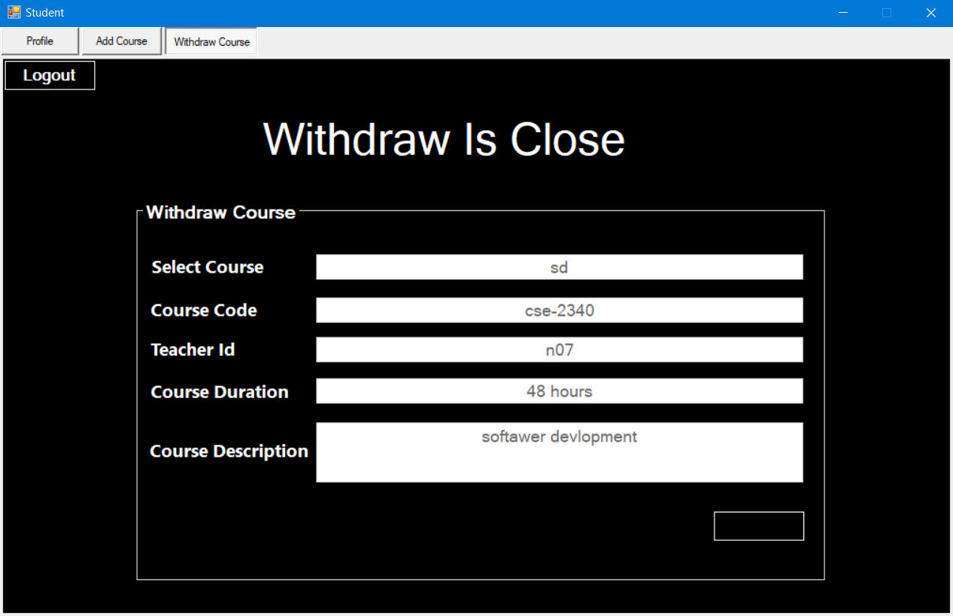

withdraw is close so you aren’t eligible for withdraw.

**Teacher -> Profile**

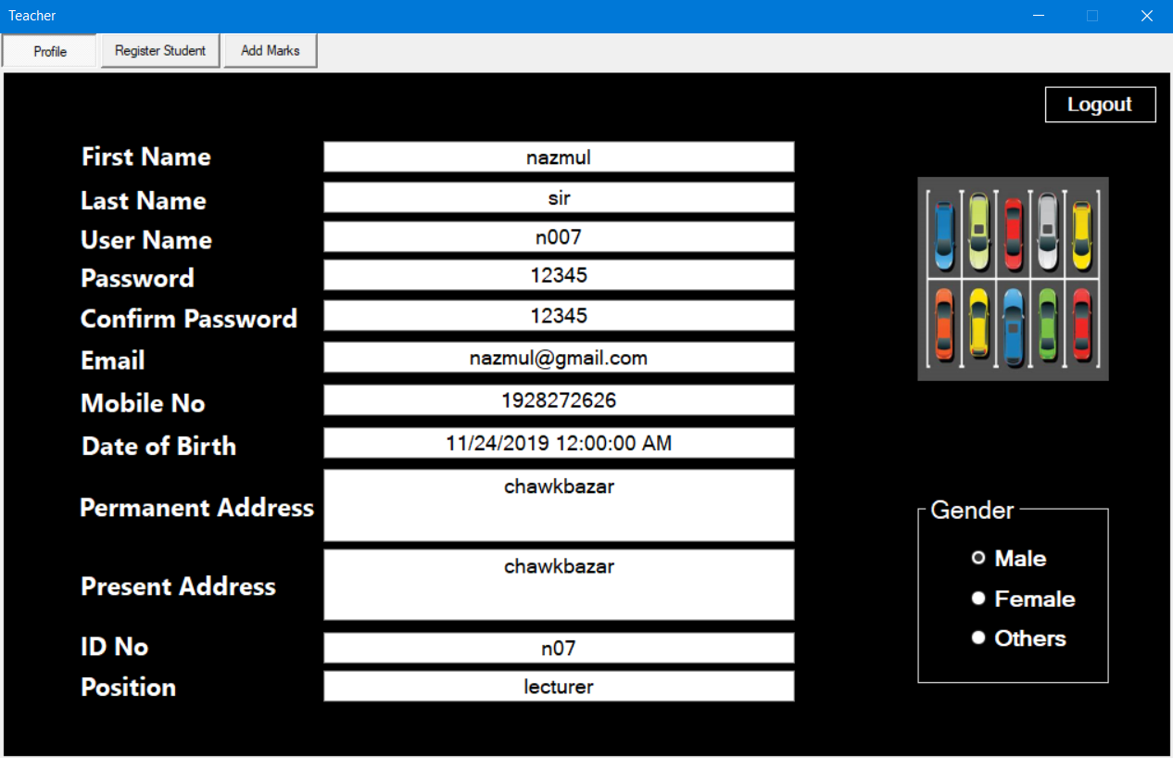

All the details of a teacher who are login.

**Teacher -> Register Student**

Search student who are taking a course with you.

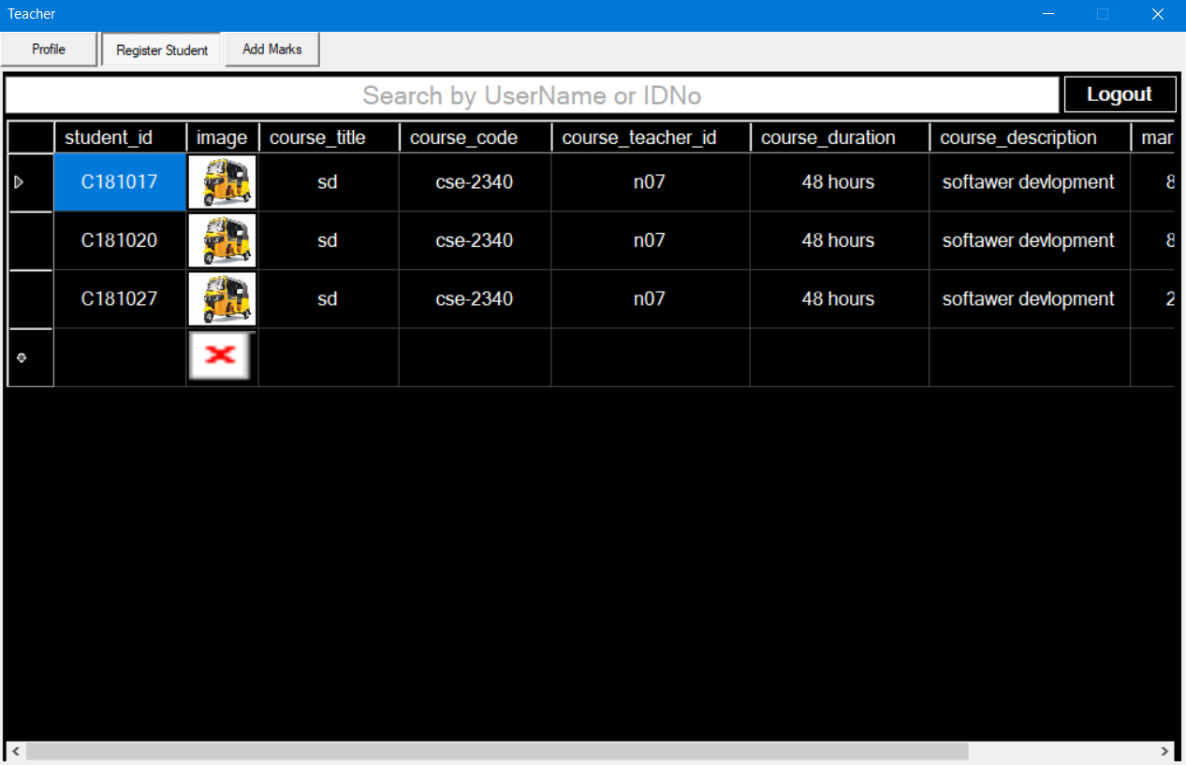

Details of student who are taking course with you.

**Teacher -> Add Marks**

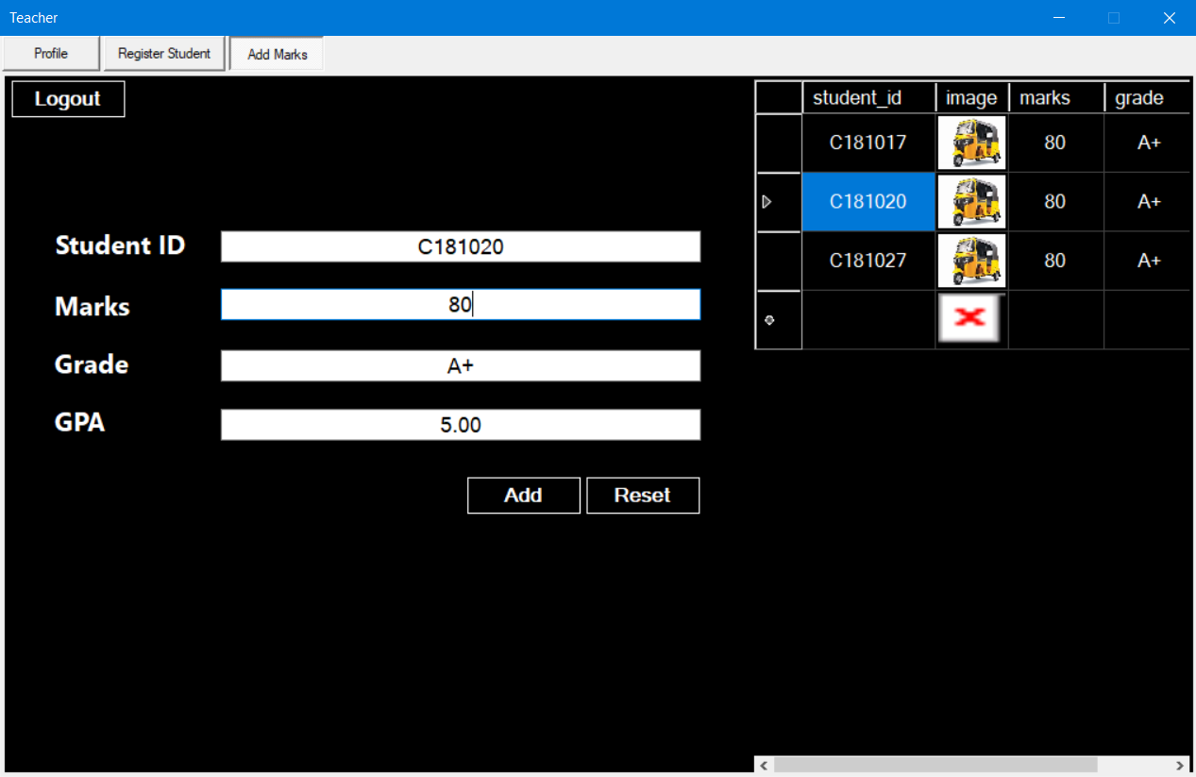

Reset all the entry.

ADD Marks of all of the student.

Marks details of all of the student.

**WELCOME**