

A Project Report

On

**“Domestic Waste Management”**

Batch Details

|  |  |  |
| --- | --- | --- |
| Sl. No. | Roll Number | Student Name |
| 1 | 20211CSE0036 | KOLIMI JAHNAVI |
| 2 | 20211CSE0136 | TATICHERLA VARSHA |
| 3 | 20211CSE0027 | SADDALA HARSHITHA |
| 4 | 20211CSE0038 | R GAGANA SHREE |
|  |  |  |

**School of Computer Science,**

**Presidency University, Bengaluru.**

Under the guidance of,

Dr. Hasan Hussain S , Professor

School of Computer Science,

Presidency University, Bengaluru

**Introduction About the Project :**

* Waste management is a critical issue affecting environmental sustainability and public health.
* Our project proposes a **Domestic Waste Management System**, a software application that allows users to report waste accumulation by capturing images, providing location details, and submitting reports to waste management authorities.
* This system enhances communication, ensures timely waste clearance, and promotes community engagement.
* By integrating geotagging and a complaint-tracking mechanism, it aims to make waste disposal more effecient

**Literature Review :**

| **S. No** | **Paper Name** | **Author Name** | **Advantages** | **Disadvantages** |
| --- | --- | --- | --- | --- |
| 1 | Smart Waste Management System Using IoT | A. S. Bagade, P. P. Kulkarni | Real-time waste monitoring and automation | High setup and maintenance costs |
| 2 | Geotagging and Mobile-Based Waste Tracking | R. J. Thomas, M. S. Naik | Accurate location-based waste reporting | GPS inaccuracies in some areas |
| 3 | Cloud-Based Waste Management Solutions | S. Verma, K. Jain | Centralized data management for waste monitoring | Dependency on internet connectivity |
| 4 | Citizen-Centric Waste Reporting Platforms | T. N. Gupta, R. Sharma | Encourages community participation in waste management | Requires active user engagement |
| 5 | Data Analytics in Waste Management | P. K. Singh, L. A. Deshmukh | Identifies waste accumulation patterns | Requires strong data infrastructure |

**Objectives:**

* Develop a user-friendly application for waste reporting.
* Implement geotagging for accurate waste location tracking.
* Provide real-time complaint submission and status tracking.
* Enable a feedback mechanism for monitoring waste clearance efficiency.
* Assist waste management authorities with data analytics for better planning

**EXPERIMENTAL DETAILS/METHDOLOGY :**

**Frontend:** React.js, HTML, CSS, JavaScript

**Backend:** Node.js with Express.js, Python/Django

**Database:** MySQL/MongoDB, Firebase

**Geotagging & Mapping:** Google Maps API, OpenStreetMap

**Notifications & Tracking:** Firebase, Email/SMS APIs

**ARCHITECTURE :**

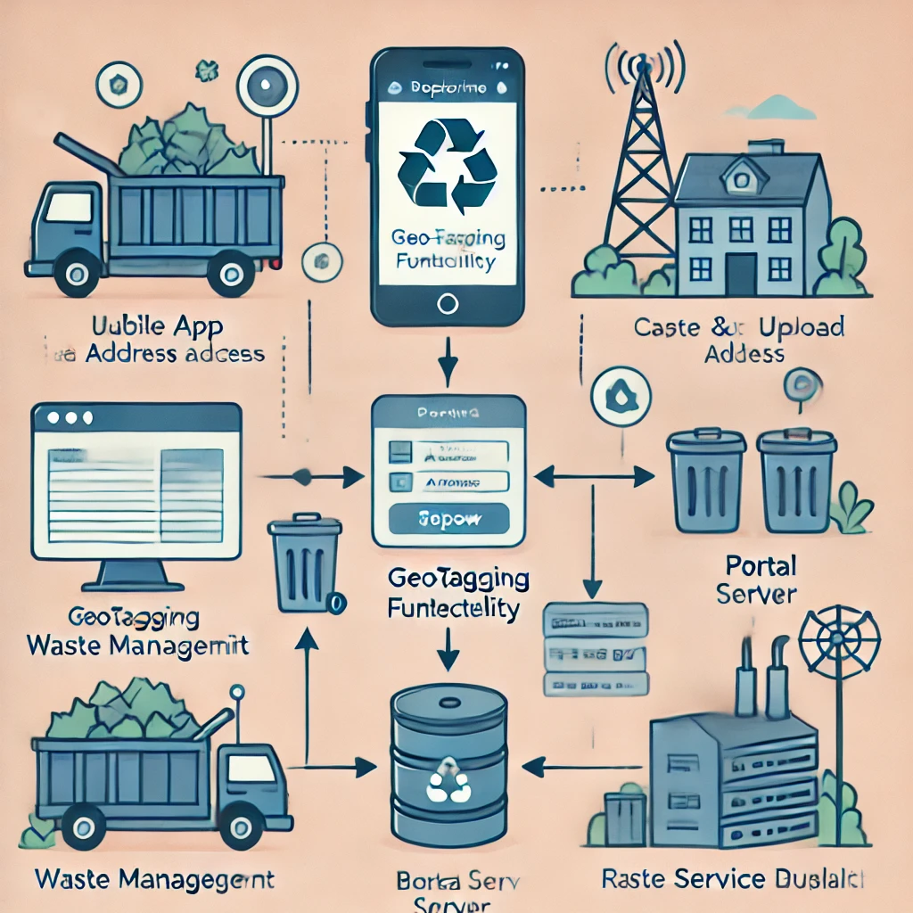

**OUTCOMES :**

**Improved Waste Clearance Efficiency** – Faster response times to waste complaints.

**Enhanced Civic Engagement** – Encouraging citizens to actively participate in waste reporting.

**Real-Time Monitoring** – Authorities can track complaints and optimize resource allocation.

**Data-Driven Insights** – Identifying waste accumulation trends for better city planning.

**Sustainability Impact** – Reducing environmental hazards caused by unattended waste.

**6. TIMELINE OF THE PROJECT/ PROJECT EXECUTION PLAN**

**CONCLUSION**

This project aims to bridge the gap between citizens and waste management authorities by leveraging technology for efficient waste disposal. With real-time reporting, tracking, and feedback mechanisms, it fosters a cleaner and more sustainable urban environment.

**References :**

1. **Gupta, P., Sinha, R., & Shukla, S. (2021).** *Smart Waste Management System Using IoT and Machine Learning.*

International Journal of Environmental Science and Technology, 18(4), 1125-1138.

Discusses the implementation of IoT and ML in waste tracking and management.

1. **Kumar, A., & Raj, P. (2020).** *A GIS-Based Approach for Effective Waste Collection and Disposal.*

Journal of Urban Planning and Development, 146(3), 103-117.

Explores how GIS-based geotagging helps in optimizing waste collection routes.

1. **Sharma, V., & Patel, D. (2019).** *Design and Implementation of a Citizen-Centric Smart Waste Reporting System.*

IEEE International Conference on Smart Cities, 245-250.

Focuses on mobile-based waste reporting and real-time tracking of complaints.

1. **Ramesh, S., & Verma, K. (2021).** *A Cloud-Based Waste Monitoring System for Urban Localities.*

Sustainable Computing: Informatics and Systems, 30, 124-136.

Discusses the role of cloud technology in real-time monitoring of waste management.

1. **Fernandez, M., & Joseph, B. (2022).**

*Enhancing Municipal Waste Collection Efficiency through Data-Driven Decision Making.*

Waste Management Journal, 79, 65-78.

Explores data analytics and AI-based optimizations for waste management operations.