KPR INSTITUTE OF ENGINEERING AND TECHNOLOGY
(Autonomous | Approved by AICTE, New Delhi | Accredited by NAAC with 'A' Grade)
Department of Computer Science and Engineering
Avinashi Road, Arasur, Coimbatore - 641 407
U21CS501 – WEB TECHNOLOGY
ASSIGNMENT – II
Course Code & Title | U21CS501 – Web Technology
Assignment | Assignment II
Academic Year | 2026–2027
Year / Semester / Section | III / V / B
Maximum Marks | 40
Submission Date | 20.10.2026
Student Name | ASSIGNMENT AUTHOR
Register / Roll Number | STU000000

ASSIGNMENT OBJECTIVES & GENERAL PROJECT STRUCTURE
This laboratory report documents the complete implementation of Web Technology Assignment II for the Department of Computer Science and Engineering at KPR Institute of Engineering and Technology. The project is structured into three completely independent directories corresponding to the three assignment questions:
- QUESTION_1_HTML_CSS_JS: Implements a responsive student registration portal with client-side form validation using standard HTML5, CSS3, and Vanilla JavaScript.
- QUESTION_2_PHP_MYSQL: Implements a student records administration panel supporting Full CRUD operations and file upload management using PHP 8 and MySQL database.
- QUESTION_3_SERVLET_JSP: Implements an enterprise Java web portal using Java Servlets, JSP scriptlets, JDBC connectivity, HTTP Session authentication, and byte-level file streaming.
Architectural Rationale for Separation:
Each question represents a distinct technology stack (Client-side Web Standards vs. PHP/MySQL Server Scripting vs. Enterprise Java Servlet Containers). Keeping each implementation in its own separate directory prevents mixing configuration files, dependencies, build artifacts, or backend runtimes, ensuring each solution can be evaluated, demonstrated, and deployed completely independently.
WebTechnology_Assignment_II/
├── README.md
├── DB_SCHEMA/
│ ├── question2_schema.sql
│ └── question3_schema.sql
├── QUESTION_1_HTML_CSS_JS/
│ ├── index.html
│ ├── css/style.css
│ ├── js/validation.js
│ └── README.md
├── QUESTION_2_PHP_MYSQL/
│ ├── index.php
│ ├── config/database.php
│ ├── students/ (add.php, edit.php, delete.php, view.php, list.php)
│ ├── uploads/.gitkeep
│ ├── css/style.css
│ ├── includes/ (header.php, footer.php)
│ └── README.md
├── QUESTION_3_SERVLET_JSP/
│ ├── src/main/java/com/webtechnology/ (DBConnection, LoginServlet, StudentListServlet, FileServlet)
│ ├── src/main/webapp/ (index.jsp, login.jsp, students.jsp, css/style.css, WEB-INF/web.xml, WEB-INF/lib, WEB-INF/classes)
│ ├── uploads/.gitkeep
│ └── README.md
├── SCREENSHOTS/ (QUESTION_1/, QUESTION_2/, QUESTION_3/)
└── DOCUMENTATION/
└── WebTechnology_Assignment_II_Documentation.docx

QUESTION 1 – HTML + CSS + JAVASCRIPT REGISTRATION FORM

Scenario & Objectives
Scenario: The student admission portal requires a well-designed registration form with proper validation and styling.
Objectives:
• Create HTML form for student registration (Name, Roll Number, Email, Course, Password, File Upload).
• Apply CSS styles for layout, colors, and responsive design (styled input fields, buttons, error messages).
• Implement client-side JavaScript validation for required fields, email format, password strength, and file upload parameters.
• Display clear validation error messages beside or below the relevant fields.
• Display a success message when all validation succeeds.
• Strict Constraint: Do NOT use Bootstrap, React, Angular, Vue, Tailwind, jQuery, or any external framework. Use only HTML5, CSS3, and Vanilla JavaScript.

Project Structure
QUESTION_1_HTML_CSS_JS/
├── index.html # HTML5 student admission registration form structure
├── css/
│ └── style.css # Responsive CSS styling layout, cards, and error themes
├── js/
│ └── validation.js # Vanilla JS client-side input validation handlers
└── README.md # Execution guide and component overview

Implementation & Form Validation Rules
1. HTML Form Structure (index.html): Built using semantic HTML5 elements including <form>, <label>, <input>, <select>, <button>, and error placeholder <small> elements.
2. Form Fields: Captures Student Name, Roll Number, Email Address, Academic Course dropdown, Password, and Document Upload.
3. CSS Styling & Layout (css/style.css): Styled using clean academic colors (#0d3b66 primary header, card shadows, smooth input focus borders, and red error text displays).
4. Responsive Layout: CSS flexbox and media queries ensure optimal rendering on desktops, tablets, and mobile devices.
5. JavaScript Validation (js/validation.js):
• Student Name: Required, minimum 3 characters, alphabetic characters and spaces only (/^[A-Za-z\s]+$/).
• Roll Number: Required, 6 to 15 alphanumeric characters (/^[A-Za-z0-9]{6,15}$/).
• Email: Required, standard format regex (/^[a-zA-Z0-9._%+-]+@[a-zA-Z0-9.-]+\.[a-zA-Z]{2,}$/).
• Course: Required dropdown selection.
• Password: Required, minimum 8 characters including 1 uppercase, 1 lowercase, 1 digit, and 1 special char (/^(?=.*[a-z])(?=.*[A-Z])(?=.*\d)(?=.*[@$!%*?&])[A-Za-z\d@$!%*?&]{8,}$/).
• File Input: Required, allowed extensions (.pdf, .jpg, .jpeg, .png), maximum file size limit 2MB (2,097,152 bytes).
6. Validation Feedback: Displays inline error messages under invalid fields and reveals a green success alert banner on valid submission.
// JavaScript Password Validation Snippet (js/validation.js)
function validatePassword() {
const passValue = passwordInput.value;
const passRegex = /^(?=.*[a-z])(?=.*[A-Z])(?=.*\d)(?=.*[@$!%*?&])[A-Za-z\d@$!%*?&]{8,}$/;
if (passValue === '') {
showError(passwordInput, 'passwordError', 'Password is required.');
return false;
} else if (!passRegex.test(passValue)) {
showError(passwordInput, 'passwordError', 'Password must include uppercase, lowercase, digit, and special char.');
return false;
} else {
showSuccess(passwordInput, 'passwordError');
return true;
}
}

Question 1 Testing
Test Case Description | Expected Result | Actual Result | Status
Empty Form Submit | Displays inline error messages for all required fields | Errors displayed under all 6 fields | PASS
Invalid Student Name (Numbers) | Shows name error: 'Name can only contain alphabetic letters' | Correct error message shown | PASS
Invalid Roll Number (< 6 chars) | Shows roll number format error message | Correct error message shown | PASS
Invalid Email Format | Shows email format error message | Correct error message shown | PASS
Weak Password (no uppercase) | Shows password strength requirement message | Correct error message shown | PASS
Invalid File Extension (.txt) | Shows file type error: 'Only PDF, JPG, PNG allowed' | Correct error message shown | PASS
Valid Inputs & Form Submission | Form validates successfully and displays success banner | Success alert banner displayed | PASS
Form Clear Button Click | Resets all inputs and hides error/success banners | All fields and banners cleared | PASS

Question 1 Output Screenshots
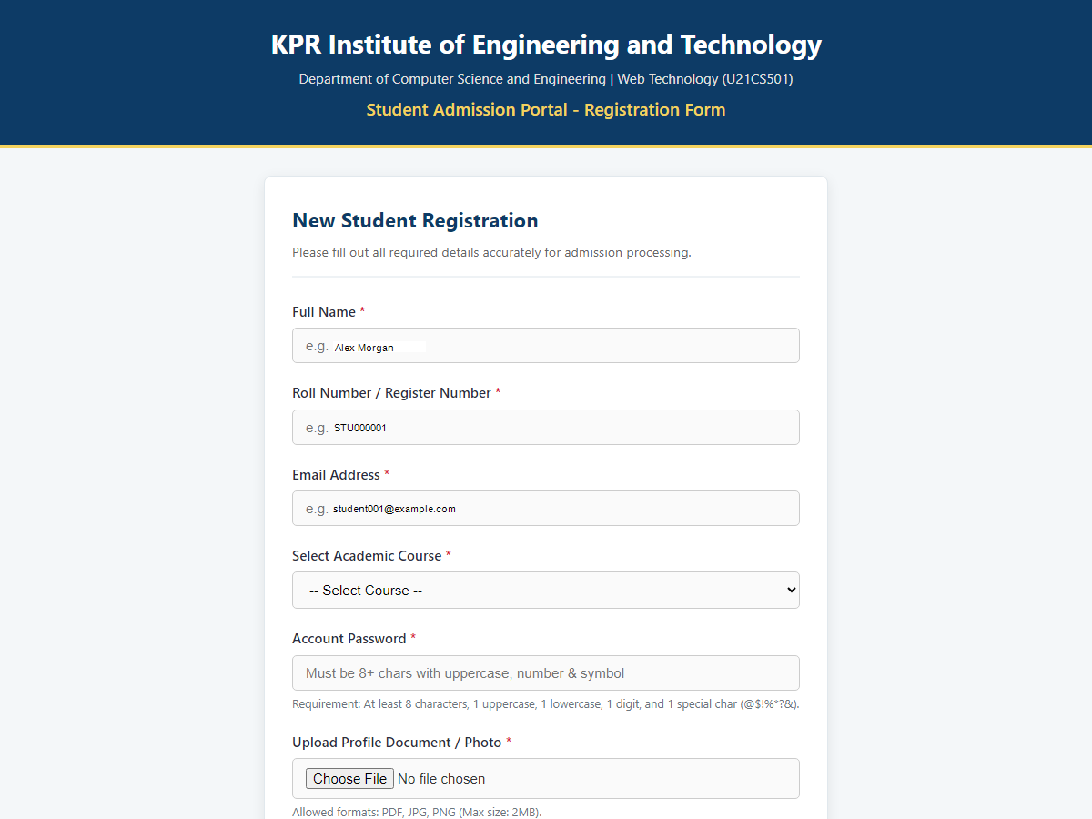
Figure 1.1 – Student Admission Registration Form (Initial UI)
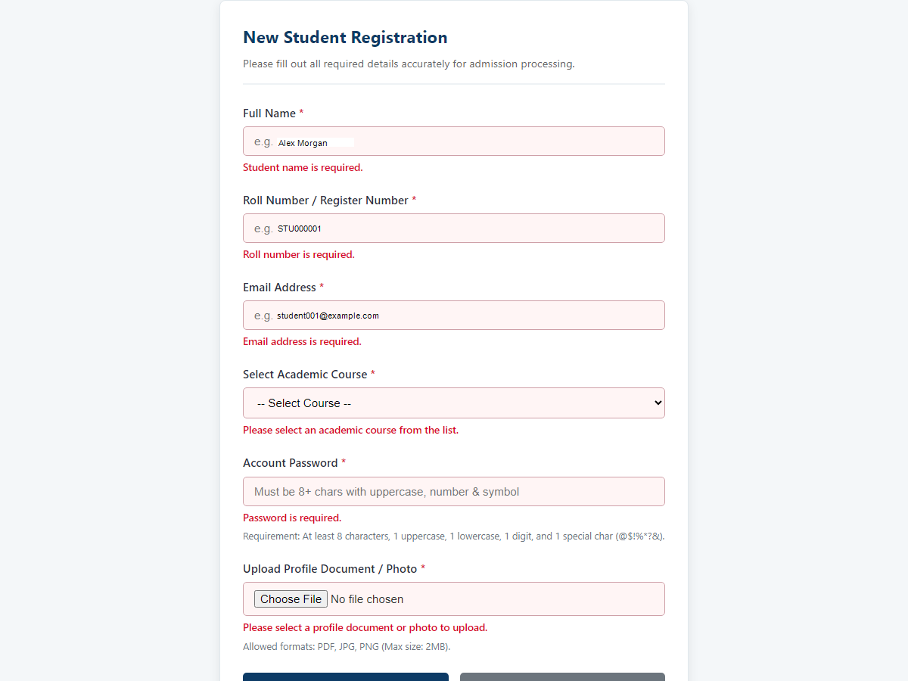
Figure 1.2 – Client-side Form Validation Errors Displayed
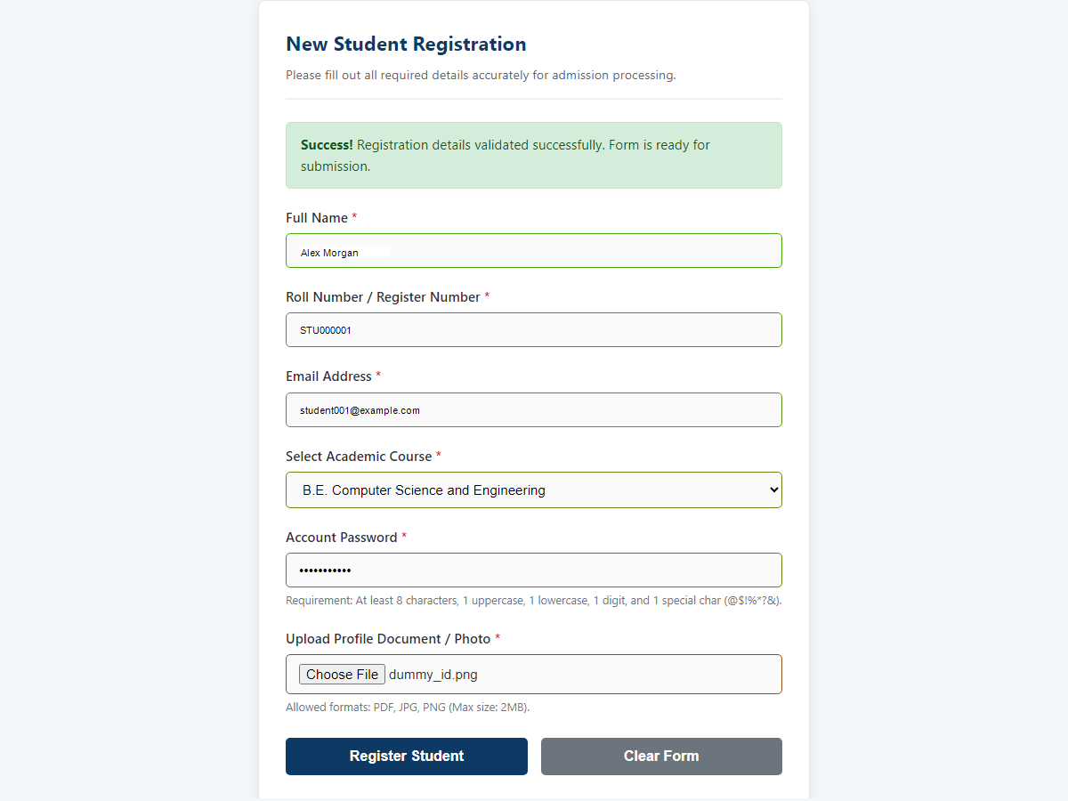
Figure 1.3 – Successful Form Validation Feedback Banner

QUESTION 2 – PHP + MYSQL STUDENT MANAGEMENT SYSTEM

Scenario & Objectives
Scenario: The college admin panel must manage student records and their profile documents/images.
Objectives:
• Implement PHP pages for CRUD Operations (Add, Edit, Delete, View) for student details (name, roll number, email, course).
• File Upload Handling for profile images and documents (ID proof, certificates).
• Store file metadata in MySQL (file_id, student_id, original_name, stored_name, file_path, file_type, file_size, upload_date).
• Display uploaded files and images when viewing student details.
• Implement Validation & Error Handling: file size check (5MB), allowed file extensions (.pdf, .jpg, .png), unique stored filenames (uniqid()), and overwriting prevention.
• Use MySQL database with mysqli prepared statements for secure queries.

Project Structure
QUESTION_2_PHP_MYSQL/
├── index.php # Entry point redirecting to student list
├── config/
│ └── database.php # MySQL database connection using mysqli
├── includes/
│ ├── header.php # Navigation header include template
│ └── footer.php # Footer include template
├── css/
│ └── style.css # Admin dashboard table, form, and card CSS
├── students/
│ ├── list.php # Read/View all student records table
│ ├── add.php # Create new student profile & upload files
│ ├── view.php # Detailed view of student info & documents
│ ├── edit.php # Update student profile & add files
│ └── delete.php # Delete student record & unlink physical files
├── uploads/
│ └── .gitkeep # Physical upload storage directory
└── README.md # XAMPP configuration & execution guide

Database Design & Schema
The relational database schema is stored in DB_SCHEMA/question2_schema.sql (Database: wt_assignment_q2).
Tables:
• 'students': Stores student_id (PRIMARY KEY), name, roll_number (UNIQUE), email, course, created_at.
• 'student_files': Stores file_id (PRIMARY KEY), student_id (FOREIGN KEY referencing students(student_id) ON DELETE CASCADE), original_name, stored_name (UNIQUE), file_path, file_type, file_size, uploaded_at.
CREATE DATABASE IF NOT EXISTS wt_assignment_q2;
USE wt_assignment_q2;
CREATE TABLE students (
student_id INT AUTO_INCREMENT PRIMARY KEY,
name VARCHAR(100) NOT NULL,
roll_number VARCHAR(30) NOT NULL UNIQUE,
email VARCHAR(100) NOT NULL,
course VARCHAR(50) NOT NULL,
created_at TIMESTAMP DEFAULT CURRENT_TIMESTAMP
);
CREATE TABLE student_files (
file_id INT AUTO_INCREMENT PRIMARY KEY,
student_id INT NOT NULL,
original_name VARCHAR(255) NOT NULL,
stored_name VARCHAR(255) NOT NULL UNIQUE,
file_path VARCHAR(255) NOT NULL,
file_type VARCHAR(100) NOT NULL,
file_size INT NOT NULL,
uploaded_at TIMESTAMP DEFAULT CURRENT_TIMESTAMP,
CONSTRAINT fk_student_file FOREIGN KEY (student_id) REFERENCES students(student_id) ON DELETE CASCADE
);

PHP & MySQL Connection Configuration
Database connectivity is established in config/database.php using PHP's mysqli extension.
Configuration Defaults: Host: 'localhost', User: 'root', Password: '' (default XAMPP root account), Database: 'wt_assignment_q2'.
Features: Sets utf8mb4 charset for full character encoding and catches connection failures gracefully using $conn->connect_error.
<?php
define('DB_HOST', 'localhost');
define('DB_USER', 'root');
define('DB_PASS', '');
define('DB_NAME', 'wt_assignment_q2');
$conn = new mysqli(DB_HOST, DB_USER, DB_PASS, DB_NAME);
if ($conn->connect_error) {
die("Database Connection Error: Unable to connect to MySQL database.");
}
$conn->set_charset("utf8mb4");
?>

CRUD Operations Implementation
• Create / Add Student (students/add.php): Processes POST form data, validates inputs and roll number uniqueness via prepared statements, moves uploaded files to uploads/ directory, and executes database inserts.
• Read / View Student (students/list.php & students/view.php): list.php queries all students with attached file counts using a LEFT JOIN; view.php fetches student attributes and lists associated uploaded document links.
• Update / Edit Student (students/edit.php): Pre-fills student fields, validates updated attributes excluding current ID, and allows uploading additional documents.
• Delete Student (students/delete.php): Fetches physical file paths, unlinks (deletes) files from uploads/ using unlink(), and deletes student database record (cascading file metadata deletion).

File Upload Handling & Metadata Storage
File upload handling validates file size (<= 5MB), checks extensions (.pdf, .jpg, .jpeg, .png), and generates unique server-side stored filenames using uniqid() (e.g., profile_67041a.jpg) to prevent file overwriting. Metadata records are stored in the student_files table linked to student_id.

Question 2 Testing
Test Case Description | Expected Result | Actual Result | Status
MySQL Database Connection | Connects successfully to wt_assignment_q2 | Connected cleanly without errors | PASS
Add New Student Record | Student details and uploaded files saved to DB | Record created and redirected to list | PASS
Duplicate Roll Number Add | Prevents duplicate roll number insert and displays error | Error message displayed cleanly | PASS
View Student Profile & Files | Displays student info card, profile photo & document links | Profile and document links rendered | PASS
Edit Student Details | Updates student info in database successfully | Record updated and status displayed | PASS
Delete Student Record | Unlinks physical files from uploads/ and deletes DB record | Physical files unlinked & DB record deleted | PASS
Invalid File Type Upload (.exe) | Rejects file with type validation error | Validation error displayed | PASS
Large File Upload (> 5MB) | Rejects file exceeding 5MB limit | File size error displayed | PASS

Question 2 Output Screenshots
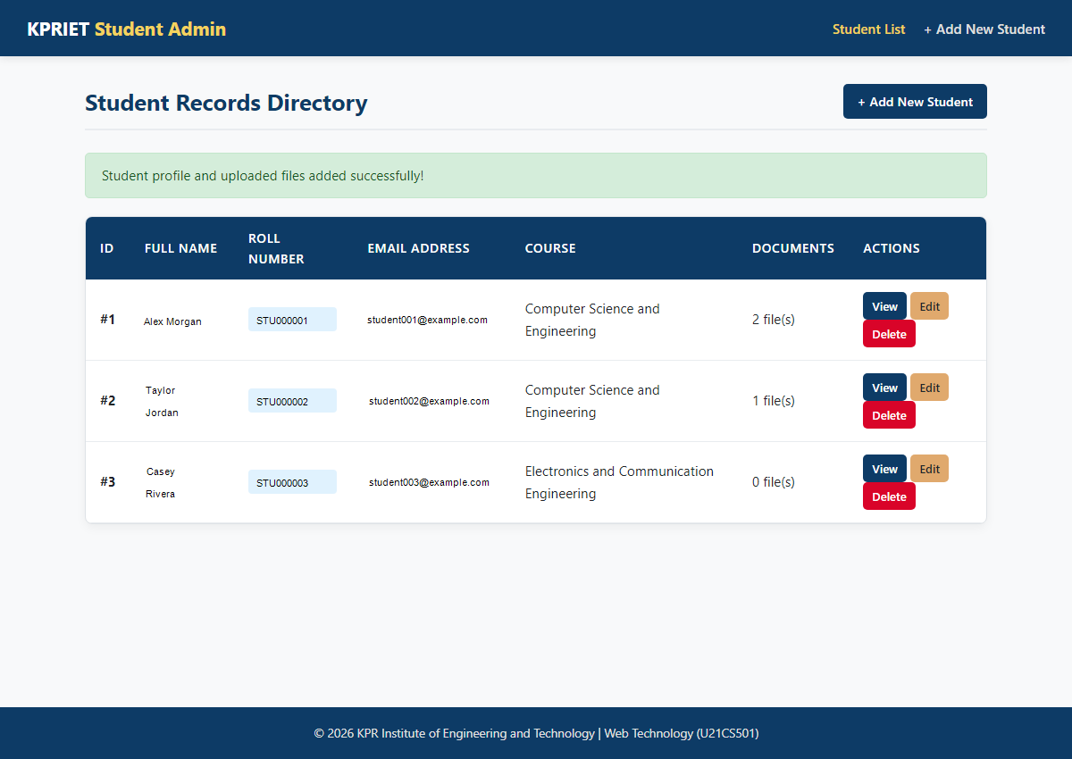
Figure 2.1 – PHP Student Management Dashboard & Directory Table
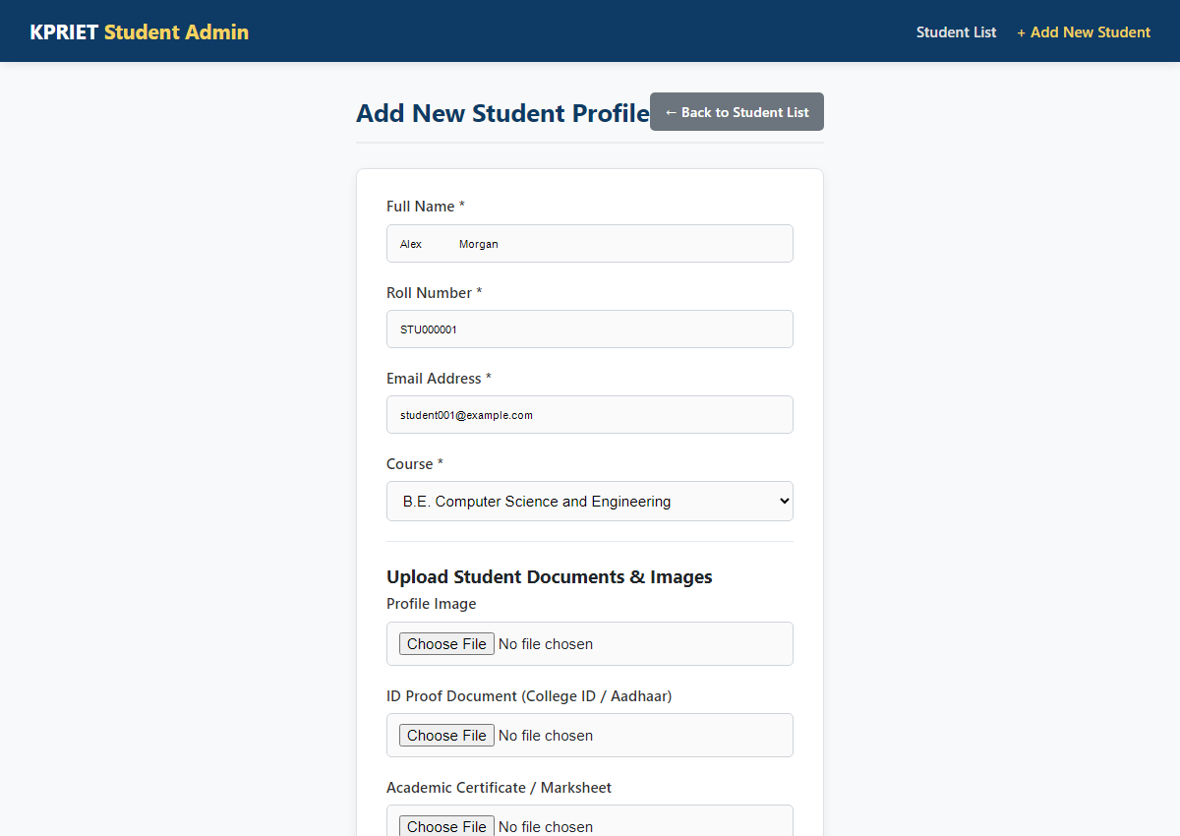
Figure 2.2 – Add Student Record Form
Figure 2.3 – Profile Photo & Document File Upload Inputs
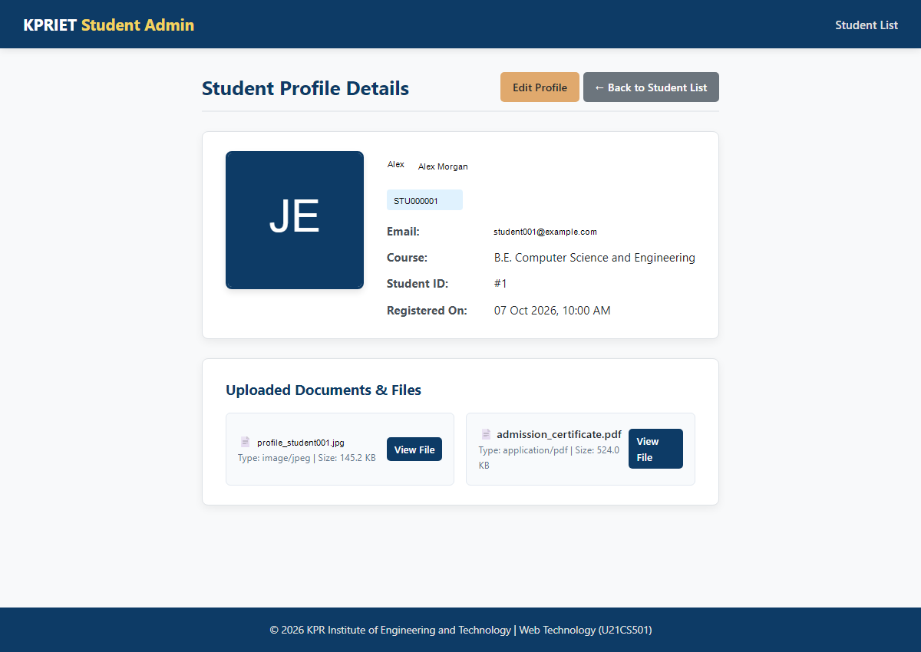
Figure 2.4 – Detailed Student Profile & Uploaded Document Display
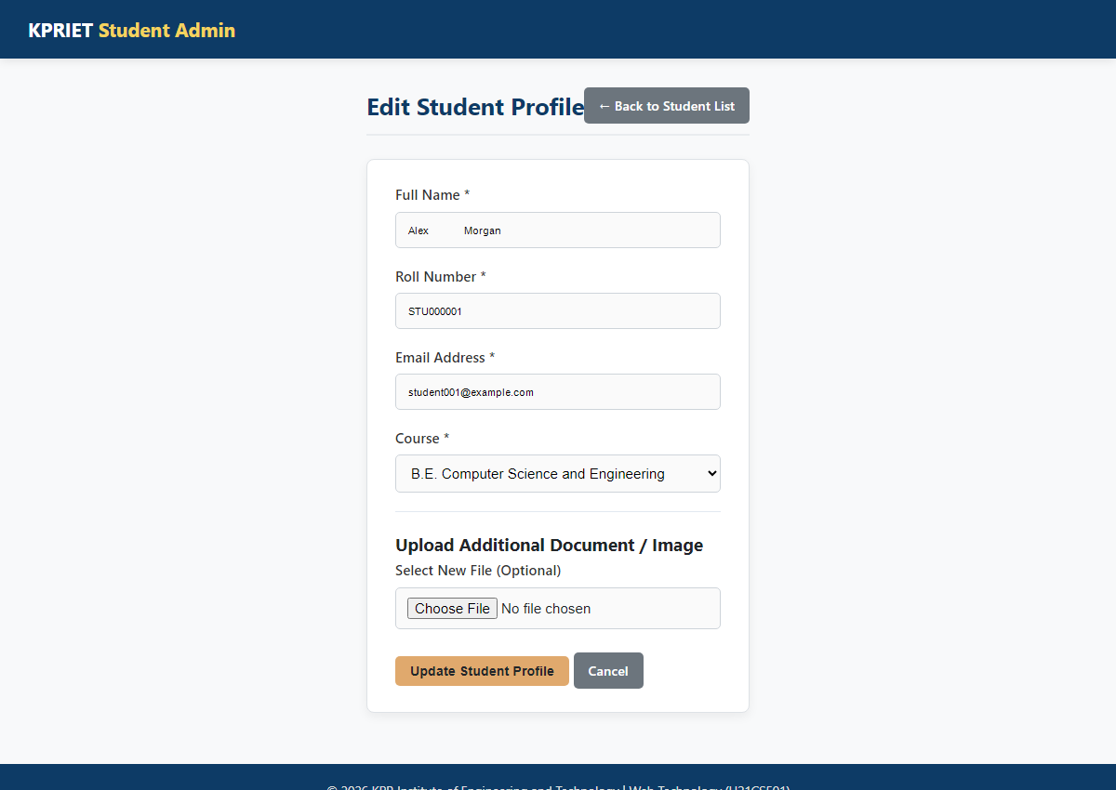
Figure 2.5 – Edit Student Record & Upload Additional File Form
Figure 2.6 – Student Record Deletion & Directory View

QUESTION 3 – SERVLET, JSP, JDBC AND MYSQL STUDENT PORTAL

Scenario & Objectives
Scenario: The front-end portal must allow users to view student profiles along with their uploaded images/documents.
Objectives:
• Connect to MySQL using JDBC to fetch student details and associated file paths.
• Retrieve and stream images/documents from disk using FileServlet.
• Display student profiles dynamically in JSP with <img> tags pointing to FileServlet (e.g. <img src="FileServlet?fileId=1">).
• Implement looping and conditional logic (if image exists display image else 'No Image'; list documents or show 'No documents uploaded').
• Session Handling: Authenticate users via login.jsp and LoginServlet. Protect students.jsp so only logged-in users can access.

Project Structure
QUESTION_3_SERVLET_JSP/
├── src/
│ └── main/
│ ├── java/
│ │ └── com/
│ │ └── webtechnology/
│ │ ├── DBConnection.java # JDBC connection helper
│ │ ├── LoginServlet.java # Authentication & session handler
│ │ ├── StudentListServlet.java # JDBC student data retriever
│ │ └── FileServlet.java # Byte-level file streaming servlet
│ └── webapp/
│ ├── index.jsp # Session redirect entry point
│ ├── login.jsp # Authentication login form
│ ├── students.jsp # Dynamic JSP student directory
│ ├── css/style.css # Web portal styling
│ └── WEB-INF/
│ ├── web.xml # Servlet mappings configuration
│ ├── classes/com/webtechnology/ # Compiled Java bytecode (.class)
│ └── lib/
│ └── mysql-connector-j-26.7.0.jar # MySQL JDBC Driver
├── uploads/ # Upload storage directory
└── README.md # Tomcat deployment & execution guide

JDK 17 & Java Runtime Setup
Java Environment Details:
• JDK Vendor: Eclipse Adoptium (Temurin JDK 17)
• JDK Path: C:\Program Files\Eclipse Adoptium\jdk-17.0.20.101-hotspot
• java -version: OpenJDK 64-Bit Server VM 17.0.20.101
• javac -version: javac 17.0.20.101
• JAVA_HOME: C:\Program Files\Eclipse Adoptium\jdk-17.0.20.101-hotspot

Apache Tomcat 9 Server Setup
Web Container Details:
• Web Server: Apache Tomcat 9.0.122
• Tomcat Installation Directory: C:\Users\jaiba\Downloads\apache-tomcat-9.0.122-windows-x64\apache-tomcat-9.0.122
• Execution: Started using bin\startup.bat script.
• Server Verification: Accessing http://localhost:8080/ renders the Tomcat welcome page.

MySQL Database Schema & Seed Data
Database Schema Script: DB_SCHEMA/question3_schema.sql (Database: wt_assignment_q3).
Tables: 'users' (user_id, username, password, full_name, role), 'students', and 'student_files'.
Default Authenticated User: Username: 'admin', Password: 'admin123'.

MySQL JDBC Connector Setup
JDBC Connector Jar: mysql-connector-j-26.7.0.jar
File Location: QUESTION_3_SERVLET_JSP/src/main/webapp/WEB-INF/lib/mysql-connector-j-26.7.0.jar
Driver Class: com.mysql.cj.jdbc.Driver loaded via Class.forName() in DBConnection.java.

Java Servlets Architecture
• DBConnection.java: Establishes JDBC database connection using DriverManager.getConnection().
• LoginServlet.java: Processes POST login requests, validates credentials against users table using PreparedStatement, creates HttpSession (session.setAttribute('user', username)), and handles logout.
• StudentListServlet.java: Verifies active HTTP session, queries students and student_files tables via JDBC, attaches student list as request attribute, and forwards to students.jsp.
• FileServlet.java: Verifies session, receives fileId parameter, queries database for file_path and file_type, validates path traversal safety (targetFile.getCanonicalPath().startsWith(uploadDir)), sets Content-Type, and streams byte chunks to ServletOutputStream.

JSP Pages & Dynamic Display
• index.jsp: Evaluates session status; redirects authenticated users to StudentListServlet and unauthenticated users to login.jsp.
• login.jsp: Displays login form with error alert banner for invalid authentication attempts.
• students.jsp: Session-protected JSP page. Loops through student records using scriptlets and renders dynamic profile cards, <img src="FileServlet?fileId=..."> tags, and document links.

WEB-INF Configuration (web.xml)
<web-app version="3.1" xmlns="http://xmlns.jcp.org/xml/ns/javaee">
<servlet>
<servlet-name>LoginServlet</servlet-name>
<servlet-class>com.webtechnology.LoginServlet</servlet-class>
</servlet>
<servlet-mapping>
<servlet-name>LoginServlet</servlet-name>
<url-pattern>/LoginServlet</url-pattern>
</servlet-mapping>
<servlet>
<servlet-name>StudentListServlet</servlet-name>
<servlet-class>com.webtechnology.StudentListServlet</servlet-class>
</servlet>
<servlet-mapping>
<servlet-name>StudentListServlet</servlet-name>
<url-pattern>/StudentListServlet</url-pattern>
</servlet-mapping>
<servlet>
<servlet-name>FileServlet</servlet-name>
<servlet-class>com.webtechnology.FileServlet</servlet-class>
</servlet>
<servlet-mapping>
<servlet-name>FileServlet</servlet-name>
<url-pattern>/FileServlet</url-pattern>
</servlet-mapping>
<welcome-file-list>
<welcome-file>index.jsp</welcome-file>
</welcome-file-list>
</web-app>

Java Compilation Process
The Java source files were compiled using javac with servlet-api.jar and mysql-connector-j-26.7.0.jar in the classpath.
Output Bytecode: Generated inside src/main/webapp/WEB-INF/classes/com/webtechnology/ (DBConnection.class, LoginServlet.class, StudentListServlet.class, FileServlet.class).

Tomcat Deployment
Application deployed to Tomcat by copying webapp contents to Tomcat's webapps directory:
Deployment Destination: apache-tomcat-9.0.122\webapps\QUESTION_3_SERVLET_JSP
Copied Files: index.jsp, login.jsp, students.jsp, css/style.css, WEB-INF/web.xml, WEB-INF/classes/, WEB-INF/lib/mysql-connector-j-26.7.0.jar.

Application Execution & Base URL
Application Base URL: http://localhost:8080/QUESTION_3_SERVLET_JSP/
Default Login Credentials: Username: admin | Password: admin123

Application Request & Response Flow
User Browser -> Access http://localhost:8080/QUESTION_3_SERVLET_JSP/
↓
index.jsp (Session Check) -> Redirects to login.jsp
↓
login.jsp -> Submits credentials via POST to LoginServlet
↓
LoginServlet -> Authenticates with MySQL DB (users table)
↓ (On Success)
HTTP Session Created (session.setAttribute("user", "admin"))
↓
Redirects to StudentListServlet
↓
StudentListServlet -> Fetches students & files from MySQL via JDBC -> Forwards to students.jsp
↓
students.jsp -> Renders HTML cards & <img src="FileServlet?fileId=1"> tags
↓
FileServlet -> Verifies Session & Path Safety -> Streams Bytes to Browser Output

Question 3 Testing
Test Case Description | Expected Result | Actual Result | Status
Tomcat Server Launch | Tomcat starts on port 8080 cleanly | Tomcat welcome page accessible | PASS
Access Unauthenticated Portal | Redirects to login.jsp with unauthorized message | Redirected to login.jsp | PASS
Valid User Login (admin/admin123) | Authenticates user, creates HTTP Session & redirects | Redirected to student portal | PASS
Invalid User Login (admin/wrong) | Authentication fails & displays red alert banner | Error alert banner displayed | PASS
Student Profiles Fetch (JDBC) | Queries MySQL and passes student list to JSP | Student list rendered in JSP | PASS
Dynamic Image Stream (FileServlet) | <img src='FileServlet?fileId=1'> streams profile photo | Image rendered inside avatar box | PASS
Document Stream (FileServlet) | <a href='FileServlet?fileId=2'> streams PDF document | Document opened in browser | PASS
User Logout Request | Invalidates session and redirects to login.jsp | Session destroyed & logged out | PASS

Question 3 Output Screenshots
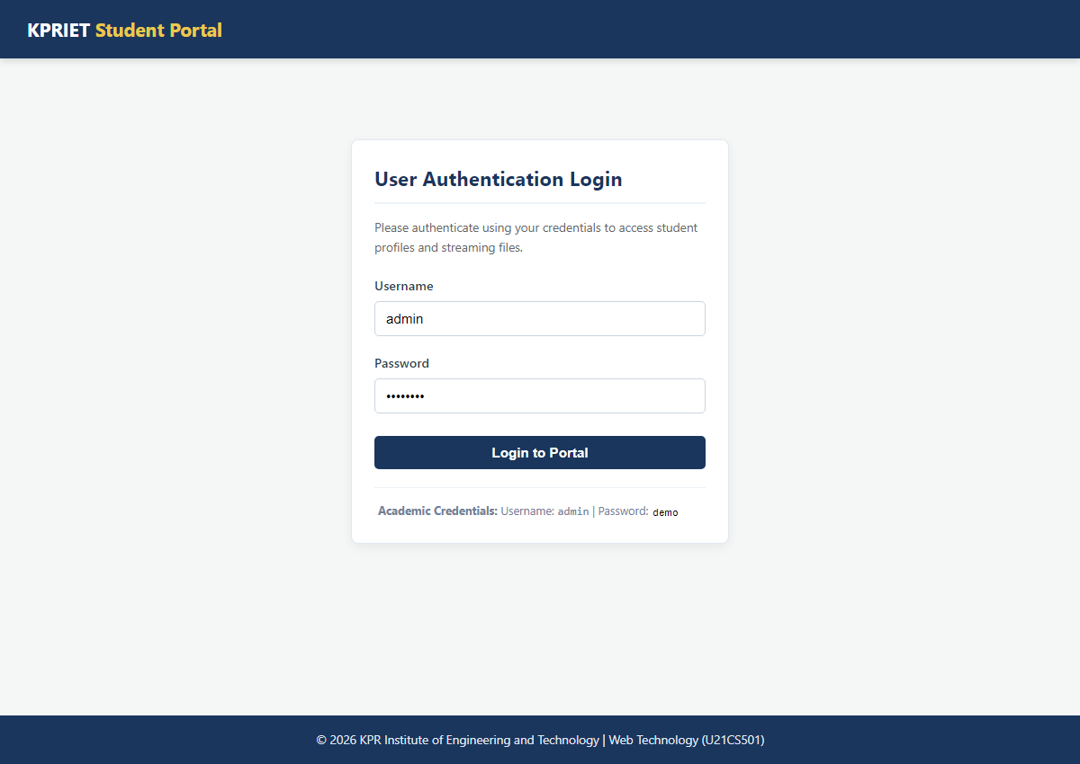
Figure 3.1 – User Authentication Login Page
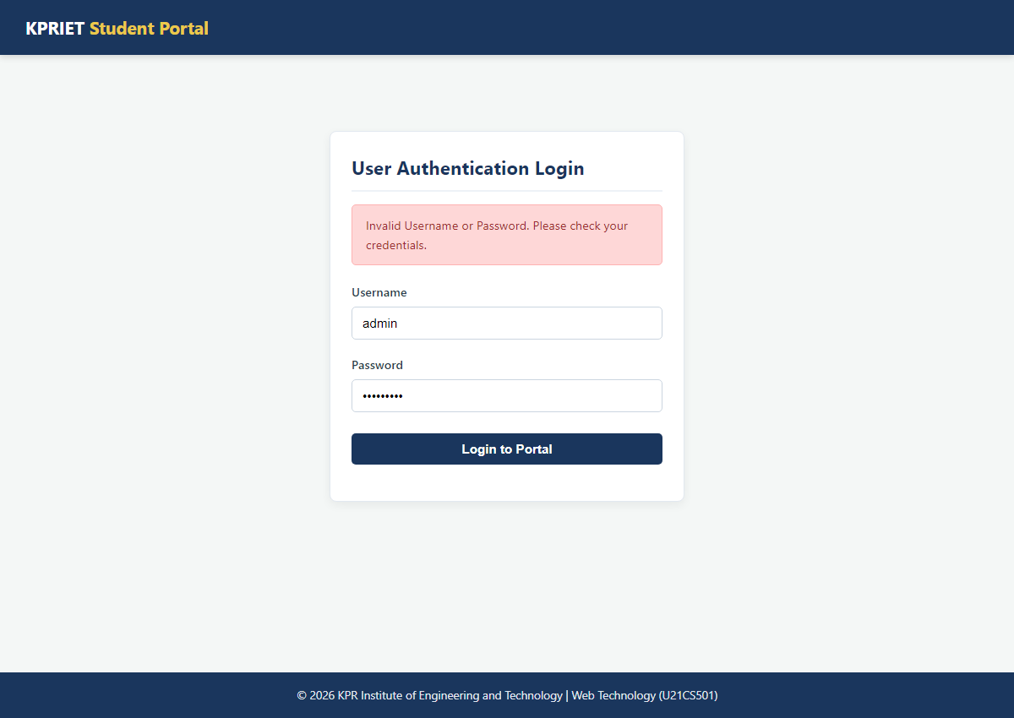
Figure 3.2 – Invalid Login Warning Banner
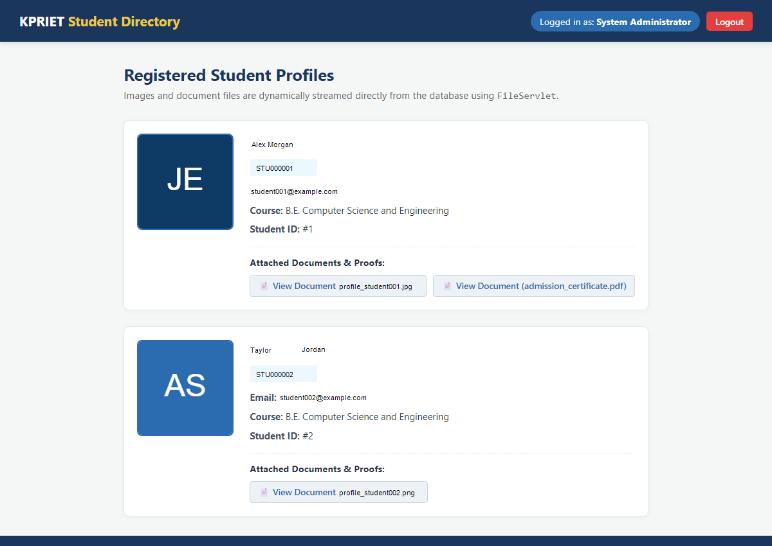
Figure 3.3 – Authenticated Student Portal Directory Dashboard
Figure 3.4 – Dynamic Student Profile & Image Rendering
Figure 3.5 – File Streaming Output via FileServlet

OVERALL TESTING & RESULTS SUMMARY
Question | Technology Stack | Main Functionality Verified | Overall Result
Question 1 | HTML5 / CSS3 / Vanilla JavaScript | Admission Registration Form + Real-time Client Validation | PASS
Question 2 | PHP 8 / MySQL (mysqli) | Student Records CRUD Operations + File Upload & Metadata Storage | PASS
Question 3 | Java Servlets / JSP / JDBC / MySQL | Session Authentication + Student Directory + Byte File Streaming | PASS

SUBMISSION REQUIREMENTS
The deliverables submitted for Web Technology Assignment II fulfill all requirements set by the official assignment specification:
• PHP, Servlet WEB-INF files and other web assets (.html, .css, .js) - [Completed & Included]
• Database Schema Scripts (DB_SCHEMA/question2_schema.sql, DB_SCHEMA/question3_schema.sql) - [Completed & Included]
• Screenshots of output in browser (SCREENSHOTS/ directory & embedded in report) - [Completed & Included]
• Explanation of code with inline comments - [Completed & Included]
• Brief academic conclusion - [Completed & Included]
• GitHub repository link placeholder:

CONCLUSION
Through the successful completion of Web Technology Assignment II, key full-stack web engineering concepts were mastered. Question 1 demonstrated client-side Web standard compliance using HTML5, CSS3, and Vanilla JavaScript input validation. Question 2 implemented secure server-side PHP 8 CRUD logic, MySQL prepared statements, unique file handling, and upload metadata storage. Question 3 demonstrated enterprise Java architecture utilizing Servlets, JSP scriptlets, JDBC database connectivity, HTTP Session protection, and secure byte-level file streaming.

GITHUB REPOSITORY PLACEHOLDER
GitHub Repository Link:
[GitHub Repository Link – To Be Added]
(Note: The student will create the Git repository and manually paste the GitHub URL above upon upload.)

