**HM-10 Serial Port Bluetooth 4.0 Module**

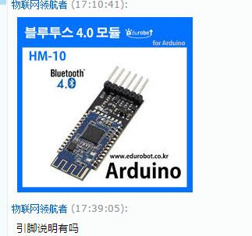

1. VCC：power supply, connect to 5V
2. GND
3. RX: serial communication, connect to microcontroller TX
4. TX: serial communication, connect to microcontroller RX
5. BRK is the input pin, short press for controlling; or inputting about 1000ms low level single pulse can achieve the following functions:

1.1. module is in hibernation state:

The module will be awakened to normal state. If open AT + NOTI, the serial port will receive OK + WAKE.

1.2. module is in connected state:

Module will initiate disconnection request.

1.3. module is in standby mode:

The module will return to the factory default state.

6、STATE is the output pin, showing the current working status of the module:

Standby mode- slow flash- repeat 500ms pulse;

Connection state- long bright- high level.

You can also set no flashing in the standby mode, long bright in the connection state.