## Calculating Performance

We are rating the servcies provided by the vendor the following table where the numbers are the days expected to have the issue resolved.

Excellent_|P1< 5days |P2< 3days |P3< 1day

Good______|P1< 10days|P2< 5days |P3< 3days

Average___|P1< 15days|P2< 10days|P3< 5days

Failed: For any other ticket is considered Bad performance is rated as failed service.

## Excellent Average Good Failed   
## 12343 1605 2243 1232

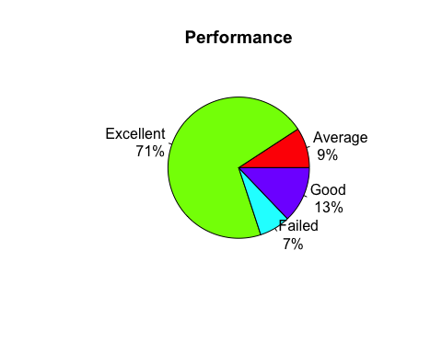

## Performance by most significant features

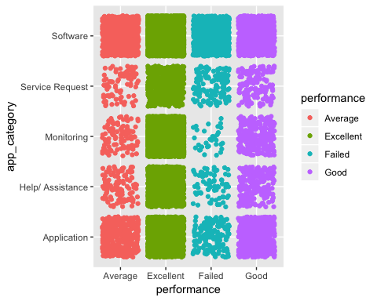

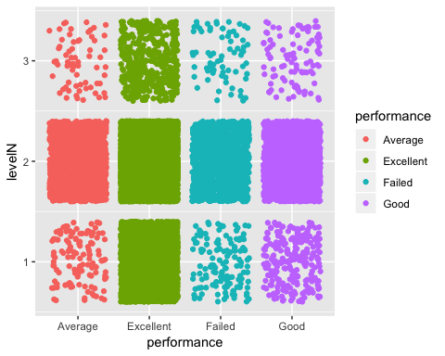

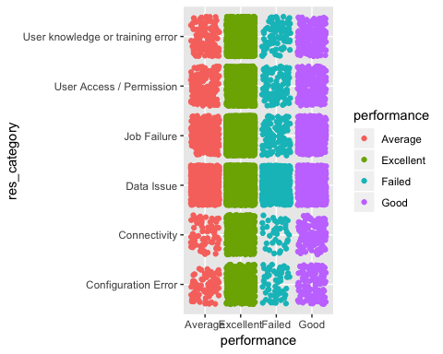

# Supervised Learning - Predicting Group Level

## Objective

For our analysis, we will predict which group level a ticket will be assigned based on the basic information provided by the User.

## What is the Problem?

A ticket usually gets escalated depending on the complexity, the time each Group Level takes to analyze the ticket and escalate it could be critical. Reliability team would like to find a way to know which team would be finally involved in a ticket so they can allocate the resources according to the number of tickets.

## Feature selection

## MeanDecreaseGini  
## app_category 712.56075  
## prod_line 426.77025  
## priorityN 437.06672  
## region 367.08991  
## impactN 53.30906

## Level of accuracy between: DLA, CART & RF

##   
## Call:  
## summary.resamples(object = results)  
##   
## Models: lda, cart, rf   
## Number of resamples: 10   
##   
## Accuracy   
## Min. 1st Qu. Median Mean 3rd Qu. Max. NA's  
## lda 0.8124043 0.8148785 0.8182862 0.8199555 0.8245642 0.8301454 0  
## cart 0.8117827 0.8228768 0.8251729 0.8249290 0.8285172 0.8347360 0  
## rf 0.8255547 0.8334921 0.8372896 0.8374011 0.8420046 0.8477429 0  
##   
## Kappa   
## Min. 1st Qu. Median Mean 3rd Qu. Max. NA's  
## lda 0.3934838 0.4001707 0.4134833 0.4198263 0.4378726 0.4572734 0  
## cart 0.3822409 0.4172898 0.4258511 0.4262499 0.4400110 0.4575774 0  
## rf 0.4422874 0.4642772 0.4770735 0.4775089 0.4929668 0.5223804 0

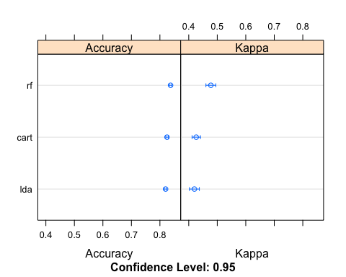

**Linear Discriminant Analysis: 81.46% Accuracy**

## Class: Level 1 Class: Level 2 Class: Level 3

## Balanced Accuracy 0.7041 0.6743 0.50000

**Classification and Regression Tree Analysis: 81.99% Accuracy**

## Class: Level 1 Class: Level 2 Class: Level 3

## Balanced Accuracy 0.70469 0.6730 0.50000

**Random Forest Analysis: 83.37% Accuracy**

## Class: Level 1 Class: Level 2 Class: Level 3

## Balanced Accuracy 0.73398 0.6988 0.5028746

# Supervised Learning - Predicting Performance

## Objective

From our previous analysis, we determined the Group Level the ticket will be providing support. Now, for the second part of our analysis, we will predict what performance a ticket will have given and basic data related to the issue.

## What is the Problem?

Business users needs to know how long a ticket would take to be resolved so they can focus on additional activities, or look for workarounds that will reduce the impact of the issue.

## Feature selection

## MeanDecreaseGini  
## app_category 354.58480  
## levelN 195.85496  
## region 154.66078  
## priorityN 143.65979  
## impactN 64.58817  
## prod_line 49.78494

## Level of accuracy between: DLA, CART & RF

##   
## Call:  
## summary.resamples(object = results)  
##   
## Models: lda, cart, rf   
## Number of resamples: 10   
##   
## Accuracy   
## Min. 1st Qu. Median Mean 3rd Qu. Max. NA's  
## lda 0.7031370 0.7063326 0.7068503 0.7066337 0.7075363 0.7087156 0  
## cart 0.7064220 0.7089067 0.7110602 0.7102308 0.7113323 0.7125382 0  
## rf 0.7051184 0.7086284 0.7106773 0.7105373 0.7116634 0.7176741 0  
##   
## Kappa   
## Min. 1st Qu. Median Mean 3rd Qu. Max.  
## lda -0.001277124 0.00737260 0.009210369 0.009439904 0.01387106 0.01632250  
## cart 0.018911855 0.03740403 0.042764849 0.042666165 0.04761031 0.06463698  
## rf 0.046462566 0.05588746 0.063110349 0.062839833 0.07084777 0.07791801  
## NA's  
## lda 0  
## cart 0  
## rf 0

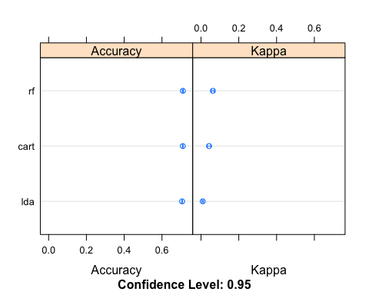

**Linear Discriminant Analysis: 70.67% Accuracy**

## Class: Excellent Class: Good Class: Average Class: Failed

## Balanced Accuracy 0.50610 0.4997364 0.501464 0.499011

**Classification and Regression Tree Analysis: 71.04% Accuracy**

## Class: Excellent Class: Good Class: Average Class: Failed

## Balanced Accuracy 0.51294 0.504069 0.506469 0.517009

**Random Forest Analysis: 70.9 % Accuracy**

## Class: Excellent Class: Good Class: Average Class: Failed

## Balanced Accuracy 0.52469 0.506952 0.509686 0.541764

**Classification and Regression Tree Analysis has the highest accuracy: 71.04% Accuracy**

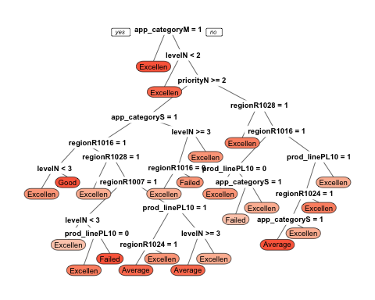

## Conclusion:

In this work we presented a method for constructing a multi-level classiﬁer to predict performance of a new ticket and what would be the number of support tickets under the different Group Level. We demonstrated that the information present at the lower level can be successfully propagated to the upper level to make reasonable predictions. No additional features other than the Application category, Product Line, Priority, Region, Impact and group level were necessary to predict the performance and Group Level of a new ticket.

Our goal, predicting performance, forced us to collect high quality data and develop a rigorous evaluation procedure. During the evaluation we carefully separated training and testing support tickets to avoid information leak. We identified that Random Forest works well to predict the Level of Support while Classification and Regression Trees (CART) method works well under these conditions better than other methods to detect a multi classification prediction to predict the performance.

There is still room for further improvements regarding classiﬁcation accuracy. We could plan to include additional features both at the vendor level and resource experienced level of the resources to see if our model can beneﬁt from them. Another direction that we want to explore is expanding the model to include other product lines, and evaluating it on bigger datasets. We hope that our work will inspire further discussions at Johnson & Johnson regarding evaluation strategies such as predicting Resolution categories. We believe that deeper understanding of those matters would allow the comparison of diﬀerent methods in a more systematic manner which would be beneﬁcial for the research done in ITSM CSI Continues Service Improvement.