

# Placement Empowerment Program

***Cloud Computing and DevOps Centre***

Host a Static Website Locally: Set Up a Local Server Apache and Host a Simple HTML page with your name

Name: Jai Riyaz G

Department : ADS



# Introduction and Overview

In this POC, we will learn how to host a static website locally using the Apache HTTP Server. This process involves setting up a local web server, configuring it correctly, and hosting a simple HTML page. By following these steps, you’ll get hands-on experience with configuring and running a local Apache server, which is a foundational skill for web hosting and server management.

# Objective

The goal of this project is to:

1. Set up a local web server using Apache.
2. Configure the server to host static files.
3. Create and host a simple HTML page displaying your name.

# Importance of Local Hosting

Local hosting is an essential skill for developers, as it allows them to test and experiment with web applications in a controlled environment. It offers several advantages, such as:

**Offline Development:** Work on web projects without requiring an active internet connection.

# Step-by-Step Overview

Step1:

Search for "XAMPP for windows" on Google and click the first link to access the official website.

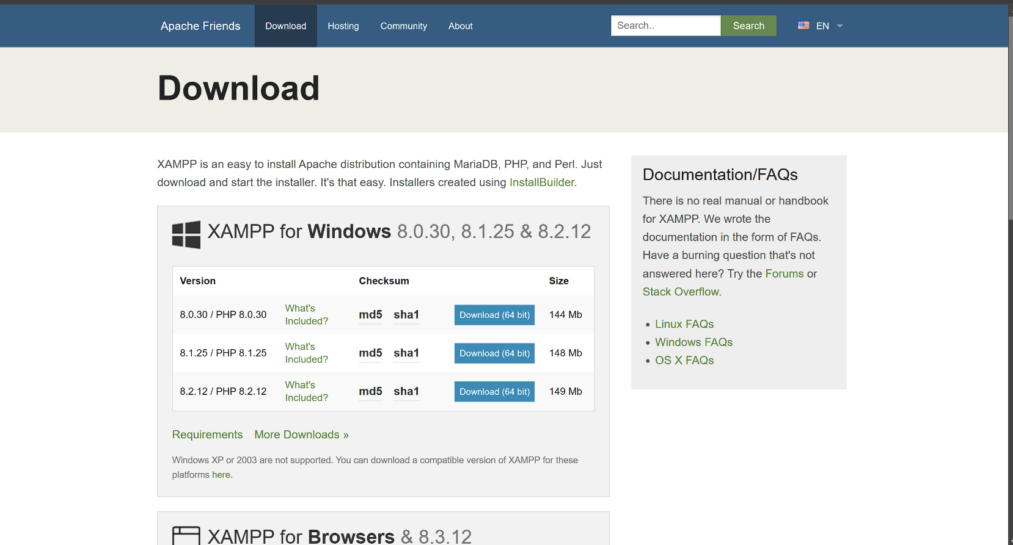

**Step 2:**

1.Open a notebook and create a html code for displaying our name

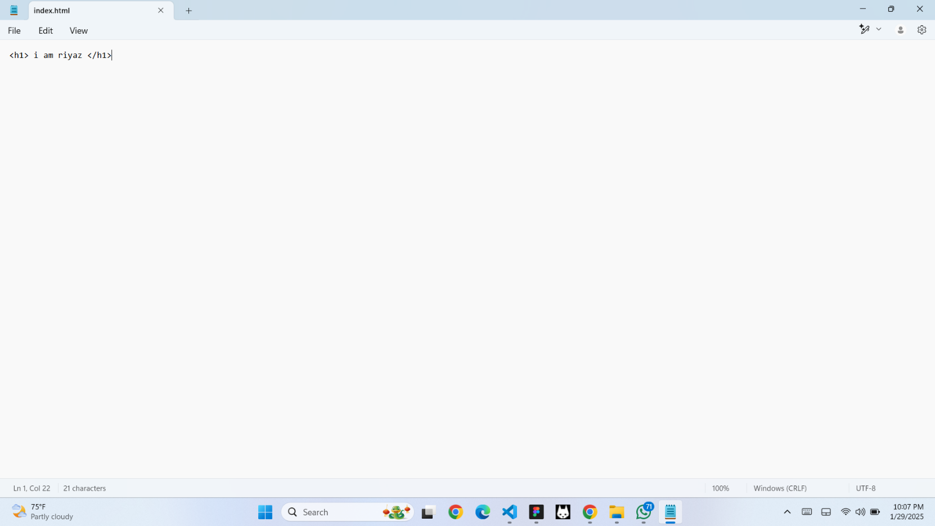

**Step 3:**

1.Save this file as index.html at htdocs folder

C:\xampp\htdocs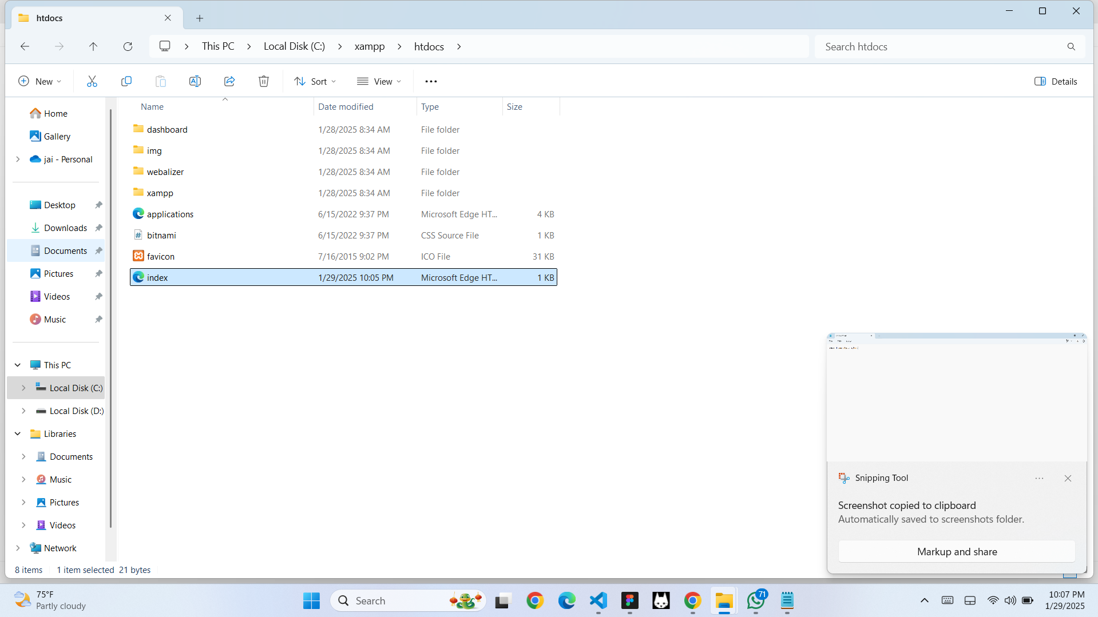

**Step 4:**

Open XAMPP control pannel and start Apache server

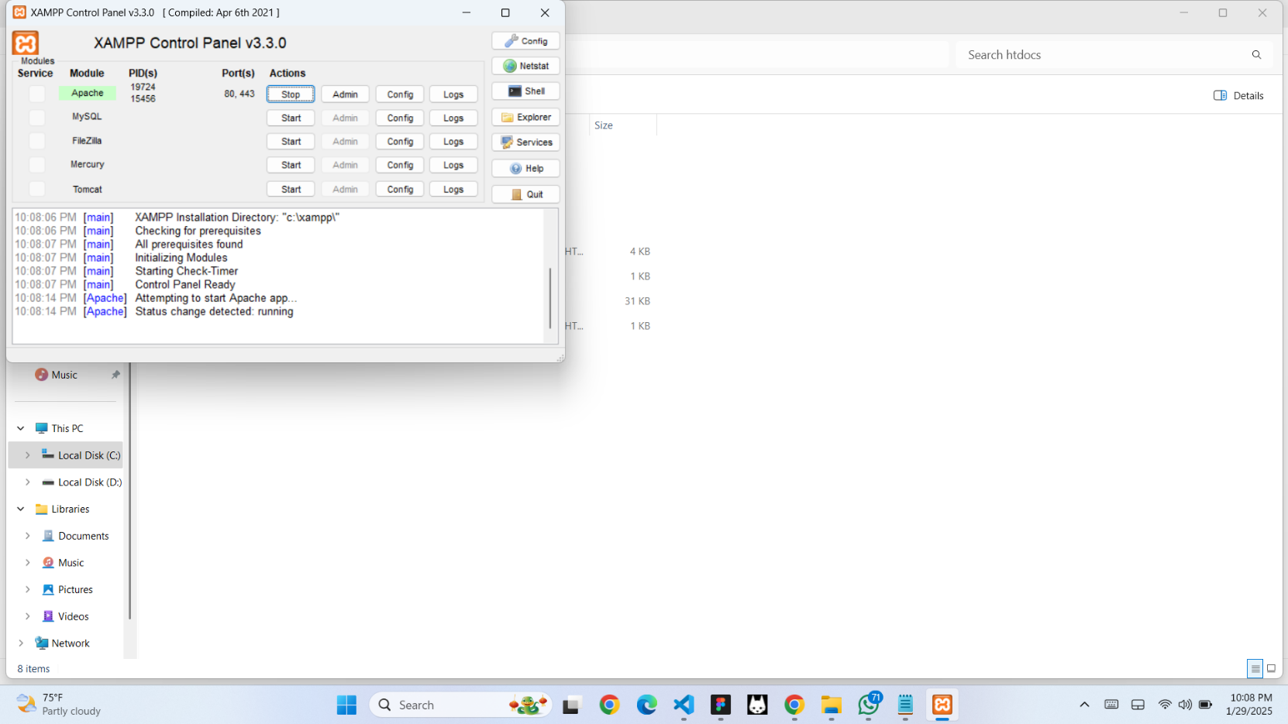

## Step 4:

Search localhost in your browser

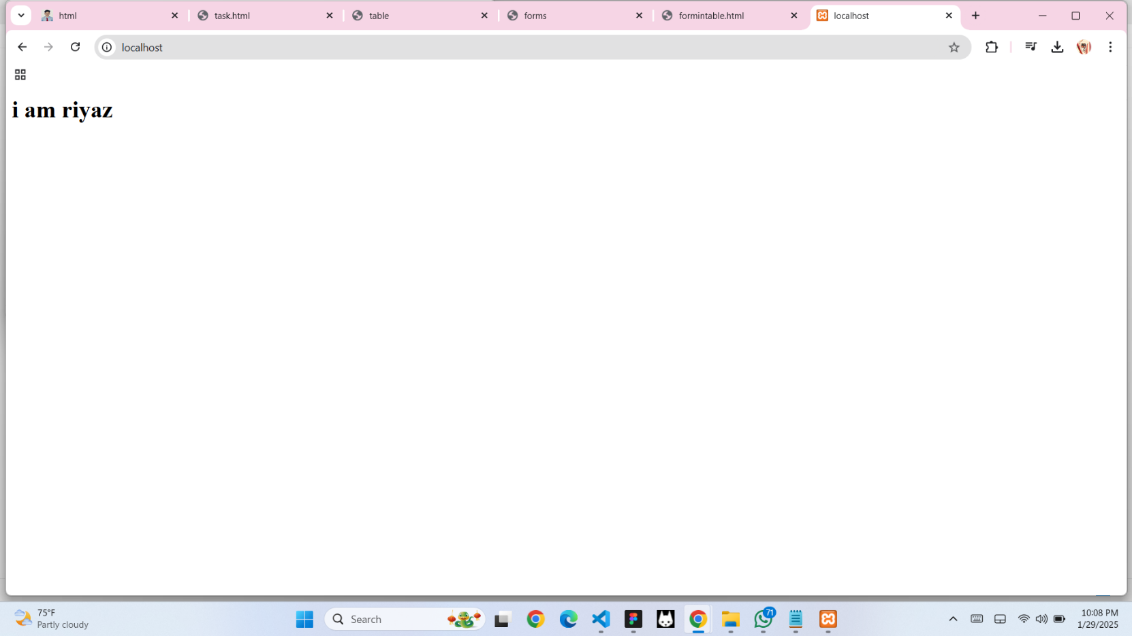

## Expected Outcome

By completing this POC, you will:

1. Successfully configure and run an Apache server locally.
2. Host a static HTML website that displays your name.
3. Understand the basics of web server configuration and file hosting.