EXPERIMENT NO:1(A)
MATPLOTLIB LIBRARY – DATA VISUALIZATION

AIM :
To analyze the trends of data science job postings over the last decade
PROCEDURE:
- Import Numpy and Matplotlib
- Give some dummy data and make it as Data Frame
- Use Bar plot for year over postings
- Give attributes like xlabel,ylabel,title ,etc
- Finally show the bar plot

PROGRAM :

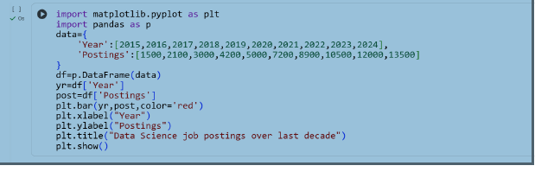
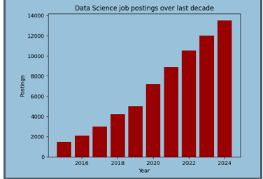
RESULT :
Thus the python program to visualize data using bar plot is executed and verified

EXPERIMENT-1(B)
MATPLOT LIBRARY – DATA VISUALIZATION
AIM :
To analyze and visualize distribution of various roles of Data Science
PROCEDURE :
- Import Pandas and Matplotlib
- Create a dataset
- Visualize through pie chart for job postings for various Data Science roles
- Use some attributes like colors ,title ,figure size etc

PROGRAM :

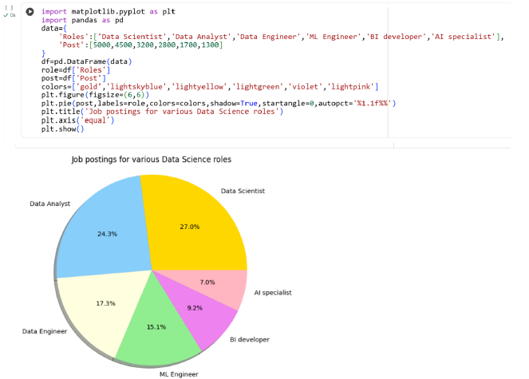

RESULT :
Thus the python program to analyze and visualize postings of data science roles is executed and verified

EXPERIMENT-1(C)
DISPLAY THE STRUCTURED , UN STRUCTURED AND SEMI-STRUCTURED DATA
Aim :
To differentiate structured , unstructured and semi structured data.
Procedure :
- Import Matplotlib and Pandas
- Create a DataFrame for structured data and print it
- Likewise create Data Frame for unstructured and normalize it using json attribute and print it
- Now create unstructured data and print it

Program:
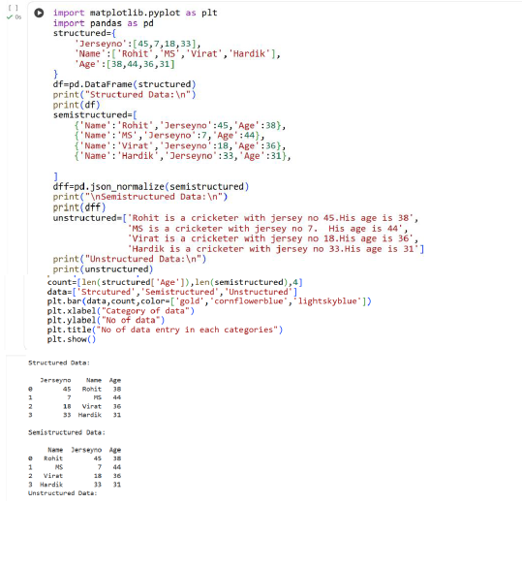
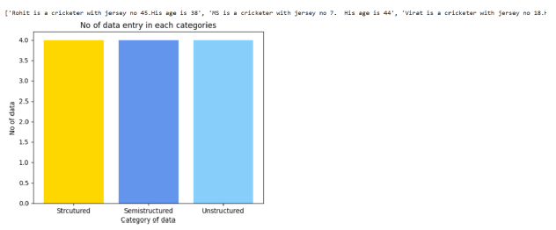
Result:
Thus the python program to differentiate the characteristics of structured , unstructured and semi-structured data

