EXPERIMENT – 5
FEATURE SCALING IN GIVEN DATASET
Aim:
To provide feature scaling for a given dataset
Procedure:
- Upload the given csv file
- Import the necessities like numpy and Pandas
- Use pandas to read_csv and make it as an data frame
- Now use SimpleImputer to fill missing values

Program:
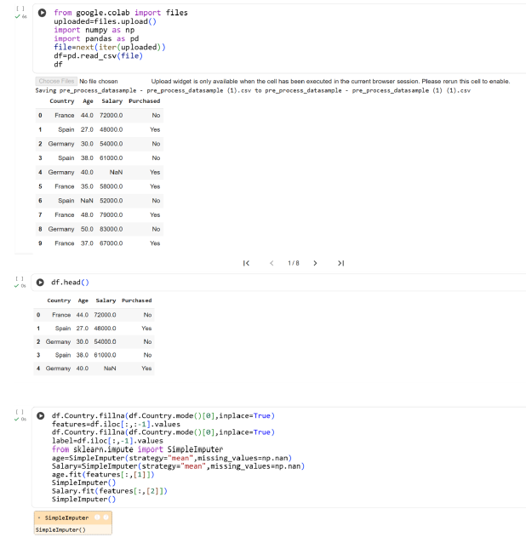

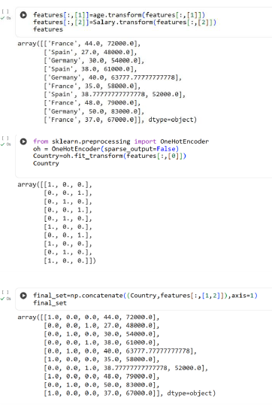
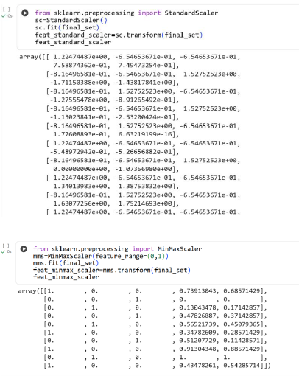
Result:
Thus the python program to do feature scaling in given dataset is executed and verified successfu

