EXPERIMENT – 7
PREDICTING MODEL - LINEAR REGRESSION
Aim:
To perform salary prediction model using Linear Regression
Procedure:
- Upload the given dataset
- Import all the necessities
- Read through the dataset and make it as dataframe
- Through sklearn train the model
- Test the model

Program:
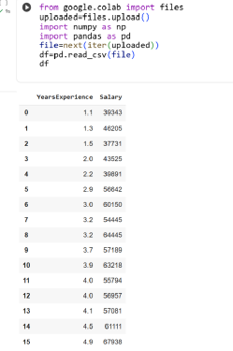

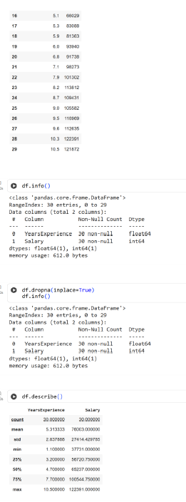
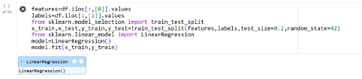

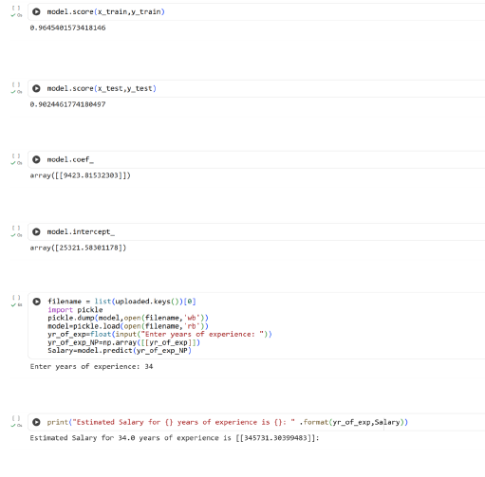
Result:
Thus the python program for predicting model using Linear Regression is executed and verified

