EXPERIMENT – 8
PREDICTING MODEL -KNN
Aim:
To perform model classification using K-nearest neighbours
Procedure:
- Upload a given dataset
- Import all necessities
- Read and make it as dataframe
- Through sklearn train the model
- Test the model

Program:
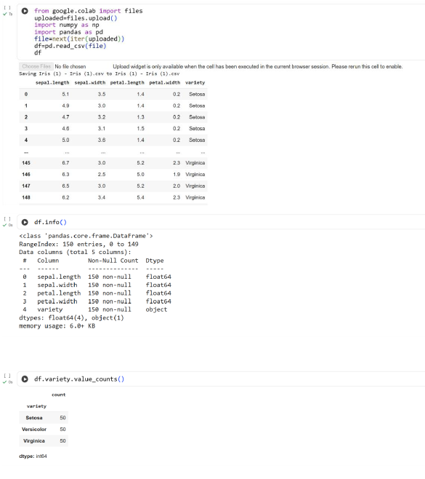

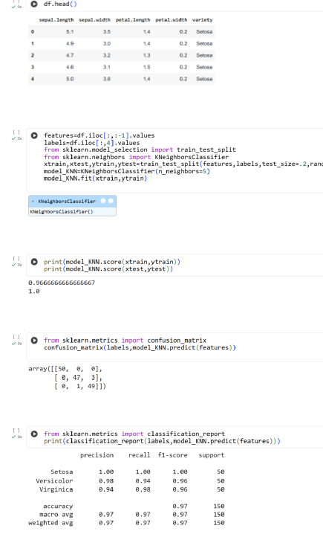
Result:
Thus the python program to perform model classification using KNN is executed and verified

