**1 Setup ESP8266 with Arduino IDE**

(source = <https://github.com/esp8266/Arduino>)

1) Install the current upstream Arduino IDE at the 1.8.7 level or later. The current version is on the Arduino website.

2) Start Arduino and open the Preferences window.

3) Enter https://arduino.esp8266.com/stable/package_esp8266com_index.json into the Additional Board Manager URLs field. You can add multiple URLs, separating them with commas.

4) Open Boards Manager from Tools > Board menu

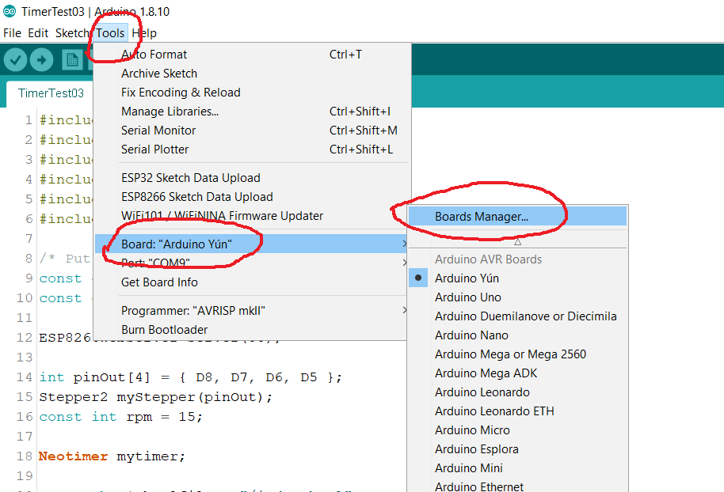

5) type esp8266 in the search bar and install esp8266 by ESP8266 Community version 2.6.x

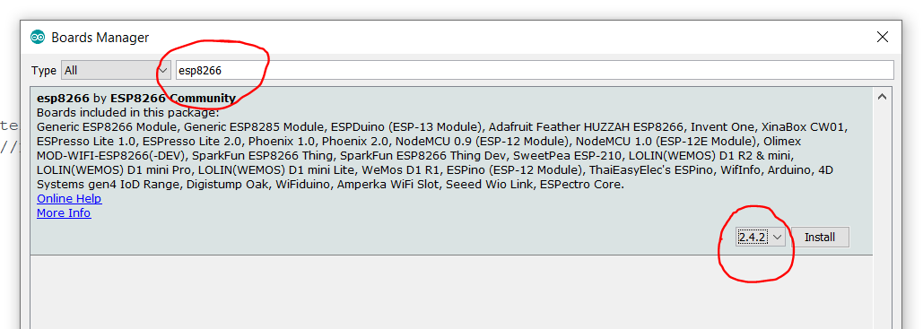

6) select the board as wemos D1 mini lite

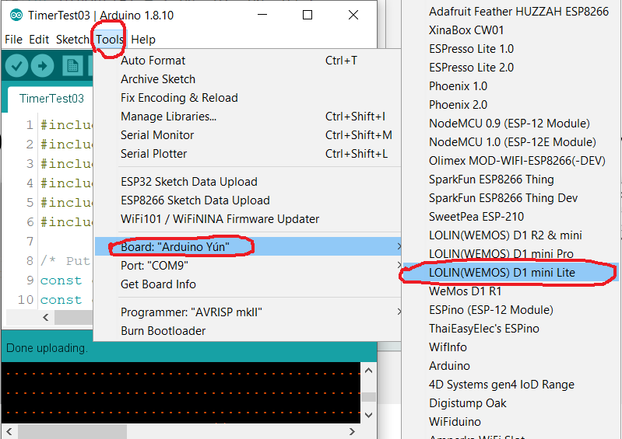

**2 Installing the Arduino ESP8266 Filesystem Uploader**

(source = <https://randomnerdtutorials.com/install-esp8266-filesystem-uploader-arduino-ide/>)

1) Go to the releases page and click the ESP8266FS-X.zip file to download.

<https://github.com/esp8266/arduino-esp8266fs-plugin/releases>

2) Go to the Arduino IDE directory, and open the Tools folder.

Arduino IDE Tools to Install ESP8266 SPIFFS Filesystem fs

3) Unzip the downloaded .zip folder to the Tools folder. You should have a similar folder structure:

<home_dir>/Arduino-<version>/**tools/ESP8266FS/tool/esp8266fs.jar**

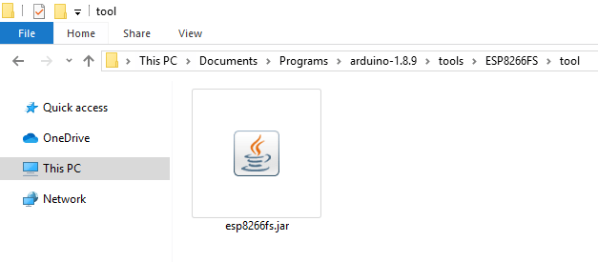

4) Finally, restart your Arduino IDE.

To check if the plugin was successfully installed, open your Arduino IDE and select your ESP8266 board. In the Tools menu check that you have the option “ESP8266 Sketch Data Upload“.

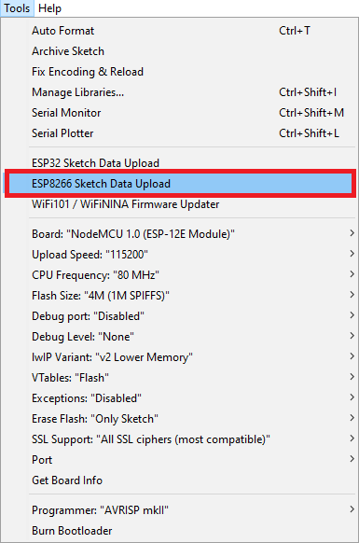

5) Select correct SPIFFS size for D1 mini lite

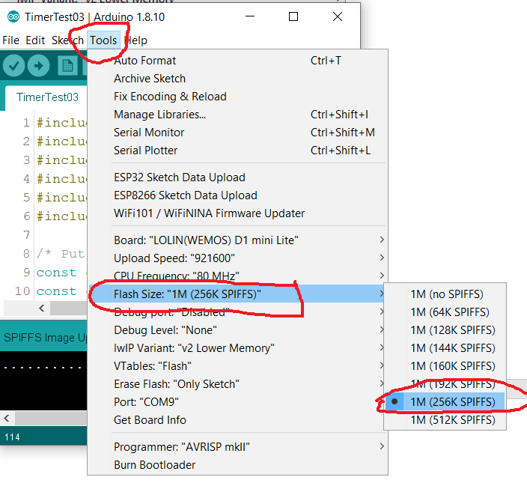

6) Upload files to SPIFFS

