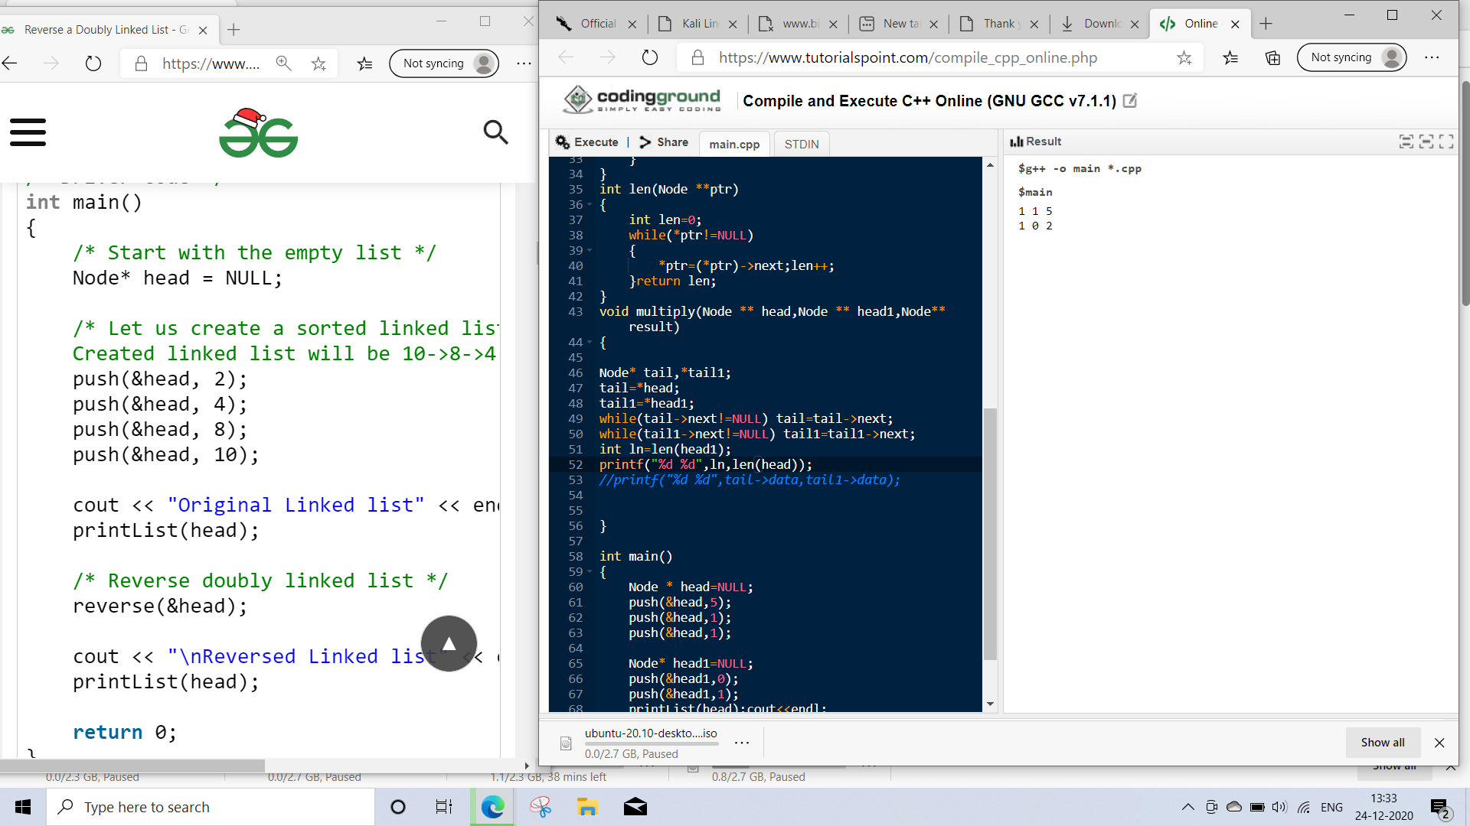
#include <iostream>

using namespace std;
class Node
{public:
int data;
Node * prev;
Node * next;
};

/* Function to insert a node at the
beginging of the Doubly Linked List */
void push(Node** head_ref, int new_data)
{
Node* new_node = new Node();
new_node->data = new_data;
new_node->prev = NULL;
new_node->next = (*head_ref);
if((*head_ref) != NULL)
(*head_ref)->prev = new_node ;

(*head_ref) = new_node;
}

/* Function to print nodes in a given doubly linked list
This function is same as printList() of singly linked list */
void printList(Node *node)
{
while(node != NULL)
{
cout << node->data << " ";
node = node->next;
}
}
int len(Node **ptr)
{
int len=0;
while(*ptr!=NULL)
{
*ptr=(*ptr)->next;len++;
}return len;
}
void multiply(Node ** head,Node ** head1,Node** result)
{

Node* tail,*tail1;
tail=*head;
tail1=*head1;
while(tail->next!=NULL) tail=tail->next;
while(tail1->next!=NULL) tail1=tail1->next;
int ln=len(head1);
printf("%d %d",ln,len(head));
//printf("%d %d",tail->data,tail1->data);

}

int main()
{
Node * head=NULL;
push(&head,5);
push(&head,1);
push(&head,1);

Node* head1=NULL;
push(&head1,0);
push(&head1,1);
printList(head);cout<<endl;
printList(head1);
//printList(head);
Node * result =NULL;
multiply(&head,&head1,&result);
}

void multiply(Node ** head,Node ** head1,Node** result)
{

Node* tail,*tail1;
tail=*head;
tail1=*head1;
while(tail->next!=NULL) tail=tail->next;
while(tail1->next!=NULL) tail1=tail1->next;
int ln = len(head);
int len1=len(head1);
//printf("%d %d",ln,len(head));
//printf("%d %d",tail->data,tail1->data);
int array[ln+len1-1][len1]={0};
//printf("%d",array[2][1]);
Node*tl1=tail1;
for(int i=0;i<len1;i++)
{
Node*tal=tail;
int carry=0,j=0;
while(tal!=NULL)
{
printf("%d*%d=%d",tal->data,tl1->data,tal->data*tl1->data);
tal=tal->prev;
}printf("\n");
tl1=tl1->prev;
}
}
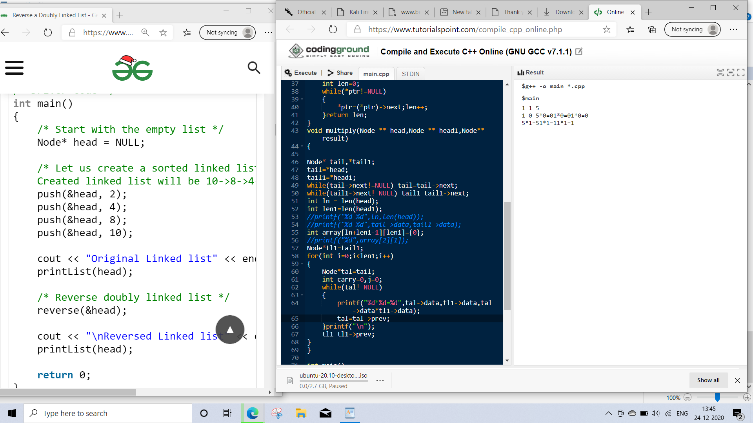
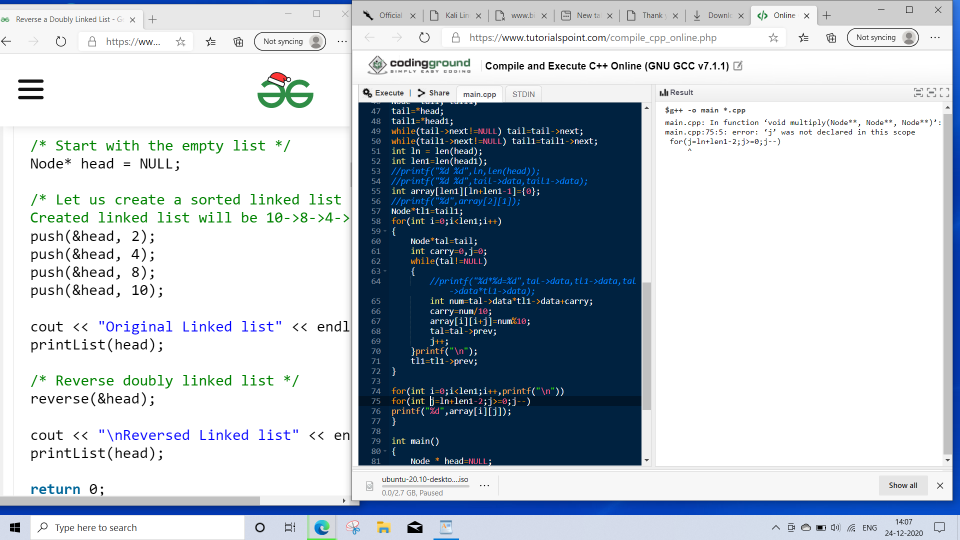

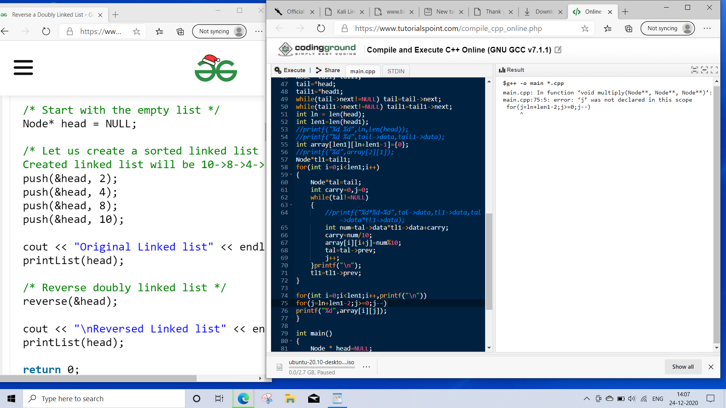

#include <iostream>

using namespace std;
class Node
{public:
int data;
Node * prev;
Node * next;
};

/* Function to insert a node at the
beginging of the Doubly Linked List */
void push(Node** head_ref, int new_data)
{
Node* new_node = new Node();
new_node->data = new_data;
new_node->prev = NULL;
new_node->next = (*head_ref);
if((*head_ref) != NULL)
(*head_ref)->prev = new_node ;

(*head_ref) = new_node;
}

/* Function to print nodes in a given doubly linked list
This function is same as printList() of singly linked list */
void printList(Node *node)
{
while(node != NULL)
{
cout << node->data << " ";
node = node->next;
}
}
int len(Node **ptr)
{
int len=0;
while(*ptr!=NULL)
{
*ptr=(*ptr)->next;len++;
}return len;
}
void multiply(Node ** head,Node ** head1,Node** result)
{

Node* tail,*tail1;
tail=*head;
tail1=*head1;
while(tail->next!=NULL) tail=tail->next;
while(tail1->next!=NULL) tail1=tail1->next;
int ln = len(head);
int len1=len(head1);
//printf("%d %d",ln,len(head));
//printf("%d %d",tail->data,tail1->data);
int array[len1][ln+len1-1]={0}; for(int i=0;i<len1;i++) for(int j=0;j<ln+len1-1;j++) array[i][j]=0;
//printf("%d",array[2][1]);
Node*tl1=tail1;
for(int i=0;i<len1;i++)
{
Node*tal=tail;
int carry=0,j=0;
while(tal!=NULL)
{
//printf("%d*%d=%d",tal->data,tl1->data,tal->data*tl1->data);
int num=tal->data*tl1->data+carry;
carry=num/10;
array[i][i+j]=num%10;
tal=tal->prev;
j++;
}printf("\n");
tl1=tl1->prev;
}

for(int i=0;i<len1;i++,printf("\n"))
for(int j=ln+len1-2;j>=0;j--)
printf("%d ",array[i][j]);
int carry=0;
Node * rslt=NULL;
for(int i;i<=ln+len1-1;i++)
{ int num=carry;
for(int j=0;j<len1;j++)
num+=array[i][j];
push(&rslt,num%10);
carry=num/10;
}
printList(rslt);
return rslt;
}

int main()
{
Node * head=NULL;
push(&head,5);
push(&head,1);
push(&head,1);

Node* head1=NULL;
push(&head1,0);
push(&head1,1);
printList(head);cout<<endl;
printList(head1);
//printList(head);
Node * result =NULL;
multiply(&head,&head1,&result);
}

