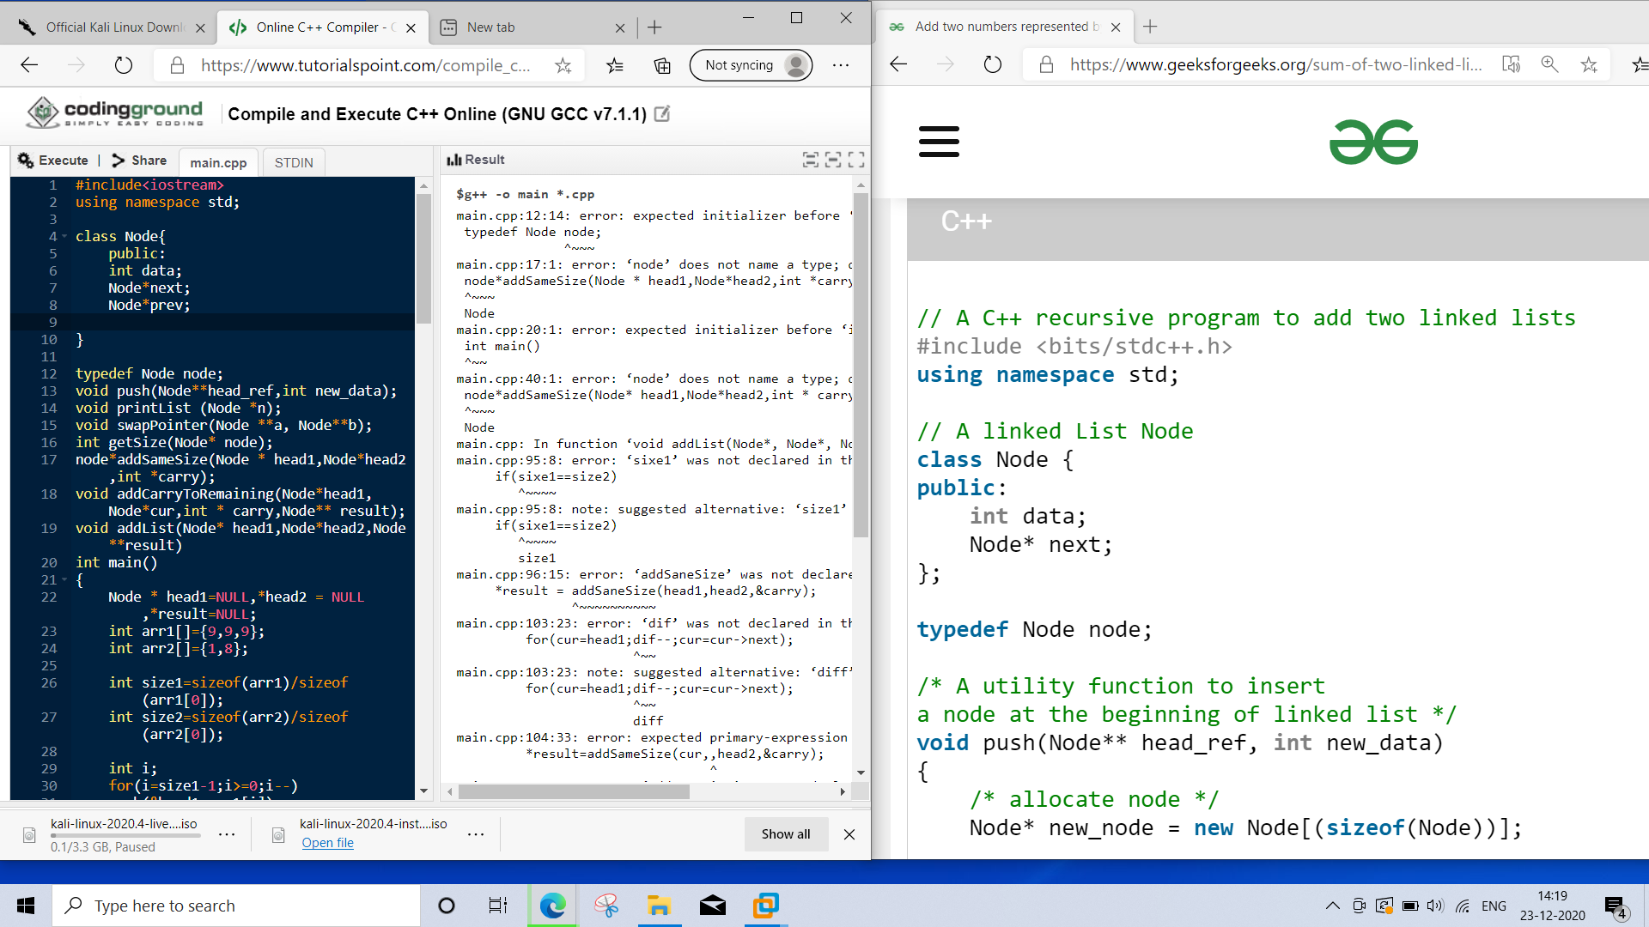

#include<iostream>

using namespace std;

class Node{

public:

int data;

Node*next;

Node*prev;

}

typedef Node node;

void push(Node**head_ref,int new_data);

void printList (Node *n);

void swapPointer(Node **a, Node**b);

int getSize(Node* node);

node*addSameSize(Node * head1,Node*head2,int *carry);

void addCarryToRemaining(Node*head1, Node*cur,int * carry,Node** result);

void addList(Node* head1,Node*head2,Node**result)

int main()

{

Node * head1=NULL,*head2 = NULL,*result=NULL;

int arr1[]={9,9,9};

int arr2[]={1,8};

int size1=sizeof(arr1)/sizeof(arr1[0]);

int size2=sizeof(arr2)/sizeof(arr2[0]);

int i;

for(i=size1-1;i>=0;i--)

push(&head1,arr1[i]);

for(i=size2-1;i>=0;i--)

push(&head2,arr2[i]);

addList(head1,head2,&result);

printList(result);

}

node*addSameSize(Node* head1,Node*head2,int * carry)

{

if(head1==NULL) return NULL;

int sum;

Node * Result = new Node[(sizeof(Node))];

result->next = addSameSize(head1>next,head2->next,carry)

sum=head1->data + head2->data + *carry;

*cfarry=sum/10;

sum=sum%10;

result->data = sum;//a

return result;

}

void addCarryToRemaining(Node* head1, Node *cur,int * carry,Node** result)

{

int sum;

if(head1!=cur)

{addCarryToRemaining(head1->next, cur,carry,result);

sum=head1->data + *carry;

*carry=sum/10;

sum=sum%10;

push(result,sum);

}

}

void addList(Node* head1,Node*head2,Node**result)

{

Node*cur;

if(head1==NULL)

{

*result=head2; return;

}

else if(head2==NULL)

{

*result=head1; return;

}

int size1=getSize(head1);

int size2=getSize(head2);

int carry=0;

if(sixe1==size2)

*result = addSaneSize(head1,head2,&carry);

else{

int diff = abs(size1 - size2);

if(size1<size2)

swapPointer(&head1,&head2);

for(cur=head1;dif--;cur=cur->next);

*result=addSameSize(cur,,head2,&carry);

addCarryToRemaining(head1,cur,&carry,result);

}

if(carry)

push(result,carry);

}

int getSize(Node*node)

{

int size==0;

while(node!=NULL)

{

node=node->nexr;

size++;

}

return size;

}

void swapPointer(Node **a,Node **b)

{

Node*t=*a;

*a=*b;

*b=t;

}

void printList(Node *node)

{

while(node!=NULL)

{

cout<<node->data<<" ";

node=node->next;

}

cout<<endl;

}

void push(Node**head_ref,int new_data)

{

Node * new_node=new Node[(sizeof(Node))];

new_node->data=new_data;

new_node->next=(*head_ref);

(*head_ref)=new_node;

}



