

Table of Contents

Table of Contents 2

1 Industry Background 3

1.1 Current Status of Traditional Advertising 3

1.2 Current Pain Points in the Advertising Industry 4

2 Blockchain Empowered Advertising 6

2.1 Blockchain Technology Reduces Trust Loss 6

2.2 dApp Market Value 8

3 About Jambo 11

3.1 Project Profile 11

4 Technical Architecture 12

4.1 About the Application Chain 12

4.2 About Polkadot 12

4.3 Substrate and Access Slots 13

4.4 Design Requirements of the Application Chain 15

4.5 Advertising Sidechain Design 16

5 Jambo Application Ecology 23

5.1 Advertiser 23

5.2 Advertising Channel 24

5.3 Advertising Users 25

6 Token System 27

6.1 Introduction of Token 27

6.2 Token Distribution 27

6.3 Functional Value 28

7 Future Prospects 29

8 Risk Warning and Disclaimers 30

8.1 Risk Warning 30

8.2 Disclaimers 33

# 1 Industry Background

## 1.1 Current Status of Traditional Advertising

Presented through digital media, digital advertising has become one of the most important forms of advertising thanks to the increasing popularity of the Internet and digital platforms. According to eMarketer, the global digital advertising market maintained an overall growth momentum from 2016 to 2018. In 2018, the global online advertising was worth $283.35 billion with a year-on-year increase of 21.99% from 2017.

The global digital advertising market is highly concentrated, of which 76.51% has been grasped by the top-10 companies and 31.1% by Google as the industry leader. The mobile advertising market has developed rapidly, while the growth rate has slowed down, worth $190.2 billion in 2019. Google has again taken up the largest market share of 46.8% in mobile advertising, followed closely by Facebook. The [global digital advertising revenue](https://www.statista.com/statistics/456679/digital-advertising-revenue-format-digital-market-outlook-worldwide/)will grow rapidly in the next few years. By 2021, the digital advertising expense will exceed $330 billion.

As the global advertising industry matures in its life cycle, its prosperity relies heavily on the economic development. The intensifying world economy globalization has led to the emergence of numerous multinational advertising companies and groups, creating a trend of centralization and intensification in the global advertising market and advertising giants through conglomeration and merger of advertising companies. The mergers and acquisitions and reorganization of members of the American Association of Advertising Agencies (4A's) have elevated the centralization and expertise of the global advertising industry substantially.

## 1.2 Current Pain Points in the Advertising Industry

In the global Internet advertising market worth trillions of U.S. dollars, marketing budgets are mainly grasped by major media such as search engines and social media. Due to the lack of trust between stakeholders in the industry chain, non-value parts such as advertisement verification, data monitoring, and advertisement blocking have appeared. The high trust cost has led to the transfer of interests of all parties, causing a high user acquisition cost for advertisers on the one hand, and a lack of competitiveness for small-and-medium-sized media firms to compete with giant monopolies on the other hand. What's worse, users are disturbed and irritated by annoying advertisements.

The simplest form of digital advertising is to deliver marketing information and content to consumers through the Internet, mobile applications and other connected devices. However, this process has become extremely complicated on Internet trading platforms.

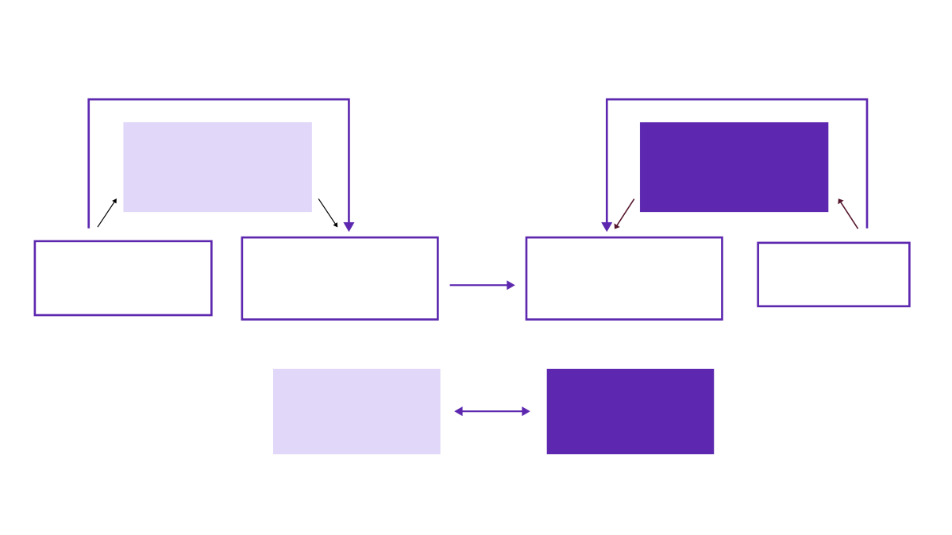

Ad network

(For buyers)

Ad network

(For media)

DSP

(RTB client)

SSP

(RTB server)

Agent trading platform or internal team

Advertiser's ad server

Media's ad server

Media

To

Remaining

Digital Advertising Ecosystem

**1.2.1 Traffic Fraud**

Seduced by high profits, traffic fraud is serious in the mobile advertising market. Risky equipment such as device farms (such as phone farms) and virtual machines have wasted advertising resources for a long time, affecting the advertising effectiveness. According to statistics of More Than Data, abnormal clicks accounted for more than 65% of the industry aggregate in Q1 2017, and numerous device farms have sprung up since Q4 2016.

**1.2.2 Data Silo**

Data is the foundation of the digital advertising ecosystem. Obtaining and using correct and valid data enable companies a clear competitive edge over their rivals in terms of measurement and target location. However, companies, large and small, are fighting their battles separately, forming large and small silos in the vast data ocean. This situation can do great harm by hindering advertisers from acquiring valid consumer data and breaking the data chain that is key for effective advertising.

**1.2.3 Advertising Harassment**

In the centralized mobile advertising industry, users, as the ultimate recipients of mobile advertising, can only passively accept advertisements in most cases. Deeply harassed by spam advertisements, their personal information security cannot be guaranteed. To block advertisements, users have to either pay a fee or use third-party ad blocker, which increase the possibility of personal privacy leaks and security risks.

**1.2.4 Extra Costs Caused by Agents**

In the process of mobile advertising, endless agents such as DSP, ADX, SSP and DMP have increased the advertising transaction cost. Moreover, the billing period of each agent causes a weak position for developers. Sometimes, upstream advertisers can delay payments developers for more than two months, squeezing the liquidity of small-and-medium-sized developers.

**1.2.5 Damaged Interests of Multiple Parties**

The above-mentioned false traffic and fraudulence have made the media dishonest, directly leading to a decline in media buying. In 2016, Unilever invested $818 million in digital advertising in the U.S., but spent 17% less in H1 2017, partly due to concerns about transparency and lack of measurement tools. In addition, traffic giants such as Google and Facebook have basically monopolized the information market and dominated more than 85% of new market shares every year. The Matthew effect of "the strong get stronger and the weak weaker" will apply to the numerous dispersed media companies. Once contract disputes occur, the rights and interests of small and medium traffic users cannot be protected.

The user experience of Internet services is seriously affected as users are frequently interrupted by advertisements that pop up suddenly, which is one of the reasons why information flow and native ads have become increasingly popular. So far, user traffic has not brought absolute benefits to users. Therefore, more and more users choose to use ad blocking technology to block ad content. PageFair Adblock report 2017 indicated that, by December 2016, ad-blocking software were used on more than 600 million devices worldwide, 62% of which were mobile devices. These "blocked" ads not only harm the user experience, but also greatly weaken the effect of the ads.

# 2 Blockchain Empowered Advertising

## 2.1 Blockchain Technology Reduces Trust Loss

Blockchain and advertising make an excellent match naturally thanks to its smart contracts and transparent records, consensus reached through globally distributed nodes, low cost for realizing multi-party trust, thus reducing the trust loss in the advertising process.

**2.1.1 Traffic Fraud Prevention**

Transparent and encrypted, blockchain allows multiple parties to collaborate through a consensus mechanism instead of relying solely on trust. As each block is added to the next block, an irreversible chain is created, showing the true existence of each event from beginning to end with reliable security and transparency and effectively preventing false traffic. Using a distributed system based on blockchain technology, advertisers can review each advertisement or each impression and pay only for the correct traffic.

**2.1.2 Data Integration**

The blockchain is essentially a ledger that records information with high security based on people's consensus. Unlike data silos caused by commercial privacy issues previously, blockchain can determine data standards, connect various data, support use on demand, and protect data privacy. Therefore, it can integrate the data of the entire society and build a data network or data cloud.

Through the blockchain, marketers can now directly build customer profiles from customers and obtain all the information that customers are willing to share. In addition, the decentralized blockchain can share the customer profile information among advertisers to solve the problem of redundant information and data silos.

**2.1.3 Protection of SMEs' Interests**

When blockchain is used in advertising, the service task of each advertiser is a smart contract. Since it clearly monitors the effect of each delivery, and the entire link data is transparent, it can be solved in real time for both parties according to each effect, greatly shortening upstream and downstream accounts and preventing contract disputes. As each block in the blockchain needs to connected to the chain, the previous block must be referenced and copied to each node on the entire chain, the blockchain is immutable. This feature can effectively increase the voice of the weaker media in the face of technology giants.

**2.1.4 Incentive Mechanism**

In the digital advertising model, the imbalance in the value of user traffic and privacy leaks have been widely criticized. Blockchain-encrypted transaction ledger (supporting virtual currencies such as Bitcoin and Ethereum) is used to reward brand interaction, allowing consumers to sell data to advertisers, or allowing consumers to play a more active role in the digital advertising ecosystem. This practice enables consumers to get rewards by relying on personal data, and become wiser in managing and sharing data. In addition, when users pay more attention to their personal and behavioral information, and the restrictions become stricter, technology giants are unlikely to have major impacts on their income-generating mechanism. This also involves the next headache of consumers: privacy.

**2.1.5 Protection of Privacy**

The privacy issue has long plagued consumers. In the field of privacy protection and personal data management, the distributed ledger technology (DLT) behind the blockchain can ensure data security through encryption, and bring data monetization methods through smart contracts and encrypted currencies. Blockchain technology provides users with a means to encrypt and protect their data, and allows users even to choose who can access their information.

**2.1.6 Protection of All Parties' Interests**

Blockchain technology can facilitate data transactions and ensure proper benefits for buyers and sellers. A decentralized system can help create a fair market for personal data owners where no entity can easily set market prices.

The problem of false traffic is solved for advertisers, who will increase their trust in media purchases, which will naturally increase media purchases and directly increase revenue for the media. At the same time, the media is more transparent to advertisers, while advertisers can save a lot of marketing expenses and make every investment more effective.

Using blockchain technology, users can independently choose how to process their information, sell information, obtain incentives, and better protect privacy. While enabling users to better control functions, and to completely control the value of data in their hands, the decentralized system also benefits advertisers. They can access a huge shared pool of related data, which has been reviewed by other participants and verified through links, thus delivering ads more accurately and saving costs.

For the entire system, blockchain effectively reduces the participation of intermediaries. Advertisers can independently monitor and verify the number of advertisement clicks, and users can directly communicate with the media and advertisers, improving the transparency of the entire system and boosting the process efficiency. The higher efficiency in turn can speed up and optimize the operating process between the three, forming a well-functioning ecosystem for advertisers, media, and users.

## 2.2 dApp Market Value

The application market on the blockchain has expanded rapidly in the past two years. The on-chain ecology of the blockchain industry has taken shape. 2020 is a milestone year for the blockchain industry. dApp's transaction volume exceeded $270 billion, 95% of which came from Ethereum DeFi ecosystem.

According to the data report of DappRadar, among the dApps with the top traffic of Ethereum, the TVL and aTVL peaked at $13 billion and $11 billion in 2020, respectively. According to the 16 well-known public blockchains, huge growth was achieved in 2020. Unique active wallets grew by 466%, from 58,000 at the end of 2019 to around 200,000 at the end of 2020. Besides, the transaction volume increased from $21 billion in 2019 to $270 billion in 2020, an increase of 1178%.

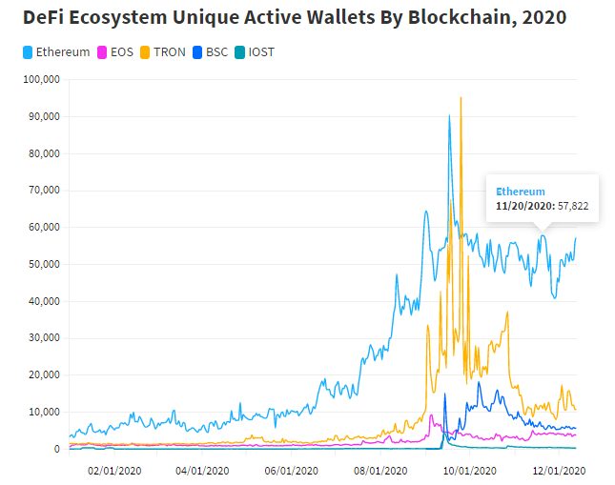

**2.2.1 DeFi's dApps**

On the other hand, most transactions occurred in just a few dApps. The top-10 DeFi dApps accounted for 87% of Ethereum's transaction volume, reaching $223 billion in 2020.

[Ethereum](https://link.jinse.com/s/K5S5A2?coin_keyword=1&coin=ethereum" \t "https://www.jinse.com/news/blockchain/_blank" \o "Ethereum)DeFi ecosystem is the main driving force for Total Value Locked (TVL). DappRadar has tracked that the Adjusted Total Value Locked (aTVL) recorded a new high in 2020 at $13 billion and $11 billion, respectively.

**Ethereum DeFi dApps Contributed 95% of the Transaction Volume Growth**

DeFi was the main propeller of dApp growth in 2020, and it has become the industry leader in terms of key indicators such as TVL, AUW and transaction volume. This is also a key topic discussed by news channels and society, driving users' attention to summits in April and September 2020.

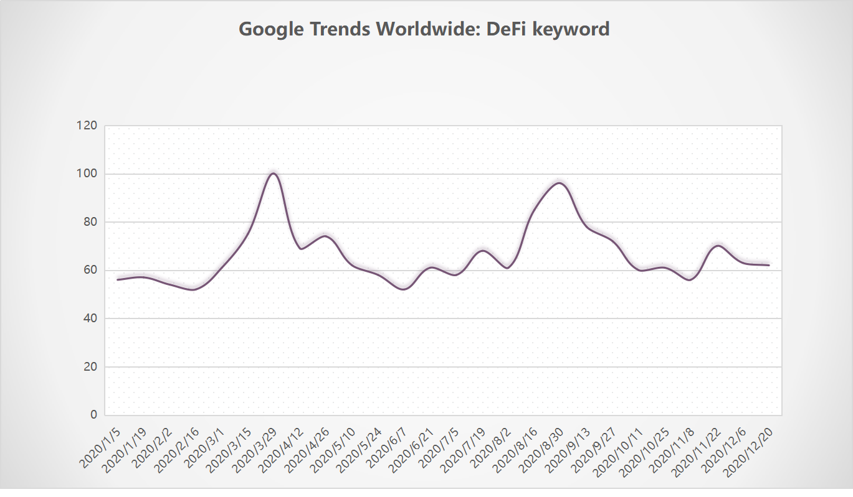

**TRON's dApps**

TRON is the first blockchain to catch up in developing a DeFi ecosystem. There are more than 70 dApps built on the network to date. The majority of activity is concentrated within the top three. UniSwap, JustSwap and UME generate more than 5,000 daily unique active wallets and account for 70% of total DeFi ecosystem activity.

**BSC's dApps**

Binance Smart Chain (BSC) as a protocol caught up quickly within a few months of its launch and generated approximately $3 billion in transaction volume. While still a relatively small amount compared to Ethereum's yearly figure of $256 billion, it is close to TRON's $3.6 billion and EOS's $6.5 billion figures.

**Active Users of dApp**

At present, blockchain application developers prefer public blockchains such as ETH, EOS, TRON, IOST, STEEM, and ONT, as well as sidechains such as NEO, OST, and LOOM. However, the formers are widely used and easy to use considering development and maintenance costs.

With the explosive growth of DeFi in 2020, the number of active users of dApp has boomed, exceeding 7 million at the end of 2020 from nearly 900,000 at the end of 2019. However, there is currently no effective way for users to obtain project information and deliver accurate industry information to target users apart from community dissemination and blockchain media. Moreover, current blockchain media and traditional media still face same problems of traffic fraud, high cost, and low efficiency.

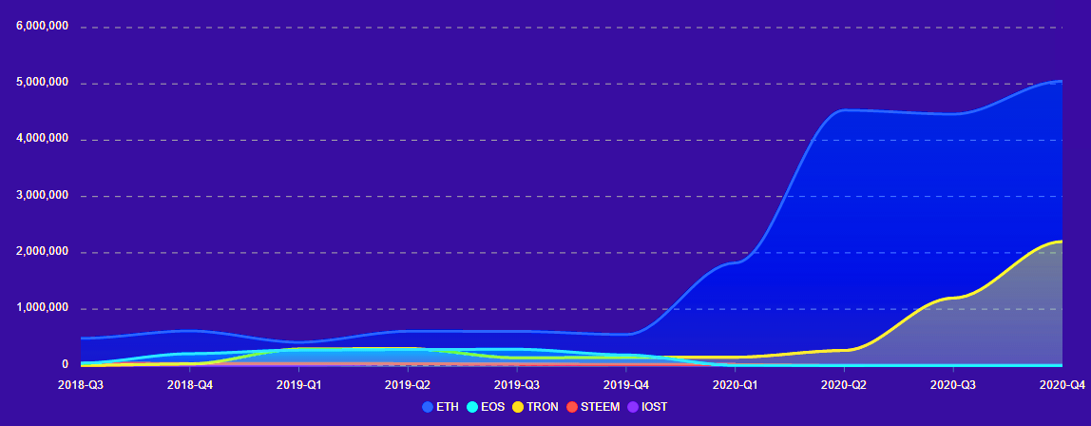

Source: DappOnline

The multiplying blockchain user traffic is not used, planned, distributed and re-directed effectively by projects and is left unsolved. Compared with traditional Internet advertising, blockchain traffic features decentralization, distribution, and decentralized sinking. Traffic is the guide for the development of the blockchain industry. Bitcoin, Ethereum, exchanges, DEFI, and IPFS have all grown in the traffic war in their development history.

Distributed blockchain traffic has obvious flaws. In the past, due to the lack of technical support and closed-loop design of traffic, the effective increment of blockchain traffic cannot be realized. The vast majority of the traffic cannot be imported into the blockchain target projects, hampering and slowing the ecological development.

# 3 About Jambo

## 3.1 Project Profile

As the first blockchain ad-tech support platform, Jambo has been committed to creating a transparent and credible decentralized advertising industry value ecology. With the Polkadot heterogeneous multi-chain architecture, the platform can realize the value interoperability of different advertising industry chains, make the database transparent, greatly improve the service development of blockchain advertising industry, and accelerate the serving efficiency of digital advertising.

**3.1.1 Mission**

Jambo has continued deepening the value of on-chain traffic and improving the accuracy of blockchain information. The application of blockchain technology has broken the border of the financial field or entertainment field to build the high-traffic data applications of the advertising communication industry based on blockchain technology, thus directly or indirectly helping users filter false information.

Jambo enables the advertising industry's service network to provide transparent, efficient and stable communication services for the industry. We are committed to helping users to participate in blockchain advertising applications, promoting implementation of high-traffic applications in the application ecosystem, gathering new potential development teams to build a large-traffic reference matrix in digital advertising, and affecting the traffic circle of multiple industries and communities, thus enabling more people to enjoy the development dividends of high-traffic applications.

**3.1.2 Open Underlying Technology**

The blockchain network has been increasingly hierarchized and specialized. The basic public chain network is responsible for consensus security and the cross-chain of data assets, while the second layer network and sidechains are developed towards specific application areas. Jambo builds an open technology platform through the Substrate framework and access slots, and maintains numerous customizable functions and modules for projects developers. Jambo provides basic technical services and opens the underlying technical network services, which have become a general option for developers in the service design and system development process.

# 4 Technical Architecture

## 4.1 About the Application Chain

When the Web3.0 technology stack was proposed, the development of the application chain had a clear direction. The combined development of a public chain plus dApp in the past encountered obvious challenges. Since any public chain is a segmentation of the current blockchain and network effects, such development path will be restrained obviously.

After in-depth study of the problems encountered in the development of dApp, we have discovered a very simple reason, that is, the use cost is high, and the benefits cannot cover the required learning cost. Each dApp is structured on a corresponding blockchain. For users, they must choose one out of many blockchains. Compared with the current Internet, we have never seen such a situation, that is, we first need to choose an Internet in order to use an app. There is only one Internet, and the underlying operating system shields all network differences.

For the development of Blockchain Web3.0, the first priority is to obtain such an operating system to shield the differences of various chains for users. Users do not need to care about which chain your dApp is running on or worry about whether their tokens can be used. This is the background where the application chain was born.

## 4.2 About Polkadot

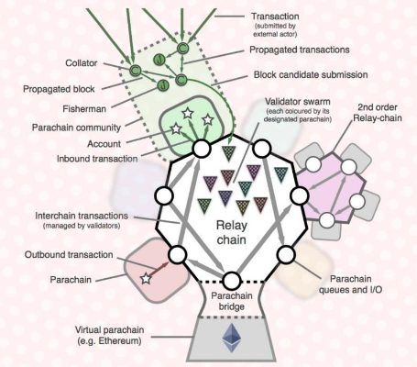

The high-profile project Polkadot is a cross-chain technology that needs to open up all chains. The Substrate framework created by its team can just be used as such a blockchain operating system. Users do not need to worry about whether the interaction on the application chain is universal. As long as they access the Polkadot ecosystem, all operations of the application chain should be universal for users. Even a Bitcoin holder can perform corresponding operations on the application chain. In the Web3.0 ecosystem, the application chain can not only seamlessly interoperate the chains built with Substrate, but also connect existing blockchains, such as Bitcoin, Ethereum, and EOS through a bridge. From the perspective of network effects, such a connection will bring network ride-hailing traffic to the new application chain. The cost of blockchain learning for users is greatly reduced, creating a new wave of blockchain technology dividends.

**Main functions of the application chain:**

303b333633373436313bbcfdcdb7Interoperable settlement layer. As we can see from the Polkadot's architecture diagram, parachains can interoperate through verification nodes in the relay chain, which of course includes basic operations such as transfers.

303b333633373436313bbcfdcdb7Basic user data of the application chain (user account, authority, token ledger).

303b333633373436313bbcfdcdb7Carrier of the application chain operation (smart contract virtual machine, running platform).

## 4.3 Substrate and Access Slots

The Substrate framework modularizes many functions of the blockchain. It is only a matter of choice for developers. In addition, it maintains many customizable functions and modules, such as the underlying communication module, account system, and consensus mechanism.

The underlying operating system framework of a blockchain must meet at least the following five requirements:

303b333633373436313bbcfdcdb7Modular functions

303b333633373436313bbcfdcdb7Interoperability of data and assets

303b333633373436313bbcfdcdb7Transaction scalability

303b333633373436313bbcfdcdb7Decentralized governance and iterative upgrade

303b333633373436313bbcfdcdb7On-demand security

We use Substrate to build our own application chain. Polkadot plus Substrate can meet all the five basic requirements. Modular functions are the biggest highlight of Substrate. As long as you use Substrate to develop a blockchain, you will enjoy the loosely coupled modules. The following figure shows the division of modules by Substrate.

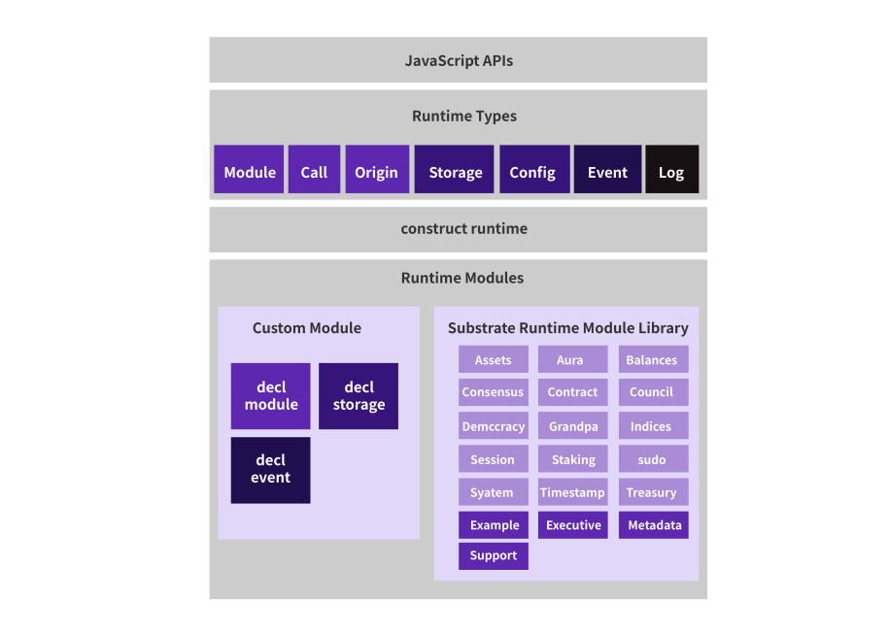

The interoperability of data and assets requires the use of Polkadot's functions. As we can see from the Polkadot architecture diagram, as long as we are connected to the Polkadot slot, the validator node of the relay chain can verify the data and assets to open up with other parachains connected to the slot. Of course, we can also communicate with the existing main blockchain through the connection bridge. This connectivity solution can also be expanded through the second-layer relay chain.

Transaction also requires scalability for an application. When a parachain cannot support the transaction of a certain application chain, new parachains can be used to continuously expand the transaction. Therefore, in the ecology of Polkadot plus the rapid development of Substrate, developers can easily meet the ever-expanding demand. Of course, when a relay chain cannot meet the demand, multi-layer relays can also be used to continuously expand the number of parachains.

Substrate's framework is naturally friendly to governance. The biggest problem of blockchain development so far is the source of credit. Blockchain is said naturally trustworthy, which is correct to a certain extent. It is indeed verifiable, If, like Ethereum, it cannot be changed once the contract is released. As long as it is verifiable, it is trustworthy. No one needs to trust the person who issued the contract because they can verify it themselves. However, the problem is that the contract cannot be iteratively upgraded. Blockchain products that have been launched definitely evolve iteratively, and iterative upgrades should be realized. As a launched application chain service, the system certainly needs to achieve the characteristics of iterative upgrade. However, by doing so, it needs to solve the problem of trust and disallow unauthorized upgrade by the developer. It is absolutely a bad idea if we have to trust the developer unconditionally. Upgrade requires a governance structure, which combines on-chain and off-chain governance, so that the application chain can iteratively adapt to market development needs.

Every developer needs to consider on-demand security distribution. The cost of absolute security is high. Relative security is good enough for application chains in certain scenarios. The security of the Polkadot ecosystem can be provided through its own consensus mechanism, or provided through Polkadot's consensus mechanism. After access to the slot, you do not need to maintain the verification node by yourself, which enables you to focus on application and function realization.

## 4.4 Design Requirements of the Application Chain

303b31373432363132393bcafdd7d631Application data and settlement data do not need to be stored on a blockchain. Most application data can be stored in the centralized storage service provider on the chain.

303b31373432363133333bcafdd7d633303b31373432363133303bcafdd7d632Data of multiple applications do not need to be mixed and coexist on the same blockchain. All smart contracts are stored in a virtual machine on the main chain in order to ensure equivalent safety, while keeping the cost reasonable. There can be multiple application modules to effectively separate multiple application data.

303b31373432363133343bcafdd7d634The number of nodes of the application chain matches its service implementation needs. The importance of data matches the degree of data security provided by the blockchain application chain. The system will focus on reasonable matching instead of believing in complete decentralization.

All application calculations do not need to pay equal handling fees. If there is only one main chain like Ethereum, then its price estimation for all the operations in the smart contract is homogeneous. The price lacks a hierarchical plan. The system will design different gas costs in different application modules.

303b31373432363133353bcafdd7d635303b31373432363133363bcafdd7d636All transaction operations do not require equal mining costs. Different transactions have different value. The system will use application chain technology to store most of the transactions on the application chain. Mining uses the main chain multi-currency conjugate mining method to achieve income in multiple currencies.

Is a unified computing virtual machine on the main chain unnecessary? For different smart contracts, the difference in importance is self-evident, so for the importance of the data that need to be saved. If a main chain is used for vertical implementation, serious performance expansion problems will occur, like Ethereum. The overburden of data synchronization can also cause security problems. The system application chain can take charge of the two parts. Each application module solves the problem of insufficient performance of the main chain, and the data storage solves the scalability problem of data governance.

## 4.5 Advertising Sidechain Design

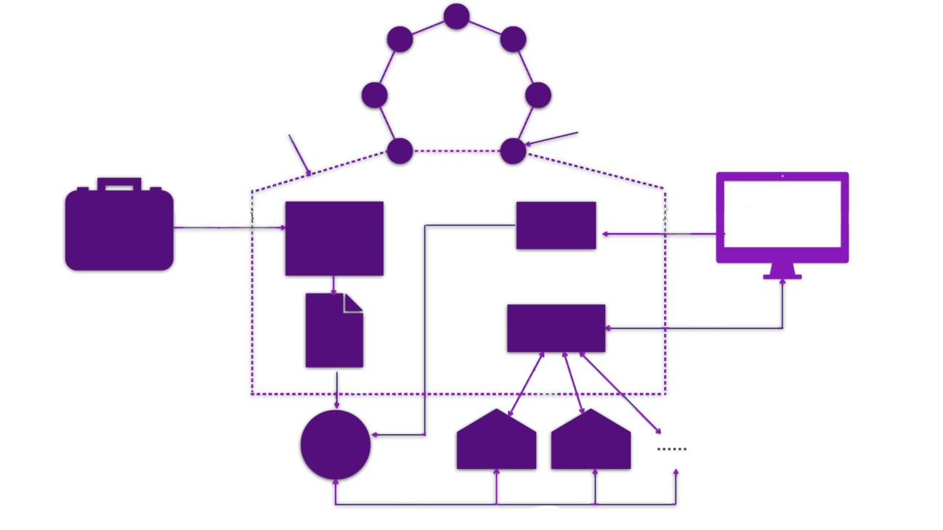

Advertiser

Content hosting engine

User log

Matching engine

Smart contract

Event notification

Oracle A

Oracle B

Upload content and plan

Display

Display

Request

return

return

Request

Monitor

Notice

Audience recall

Digital media

The entire service scenario consists of three main parts:

303b363738323639313bb5e3Advertising by advertisers

303b363738323639313bb5e3Display on digital advertising media

303b363738323639313bb5e3User behavior recall

**4.5.1 Advertising by Advertisers**

Advertiser posts advertising needs to the advertising trading platform, and advertisement producers participate in the bidding; the bid winner begins to produce multimedia advertising content, including but not limited to pictures, videos, web pages, AR, and VR. The production is completed and delivered to the advertiser.

Advertiser draws up costs, formulates advertising plans, and calls the upper-level application interface to upload advertising content and advertising plans. After the blockchain client receives all the upper-level applications and calls, it creates a transaction containing the original advertisement request. After the verification node in the sidechain receives the transaction created by the blockchain, it will verify the signature to ensure that the transaction is legal. If yes, it will start the advertising hosting engine and add the transaction information in the pending queue. In a decentralized network, advertisers and advertising producers may do bad things together. Therefore, advertising content must be reviewed and approved by the entire network. When the review is completed, the ad hosting engine starts tasks in parallel:

303b333633373436313bbcfdcdb7Extract features of advertising content and generate Meta Data;

303b333633373436313bbcfdcdb7The advertising content is divided into pieces, and each piece is encrypted, and a hash index and merkle root are generated;

303b333633373436313bbcfdcdb7Advertiser's delivery plan, metadata and content hash index are used to generate the advertisement smart contract;

When the task is completed, the advertising hosting will include the advertisement smart contract in the newly added block, and at the same time broadcast the new delivery plan to the entire network as a message. The oracle receives the message, pulls the smart contract from the chain and perform the search.

**4.5.2 Display on Digital Advertising Media**

When the audience watch the digital advertising media, the digital media collects user information through edge computing, creates a unique digital identity for each user, and sends the user's digital identity to the advertising matching engine. The advertising matching engine sends the media attributes and the user's digital identity to the oracle participating in the advertising ecology, and waits for the oracle to return the recommended advertising content.

Inside the oracle:

303b363738323639313bb5e3Query user logs based on the user's digital identity

303b363738323639313bb5e3Load the smart contract according to the index

303b363738323639313bb5e3Analyze user logs and extract user characteristics

303b363738323639313bb5e3Match user characteristics, filter contracts, estimate click-through rate

303b363738323639313bb5e3Calculate the ranking of advertisements based on the bidding price in the delivery contract

303b363738323639313bb5e3Return recommended advertising content

After receiving the advertising content returned by different oracles, the matching engine selects the content recommended by the oracles with better effect and reputation based on internal algorithms and probability weighting, and returns the hash value of the final advertising content to the digital media.

The digital media obtains the hash value of the advertising content, and requests the key and streaming media content from the advertising hosting engine, decrypts the returned key in the system's internal trust zone (Trust Zone) and generates the streaming media content decryption key, and uses the key to decrypts each piece of streaming media content and plays the advertising content to the audience.

After the display is completed, the display result is broadcast to the entire network, the user log is updated, and the single display amount in the smart contract is automatically transferred to the digital media and the oracle that makes this recommendation.

**4.5.3 User Behavior Recall**

Digital media needs to perform event tracking for the follow-up behavior of the advertising audience before the advertisement is displayed. After the advertising audience watch the advertisement in the digital media, the digital media needs to continuously collect the follow-up behaviors of the audience, such as whether the audience clicks, whether to watch repeatedly, whether to generate related consumption, and complete the user log on the chain. In addition, the audience can also set their own preferences, monetize their own data, and open it to traffic providers to match advertisements that they are more interested in.

All the data generate an intermediate key (Diffie-Hellman Key Exchange) based on the user's public key. The intermediate key can be used to encrypt user information and send the information (HTTPS) to the on-chain user log, which is encrypted and stored by AES256. Digital identities and assets based on blockchain technology are both open, anonymous and immutable. Therefore, they can solve the problem of false traffic that has plagued the advertising industry for many years once and for all.

**4.5.4 Technical Features of Advertising Sidechains**

The oracle needs to achieve massive real-time response, and the advertising content needs to be returned to the front-end display in an average of 100 ms. It is difficult to meet the requirements in a decentralized network. Substrate combines decentralization and centralization. The system adopts off-chain computing and on-chain verification to meet real-time requirements.

The sidechains need to integrate the identity system, reputation system, anti-fingerprint system, decentralized voting, and additional anti-fraud technologies to create a significantly more transparent environment that convinces advertisers. At the same time, a series of machine learning algorithms and manual review (voting or phishing punishment) are used to provide a network environment with complete data for publishers and advertisers. All clicks and usage traces will be analyzed by the system in real time. The identity and reputation system guarantees the ecosystem by providing a reliable and protective layer to prevent damage by malicious advertisements, users or publishers.

**4.5.5 Detailed design of sidechain module**

**Managed engine**

The main job of the managed advertisement engine is to encrypt and store the advertisement content in the decentralized environment and generate the smart contract for advertisement. Therefore, it is necessary to construct a special block body, which includes the copyright information of content and the digital content summary.

Considering the existence of untrusted nodes in the distributed system, the integrity and consistency of distributed content need to be confirmed before the content is transferred. The digital content summary generated by the one-way hash function can be used to verify the content and detect data corruption. Copyright information usually contains information such as the content creator or the public key address of the copyright owner.

When the advertisement content owner uploads the resource to the managed advertisement engine, the engine applies the 3DES algorithm among the symmetric encryption algorithms to the resource content, and the total length of the key used is 192 bits, including 168 valid data bits and 24 data check bits. Due to the extremely high security of 3DES algorithm, only exhaustive search attacks can be launched, which means that the key exhaustive space of 168 valid data bits is 2168. Therefore, it is almost impossible to crack the key that adopts 3DES algorithm in a meaningful time range with the attacker's existing computing power. In order to take advantage of the distributed network in terms of resource sharing and content distribution, the same content distributed in the network adopts the same encryption mode, and the decryption key of the resource content is included in the license after encrypting it through the public key of the engine. No matter how the user obtains the resource, the corresponding content cannot be accessed without the license.

When the content is encrypted, the entire digital content summary is generated and written into the advertisement smart contract. The contract also includes the advertiser's serving plan, such as the serving cycle, serving scenario, single-click payment amount, and so on. The managed engine initiates a network-wide broadcast that notifies the oracle to pull the smart contract.

**Matching engine**

A plurality of decentralized oracles utilizes erasure coding technology to achieve answer redundancy, so that the advertisement matching engine is responsible for summarizing the recommended advertisement content in each oracle and selecting the most appropriate advertisement content to broadcast to the chain based on the probability-weighted "recommendation accuracy" of the specific user and the specific advertisement by each oracle. The higher the "recommendation accuracy", the greater the probability of getting a playback, which is eventually played by digital media.

The advertisement matching engine needs to quantify the "recommendation accuracy" of each oracle, that is, the accuracy of the advertisements served by each oracle. Common evaluation algorithms include Area under ROC curve (AUC), Precision & Recall, Average Precision (AP), Normalized discounted cumulative gain (NDCG), etc. In advertising scenarios, advertisers are more concerned with user recall rates, so Recall is used here as a measure. It is assumed that the known behavior of the advertisement audience has been cochained and stored in the user log, so it is only necessary to sample the user data and calculate the recall rate.



Based on the recall rate of the oracle history, the rank distribution under this sampling and the expected value of the recall rate can be calculated.

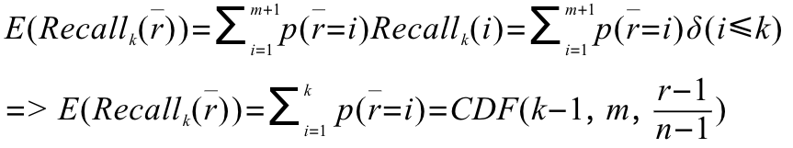

According to the expected value, the "recommendation accuracy" of all oracles can be sorted and the advertisements to be played can be finalized.

**Oracle**

From users' access to digital media to the presentation of advertisement content to users, the system needs to go through a series of processes, such as user tag extraction, advertisement tag extraction, advertisement retrieval, CTR estimation, advertisement sorting, and user behavior recall. Each process contains numerous subprocesses. For example, advertisement sorting includes advertisement bidding logic, budget management and other complex logic calculation. At the same time, due to the particularity of the advertising scenarios, the system needs to serve the advertisement content to the digital advertisement media and display to the advertisement audience in several milliseconds. However, in a decentralized network environment, it is difficult to meet service requirements.

We abstract the service logic of choosing advertisements into the oracle under the chain. Each oracle under the chain provides the basic hashrate to match the appropriate advertisement content for the digital media on the chain. Through the advertisement matching engine, the advertisement content that accurately matches the user attribute is screened out, and the oracle is given a certain reward. In the whole ecology, the better oracle opportunity gets more rewards, prompts the oracle to continuously improve its hashrate and optimize the algorithm, further promotes the continuous development of ecology.

The overall system architecture of the advertisement oracle is as follows:

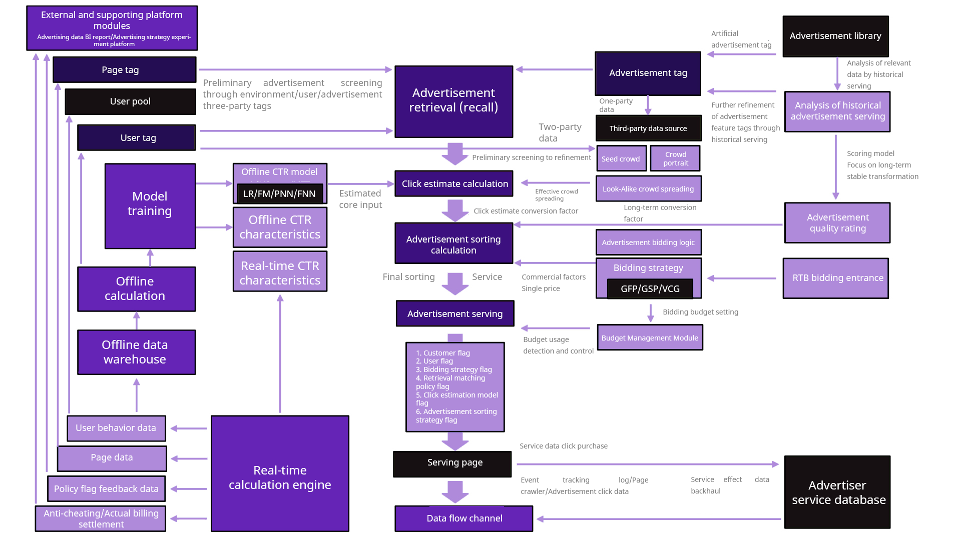

The oracle framework is published in the form of an SDK and provides an open interface for third-party developers to write unique core advertisement recommendations and bidding logic.

**Model and training of advertisement recommendation algorithm**

The entire model consists of two main steps:

303b333633373436313bbcfdcdb7Feature extraction: Using four model units including pressed interaction network (CIN) (xDeepFM), key value memory (Key-Value), Word2Vec and DeepWalk to extract features, and finally merge into tensor.

303b333633373436313bbcfdcdb7Feed neural network training

The user log has extracted the user behavior data and converted it into a text sequence. Therefore, it is only necessary to monitor the message of the user log changes, then append the modified data to the local database of the oracle for analysis. The specific process is as follows:

303b333633373436313bbcfdcdb7Using the word2vec algorithm to embed the advertisement, you can get the embedding about the advertisement content.

303b333633373436313bbcfdcdb7In the recommended scenario, graph structure is presented between data objects in most cases. A typical scenario is the global relationship graph between the advertisement generated by the user behavior data. At this time, the word2vec algorithm can't display this relationship very well, so the system chooses the Graph Embedding mode and uses DeepWalk, which can convert the user's behavior record into a relationship graph.

303b333633373436313bbcfdcdb7Compressed Interactive Network (CIN) is used to further extract data features, mainly considering the following factors:

303b363738323639313bb5e3User behavior is massive sparse data;

303b363738323639313bb5e3Interaction is applied at the vector level, not at the bit level;

303b363738323639313bb5e3High-order feature interaction is explicitly measured;

303b363738323639313bb5e3The complexity of the network does not follow the degree of interaction.

303b363738323639313bb5e3The outer product of each dimension is used for feature interaction, and the resulting tensor is the intermediate result of further learning.

303b333633373436313bbcfdcdb7The neural model of key-value memory is used to realize the mapping of floating-point numbers to vectors.

303b363738323639313bb5e3Compared with the direct use of floating-point numbers, the method preserves more semantic information;

303b363738323639313bb5e3The adjacent vectors of the method have a correlation compared to the method of barreling as a class feature;

303b363738323639313bb5e3Compared with the numerical value × vector method, this method has nonlinear characteristics;

303b363738323639313bb5e3The exposure log records are fully utilized to cluster advertisements based on user behavior.

303b333633373436313bbcfdcdb7Finally, the extracted features are merged and entered into the neural network for training.

With the increase of data in the chain, the system will use the new data cycle to train the model at a certain interval to gradually fit the user's demand for advertisements, so as to achieve the best effect.

**4.5.6 Microservice and Security in Advertising Ecology Sidechain**

The advertising industry often involves multi-party integration and complex service logic. In order to facilitate the deployment and the operation and maintenance, the microservice architecture, container and other related technologies will be adopted. For the sake of security, advertisement ecology wants to add CA authentication to digital media.

For complex service scenarios, the system expects to try to modularize all system functions so that invoking across various services can be implemented using microservice frameworks such as gRPC-based and HTTP2-based microservice frameworks for communication between modules and cross customers. For example, if the verification results are clustered by microservices to increase the throughput of endorsed nodes, Docker or Kubernetes management makes it very easy to expand and increase the number of nodes, and microservices can also reduce the distribution pressure.

# 5 Jambo Application Ecology

## 5.1 Advertiser

Jambo uses the characteristics of blockchain to realize transparent and credible value ecology of decentralized advertising industry. Advertisers can use the platform for blockchain-based user and advertising space purchases and use smart contracts to sign media purchase contracts, so as to enhance ecosystem transparency and trust.

**5.1.1 Application Role**

Advertisers, sponsors, homogeneous product competitors, etc.

Requirements of project investors: Competitive products, brand building, increase of user traffic, etc.

**5.1.2 Homogeneous Competitive Projects**

Take the first year of DeFi's explosive growth 2020 as an example, countless DeFi projects can be roughly divided into deposit and loan class, decentralized algorithm stablecoin class, aggregation class, AMM class, derivative class and other homogeneous competitive projects, and these advertisers have a high demand for promotion and information spreading.

However, on the other hand, due to this wave of DeFi, there are a lot of projects based on the DeFi concept on the market. Users swarm forward for DeFi service. This may lead to information congestion, data fraud and other issues, so that project information cannot be accurately and effectively communicated to users.

**5.1.3 Jambo Precise Serving**

At present, users get blockchain project information through community, blockchain media, KOL and other channels, but these channels have common problems with traditional media:

(1) Traffic fraud;

(2) Inaccurate information;

(3) User privacy issues;

(4) Spreading efficiency and serving accuracy.

Jambo uses the characteristics of blockchain to realize transparent and credible value ecology of decentralized advertising industry. Decentralized advertising link bridge: Smart contract set on Polkadot Parachain.

(1) Semantic analysis contract: The natural semantic analysis engine can accurately analyze the demand of advertisers and the supply of advertising channels.

(2) Smart matching contract: Match the supply and demand of advertisers and advertising channels.

(3) Security audit contract: For cheating behaviors such as click farming, the system will automatically deduct the security deposit pledged by the advertising channels.

## 5.2 Advertising Channel

Through Jambo, the whole ecology can be optimized, the complex and high-cost middle links can be simplified, and the new business model can be formed through the new mode of nodes on the chain.

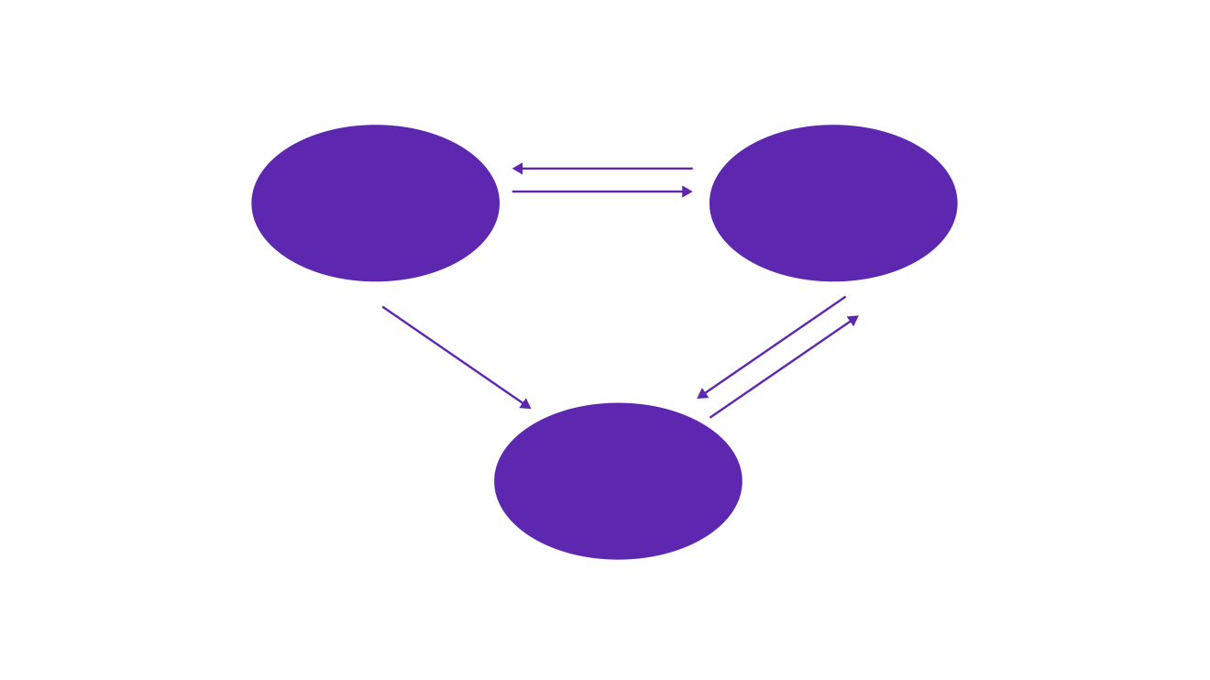

Publisher

Advertiser

User

Bidding

Accept

Advertisement serving

Advertisement impression archive

Anonymous feedback of advertisement impression

During advertisement serving, advertisers target end-users, and users gather in search engines, social networks, portals and so on. The original digital advertisement mode is that the advertiser requests the demand side platform (DSP) and pays for it. According to the programmed advertisement transaction and information flow ads purchase, the advertiser changes from buying the advertisement space to buying users. By precisely controlling his own serving crowd and budget, the advertiser can achieve the best conversion effect by means of integration of advertisement creativity and content. Precise serving is an improvement on advertisement space purchase. But among them, large traffic owners, like Google, [Baidu](https://36kr.com/projectDetails/28215" \t "https://36kr.com/p/_blank)will still obtain huge intermediary revenue, which is provided by Internet users for free.

Jambo advertising protocol matches the right channel, integrate channel resources, classify data and cochain, which change the original business model.

**Smart contract:** With smart contracts, advertisers can directly communicate with the media for pricing matters, resulting in a reduction of costs. Advertisers can collect feedback information and archive users' preferences, allowing them to get more accurate data and better rewards.

**Data transparency:** The media serves the advertisements to users, and then the users provide feedback on the impression of the advertisements to the advertisers based on data immutability in blockchain. In this feedback operation, since the blockchain is anonymous, the user privacy can be effectively protected.

**5.2.1 dApp Market Potential**

Currently, advertising display service is not involved in wallet, gaming, social media, finance and other decentralized applications (dApp), which will become one of the Jambo strategic ecological expansion.

Through the Jambo cross-chain slot, both advertisers and channels can choose the appropriate advertisement form to serve by one click through the Jambo advertising protocol. The viewer crowd, coverage area, play time, play times and other information are recorded on the chain, which creates a rich new ecology of advertising media on the chain, leading the development of the blockchain advertising industry.

## 5.3 Advertising Users

At present, users' access to project information is generally spread through the media or communities in the blockchain industry, and there is no effective way to accurately deliver industry information to the target users. Moreover, the current blockchain media still has the same defects as the traditional media, such as traffic fraud, high cost, low efficiency and invalid information.

Jambo always puts the authenticity, traceability and low cost of advertisement information in the first place, and will adopt a distributed system to avoid fraud and opaque advertisement. And it accurately depicts the users' portraits, displays the information most suitable for the users' needs, realizes the precise serving of advertisements, reduces the infinite play to the maximum extent, and combines the live broadcast, shopping mall, consultation, small games and other diversified content, so that the advertisement information is no longer single and boring, greatly improving the users' experience.

Throughout the advertising process, Jambo is based on tokens and smart contracts to ensure that participants can openly, fairly and retroactively submit needs, pay and obtain benefits.

As the carrier of ecological value, Jambo takes platform equality as a benchmark. Jambo token can let users get corresponding real-time economic reward through watching advertisements and other behaviors, and even can get the distribution of advertisement fee generated by the screen through pledge Jambo. In this way, information becomes more valuable flow between advertisement flows, and the user is no longer the party whose interests have been damaged all the time. This process constructs an interest community of advertisement value.

# 6 Token System

## 6.1 Introduction of Token

Jambo is the value carrier of Jambo ecology, using Jambo's stable ecosystem to provide the value of long-term effective Jambo growth. The value dividend of the Jambo distributed network can be shared at Jambo by advertisers, channels, or users, and Jambo will be used as the only means of value exchange:

303b363738323639313bb5e3Cross-chain services on Jambo technology platform

303b363738323639313bb5e3Liquidity pledge of Jambo advertising alliance

303b363738323639313bb5e3Exchange media of advertising and channels

## 6.2 Token Distribution

In order to effectively stimulate the builders and ecology participants of the advertising alliance and realize the ecological growth of the blockchain advertisements of the platform, a total of 1 billion of Jambo tokens are issued. The number of tokens is constant with no additional issue.

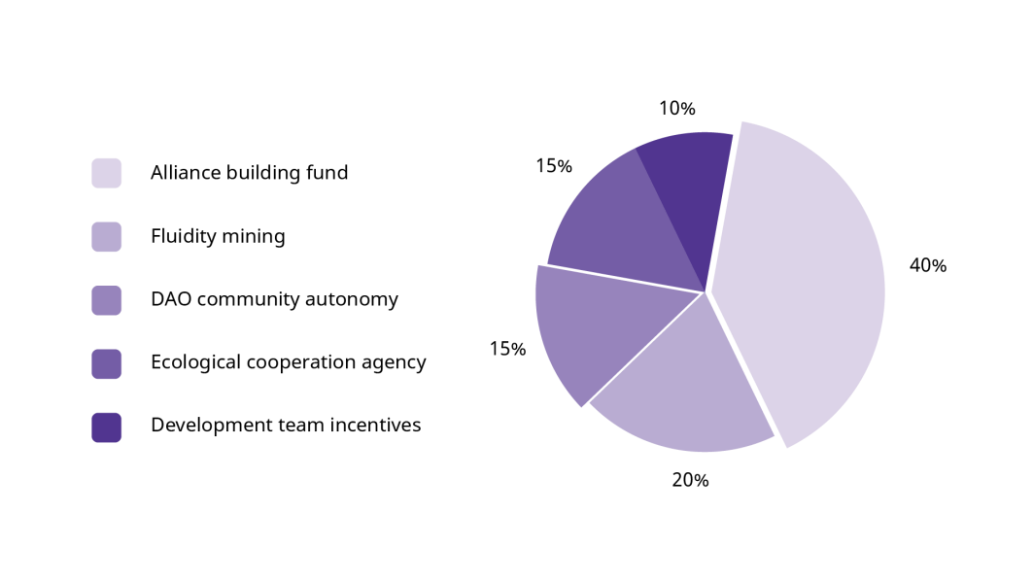

JAM distribution

## 6.3 Functional Value

Ecological application consumption settlement l All projects in the ecology, application settlement and consumption can use Jambo for direct or exchange settlement;

Transaction handling fee discount | As the basis for participating in activities such as handling fee deduction, deduction of various service expenses, and coin-based dividend;

Project go-live deposit | Can be used as a sub-project or contract transaction deposit;

Voting right of ecological autonomy | Participate in Jambo ecological autonomy and have the voting right of ecological construction;

Super partner deposit | Partners with a certain number or proportion of holdings will become super partners and enjoy ecological dividends of the projects;

Subscription right of high-quality projects | Jambo regularly launches preferential promotion combination, which can be purchased with the subscription right.

In order to strengthen the self-cycling "regenerative" development of Jambo ecology, Jambo will be launched by the top R&D and design teams in the world after rational planning and construction based on Jambo's technology accumulation and rich industry resources. As the carrier of ecological token, Jambo will bear all kinds of decisions of Jambo ecology and become a basic component of global community autonomy. It will also provide important channels for users to enjoy participation rights of Jambo blockchain.

**7 Future Prospects**

The earliest blockchain system was born to serve Bitcoin. Because of the rapid development of technology, now it has developed into the cutting-edge technology and core of the whole blockchain world, reflecting the infinite vitality and extremely rapid development process from one aspect. This also lays the technological foundation for the future development of Jambo platform.

As the first blockchain advertising technology support platform, Jambo is committed to achieving transparent and credible value ecology of decentralized advertising industry. With the Polkadot heterogeneous multi-chain architecture, the platform can realize the value interoperability of different advertising industry chains, make the database transparent, greatly improve the service development of blockchain advertising industry, and accelerate the serving efficiency of digital advertising.

Jambo's brand-new ecosystem can be developed from the purchase channel. As a traffic-side platform, it will no longer earn income through advertising sales, but through the operation and maintenance of the ecosystem to enhance the value of its own ecosystem, so as to achieve the purpose of creating income by appreciating the tokens used in the ecology. Under the Jambo ecosystem, the contract system of advertisement will no longer exist. Every user can spread the advertisements. The artificial intelligence system judges how much attention the spreading party's video, text, pictures and other parts containing the advertisement have attracted, and calculates the reward to the user based on attention. Advertisement users can also become advertisement publishers. The advertising industry will show a revolutionary development posture.

Jambo enables the advertising industry's service network to provide transparent, efficient and stable communication services for the industry. We are committed to helping users to participate in blockchain advertising applications, promoting implementation of high-traffic applications in the application ecosystem, gathering new potential development teams to build a large-traffic reference matrix in digital advertising, and affecting the traffic circle of multiple industries and communities, thus enabling more people to enjoy the development dividends of high-traffic applications.

**8 Risk Warning and Disclaimers**

**8.1 Risk Warning**

There are many risks involved in the development, maintenance, and operations of Jambo, many of which beyond the control of the Jambo founding team. Each Jambo token participant should carefully read, understand, and consider the risks described below and carefully decide whether to participate in the token swap program. Participation in the Jambo token swap program will be deemed to be that the participant is fully aware of and agrees to accept the following risks:

**8.1.1 Legal Policy and Regulatory Risk**

Cryptographic tokens are being or may be regulated by competent authorities in different countries. In different countries, Jambo may be defined at any time as virtual commodity, digital asset or even security or currency token. Therefore, in some countries, Jambo may be prohibited from trading or holding in accordance with local regulatory requirements. If relevant regulations are issued by the supervisor, the Jambo founding team may be ordered to suspend or terminate any plans for this token swap program. The development, marketing, advertising or other aspects of Jambo may also be seriously affected, hindered or terminated. As regulatory policy may change at any time, existing regulatory permits or tolerances in any country for Jambo or this public sale proposal may be temporary. If this open Jambo swap program is terminated early, the holders may only be partially refunded due to the price fluctuation of Ethereum and the expenses of the Jambo founding team.

**8.1.2 Project Team Risk**

At present, there are many teams and projects in the blockchain technology field, accompanied by fierce market competition and intense project operation pressure. Whether the Jambo project can come out ahead in many excellent projects and be widely recognized is not only related to its own team ability and vision planning, but also affected by market competition, even potential cutthroat competition. The core members of the Jambo community have many years of experience in the insurance industry and the knowledge accumulation of blockchain technology, which can attract more talents to the community. However, we cannot rule out the possibility of negative impact on the Jambo project as a whole due to community core personnel outflow, internal conflicts or other issues.

**8.1.3 Technical Risk**

Computer technology and cryptography is constantly developing and improving, so we cannot guarantee absolute security at any time, which may lead to the theft, disappearance, destruction or depreciation of the holder's Jambo. Although the Jambo founding team strives to secure the Jambo network, we cannot guarantee that there are no weaknesses or permissions in Jambo. Besides, anyone may intentionally or unintentionally bring weaknesses or defects into the core infrastructure elements of Jambo that the Jambo founding team cannot prevent or remedy through the security measures it adopted. This may ultimately result in the loss of the participant's Jambo or other digital tokens. In addition, the source code of the Jambo may contain certain flaws, errors, defects, and vulnerabilities, which may prevent the user from using specific features, exposing the user's information, or causing other problems. If such defects really exist, they will compromise the availability, stability, and/or security of Jambo, and therefore have a negative impact on the value of Jambo. Open source code is fundamentally transparent to facilitate community-based code identification and problem resolution.

The Jambo founding team will work closely with the Jambo community to continuously improve, optimize and refine Jambo source code in the future. The rapid development of Jambo will be accompanied by a sharp increase in transaction volume and the increasing demand for handling capacity. If the demand for handling capacity exceeds the load available within the network at that time, the Jambo network may be paralyzed or stagnated, and there may be incorrect transactions. In the worst case, anyone may lose their Jambo holdings. These events could compromise the usability, stability, and safety of Jambo and the value of Jambo. In addition, Jambo is still in the development phase, and the Jambo founding team may face unpredictable or insurmountable difficulties from time to time due to the technical complexity of the Jambo system. Therefore, the development of Jambo may fail or be abandoned at any time for any reason, such as lack of funds. Failure or abandonment of development will result in the failure of Jambo to be delivered to participants of the swap program.

**8.1.4 Security Risk**

Attacks from outside can negatively impact, stagnate, paralyse, or even incorrectly compute the Jambo system, and therefore cause transactions on top of this to be delayed or even temporarily unexecutable, or cause data errors, crashes, or loses, compromising the availability, reliability, security, and value of Jambo. In addition, attempts may be made to steal the funds received by the Jambo founding team from public sales, including those that have been converted into fiat money tokens. Such theft or attempted theft may affect the ability of the Jambo founding team to fund Jambo development. Although the Jambo founding team will take steps to secure raised funds, it will be difficult to stop theft once and for all.

**8.1.5 Source Code Upgrade Risk**

The source code of Jambo is open source and may be upgraded, amended, modified or changed from time to time by any member of the Jambo community. No person can predict or guarantee the exact result of an upgrade, amendment, modification or change. As a result, any upgrades, amendments, modifications, or changes may result in unpredictable or unexpected results that significantly adversely affect the operation of the Jambo or the value of the Jambo.

**8.1.6 Risk of Unauthorized Jambo Claim**

Anyone who gains access to a registered email address or account by decrypting or cracking the Jambo holder's password will be able to maliciously obtain the Jambo token of the Jambo holder. Accordingly, the holder's Jambo token may be sent to another person's Jambo address, and such sending is irrevocable and irreversible. Each Jambo holder should take measures to properly maintain the security of his/her registered email address or account, such as: (i) set complex, high-security passwords; (ii) do not open or reply to any fraudulent email; (iii) strictly keep his/her confidential or personal information secret and adopt other related security measures.

**8.1.7 Market Risk**

The value of Jambo depends largely on the market development and user acceptance of the Jambo platform. Jambo is not expected to be popular, prevailing or widely used shortly after its offering. In the worst case, Jambo may even be marginalized for a long time, attracting only a small number of users. By contrast, a large proportion of Jambo demands may be speculative. Lack of users may lead to increased price fluctuations in the Jambo market, thus affecting the long-term development of Jambo. When such price fluctuations occur, the Jambo founding team will not and has no responsibility to stabilize or influence the market price of Jambo.

**8.1.8 Liquidity Risk**

Jambo is neither a currency token issued by any person, entity, central bank or national organization, or does it have any hard assets or other credit support. The circulation and trading of Jambo in the market is not the responsibility or pursuit of the Jambo founding team. Jambo trading is based solely on the consensus of the relevant market participants on its value. No one is obliged to redeem any Jambo from the Jambo holders and no one can guarantee to any extent the liquidity or market price of the Jambo at any time. To transfer Jambo, the Jambo holder needs to look for one or more persons interested in swap. The process may be costly, time-consuming, and ultimately unsuccessful. In addition, Jambo may not be available for public trading on cryptocurrency token exchanges or other markets.

**8.1.9 Price Fluctuation Risk**

When traded on the open market, encrypted tokens generally fluctuate in price. Price oscillations are common in the short term. The price may be calculated in Bitcoin, Ethereum, United States dollars or other fiat money tokens. This kind of price fluctuations may be caused by market forces (including speculative trade), changes in regulatory policies, technological innovations, availability of stock exchanges and other objective factors, which also reflects changes in supply and demand balance. Regardless of whether or not there is a secondary market for Jambo trading, the Jambo founding team is not responsible for Jambo trading in any secondary markets and is not obligated to stabilize the price fluctuations of Jambo. The risks involved in the Jambo transaction price shall be borne by the Jambo traders.

**8.1.10 Competition Risk**

The underlying protocol of Jambo is based on open source computer software. No one claims copyright or other intellectual property rights in the source code. Thus, anyone can legally copy, duplicate, reproduce, design, modify, upgrade, improve, re-encode, re-program, or otherwise utilize Jambo's source code or underlying protocol to develop competitive protocols, software, systems, virtual platforms, virtual machines, or smart contracts to compete with, or even catch up with or replace Jambo, which is beyond the control of the Jambo founding team. Under no circumstances can the Jambo founding team eliminate, prevent, limit, or reduce these competitive efforts to compete with or replace Jambo.

**8.1.11 Risk of Insufficient Information Disclosure**

As of the release of this White Paper, Jambo is still in the development phase, and its philosophy, consensus mechanisms, algorithms, code, and other technical details and parameters may be updated and changed frequently. Although this White Paper contains the most up-to-date key information about Jambo, it is not entirely complete and will be adjusted and updated from time to time by the Jambo founding team for specific purposes. The Jambo founding team is not able and obligated to keep participants informed of every detail in the Jambo development (including its progress and expected milestones, whether delayed or not), so it is inevitable that the holders will not have timely and full access to new information in Jambo development. The adequacy of information disclosure is avoidable and reasonable.

**8.2 Disclaimers**

This white paper is for informative purpose only. The contents in the document are for reference only and do not constitute any proposal, solicitation or offer to investing in or buying and selling digital goods, shares or securities. Such offers must be in the form of a confidential memorandum and in accordance with the relevant securities and other laws.

The contents of this document shall not be construed as forced participation in the swap. Any act in connection with this White Paper shall not be regarded as participating in swap, including the request to obtain a copy of this White Paper or to share it with others. Participation in the swap represents that the participant has reached the age standard, has full capacity for civil conduct, and the contract with the Jambo founding team is authentic and valid. All participants signed the contract voluntarily and had a necessary clear understanding of the Jambo prior to signing the contract.

The Jambo founding team will continue to make reasonable attempts to ensure that the information in this White Paper is true and accurate. During the development process, the platform may be updated, including but not limited to the platform mechanism, tokens and mechanism, token distribution. Some of the contents of the document may be adjusted in the new version of the white paper as the project progresses, and the Jambo founding team will release the updated content to the public through announcements on the website or a new version of the white paper. Participants are required to get the latest version of the white paper in time and adjust their decisions based on updates.

The Jambo founding team shall not bear the losses of participants as a result of: (i) reliance on the contents of this document, (ii) the inaccuracies of information in this document, and (iii) any acts caused by this document. The Jambo founding team will spare no effort to achieve the objectives mentioned in the document. However, due to the potential force majeure, the team is not fully committed to achieve all the objectives.

Jambo is an important tool for platform performance, not an investment product. Holding Jambo does not grant its owner ownership, control, and decision-making power over the Jambo platform. As an encrypted token, Jambo does not belong to the following categories: (a) currency token of any kind; (b) security; (c) equity of legal entities; (d) stock, bond, note, warrant, certificate or other instruments conferring any rights.

The appreciation of Jambo depends on the market rules and the demand after the application is landed, and it may not have any value. The Jambo founding team makes no commitment to its appreciation and is not responsible for its consequences due to the increase or decrease in value. To the fullest extent permitted by applicable law, the Jambo founding team shall not be liable for damages and risks arising from participation in the swap, including, but not limited to, direct or indirect personal damages, loss of business profits, loss of business information or any other financial losses.

The Jambo platform complies with any regulatory regulations and industry self-regulatory statements that are conducive to the healthy development of the industry. The participation of participants means that such supervisions will be fully accepted and complied with. At the same time, all information disclosed by participants to complete such supervisions must be complete and accurate. The Jambo platform clearly communicates the possible risks to the participants, and once the participants participate in the swap, it means that they have confirmed that they understand and accept the terms and conditions of detailed regulations, and accept the potential risks of this platform at their own risk.