3.3 System Architecture
The Fuel Station Locator follows a client-server architecture. This means the app is split into two sides — the client side, which is what the user sees and touches on their phone, and the server side, which stores all the data and handles everything happening behind the scenes.
The client is the Flutter mobile app running on the user’s Android phone. When a user opens the app, searches for a station, or submits a report, the app communicates with the server in real time to fetch or save the relevant information. The server side is made up of three main services provided through Firebase and Google.
Firebase Authentication handles everything related to user accounts. When someone creates an account or logs in, Firebase Authentication verifies their identity and grants them access to the reporting features of the app. Users who are not logged in can still browse the map and view station details, but they cannot submit reports or upload photos.
Firebase Firestore is the main database. It stores all station information — names, locations, fuel types, operating hours — as well as user-submitted reports, ratings, and feedback. Firestore updates in real time, which means when one user submits a price update, other users nearby see it immediately without refreshing.
Google Maps and Places API powers everything map-related inside the app. It displays the live map, finds nearby fuel stations based on the user’s location, and provides turn-by-turn directions to any station they choose.
Firebase Storage handles user-uploaded photos. When a logged-in user submits a report and includes a photo as proof, that image is stored securely in Firebase Storage and linked to the relevant report in Firestore.

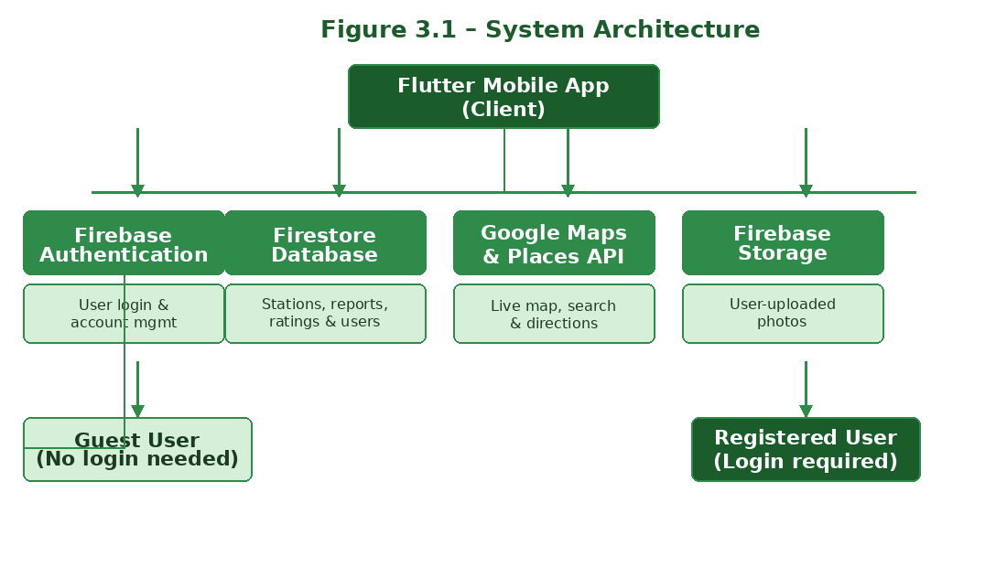
Figure 3.1 – System Architecture of the Fuel Station Locator App
3.4 Block Diagram — Component Level
At the component level, the Fuel Station Locator app is made up of four main layers that work together to deliver the full experience to the user.
Layer 1 — The User Interface (Flutter): This is the front-end layer — the screens the user interacts with directly. It includes the map screen, the search and filter screen, the station details screen, the report submission screen, and the login and sign-up screens. This layer is built entirely in Flutter using the Dart programming language.
Layer 2 — The Application Logic: This layer handles what happens between the user’s actions and the data. When a user taps a station on the map, the application logic fetches that station’s details from Firestore and displays them on screen. This layer also enforces the access rules — ensuring only logged-in users can submit reports.
Layer 3 — The Backend Services: This layer is made up of Firebase Authentication, Firebase Firestore, Firebase Storage, and the Google Maps, Places, and Directions APIs. These services handle all data storage, user authentication, photo storage, and map functionality.
Layer 4 — The Data Layer: This is where all information lives — station records, user accounts, submitted reports, ratings, and photos. The data is stored in Firestore collections and Firebase Storage, and accessed by the application logic layer in real time.

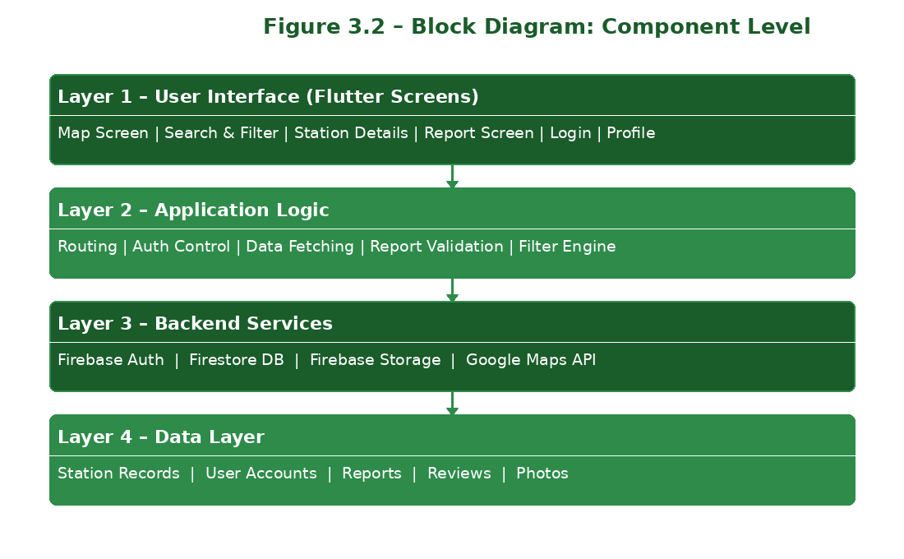
Figure 3.2 – Block Diagram: Component Level
3.5 Schematic of the System
The diagram below shows how a user interaction flows through the system from start to finish. When a user opens the app, the Flutter front-end loads and requests the user’s location from the phone’s GPS. That location is passed to the Google Maps API, which displays a live map centred on where the user is. Nearby fuel stations are fetched from Firestore and shown as pins on the map.
If the user taps a station pin, the app fetches that station’s full details from Firestore — fuel types, address, hours, current community reports — and displays them on the station details screen.
If the user wants directions, the app passes the station’s coordinates to the Google Directions API, which returns a route that is displayed on the map with turn-by-turn instructions.
If the user wants to submit a report, the app first checks whether they are logged in via Firebase Authentication. If they are not logged in, they are taken to the login screen. If they are logged in, they can fill in the report form and optionally attach a photo. On submission, the report is saved to Firestore and the photo is saved to Firebase Storage. Other users in the area see the update immediately.

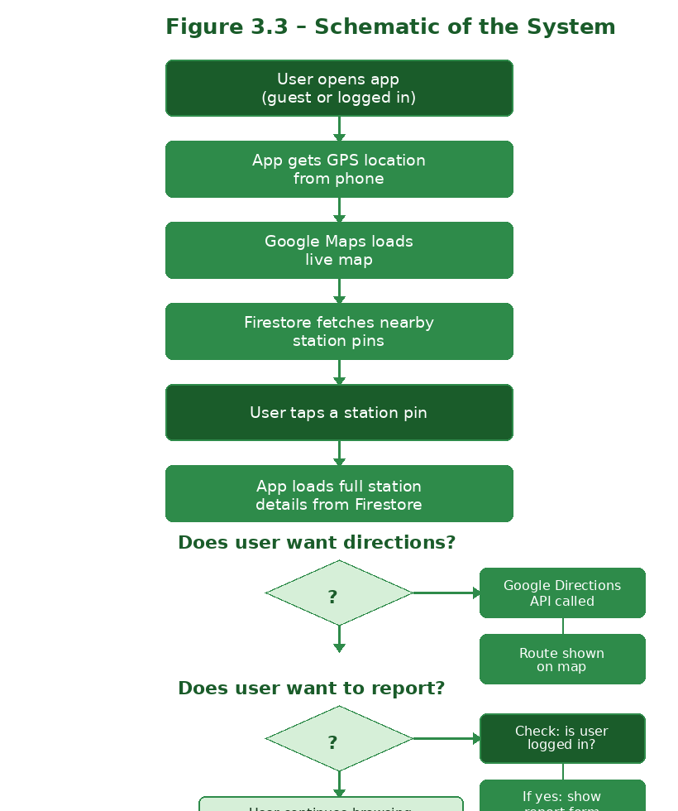
Figure 3.3 – Schematic of the System (User Flow)
3.6 Model of the System
The Fuel Station Locator uses a role-based access model. There are two types of users in the system, each with different levels of access.
Guest Users — Anyone with the app: A guest user is anyone who downloads and opens the app without creating an account. Guest users can browse the live map, search and filter stations by fuel type, view station details, read community reports and ratings, and get turn-by-turn directions to any station — all without needing to log in.
Registered Users — Logged-in account holders: A registered user has created an account and is logged in. In addition to everything a guest user can do, registered users can submit live price reports, update queue length and fuel availability, flag broken pumps or faulty EV chargers, upload photos as proof, and leave ratings and written feedback for stations.
This model ensures that the app is open and useful to everyone, while keeping the quality of reported information high — since only verified account holders can contribute updates.

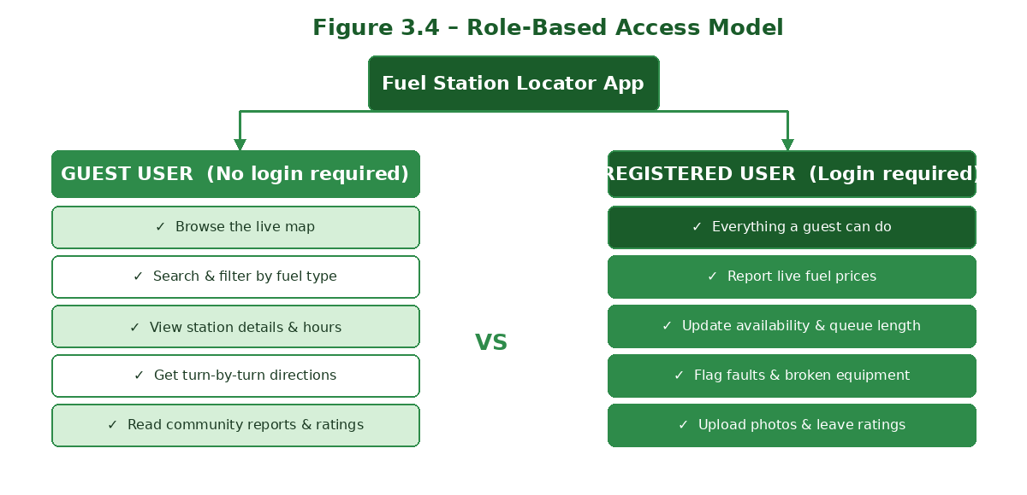
Figure 3.4 – Role-Based Access Model
3.6.1 Data Model
The Firestore database is organised into four main collections. The Stations collection stores each station’s name, GPS coordinates, address, list of fuel types available, operating hours, and contact details. The Reports collection stores each user-submitted update, including the station it refers to, the type of report, the value reported, a timestamp, the user ID of who submitted it, and a link to any attached photo. The Users collection stores basic profile information for each registered user. The Reviews collection stores star ratings and written comments left by registered users for specific stations.

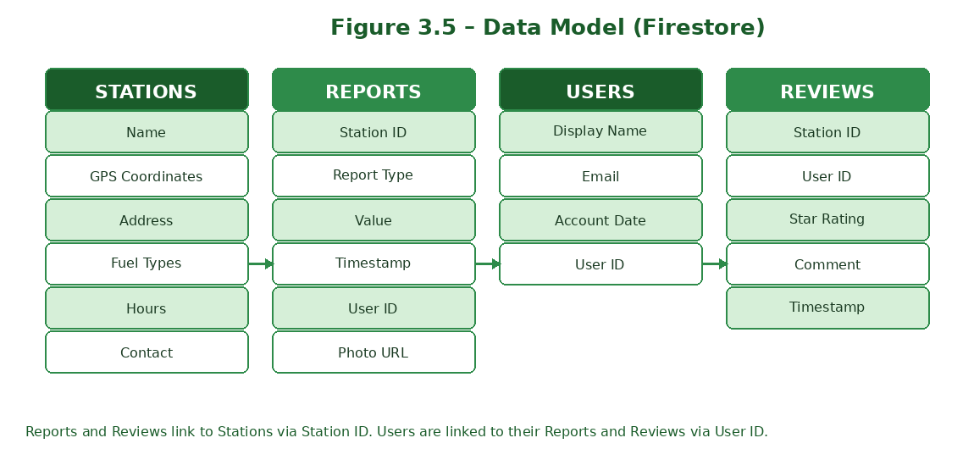
Figure 3.5 – Data Model: Firestore Collections
3.7 Design Process
The design of the Fuel Station Locator went through three stages — user research, interface design, and system design.
User Research: Before designing anything, we thought carefully about the different types of people who will use this app in Ghana. A market woman sending someone to refill her cooking gas cylinder has very different needs from a commercial driver looking for the cheapest diesel along his route. An EV owner hunting for a working charger has different needs again. Understanding all of these users shaped every design decision we made.
Interface Design: The interface was designed to be as simple and clean as possible. The main screen is a map — because finding a nearby station is the first thing most users want to do. From the map, everything else is one or two taps away. Filters are clearly labelled with fuel type names so that any user can understand them immediately. The report screen is a simple form with clear fields — no complicated steps or confusing menus. The colour scheme uses green and white throughout, consistent with the app’s brand identity.
System Design: On the technical side, the system was designed to be scalable. Firebase Firestore handles large volumes of real-time data efficiently, meaning the app can support many users submitting and viewing reports at the same time without slowing down. The app is also designed to work on basic Android phones, since not all users in Ghana will have high-end devices.
3.8 Application Layer — Frontend (Flutter)
Flutter is the framework used to build the entire front-end of the app. Flutter uses the Dart programming language and allows a single codebase to run on both Android and iOS, which saves development time significantly. The app is made up of the following key screens:
Map Screen: The home screen of the app. It displays a live Google Map centred on the user’s current location, with pins showing nearby fuel stations. Each pin is colour-coded by fuel type. The user can tap any pin to see station details.
Search and Filter Screen: Allows the user to search for stations by name or location, and apply filters such as fuel type, distance, and availability. Results are shown as a list or directly on the map.
Station Details Screen: Shows everything about a selected station — fuel types offered, address, opening hours, current community reports, average rating, and a button to get directions.
Report Screen: A form for logged-in users to submit a report. Fields include fuel type, current price, availability status, queue length, fault description, and an option to attach a photo.
Login and Sign-Up Screen: Simple account creation and login screens connected to Firebase Authentication.
Profile Screen: Shows the logged-in user’s account details and their past reports and ratings.
3.9 Backend — Firebase and Google APIs
Firebase Authentication: Handles user sign-up, login, and session management. Users register with an email and password. Firebase Authentication keeps this process secure and straightforward.
Firebase Firestore: The real-time database that stores all station data, reports, user profiles, and reviews. Firestore is a NoSQL database, which means data is stored in flexible documents rather than rigid tables. This makes it easy to add new fields as the app grows without breaking existing data.
Firebase Storage: Stores all photos uploaded by users when they submit reports. Each photo is linked to its corresponding report document in Firestore.
Google Maps SDK: Powers the live map display inside the app. The Maps SDK for Flutter renders the interactive map that users see on the home screen.
Google Places API: Used to search for fuel stations by name or location. When a user types a search query, the Places API returns matching stations with their details.
Google Directions API: Provides turn-by-turn navigation from the user’s current location to the selected fuel station.
3.10 Tools and Technologies Summary
The table below summarises the key tools and technologies used in the development of the Fuel Station Locator app.

What It Does | Tool / Technology
Building the mobile app | Flutter (Dart)
Maps, nearby search & directions | Google Maps SDK, Places API, Directions API
User login and authentication | Firebase Authentication
Storing station data and reports | Firebase Firestore
Storing user-uploaded photos | Firebase Storage
Backup database option | Supabase (PostgreSQL)
Code management and teamwork | Git and GitHub
Development environment | VS Code and Android Studio

3.11 Testing
Once the app is built, it will go through a full round of testing before submission to make sure every feature works correctly and the app is ready for real users.
Functional Testing: Every feature will be tested to confirm it works as expected. Can a guest user browse the map without logging in? Can a logged-in user successfully submit a report with a photo? Does the filter return the correct station types?
Usability Testing: A small group of real users will be asked to use the app and give honest feedback. This will help identify anything that is confusing or difficult to use so it can be fixed before the final submission.
Performance Testing: The app will be tested on a basic Android phone to make sure it loads quickly, the map responds smoothly, and the app does not crash or freeze during normal use.
Security Testing: We will confirm that guest users cannot access reporting features, that user data is stored securely in Firebase, and that no sensitive information is exposed through the app.
3.12 Conclusion
The methodology described in this chapter provides a clear and structured path from planning to delivery. The Waterfall model keeps the project organised and well-documented at every stage. The combination of Flutter, Firebase, and Google Maps gives us a proven, reliable technology stack that is well suited to building a real-time, community-driven mobile application. The role-based access model ensures the app is open for everyone while keeping the quality of user-submitted information high. By following this process carefully, we aim to deliver a complete, well-tested, and fully functional app that solves a real problem for fuel users across Ghana by June 2026.

