CyberLens
  - AI-Powered Threat Detection Intelligence
Table Of Content
INTRODUCTION TO QT CREATOR 1
1.1 What is Qt Creator? 1
1.2 Role of Qt Creator in Application Development 2
1.4 Qt Creator User Interface Overview 3
1.5 Why Qt Creator is Used for Qt Projects 4
1.6 Platforms Supported by Qt Creator 4
DOWNLOADING AND INSTALLING QT CREATOR ON WINDOWS 11 5
2.1 System Requirements 5
2.2 Downloading Qt Online Installer 5
2.3 Selecting Open-Source License 6
2.4 Running the Qt Installer 7
2.5 Qt Account Login 8
2.6 Installation Folder Selection 9
2.7 Component Selection (Qt 6.10.1) 10
2.8 Accepting License Agreements 10
2.9 Launching Qt Creator 11
2.10 Verifying Installation with Test Application 11
CREATING A NEW QT PROJECT & PROJECT STRUCTURE 12
3.1 Starting a New Project in Qt Creator 12
3.2 Project Folder Structure 13
3.3 MainWindow.ui Overview 14
3.4 Main.cpp Overview 15
IMPLEMENTATION DETAILS 16
4.1 Overview 16
4.2 URL Analyzer Implementation 16
4.3 File Scanner Implementation 17
4.5 Connecting GUI to Backend 19
4.6 HistoryManager & ReportGenerator Implementation 20
TESTING & RESULTS 21
5.1 Overview 21
5.2 Test Environment 21
5.3 URL Testing 22
5.3.1 Safe URLs 22
5.3.2 Malicious / Phishing URLs 22
5.4 File Scanning Testing 23
5.4.1 Safe Files 23
5.4.2 Potentially Harmful Files 24
5.5 Offline and Online Mode Testing 24
5.6 History and Report Testing 25

INTRODUCTION TO QT CREATOR

1.1 What is Qt Creator?
Qt Creator is a powerful, cross-platform Integrated Development Environment (IDE) developed by The Qt Company. It is specifically designed for developing applications using the Qt framework and supports programming languages such as C++, QML, and JavaScript.
Qt Creator provides a complete environment for application development, including code editing, graphical user interface design, debugging, and project management. It allows developers to build professional desktop applications efficiently using modern development tools.
Qt Creator is widely used by students, researchers, and professional software developers for creating applications on Windows, Linux, and macOS platforms.

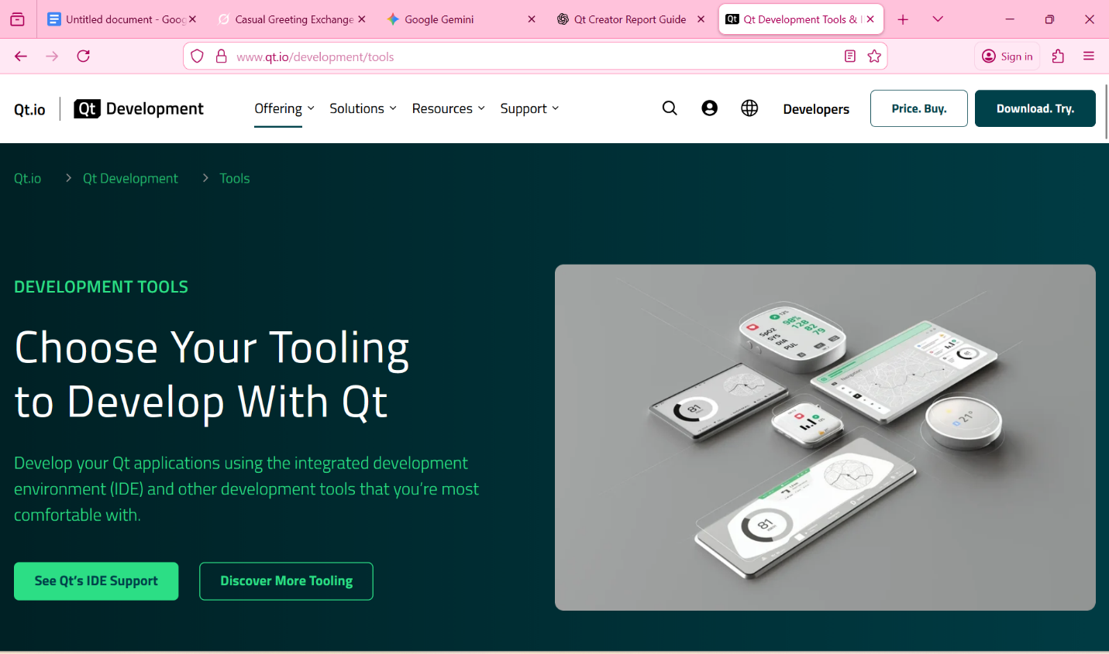
Figure 1.1: Official Qt Creator Development Tools Webpage

1.2 Role of Qt Creator in Application Development
Qt Creator plays a central role in the development lifecycle of Qt-based applications. It combines multiple development tools into a single interface, allowing developers to perform all development tasks efficiently.
Key roles of Qt Creator include:
- Writing and editing source code
- Designing graphical user interfaces using Qt Designer
- Compiling and building applications
- Debugging and testing applications
- Managing project files and configurations
By providing these features in one environment, Qt Creator reduces development complexity and increases productivity.

1.3 Features of Qt Creator
Qt Creator offers a wide range of features that make it suitable for professional software development:
- Advanced C++ code editor with syntax highlighting
- Integrated Qt Designer for GUI development
- Built-in debugger and profiler
- Project management tools
- Support for CMake and qmake
- Version control system integration
These features help developers create high-quality applications with clean code and professional user interfaces.

1.4 Qt Creator User Interface Overview
The Qt Creator interface is designed to be intuitive and user-friendly. It consists of multiple panels and tool windows that assist developers throughout the development process.
Main components of the Qt Creator interface include:
- Code Editor
- Project Explorer
- Form Designer
- Build & Run Controls
- Output and Debug Console

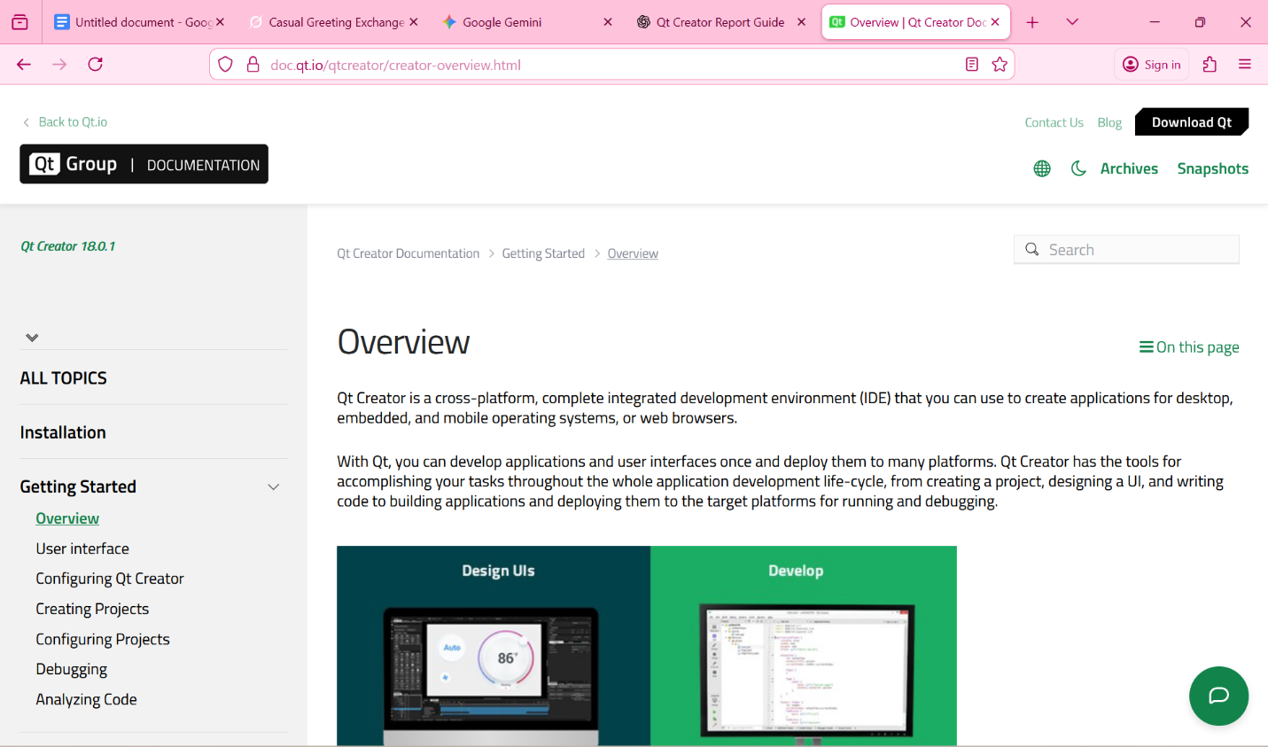
Figure 1.2: Qt Creator Integrated Development Environment Interface

1.5 Why Qt Creator is Used for Qt Projects
Qt Creator is optimized specifically for Qt development, making it the best choice for building Qt applications. It provides seamless integration with Qt libraries and tools, ensuring smooth compilation and execution.
Reasons for choosing Qt Creator include:
- Official IDE for Qt framework
- Excellent integration with Qt 6.10.1
- Strong debugging support
- Easy GUI design using drag-and-drop
- Suitable for beginners and professionals

1.6 Platforms Supported by Qt Creator
Qt Creator supports application development on multiple platforms. Developers can create applications for:
- Windows (Windows 10 and Windows 11)
- Linux distributions
- macOS
This cross-platform capability makes Qt Creator a flexible and powerful development environment.

DOWNLOADING AND INSTALLING QT CREATOR ON WINDOWS 11

2.1 System Requirements
Before installing Qt Creator, the system must meet certain minimum requirements to ensure smooth installation and execution.
Minimum System Requirements:
- Operating System: Windows 11 (64-bit)
- Processor: Intel or AMD 64-bit processor
- RAM: Minimum 8 GB (recommended)
- Disk Space: At least 10 GB free space
- Internet Connection: Required for downloading components
Ensuring these requirements are met helps avoid installation and runtime issues.

2.2 Downloading Qt Online Installer
Qt Creator and the Qt framework are downloaded using the Qt Online Installer, provided officially by The Qt Company.
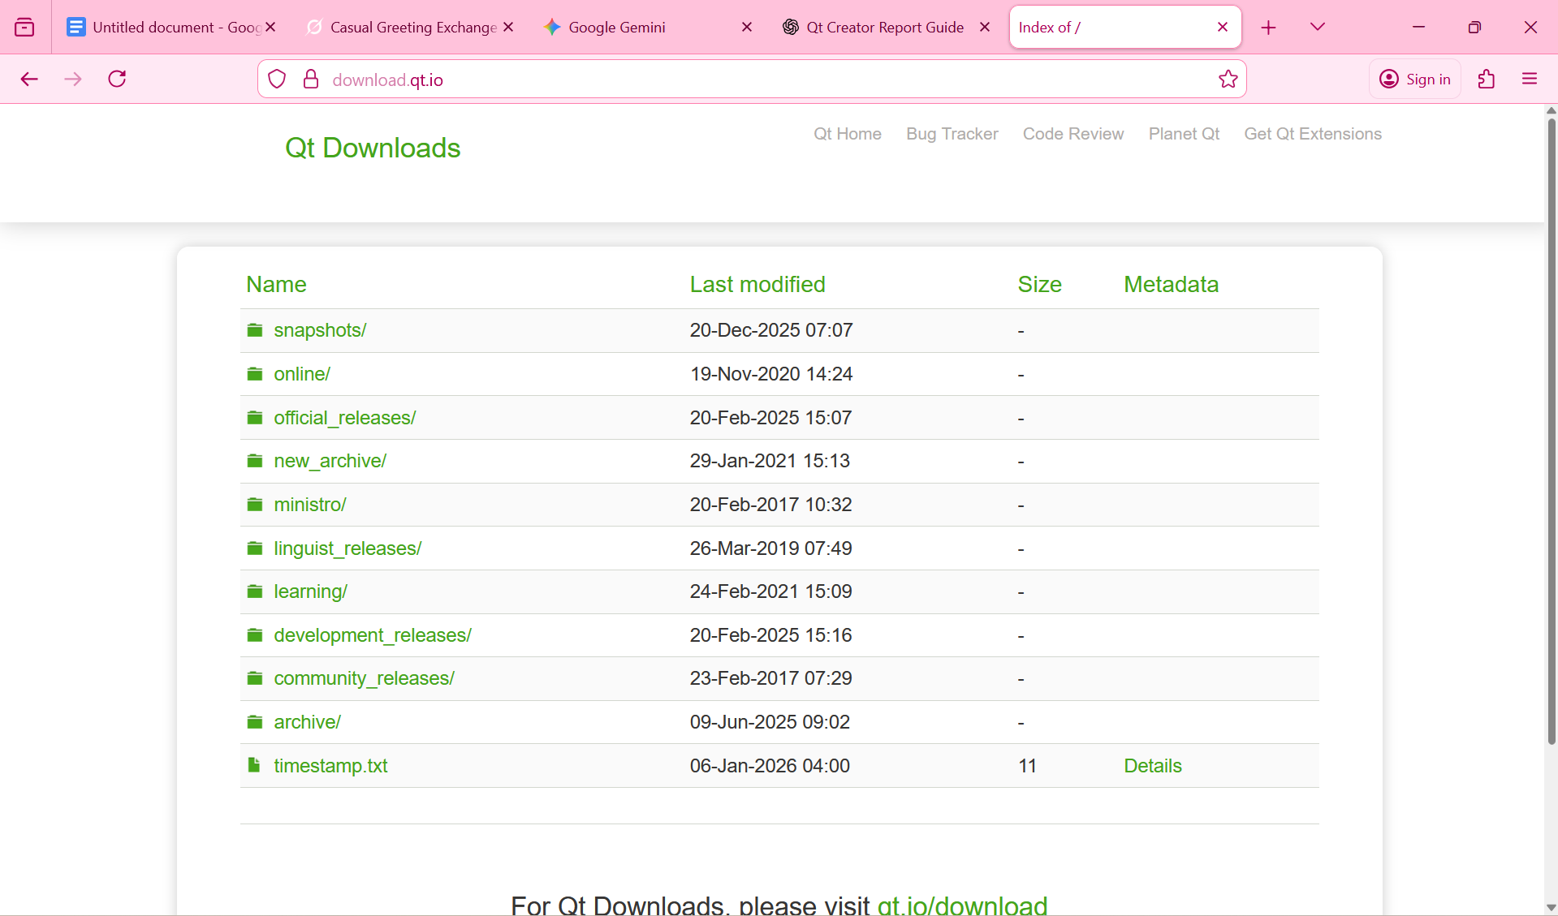
Figure 2.1: Qt Official Download Page

2.3 Selecting Open-Source License
Qt offers both commercial and open-source licenses. For educational and academic purposes, the open-source license is used.
After clicking download:2
- Select Open Source
- Choose Qt Online Installer for Windows
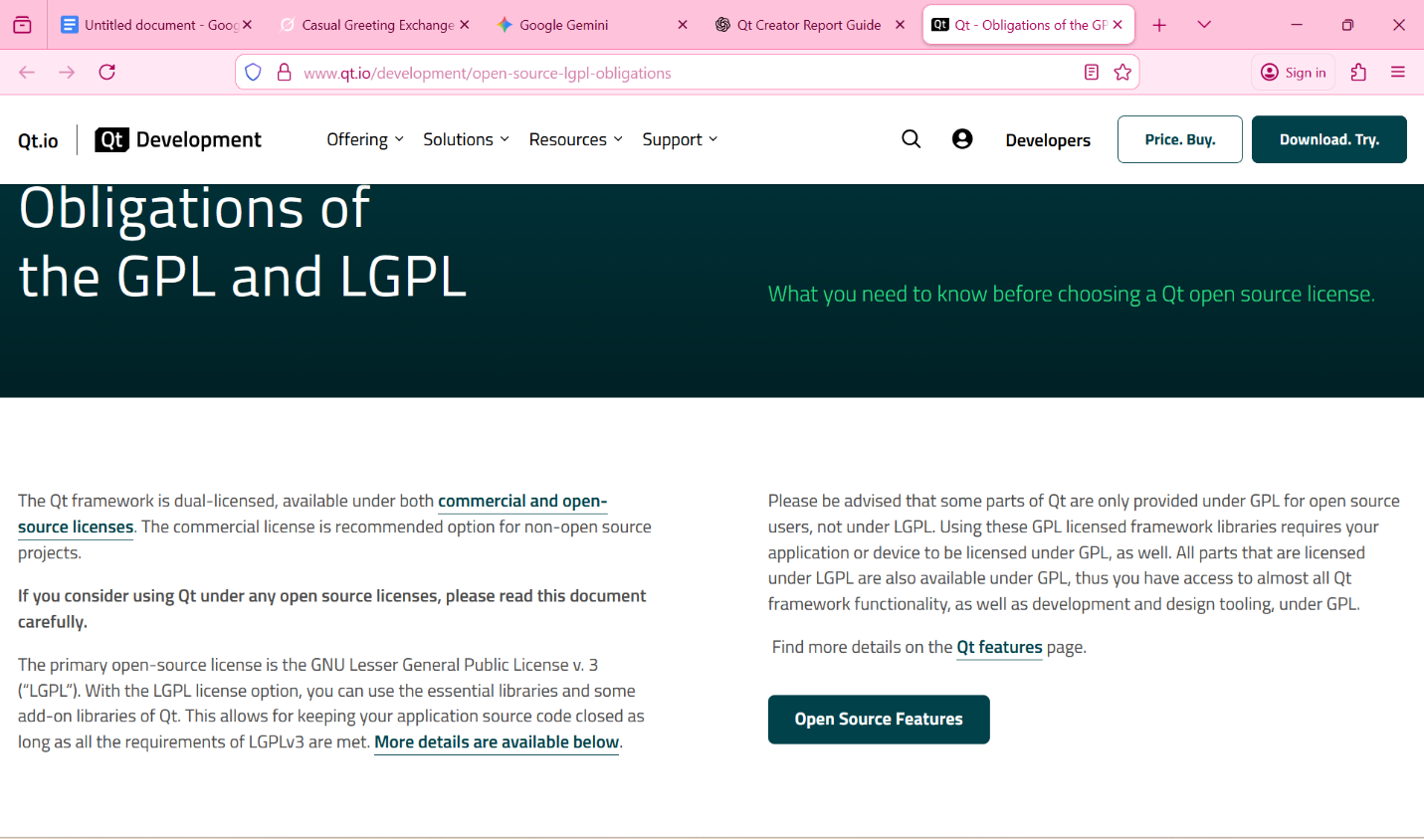
Figure 2.2: Qt Open Source License Selection Screen

2.4 Running the Qt Installer
Once the installer is downloaded:
- Double-click the installer file
- The Qt Setup Wizard will start
This wizard guides the user through the installation process step by step.
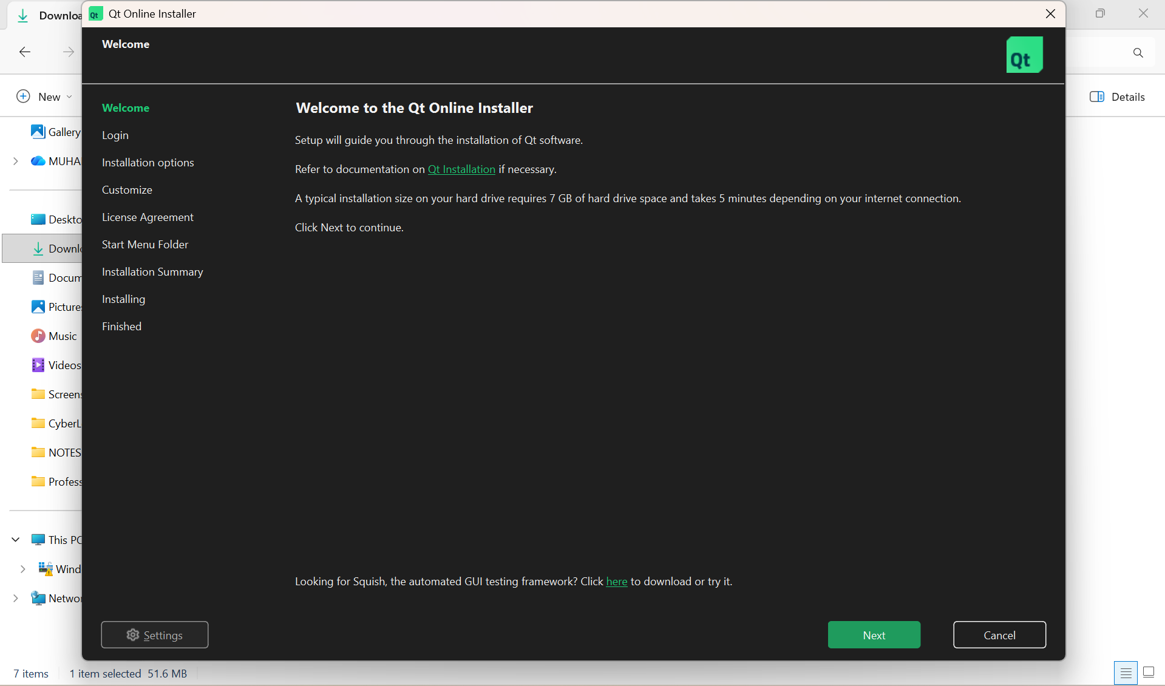
Figure 2.3: Qt Installer Welcome Screen

2.5 Qt Account Login
Qt requires users to sign in with a Qt account before proceeding with installation.
Steps:
- Enter Qt account email and password
- If no account exists, create one using a valid email address
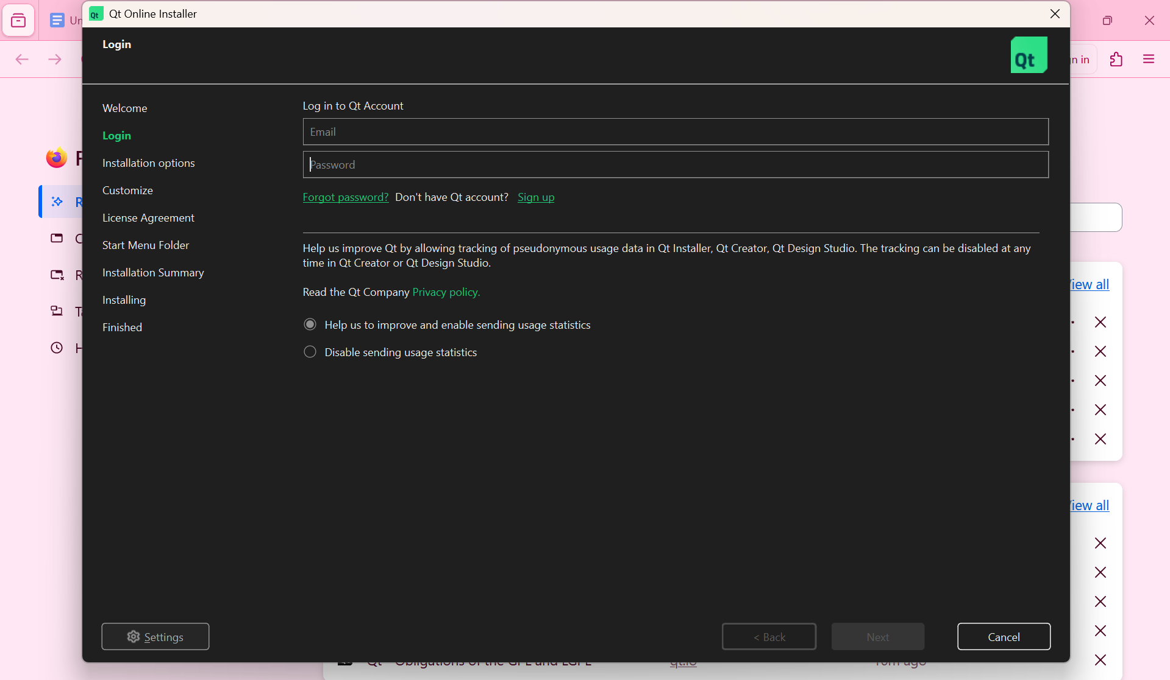
Figure 2.4: Qt Account Login Screen

2.6 Installation Folder Selection
The installer asks the user to select a destination folder where Qt will be installed.
Recommended:
- Use the default installation path
- Avoid installing in system-restricted directories
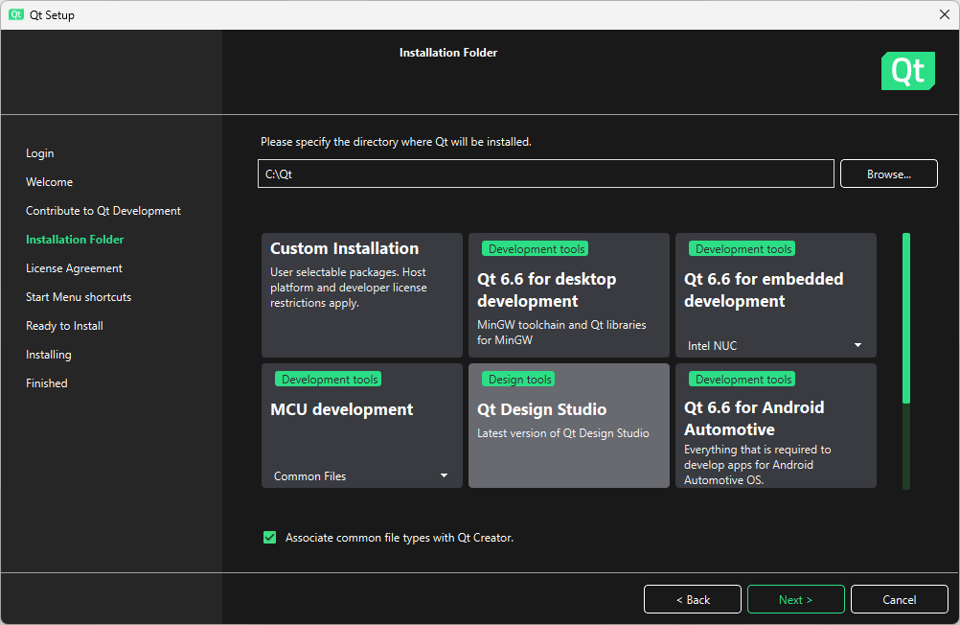
Figure 2.5: Qt Installation Directory Selection

2.7 Component Selection (Qt 6.10.1)
This is the most important step of the installation process.
During component selection:
- Expand Qt 6.10.1
- Select MSVC 64-bit
- Ensure Qt Creator is selected
- Select Qt Debugging Tools
- Select CMake (if not already installed)
⚠️ The compiler must match your system architecture.

2.8 Accepting License Agreements
After selecting components:
- Accept all license agreements
- Proceed to installation

2.9 Launching Qt Creator
Once installed:
- Open Qt Creator from the Start Menu
- The welcome screen will appear
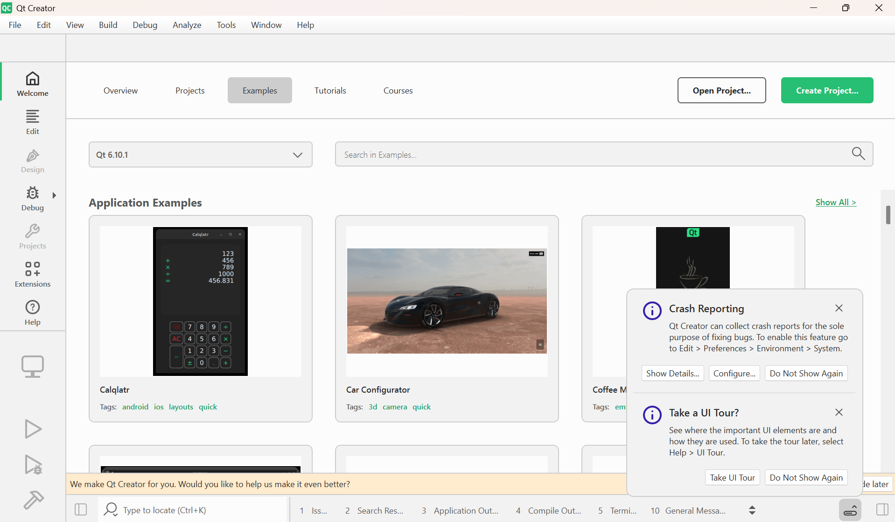
Figure 2.6: Qt Creator Welcome Screen on Windows 11

2.10 Verifying Installation with Test Application
To verify successful installation:
- Create a new Qt Widgets Application
- Run the project
- Ensure an empty window appears without errors
- Capture the running empty Qt application
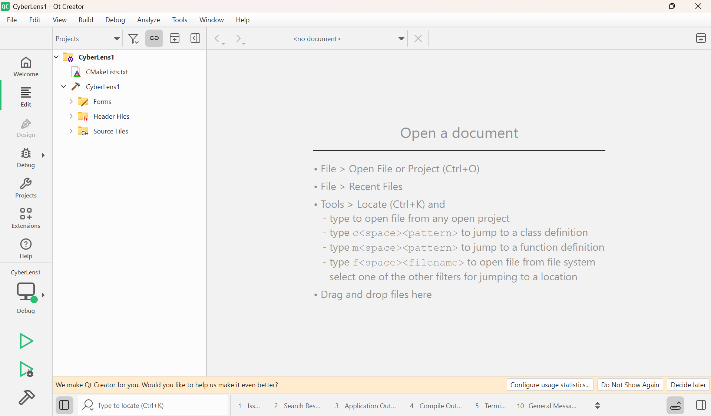
Figure 2.7: First Test Qt Application Running Successfully

CREATING A NEW QT PROJECT & PROJECT STRUCTURE

3.1 Starting a New Project in Qt Creator
After installing Qt Creator, the first step in developing CyberLens is creating a new project.
Steps:
- Open Qt Creator on Windows 11.
- Go to File → New File or Project → Application → Qt Widgets Application.
- Click Choose, then set the Project Name (e.g., CyberLens) and Project Location.
- Select the Qt Version: Qt 6.10.1
- Choose the MSVC 64-bit Compiler.
- Click Finish to create the project.
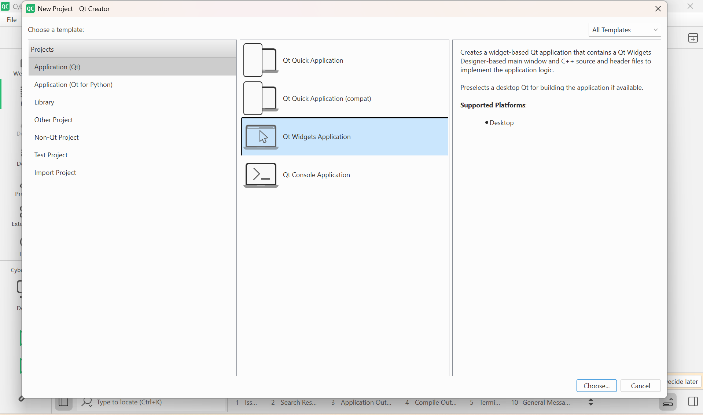
Figure 3.1: Creating a New Qt Widgets Application in Qt Creator

3.2 Project Folder Structure
After creating the project, the folder structure appears as follows:
- CyberLens1
  - Main.cpp – Entry point of the application
  - MainWindow.h / MainWindow.cpp – Main GUI logic
  - MainWindow.ui – UI layout designed in Qt Designer
  - .pro file – Qt project configuration
  - build-CyberLens-Desktop…/ – Build output directory
  - src/ – Optional folder for additional backend classes
This structure separates the UI, logic, and build files, ensuring maintainability.
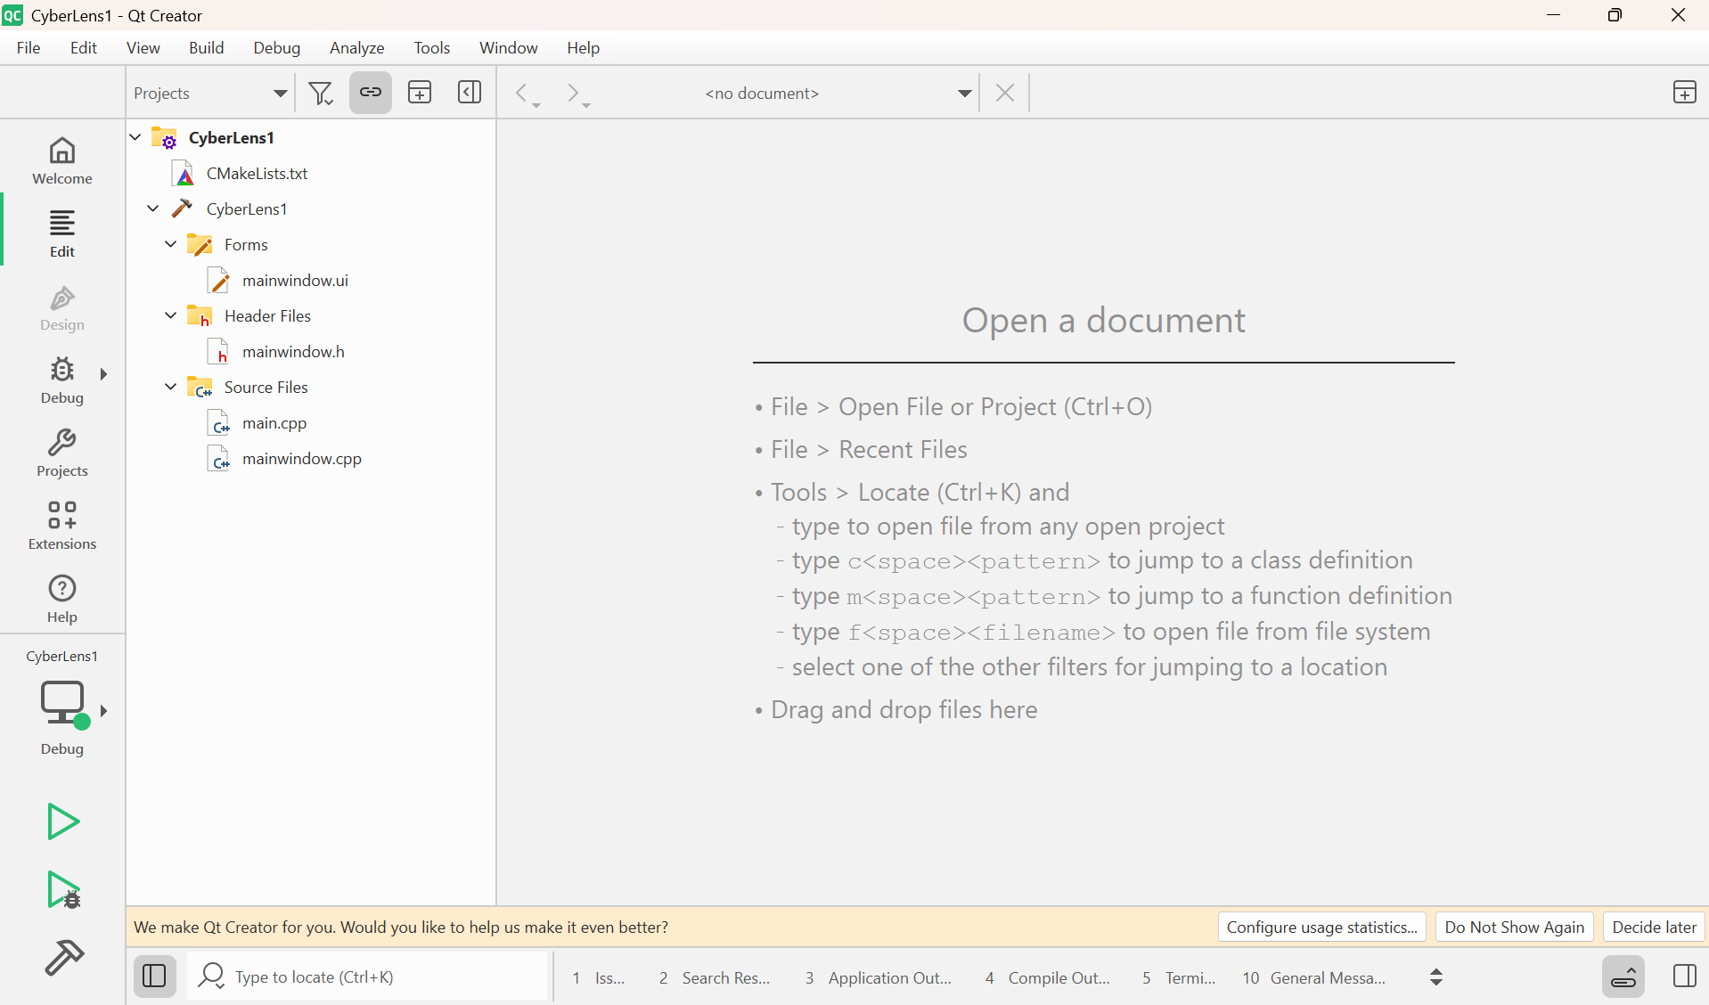
Figure 3.2: Qt Project Folder Structure in Qt Creator

3.3 MainWindow.ui Overview
The MainWindow.ui file contains the graphical user interface:
- Header panel
- URL analyzer area
- File analyzer area
- Bottom buttons
You can open it in Qt Designer (inside Qt Creator) to drag-and-drop widgets.
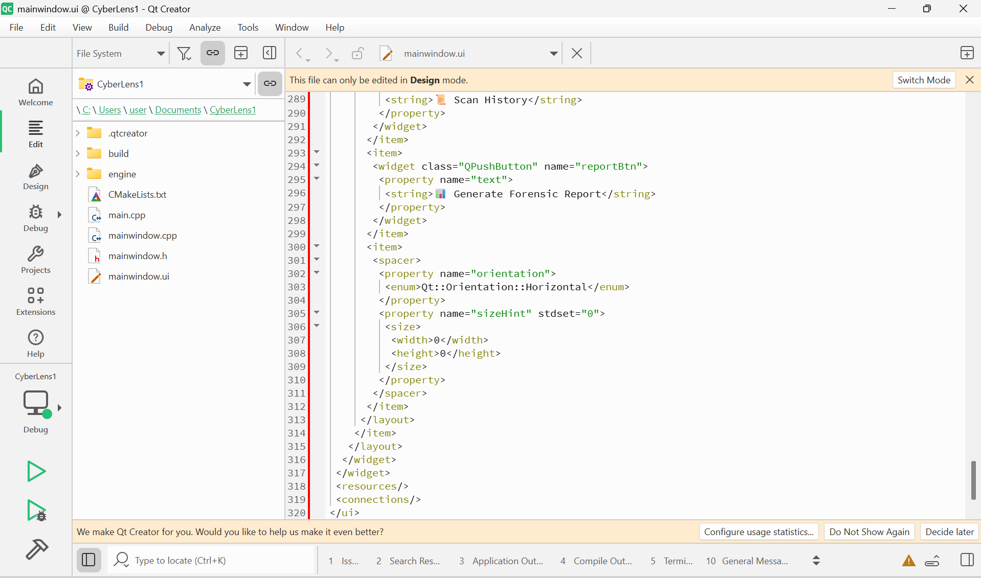
Figure 3.3: MainWindow.ui Layout in Qt Designer

3.4 Main.cpp Overview
The Main.cpp file contains the entry point of the application:
#include "mainwindow.h"
#include <QApplication>

int main(int argc, char *argv[])
{
QApplication a(argc, argv);
MainWindow w;
w.show();
return a.exec();
}
This code initializes the Qt application and displays the main window.

IMPLEMENTATION DETAILS

4.1 Overview
This chapter discusses the implementation of the CyberLens application, connecting the GUI designed in Qt Designer to the backend logic implemented in C++.
It explains how different modules work together, including:
- URL analysis (offline & online)
- File scanning and hashing
- Network checking
- History and reporting
- Signals and slots integration in Qt

4.2 URL Analyzer Implementation
The UrlAnalyzer class is responsible for scanning URLs offline and online.
Offline URL Analysis Rules:
- URL length > 75 characters
- Contains “@” symbol
- More than 4 dots
- Suspicious TLDs (.tk, .ml, .ga…)
- IP address instead of domain
- Punycode "xn--"
- URL shorteners (bit.ly, tinyurl)
- Suspicious keywords (login, verify, update)
Each rule returns a score (0–100).
The final risk score is displayed in the GUI with color coding:
int riskScore = calculateRisk(url);
ui->lblRiskScore->setText(QString::number(riskScore));
if (riskScore > 70)
ui->lblRiskScore->setStyleSheet("QLabel { color: red; }");
else
ui->lblRiskScore->setStyleSheet("QLabel { color: green; }");
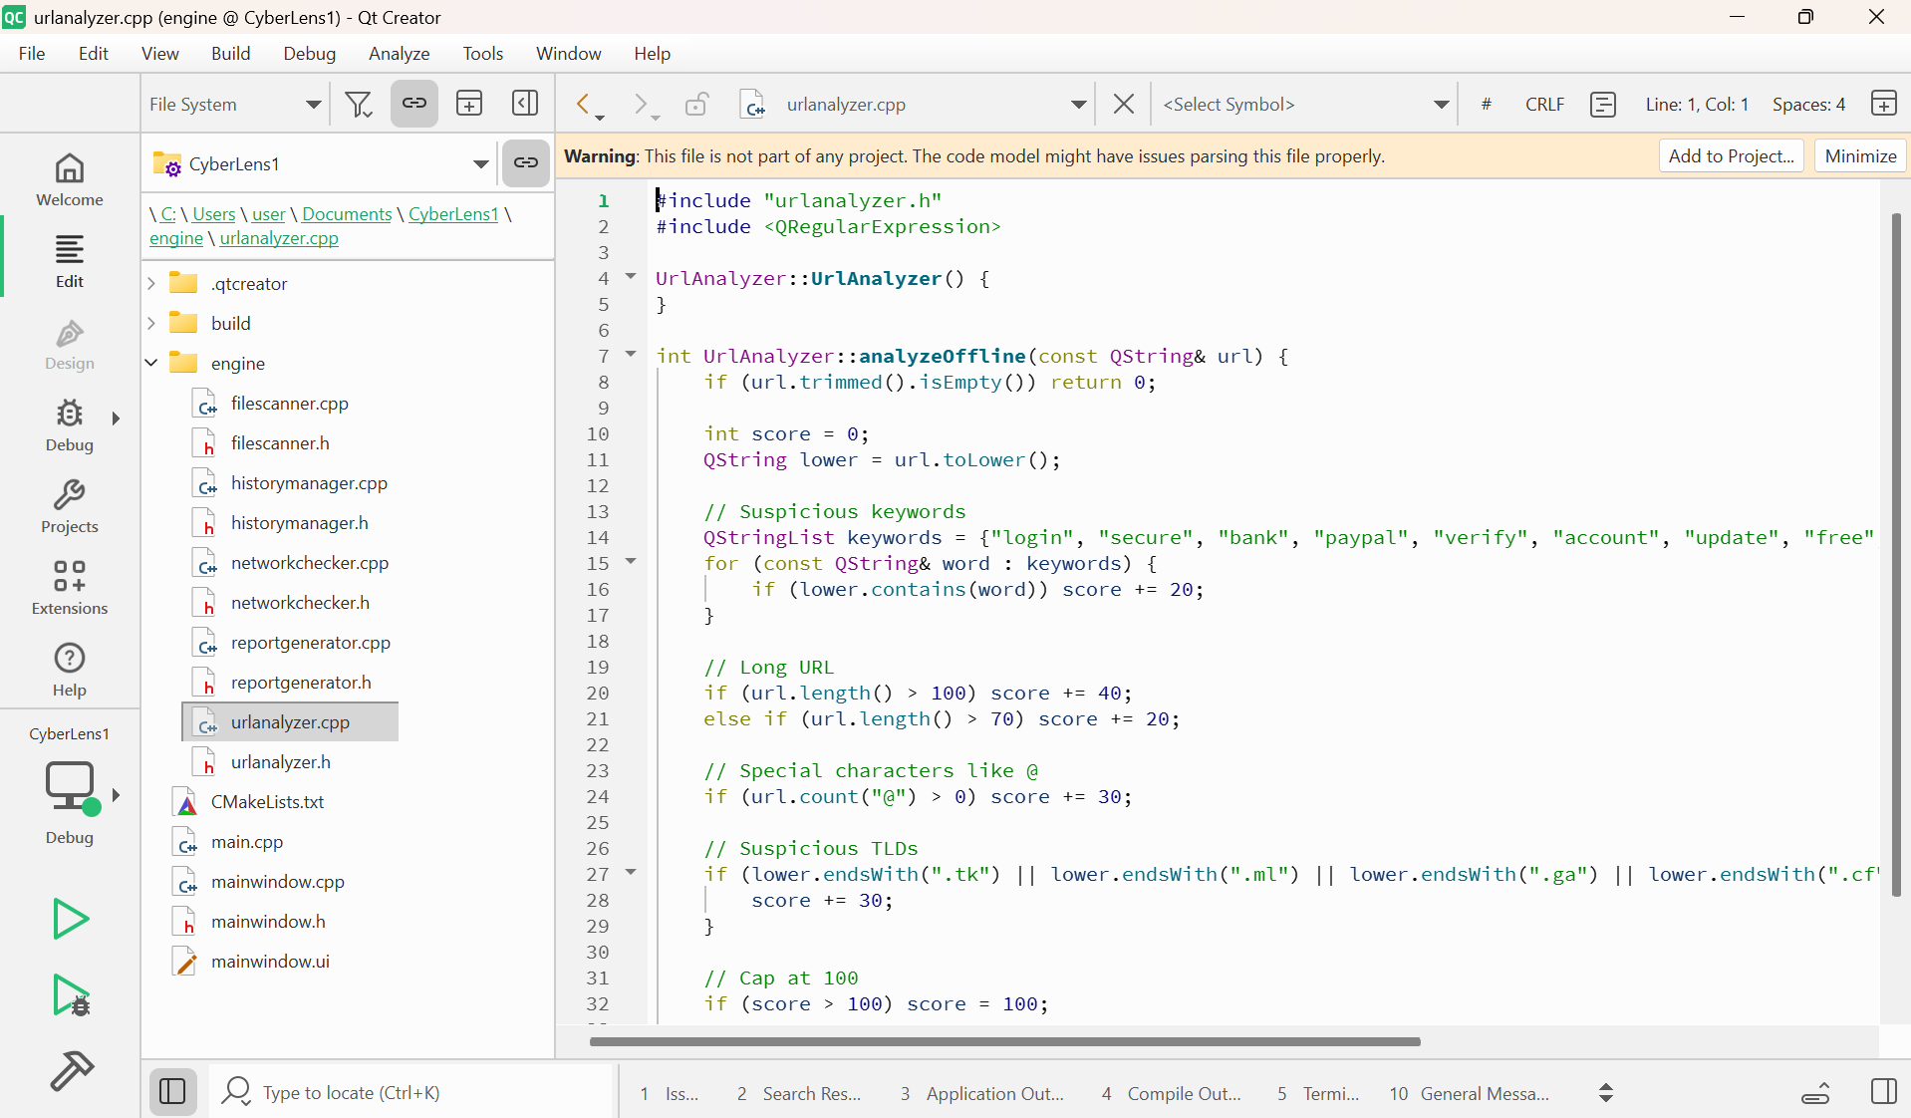
Figure 4.1: URL Analyzer Implementation in C++

4.3 File Scanner Implementation
The FileScanner class handles file analysis:
- Computes SHA-256 hash using Qt’s QCryptographicHash
- Performs offline scoring based on file type (.exe = high risk, .pdf = medium risk)
- Optional online hash check with VirusTotal API
Example:
QFile file(filePath);
if(file.open(QFile::ReadOnly)) {
QCryptographicHash hash(QCryptographicHash::Sha256);
if(hash.addData(&file)) {
QByteArray fileHash = hash.result();
ui->lblFileHash->setText(fileHash.toHex());
}
}
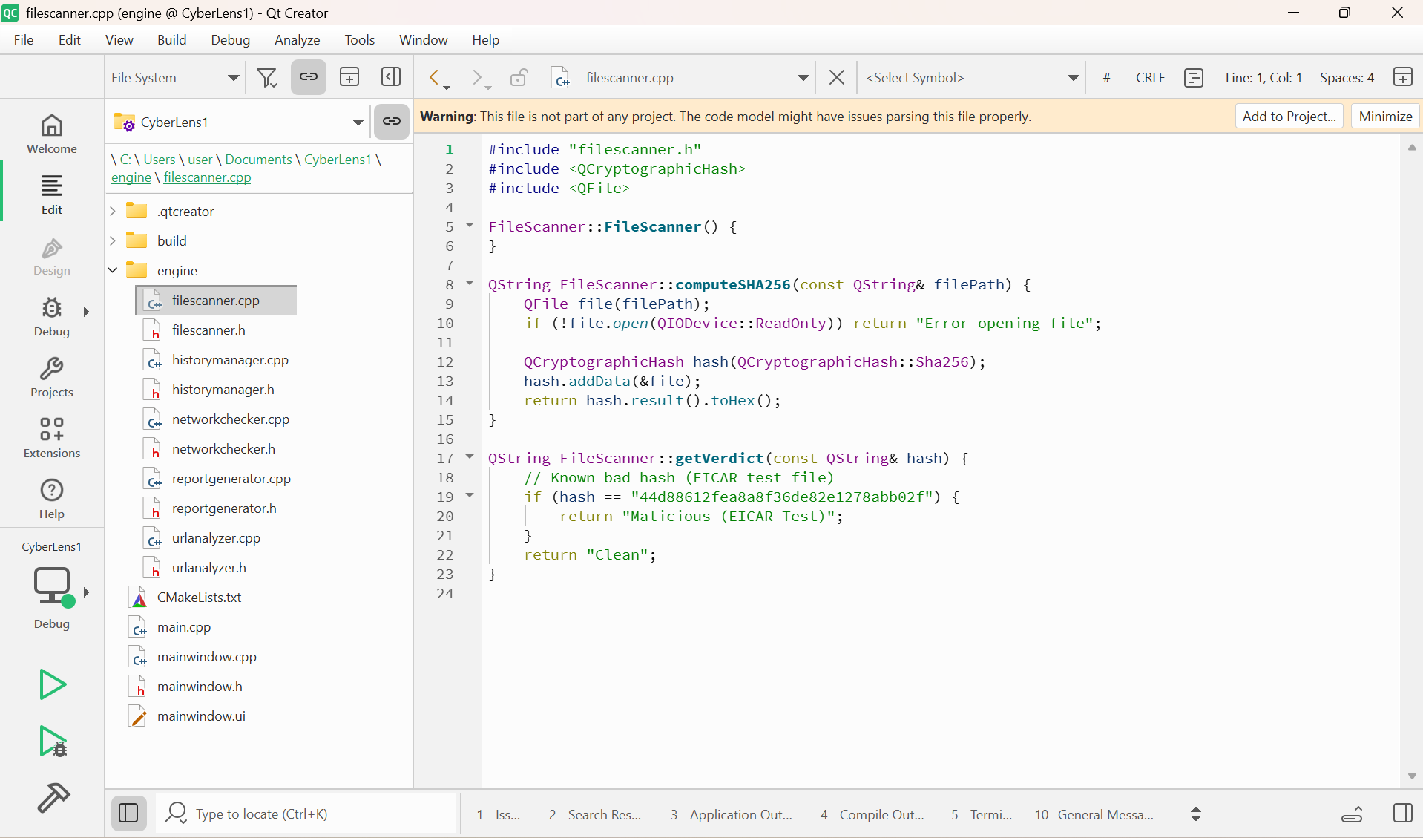
Figure 4.2: File Scanner Implementation Using SHA-256

4.4 NetworkChecker Implementation
The NetworkChecker class automatically switches between online and offline modes:
QNetworkAccessManager manager;
QNetworkRequest request(QUrl("https://google.com"));
QNetworkReply *reply = manager.get(request);
connect(reply, &QNetworkReply::finished, this, [=](){
if(reply->error() == QNetworkReply::NoError)
ui->lblStatus->setText("🔵 Online");
else
ui->lblStatus->setText("🔴 Offline");
});
- Updates UI label dynamically
- Ensures hybrid mode functionality
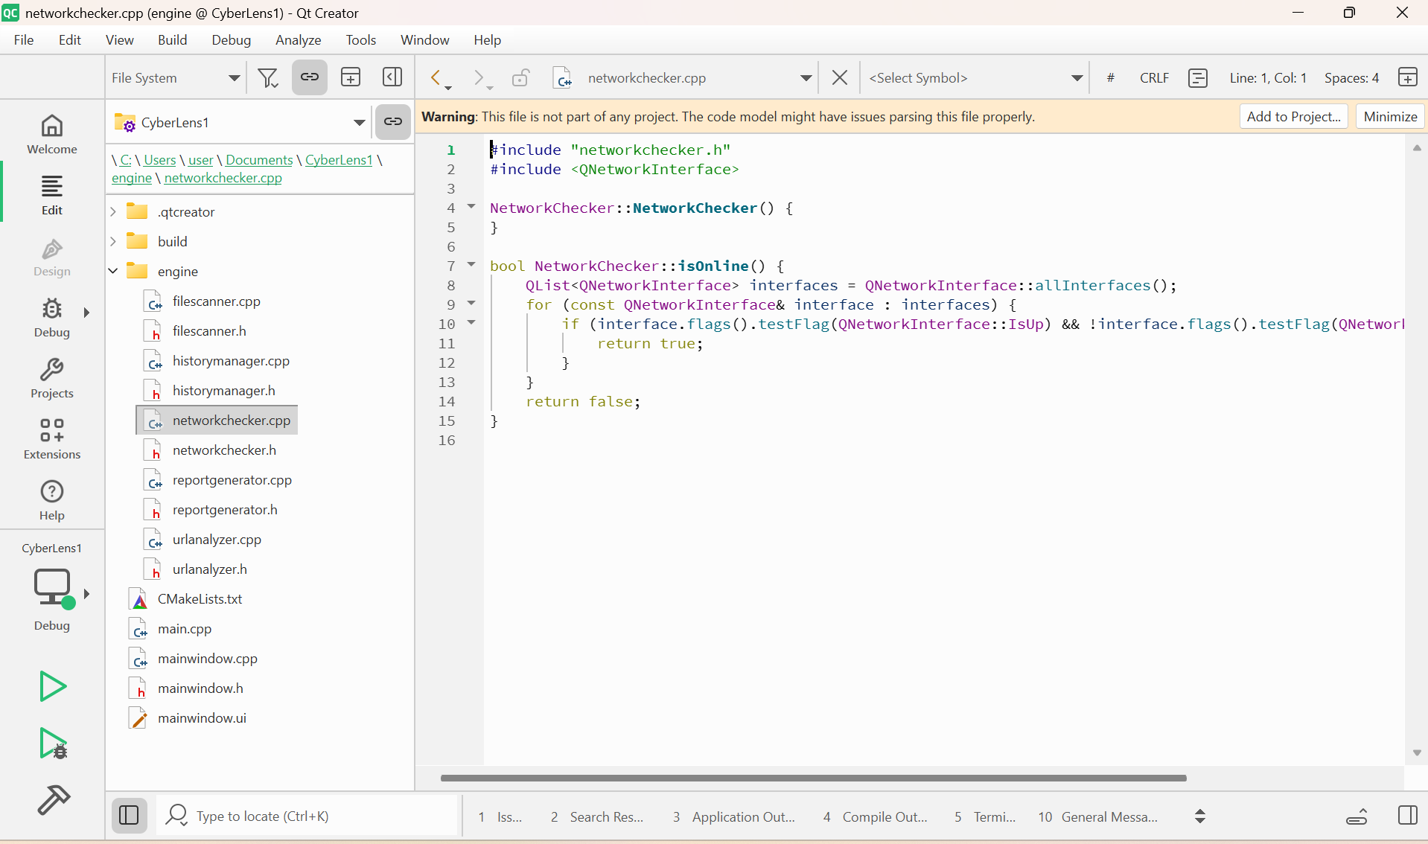
Figure 4.3: Online/Offline Status Detection Using NetworkChecker

4.5 Connecting GUI to Backend
All GUI elements are connected to backend logic:
GUI Widget | Connected Backend Function
Analyze URL button | UrlAnalyzer::analyzeURL()
Browse File button | FileScanner::scanFile()
Drag & Drop area | FileScanner::scanFile()
History button | HistoryManager::showHistory()
Generate Report button | ReportGenerator::generateReport()
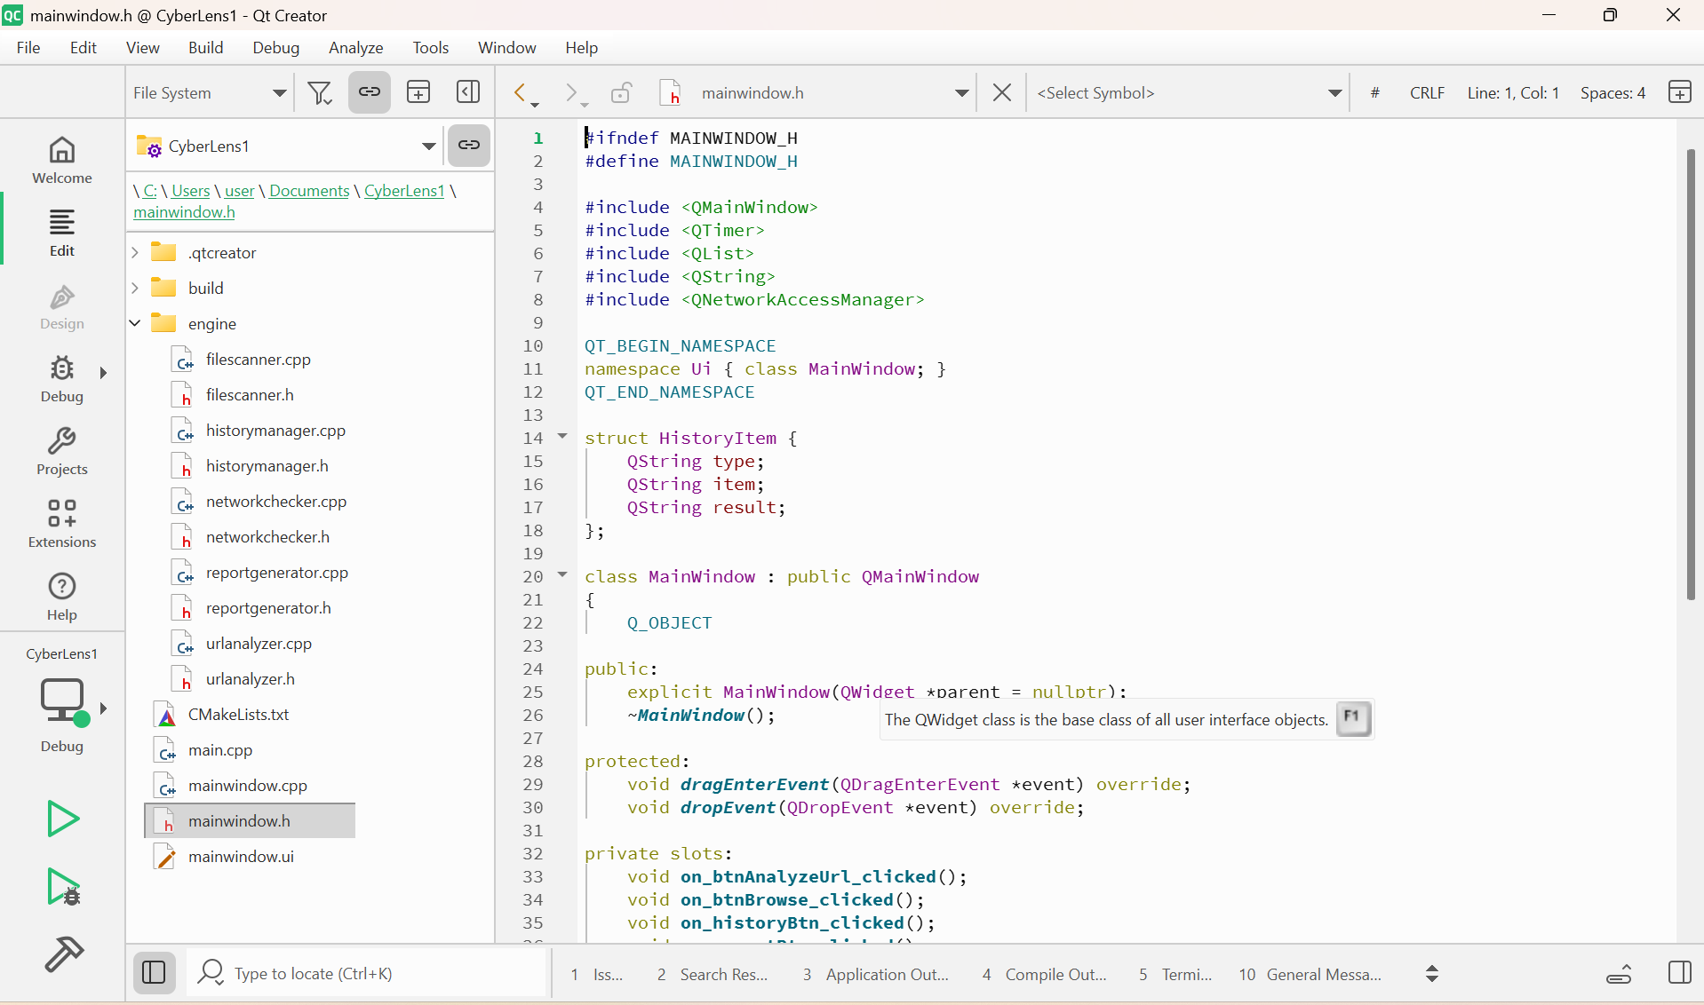
Figure 4.4: GUI Widgets Connected to Backend Functions

4.6 HistoryManager & ReportGenerator Implementation
- HistoryManager: Stores last 20 URL/file results in QList or local file
- ReportGenerator: Creates .txt reports summarizing scans
Example:
QFile report("scan_report.txt");
if(report.open(QFile::WriteOnly)) {
QTextStream out(&report);
out << "URL: " << url << "\n";
out << "Risk Score: " << riskScore << "\n";
}
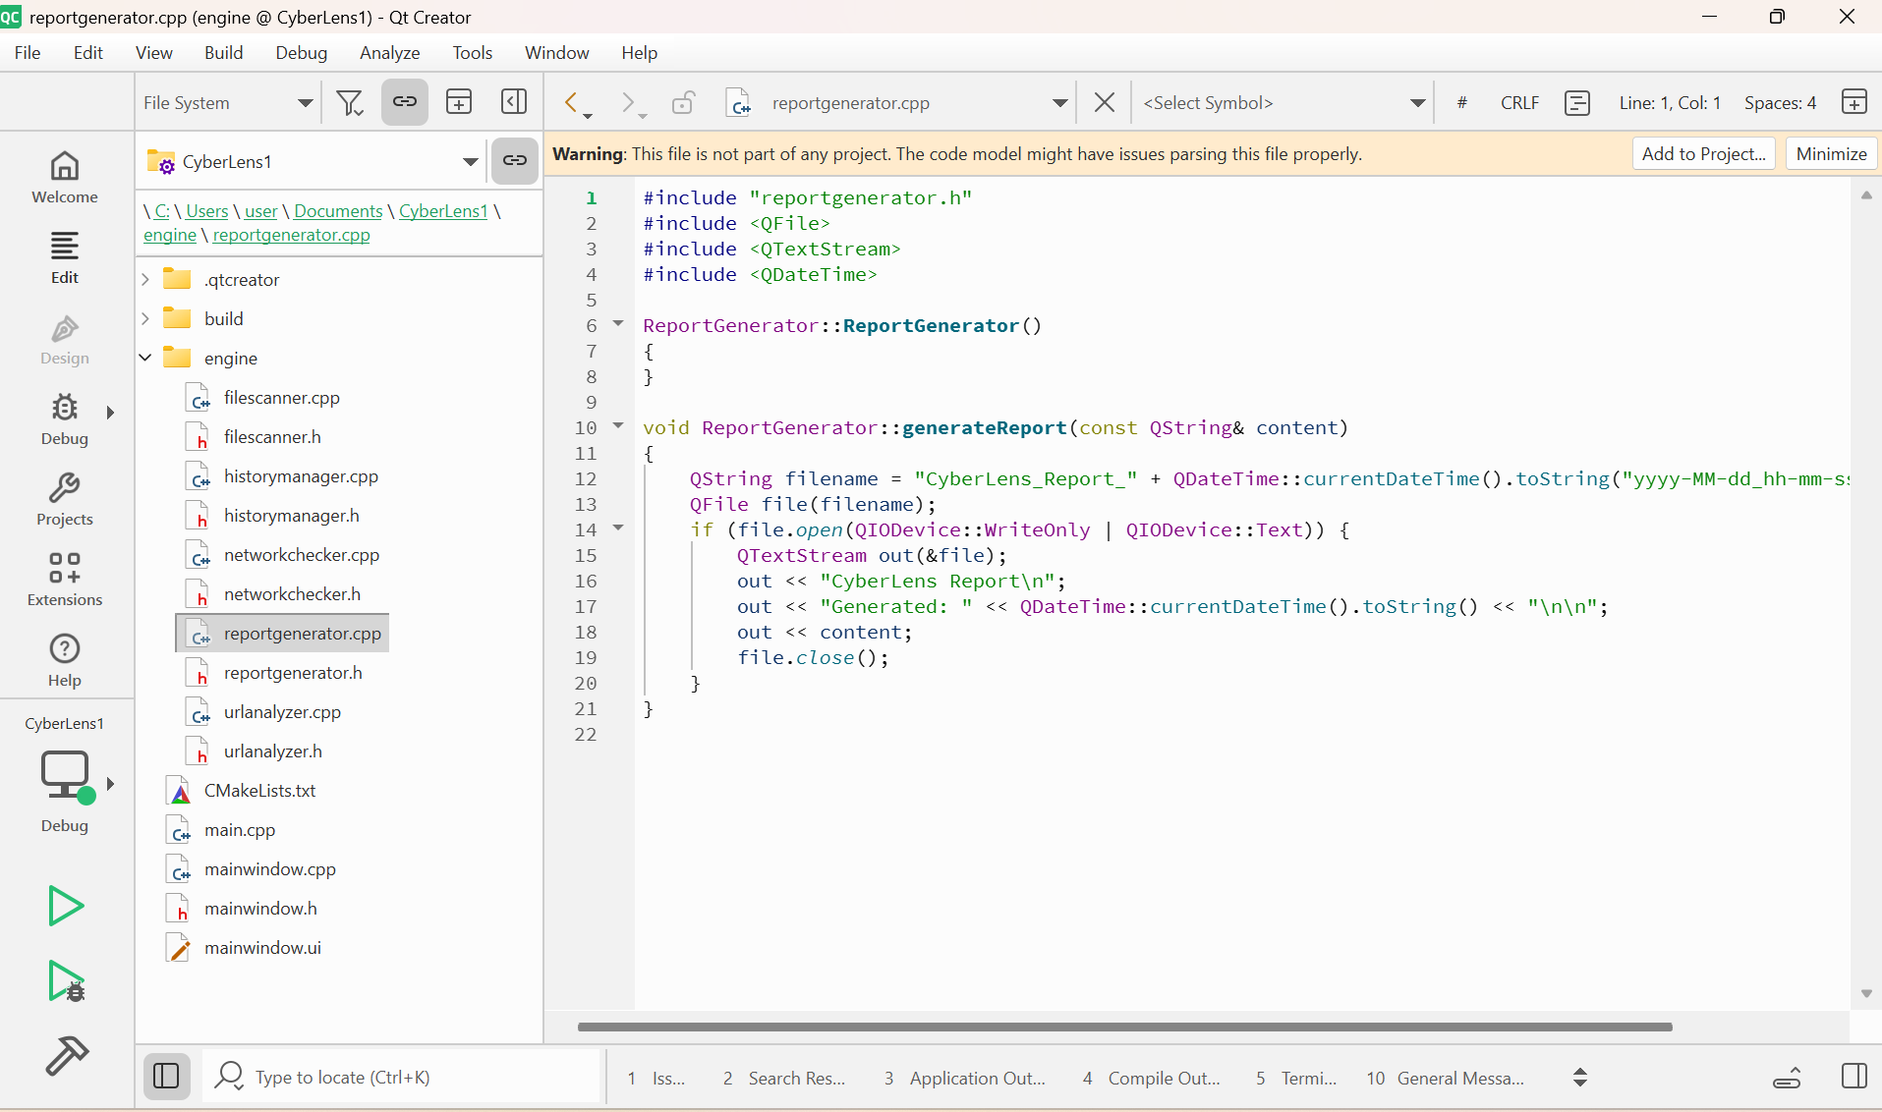
Figure 4.5: Report Generation and History Management Code

TESTING & RESULTS

5.1 Overview
Testing ensures that CyberLens works correctly in all scenarios. The application was tested in Windows 11, using Qt 6.10.1, for both online and offline modes.
The testing process focused on:
- URL analysis (safe vs malicious)
- File scanning (hash and type analysis)
- Online/offline mode switching
- GUI functionality and button responses
- History and report generation

5.2 Test Environment
- Operating System: Windows 11, 64-bit
- Qt Version: 6.10.1
- Compiler: MSVC 64-bit
- Test Data:
  - 10 safe URLs
  - 10 phishing/malicious URLs
  - 5 safe files
  - 5 potentially risky files (.exe, .scr)

5.3 URL Testing

5.3.1 Safe URLs
Safe URLs (e.g., https://www.wikipedia.org, https://www.microsoft.com) were analyzed offline and online.
- Expected Result: Low-risk score (0–20)
- Actual Result: Risk score matches expected
- Color Coding: Green label in GUI
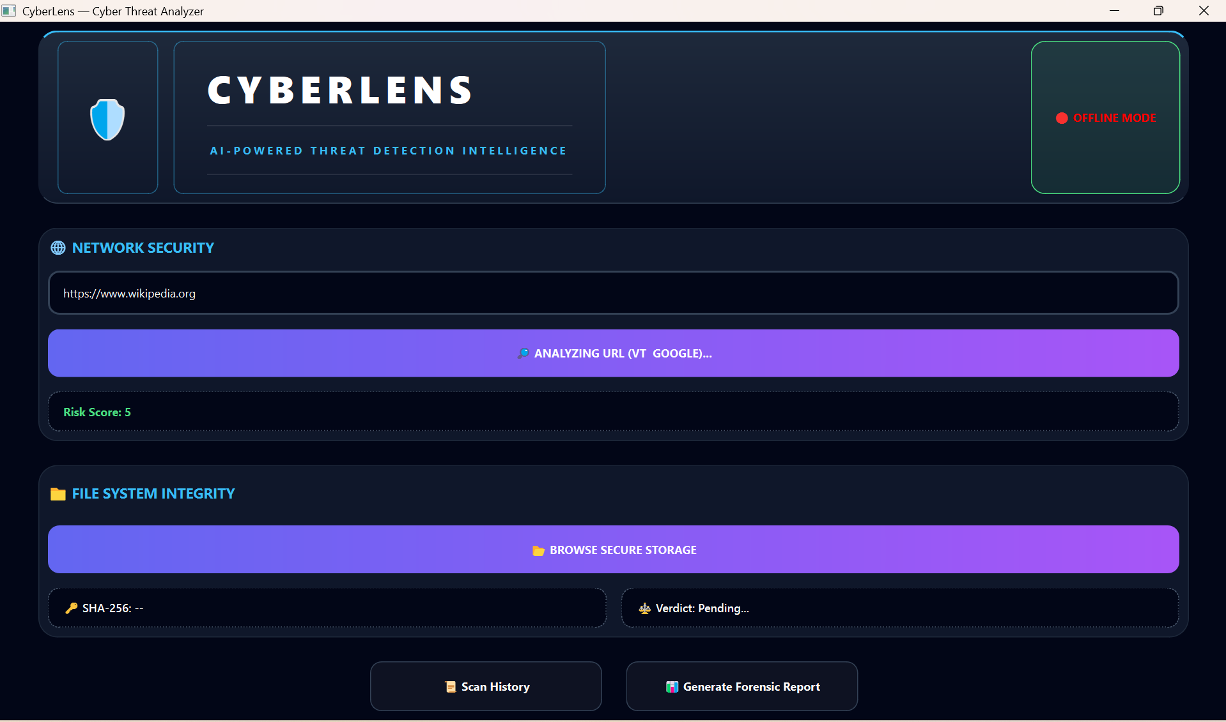
Figure 5.1: Safe URL Analysis Result

5.3.2 Malicious / Phishing URLs
Malicious URLs (e.g., fake login pages, URL shorteners) were tested.
- Expected Result: High-risk score (70–100)
- Actual Result: Risk score correctly displayed
- Color Coding: Red label in GUI
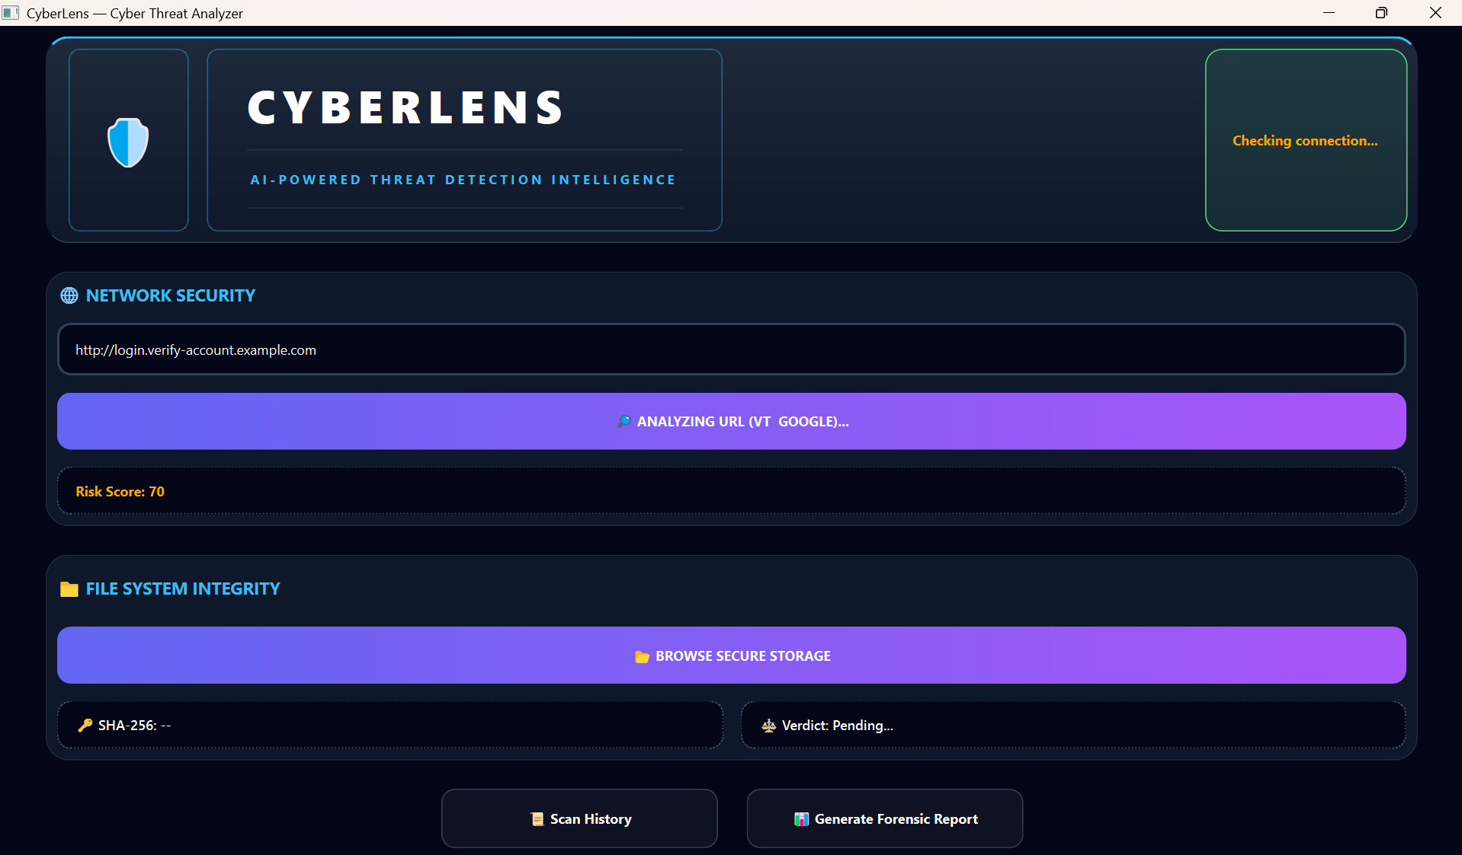
Figure 5.2: Malicious URL Analysis Result

5.4 File Scanning Testing

5.4.1 Safe Files
Safe files (e.g., PDFs, text documents) were scanned.
- Expected Result: Low-risk score
- Actual Result: Correct file hash displayed, low-risk verdict
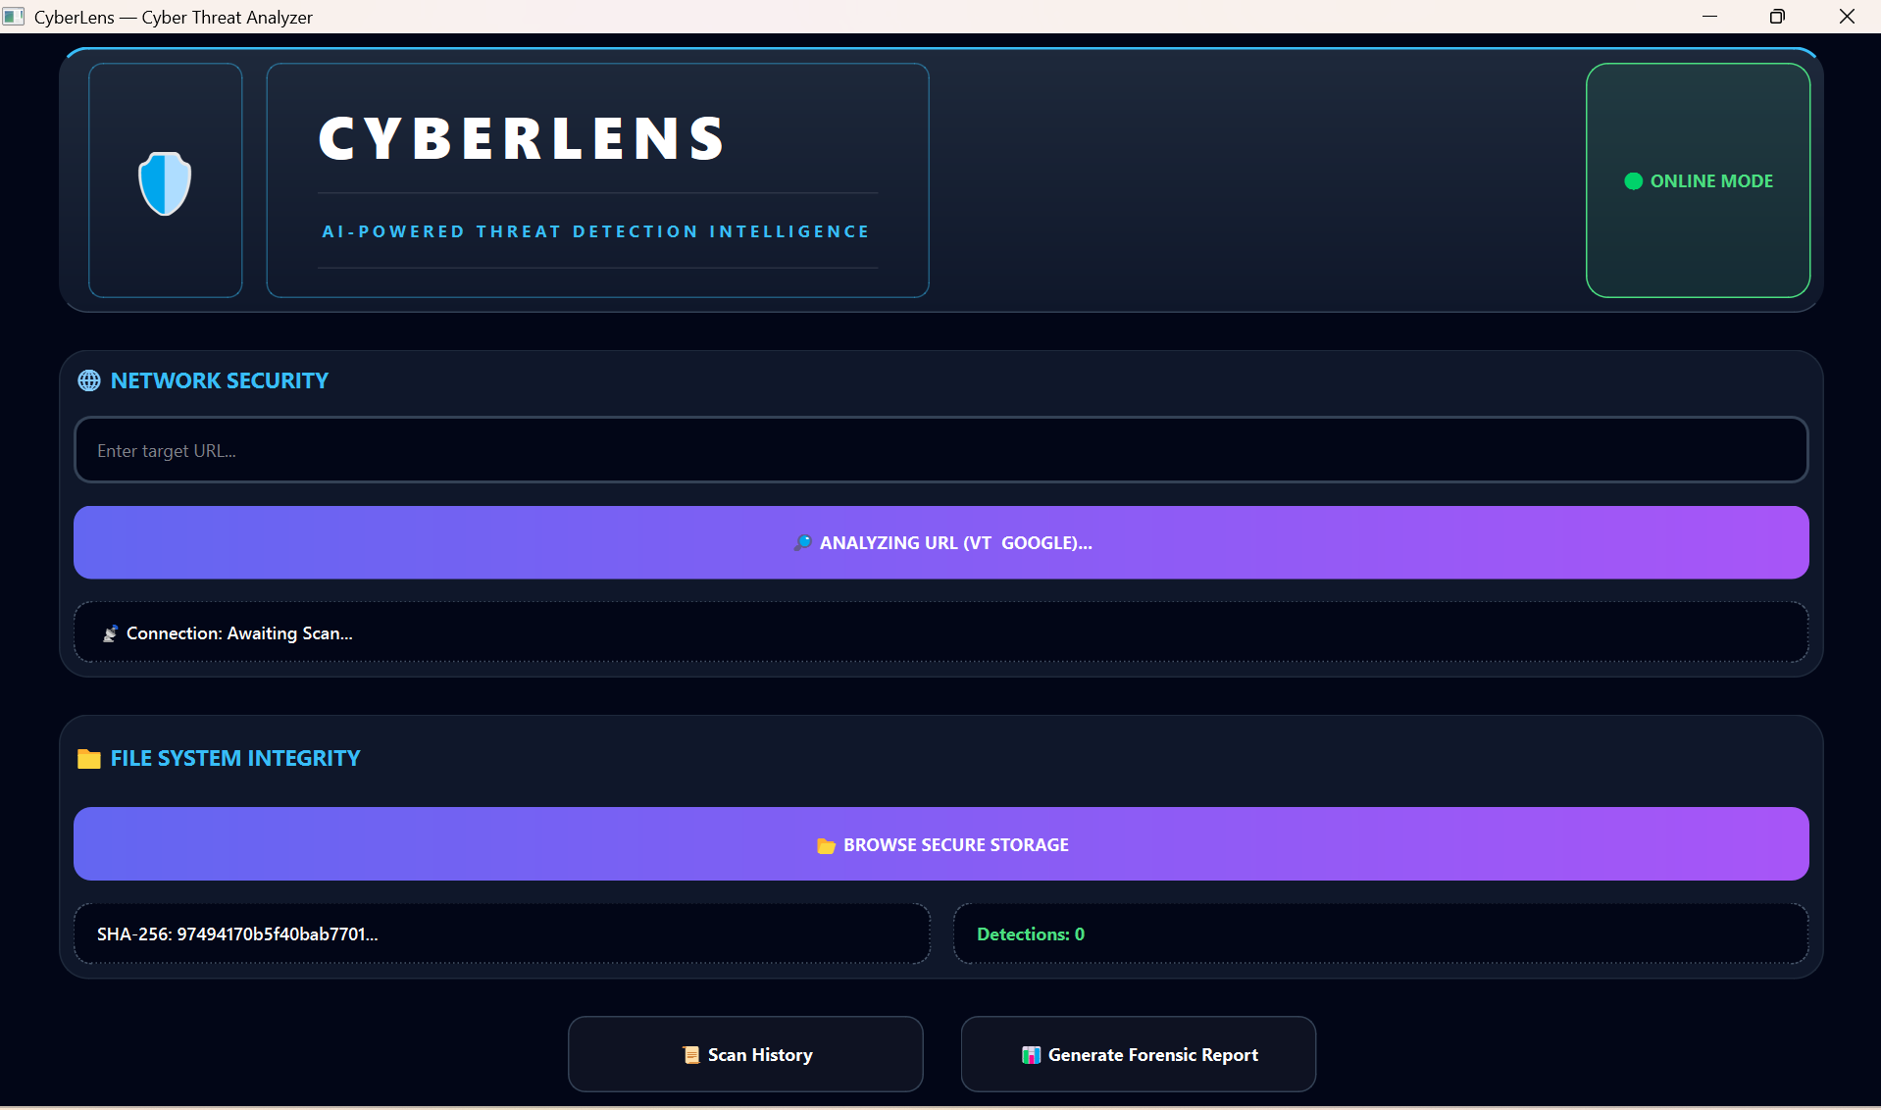
Figure 5.3: Safe File Scan Result

5.4.2 Potentially Harmful Files
Files like .exe or .scr were scanned offline.
- Expected Result: High-risk score
- Actual Result: Correct risk score displayed
- Verdict: “High Risk”
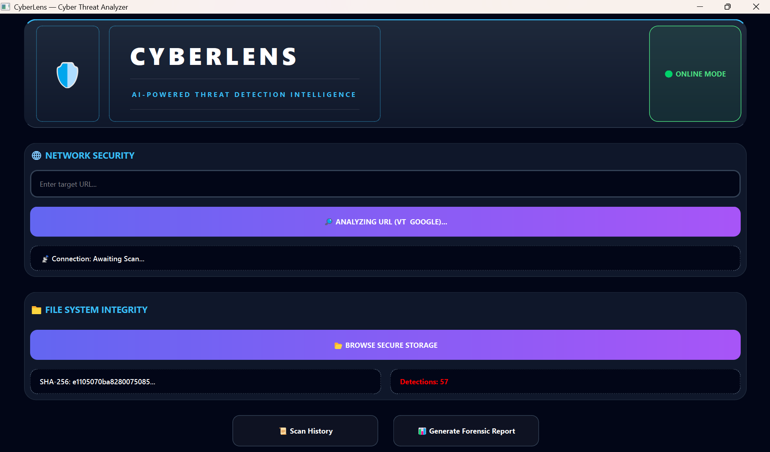
Figure 8.4: Risky File Scan Result

5.5 Offline and Online Mode Testing
CyberLens automatically switches between online and offline modes using the NetworkChecker module.
- Offline Test: Disconnected internet → GUI shows “🔴 Offline”
- Online Test: Connected internet → GUI shows “🔵 Online”
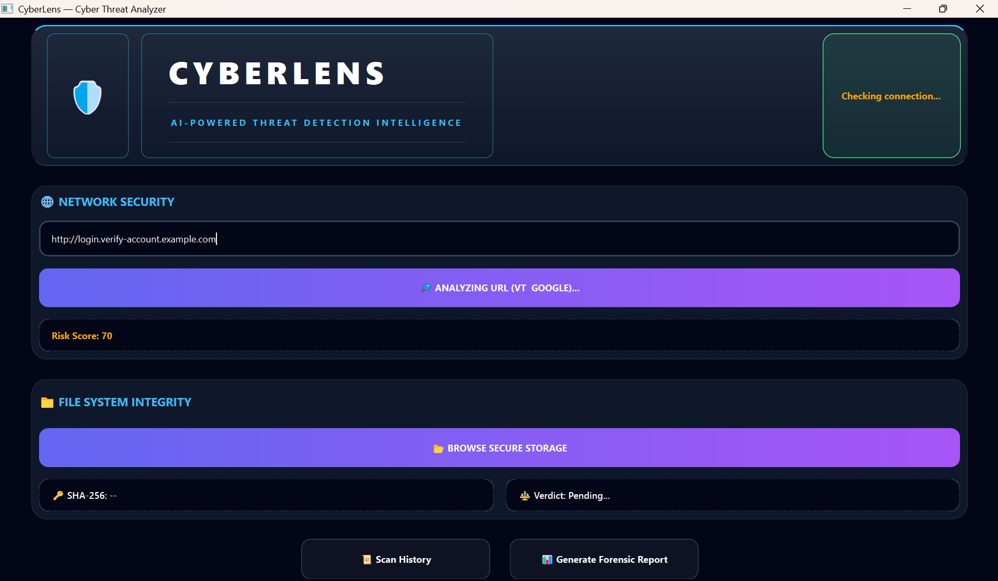
Figure 8.5: Online and Offline Mode Switching

5.6 History and Report Testing
The HistoryManager stores the last 20 results.
The ReportGenerator produces a .txt summary.
- Test steps:
  - Scan multiple URLs/files
  - Click “View History” → GUI shows previous scans
  - Click “Generate Report” → check generated file
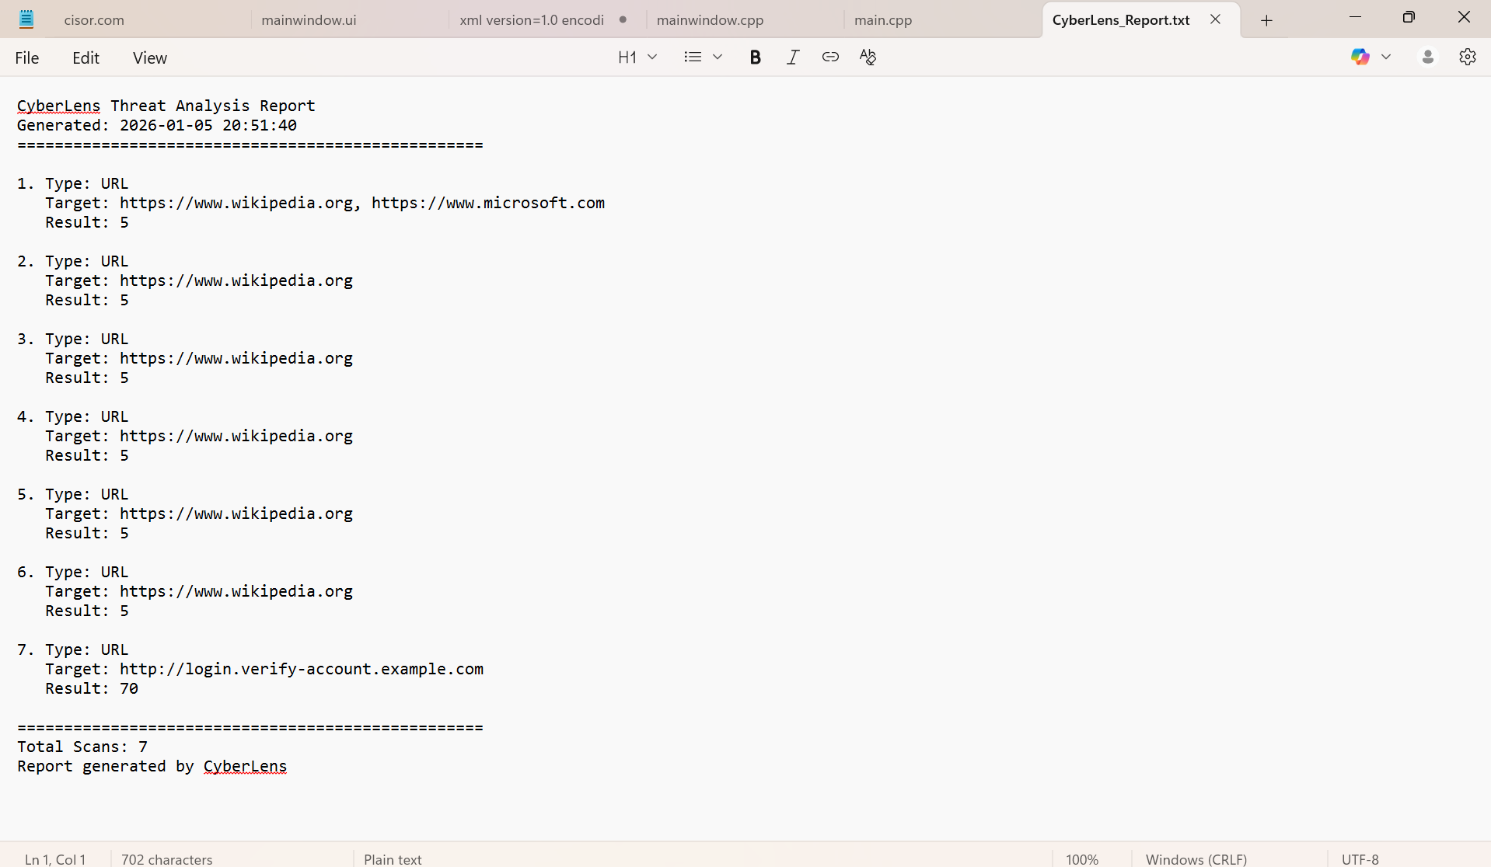
Figure 8.6: Scan History and Report Generation

