506CourseWork

Table of contents

For the love of god don’t forget 1

Question 1 1

Question 1 a) 2

Question 1 b) 2

Question 1 c) 3

Question 1 d) 3

Question 1 e) 4

Question 1 f) 5

Question 1 g) 5

Question 2 7

Question 2 a) 7

Question 2 b) 7

Question 2 c) 10

Question 2 d) 11

Question 2 e) 12

Question 2 f) 14

Question 2 g) 15

## For the love of god don’t forget

Do not display too much raw R output (e.g. don’t display the full output of ‘summary(model)’), but edit this down to the essentials. Ensure to include justification for each step of your analyses, providing comments alongside your R code to explain what you are doing and add appropriate titles and labelled axes to your plots.

## Question 1

We have the model:

~ ,

## Question 1 a)

Due to the visible non-linearity of the model, we would be required to significantly transform our data to get a linear model that would have an acceptable fit of the data. We can also see that the data seems to be only positive while a normal distribution goes from ]-,[ . Such arbitrary transformation increases the complexity of the model, making it less interpretable and not respect the nature of the data.

Linear regression models are based on the assumption that the relationship between the independent and dependent variables is linear. If the relationship between the variables is non-linear, a linear regression model is not be appropriate. In such cases, transforming the data to make the relationship linear may not result in an accurate representation of the true relationship, and can lead to overfitting or underfitting. Additionally, transforming the data can result in a loss of interpretability of the results, as it can be difficult to understand the meaning of the transformed variables.

Another issue with using a linear regression model for non-linear data is that the residuals, which represent the difference between the observed and predicted values, may not be normally distributed, which is another assumption of linear regression models. This can lead to biased or incorrect results.

In conclusion, when the data is non-linear, a linear regression model may not be the best choice for modelling the relationship between the variables, and alternative methods need to be considered.

## Question 1 b)

The Yi are independent so the likelihood is a product of the individual pdfs.

Likelihood of a normal distribution where =

=

= =

=

Replacing the with the respective formula and n, we have the likelihood as:

=

= =

=

The log-likelihood of a normal distribution is:

=

= =

= =

= =

= =

=

Once again replacing the with the respective formula and n, we have the log-likelihood as:

=

= =

=

## Question 1 c)

n = nrow(nlmodel)  
  
  
### Create a function to evaluate minus the log-likelihood  
myLike = function(variables) {  
  
 theta1 = variables[1] #theta1  
 theta2 = variables[2] #theta2  
 sigma = variables[3] #sigma  
  
 mu = ((theta1 * nlmodel$x)/(theta2 + nlmodel$x))  
  
 # Log-likelihood  
 result = (-(n/2) * log(2 * pi)) - ((n/2) * log(sigma^2)) - (1/(2 * (sigma^2))) *  
 (sum((nlmodel$y - mu)^2))  
  
 # Returning negative log-likelihood  
 return(-result)  
}

## Question 1 d)

From the graph data we can clearly see that the deviantion is approximatly 15 from the value scatter which is easier to destinguish and measure between the interval.

We can observethat when x -> 1 y is approximately 215 and as x -> 0 y is approximately to 50

To determine the thetas we will first see see that when x approximates to zero we can observe that:

As such $ Y$ ~ becomes 50 ~

Solving it for we get:

Now that we have we can use the approximation of x to 1 to determine the value of

As such Y ~ becomes ~

Solving it for we get:

# Estimating the MLE  
out <- nlm(myLike,  
 p = c(210.7,0.02,15), #plugging in the starting values  
 hessian = T,  
 iterlim = 10000,  
 steptol = 1e-10)  
  
# Reporting estimates  
variableEstimates = out$estimate  
out$estimate

[1] 214.65008415 0.06353447 13.61564428

## Question 1 e)

# Invert the negated Hessian to obtain the Observed Information Matrix  
OIM <- solve(out$hessian)  
  
# The diagonal entries are the variances of beta0 and beta1  
# respectively so # obtain them  
VarianceBeta <- diag(OIM)  
  
# and then square root them to obtain standard errors  
stand_error <- sqrt(VarianceBeta)  
  
# reporting standard errors  
stand_error

[1] 2.674798031 0.005140379 0.963024267

The formula to calculate a 99% confidence interval is: β ± 2.576 * SE(β)

# Estimating CIs  
CIs <- cbind(variableEstimates - 2.576 * stand_error, variableEstimates +  
 2.576 * stand_error)  
  
# Reporting the CIs  
CIs

[,1] [,2]  
[1,] 207.75980442 221.54036388  
[2,] 0.05029285 0.07677609  
[3,] 11.13489377 16.09639479

## Question 1 f)

H0 : θ2 = 0,08 vs. H1 : θ2 0,08

## Hypothesis thest without using confidence interval  
  
z_stat <- (variableEstimates[2] - 0.08)/stand_error[2]  
  
# Print the test values  
z_stat ## significance tests

[1] -3.203174

So now we need to decide if this value of the z-statistic is extreme at the 10% significance level

### Note that equivalently we can look at the 95% quantile of N(0,1)  
qnorm(0.95, 0, 1)

[1] 1.644854

qnorm(0.05, 0, 1)

[1] -1.644854

As we can see the value from the z-statistician test is considerably lower than -1,645, as the value is not between the [-1.644854, 1.644854] is an extreme value and therefore we reject the null hypothesis that is 0,08.

## Question 1 g)

# Plotting initial starting guess  
xx <- seq(0, 1, len = 200)  
  
# Estimating mean relationship (mean mu = )  
mu <- (out$estimate[1] * xx)/(out$estimate[2] + xx)  
  
# Getting standard Deviation  
standardDeviation <- out$estimate[3]  
  
  
# Getting 95% interval from the quantiles of a Normal distribution  
plot(nlmodel$x, nlmodel$y, pch = 20, xlab = "X variable", ylab = "Y variable")  
  
lines(xx, qnorm(0.025, mean = mu, sd = standardDeviation), col = "blue",  
 lty = "dashed")  
lines(xx, qnorm(0.975, mean = mu, sd = standardDeviation), col = "blue",  
 lty = "dashed")  
  
lines(xx, qnorm(0.5, mean = mu, sd = standardDeviation), col = "red")

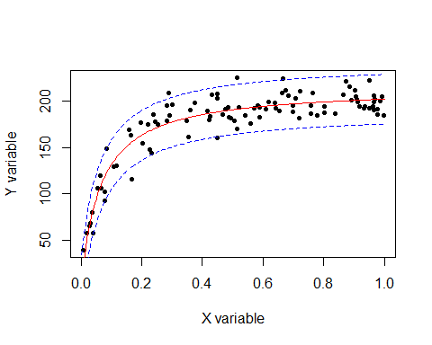

From the estimations produced through our model we can see that the current model with a 95% prediction fits the data quite nicely, having only 4 of the 100 observations shortly out of the 95% prediction interval.

However it should be noted that even though the model has a good performance, a normal distribution has the assumption that data can take any value in the real line however this data is bounded between the [0,1] interval.

Considering that the variance increases trough the model it further indicates that a normal distribution should be switched for another distribution that better respects the nature of our data.

## Question 2

Model 2:

~

Model 1:

~

## Question 2 a)

As we can from the graph and what we can determine from the nature of the data represented in such graph the recorded number of AIDS cases is a count variable and the counts are non-negative integers.

The first model, a Poisson distribution, would be a more appropriate choice. The Poisson distribution is a discrete distribution that models count data which respects the nature of the data

The second model, a Normal distribution, would not be the best fit since its range is from ]-,[ and expects continuous values, not respecting the nature of the data.

The log-link function in both models ensures that the predicted values are always positive. This behaviour is standard for a poisson distribution but is inadequate for a normal distribution.

## Question 2 b)

The Yi are independent so the likelihood is a product of the individual pdfs.

# Fitting in R  
  
model2 = glm(cases ~ date, data = aids, family = poisson(link = "log"))  
  
# Summarise the model  
summary(model2)

Deviance Residuals:   
 Min 1Q Median 3Q Max   
-7.768 -4.042 -0.335 3.048 7.281   
  
Coefficients:  
 Estimate Std. Error z value Pr(>|z|)   
(Intercept) -16.875879 0.350353 -48.17 <2e-16 ***  
date 0.247169 0.003856 64.10 <2e-16 ***  
  
 Null deviance: 5738.16 on 44 degrees of freedom  
Residual deviance: 854.02 on 43 degrees of freedom  
AIC: 1153.9

# Fitting model 1  
model1 = glm(cases ~ date, data = aids, family = gaussian(link = "log"))  
  
# Summarise the model  
summary(model1)

Call:  
glm(formula = cases ~ date, family = gaussian(link = "log"),   
 data = aids)  
  
Deviance Residuals:   
 Min 1Q Median 3Q Max   
-79.54 -50.35 -12.50 24.94 112.83   
  
Coefficients:  
 Estimate Std. Error t value Pr(>|t|)   
(Intercept) -12.6047 1.2663 -9.954 9.94e-13 ***  
date 0.2004 0.0138 14.523 < 2e-16 ***  
  
(Dispersion parameter for gaussian family taken to be 2448.904)  
  
 Null deviance: 974004 on 44 degrees of freedom  
Residual deviance: 105306 on 43 degrees of freedom  
AIC: 482.81

## Sorry Matthew, but it seems I have switched the model numbers and I  
## only noticed after finished the exercise

## We can use this to obtain 95% confidence intervals on our estimated  
## relationship  
xx <- seq(83, 94, len = 45)  
  
## predict Poisson  
predPoisson = predict(model2, newdata = aids, type = "link", se.fit = T)  
  
  
## Mean and Confidence Intervals estimation  
muPoisson = exp(predPoisson$fit)  
muPoisson_upper = exp(predPoisson$fit + qnorm(1 - 1.96/2) * predPoisson$se.fit) ##exp(p$fit+qnorm(1-a/2)*p$se.fit)  
muPoisson_lower = exp(predPoisson$fit - qnorm(1 - 1.96/2) * predPoisson$se.fit)   
  
  
## predict normal  
predNormal = predict(model1, newdata = aids, type = "link", se.fit = T)  
  
## Mean and Confidence Intervals estimation  
muNormal = exp(predNormal$fit)  
muNormal_upper = exp(predNormal$fit + qnorm(1 - 1.96/2) * predNormal$se.fit) ## p$fit+qnorm(1-a/2)*p$se.fit  
muNormal_lower = exp(predNormal$fit - qnorm(1 - 1.96/2) * predNormal$se.fit) ## p$fit-qnorm(1-a/2)*p$se.fit  
  
## plot the data  
  
plot(aids$date, aids$cases, pch = 20, xlab = "date", ylab = "Number of aids cases")  
  
lines(xx, muPoisson, col = "blue")  
lines(xx, muPoisson_upper, col = "blue", lty = "dashed")  
lines(xx, muPoisson_lower, col = "blue", lty = "dashed")  
  
lines(xx, muNormal, col = "red")  
lines(xx, muNormal_upper, col = "red", lty = "dashed")  
lines(xx, muNormal_lower, col = "red", lty = "dashed")

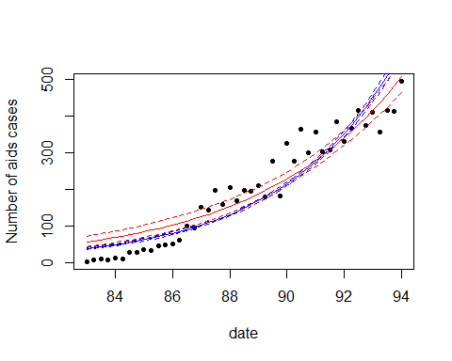

## even if the Confidence Intervals are not exactly clear, it is still  
## correct to make the exp of the mean and CI When we are using a  
## log-link function

As we can see from the plot alone, neither the gaussian model nor the poisson model fits the data very well.

The poisson model is clearly not a good model since the big majority of the model is either overestimating or underestimating the data, which is a clear indicator that this model is inadequate.

The Normal distribution, seems to fit the data almost as equally poorly, with too much overpredicitons or underpredictions, making it also a not very adequate fit to the data, even if the distribution was well choosen for this type of data.

## Question 2 c)

In this question we will be using the AIC

# Model comparison aka AIC time  
# the formula to for the AIC: −2l + 2p  
  
AIC(model1)

[1] 482.8128

AIC(model2)

[1] 1153.873

As we can see from the Akaike Information Criterion, model 1 as a much lower AIC, meaning model 1 has a much better fit than model 2 since when comparing AICs, the model with the lower values has the better fit

## Question 2 d)

plot(model1, 1)

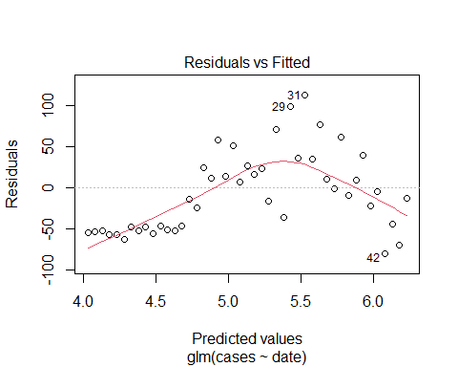

As we can see from the Residual vs fitted model, there seems to be quadratic pattern in how the model overfits and underfits the data in a way the would require more flexibility from a quadratic term.

plot(model2, 1)

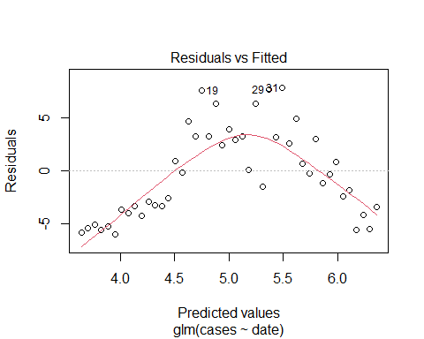

The Poisson model residuals seem to follow a quadratic function with some slight curves along the quadric function, this mean it required a quadratic and a cubic term for the flexibility to better fit the data.

## Question 2 e)

As we commented on the previous exercise we will be adding the quadratic and cubic term values directly to the aids so we can use them in our model

aids$dataSq = aids$date^2  
  
aids$dataCubic = aids$date^3

# Fitting model 2 improvement  
model2Improved = glm(cases ~ date + dataSq + dataCubic, data = aids, family = poisson(link = "log"))  
  
summary(model2Improved)

Call:  
glm(formula = cases ~ date + dataSq + dataCubic, family = poisson(link = "log"),   
 data = aids)  
  
Deviance Residuals:   
 Min 1Q Median 3Q Max   
-5.5861 -1.2939 -0.3798 1.1213 4.1190   
  
Coefficients:  
 Estimate Std. Error z value Pr(>|z|)   
(Intercept) -4.151e+03 4.358e+02 -9.525 <2e-16 ***  
date 1.356e+02 1.460e+01 9.290 <2e-16 ***  
dataSq -1.477e+00 1.630e-01 -9.059 <2e-16 ***  
dataCubic 5.362e-03 6.062e-04 8.845 <2e-16 ***  
---  
Signif. codes: 0 '***' 0.001 '**' 0.01 '*' 0.05 '.' 0.1 ' ' 1  
  
(Dispersion parameter for poisson family taken to be 1)  
  
 Null deviance: 5738.16 on 44 degrees of freedom  
Residual deviance: 166.68 on 41 degrees of freedom  
AIC: 470.53  
  
Number of Fisher Scoring iterations: 4

# Fitting model 1 improvement  
model1Improved = glm(cases ~ date + dataSq, data = aids, family = gaussian(link = "log"))

## compare the full and reduced models using ANOVA (this order)  
anova(model2Improved, model2, test = "Chisq")

Analysis of Deviance Table  
  
Model 1: cases ~ date + dataSq + dataCubic  
Model 2: cases ~ date  
 Resid. Df Resid. Dev Df Deviance Pr(>Chi)   
1 41 166.68   
2 43 854.02 -2 -687.34 < 2.2e-16 ***  
---  
Signif. codes: 0 '***' 0.001 '**' 0.01 '*' 0.05 '.' 0.1 ' ' 1

We can see that the p-value is less than 0.05 and therefore we can reject the null hypothesis and conclude that the model with the quadratic and cubic terms is better than the linear Poisson model statistically so we should choose the improved model.

## compare the full and reduced models using ANOVA (this order)  
anova(model1Improved, model1, test = "Chisq")

Analysis of Deviance Table  
  
Model 1: cases ~ date + dataSq  
Model 2: cases ~ date  
 Resid. Df Resid. Dev Df Deviance Pr(>Chi)   
1 42 46327   
2 43 105306 -1 -58979 2.627e-13 ***  
---  
Signif. codes: 0 '***' 0.001 '**' 0.01 '*' 0.05 '.' 0.1 ' ' 1

We can once again see that the p-value is less than 0.05 and therefore we can reject the null hypothesis and conclude that the model with the quadratic term is better than the linear Gaussian model statistically so we should choose the improved model.

## Question 2 f)

Firstly I will talk about each model flaws.

Starting from the improved Gaussian model, its main flaw is how a normal distribution simply does not respect the nature of this data, that is count data with only values on the real line for the reasons already mentioned on question 2 a).

The improved Poisson model although respects the nature of the nature, the initial model was underestimating and overestimating too much of the data and required a clear flexibility improvement by adding quadratic and cubic terms, however such performance improvement come at the cost of interpretability as it is not very clear what quadratic and cubic time real represent in this new model.

Now that we have established that both models have their flaws I will begin by comparing both models.

We can extract the deviance from the model and calculate a p-value to check whether the model fits the data using an LRT:

# Deviance goodness of fit of model 1 looks OK:  
1 - pchisq(model1Improved$deviance, model1Improved$df.residual)

[1] 0

# Deviance goodness of fit of model 1 looks OK:  
1 - pchisq(model2Improved$deviance, model2Improved$df.residual)

[1] 0

The p-value for both models are smaller than 0.05, so it means that both models although already improved still aren’t a good fit for the data.

Comparing both models using AIC we can see that:

AIC(model1Improved)

[1] 447.8615

AIC(model2Improved)

[1] 470.5294

Both models have a relatively close AIC result.

Leaving us to choose neither of the models as good fit for the data, although the improved Poisson would still be preferred to the improved Gaussian since it is the only one of the improved models respecting the nature of the data.

## Question 2 g)

# Fit the model model2Improved = glm(cases ~ date + dataSq + dataCubic,  
# data = aids, family = poisson(link='log'))  
modelNegativeBinom <- glm.nb(cases ~ (date + dataSq + dataCubic), data = aids)  
  
# Model summary  
summary(modelNegativeBinom)

Call:  
glm.nb(formula = cases ~ (date + dataSq + dataCubic), data = aids,   
 init.theta = 64.08286877, link = log)  
  
Deviance Residuals:   
 Min 1Q Median 3Q Max   
-2.5965 -0.6448 -0.1348 0.6123 2.1889   
  
Coefficients:  
 Estimate Std. Error z value Pr(>|z|)   
(Intercept) -4.203e+03 7.696e+02 -5.462 4.71e-08 ***  
date 1.374e+02 2.594e+01 5.296 1.18e-07 ***  
dataSq -1.496e+00 2.913e-01 -5.135 2.81e-07 ***  
dataCubic 5.432e-03 1.090e-03 4.986 6.17e-07 ***  
---  
Signif. codes: 0 '***' 0.001 '**' 0.01 '*' 0.05 '.' 0.1 ' ' 1  
  
(Dispersion parameter for Negative Binomial(64.0829) family taken to be 1)  
  
 Null deviance: 1812.085 on 44 degrees of freedom  
Residual deviance: 45.007 on 41 degrees of freedom  
AIC: 405.92  
  
Number of Fisher Scoring iterations: 1  
  
 Theta: 64.1   
 Std. Err.: 20.4   
  
 2 x log-likelihood: -395.915

# Fit the model  
modelNegativeBinom <- glm.nb(cases ~ (date + dataSq + dataCubic), data = aids)  
  
# Model summary  
summary(modelNegativeBinom)

Call:  
glm.nb(formula = cases ~ (date + dataSq + dataCubic), data = aids,   
 init.theta = 64.08286877, link = log)  
  
Deviance Residuals:   
 Min 1Q Median 3Q Max   
-2.5965 -0.6448 -0.1348 0.6123 2.1889   
  
Coefficients:  
 Estimate Std. Error z value Pr(>|z|)   
(Intercept) -4.203e+03 7.696e+02 -5.462 4.71e-08 ***  
date 1.374e+02 2.594e+01 5.296 1.18e-07 ***  
dataSq -1.496e+00 2.913e-01 -5.135 2.81e-07 ***  
dataCubic 5.432e-03 1.090e-03 4.986 6.17e-07 ***  
---  
Signif. codes: 0 '***' 0.001 '**' 0.01 '*' 0.05 '.' 0.1 ' ' 1  
  
(Dispersion parameter for Negative Binomial(64.0829) family taken to be 1)  
  
 Null deviance: 1812.085 on 44 degrees of freedom  
Residual deviance: 45.007 on 41 degrees of freedom  
AIC: 405.92  
  
Number of Fisher Scoring iterations: 1  
  
 Theta: 64.1   
 Std. Err.: 20.4   
  
 2 x log-likelihood: -395.915

Now that we have extended the improved Poisson into a negative Binomial, we will compare this new model against the previously improved Poisson model and the improved Gaussian model.

# Deviance goodness of fit of the negative model looks OK:  
1 - pchisq(modelNegativeBinom$deviance, modelNegativeBinom$df.residual)

[1] 0.3078234

# Deviance goodness of fit of improved model 2 looks OK:  
1 - pchisq(model2Improved$deviance, model2Improved$df.residual)

[1] 0

# Deviance goodness of fit of improved model 1 looks OK:  
1 - pchisq(model1Improved$deviance, model1Improved$df.residual)

[1] 0

As we can see, the negative binomial model is the only model with a p-value is larger than 0.05, meaning that only negative binomial is considered a good fit to the data.

Lastly from the Akaike Information Criterion test we can see that the Negative Binomial has the best goodness of fit per penalised complexity meaning it simply performs better than the other 2 models.

AIC(modelNegativeBinom)

[1] 405.9155

AIC(model1Improved)

[1] 447.8615

AIC(model2Improved)

[1] 470.5294

To conclude the negative binomial model not only is preferable to both the improved poisson and improved gaussian model, it is also a good fit for the data.