# Snapshot and context

This dataset profiles 200 top Instagram accounts with metrics such as followers, posts, average likes, 60-day engagement rate, total likes and an influence score. The data was cleaned so abbreviated values like "3.3k" or "8.7m" are converted to numeric counts,

enabling comparisons across accounts and countries.

# Key insight — big accounts dominate but engagement varies

 High follower counts are concentrated in a few mega-accounts; these accounts also dominate total likes and skew raw comparisons.

 Supporting data: the scatter "Followers vs. Engagement Rate by Country" shows many extremely large follower values with engagement rates that range widely; some large accounts have modest engagement while others maintain higher rates.



Download

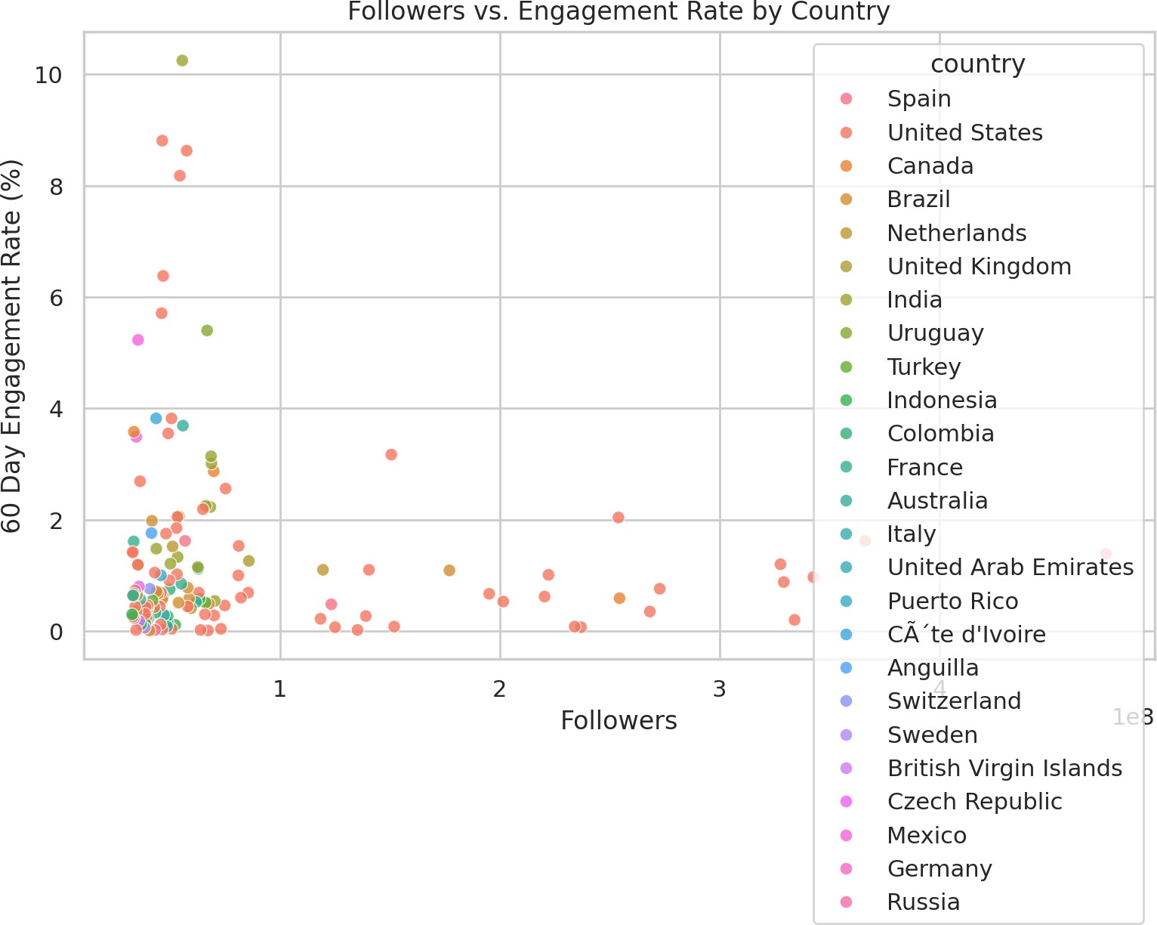

 Practical takeaway: audience size alone doesn’t guarantee high engagement; consider engagement rate when selecting partners.

# Who sits at the top by reach

 The follower leaderboard is heavily skewed: the top entries include accounts with hundreds of millions of followers.

 Supporting data: "Top 10 Instagram Influencers by Followers" highlights these top accounts and their relative scale (note the largest bars tower above the rest).



Download

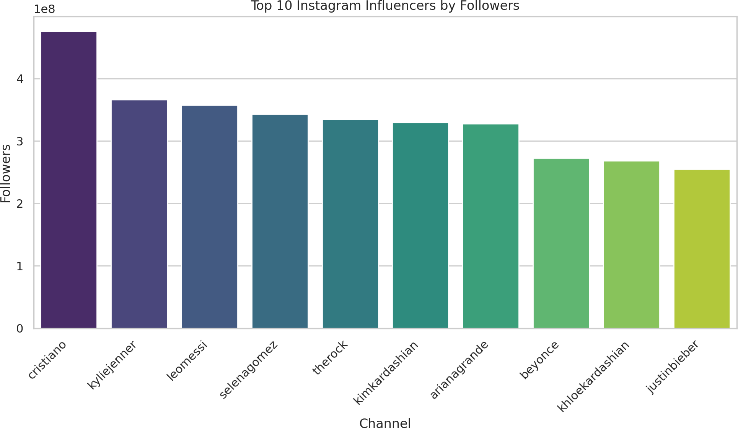

 Practical takeaway: Campaign reach will be dominated by a handful of names; for diversity or cost-efficiency, consider mid-tier accounts.

# Engagement (average likes) differs by country

 Average likes per post varies across countries with noticeable spread and outliers.

 Supporting data: the box plot "Distribution of Average Likes by Country" shows different medians and wide IQRs for several countries, indicating heterogeneous audience

response by market.

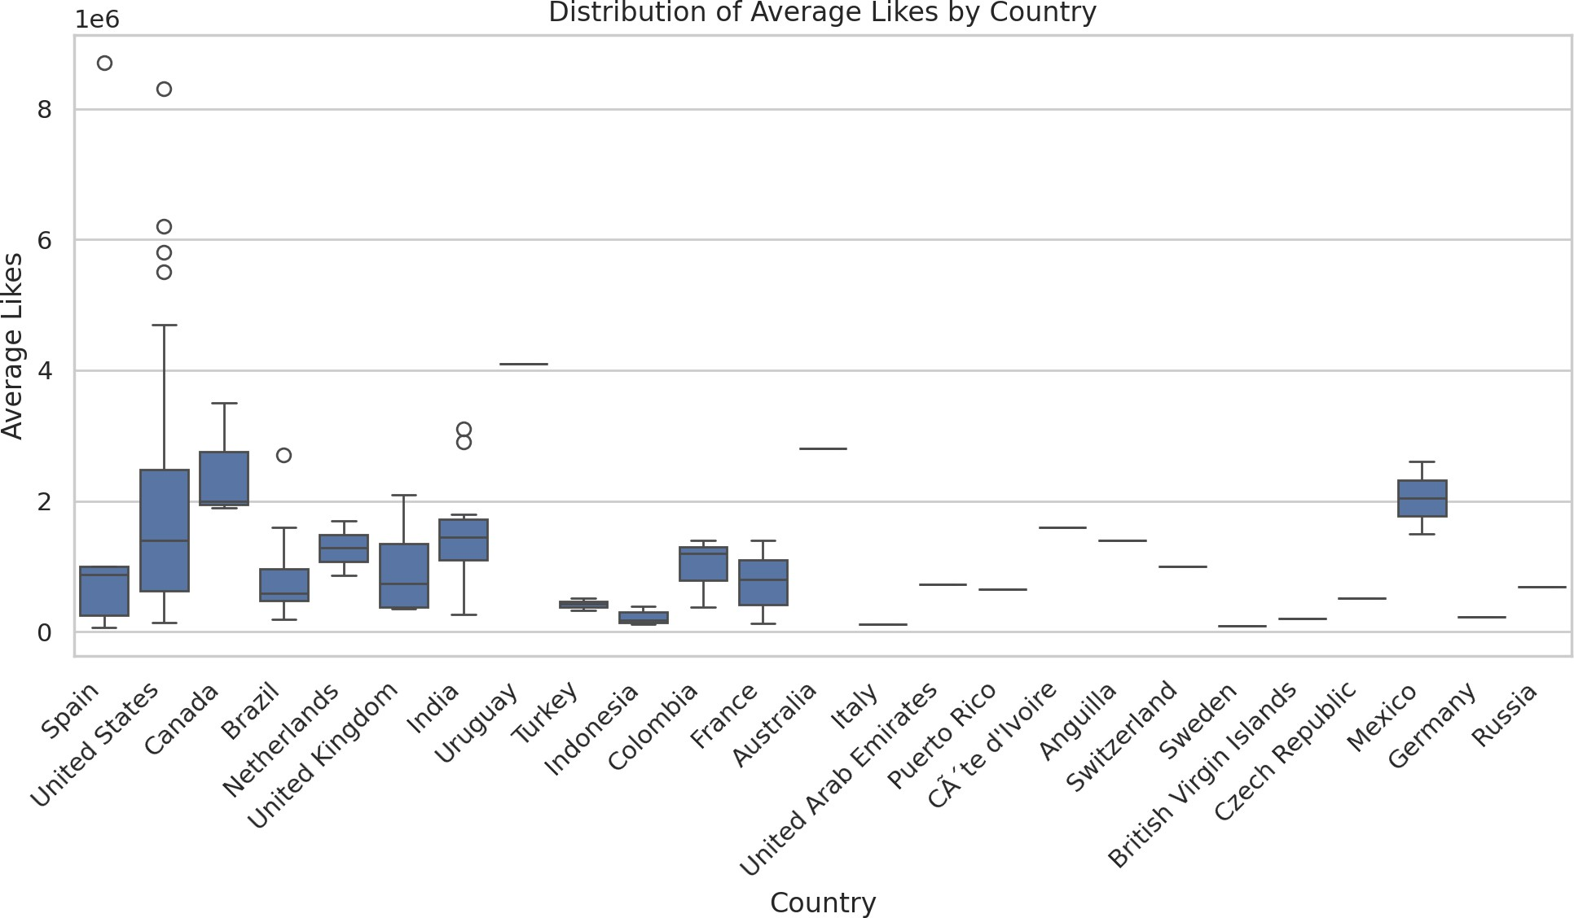

 Practical takeaway: country-level norms matter — benchmark performance within countries rather than globally.

# Influence score distribution — many high scorers with a tail

 Influence scores are concentrated toward the upper range but there is a long tail.

 Supporting data: the histogram "Distribution of Influence Scores" (with KDE) shows clustering at higher values and fewer accounts at the low end.

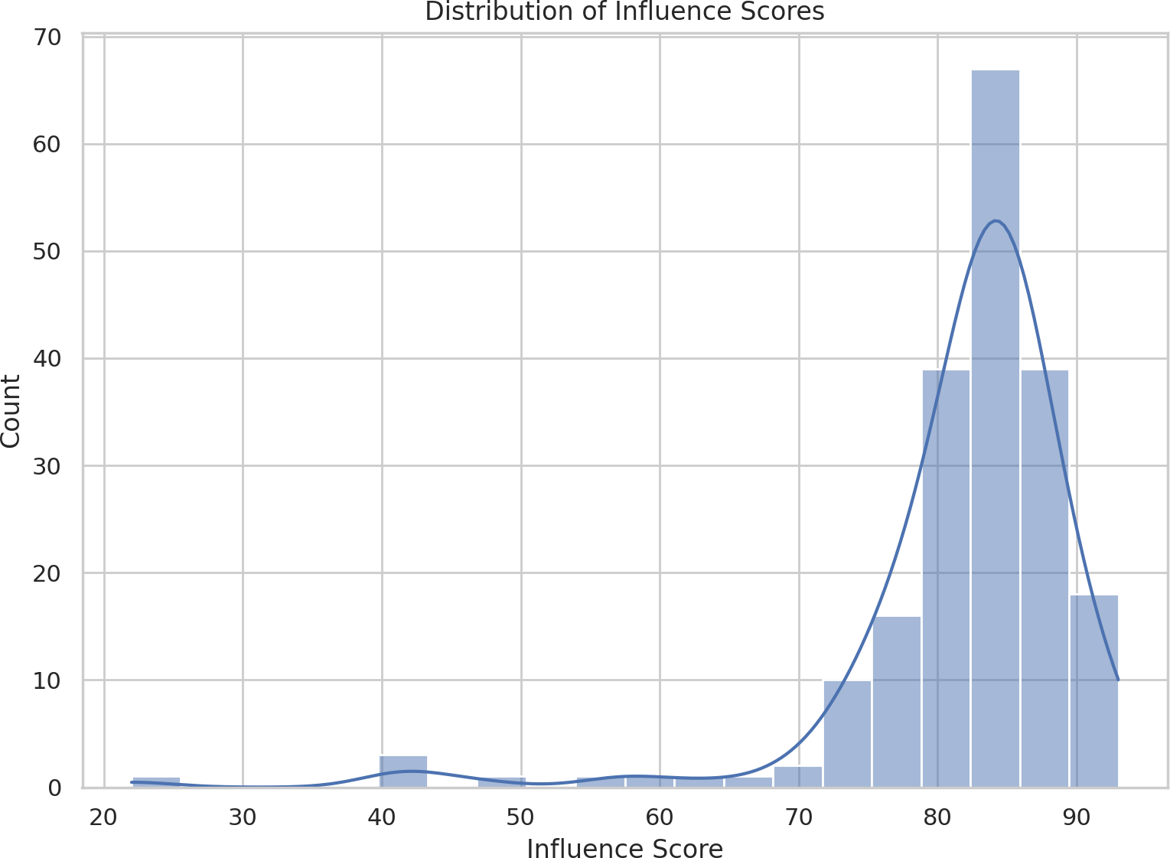

 Practical takeaway: while many accounts rate highly on an influence metric, other signals (engagement rate, audience fit) should guide selections.

# Total likes concentrated among top accounts

 Total lifetime likes are extremely skewed; the leaderboard is dominated by a small set of mega accounts.

 Supporting data: "Top 20 Influencers by Total Likes" presents a horizontal ranking where a handful of channels have far higher totals than peers.

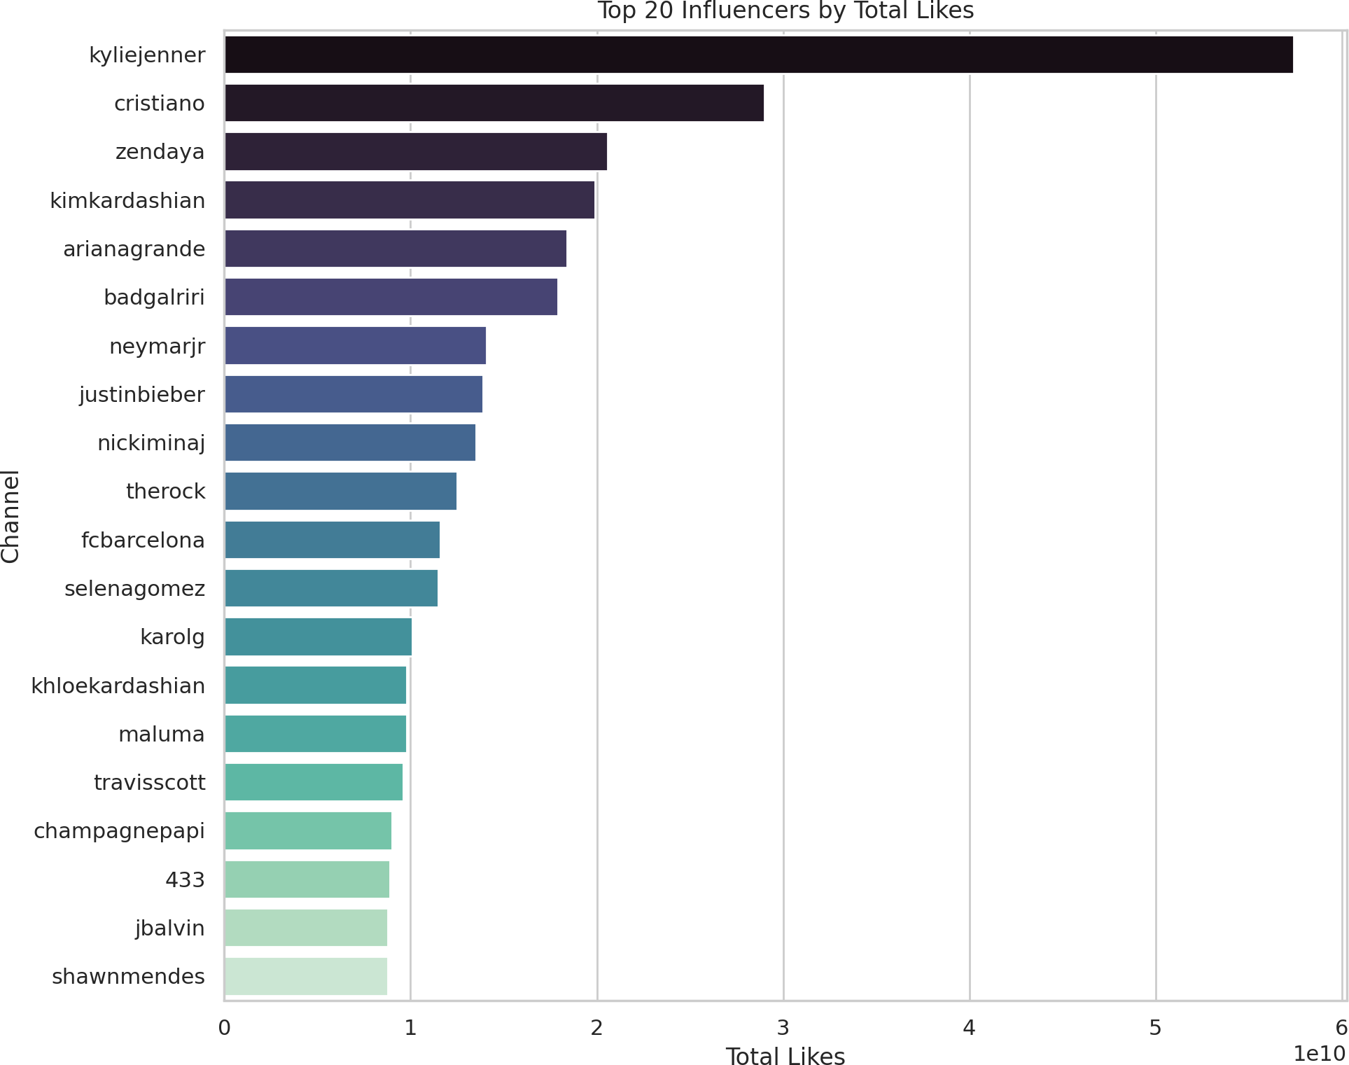

 Practical takeaway: total likes are useful to identify historical reach but can overweight legacy popularity versus current engagement.

# Posts vs followers — no simple linear relationship

 Posting volume does not directly predict follower counts in a simple linear way.

 Supporting data: the "Posts vs. Followers Relationship" scatter shows no strong straight- line trend; some accounts with fewer posts have massive followings, while others post a lot with more moderate follower totals.

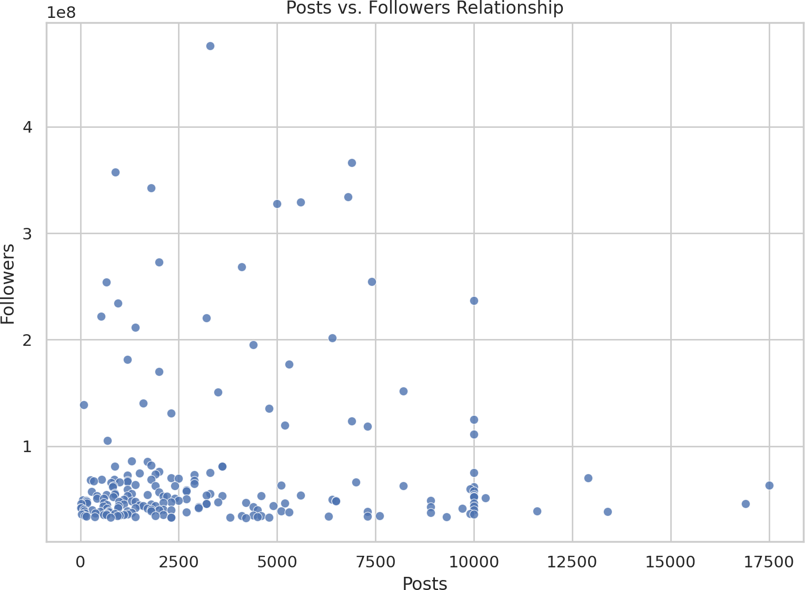

 Practical takeaway: content quality, tenure and offline fame likely matter more than sheer posting frequency.

# Representative table preview (first 5 rows)

|  |  |  |  |  |
| --- | --- | --- | --- | --- |
| rank | channel_info | influence_score | posts | followers |
| 1 | cristiano | 92 | 3.3k | 475.8m |
| 2 | kyliejenner | 91 | 6.9k | 366.2m |
| 3 | leomessi | 90 | 0.89k | 357.3m |
| 4 | selenagomez | 93 | 1.8k | 342.7m |
| 5 | therock | 91 | 6.8k | 334.1m |

**Data summary statistics (selected)**

 Count: 200 accounts

 Followers: mean ~77.4M, median ~50.05M, max 475.8M

 Avg likes: mean ~1.79M, median 1.10M

 60-day engagement rate: mean ~1.90%, median ~0.88%  Total likes: mean ~3.66B (skewed by mega-accounts)

Concluding summary

A few mega accounts drive reach and total likes, but engagement rates and average

likes vary substantially across accounts and countries. For campaign planning, balance reach with engagement and local audience behavior. If you want, I can produce the

same charts with log scales, annotate top accounts, or produce concise lists of recommended accounts by region and campaign objective.