CA2 727721euit059-Janani K S

QUESTION 1:

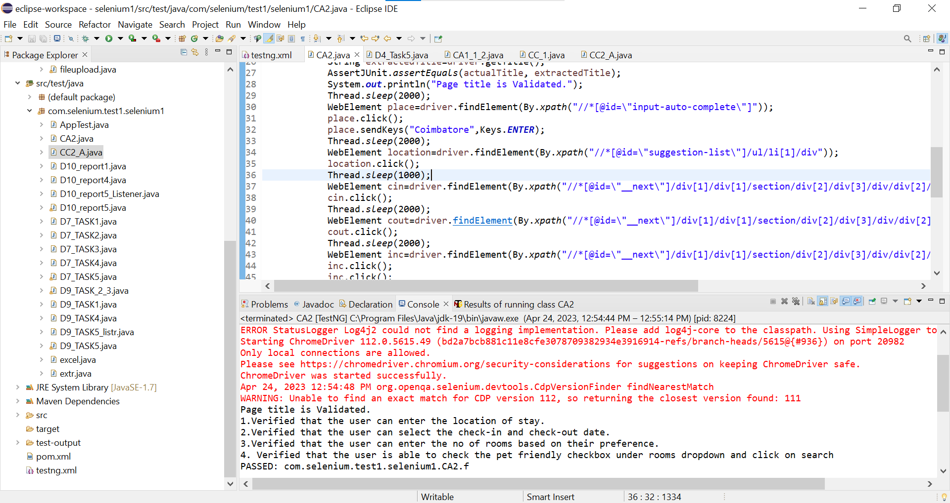

**package** com.selenium.test1.selenium1;

**import** org.openqa.selenium.By;

**import** org.openqa.selenium.Keys;

**import** org.openqa.selenium.WebDriver;

**import** org.openqa.selenium.WebElement;

**import** org.openqa.selenium.chrome.ChromeDriver;

**import** org.openqa.selenium.chrome.ChromeOptions;

**import** org.testng.AssertJUnit;

**import** org.testng.annotations.Test;

**import** io.github.bonigarcia.wdm.WebDriverManager;

**public** **class** CA2 {

@Test

**public** **void** f()**throws** InterruptedException {

WebDriverManager.*chromedriver*().setup();

WebDriver driver;

ChromeOptions co = **new** ChromeOptions();

co.addArguments("--remote-allow-origins=*");

driver=**new** ChromeDriver(co);

driver.manage().window().maximize();

driver.get("https://www.trivago.in/");

Thread.*sleep*(2000);

String actualTitle="trivago.in - Compare hotel prices worldwide";

String extractedTitle=driver.getTitle();

AssertJUnit.*assertEquals*(actualTitle, extractedTitle);

System.***out***.println("Page title is Validated.");

Thread.*sleep*(2000);

WebElement place=driver.findElement(By.*xpath*("//*[@id=\"input-auto-complete\"]"));

place.click();

place.sendKeys("Coimbatore",Keys.***ENTER***);

Thread.*sleep*(2000);

WebElement location=driver.findElement(By.*xpath*("//*[@id=\"suggestion-list\"]/ul/li[1]/div"));

location.click();

Thread.*sleep*(1000);

WebElement cin=driver.findElement(By.*xpath*("//*[@id=\"__next\"]/div[1]/div[1]/section/div[2]/div[3]/div/div[2]/div/div/div/div[2]/div/div[1]/div[2]/button[2]/time"));

cin.click();

Thread.*sleep*(2000);

WebElement cout=driver.findElement(By.*xpath*("//*[@id=\"__next\"]/div[1]/div[1]/section/div[2]/div[3]/div/div[2]/div/div/div/div[2]/div/div[1]/div[2]/button[7]/time"));

cout.click();

Thread.*sleep*(2000);

WebElement inc=driver.findElement(By.*xpath*("//*[@id=\"__next\"]/div[1]/div[1]/section/div[2]/div[3]/div/div[2]/div/div/div[1]/div/div[1]/div[1]/div/button[2]/span/span[1]"));

inc.click();

inc.click();

inc.click();

Thread.*sleep*(2000);

WebElement pet=driver.findElement(By.*id*("checkbox-13"));

pet.click();

Thread.*sleep*(3000);

WebElement apply=driver.findElement(By.*xpath*("//*[@id=\"__next\"]/div[1]/div[1]/section/div[2]/div[3]/div/div[2]/div/div/div[2]/div/button[2]"));

apply.click();

Thread.*sleep*(3000);

String Title="Coimbatore (Pet friendly) Hotels | Find & compare great deals on trivago";

String extTitle=driver.getTitle();

**if**(Title.equals(extTitle)) {

System.***out***.println("1.Verified that the user can enter the location of stay.");

System.***out***.println("2.Verified that the user can select the check-in and check-out date.");

System.***out***.println("3.Verified that the user can enter the no of rooms based on their preference.");

System.***out***.println("4. Verified that the user is able to check "

+ "the pet friendly checkbox under rooms dropdown and click on search");

}

}

}