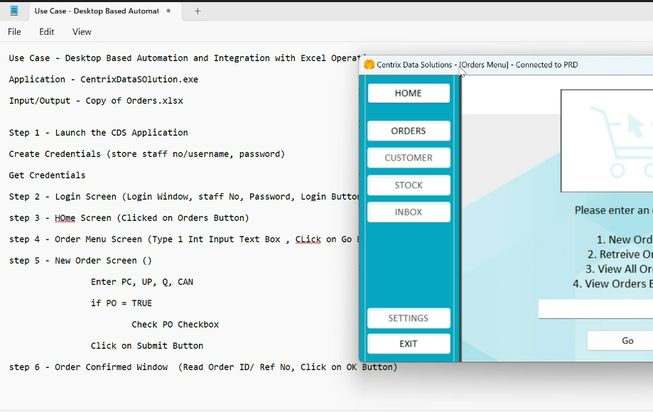

staff no : bp

password :     password

