xEXPERIMENT 8- ASSOCIATION LEARNING AND DIMENSIONALITY REDUCTION

1.SCENARIO 1: APRIORI
OUTPUT:

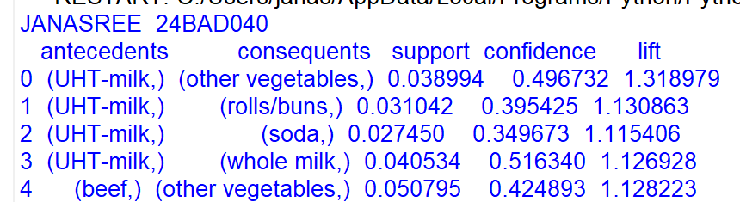
FIGURE:
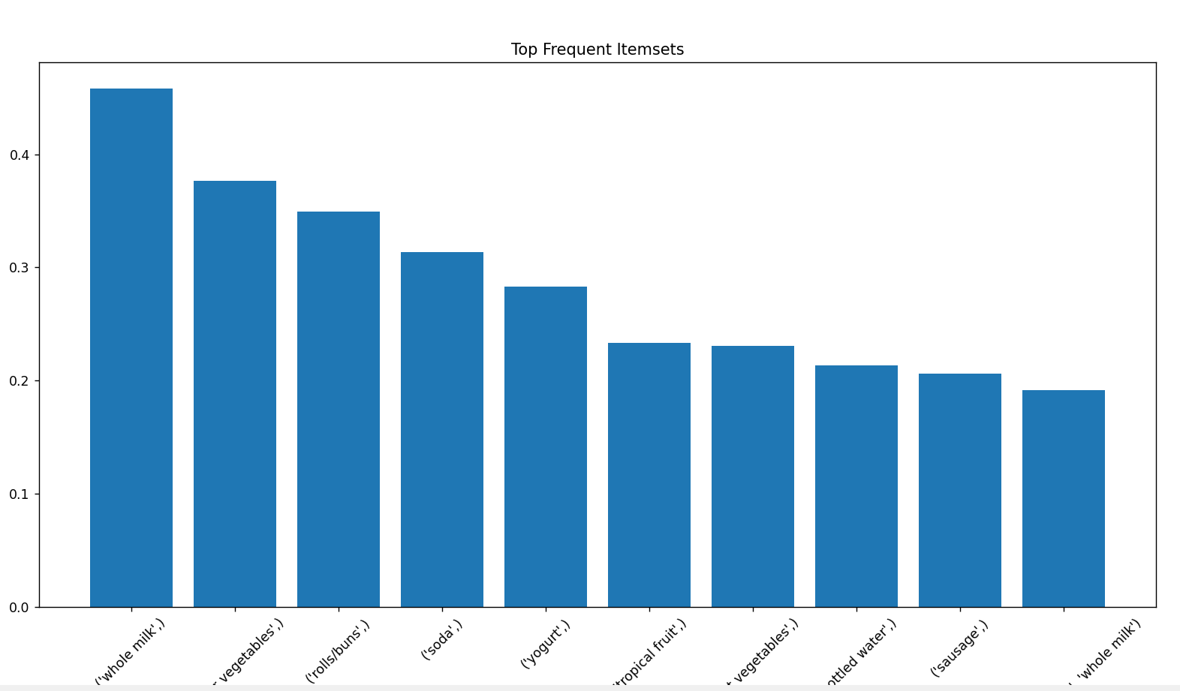
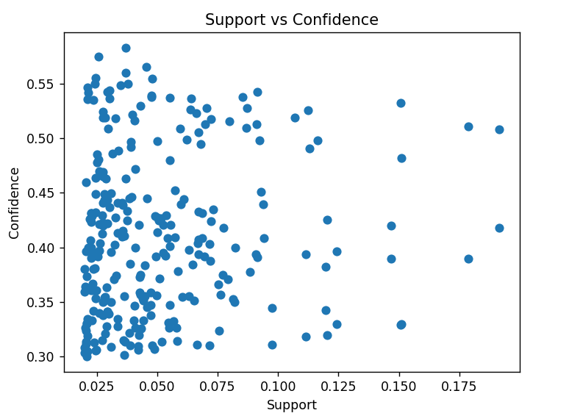
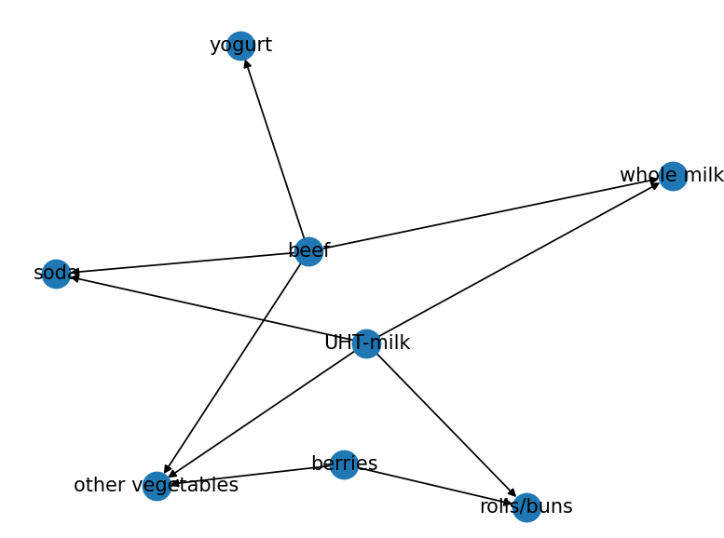
2.SCENARIO 2: PCA
OUTPUT:
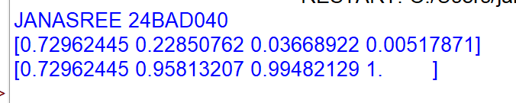
PLOT:
