Deep Learning Project Report

RescueBite

A Deep Learning-Based Food Recognition, Spoilage Detection and Surplus Food Rescue System

Student name | Janasree P, Dhivya A, Ramya R
Register number | 24BAD040, 24BAD020, 24BAD096
Department | B.Tech, Artificial Intelligence and Data Science
Institution | Kumaraguru College of Technology
Date | 17.10. 2026

1. Title and Introduction
RescueBite is a deep learning-based system that helps canteens, hostels and event caterers donate surplus cooked food safely to NGOs. A donor uploads a photo of the food and enters when and how it was prepared and stored. The system recognises the food, checks it for visible spoilage, applies food-safety time and storage rules, and lists eligible donations on an NGO dashboard with a collection deadline.

2. Objective
- Recognise the type of food from an image using a MobileNetV2 transfer-learning classifier.
- Detect visible spoilage (fresh or spoiled) using a second MobileNetV2 classifier, returning an "uncertain" result when model confidence is low.
- Calculate a safe window and latest collection time from the entered preparation time, storage method and temperatures using a rules-based module.
- Provide a Streamlit web application where donors register donations and NGOs request and collect them.
- Reduce food waste while keeping a human check as the final safety step.

Key design rule
A photograph cannot show how long food has been stored or at what temperature. The collection deadline is therefore calculated from the entered details and is never predicted from the image. The system does not approve a donation from an image result alone.

3. SDG Mapping
SDG | Goal | How RescueBite contributes
SDG 2 | Zero Hunger | Connects surplus cooked food with NGOs that can serve people in need.
SDG 12 | Responsible Consumption and Production | Reduces food waste by rescuing edible surplus before it is discarded.
SDG 3 | Good Health and Well-being | Uses spoilage checks, time limits and temperature rules to lower the risk of unsafe food being donated.
SDG 17 | Partnerships for the Goals | Brings donors and NGOs together on one shared platform.

4. Datasets
Both datasets are downloaded from Hugging Face inside the notebook and arranged as one folder per class, which is the layout Keras expects.
 | Food recognition | Spoilage detection
Source | Hugging Face: SKSKCulinaryAI/Indian_Food_Images_Dataset | Hugging Face: Project-AgML/fresh_rotten_fruit_classification
Task | Multi-class classification of Indian food images | Binary classification: fresh or spoiled
Classes | 25 food classes | 2 classes: fresh and spoiled (label 0 = fresh, 1 = rotten)
Total images | 10,773 | 3,200 (1,600 fresh and 1,600 rotten)
Content | Biryani, butter chicken, chappati, chicken tandoori, chole bhature, dal makhani, dhokla, dosa, gajar halwa, ghevar, gulab jamun, idli, jalebi, kadai paneer, kathi roll, kofta, masala bhindi, meduvada, pani puri, pav bhaji, poori, rasgulla, samosa, toor dal, vada pav | Eight fruit types with 400 images each, including apple, banana, grape, guava, jujube, orange and pomegranate
Preparation | Split folders (train, valid, test) merged into one folder per class, then re-split by the notebook. | Images converted to RGB JPEG and saved into fresh/ and spoiled/ with the fruit type in the file name.

5. Training, Validation and Test Data
Each dataset is split into 70% training, 15% validation and 15% test data using a fixed random seed of 42. The test images are never used during training, so they give an honest measure of performance on unseen data.
Split | Share | Food images | Spoilage images
Training | 70% | 7,542 | 2,240
Validation | 15% | 1,600 | 480
Test | 15% | 1,631 | 480
Total | 100% | 10,773 | 3,200

Training settings
Setting | Value
Image size / batch size | 224 x 224 pixels / 32
Base model | MobileNetV2 pretrained on ImageNet
Augmentation | Random flip, rotation (0.1), zoom (0.1) and contrast (0.1)
Classifier head | Global average pooling, dropout 0.3, softmax dense layer
Step 1: head training | Up to 8 epochs, Adam, learning rate 1e-3, base frozen
Step 2: fine-tuning | Up to 5 epochs, Adam, learning rate 1e-5, last 30 base layers unfrozen
Early stopping | Monitors validation accuracy, patience 3, restores best weights
Environment | Google Colab, TensorFlow 2.21.0, GPU runtime

6. IPYNB Code Explanation
Section | Title | What the code does
1 | Install and set up | Installs Streamlit, pingo, scikit-learn and seaborn; imports TensorFlow/Keras; sets folders, image size (224), batch size (32) and random seed (42).
2 | Prepare datasets | Downloads the food dataset with snapshot_download and merges its splits into one folder per class. Loads the fresh/rotten fruit dataset with the datasets library and saves images into fresh/ and spoiled/.
3 | Check datasets | Counts images per class, warns if a class has fewer than 50 images and plots a bar chart.
4 | Load data | Uses image_dataset_from_directory to make training data (70%) and held-out data, which is divided equally into validation and test sets.
5 | Build models | build_model creates augmentation, a frozen MobileNetV2 base, pooling, dropout and a softmax layer. train_model trains the head first, then fine-tunes the last 30 layers.
6 | Train food model | Trains the food recognition classifier on the food dataset.
7 | Train spoilage model | Trains the fresh/spoiled classifier on the spoilage dataset.
8 | Evaluate | Plots accuracy and loss curves, then prints test accuracy, a classification report and a confusion matrix on the unseen test set.
9 | Sample predictions | Shows test images with true label, predicted label and confidence.
10 | Uncertain option | Returns "uncertain" when spoilage confidence is below 0.75. Reports how often the model abstains and its accuracy on confident predictions.
11 | Save models | Saves food_model.keras, spoilage_model.keras and meta.json (class names, thresholds, image size) and zips them for download.
12 | Time and storage module | assessment.py holds the rules that decide ELIGIBLE_FOR_REVIEW, NEEDS_VERIFICATION or NOT_ELIGIBLE and calculate the safe window and collect-by time.
13 | Test the module | Runs eight scenarios through the rules module.
14 | Single image analysis | Predicts food name and visible condition for one uploaded photo.
15 | Streamlit app | Writes app.py with five pages and an SQLite database for donations.
16 | Launch the app | Starts Streamlit on port 8501 and exposes it with an ngrok public URL.

Rules module: assessment logic
- Visible spoilage in the image makes the donation not eligible.
- Missing preparation time or storage history gives "needs verification".
- Room temperature limit is 2 hours, reduced to 1 hour when the surroundings are above 32 °C.
- Hot food must be held at 60 °C or above and cold food at 5 °C or below. If unverified, the stricter room-temperature rule is applied.
- A 15-minute buffer is subtracted from the end of the safe window to give the collect-by time.
- The 4-hour hot-holding and 24-hour refrigerated limits are placeholders and should be set according to local food-safety rules, for example FSSAI requirements in India.

7. Testing and Validation

7.1 Training
Both models were trained in two steps. The food model trained its new top layers for 8 epochs and then fine-tuned for 3 more epochs before early stopping ended training. The spoilage model followed the same pattern. Validation accuracy reached about 85% for the food model and up to about 95% for the spoilage model. Accuracy dipped briefly when fine-tuning started and then recovered, and early stopping restored the best weights.
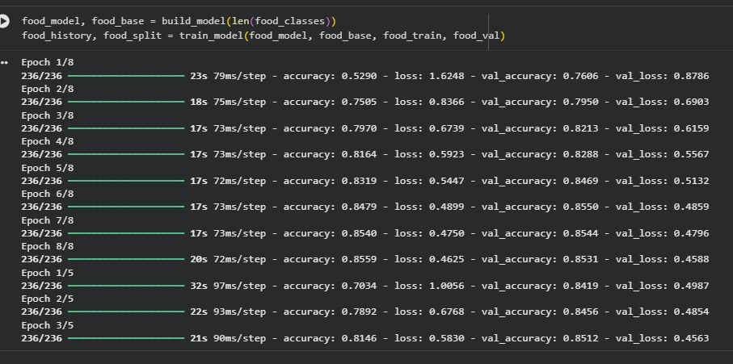
Figure 1: Food recognition training log
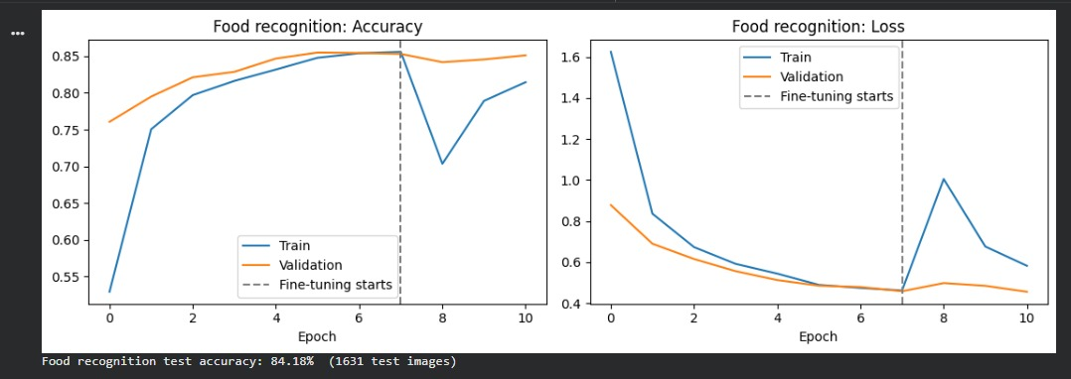

Figure 2: Food recognition accuracy and loss curves
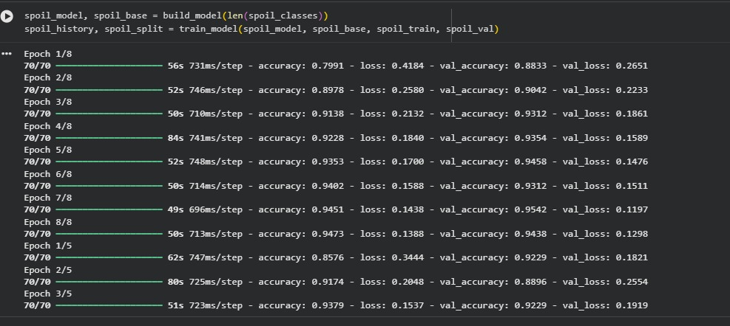

Figure 3: Spoilage detection training log
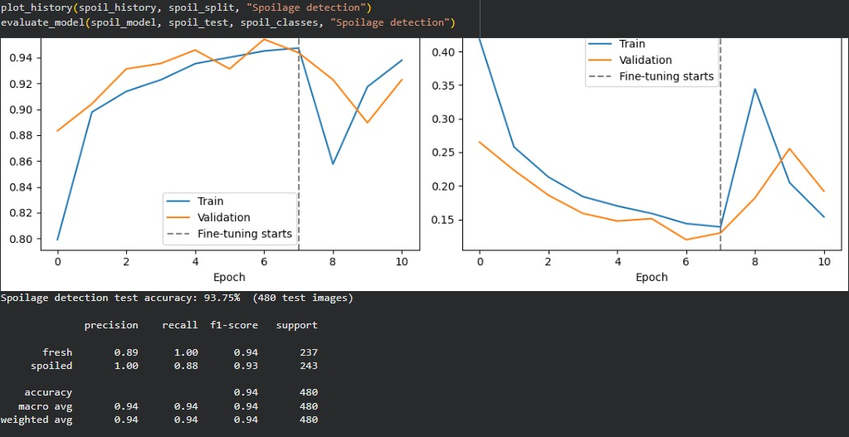
Figure 4: Spoilage detection accuracy and loss curves

7.2 Food recognition test results
On the unseen test set of 1,631 images the food recognition model reached a test accuracy of 84.18%. The macro average precision, recall and F1-score were 0.86, 0.84 and 0.84.
Group | Classes | F1-score
Strongest classes | Jalebi, gulab jamun, rasgulla | 0.96, 0.94, 0.93
Weakest classes | Butter chicken, kadai paneer, kofta | 0.64, 0.66, 0.70
Butter chicken was often confused with kadai paneer and kofta (similar red-orange gravies), and masala bhindi and gajar halwa were also sometimes predicted as kadai paneer.
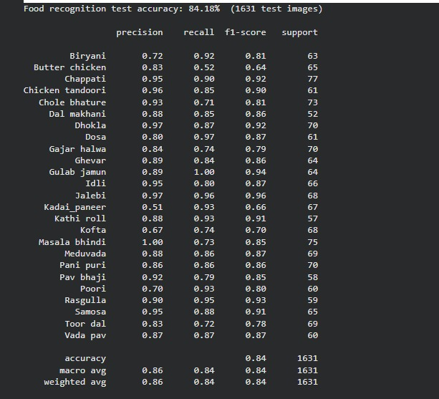

Figure 5: Food recognition classification report
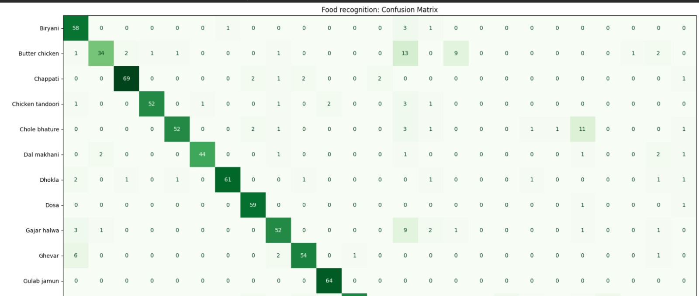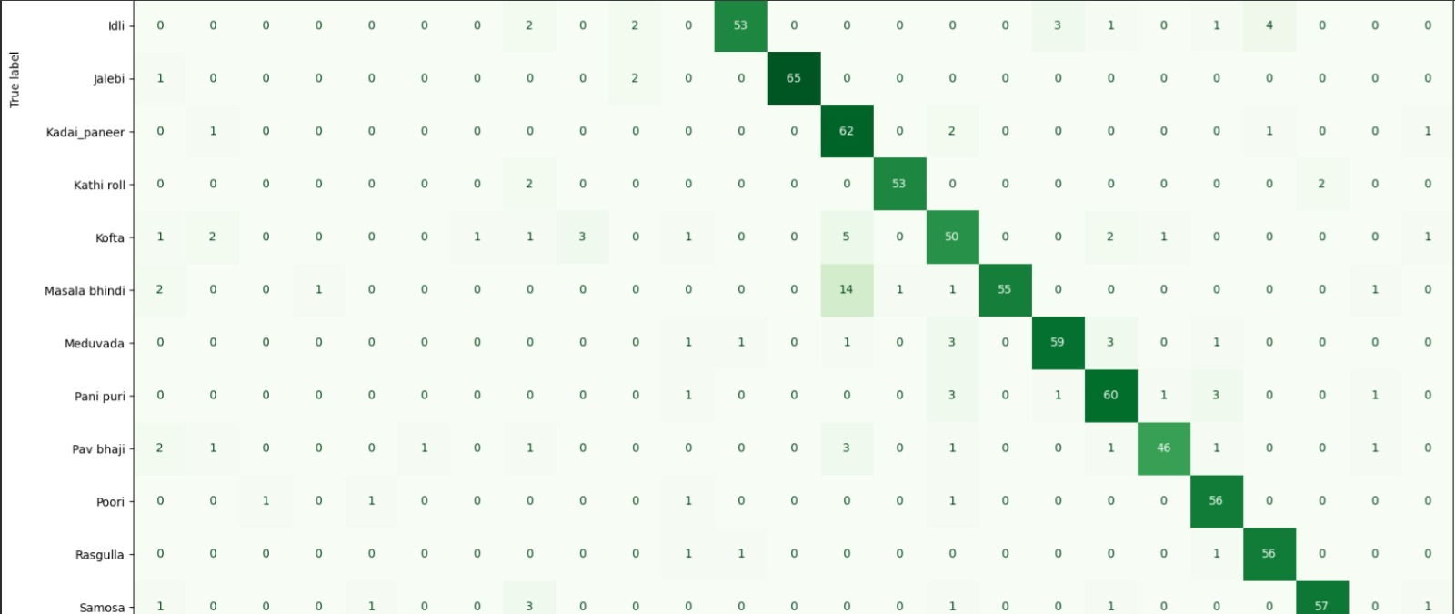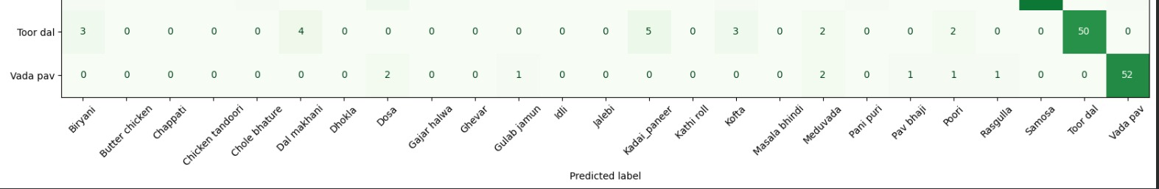

Figure 6: Food recognition confusion matrix
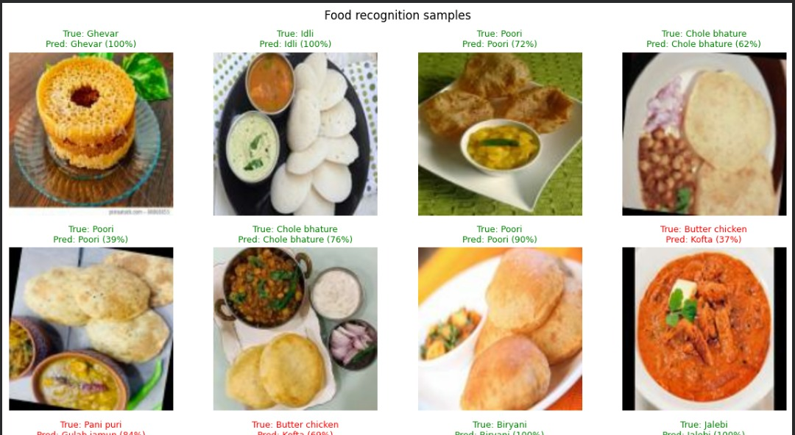

Figure 7: Sample food predictions (true label and predicted label with confidence)

7.3 Spoilage detection test results
The spoilage model was tested on 480 unseen images. From the confusion matrix, 450 of 480 images were classified correctly, a test accuracy of 93.75%.
Measure | Fresh | Spoiled
Images in test set | 237 | 243
Correctly classified | 236 | 214
Recall | 99.6% | 88.1%
Precision | 89.1% | 99.5%
The model rarely marks fresh food as spoiled (1 image), but it missed 29 spoiled images by calling them fresh. This is the more serious kind of error for a food-safety application, which is why the "uncertain" option and the human check are part of the design.
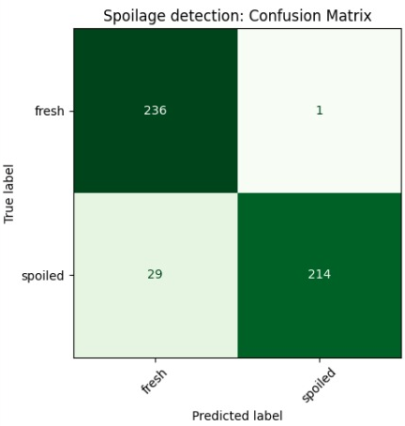

Figure 8: Spoilage detection confusion matrix
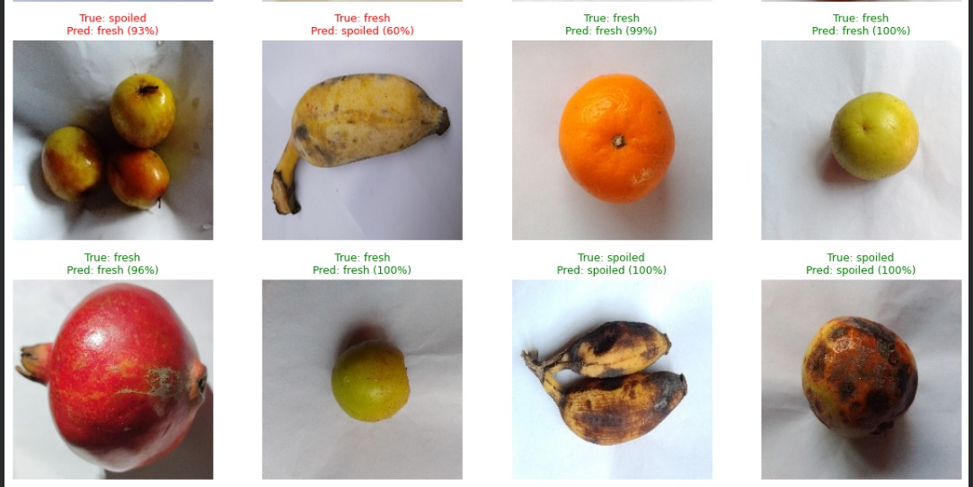

Figure 9: Sample spoilage predictions

7.4 Uncertain option
Spoilage predictions below 0.75 confidence are reported as "uncertain" and food-name predictions below 0.60 are flagged for manual confirmation. On the test set, 8.3% of spoilage images were marked uncertain, and accuracy on the remaining confident predictions rose to 95.23%. The model therefore abstains on its least certain cases instead of guessing.

7.5 Rule-based testing
The rules module was run on the eight scenarios from Section 13 of the notebook, with the reference time set to 16 October 2026, 2:00 PM. All eight results matched the expected behaviour.
No. | Scenario | Result | Collect by | Reason
1 | Rice, 1 hour old, room temp 30°C, fresh-looking, pickup in 20 min | Eligible for review | 02:45 PM | Entered details are within the configured limits. Final check by a person is still required.
2 | Rice, 3 hours old at room temperature | Not eligible | 12:45 PM | The safe window for this food has ended.
3 | Biryani, hot-held at 65°C, 2 hours old | Eligible for review | 03:45 PM | Entered details are within the configured limits. Final check by a person is still required.
4 | Idli, refrigerated at 4°C, 5 hours old | Eligible for review | 08:45 AM | Entered details are within the configured limits. Final check by a person is still required.
5 | Dosa, unknown storage history | Needs verification | - | Preparation time or storage history is missing, so a safe window cannot be calculated.
6 | Curry, visible spoilage in photo | Not eligible | - | The image model found visible signs of spoilage.
7 | Rice, hot weather (36°C), 40 min old | Eligible for review | 02:05 PM | Entered details are within the configured limits. Final check by a person is still required. Ambient temperature above 32 °C: shorter limit of 1 hour applied.
8 | Rice, photo result uncertain | Needs verification | 02:45 PM | Some information is unverified or uncertain, so a person must verify it first. Visual condition is uncertain. The food must be inspected by a person.

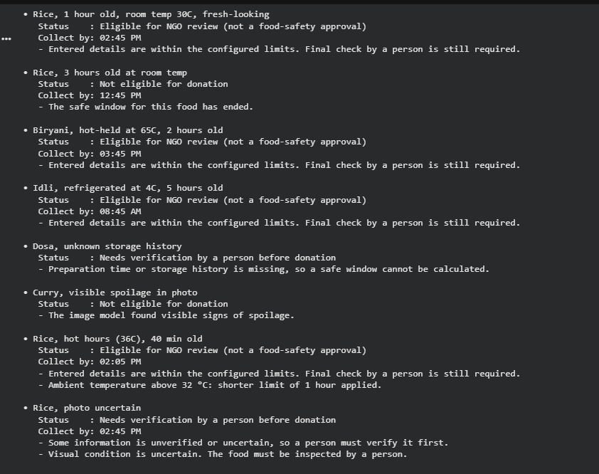

Figure 10: Rules module output from the notebook
Spoiled food is rejected, food past its safe window is rejected, missing storage history and uncertain photos are sent for human verification, and hot weather shortens the safe window.

8. UI Screenshots and Explanation
Replace each dashed box with a screenshot from the running application.

Home page
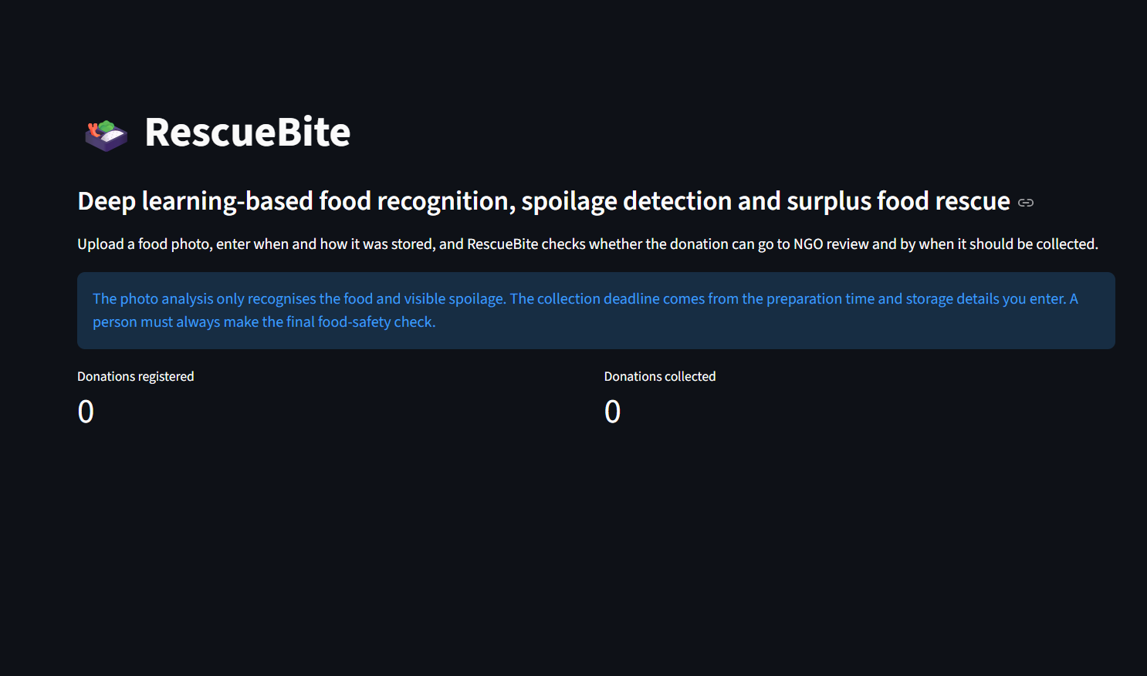
Figure 11: RescueBite home page
Explanation: The landing page introduces the system, shows a notice that the final food-safety check must be done by a person, and displays live counts of donations registered and collected from the database.

Food Analysis (testing)
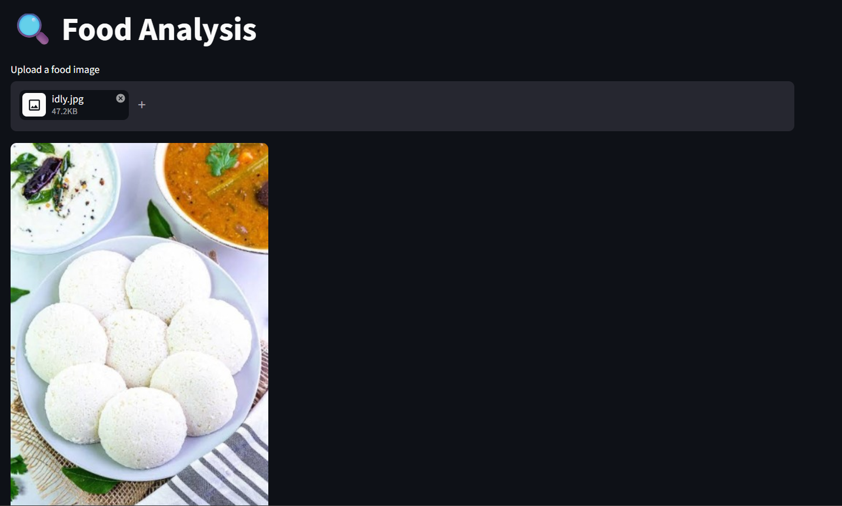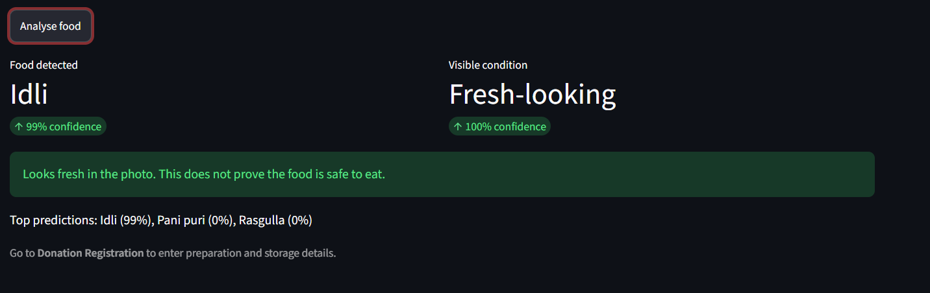
Figure 12: Food Analysis page with an uploaded food image
Explanation: The donor uploads a food photo and clicks Analyse food. The page shows the detected food name with confidence, the visible condition (fresh-looking, visible spoilage or uncertain) with confidence, and the top three predictions. A warning appears when food-name confidence is low or the result is uncertain.

Donation Submission

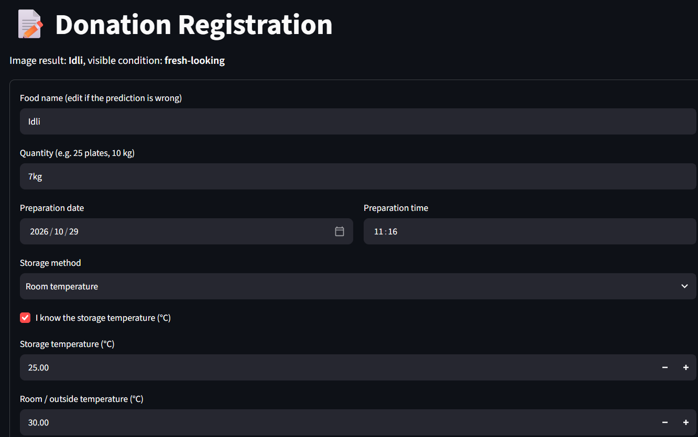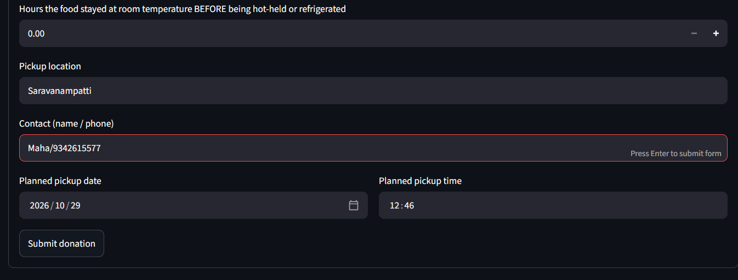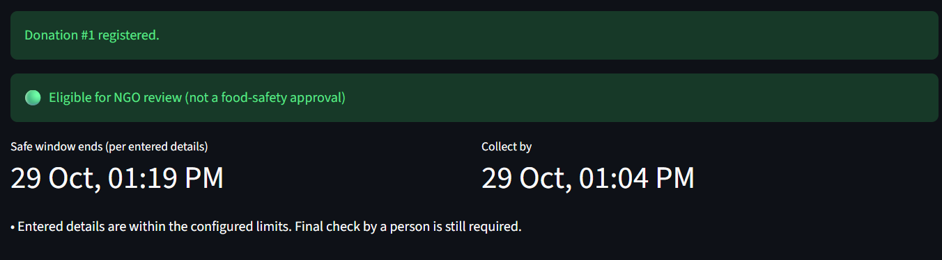
Figure 13: Donation Registration form
Explanation: The donor confirms the food name and enters quantity, preparation date and time, storage method, storage temperature, surroundings temperature, hours at room temperature before storage, pickup location, contact and planned pickup time. On submission the donation is saved to SQLite and its assessment is shown immediately.

Time and Storage Assessment
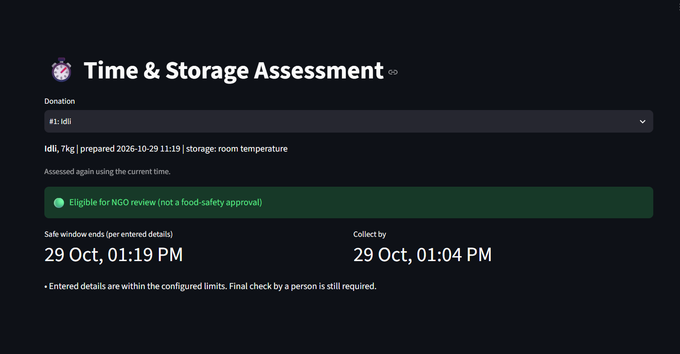
Figure 14: Assessment result with status and collect-by time
Explanation: The page re-assesses a chosen donation using the current time. It shows the status (eligible, needs verification or not eligible), when the safe window ends, the latest collection time, and the reasons and warnings.

NGO Dashboard
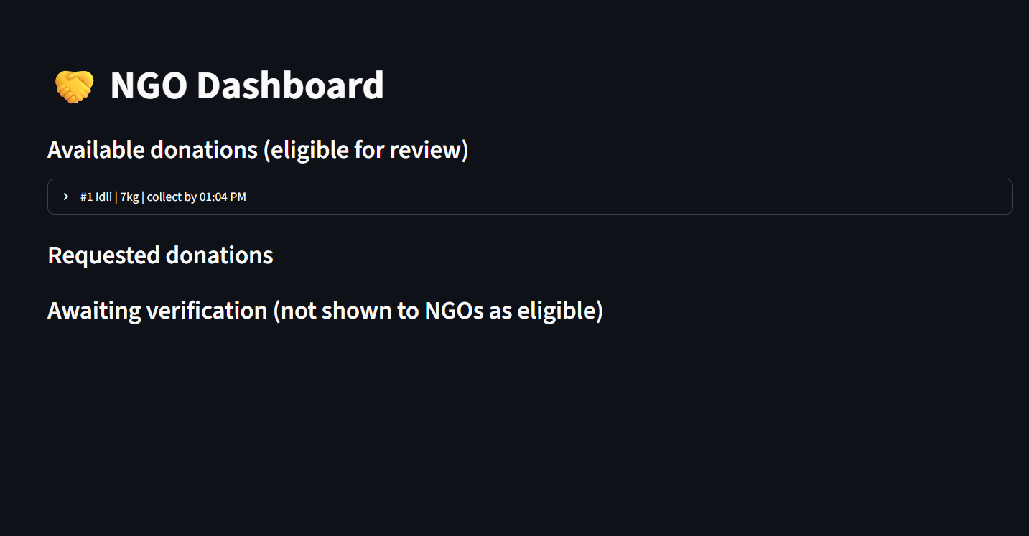
Figure 15: NGO Dashboard
Explanation: NGOs see donations that are eligible for review with pickup location, contact and minutes left to collect. They can request a donation and later mark it collected. Donations needing verification are listed separately and are not shown as eligible.

9. UI Link
Streamlit application (served through ngrok): https://grub-sphinx-gigabyte.ngrok-free.dev/
This link only works while the Colab runtime and ngrok session are running, so keep the notebook running during evaluation or rely on the screenshots above.

10. GitHub Link
Repository:https://github.com/JANASREE-P/24ADI006_DL_RESCUEBITE_FOOD_REDISTRIBUTION.git

11. Results and Conclusion

Results
Measure | Food recognition | Spoilage detection
Classes | 25 | 2
Test images | 1,631 | 480
Test accuracy | 84.18% | 93.75%
Macro F1-score | 0.84 | Not reported

- With a confidence threshold of 0.75, 8.3% of spoilage test images were marked "uncertain" and accuracy on the confident predictions was 95.23%.
- The rules module handled all eight test scenarios correctly: 4 eligible for review, 2 not eligible and 2 needing verification.
- The five-page Streamlit application runs from photo analysis through to NGO collection.

Conclusion
RescueBite combines two transfer-learning image classifiers with a transparent rules module to turn a food photo and a few storage details into a clear donation decision and collection deadline. The food model recognises 25 dishes with 84.18% test accuracy and the spoilage model reaches 93.75%. Keeping the time and storage assessment separate from the image models, and adding an "uncertain" outcome, makes the system cautious by design.

Limitations
- Image-based spoilage detection reflects only what is visible and what the training labels represent. It cannot detect bacteria or toxins.
- The spoilage model missed 29 of 243 spoiled test images, so it must never be the only safety check.
- The spoilage dataset contains fruit images, so performance on cooked dishes may be lower.
- Visually similar curries are sometimes confused by the food model, for example butter chicken and kadai paneer.
- Preparation and storage details are entered by the donor and are not independently verified.
- The hot-holding and refrigeration limits are placeholders that need to be set to local regulations.
- Colab sessions are temporary, so the models and database must be downloaded to be kept.

Future improvements
- Collect and label images of cooked dishes for the spoilage model.
- Add more images of easily confused dishes to improve food recognition.
- Deploy on a permanent host with user login for donors and NGOs.
- Add location-based matching and notifications to nearby NGOs.
- Add temperature sensor input to verify storage conditions.

12. Individual Contribution:
Team member | Team member | Work carried out
Janasree P | Model training | Trained the MobileNetV2 food recognition model on the 25-class food dataset. Trained the MobileNetV2 spoilage detection model on the fresh and spoiled dataset. Evaluated both models on the test set using accuracy, classification report and confusion matrix.
Dhivya | UI interface | Designed the Streamlit user interface with five pages: Home, Food Analysis, Donation Registration, Time and Storage Assessment and NGO Dashboard. Implemented the application, integrated the trained models and launched it through ngrok. Prepared this project report.
Ramya | Backend | Developed the backend of the system, including the SQLite database that stores donations. Implemented the time and storage assessment rules that decide eligibility and the collection deadline. Handled the NGO request and collection status updates.

