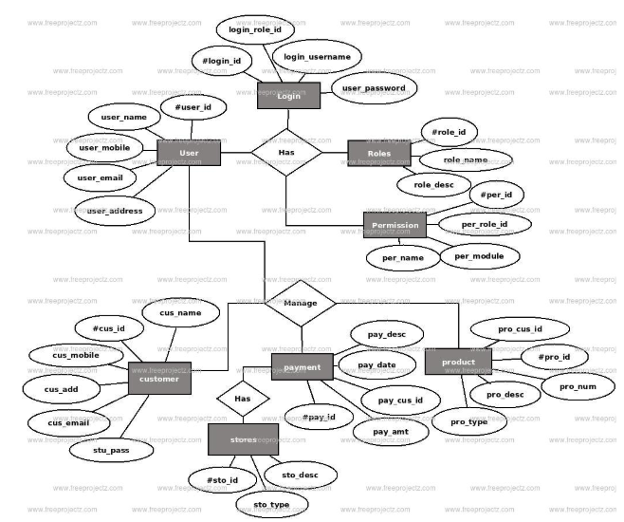
Source: https://www.freeprojectz.com/entity-relationship/super-market-management-system-er-diagram

Sample Tables and Data:
Tables
- Products
  - ProductID (Primary Key)
  - ProductName
  - Price
  - Quantity
- Customers
  - CustomerID (Primary Key)
  - CustomerName
  - Address
  - ContactNumber
- Orders
  - OrderID (Primary Key)
  - CustomerID (Foreign Key referencing Customers)
  - OrderDate
  - TotalAmount
- OrderDetails
  - DetailID (Primary Key)
  - OrderID (Foreign Key referencing Orders)
  - ProductID (Foreign Key referencing Products)
  - Quantity
  - Subtotal

1. Data Table for Products
ProductID | ProductName | Price | Quantity
1 | Milk | 2.5 | 100
2 | Bread | 1.2 | 150
3 | Eggs | 1.0 | 200
4 | Cheese | 3.0 | 50
5 | Apple | 0.8 | 120
6 | Pasta | 2.0 | 80
7 | Chicken | 5.0 | 30
8 | Rice | 1.5 | 90
9 | Yogurt | 1.8 | 70
10 | Orange | 1.2 | 100
2. Data Table for Customers
CustomerID | CustomerName | Address | ContactNumber
101 | John Doe | 123 Main St | 555-1234
102 | Jane Smith | 456 Oak St | 555-5678
103 | Alice Brown | 789 Pine St | 555-9876
104 | Bob Johnson | 101 Elm St | 555-4321
105 | Emma White | 202 Maple St | 555-8765
106 | James Black | 303 Birch St | 555-2109
107 | Sarah Grey | 404 Cedar St | 555-6543
108 | Chris Lee | 505 Pine St | 555-1098
109 | Olivia Green | 606 Oak St | 555-5432
110 | Daniel Taylor | 707 Elm St | 555-9876
3. Data Table for Orders
OrderID | CustomerID | OrderDate | TotalAmount
501 | 101 | 2024-02-16 | 8.7
502 | 102 | 2024-02-17 | 2.4
503 | 103 | 2024-02-18 | 15.2
504 | 104 | 2024-02-19 | 6.5
505 | 105 | 2024-02-20 | 12.0
506 | 106 | 2024-02-21 | 9.8
507 | 107 | 2024-02-22 | 5.3
508 | 108 | 2024-02-23 | 7.2
509 | 109 | 2024-02-24 | 11.5
510 | 110 | 2024-02-25 | 4.6

4. Data Table for OrderDetails
DetailID | OrderID | ProductID | Quantity | Subtotal
1001 | 501 | 1 | 2 | 5.0
1002 | 501 | 2 | 3 | 3.6
1003 | 502 | 3 | 1 | 1.0
1004 | 503 | 4 | 4 | 12.0
1005 | 503 | 5 | 2 | 1.6
1006 | 504 | 6 | 1 | 2.0
1007 | 505 | 7 | 3 | 15.0
1008 | 506 | 8 | 2 | 3.0
1009 | 507 | 9 | 2 | 3.6
1010 | 508 | 10 | 3 | 3.6

use mysql queries to create the above mentioned tables and input the values as shown in the tables.
1. MySQL Query to Create Products Table
CREATE TABLE Products (
ProductID INT PRIMARY KEY,
ProductName VARCHAR(50),
Price DECIMAL(10, 2),
Quantity INT
);

-- Inserting Values
INSERT INTO Products (ProductID, ProductName, Price, Quantity)
VALUES
(1, 'Milk', 2.5, 100),
(2, 'Bread', 1.2, 150),
(3, 'Eggs', 1.0, 200),
(4, 'Cheese', 3.0, 50),
(5, 'Apple', 0.8, 120),
(6, 'Pasta', 2.0, 80),
(7, 'Chicken', 5.0, 30),
(8, 'Rice', 1.5, 90),
(9, 'Yogurt', 1.8, 70),
(10, 'Orange', 1.2, 100);

2. MySQL Query to Create Customers Table
CREATE TABLE Customers (
CustomerID INT PRIMARY KEY,
CustomerName VARCHAR(100),
Address VARCHAR(255),
ContactNumber VARCHAR(20)
);

-- Inserting Values
INSERT INTO Customers (CustomerID, CustomerName, Address, ContactNumber)
VALUES
(101, 'John Doe', '123 Main St', '555-1234'),
(102, 'Jane Smith', '456 Oak St', '555-5678'),
(103, 'Alice Brown', '789 Pine St', '555-9876'),
(104, 'Bob Johnson', '101 Elm St', '555-4321'),
(105, 'Emma White', '202 Maple St', '555-8765'),
(106, 'James Black', '303 Birch St', '555-2109'),
(107, 'Sarah Grey', '404 Cedar St', '555-6543'),
(108, 'Chris Lee', '505 Pine St', '555-1098'),
(109, 'Olivia Green', '606 Oak St', '555-5432'),
(110, 'Daniel Taylor', '707 Elm St', '555-9876');
3. MySQL Query to Create Orders Table
CREATE TABLE Orders (
OrderID INT PRIMARY KEY,
CustomerID INT,
OrderDate DATE,
TotalAmount DECIMAL(10, 2),
FOREIGN KEY (CustomerID) REFERENCES Customers(CustomerID)
);
INSERT INTO Orders (OrderID, CustomerID, OrderDate, TotalAmount)
VALUES
(501, 101, '2024-02-16', 8.7),
(502, 102, '2024-02-17', 2.4),
(503, 103, '2024-02-18', 15.2),
(504, 104, '2024-02-19', 6.5),
(505, 105, '2024-02-20', 12.0),
(506, 106, '2024-02-21', 9.8),
(507, 107, '2024-02-22', 5.3),
(508, 108, '2024-02-23', 7.2),
(509, 109, '2024-02-24', 11.5),
(510, 110, '2024-02-25', 4.6);
4. MySQL Query to Create OrderDetails Table
CREATE TABLE OrderDetails (
DetailID INT PRIMARY KEY,
OrderID INT,
ProductID INT,
Quantity INT,
Subtotal DECIMAL(10, 2),
FOREIGN KEY (OrderID) REFERENCES Orders(OrderID),
FOREIGN KEY (ProductID) REFERENCES Products(ProductID)
);

INSERT INTO OrderDetails (DetailID, OrderID, ProductID, Quantity, Subtotal)
VALUES
(1001, 501, 1, 2, 5.0),
(1002, 501, 2, 3, 3.6),
(1003, 502, 3, 1, 1.0),
(1004, 503, 4, 4, 12.0),
(1005, 503, 5, 2, 1.6),
(1006, 504, 6, 1, 2.0),
(1007, 505, 7, 3, 15.0),
(1008, 506, 8, 2, 3.0),
(1009, 507, 9, 2, 3.6),
(1010, 508, 10, 3, 3.6);

