**Wireless Light Switcher**

SE Practicum - Architecture

Group 9

• 13304010 – Andrew Sebastian (Team leader)

• 14309003 - Jang Soon Myun

• 14309002 - Jin Kwang Un

• 14309001 - Park Geun O

• 13304011 - Hassan

• 13304013 - Vincent

1. UI Design (User Interface)

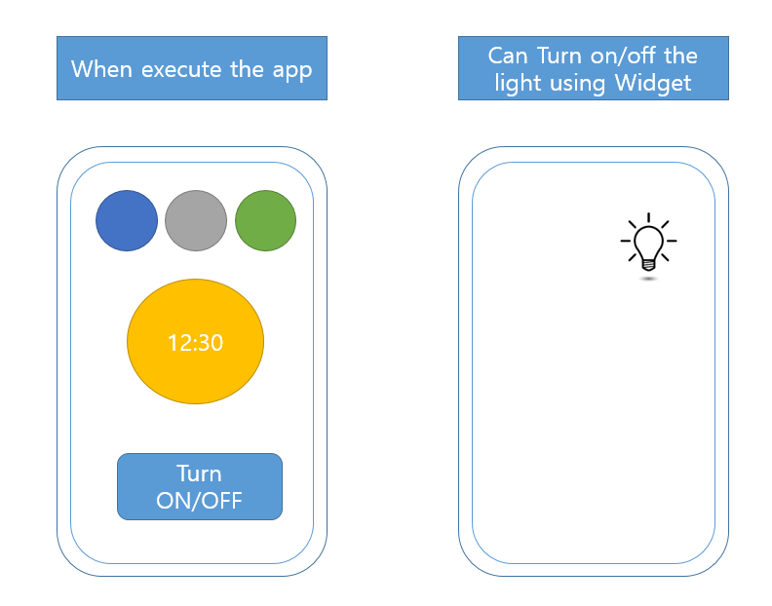

1. Architecture

Conceptual Architecture

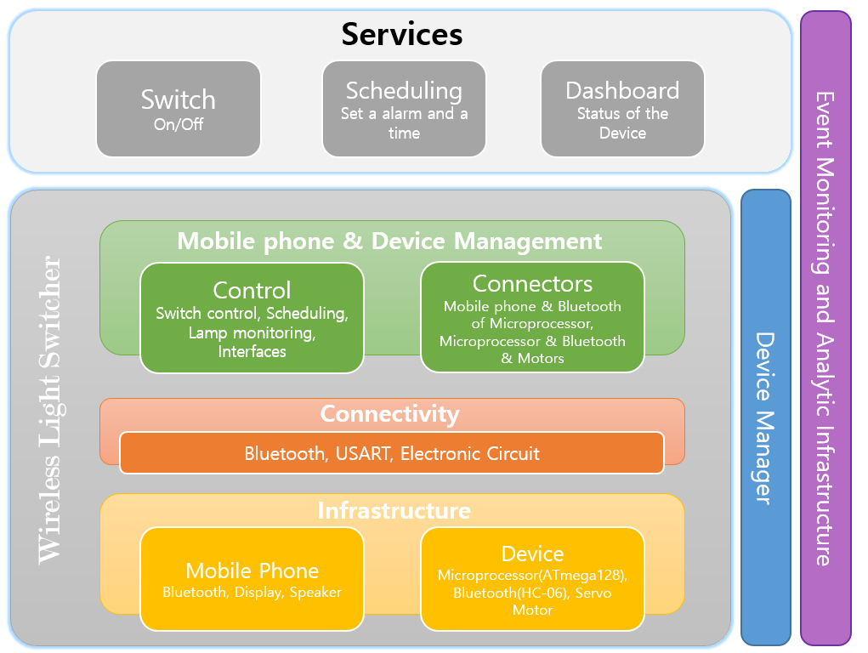

Logical Architecture

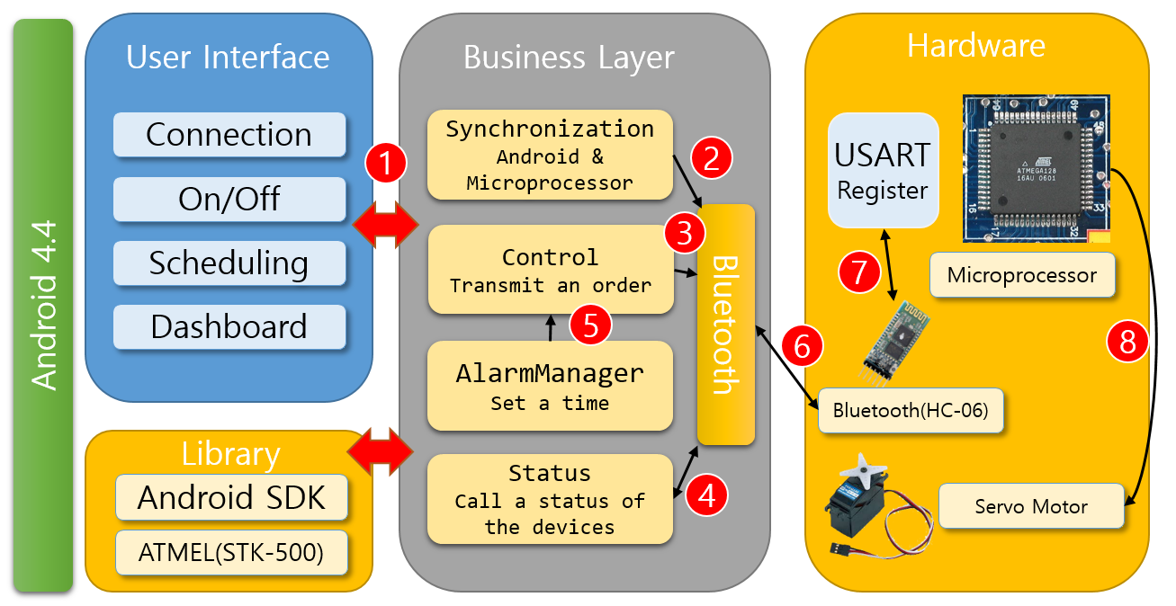

1. User can choose 4 functions.  
   - Connection : The connection between the Bluetooth of Android and the Bluetooth of Device  
   - On/Off : You can turn on or off the lamp switch.  
   - Scheduling : You can set an alarm.  
   - Dashboard : You can see the status of the Light Switcher
2. Transmit the command of synchronization with Bluetooth of Device to Bluetooth.
3. Transmit the command to turn on/off the Light Switcher to Bluetooth.
4. 1) Transmit the command to see the status of the devices to Bluetooth.  
   2) Receive the status of the devices from Bluetooth.
5. 1) Set a time in the mobile phone.  
   2) When the alarm is running, execute the function of turn on the Light Switcher.
6. Transmit or receive the commands to HC-06(Bluetooth).
7. Transmit or receive the commands to USART Register in the Microprocessor.
8. If the Microprocessor received the commands to turn on/off, the Servo motor will work.

Physical Architecture

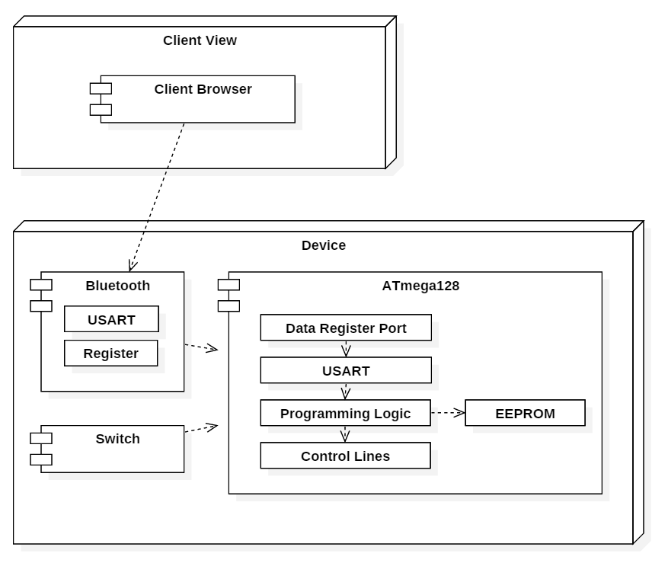

USART(Universal Synchronous/Asynchronous Receiver/Transmitter)

* A microchip that facilitates communication through a computer's serial port using the RS-232C protocol.

Register  
 - A component inside a central processing unit for storing information

Data Register Port  
 - A port to receive/transmit a data.

Programming Logic  
 - Write a code and a data to EEPROM.

EEPROM(Electrically Erasable Programmable Read-Only Memory)  
- A type of non-volatile memory used in computers and other electronic devices to store relatively small amounts of data but allowing individual bytes to be erased and reprogrammed.

Control Lines  
- Send a command to a data register ports.

Application Conceptual Diagram

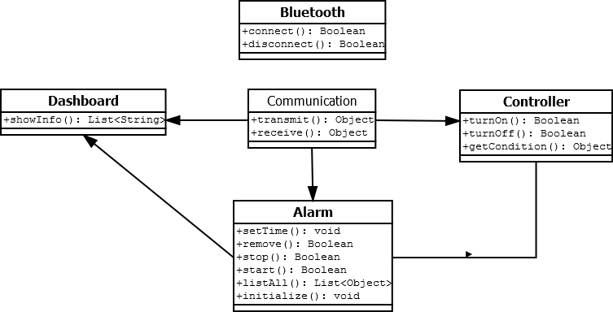

## Modules to be Tested

|  |  |  |
| --- | --- | --- |
| **Module Number** | **Module Name** | **Module Description** |
| 1 | Frame | Framework for the production hardware features |
| 2 | Application | Application for using the Bluetooth |
| 3 | Bluetooth Device | Devices for applications received  Device for switching operation using Bluetooth. |
| 4 | Motor Device | Controlling a Bluetooth signal.  Basic device for a switching operation |
| 5 | Program processor | A processor that controls the Bluetooth unit and the motor unit. |

These are taken from the Design Specification found in section 1.3

## Test Description

The following sections will describe the test cases that will be performed. These test cases will be identified by the component that they test.

### Frame & Application

Frame- Application

|  |  |
| --- | --- |
| Test Number | A1 |
| Test Name | Data communication |
| Startup State | Bluetooth active |
| Input Specification | Request bluetooth connection |
| Output Specification | Bluetooth connection established |

|  |  |
| --- | --- |
| Test Number | A2 |
| Test Name | Alarm set |
| Startup State | none |
| Input Specification | Set alarm for specific time |
| Output Specification | Alarm is set |

|  |  |
| --- | --- |
| Test Number | A3 |
| Test Name | Alarm Test |
| Startup State | none |
| Input Specification | Set alarm for specific time |
| Output Specification | Lights on at time |

### Frame & Bluetooth Device

|  |  |
| --- | --- |
| Test Number | B1 |
| Test Name | Bluetooth config. on |
| Startup State | Bluetooth Inactive |
| Input Specification | Turn on bluetooth |
| Output Specification | Bluetooth is active |

|  |  |
| --- | --- |
| Test Number | B2 |
| Test Name | Bluetooth config. off |
| Startup State | Bluetooth Active |
| Input Specification | Turn off bluetooth |
| Output Specification | Bluetooth is inactive |

### Bluetooth device & Motor device

|  |  |
| --- | --- |
| Test Number | MB1 |
| Test Name | Motor-Bluetooth config.1 |
| Startup State | Bluetooth active |
| Input Specification | Establish connection via application |
| Output Specification | Connection established |

|  |  |
| --- | --- |
| Test Number | MB2 |
| Test Name | Motor-Bluetooth config.1 |
| Startup State | Bluetooth connection established |
| Input Specification | Terminate connection via application |
| Output Specification | Connection Terminated |

### Frame & Motor device

|  |  |
| --- | --- |
| Test Number | FM1 |
| Test Name | Motor Config. |
| Startup State | None |
| Input Specification | Assemble Motor device |
| Output Specification | Functional motor |

### Application & Bluetooth device

|  |  |
| --- | --- |
| Test Number | AB1 |
| Test Name | Click operation |
| Startup State | None |
| Input Specification | Click screen connect to device via application |
| Output Specification | Connection established |

### Program processor & Bluetooth device

|  |  |
| --- | --- |
| Test Number | PB1 |
| Test Name | Check operation |
| Startup State | Program processor Active |
| Input Specification | Coded into the program to make sure the process is working well in Bluetooth |
| Output Specification | Connection established |

### Program processor & Motor device

|  |  |
| --- | --- |
| Test Number | PM1 |
| Test Name | Check operation |
| Startup State | Program processor Active |
| Input Specification | Coded into the program to make sure the process is working well in Motor Device |
| Output Specification | Connection established |