1. Meeting Report

|  |  |  |  |  |  |
| --- | --- | --- | --- | --- | --- |
| Sprint #1 | | | | | |
| Meeting No. | Task | | Owner | Task Status | Test Criteria & Result |
| 1 | 4/12/2016 | | | |  |
| Discussed task | Wire bluetooth device and motor into processor chipset | Jang Soon Myun | | Ongoing | - |
| Configure motor movement | Park Geon O | | Planned | - |
| 2 | 4/13/2016 | | | |  |
| Discussed task | Configure motor movement | Park Geon O | | Ongoing | - |
|  | Wire bluetooth device and motor into processor chipset | Jang Soon Myun | | Complete | Test Number : MB1, MB2, B1, B2  Result : All is working |
| 3 | 4/14/2016 | | | |  |
| Discussed task | Configure motor movement | Park Geon O | | complete | Test Number : FM1  Result : All is working |
|  | Configure bluetooth frequency and ID | Park Geon O | | Planned | - |
| 4 | 4/15/2016 | | | |  |
| Discussed task | Configure bluetooth frequency and ID | Park Geon O | | Ongoing | - |
| 5 | 4/16/2016 | | | |  |
| Discussed task | Program processor to receive command | Jang Soon Myun | | Planned | - |
|  | Configure bluetooth frequency and ID | Park Geon O | | Complete | Test Number : PB1, A1  Result : All is working |
| 6 | 4/17/2016 | | | |  |
| Discussed task | Program processor to receive command | Jang Soon Myun | | ongoing | - |
| 7 | 4/18/2016 | | | |  |
| Discussed task | Program processor to receive command | Jang Soon Myun | | Complete | Test Number : PM1  Result : All is working |

Test cases are based from architecture’s integration test case and only the completed tasks are tested. The result “All is working” means specific task fully completion and ready to deploy.

1. Sprint #1 Burn Down Chart

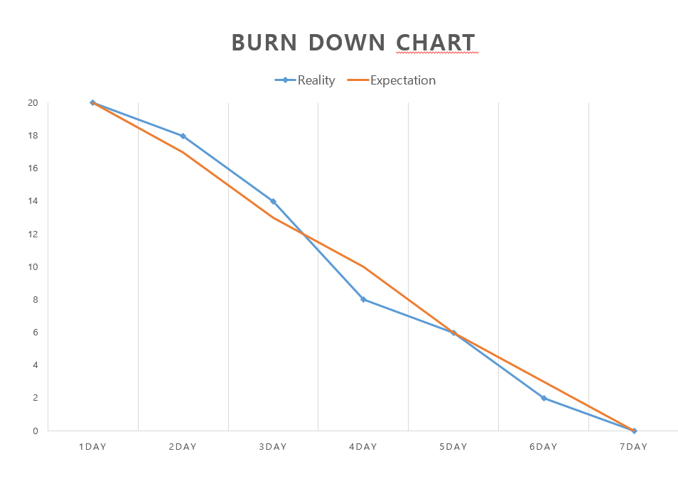

1. Task Kanban
2. 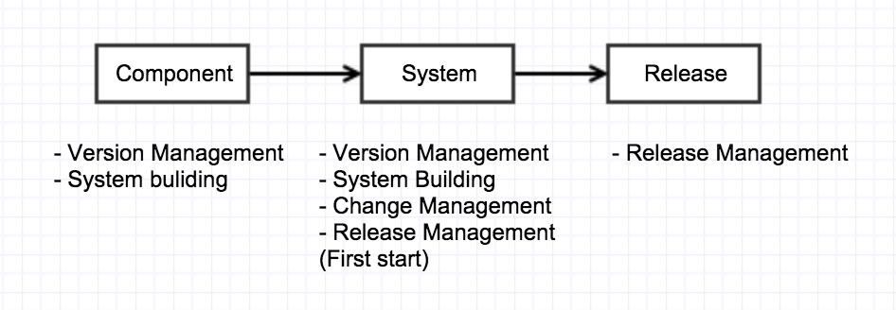Configuration Management
   1. Software Configuration Item (SCI)

|  |  |  |
| --- | --- | --- |
|  | **Configuration Item** | **Note** |
| **1** | **Project plan** | **Planning** |
| **2** | **Configuration Management document** | **Planning** |
| **3** | **Changing Management document** | **Planning** |
| **4** | **Requirements definition document** | **Planning** |
| **5** | **Design definition document** | **Design** |
| **6** | **Functions definition document** | **Development** |
| **7** | **Codes definition document** | **Development** |
| **8** | **Design guide** | **Design** |
| **9** | **Coding guide** | **Development** |
| **10** | **Testing document** | **Planning /Development** |
| **11** | **Source code files** | **Development** |
| **12** | **User manual** | **Planning** |

* 1. Base-Line

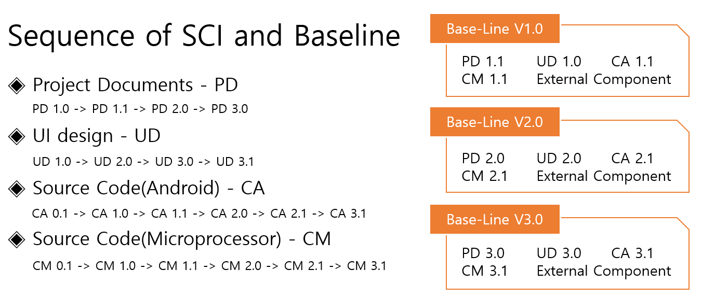

Version management

* **A version of document begins with 0.1 and it is increased by 0.1.**
* **When Base-Line is registered, give 1.0 version and it is increased by 0.1.**
  1. Version Control

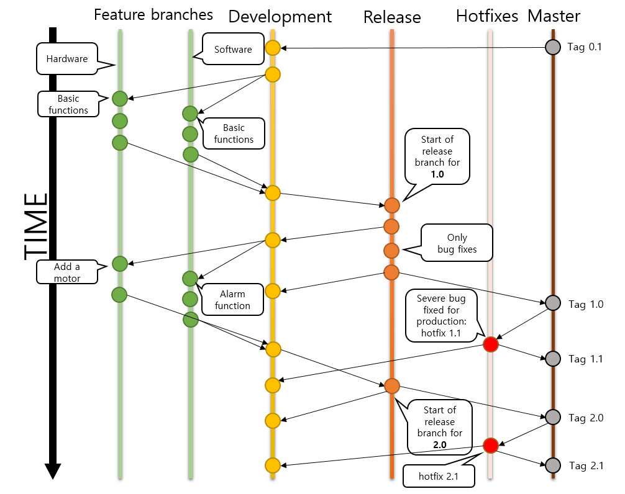

**A point in time of Base-Line registration**

* **Documentation deliverables : After complete each milestones step or after create documentation,**
* **Program source code: At the begin of development step.**
  1. Library

**- Version management program: Git, SourceTree**

**- Documentation deliverables and Program source code :**

<https://github.com/JANGSOONMYUN/SEP_Project.git>

**C:\Users\SOONMYUN\AppData\Local\Microsoft\Windows\INetCache\Content.Word\logoSourceTree.png**

* 1. Change Control Boards (CCBs)

**Members**

**Group A:** Andrew (PO), JANG SOONMYUN(SM)

**Group B:** Vince, JIN KWANGUN, Hassan, Andrew

**Group C:** JANG SOONMYUN, Park Geun O, Andrew

|  |  |
| --- | --- |
|  |  |
| **Group A** | **Make out a proceedings and reference documents** |
| **Group B** | **Report an issue of CCBs on weekly report, and manage a report.** |
| **Group C** | **The PM is determined; report an issue of CCBs on weekly report if necessary.** |

The convocation of the CCBs

- If changes that may affect the overall projects: A group convened

- If the change can be an issue of major projects: B group convened

- If the changes impact occurred only in some development units: C group convened

1. Configuration Control Process

