|  |
| --- |
| Software Engineering Practicum |
| Wireless Light Switch |
| Test Planning and Execution (Quality Assurance) |

|  |
| --- |
| Group 9 :   * 13304010 – Andrew Sebastian * 14309003 - Jang Soon Myun * 14309002 - Jin Kwang Un * 14309001 - Park Geun O * 13304011 - Hassan * 13304013 - Vincent |

1. Introduction

The Test Plan has been created to communicate the test approach to team members. After the completion of some task, developing team need to make sure no significant issues could happen. This document will clearly identify what the test deliverables will be and list of document will be reviewed.

1. SQA Team Member

|  |  |  |
| --- | --- | --- |
| No | Member | Roles |
| 1 | Jang SoonMyun | Quality Coordinator, SQA Leader |
| 2 | Vince | Quality Reviewer |
| 3 | Hassan | SQA auditor |
| 4 | Jin KwangUn | SQA auditor |

1. Roles & Responsibilty

|  |  |
| --- | --- |
| Role | Responsibilities |
| Quality Coordinator | Responsible for ensuring all quality activities are planned and carried out accordingly  Responsible for ensure all team member are properly trained and equipped for their given roles and responsibilities  Ensures SQA activities align with available resources |
| Software Quality Leader | Responsible for leading SQA activities(i.e. coordinating reviews and walkthroughs) |
| Quality Reviewer | Reviews and identifies defects in project artifacts  Provides feedback for improved quality in software artifacts |
| SQA Team Member(auditor) | Responsible for providing support during SQA activities by carrying out assigned tasks as they relate to quality of the system |

1. Change Management
2. Control Process

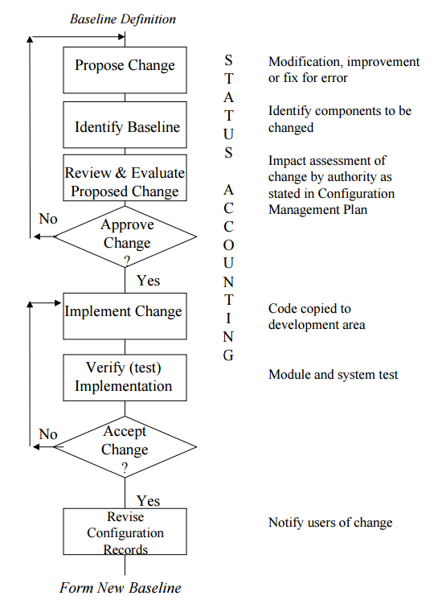

1. Change Made

|  |  |  |  |  |
| --- | --- | --- | --- | --- |
| **SUBMITTER - GENERAL INFORMATION** | | | | |
| **CR#** | CR001 | | | |
| **Submitter Name** | Jang Soon Myun | | | |
| **Brief Description of Request** | Change the frame design | | | |
| **Date Submitted** | 2016/04/28 | | | |
| **Priority** | Low | Medium | High | Mandatory |
| **Reason for Change** | The first frame design doesn’t fit in every switch.  You should able to use the Switcher in every switch. | | | |
| **Change(Task)** | Change the frame design to fit in every switch.   1. Change the position of motors. 2. Change a cover of device to make smaller. | | | |
| **Hour Impact** | 2 hours | | | |
| **Other Artifacts Impacted** | Project Timeline | | | |
| **Assumptions and Notes** |  | | | |
| **Attachments or References** | Yes | No |  | |
| **Link:** | | | |

|  |  |  |  |  |
| --- | --- | --- | --- | --- |
| **CHANGE CONTROL BOARD – DECISION** | | | | |
| **Decision** | Approved | Approved w/Conditions | Rejected | More Info |
| **Decision Date** | 2016/04/29 | | | |
| **Decision Explanation** |  | | | |

|  |  |  |  |  |
| --- | --- | --- | --- | --- |
| **SUBMITTER - GENERAL INFORMATION** | | | | |
| **CR#** | CR002 | | | |
| **Submitter Name** | Park Geon O | | | |
| **Brief Description of Request** | I want the device to can support WIFI capabilities (Hardware). | | | |
| **Date Submitted** | 2016/05/06 | | | |
| **Priority** | Low | Medium | High | Mandatory |
| **Reason for Change** | You can’t use the switcher in these cases:   1. Your Bluetooth service is not worked. 2. The distance from you to the switcher device is too far. 3. You are not in your house.   So you need to the WIFI function. | | | |
| **Change(Task)** | 1. 1. Wire WIFI transmitter and receiver to current device 2. 2. Configuring the WIFI frequency and ID 3. 3. Program the processor to identify WIFI signal and translates it | | | |
| **Hour Impact** | 25 hours | | | |
| **Other Artifacts Impacted** | Project Timeline | | | |
| **Assumptions and Notes** |  | | | |
| **Attachments or References** | Yes | No |  | |
| **Link:** | | | |

|  |  |  |  |  |
| --- | --- | --- | --- | --- |
| **CHANGE CONTROL BOARD - DECISION** | | | | |
| **Decision** | Approved | Approved w/Conditions | Rejected | More Info |
| **Decision Date** | 2016/05/09 | | | |
| **Decision Explanation** |  | | | |

|  |  |  |  |  |
| --- | --- | --- | --- | --- |
| **SUBMITTER - GENERAL INFORMATION** | | | | |
| **CR#** | CR003 | | | |
| **Submitter Name** | Hassan | | | |
| **Brief Description of Request** | I want the application to send and collect data with WIFI (Software) | | | |
| **Date Submitted** | 2016/05/06 | | | |
| **Priority** | Low | Medium | High | Mandatory |
| **Reason for Change** | According to the request in CR002, you need to change functions in an application for use the WIFI. | | | |
| **Change(Task)** | 1. Gain user runtime permission from run WIFI  2. Create a function for opening stream I/O operation(WIFI-based)  3. Create WIFI signal data manipulation | | | |
| **Hour Impact** | 21 hours | | | |
| **Other Artifacts Impacted** | Project Timeline | | | |
| **Assumptions and Notes** |  | | | |
| **Attachments or References** | Yes | No |  | |
| **Link:** | | | |

|  |  |  |  |  |
| --- | --- | --- | --- | --- |
| **CHANGE CONTROL BOARD - DECISION** | | | | |
| **Decision** | Approved | Approved w/Conditions | Rejected | More Info |
| **Decision Date** | 2016/05/09 | | | |
| **Decision Explanation** |  | | | |

1. Change Log

|  |  |  |  |  |  |  |  |  |
| --- | --- | --- | --- | --- | --- | --- | --- | --- |
| Project Information | | | | | | | | |
| Project Title: Wireless Light Switcher | | | | | | | | |
| Project Owner: Andrew Sebastian | | | | | | | | |
| Change Number | **Description of Change** | **Priority** | **Date Requested** | **Requested By** | **Status(Evaluating, Pending, Approved, Rejected)** | **Decision Date** | **Resolution/Comments** |
| CR001 | Change the Frame design | High | 2016/04/28 | Jang Soon Myun | Approved | 2016/04/29 |  |
| CR002 | Add WIFI function(Device) | Low | 2016/05/06 | Park Geon O | Approved | 2016/05/09 |  |
| CR003 | Add WIFI function (App) | Low | 2016/05/06 | Hassan | Approved | 2016/05/09 |  |

1. Affected Artifacts
2. Product Backlog

Refer to the attached document (Product_backlog(05-11-2016.xlsx)).

1. Project Timeline

|  |  |  |  |  |  |  |  |  |  |  |  |  |  |  |  |  |
| --- | --- | --- | --- | --- | --- | --- | --- | --- | --- | --- | --- | --- | --- | --- | --- | --- |
|  | 2016 | | | | | | | | | | | | | | | |
|  | W1 | W2 | W3 | W4 | W5 | W6 | W7 | W8 | W9 | W10 | W11 | W12 | W13 | W14 | W15 | W16 |
| Sprint 1 |  |  |  |  |  |  |  |  |  |  |  |  |  |  |  |  |
| Sprint 2 |  |  |  |  |  |  |  |  |  |  |  |  |  |  |  |  |
| Sprint 3 |  |  |  |  |  |  |  |  |  |  |  |  |  |  |  |  |
| Sprint 4 |  |  |  |  |  |  |  |  |  |  |  |  |  |  |  |  |
| Sprint 5 |  |  |  |  |  |  |  |  |  |  |  |  |  |  |  |  |
| Sprint 6 |  |  |  |  |  |  |  |  |  |  |  |  |  |  |  |  |
| Sprint 7 |  |  |  |  |  |  |  |  |  |  |  |  |  |  |  |  |
| Prototype(1st) |  |  |  |  |  |  |  |  |  |  |  |  |  |  |  |  |

1. Status Report
2. Project Burn Up
3. Release Backlog

Refer to the attached document (release_backlog(05-11-2016).xlsx).

1. Review
2. Artifacts

|  |  |  |  |  |
| --- | --- | --- | --- | --- |
| No | Project Phase | Project Artifact | Permission | Grant to Member |
| 1 | Planning | Road Map/ Timeline Document | Read | Jin Kwang Un |
| User Story List | Read & Change | Jang Soon Myun |
| Product Backlog Document | Read & Change | Jang Soon Myun |
| Sprint Backlog Document | Read & Change | Jang Soon Myun |
| Release Plan Document | Read & Change | Jin Kwang Un |
| Test Plan Document | Read | Vince |
| 2 | Analysis | Value Comparison Document | Read | Hassan |
| 3 | Development | Task Kanban | Read & Change | All member |
| 4 | Testing | Testing Report Document | Read | Vince |
| Acceptance Criteria Report | Read | Jin Kwang Un |
| 5 | Release | Bug Report Document | Read | Hassan |

For each project phase, team members produce specific document according to it. The SQA members provide consultation and review of the project artifacts with regard to compliance with standard procedures.