# CS 255 System Design Document Template

John Annaian

12/14/24

## UML Diagrams

### UML Use Case Diagram

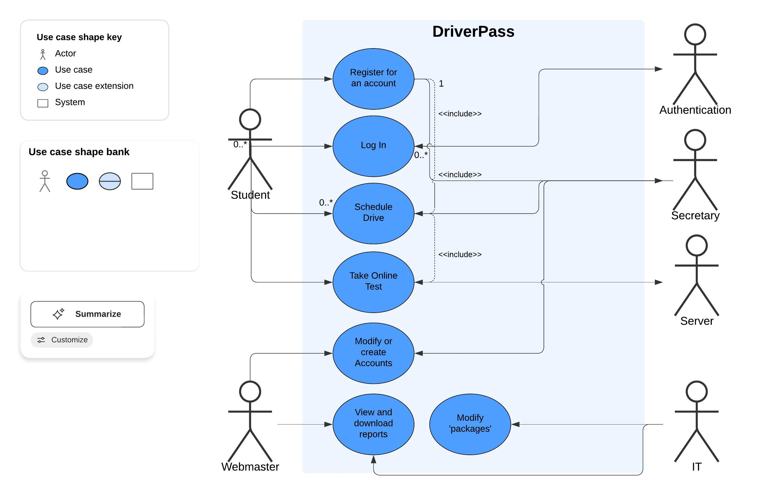

### UML Activity Diagrams

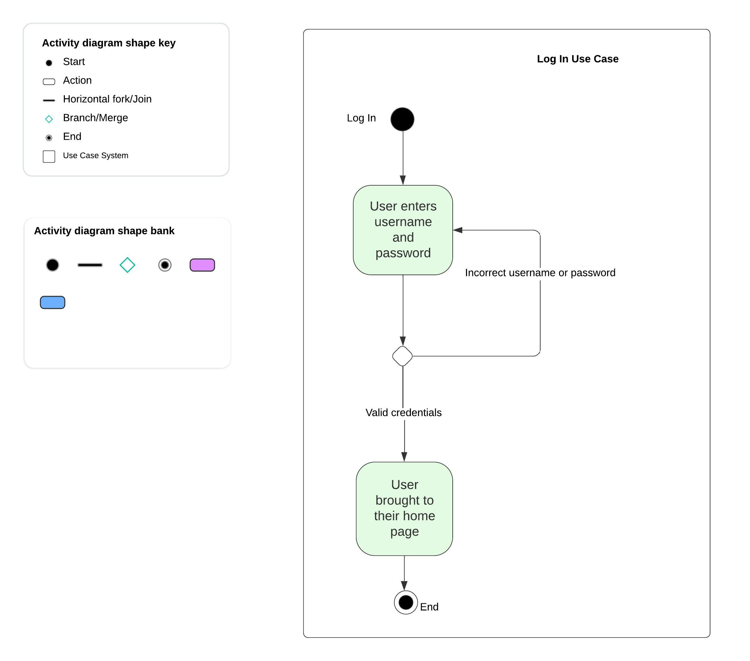

The above use case diagram shows the actions that happen when logging in. The user enters their log in credentials, and if they are correct, logs in and goes straight to their personalized home page. If the credentials are wrong, it goes back to the log in box.

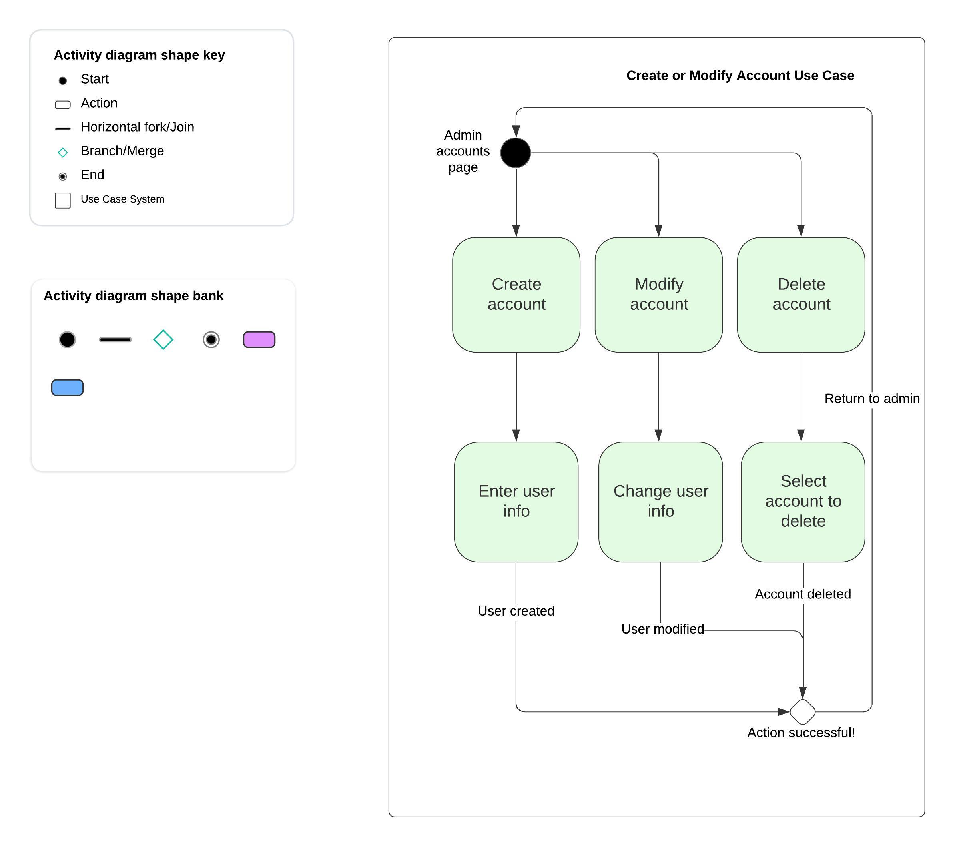

The above use case diagram shows the basics of when the administrator wants to modify a user account. They can create a new account, modify an existing account, or delete an existing account. When that action is completed, they are brought back to their admin account page.

### UML Sequence Diagram

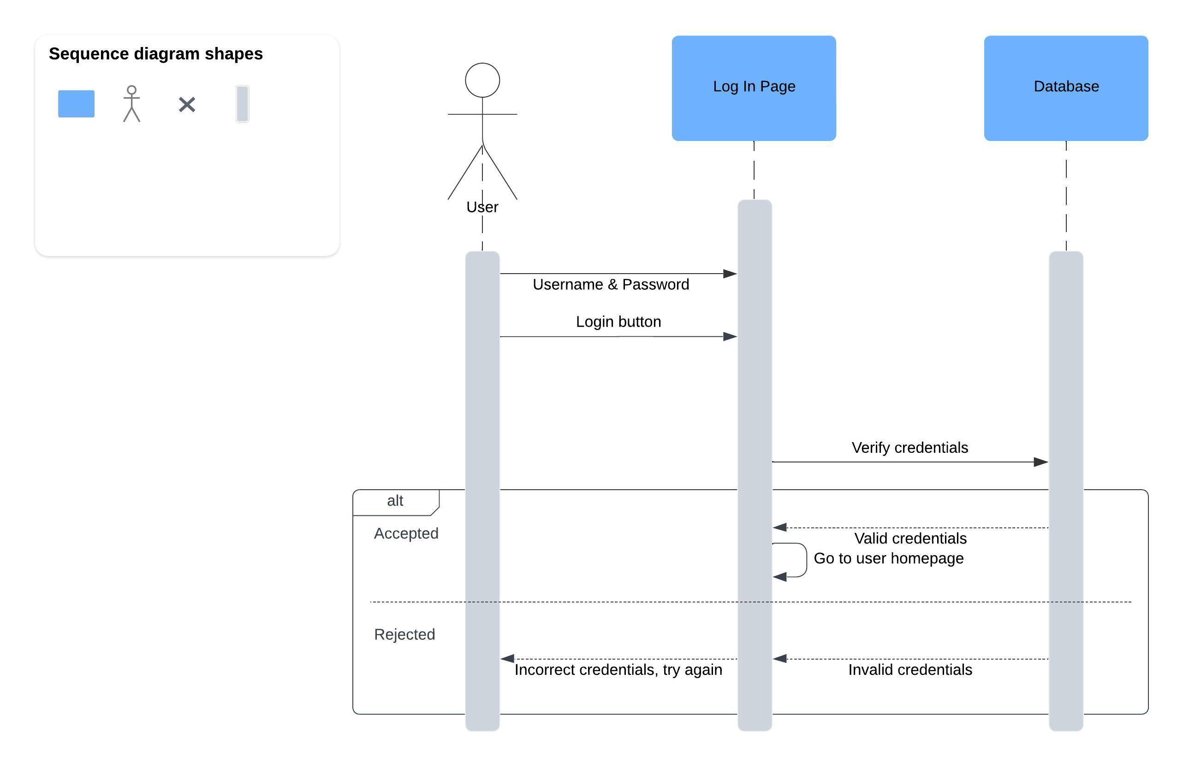

This is a basic sequence diagram for logging in.

### UML Class Diagram

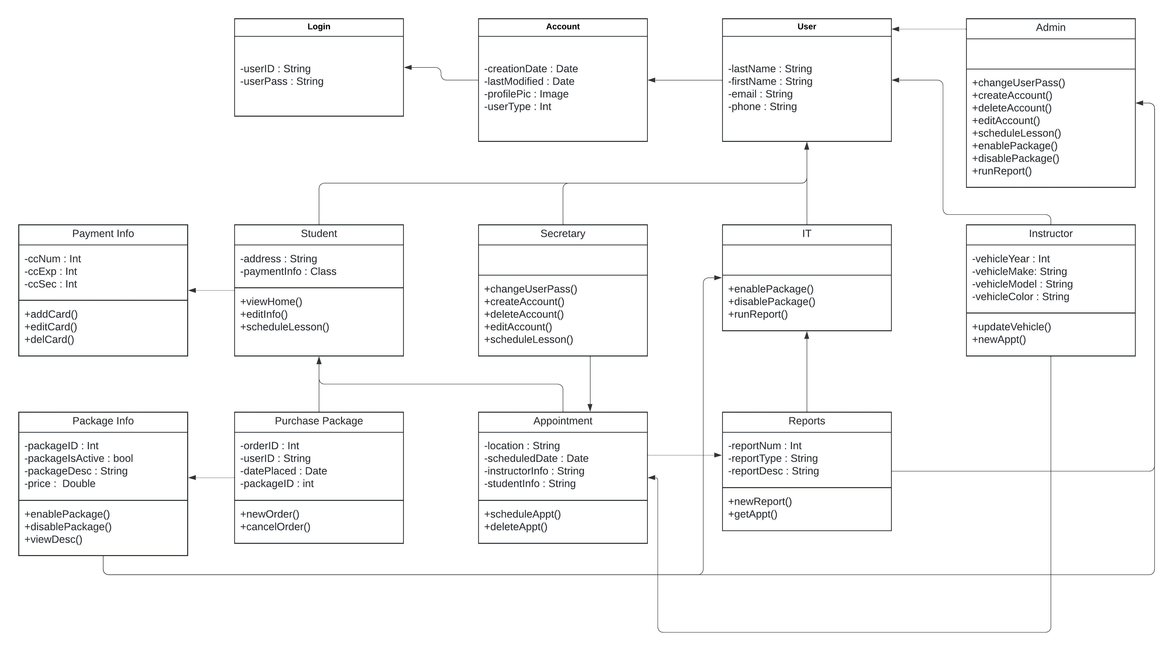

This is a basic class diagram showing the major classes and functions of the DriverPass system.

## Technical Requirements

*Technical requirements include:*

*Host / Server Hardware and Software:*

* *Server*
* *Operating System (Linux, Windows, MacOS, etc)*

*Client (including Admin) Hardware and Software:*

* *Internet capable device*
* *(Desktop only) Keyboard, mouse*
* *Internet access*
* *Modern web browser*
* *Telephone access*

*Infrastructure:*

* *Physical server location*
* *Electricity*
* *Internet access*
* *Vehicles for road tests*
* *Payment processor*
* *Telephone*

*Tools:*

* *None (Based on the fact that it seems like the owner of DriverPass does not want to actively develop software and wants it off-site).*