The Team

|  |
| --- |
| Alicia Briscoe |
| Alimam Diaby |
| Nimisha Patel |
| Clint Jansson |

Problem Statement a.k.a Decompose The Ask

Collect a data set that will allows us to create multiple charts from a dataset.

Use NEW JS Library

Data set with > 100 records

With Drop downs, Menus, and textboxes.

Identify Data Sources

Data source 1 = Food recall database JSON

Define Strategy and Metrics

Collect data set in JSON Format

User’s are going to be able to interact with the site by changing the year of the data presented.

Create charts.

Filter by year

Chart 1 Chart of recalls by state

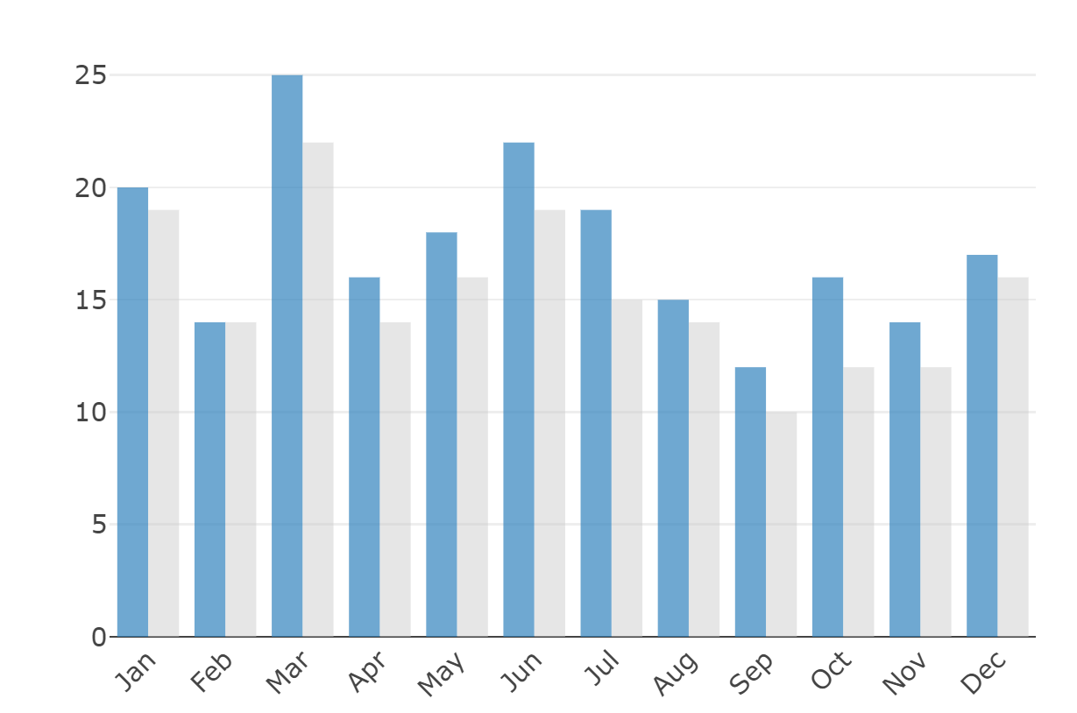

Chart 2 Chart of recalls by firm



Chart 3 chart of recalls by classification Terminated, active

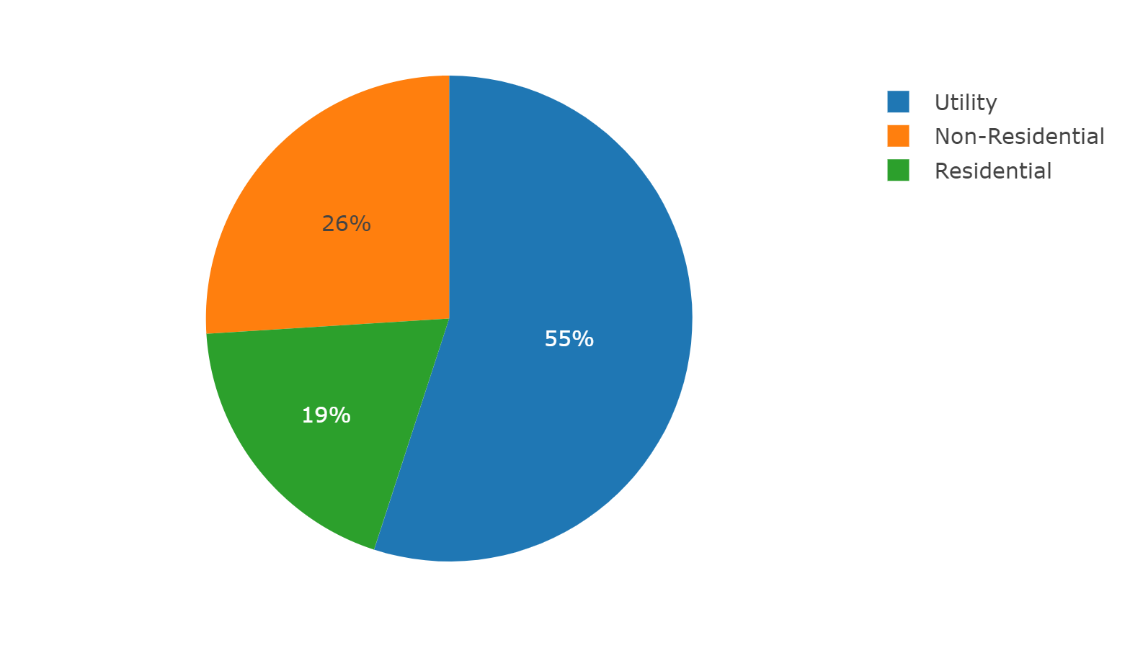

Chart 4 chart of recalls by Category, Voluntary or mandatory



Chart 5

Year vs total recalls

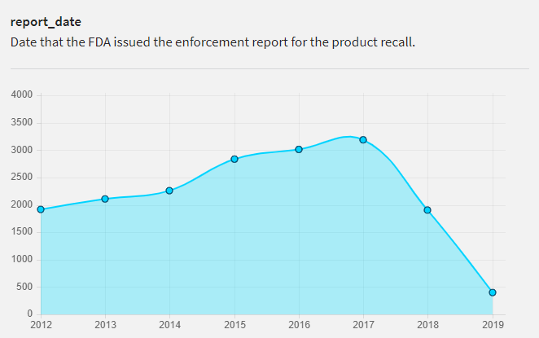

Description of Data Analysis Tools You Plan to Use

* Host data using flask routes
* Create website using HTML CSS and Javascript
* Add 3 charts with data tables showing filtered data.

Describe the Data Products Your Project Will Produce

Data set will be in SQLlite database, HTML with a main page, and 3 links to a page that represents each chart, and displays the raw data below.

Each page will have a description of the data and the operation parameters.

Drop down menu to navigate between the different pages.

Java script library

TEAM plan

1. Database creation JSON to SQLLITE database (Prepare data for JavaScript)
2. HTML and CSS (Template, NAV bar, Formatting)
3. JAVASCRIPT (create filtering dataset for charts)
4. FLASK (Create Routes to host)