**OBJECT POOL DESIGN PATTERN**

Object pooling can offer a significant performance boost; it is most effective in situations where the cost of initializing a class instance is high, the rate of instantiation of a class is high, and the number of instantiations in use at any one time is low.

Object pools (otherwise known as resource pools) are used to manage the object caching. A client with access to an Object pool can avoid creating a new Objects by simply asking the pool for one that has already been instantiated instead. Generally the pool will be a growing pool, i.e. the pool itself will create new objects if the pool is empty, or we can have a pool, which restricts the number of objects created.

It is desirable to keep all Reusable objects that are not currently in use in the same object pool so that they can be managed by one coherent policy. To achieve this, the Reusable Pool class is designed to be a singleton class.

The Object Pool lets others "check out" objects from its pool, when those objects are no longer needed by their processes, they are returned to the pool in order to be reused.

However, we don't want a process to have to wait for a particular object to be released, so the Object Pool also instantiates new objects as they are required, but must also implement a facility to clean up unused objects periodically.

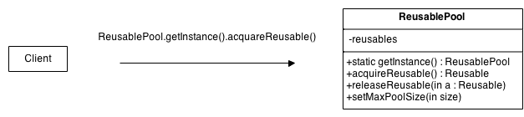

The general idea for the Connection Pool pattern is that if instances of a class can be reused, you avoid creating instances of the class by reusing them.

* **Reusable** - Instances of classes in this role collaborate with other objects for a limited amount of time, then they are no longer needed for that collaboration.
* **Client** - Instances of classes in this role use Reusable objects.
* **ReusablePool** - Instances of classes in this role manage Reusable objects for use by Client objects

### Example:

Object pool pattern is similar to an office warehouse. When a new employee is hired, office manager has to prepare a work space for him. She figures whether or not there's a spare equipment in the office warehouse. If so, she uses it. If not, she places an order to purchase new equipment from Amazon. In case if an employee is fired, his equipment is moved to warehouse, where it could be taken when new work place will be needed.