- What is Power Bi?
Power Bi is the Data Visualization platform and Business Analytics tool offered by Microsoft which helps to transform raw, complex and very unlike Data into Reports, Dashboards, graphs and Analytics using its platform. PowerBi helps the individuals or organizations to publish, share and collaborate also monitor performance, analyze trends with the help of visualization.

Components of Power Bi:
Power BI Desktop, Power BI Service, Power BI Mobile, Power BI Report Server.

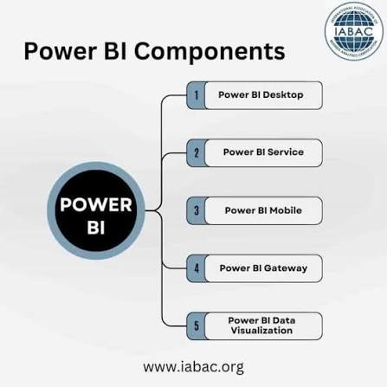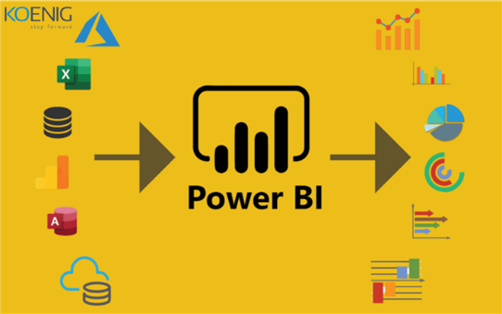

- What is Data Analysis?
Data Analysis is the process of collecting, cleaning, transforming and interpreting data to find useful insights and support decision-making. It helps to convert raw data into meaningful information to solving problems, evaluating performance and making predictions.

Process of Data Analysis:
Defining Objectives, Collection of Data, Cleaning the Data, Processing the Data, Analyzing, and Visualization.

Types of DA:
Descriptive: Identify Data
Diagnostic: Investigate Data
Predictive: Predict the Outcome
Prescriptive: Perform Actions

- Who is Data Analyst?
A Data Analyst is the Professional who collects, cleans, and interprets the raw and complex Data to help their organization to make better, evidence-based business decisions. They are the one who helps to connect and provide insights between data and decisions to strategic leaderships by turning data into clear insights.

- Who is Business Analyst?
A business analyst is a person who analyses the existing products, services and systems of a company and presents the organisation's higher management with a clear picture of its business operations. They also advise the company on how to improve various processes, how to increase efficiency and how to boost revenues. Business analysts use data analytics to assess different processes, gather requirements and deliver reports with recommendations and insights to the senior executives and collaborators. With these reports, they hope to improve a company's decision-making process.

- How to Download Power Bi?
Microsoft Store Search Power Bi Download Power Bi

- What is Power Bi Service?
The Power BI service is a cloud-based Software as a Service (SaaS) platform accessible via a web browser. It serves as the central hub where reports built in Power BI Desktop are published, shared, managed, and consumed across an organization.

Core Functions of Power Bi Service:
Sharing and Collaboration
Cloud Publishing & Storage
Scheduled Data Refreshes
Dashboards & Real-Time Monitoring
Apps and Distribution

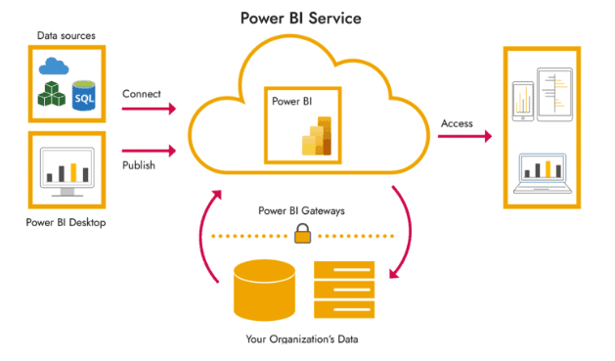

- Explain the User Interface of Power Bi?
The Power Bi Desktop User Interface is centered around a ribbon, canvas background, left-side view navigation and Ride-side pane navigation, also includes fit to size option, desktop / mobile layout option.
The Top Ribbon
File, Home, Insert, Modelling, View, Optimize, Help.
Left-Side View Navigation
Report View, Table View, Model View, DAX Query View.
Right-Side Panes
Data Pane, Visualization Pane, Filters Pane

- What is connector in Power Bi?
A connector in Power BI is a software component that acts as a bridge between Power BI and an external data source, allowing you to fetch, import, or query data without writing manual extraction code.

- Explain the DAX Query View?

- Explain the TMDL View?

- Column Chart (Clustered Column Visual)?
A clustered column chart in Power BI is a data visualization that is used to display numerical values as vertical bars grouped side by side across different categories. We generally use the visual when we have to compare multiple data variables within the same primary category (e.g., when we have to show the comparison between the sales by country and product)
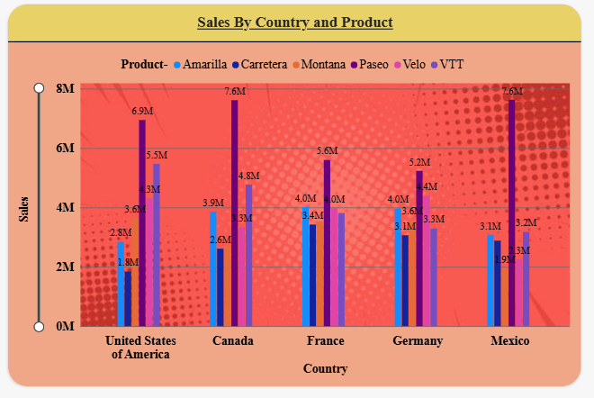

- What is Dashboard?

- What is Report?

- What is Visual?

