# João Costa – 99088

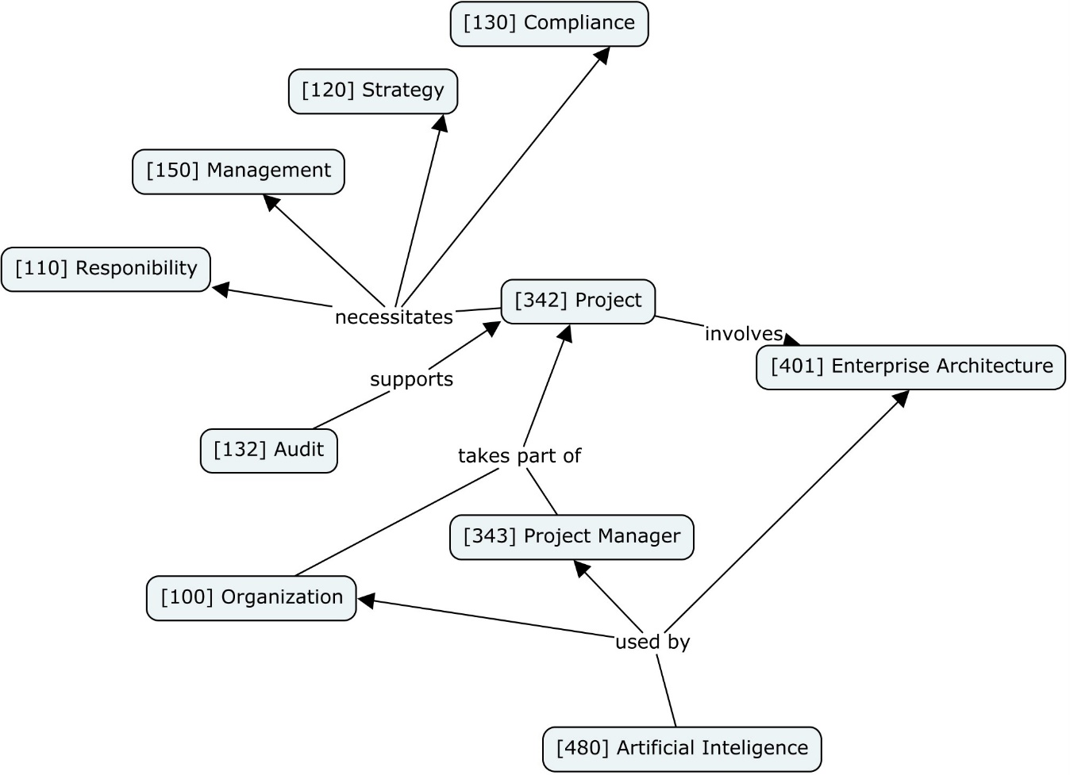

The CMap illustrates how a project group, which could be seen as an organization, manages its projects through a framework that integrates strategy, compliance, and enterprise architecture. Projects are overseen by project managers, which represent all its members, supported by audits, and necessitate adherence to compliance and strategic goals. Responsibilities within the group are clearly defined, with management ensuring these are met. Additionally, the use of artificial intelligence enhances the capabilities of each member and the overall efficiency of the enterprise architecture, aligning technological advancements with the students’s goals.

The concept map focuses on cyber insurance, illustrating its various interconnected elements. It delves into risk management, encompassing risk assessment and measures for safeguarding against data breaches. The map also addresses the cost of insurance and emphasizes data protection, aligning with data breach policies. Additionally, reinsurance is depicted within the map, albeit not directly linked to other aspects.

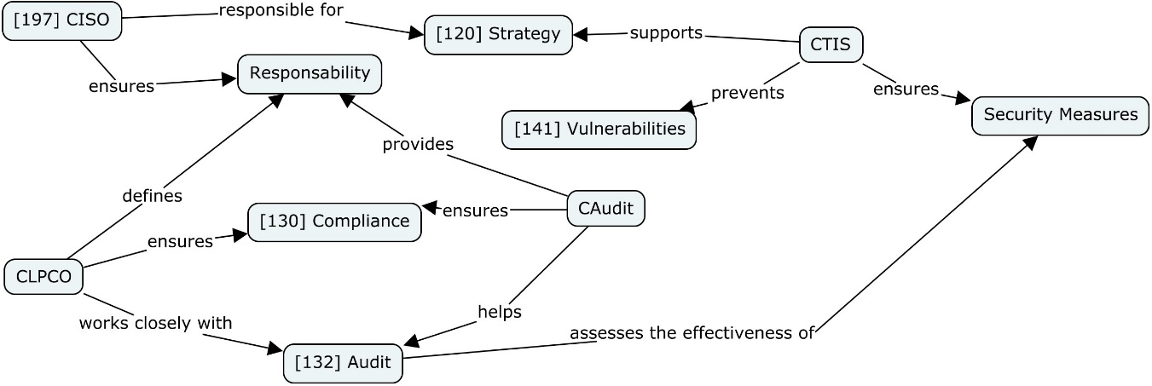

The Chief Information Security Officer (CISO) is responsible for the overarching security strategy, ensuring that the organization's responsibilities are met. This strategy is supported by the Cyber Threat Intelligence Specialist (CTIS), who helps prevent vulnerabilities and ensures the implementation of security measures. The Cyber Legal, Policy & Compliance Officer (CLPCO) defines and ensures compliance, working closely with the Cybersecurity Auditor (CAudit). The CAudit assesses the effectiveness of security measures and helps ensure compliance, providing feedback to the audit process. This framework highlights the collaborative efforts required to maintain robust cybersecurity within an organization.

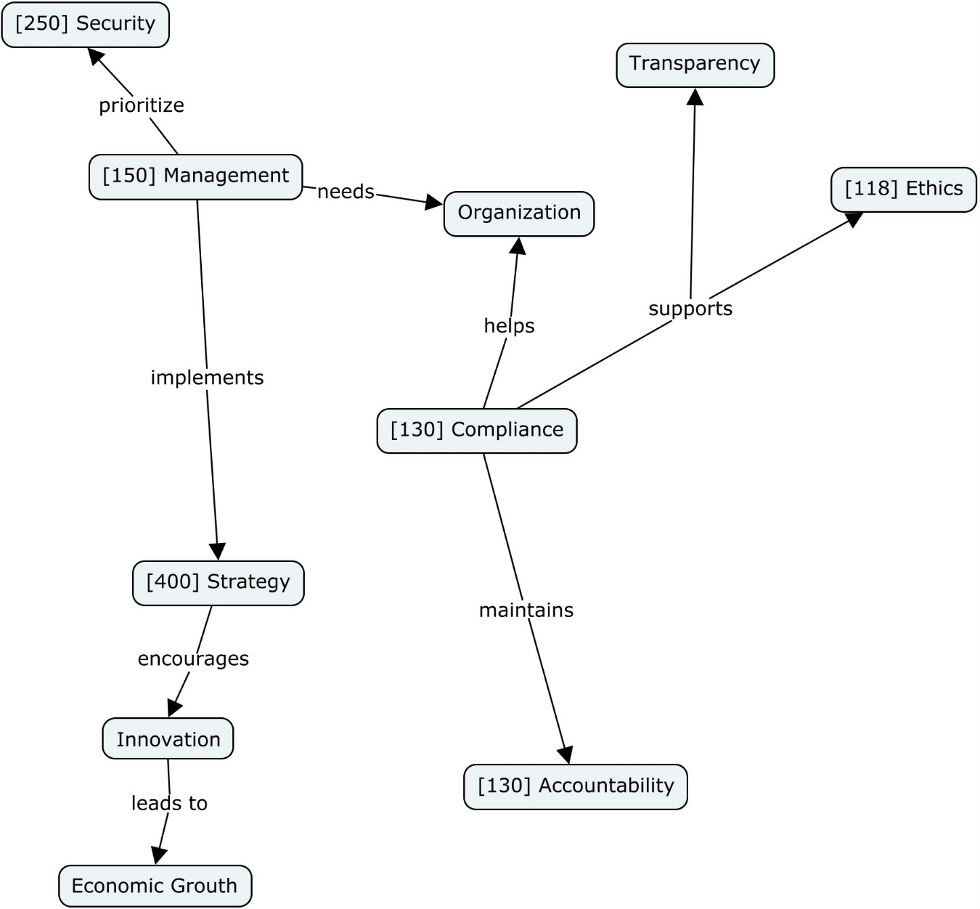

The concept map illustrates the relationships and dynamics involved in the regulation of AI within an organization. It starts with the organization needing effective management (150) to prioritize security (250). Management implements strategies (400) that encourage innovation, leading to economic growth. Compliance (130) plays a central role, helping the organization maintain accountability (130) and support ethics (118). Ethical practices, in turn, bolster transparency. Compliance also ensures that management strategies align with organizational needs and ethical standards, creating a framework that balances security, innovation, and economic growth while maintaining transparency and accountability.