 |  | DS 2023

Data Science Project

Team nr: 4 | Student 1: Francisco Gonçalves Ferreira |  | IST nr: 96861
Team nr: 4 | Student 2: Gustavo Manuel Cabral de Mascarenhas Diogo |  | IST nr: 99233
Team nr: 4 | Student 3: João André Roque Costa |  | IST nr: 99088
 | Student 4: José Maria Costa Luís Cardoso |  | IST nr: 99096
  - Classification

Data Profiling

Data Dimensionality
Both datasets present a healthy ratio between records and variables. Although the number of variables from the dataset 1 could be considered extensive, 8 out of the 10 symbolic variables and all binaries were converted into numeric, leaving “Ethnicity” and “State” behind to be dummified. In dataset 2’s case the dataset benefits from having multiple numerical variables already and having a high records/variables ratio which will be great to build models.
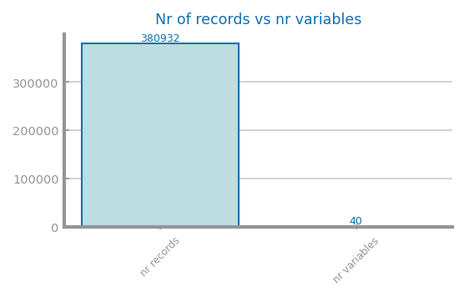 | 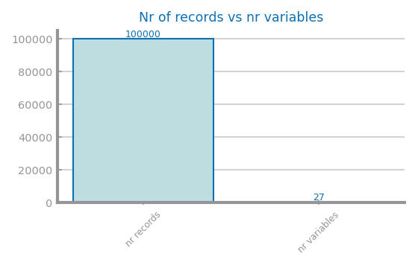

Figure 1 Nr Records x Nr variables for dataset 1 (left) and dataset 2 (right)
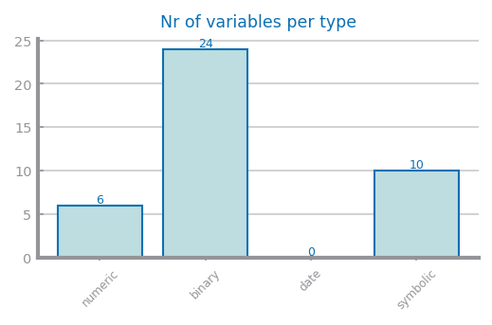 | 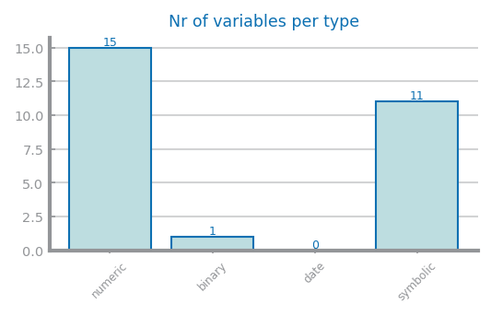

Figure 2 Nr variables per type for dataset 1 (left) and dataset 2 (right)
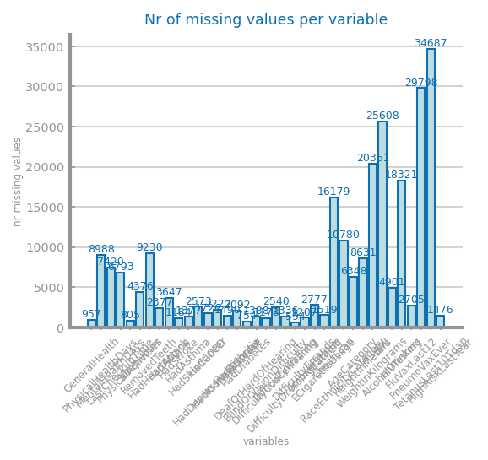 | 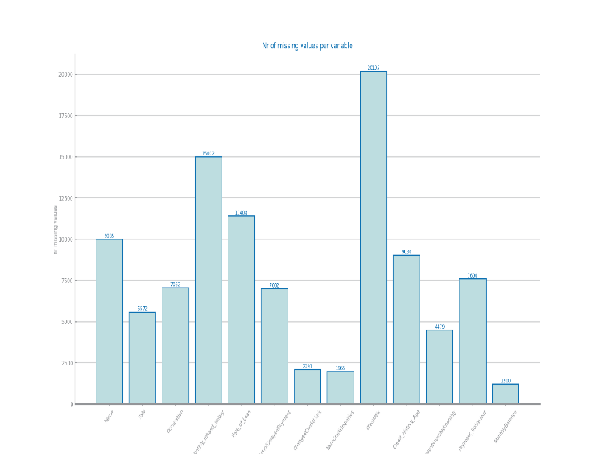

Figure 3 Nr missing values for dataset 1 (left) and dataset 2 (right)

Data Distribution
The individual distributions per variable from Figures 5, 7 and 9 seem healthy aside from PhysicalHealthDays and MentalHealthDays seem somewhat unbalanced (too many records with value 0 compared to the rest). By analysing the Figures 11 and 12, both datasets present unbalanced class distributions.
The dataset 2 has many variables with a high number of outliers and a high imbalance in the target distribution. This indicates that the data for dataset could be considered unbalanced.
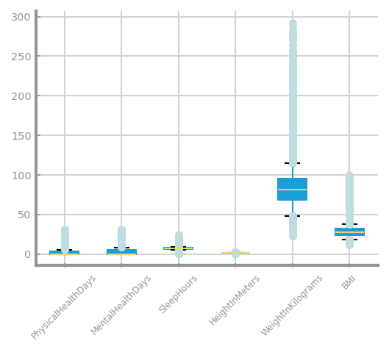 | 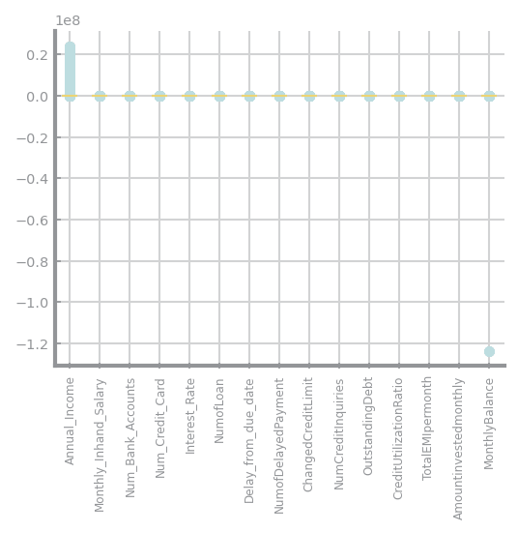

Figure 4 Global boxplots dataset 1 (left) and dataset 2 (right)
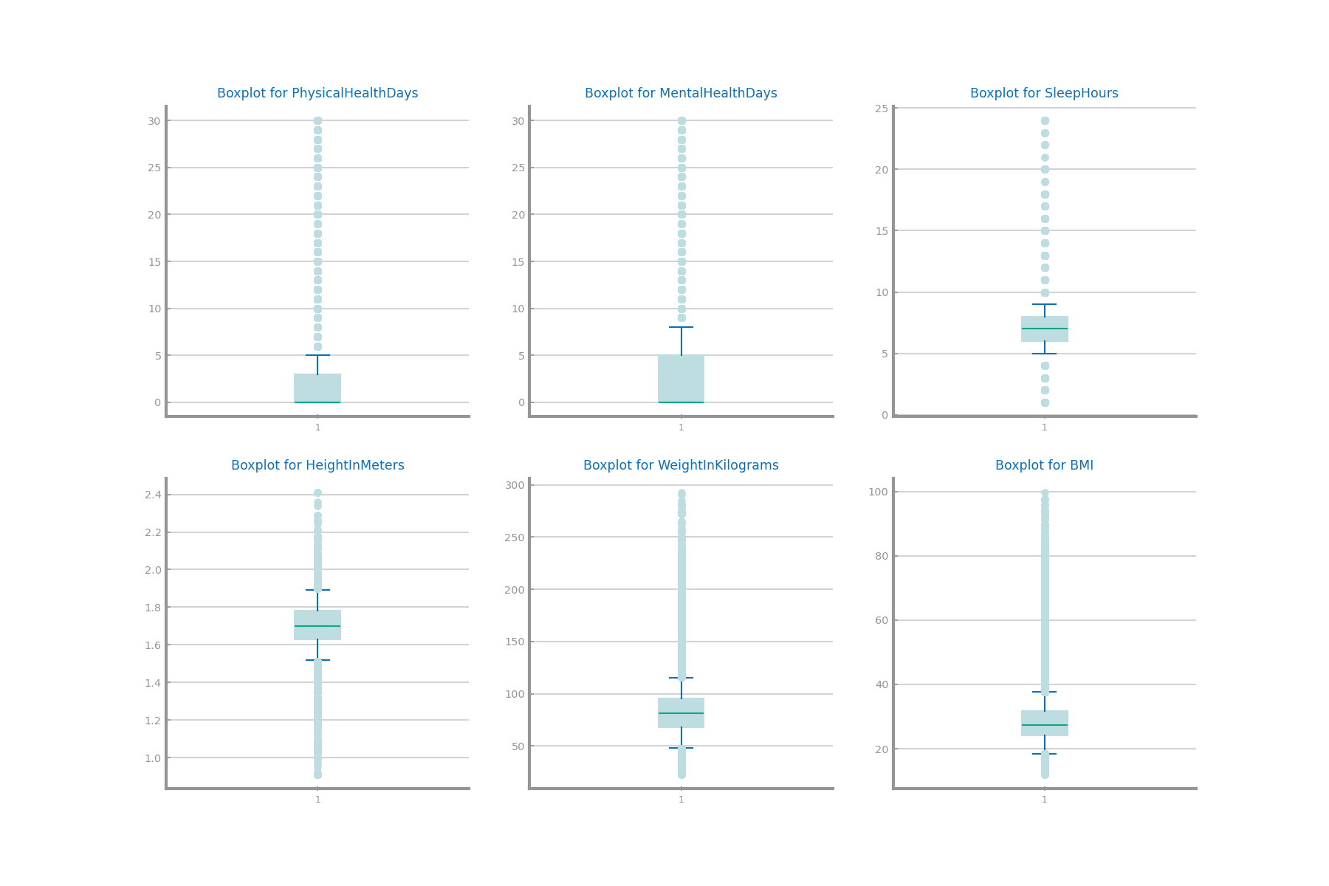
Figure 5 Single variable boxplots for dataset 1
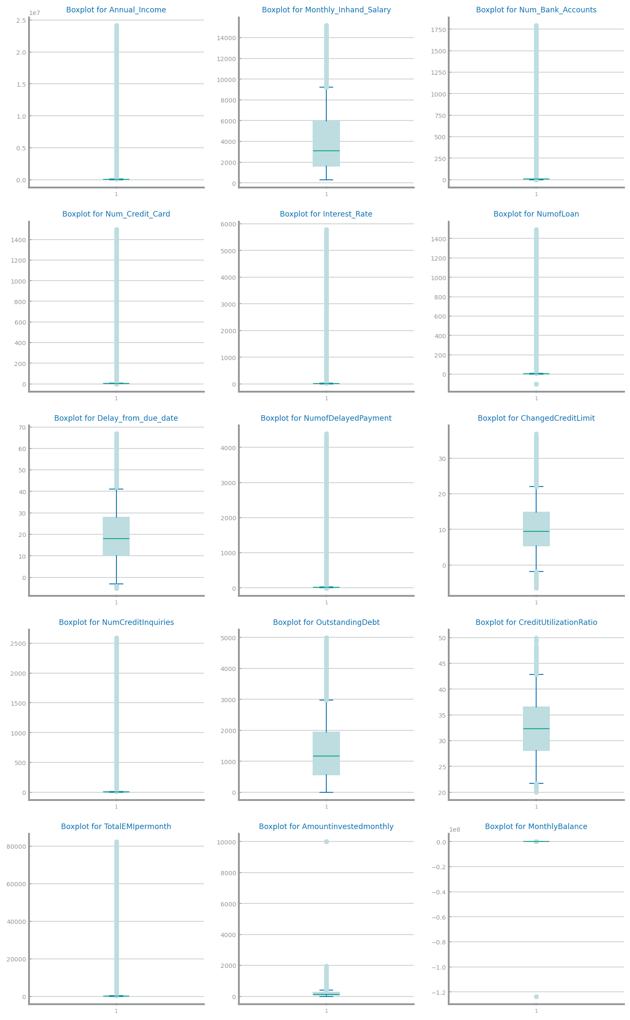
Figure 6 Single variable boxplots for dataset 2

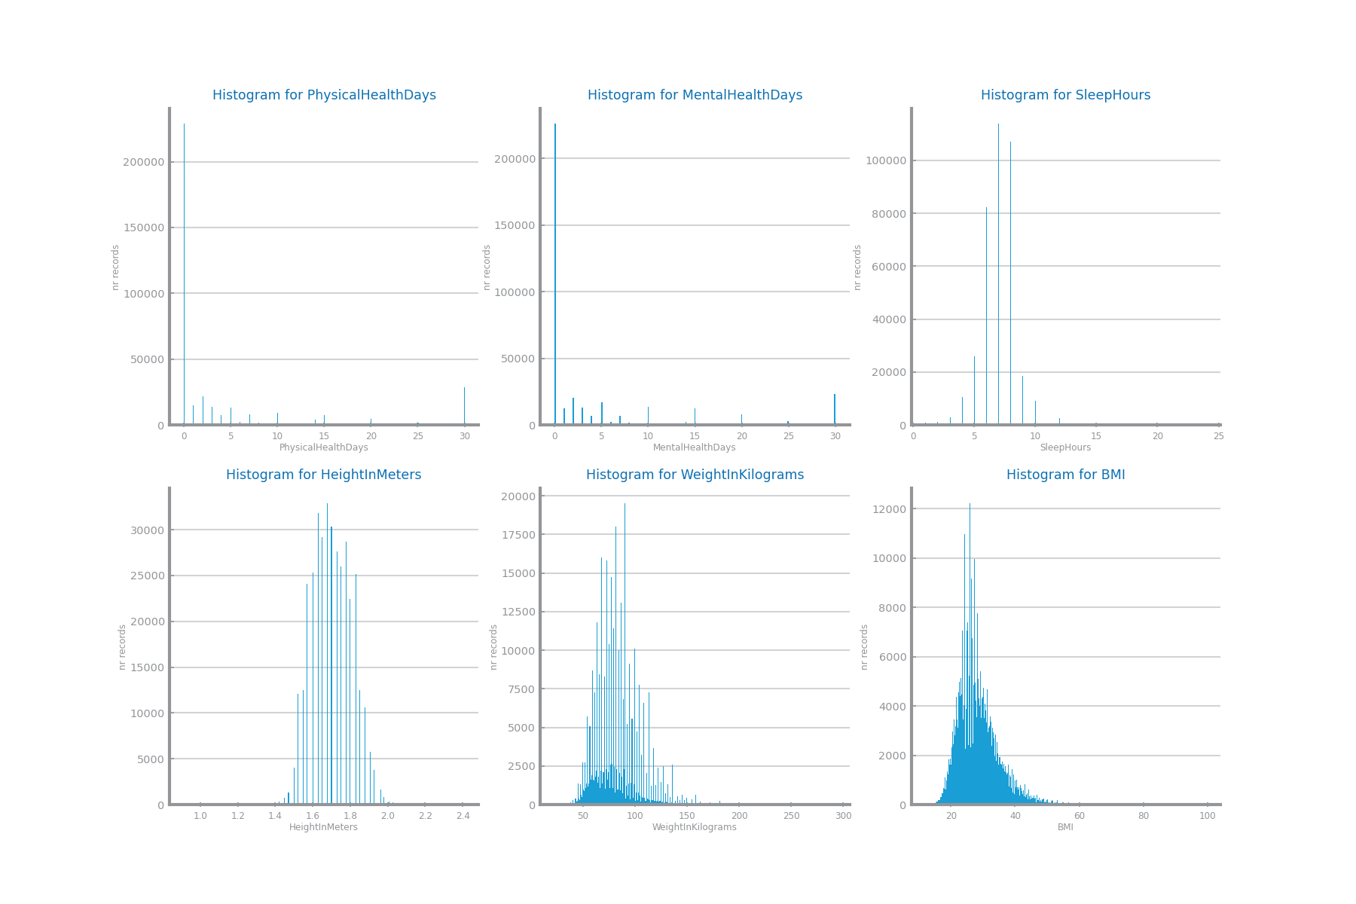
Figure 7 Histograms for dataset 1
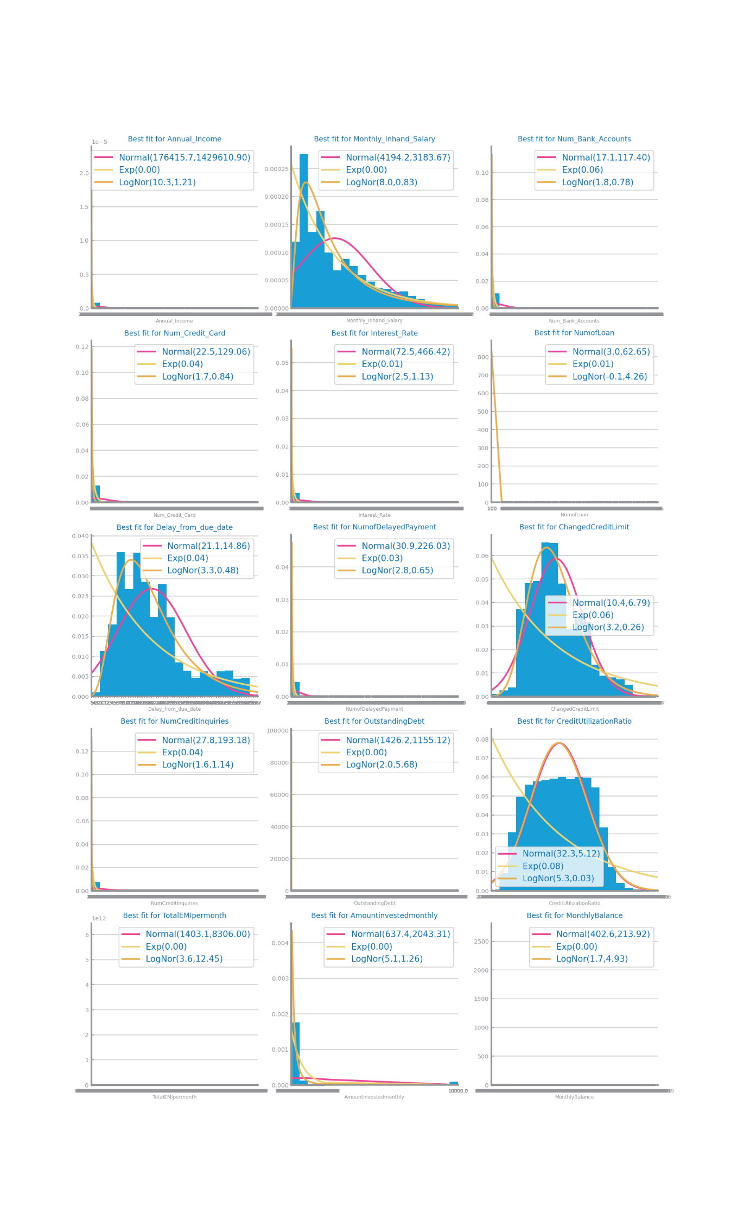
Figure 8 Histograms for dataset 2
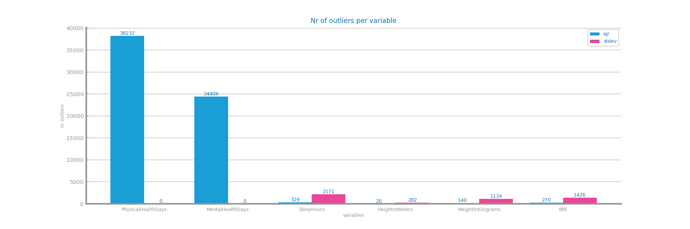
Figure 9 Outliers study dataset 1
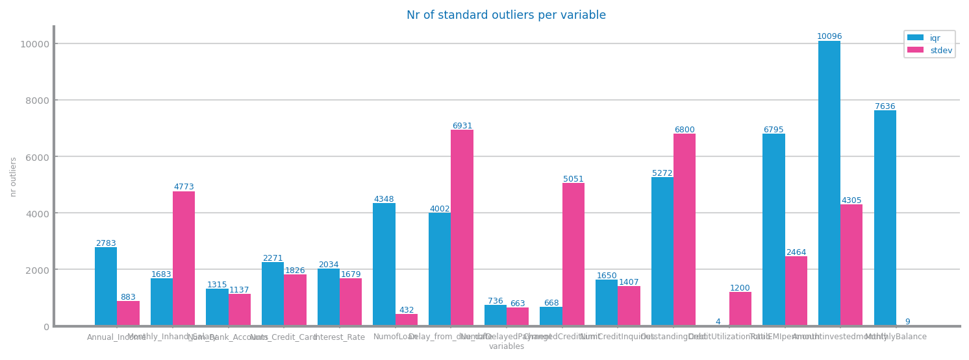
Figure 10 Outliers study for dataset 2
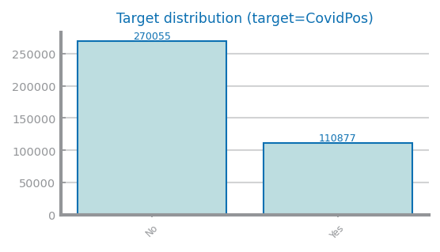
Figure 11 Class distribution for dataset 1
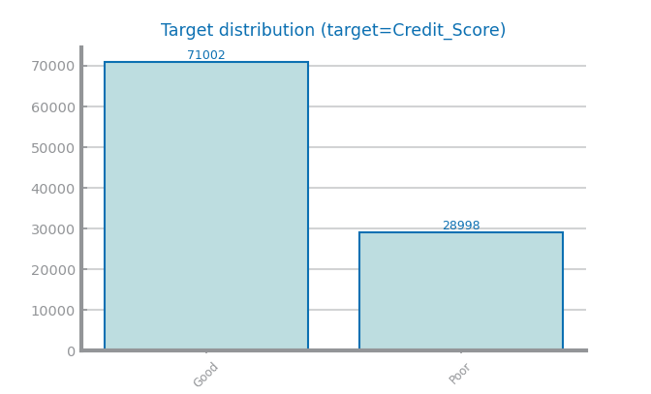

Figure 12 Class distribution for dataset 2

Data Granularity
Variable State is arguably unbalanced, this was another argument about the discussion on the variables’ existence in dataset 1.
For dataset 2 we have a variable state that could be considered balanced as the distribution shown in Figure 14 is uniform.
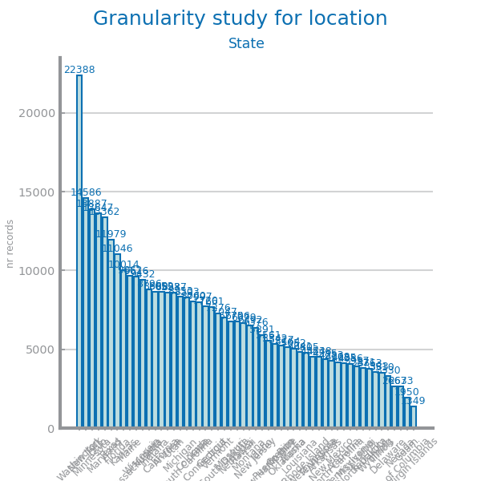
Figure 13 Granularity analysis for dataset 1

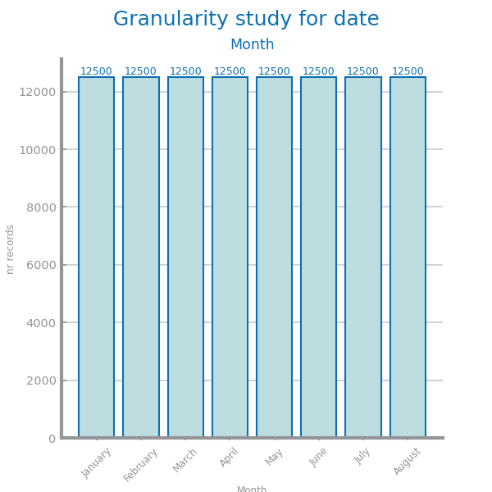
Figure 14 Granularity analysis for dataset 2

Data Sparsity
D1: WeightInKilograms x BMI sparsity analysis appears to be close to a linear relation, this happening leads to a high correlation.
D2: There is great correlation between OutstandingDebt and CreditMix and a considerable correlation between CreditMix and Delay_From_Due_Date showing the importance of the variable CreditMix in dataset 2.
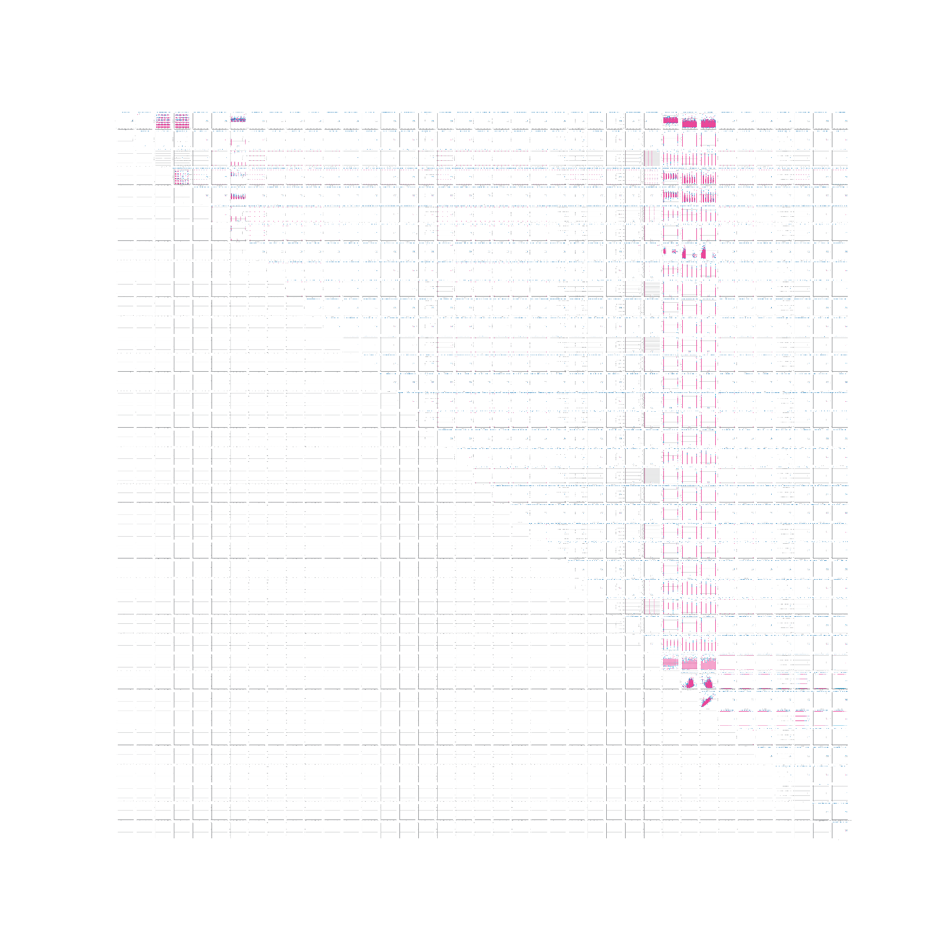
Figure 15 Sparsity analysis for dataset 1 (link para download com melhor qualidade)
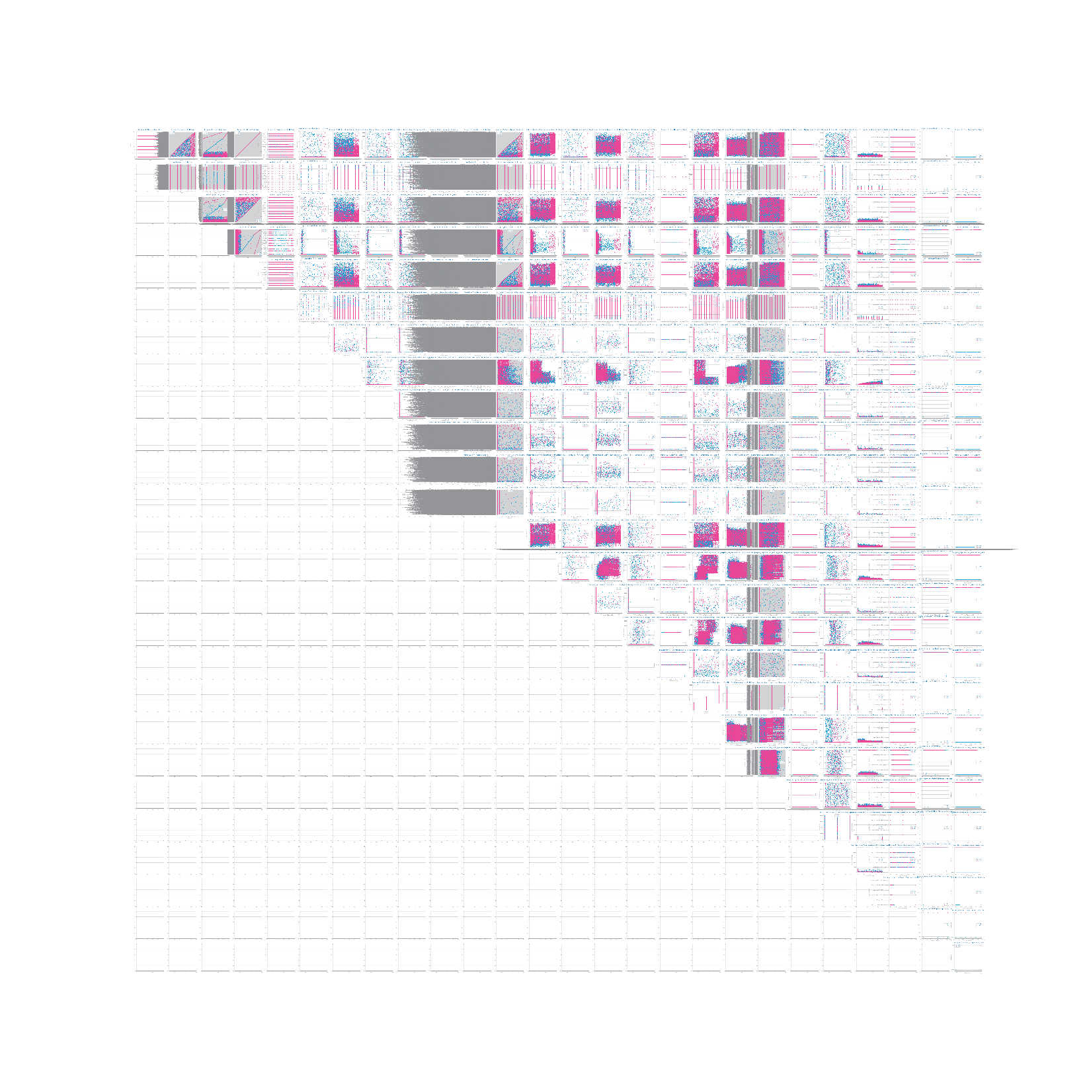
Figure 16 Sparsity analysis for dataset 2 (link para download com melhor qualidade)
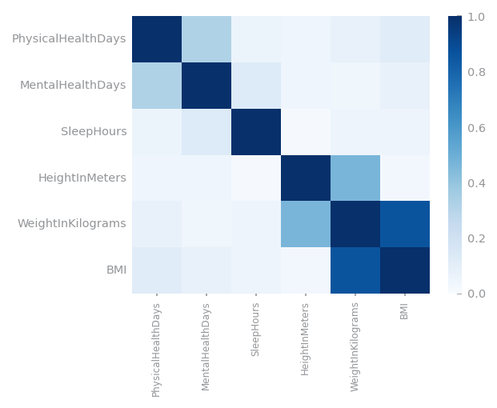
Figure 17 Correlation analysis for dataset 1
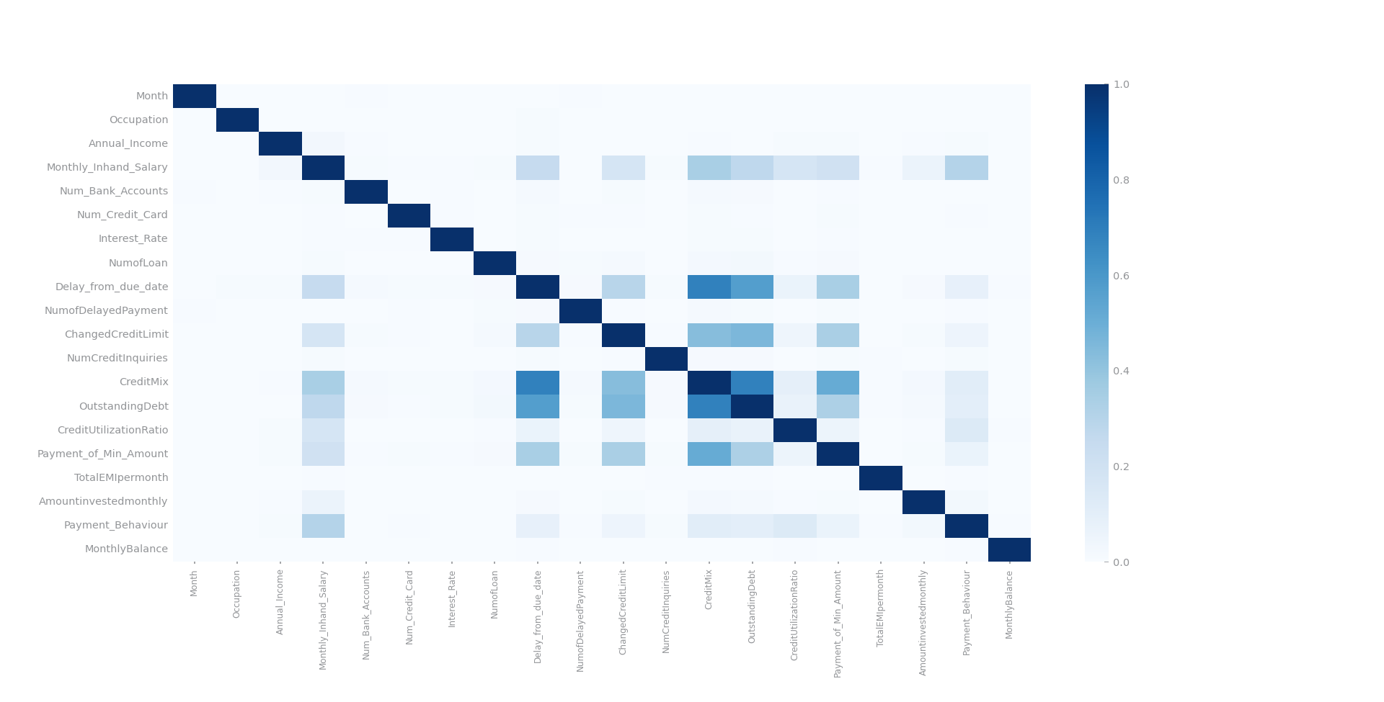
Figure 18 Correlation analysis for dataset 2

Data Preparation

Variables Encoding
D1:
- Ordinal linear encoding: GeneralHealth, LastCheckupTime, AgeCategory
- Ordinal encoding based on taxonomy: SmokerStatus, ECigaretteUsage, TetanusLast10Tdap
- Dummification: State, RaceEthnicityCategory
D2:
- Drop var: IDs, Name, SSN
- Ordinal linear encoding: CreditMix, Payment_Behaviour
- Ordinal encoding based on taxonomy: Occupation
- Cyclic Encoding: Month
- Other:
- Type_of_Loan -> Created a new variable for each type of loan and counted from 1 to n depending on the number of times it appeared in the string
- Credit History Age -> Turned the string into a float with the formula: x = year + (1/12 * month)

Missing Value Imputation
D1: Fill by the most frequent value after deleting 90% of missing values ended up with more balanced results, so it was the approach taken.
D2: KNN filling was chosen as it showed the best overall results.
Frequent fill after deleting 0.9% of MV 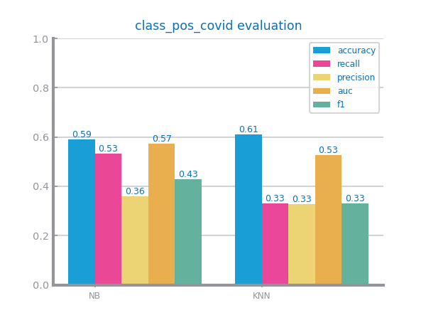 | KNN fill after deleting 0.9% of MV 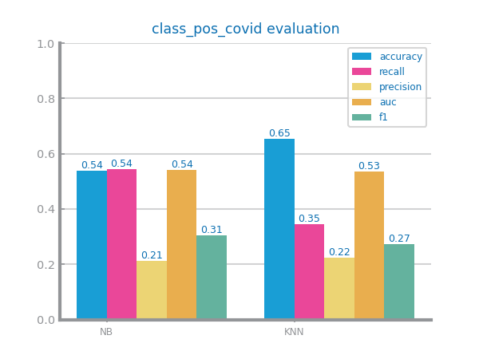
Figure 19 Missing values imputation results with different approaches for dataset 1
Frequent filling after deleting 0.9% of MV KNN filling
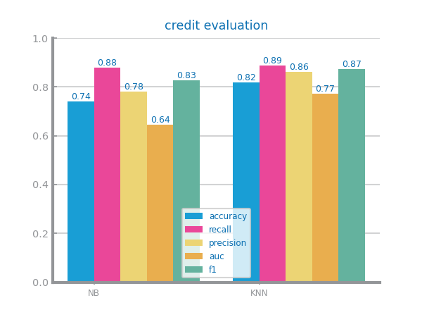
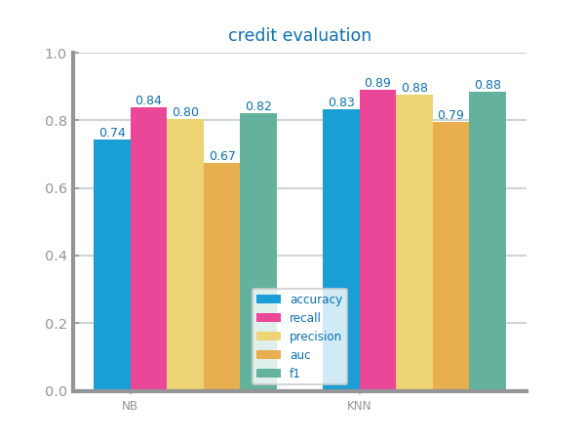
Figure 20 Missing values imputation results with different approaches for dataset 2

Outliers Treatment
D1: Since both approaches have close results on the test set and Outliers’ drop a small step up on the train’s recall, the approach to drop the outliers was taken.
D2: as shown in the graph dropping the outliers is more beneficial as it presents better overall results except for the auc which we have deemed not as important as the benefit we get from the higher recall results in dropping the outliers than truncating them.
Outliers’ drop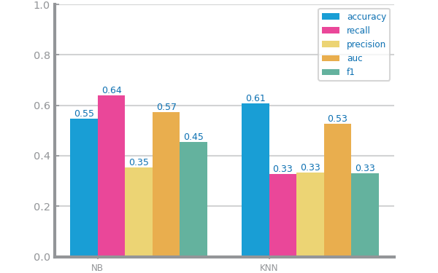 | Outliers’ truncation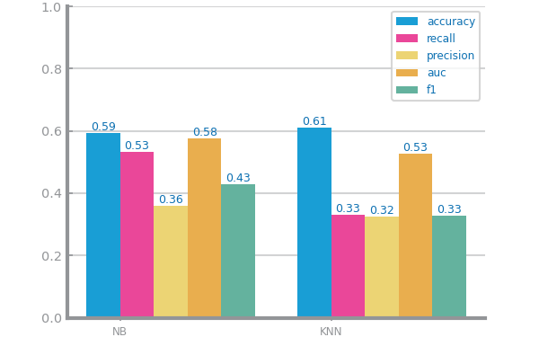
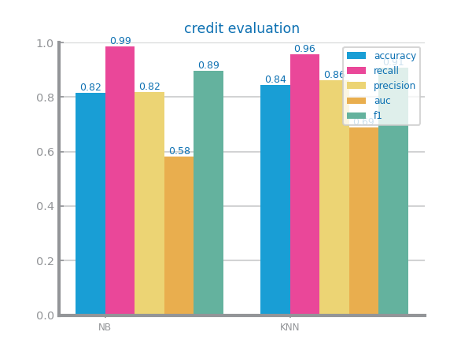
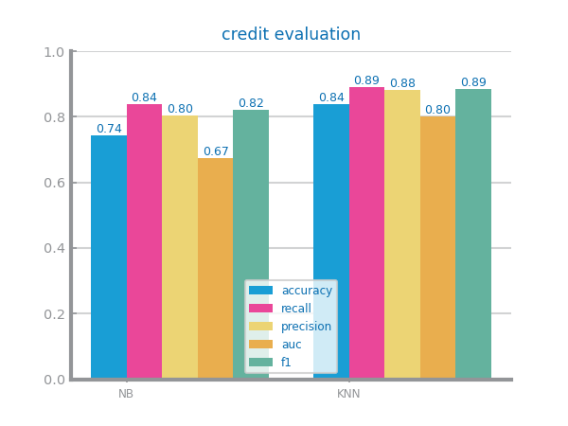
Figure 21 Outliers imputation results with different approaches for dataset 1
Figure 22 Outliers imputation results with different approaches for dataset 2

Scaling
D1: Although both approaches highly improve the accuracy, it is followed by a decrease in recall, leading to a worse model in the context of the dataset.
D2: Even though both approaches boast good values MinMax clearly shows better results in all parameters.
MinMax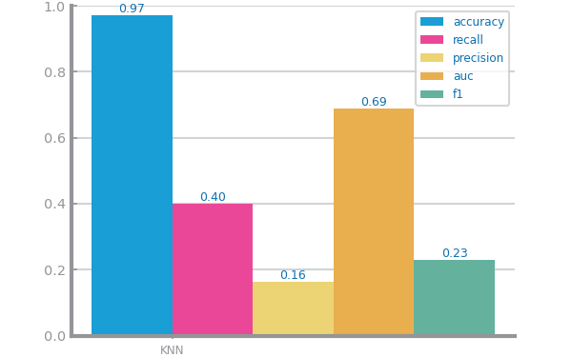 | Z-score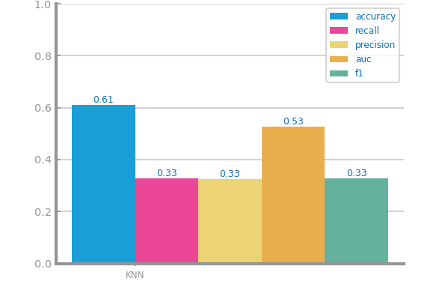
Figure 23 Scaling results with different approaches for dataset 1
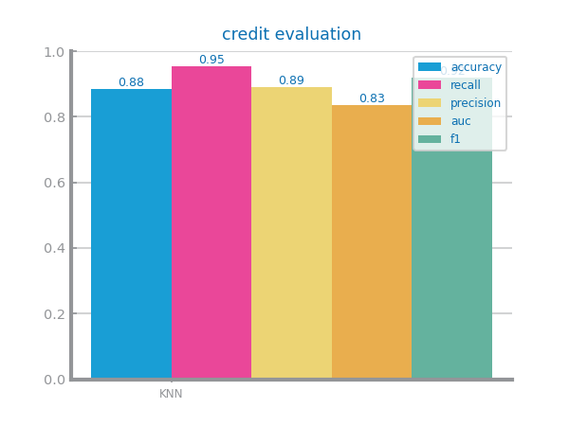
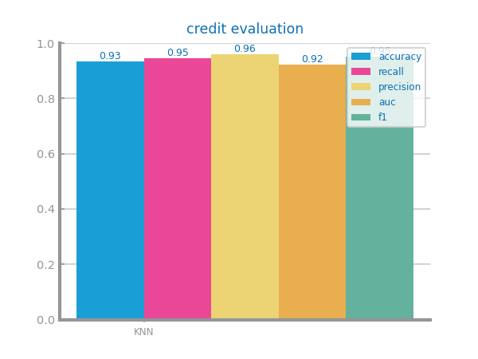
Figure 24 Scaling results with different approaches for dataset 2

Balancing
Like mentioned before, both datasets present unbalanced class distributions.
As of the dataset 1, there is a visible improvement to multiple classifications after executing the SMOTE approach, mainly recall.
The oversampling approach was chosen as the approach for dataset 2 as it shows the best results overall, at least when comparing KNN seeing as NB is equal for all approaches. With this approach we can more effectively balance the minority classes in the model.
Over sampling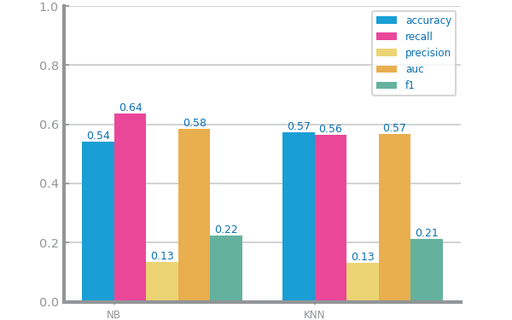 | Under sampling 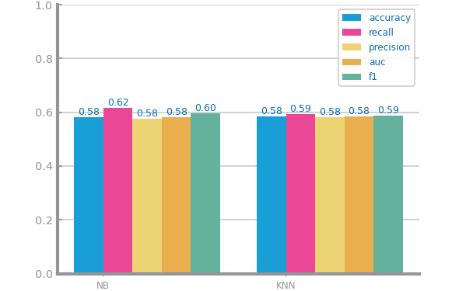
SMOTE
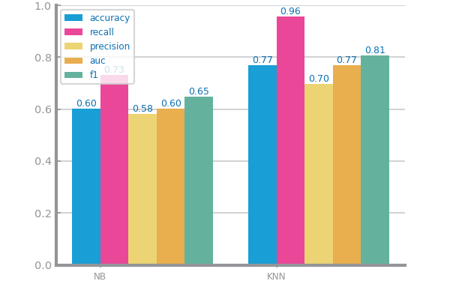
Figure 25 Balancing results with different approaches for dataset 1
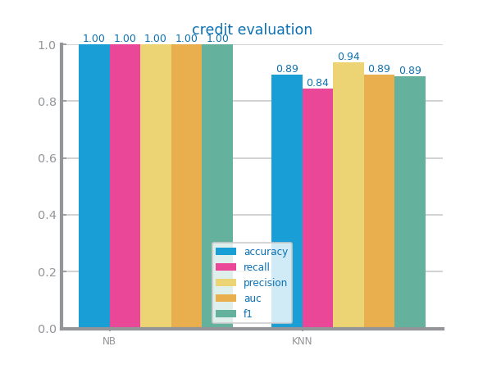
Under sampling Over sampling
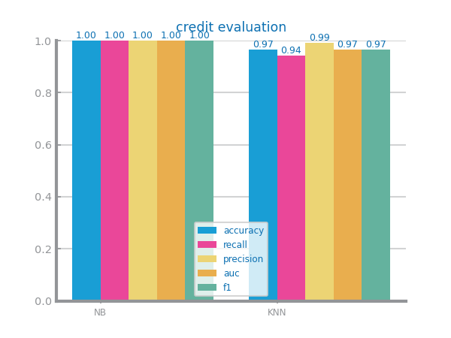

SMOTE
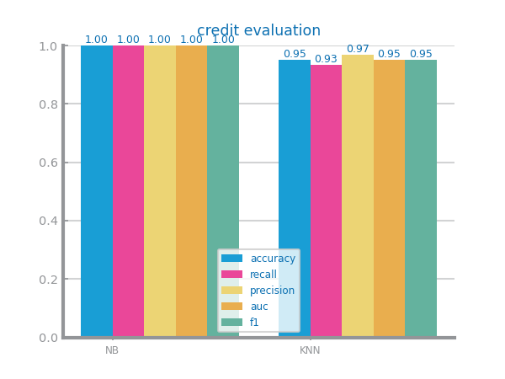
Figure 26 Balancing results with different approaches for dataset 2

Feature Selection
Redundancy:
D1: Better balanced with threshold 0.35.
Drop: HadDepressiveDisorder, DifficultyConcentrating, HadArthritis, PneumoVaxEver, MentalHealthDays, PhysicalHealthDays, DifficultyDressingBathing, DifficultyErrands, DifficultyWalking
D2: Spike in performance for NB threshold of 0.55.
Drop: CreditMix, OutstandingDebt, Delay_from_due_date, Credit_History_Age
Relevance:
D1: No changes
No drop.
D2: Spike in performance for NB threshold 0.4.
Drop: Payment_of_Min_Amount, Month_sin, Month_cos
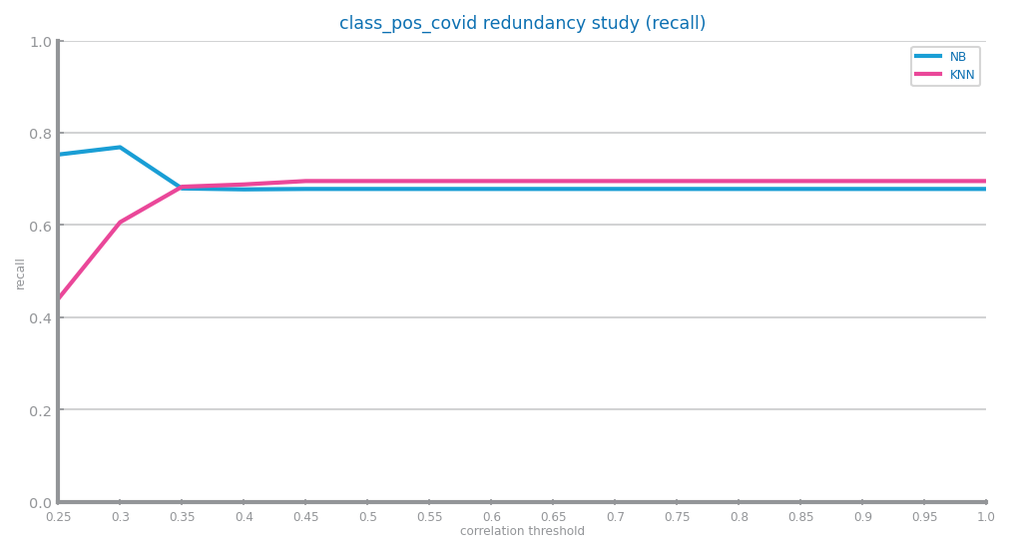
Figure 27 Feature selection of redundant variables results with different parameters for dataset 1
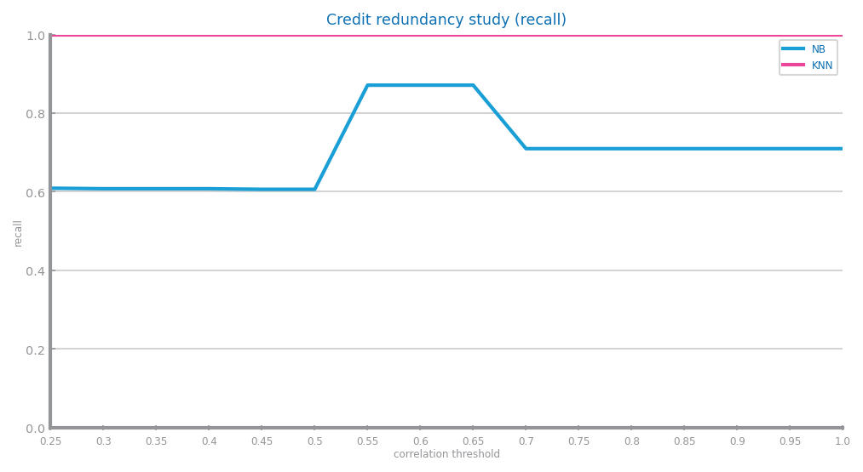
Figure 28 Feature selection of redundant variables results with different parameters for dataset 2
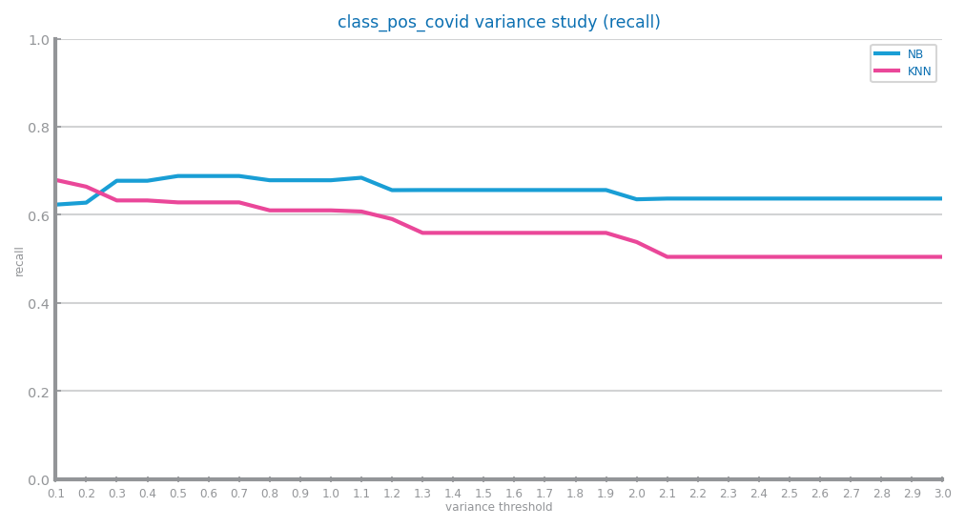
Figure 29 Feature selection of relevant variables results with different parameters for dataset 1 (variance study)
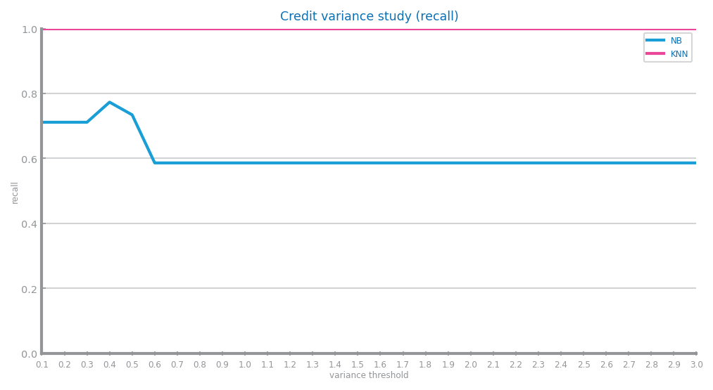
Figure 30 Feature selection of relevant variables results with different parameters for dataset 2 (variance study)

Models’ Evaluation
Since False negative is the classification which we want to minimize, the process we want to take would be to maximize the recall measure (maximize Number of correct Covid Positive predictions over all Covid Positive Diagnosis).
D2: We chose recall as the main measure in order to minimize the number of False negatives because in a credit score scenario, we want to correctly identify good credit scores minimizing the risk of approving loans for individuals with high credit risk.

Naïve Bayes
D1: While MultinomialNB and BernoulliNB excel on the accuracy measure, both with 0.6. The GaussianNB presents substantially better results.
D2: BernoulliNB is better than the others. Since the train and test data have similar results, we can say that NB is a good model for the dataset.
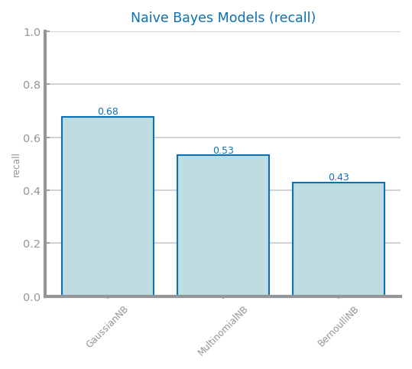
Figure 31 Naïve Bayes alternatives comparison for dataset 1
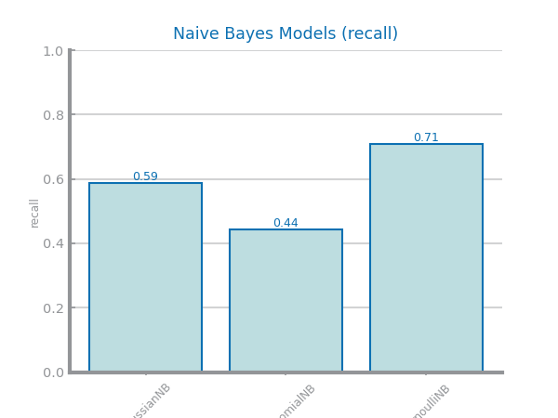
Figure 32 Naïve Bayes alternative comparison for dataset 2
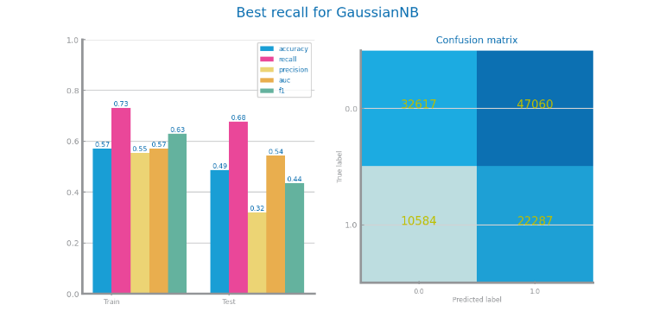 | 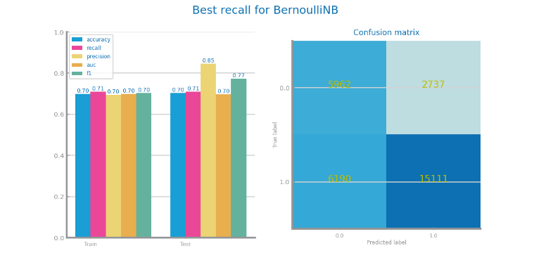
Figure 33 Naïve Bayes best model results for dataset 1 (left) and dataset 2 (right)

KNN
D1: The KNN model presents no overfitting, getting better for each increment of the k value. On higher value of k, the performance can get worse with little recall improvements.
The approach taken (not considering computation time) was k=25 on Euclidean metric.
D2: The KNN model present overfitting, worsening with increase in k value. The higher the k value, the worse the performance with a deterioration in the recall.
The approach taken was k= 1 using the Manhattan metric.
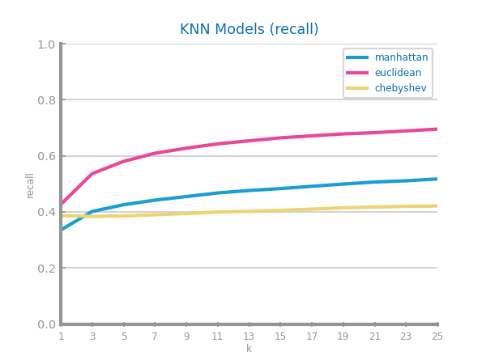
Figure 34 KNN different parameterisations comparison for dataset 1
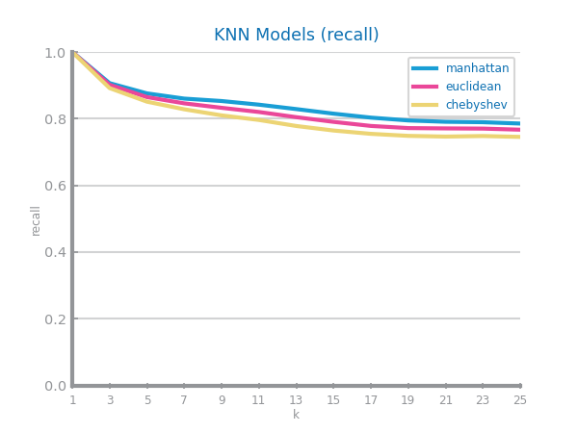
Figure 35 KNN different parameterisations comparison for dataset 2
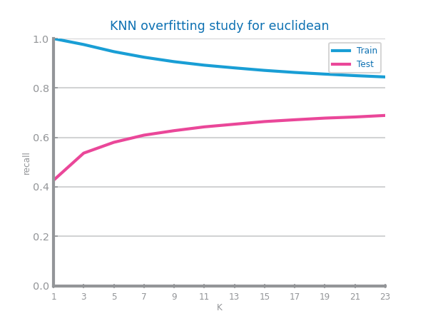 | 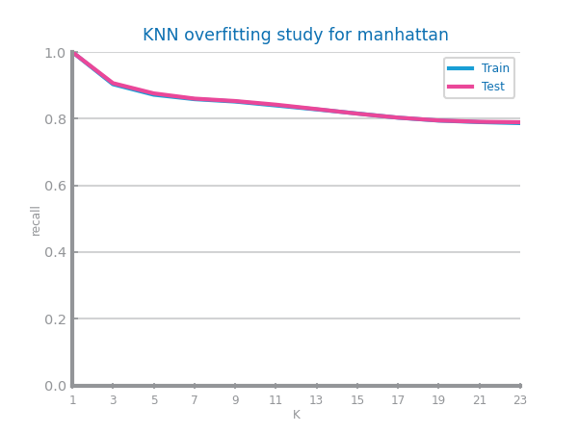
Figure 36 KNN overfitting analysis for dataset 1 (left) and dataset 2 (right)
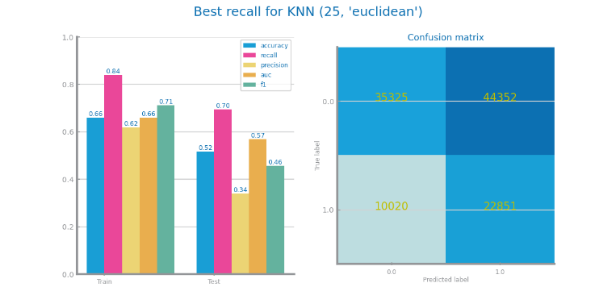 | 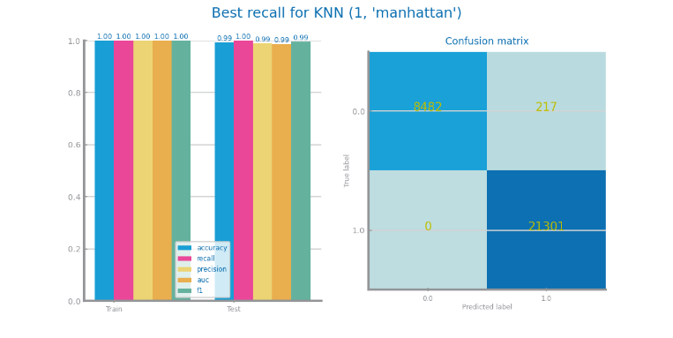
Figure 37 KNN best model results for dataset 1 (left) and dataset 2 (right)

Decision Trees
D1: Both entropy and gini present close recalls on their best d parameter, but the approach was to use the best model, entropy with d=2.Although mathematically the model overfits at d=3, it gets better results on d=4, getting the same or worse results with higher d values.
D2: The entropy and gini follow a similar evolution in recall for DT models. There is an increase in overfitting as we increment the max depth. We use an entropy model with d=24.
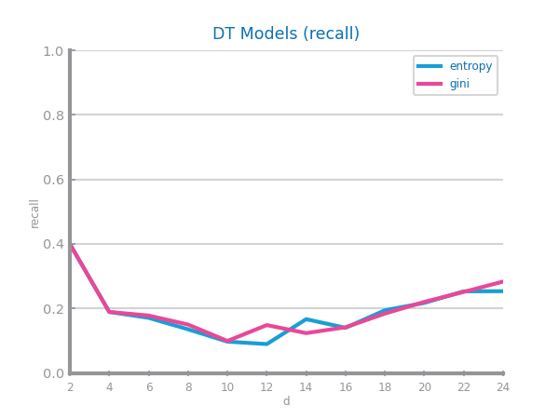
Figure 38 Decision Trees different parameterisations comparison for dataset 1
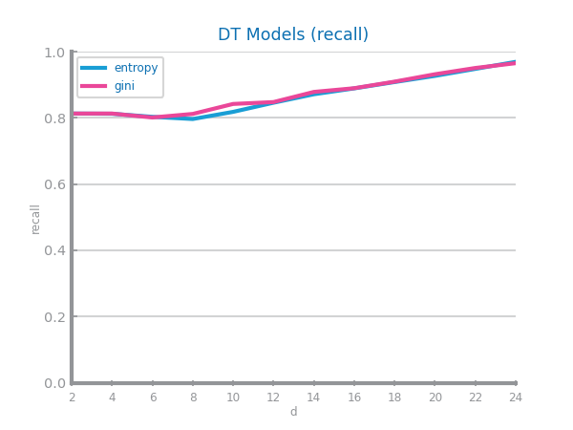
Figure 39 Decision Trees different parameterisations comparison for dataset 2
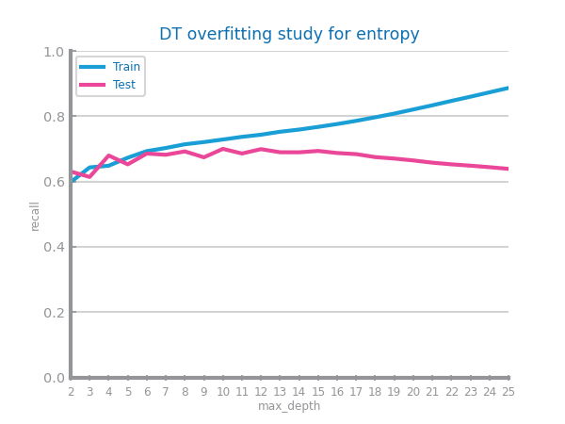 | 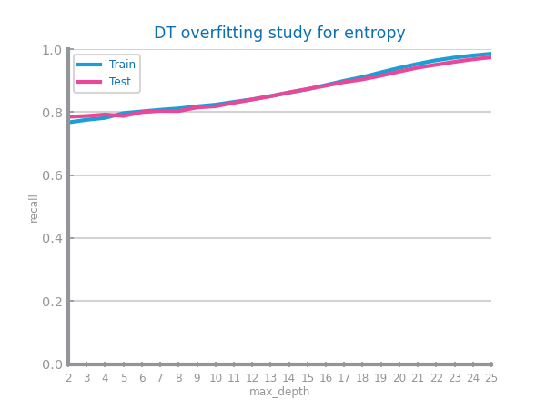
Figure 40 Decision Trees overfitting analysis for dataset 1 (left) and dataset 2 (right)
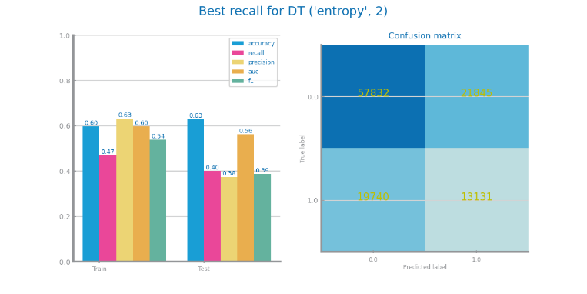 | 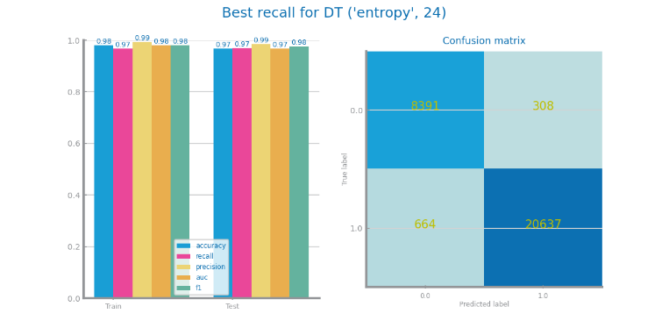
Figure 41 Decision trees best model results for dataset 1 (left) and dataset 2 (right)
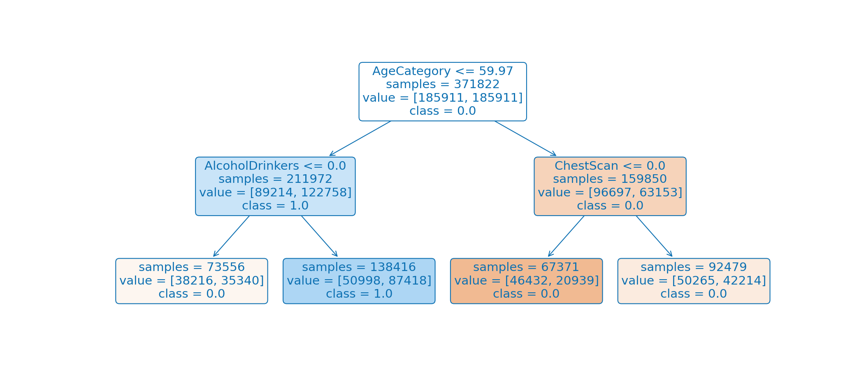
Figure 42 Best tree for dataset 1
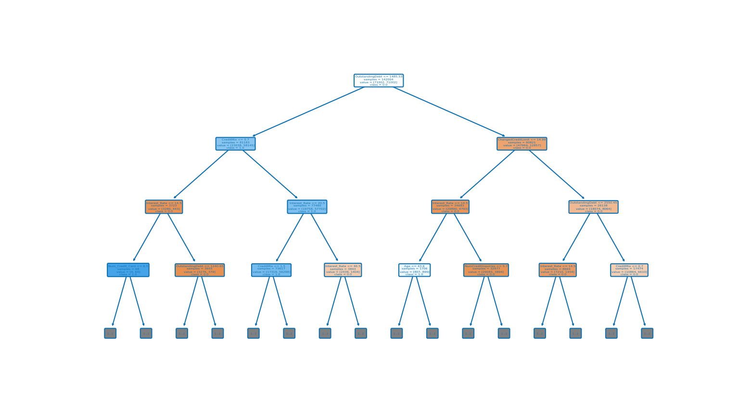
Figure 43 Best trees for dataset 2

Random Forests
D1: It is close, but the best RF’s parameters for the dataset in analysis is max_depth=2, max_features=0.5 and n_estimators=100. It doesn’t seem to present much overfitting over the number of trees. It appears to depend on too little variables.
D2: We ended having a hard choosing the best parameters, in the end, opting for largest depth, max_depth=7, max_features=0.1 and n_estimators=100.We have a consistent model with no little to no overfitting. We can see a good number of important variables.
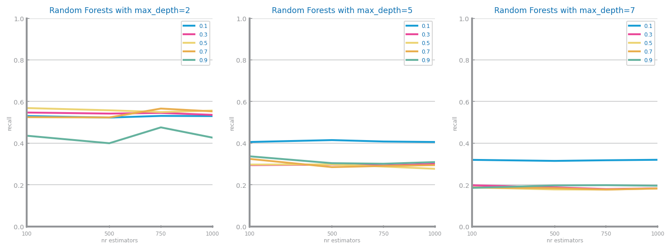
Figure 44 Random Forests different parameterisations comparison for dataset 1
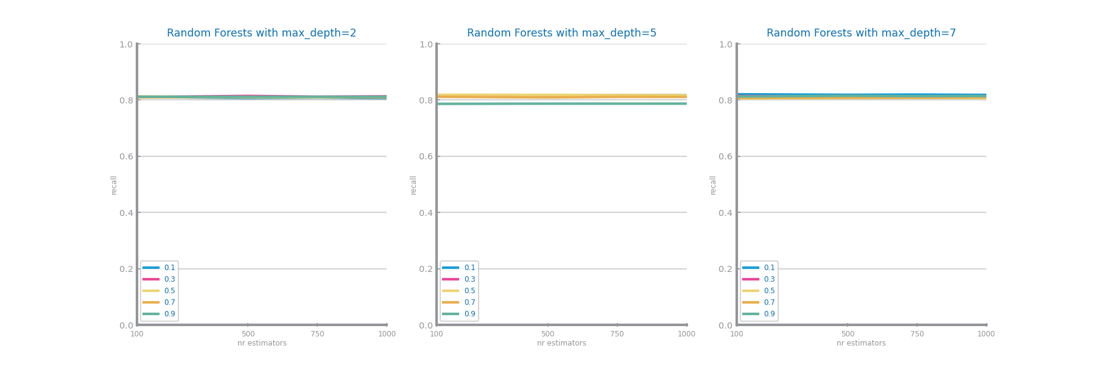

Figure 45 Random Forests different parameterisations comparison for dataset 2
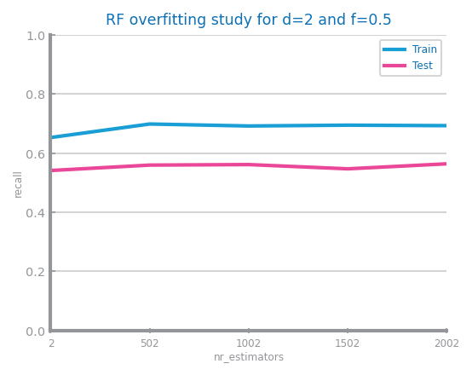 | 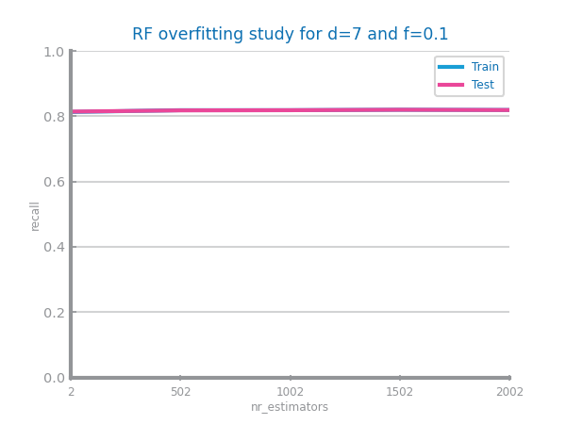
Figure 46 Random Forests overfitting analysis for dataset 1 (left) and dataset 2 (right)
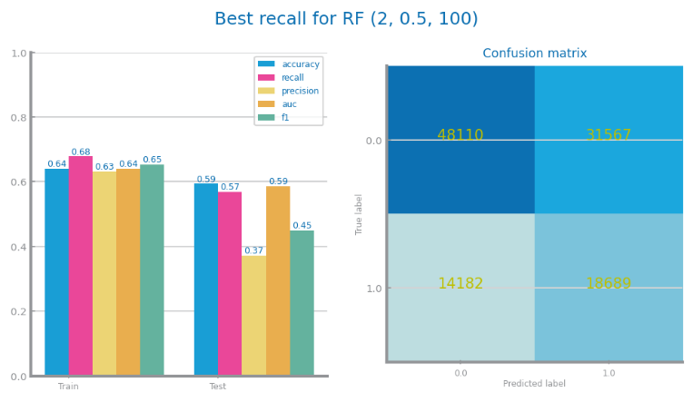 | 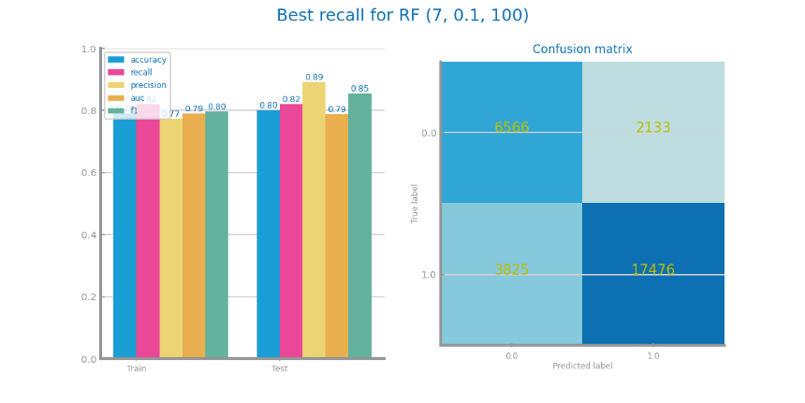
Figure 47 Random Forests best model results for dataset 1 (left) and dataset 2 (right)
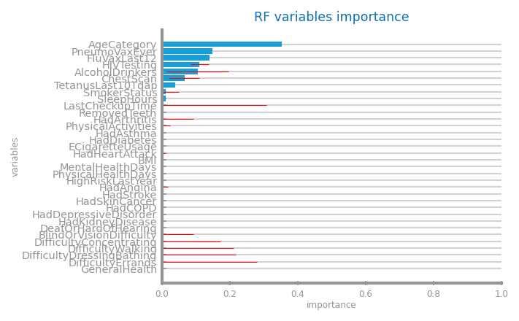 | 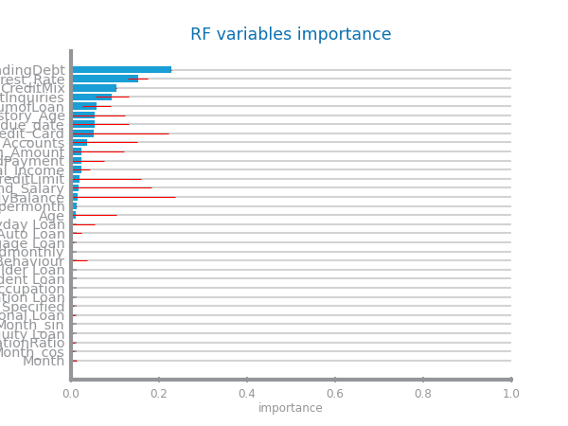
Figure 48 Random Forests variables importance for dataset 1 (left) and dataset 2 (right)

Gradient Boosting
D1: Although the recall only gets better the higher depth, estimators and learning rate, the distinct evaluation values from train to test lead us to conclude that there was overfit and there is no clear best model for maximising recall that doesn’t overfit.
D2: As we increase the depth and estimators our recall follows suit, although learning rate does not change much at this depth. We can see that we have almost no overfitting. We conclude that this model has adapted well to unseen data.
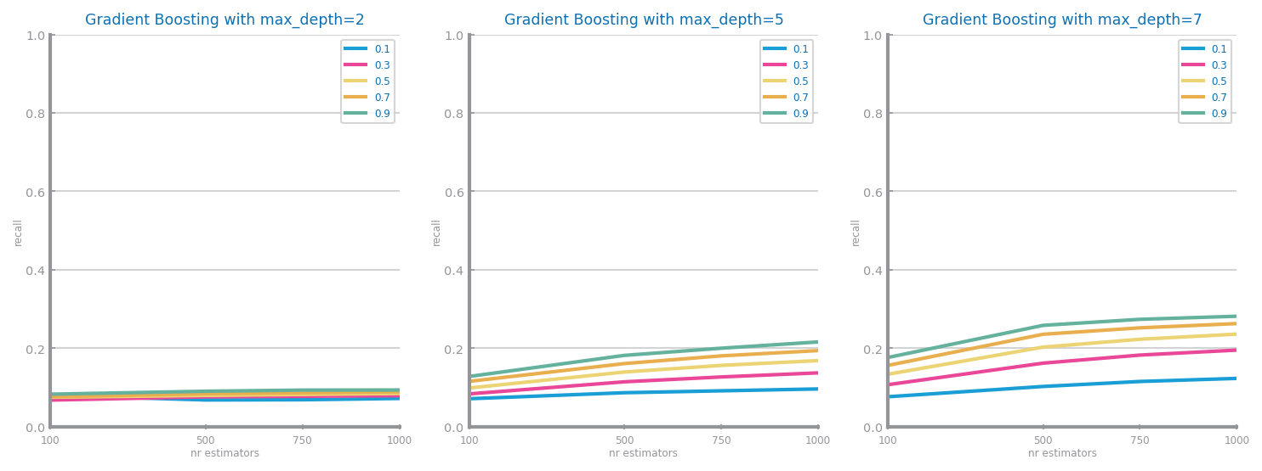
Figure 49 Gradient boosting different parameterisations comparison for dataset 1
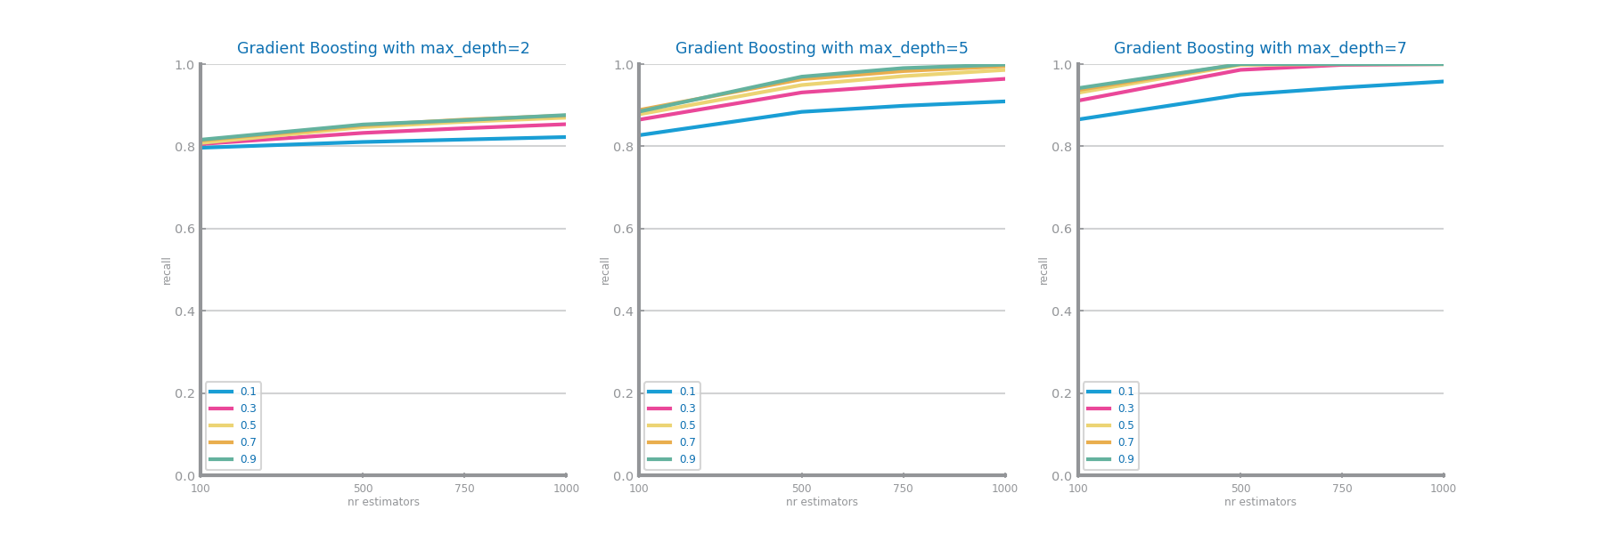
Figure 50 Gradient boosting different parameterisations comparison for dataset 2
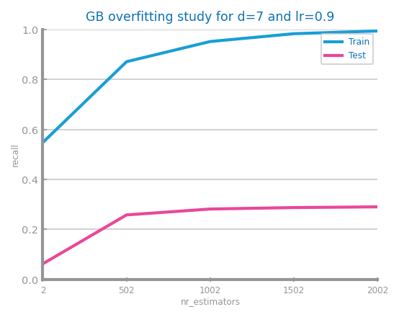 | 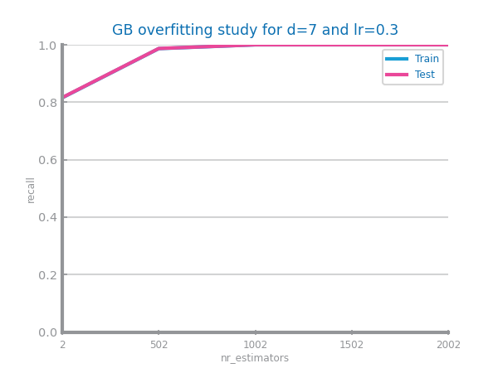
Figure 51 Gradient boosting overfitting analysis for dataset 1 (left) and dataset 2 (right)
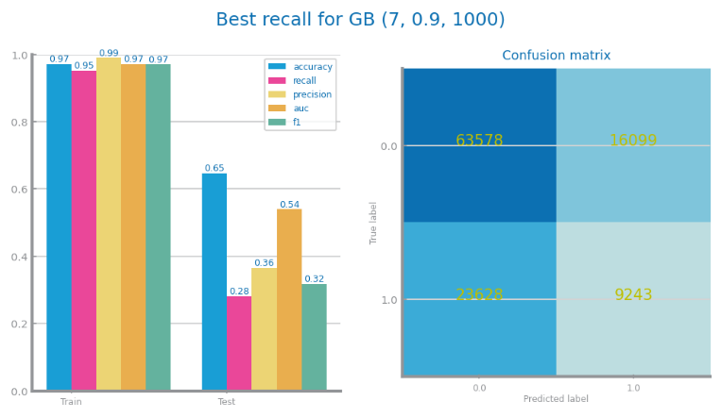 | 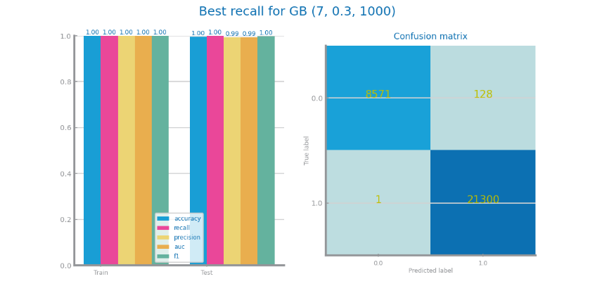
Figure 52 Gradient boosting best model results for dataset 1 (left) and dataset 2 (right)
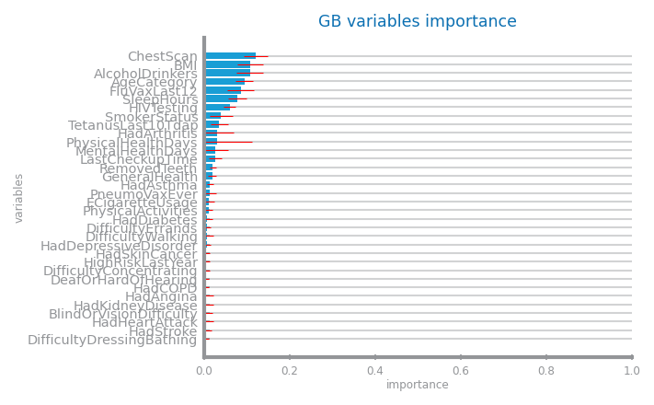 | 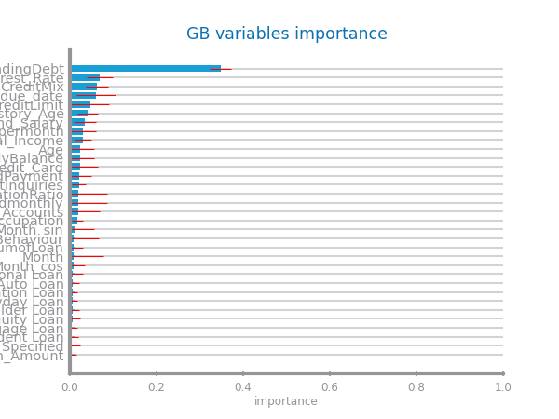
Figure 53 Gradient boosting variables importance for dataset 1 (left) and dataset 2 (right)

Multi-Layer Perceptrons
D1: Due to some computer limitations during the model study, the results appeared vastly different for every execution of the study, these erratic results are present on the Confusion Matrix.
D2:We chose a constant learning rate of 0.05, being the one that starts with the highest recall for the smallest number of estimators, with all learning rates converging the higher the number of estimators. Overfitting occurs due to the erratic nature of MLPs.
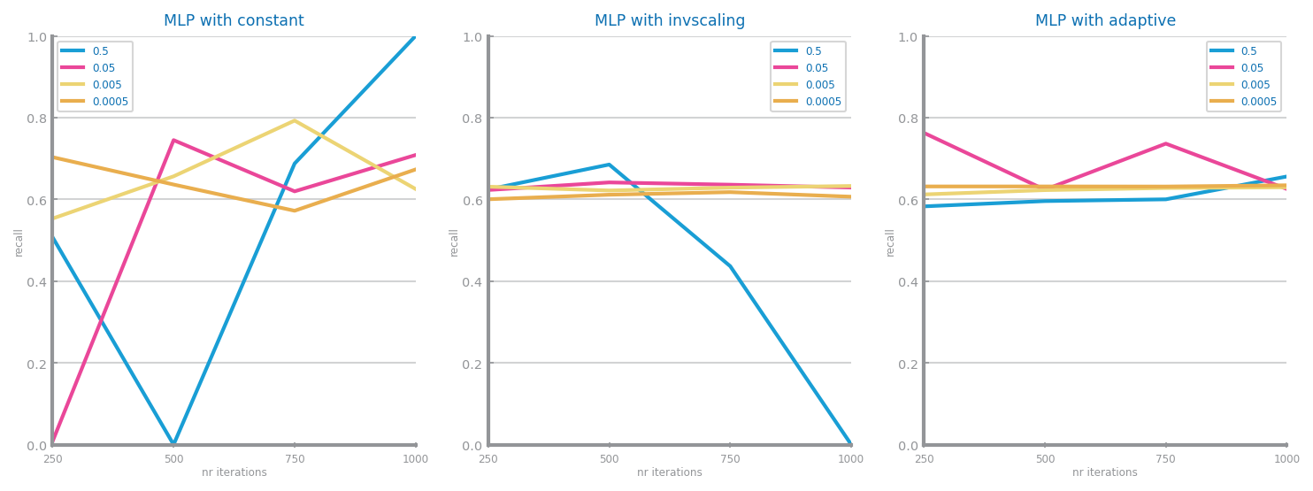
Figure 54 MLP different parameterisations comparison for dataset 1
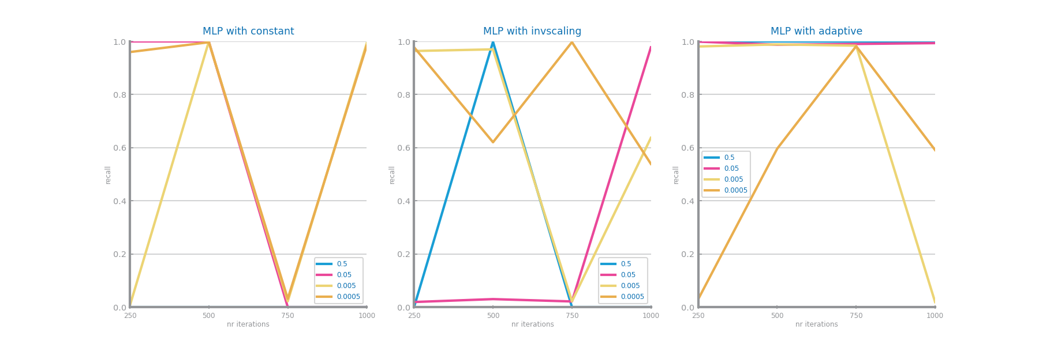
Figure 55 MLP different parameterisations comparison for dataset 2
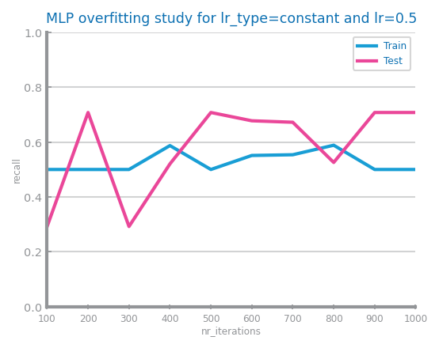 | 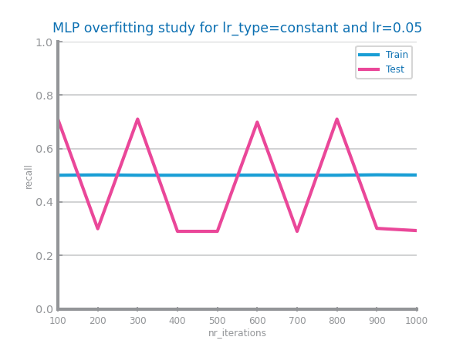
Figure 56 MLP overfitting analysis for dataset 1 (left) and dataset 2 (right)
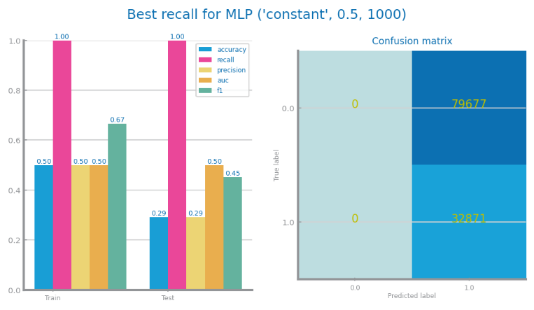 | 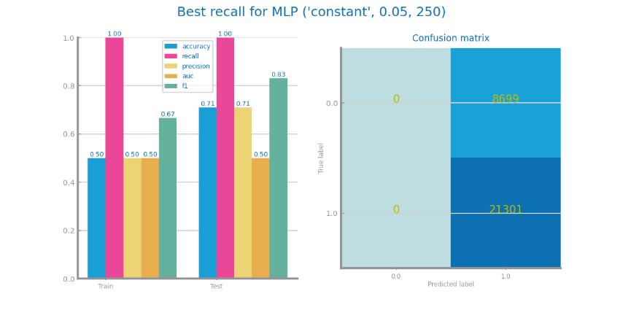
Figure 57 MLP best model results for dataset 1 (left) and dataset 2 (right)

Critical Analysis
D1: Most data preparation didn’t end up being very effective aside from Balancing and the necessary Encoding, but after some independent tests and research, outside the main goal of the report, the variable State and RaceEthnicityCategory (dummified variables) ended up being not that useful and would vastly simplify the model’s computation work. After all the model evaluation, the classic NB and KNN models ended up being the most assertive, with NB overfitting a little less then KNN. Decision Trees and Random Forest both ended up with decent overall results, with little overfitting, however, they didn’t reach competitive recall values. Finally, Gradient Boost, showed some pretty good results on the train test, but massively overfitted ending up with the worst test results from all the models.
D2: Data preparation had a massive impact in increasing our scores on our performance since the increase in variables trough variables encoding hugely helped in our classification. Now discussing models, by analysing the performance measures and overfitting study of each one we can reach that the best model for our dataset will be Gradient Boosting followed by the KNN model since they both register almost no overfitting and the best scores in performance for their best parameters. Using the confusion matrix, we can conclude that the MLP model isn’t very good seeing as it classifies everything as true which doesn’t make sense when talking about our target variable(...). On the other hand, the other models have healthier confusion matrixes with Gradient Boosting having arguably the best confusion matrix with mostly TP and TN meaning the target variable was correctly predicted, strengthening our decision of choosing GB as the best model for our dataset.
  - Time Series Forecasting

Data Profiling

Data Dimensionality and Granularity
D1:
Atomic granularity: weekly records
Aggregation approaches: Monthly (4:1 ratio), Quarterly (16:1 ratio)
Since the original number of records was not that high, there is no performance need to simplify the time series in the expense of some information loss.
D2:
Atomic granularity: 15-minute interval
Aggregation approaches: Hourly (4:1 ratio), Daily (96:1 ratio)
No need to do any aggregation, since both the second and third granularities don’t improve our series and cost a lot of records.
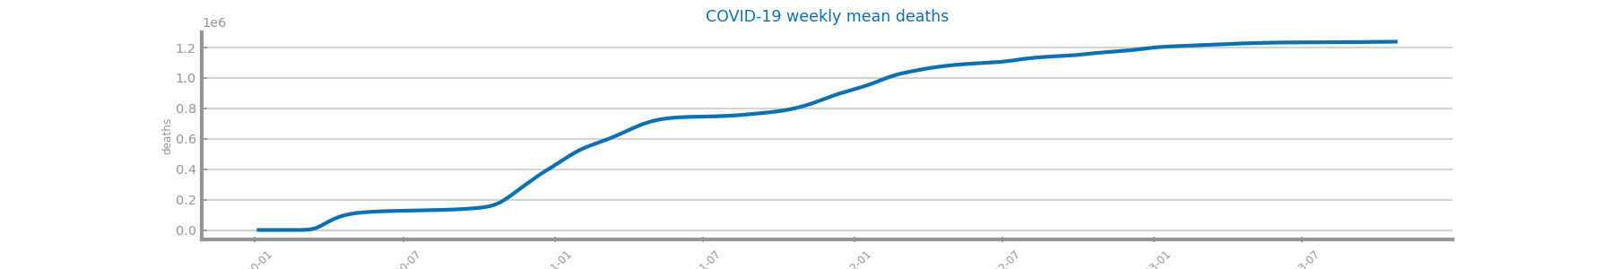
Figure 58 Original time series 1 (the most atomic detail)
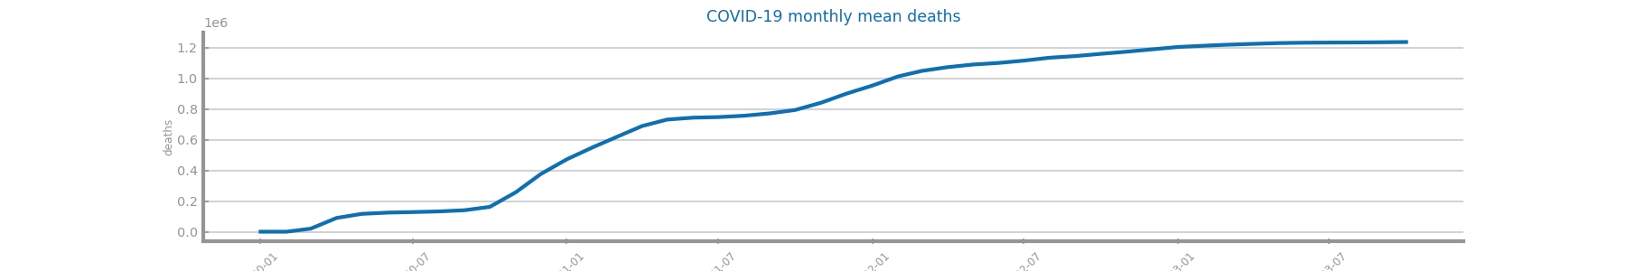
Figure 59 Time series 1 at the second chosen granularity
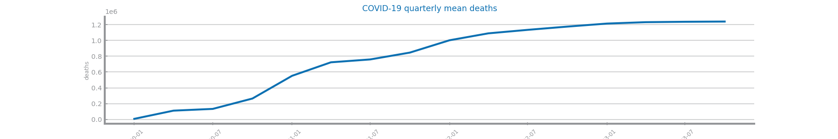
Figure 60 Time series 1 at the third chosen granularity

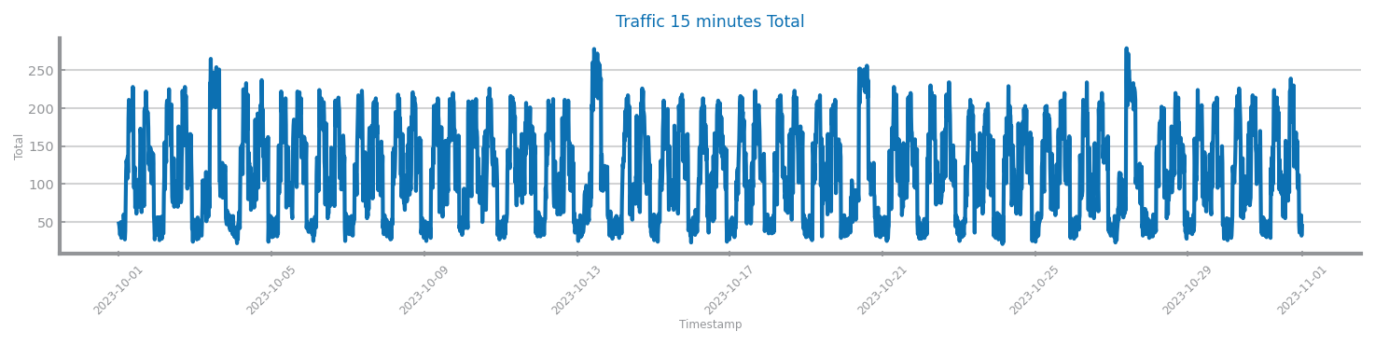
Figure 61 Original time series 2 (the most atomic detail)
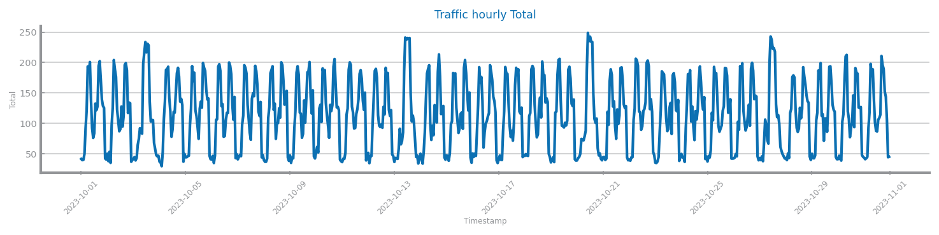
Figure 62 Time series 2 at the second chosen granularity
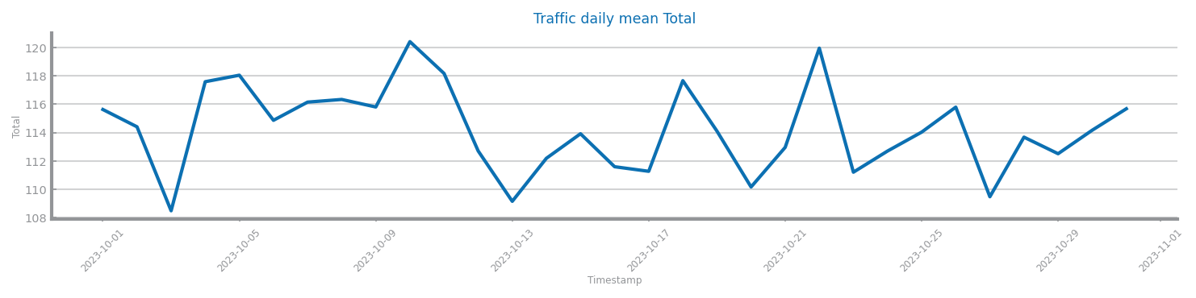
Figure 63 Time series 2 at the third chosen granularity

Data Distribution
D1: There is no major information loss, 199 records reduced to 46 or 16.
Though Figure 74, by having an autocorrelation constantly at 0 the series appears to be somewhat random, thus having no predictable line of thought.
D2: Major loss of records from almost 3000 to 750 and then 31. The default granularity presents more uniform distribution of values. By observing Figure 75 we know our dataset is not random.
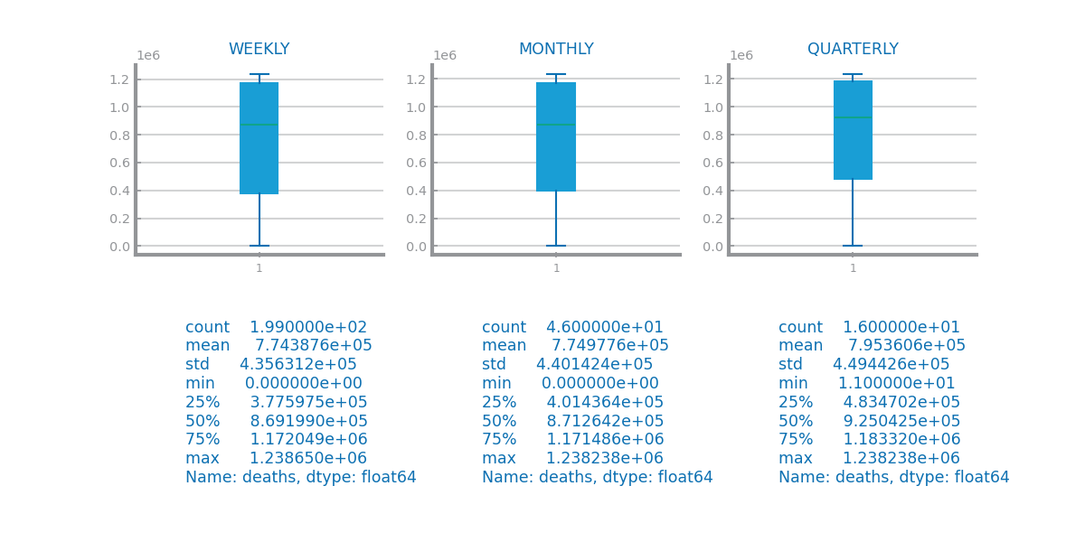
Figure 64 Boxplots for time series 1 at different granularities
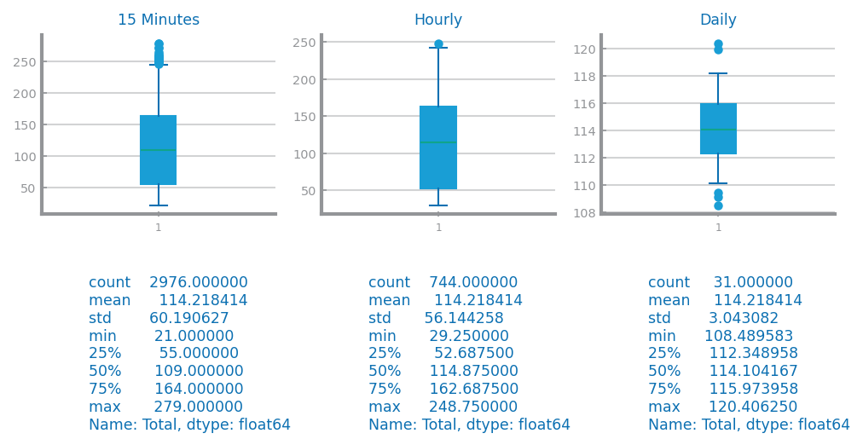
Figure 65 Boxplots for time series 2 at different granularities
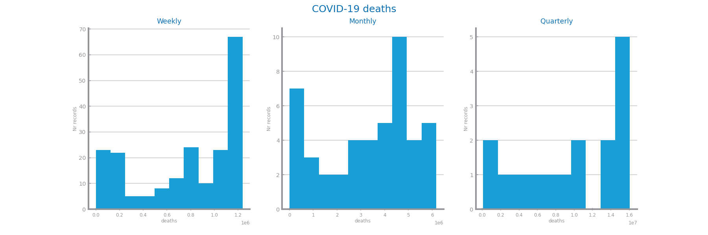
Figure 66 Histograms for time series 1 at different granularities
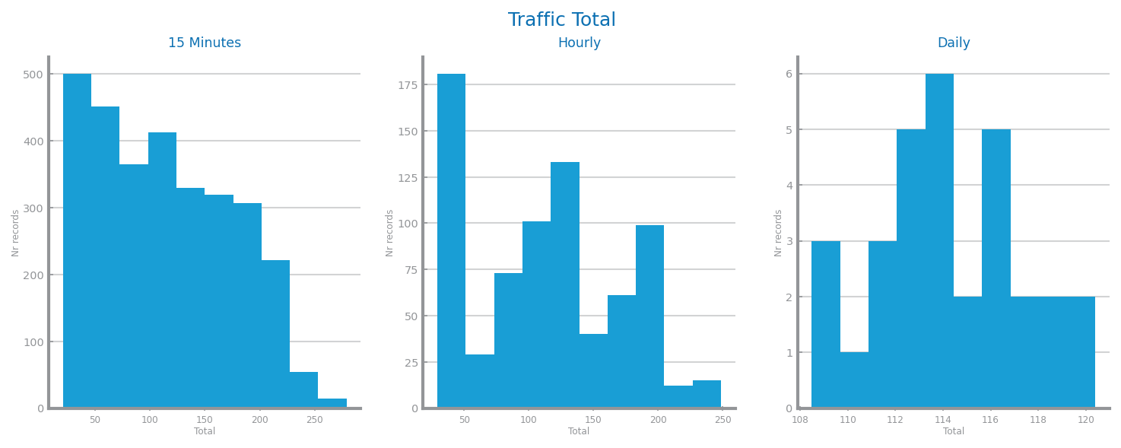
Figure 67 Histograms for time series 2 at different granularities
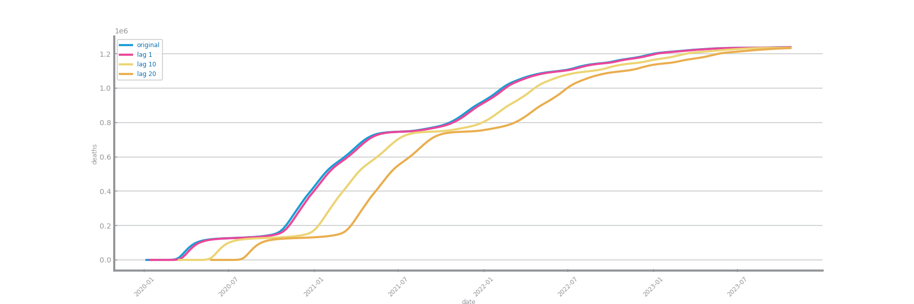
Figure 68 Autocorrelation lag-plots for original time series 1
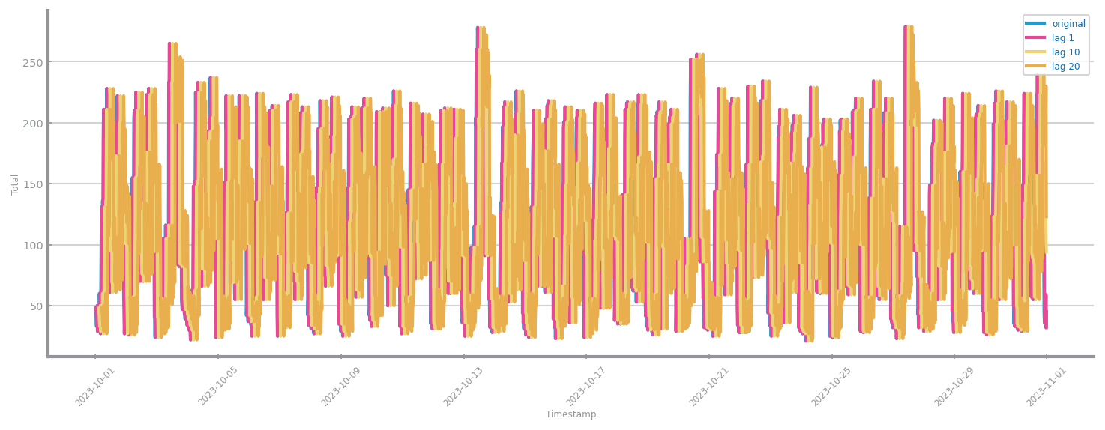
Figure 69 Autocorrelation lag-plots for original time series 2
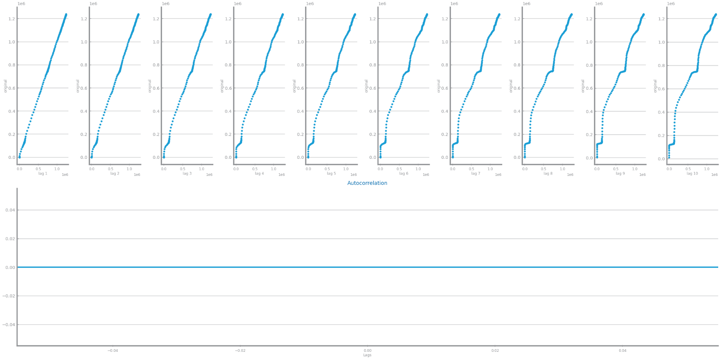
Figure 70 Autocorrelation correlogram for original time series 1
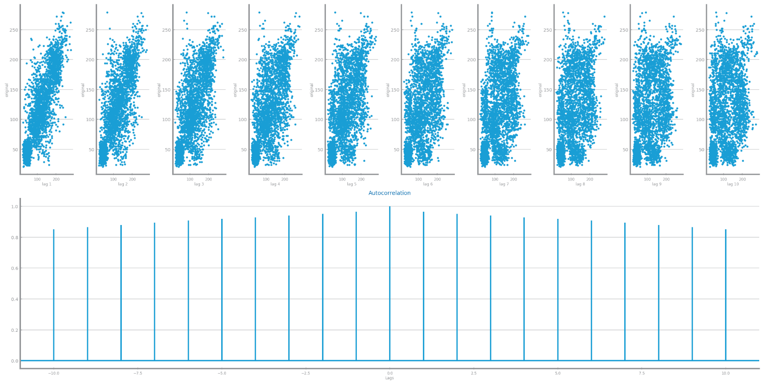
Figure 71 Autocorrelation correlogram for original time series 2

Data Stationarity
D1: Through Figure 76, there appears to be some seasonality over the crescent trend (higher death rate over the summer months). There is no stationarity, visible in Figure 77.
D2: There appears to be a cyclical seasonality shown by the trend using an hourly rate.
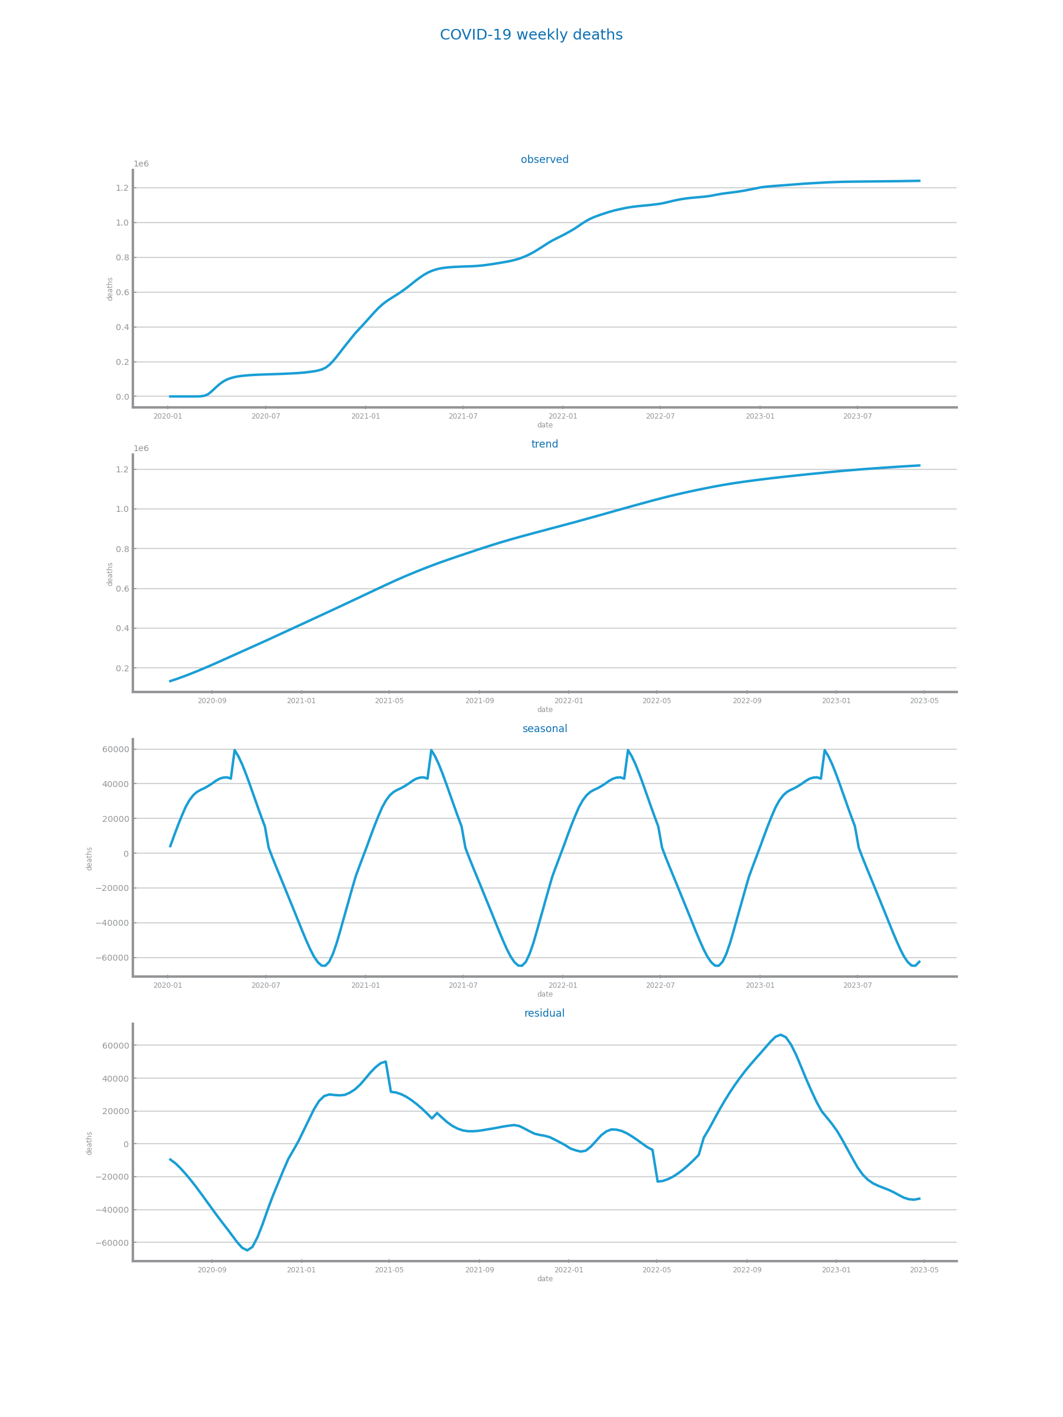
Figure 72 Components study for time series 1
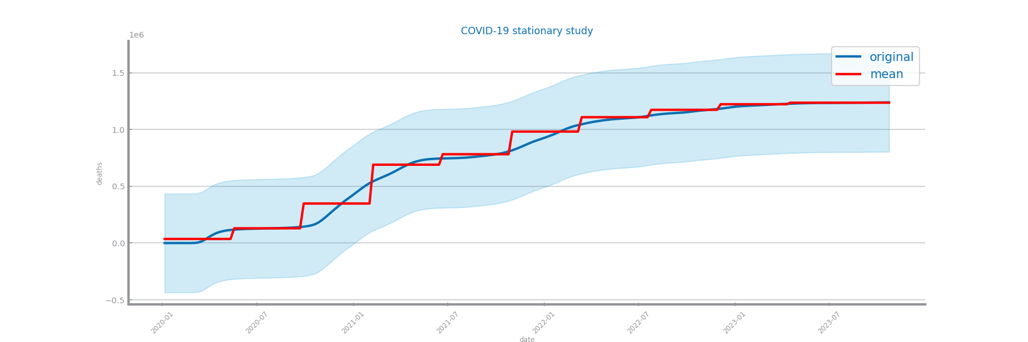
Figure 73 Stationarity study for time series 1
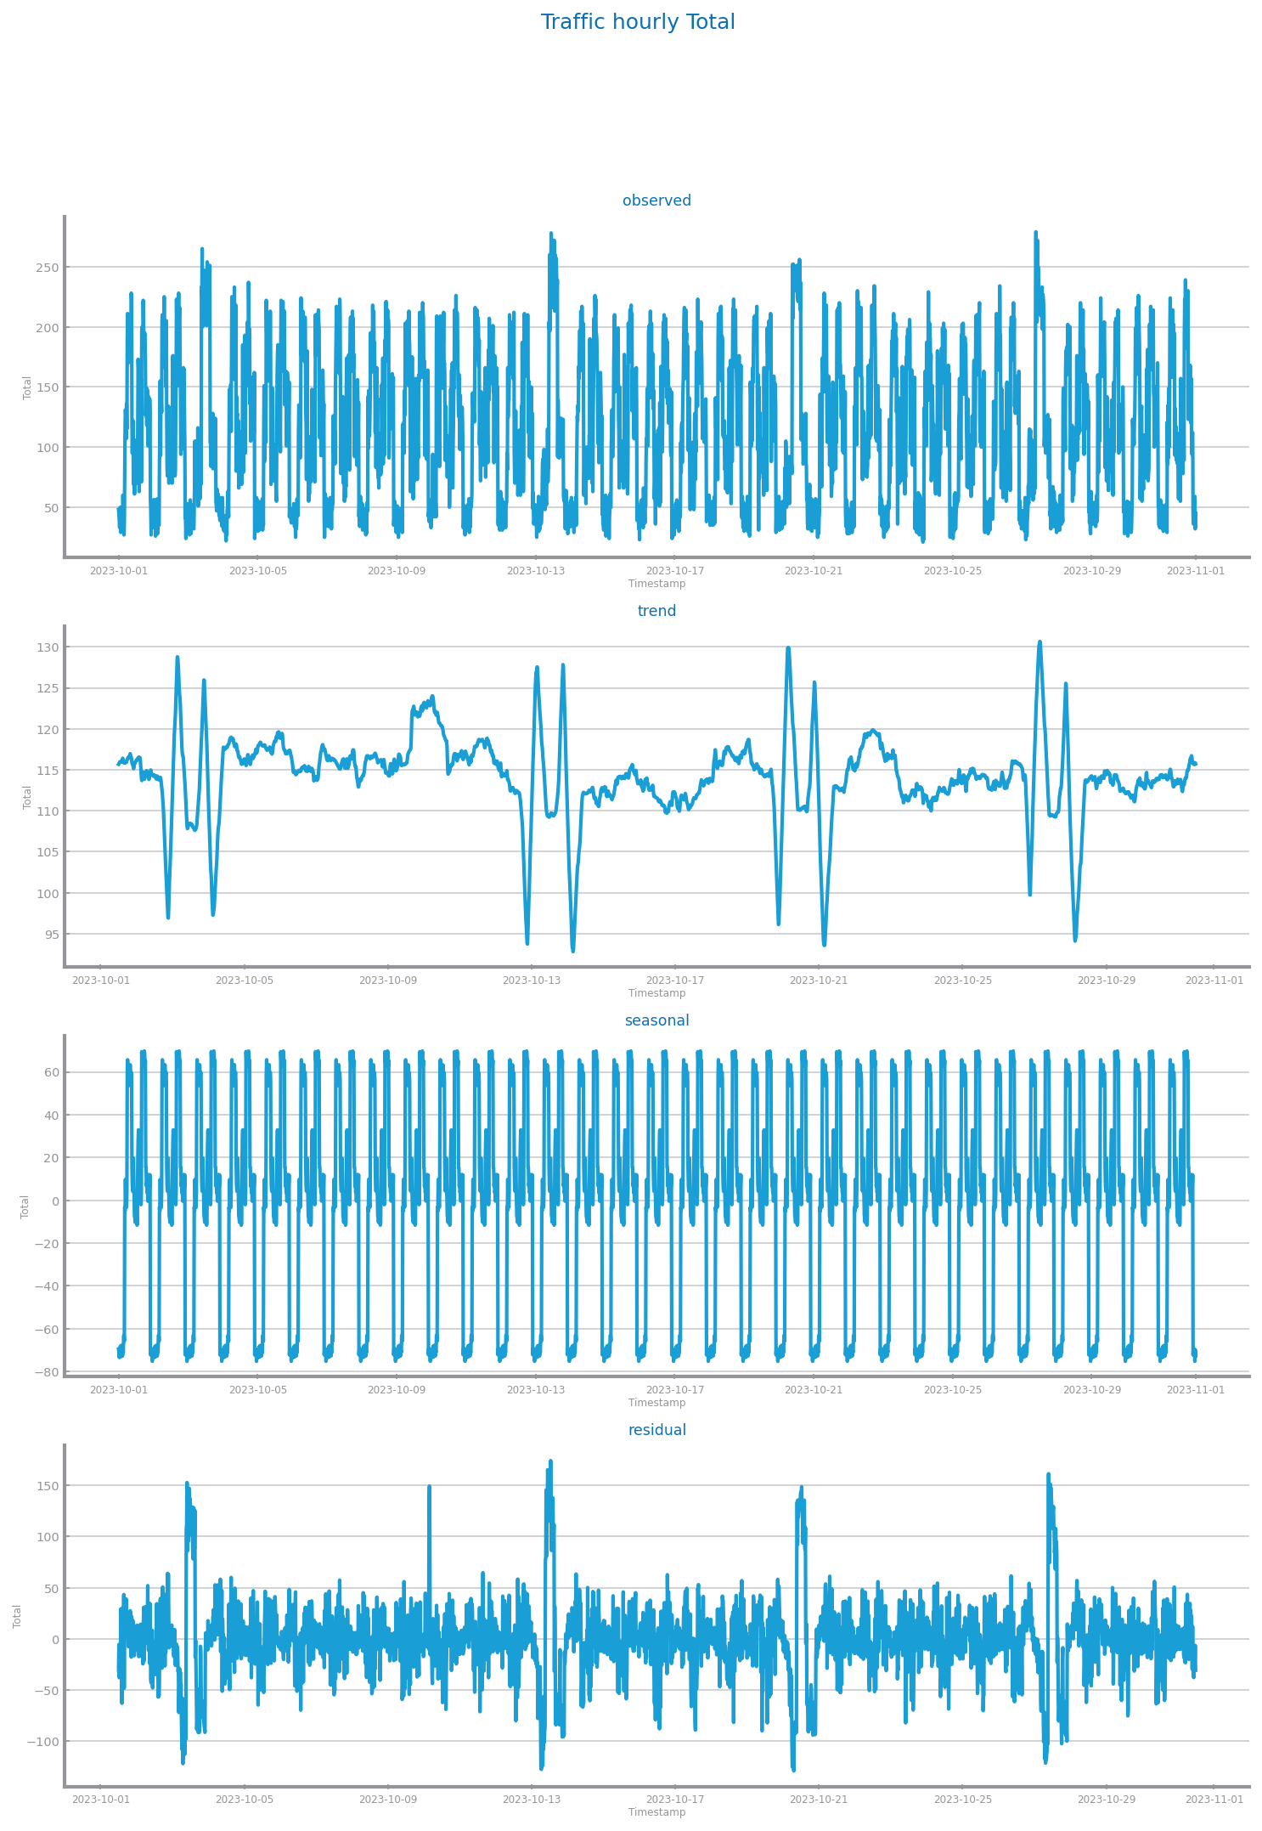
Figure 74 Components study for time series 2

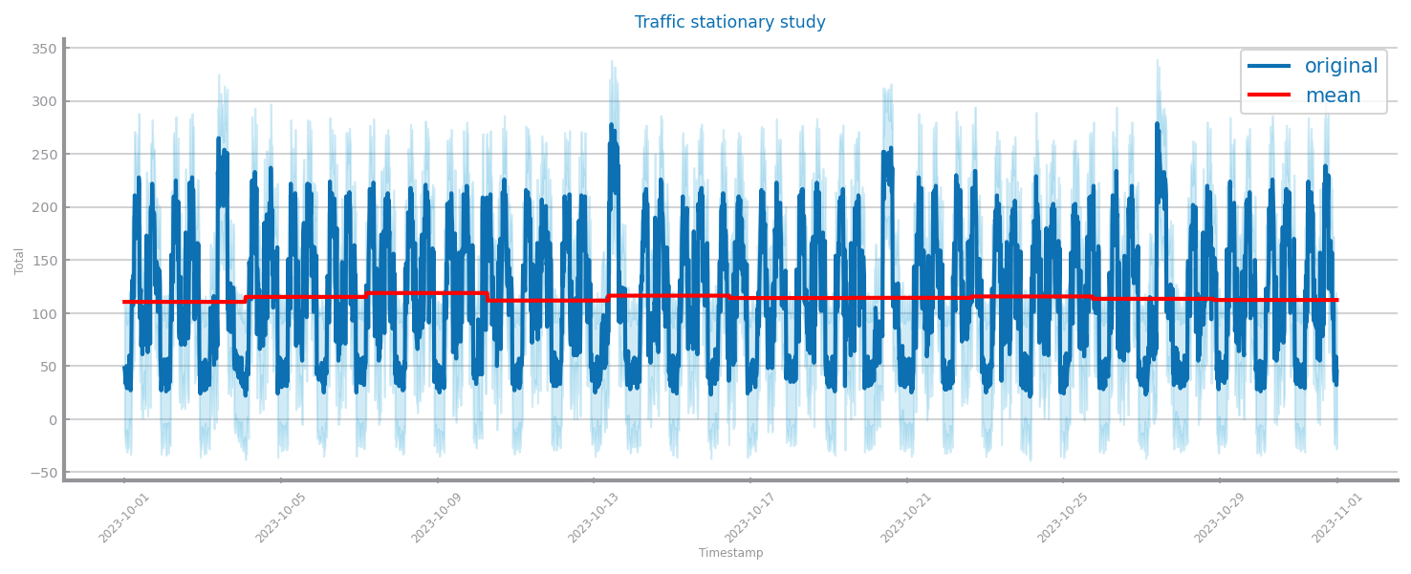
Figure 75 Stationarity study for time series 2

Data Transformation

Aggregation
D1: There appears to be no major benefit for aggregating the series. Also, with the context of the data in study, there seems to be no great reasoning to aggregate the data.
D2: The aggregation using a granularity of 15 minutes results in a better performance of the model.
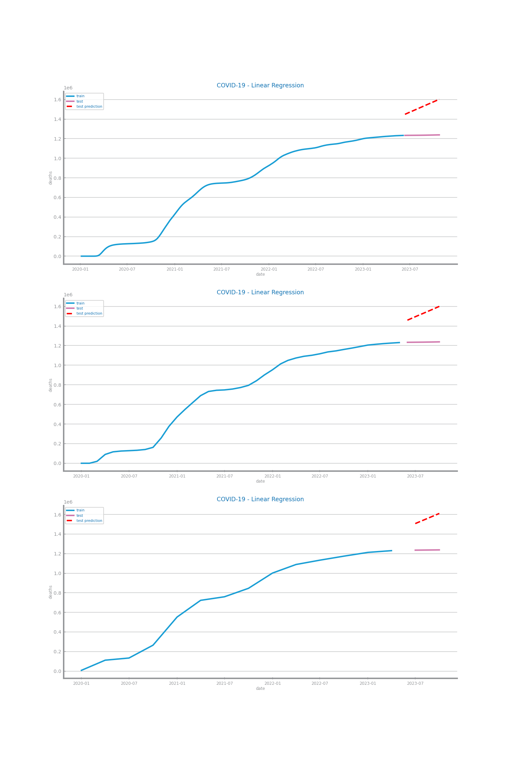
Figure 76 Forecasting plots after different aggregations on time series 1
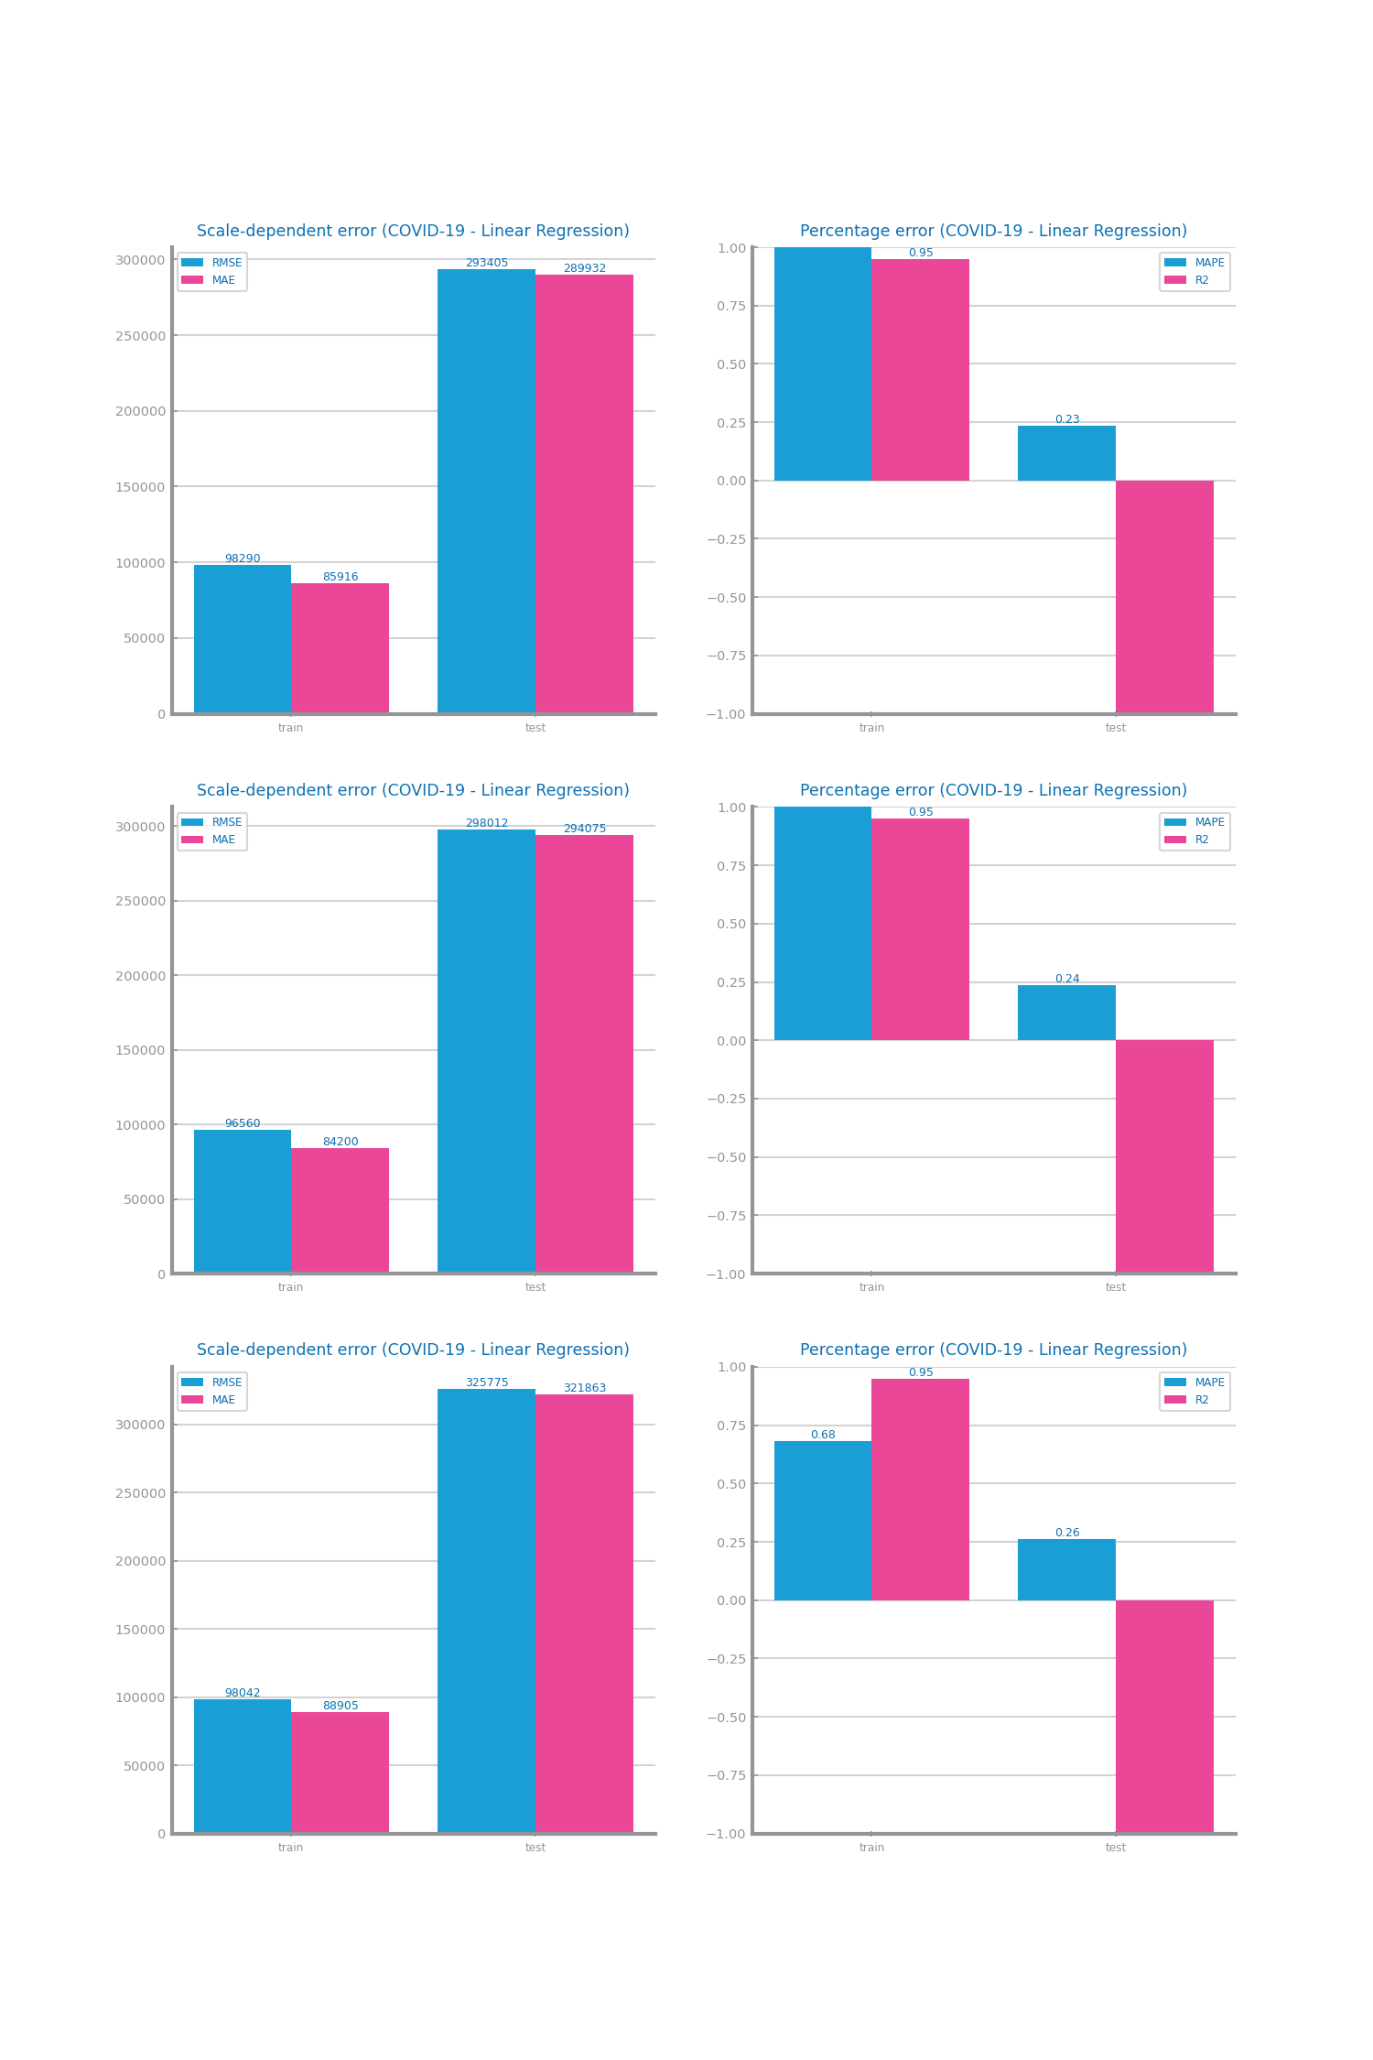
Figure 77 Forecasting results after different aggregations on time series 1

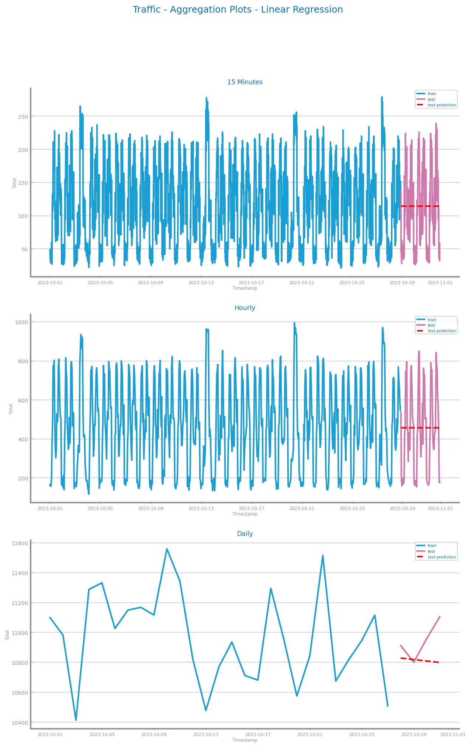
Figure 78 Forecasting plots after different aggregations on time series 2
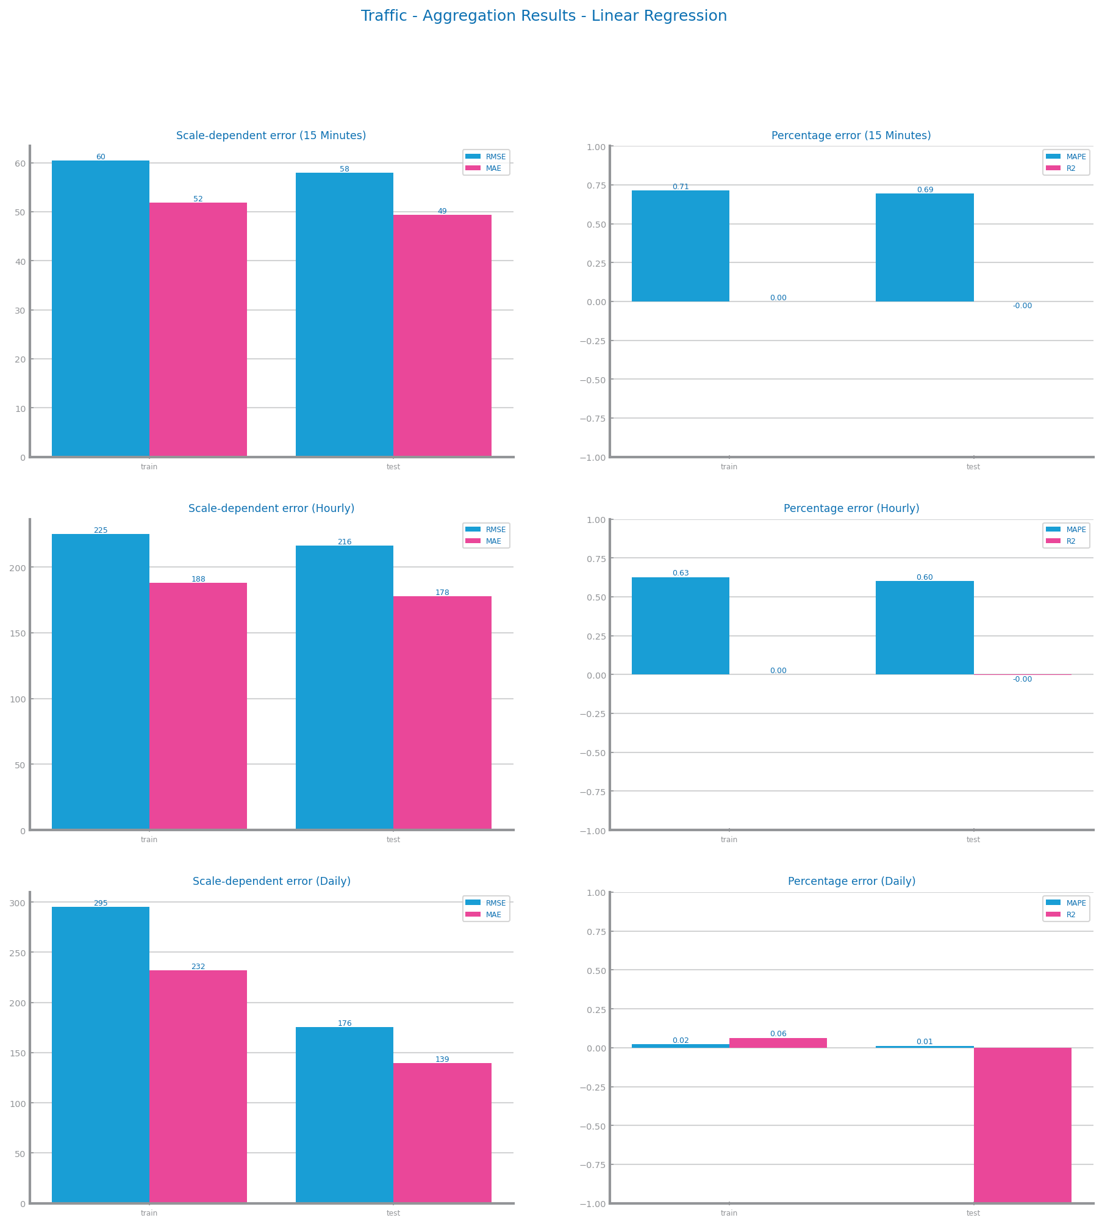
Figure 79 Forecasting results after different aggregations on time series 2

Smoothing
D1: A smoothing window of 25 was the approach that appeared to strike the best balance between preserving data information and achieving data smoothness.
D2: Using a smoothing window of 50 presents better results for the time series.
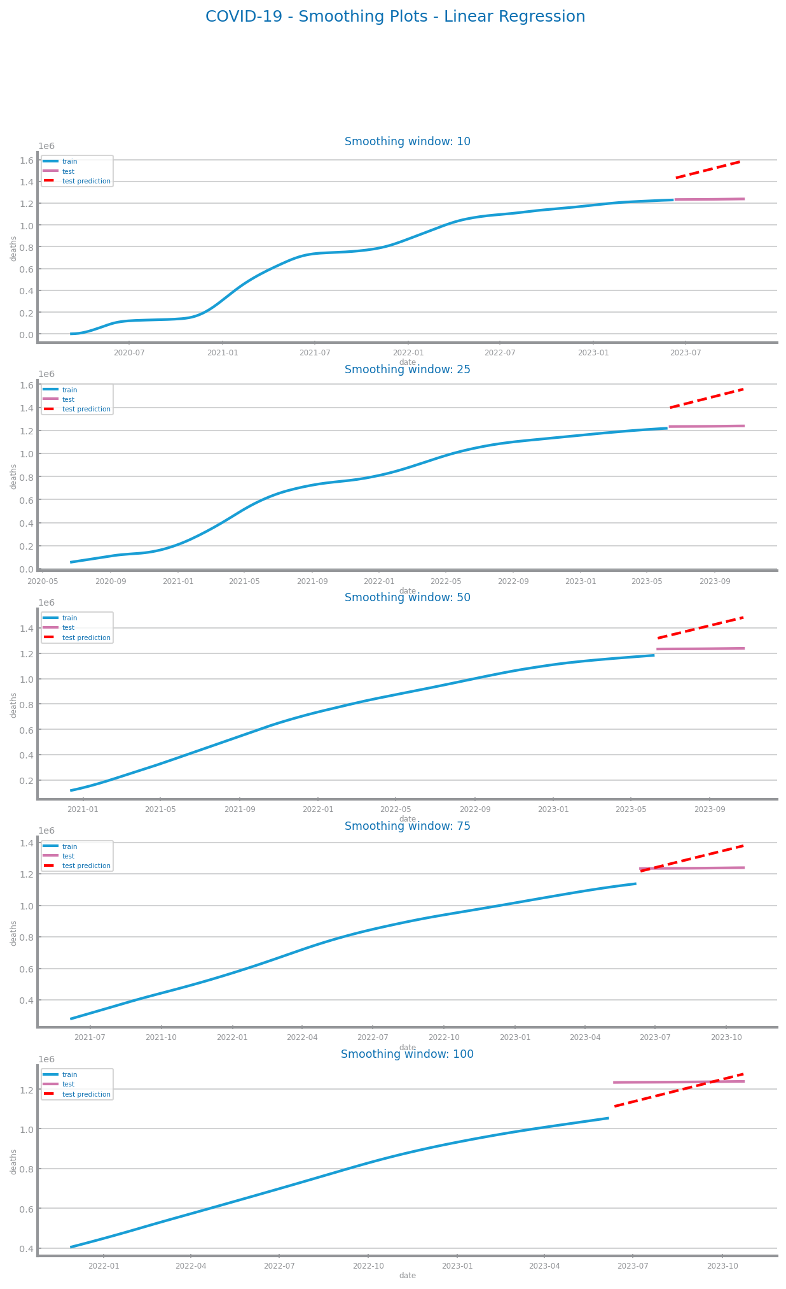
Figure 80 Forecasting plots after different smoothing parameterisations on time series 1
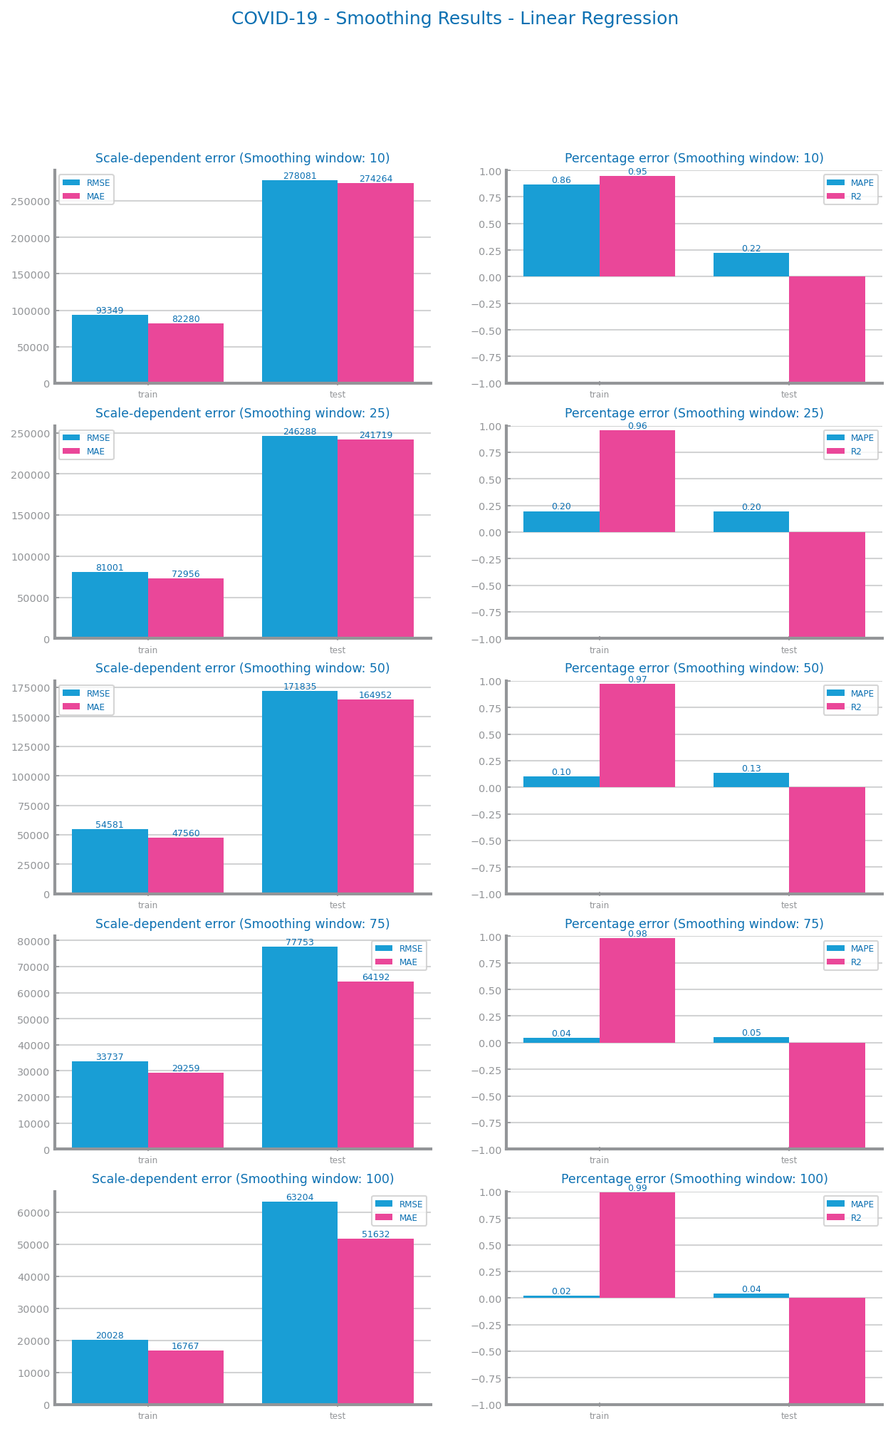
Figure 81 Forecasting results after different smoothing parameterisations on time series 1

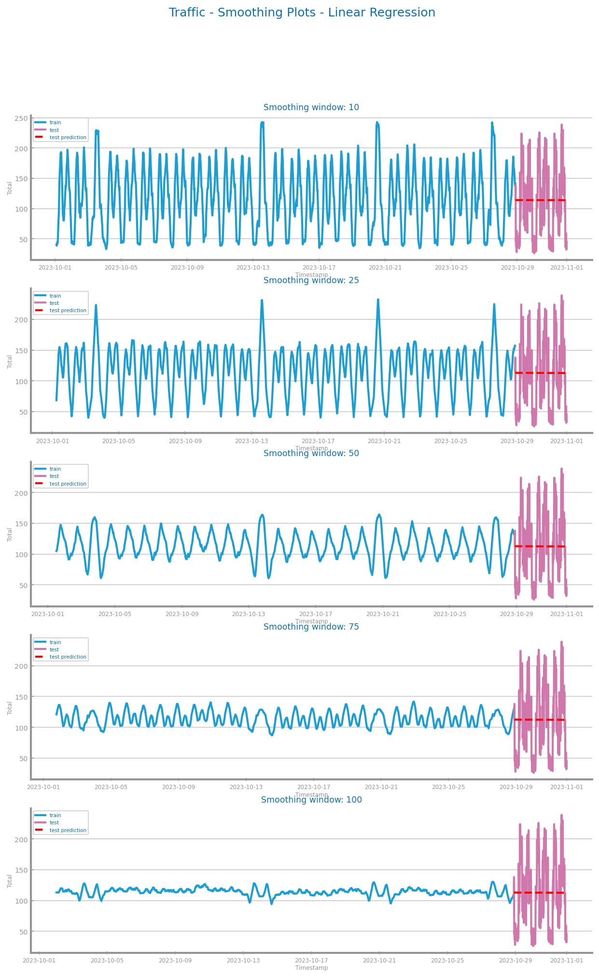
Figure 82 Forecasting plots after different smoothing parameterisations on time series 2
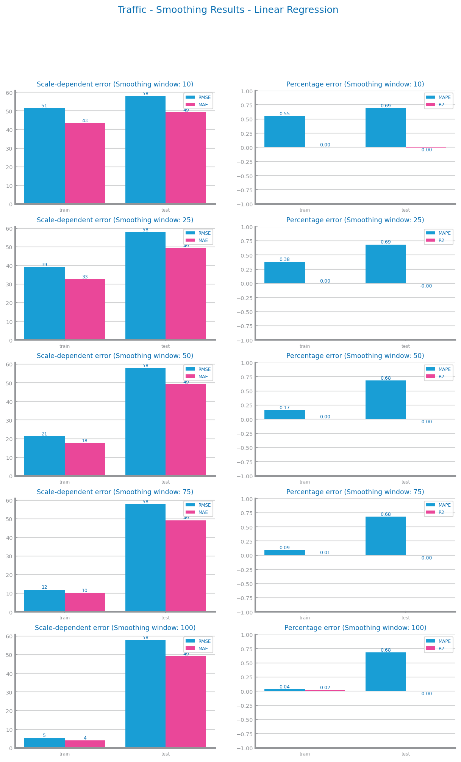
Figure 83 Forecasting results after different smoothing parameterisations on time series 2

Differentiation
D1: A differentiation level of 2 seemed to fit well with the context of the data, both with better evaluation results and because the removal of the trend for a better prediction.
D2: Applying only one differentiation to the dataset was considered the best course of action.
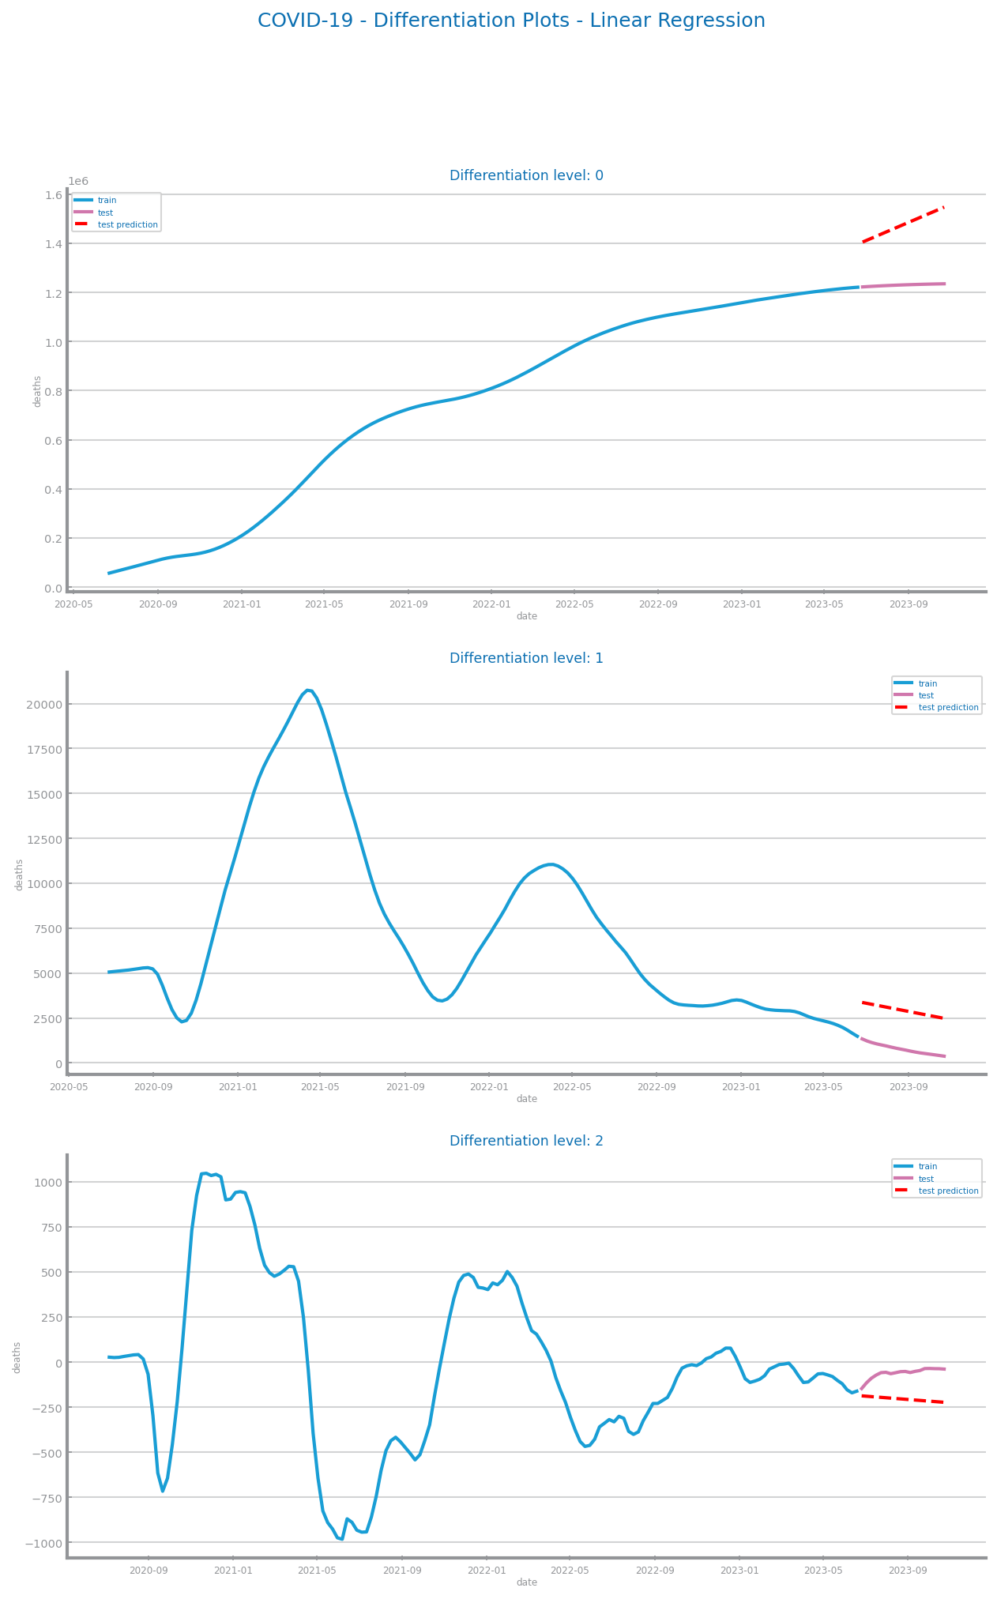
Figure 84 Forecasting plots after first and second differentiation of time series 1
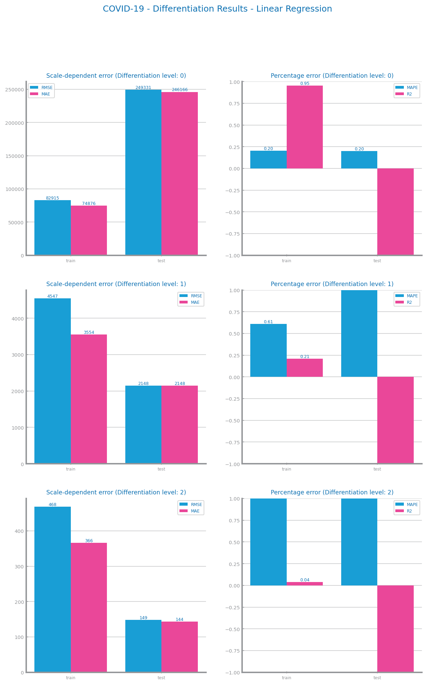
Figure 85 Forecasting results after first and second differentiation of time series 1

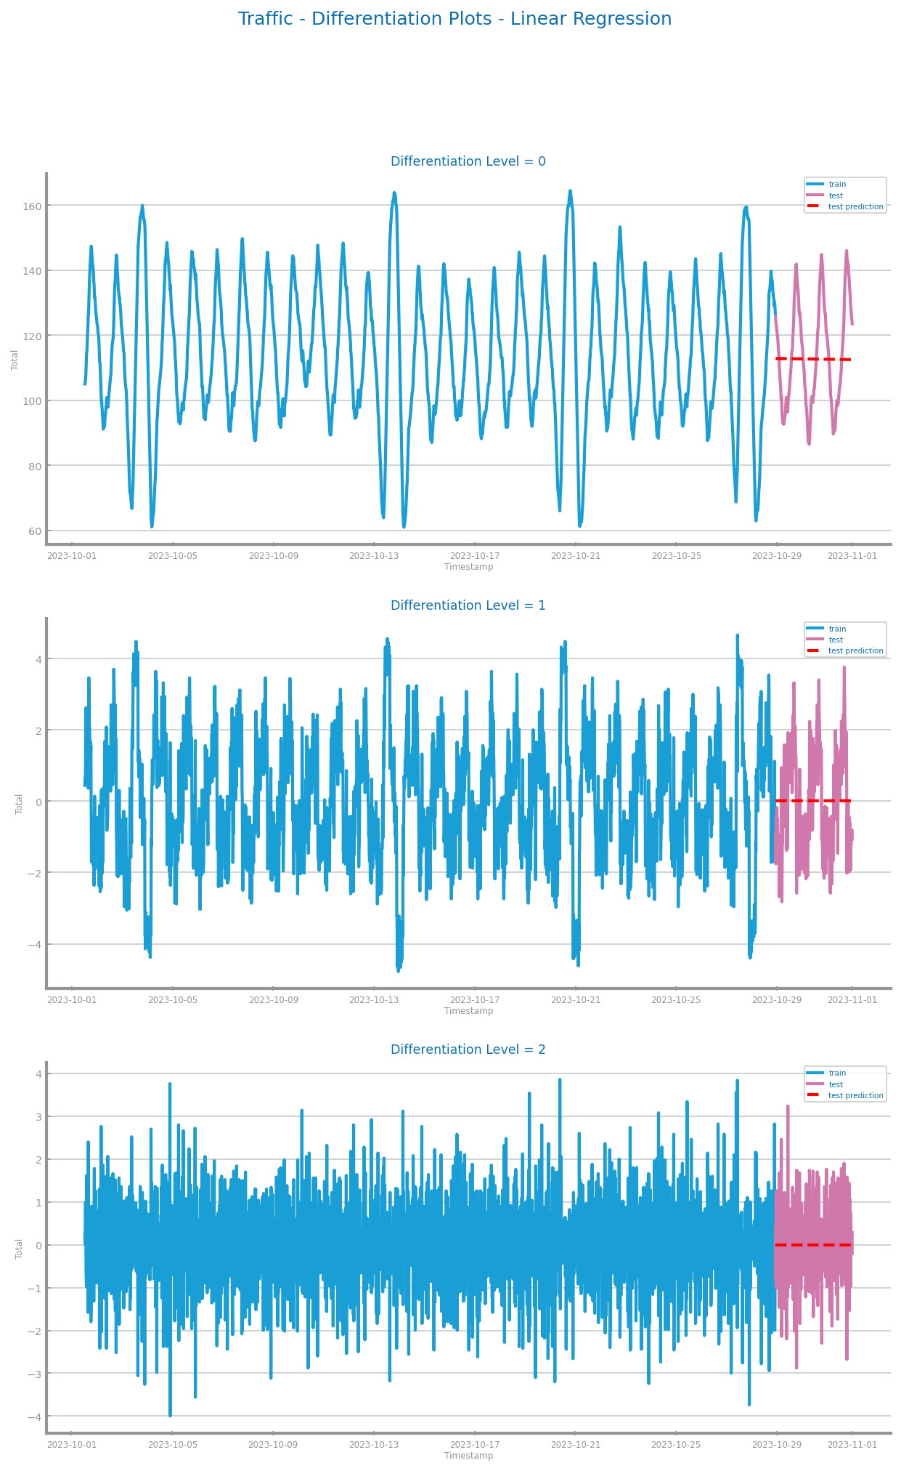
Figure 86 Forecasting plots after first and second differentiation of time series 2
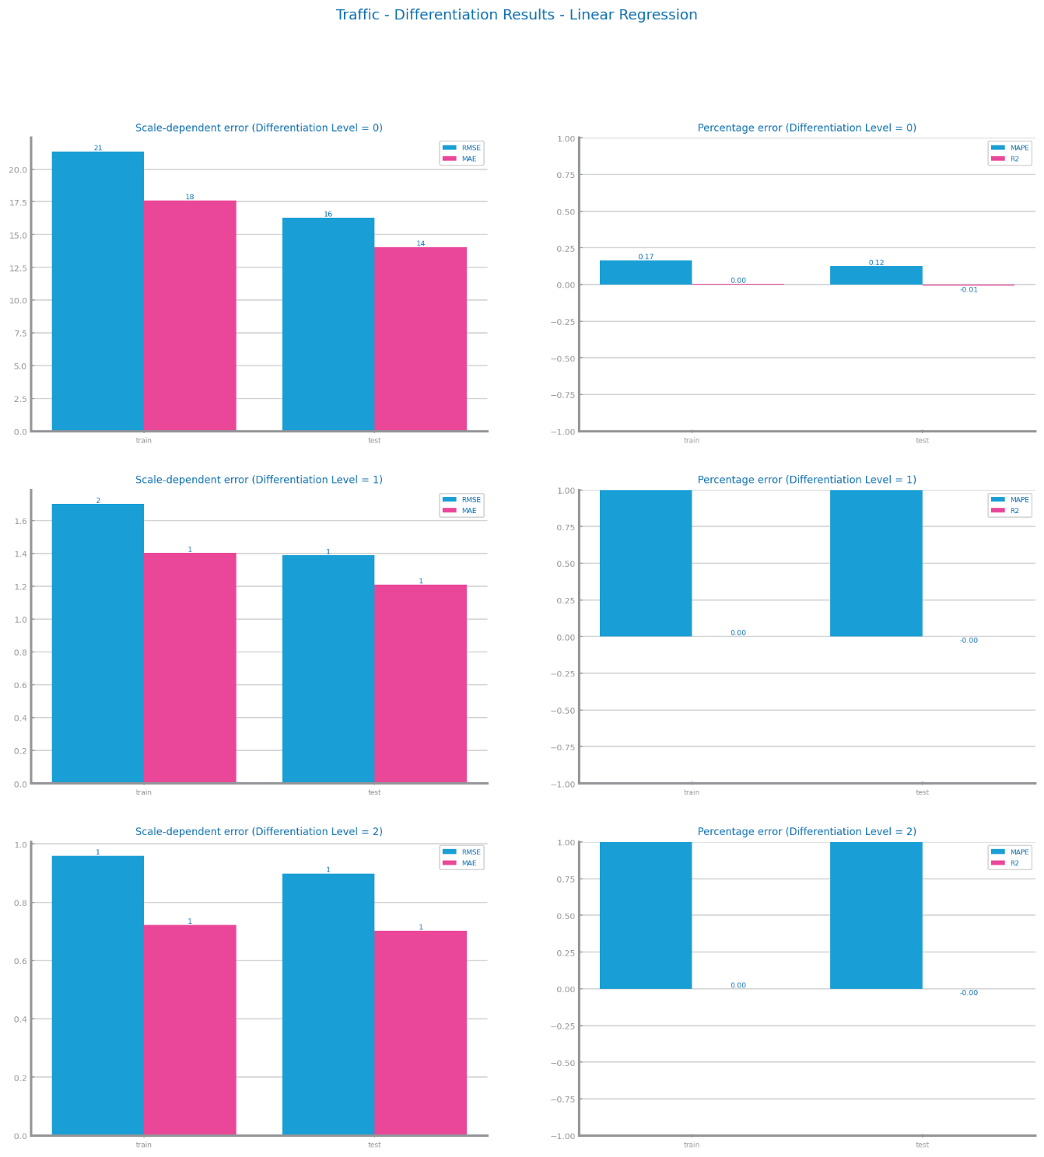
Figure 87 Forecasting results after first and second differentiation of time series 2

Other transformations (optional)
There was no benefit to applying scaling to both time series.
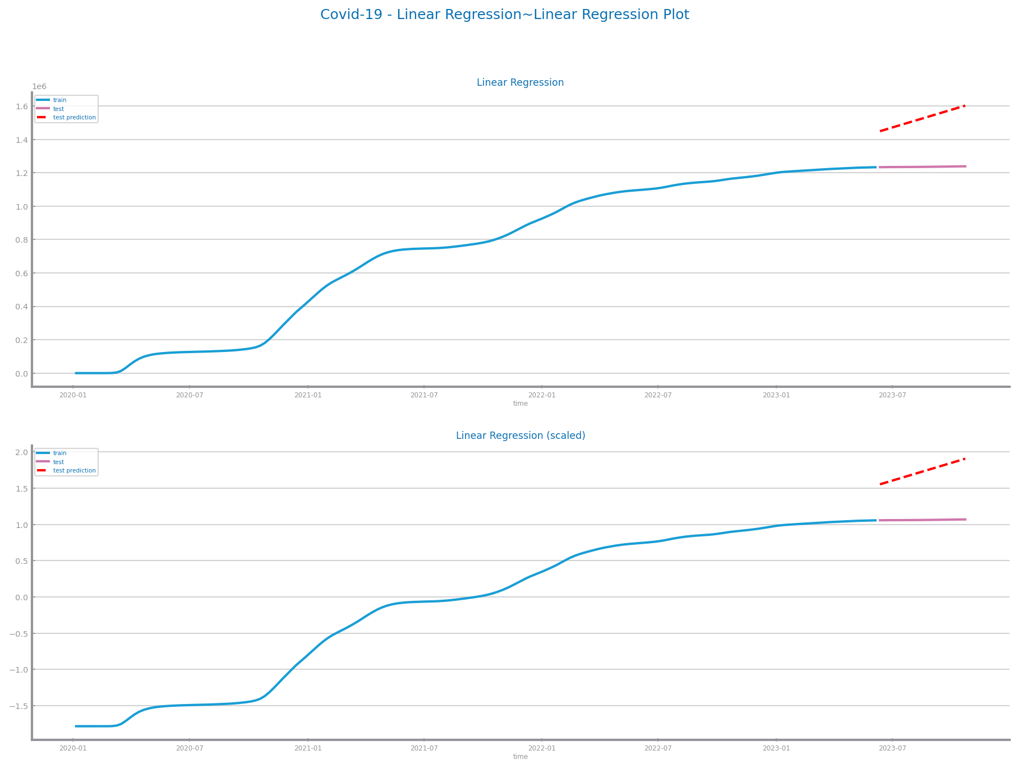
Figure 88 Forecasting plots after applying other transformations over time series 1
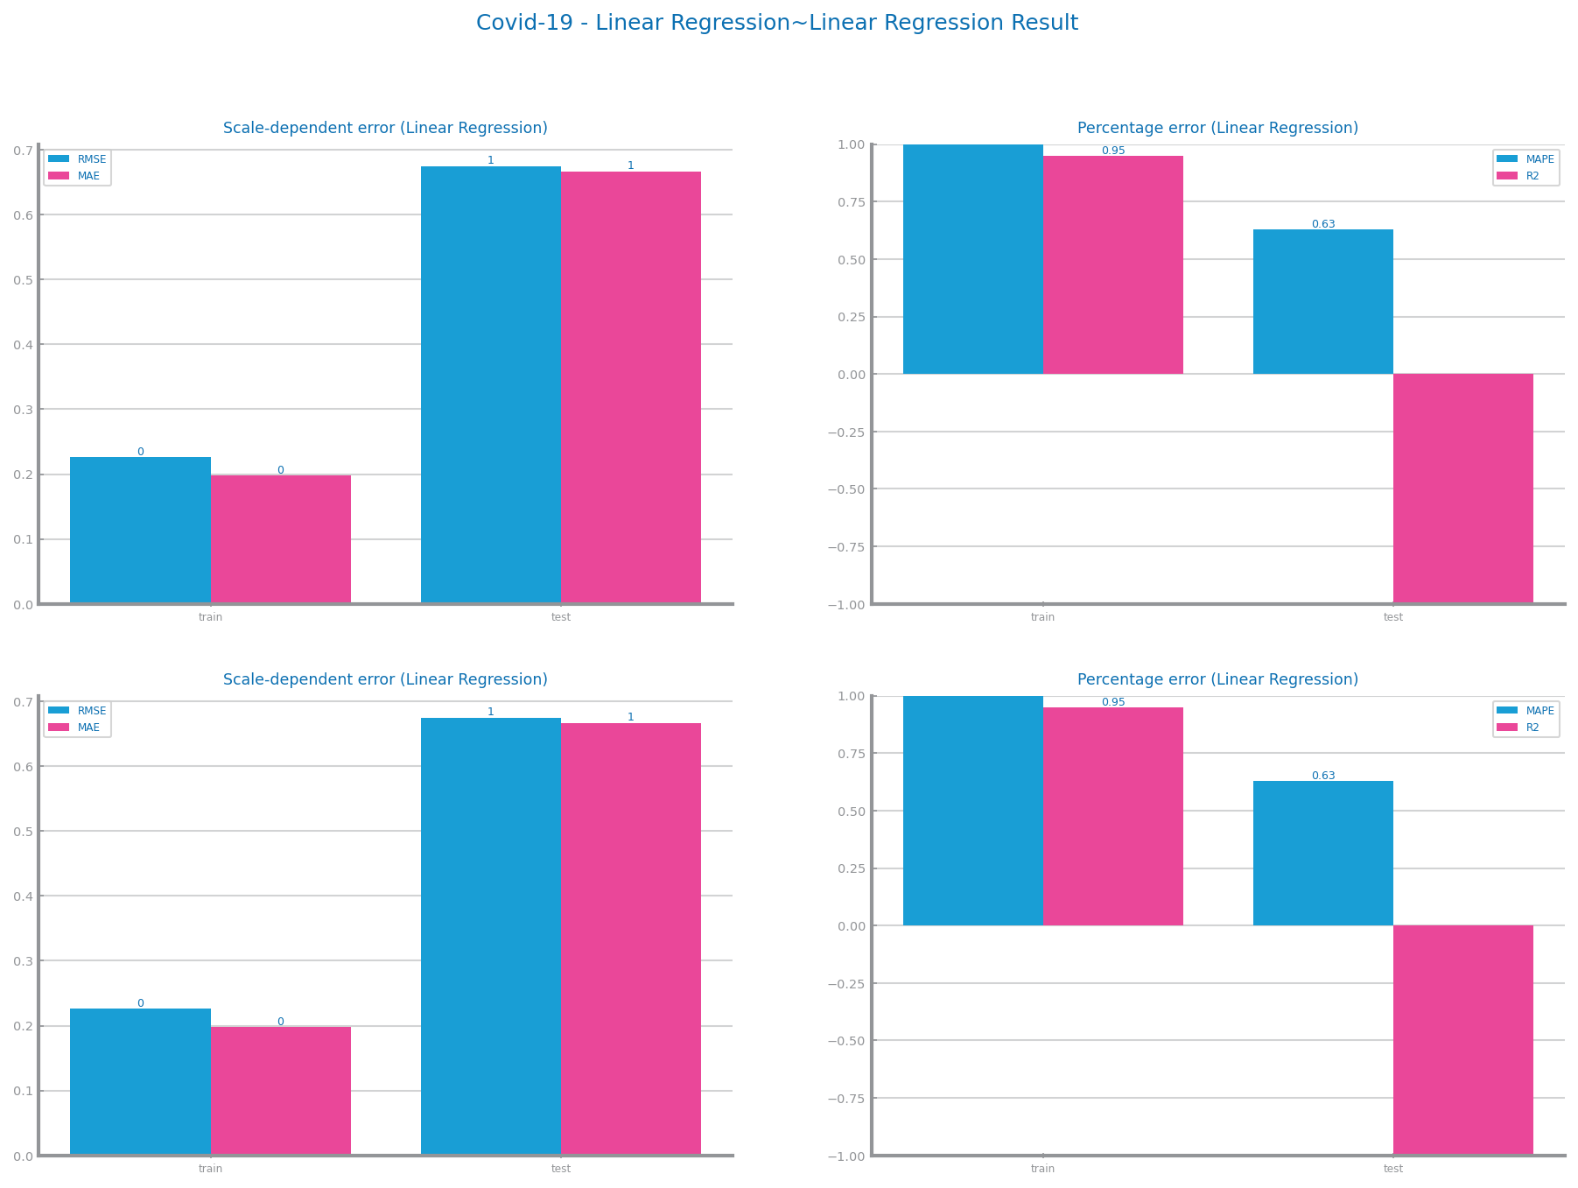
Figure 89 Forecasting results after applying other transformations over time series 1
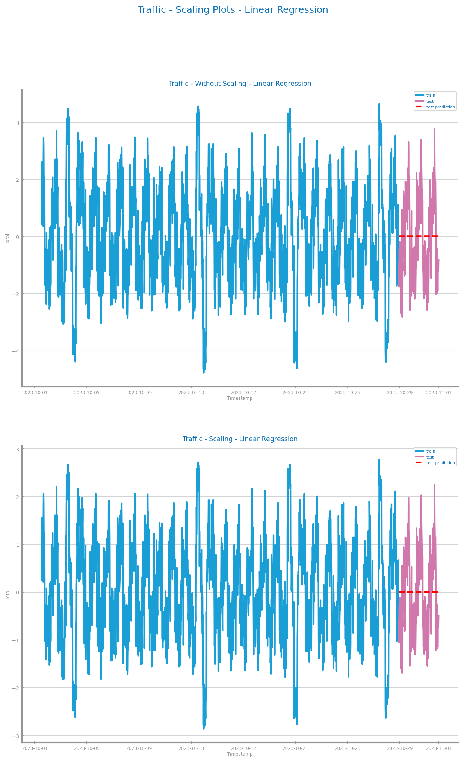

Figure 90 Forecasting plots after applying other transformations over time series 2
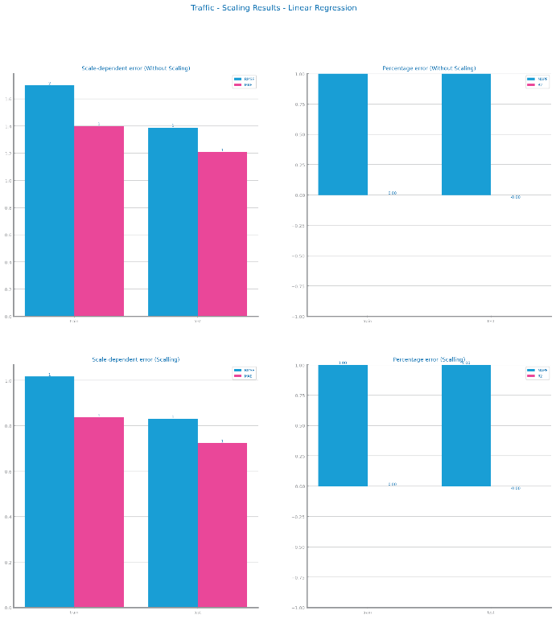
Figure 91 Forecasting results after applying other transformations over time series 2

Models’ Evaluation
Dataset 1: No Aggregation, 25 Smoothing, Second Differentiation and no Scaling.
Dataset 2: No Aggregation, 50 Smoothing, First Differentiation and no Scaling.

Simple Average Model
D1: Simple Average is accurate but not practical or realistic.
D2: Simple Average is too simple to capture the full scope to achieve worthwhile results.
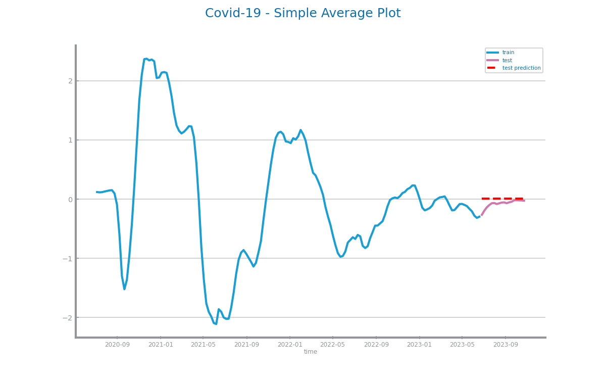
Figure 92 Forecasting plots obtained with Simple Average model over time series 1
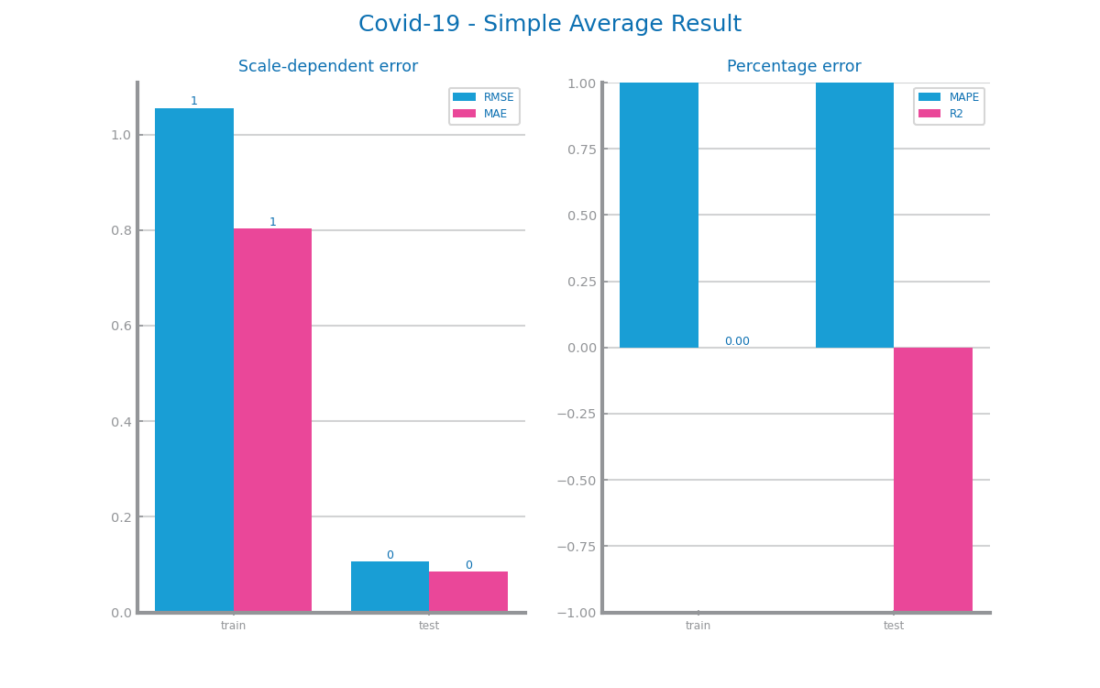
Figure 93 Forecasting results obtained with Simple Average model over time series 1
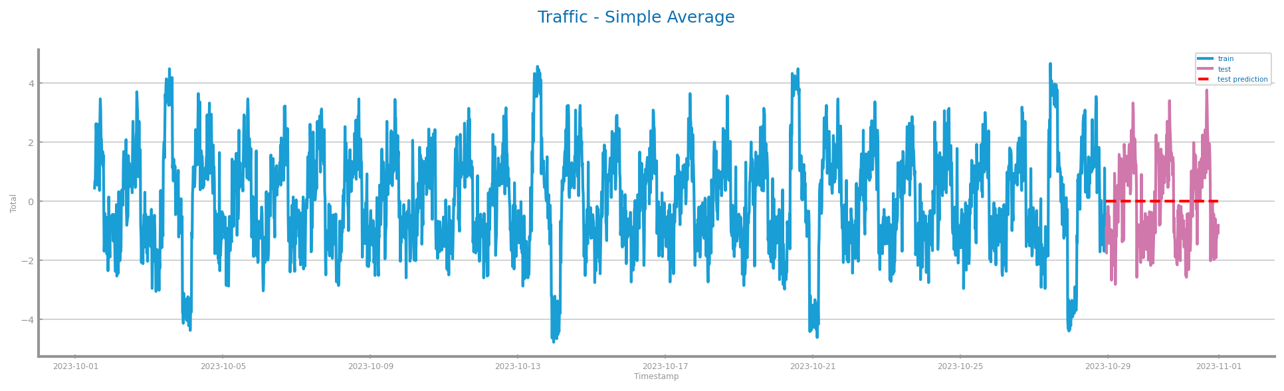
Figure 94 Forecasting plots obtained with Simple Average model over time series 2
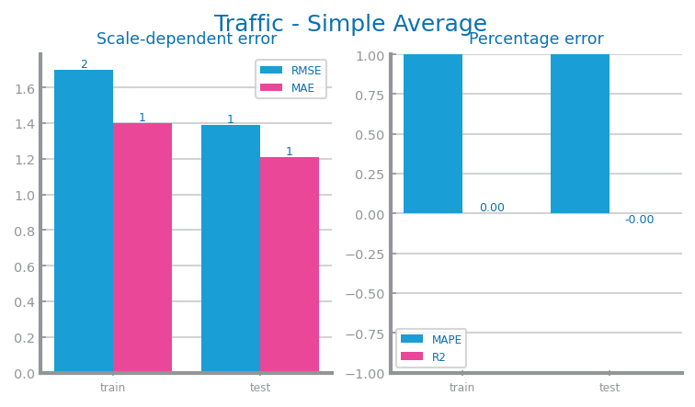
Figure 95 Forecasting results obtained with Simple Average model over time series 2

Persistence Model
D1: The results from the short-term prediction were very appealing, having 0.2 of error. In terms of long term prediction, the model gets much worse, predicting values 5 times further that the short term model.
D2: For this dataset, only the optimistic approach shows good results because, the realist approach, the one we use to compare with other models, displays double the number of errors and reaching 2 in scale dependent errors and thus not being a great model.
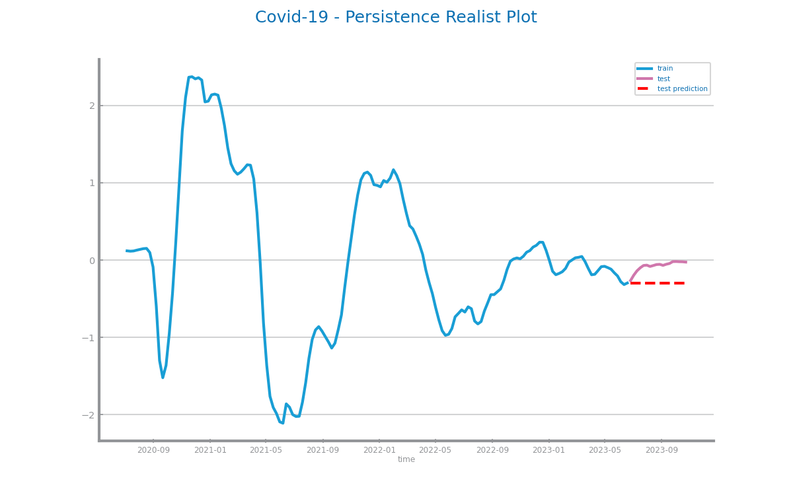
Figure 96 Forecasting plots obtained with Persistence model (long term) over time series 1
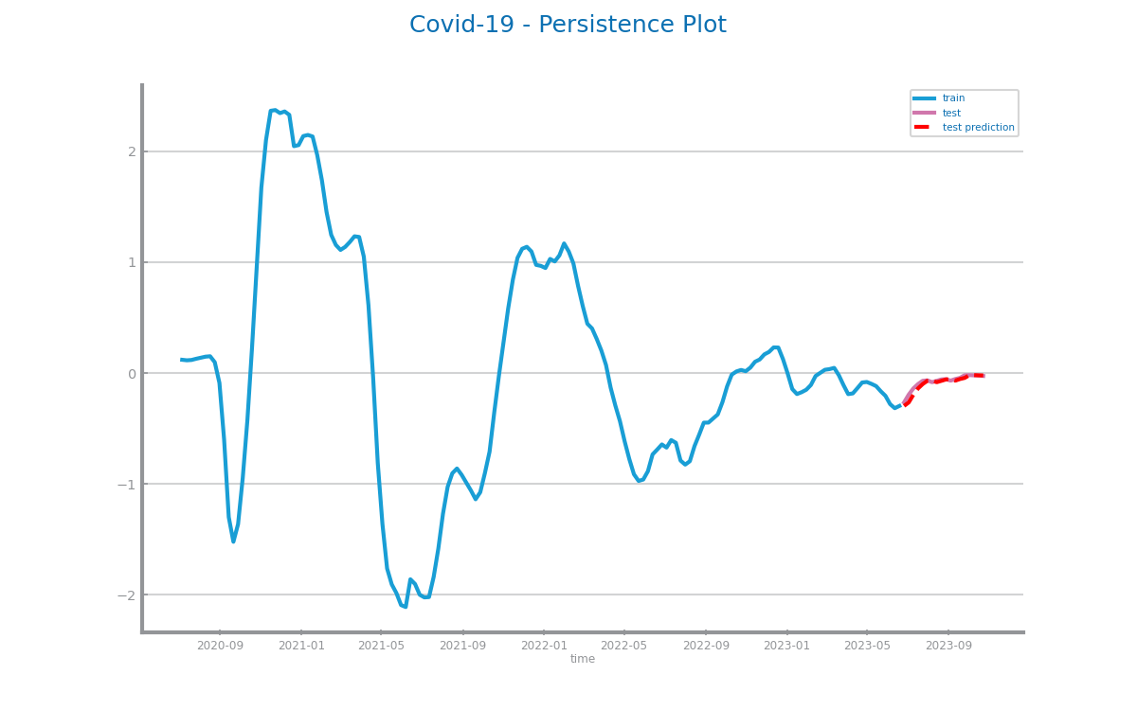
Figure 97 Forecasting plots obtained with Persistence model (next point) over time series 1
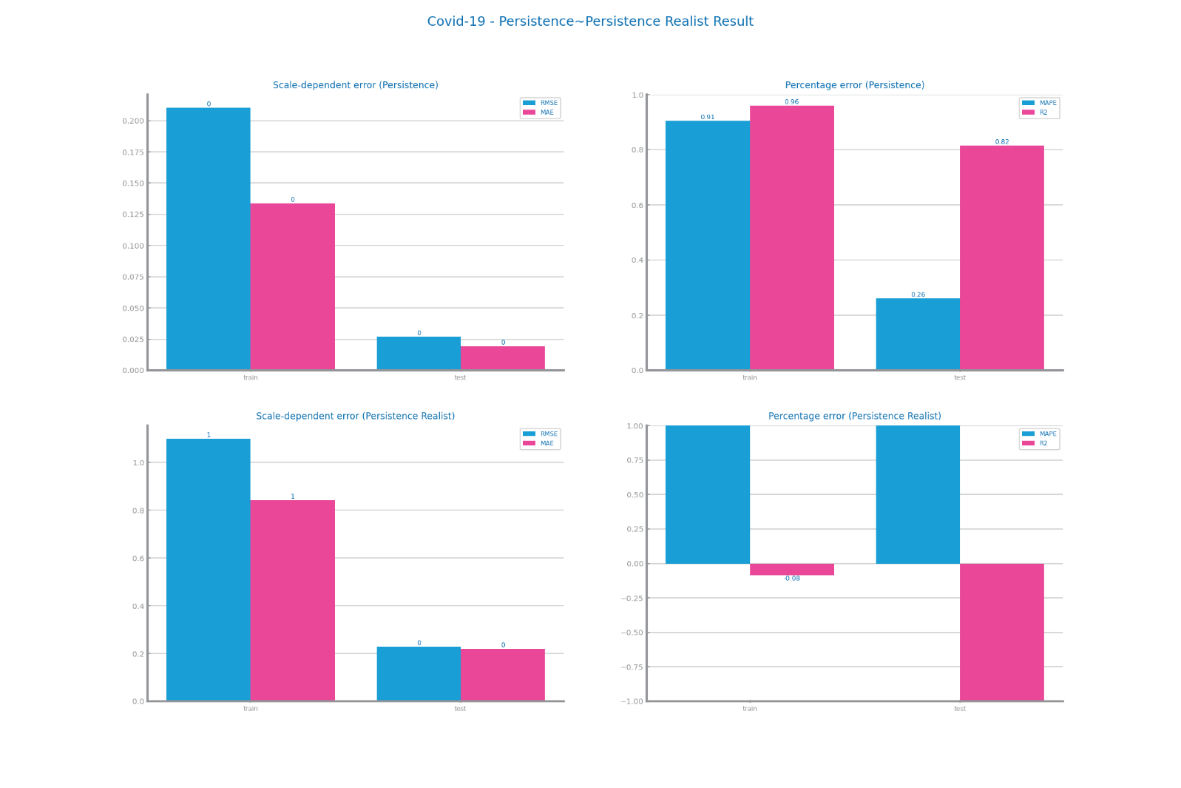
Figure 98 Forecasting results obtained with Persistence model in both situations over time series 1
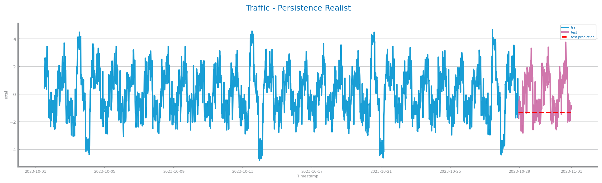
Figure 99 Forecasting plots obtained with Persistence model (long term) over time series 2
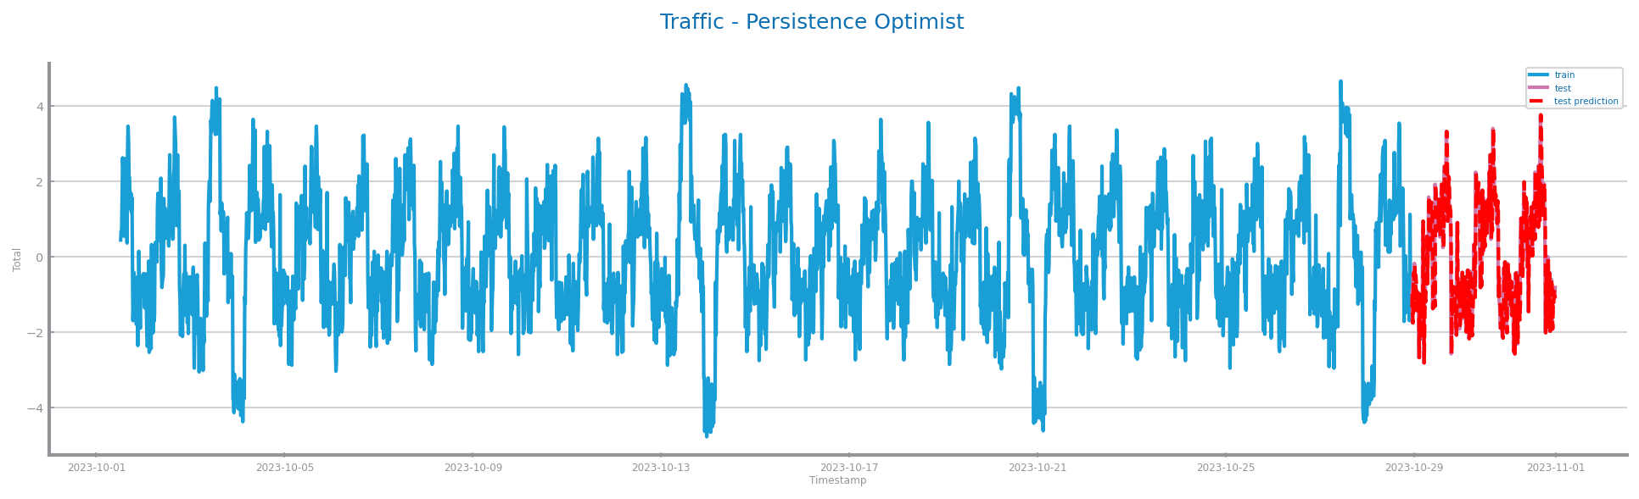
Figure 100 Forecasting plots obtained with Persistence model (next point) over time series 2
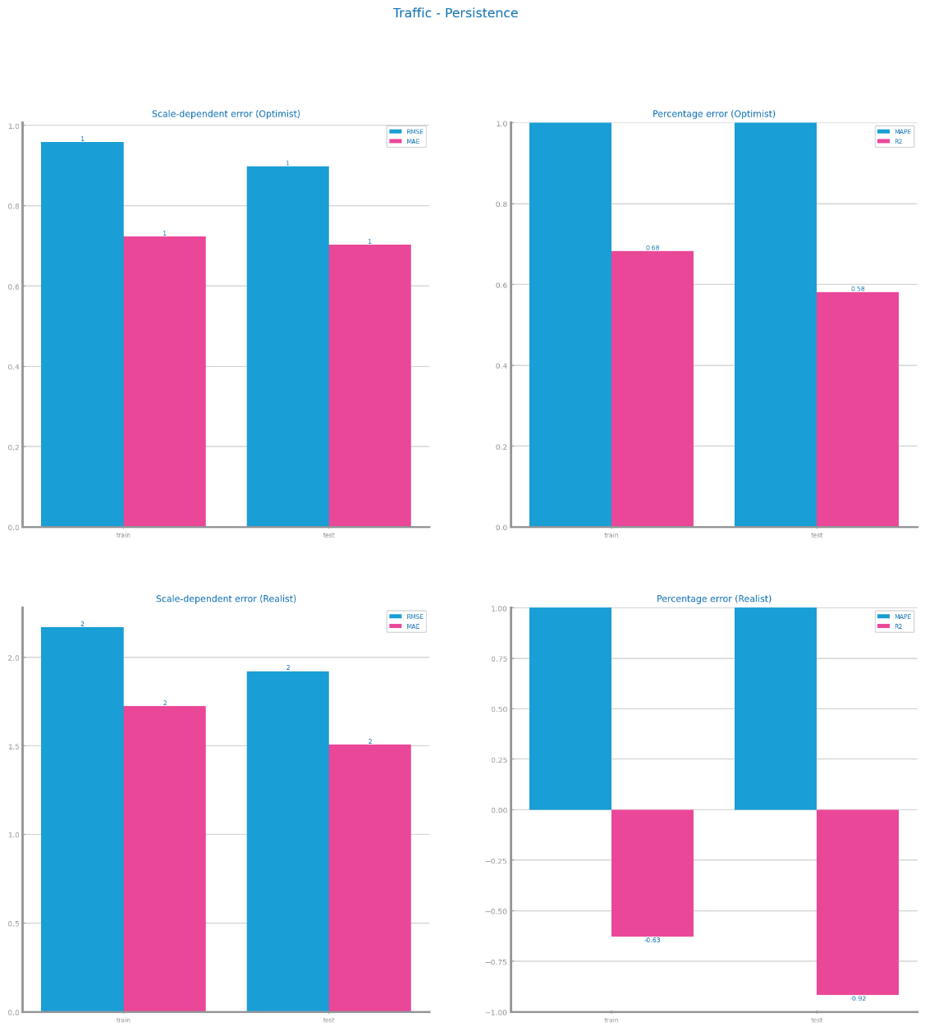
Figure 101 Forecasting results obtained with Persistence model in both situation over time series 2

Rolling Mean Model
D1: The use of differentiation left the model without one of its main strengths of forgetting old information, being effective on series with trends and the inexistence of spikes appears to have helped massively the model. The evaluation results were acceptable.
D2: We achieve an optimal window size of 768. The model is good at capturing the seasonal trend but it wasn´t able to capture certain sudden changes for a complex time series like this, leaving us with decent but not the best results.
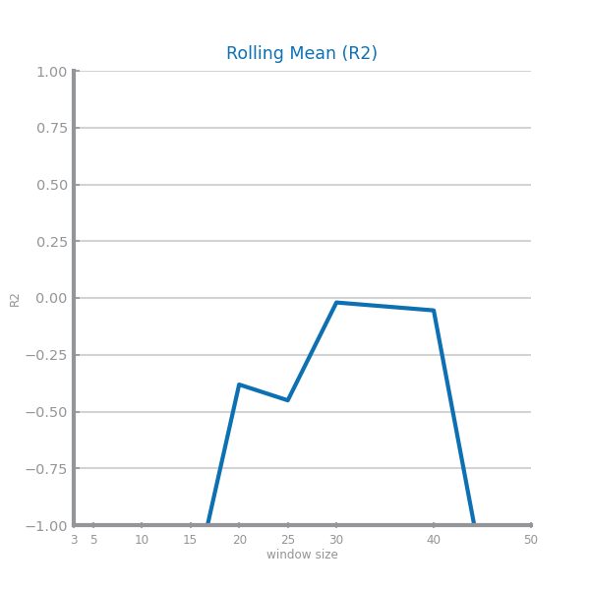
Figure 102 Forecasting study over different parameterisations of the rolling mean algorithm over time series 1
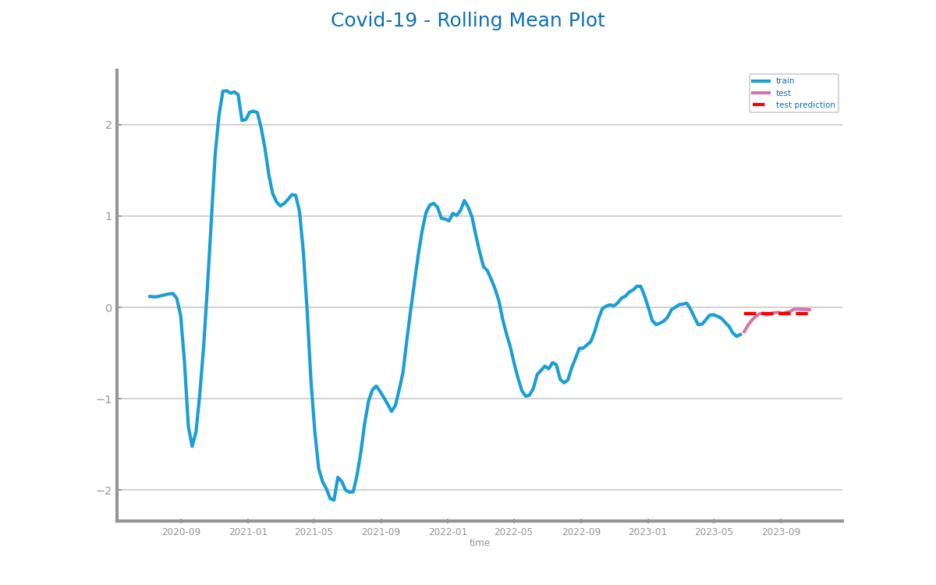
Figure 103 Forecasting plots obtained with the best parameterisation of rolling mean algorithm, over time series 1
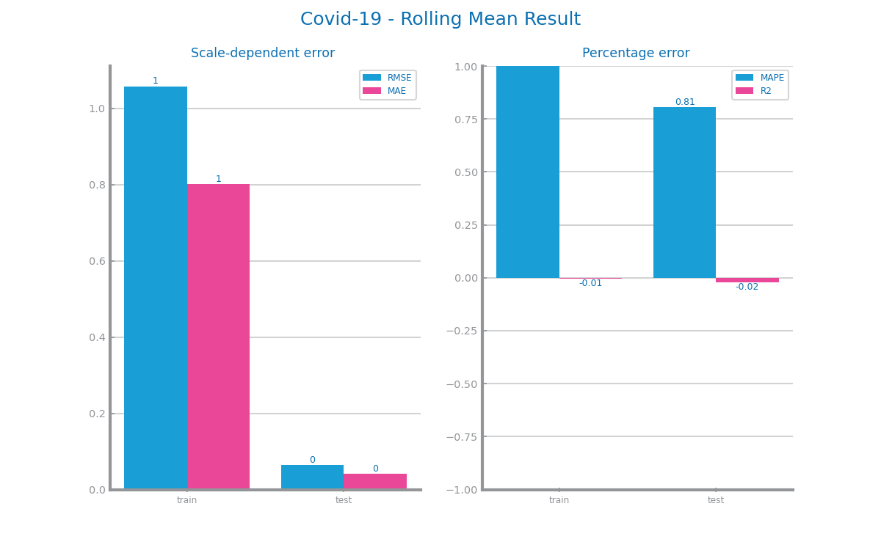
Figure 104 Forecasting results obtained with the best parameterisation of rolling mean algorithm, over time series 1
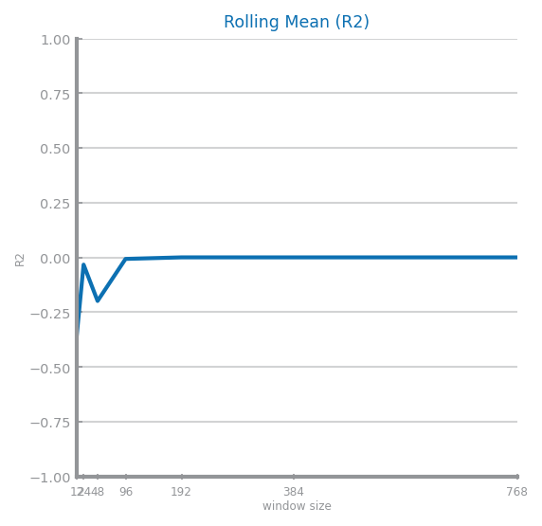
Figure 105 Forecasting study over different parameterisations of the rolling mean algorithm over time series 2
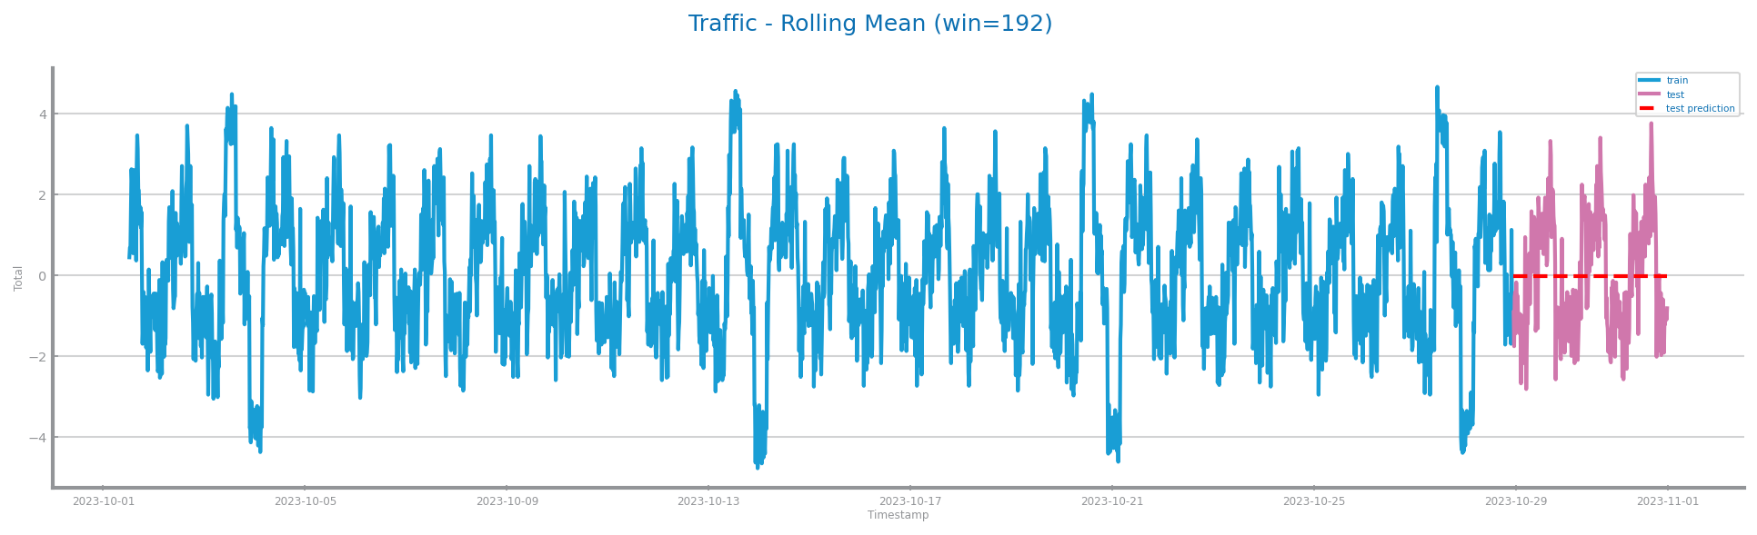
Figure 106 Forecasting plots obtained with the best parameterisation of rolling mean algorithm, over time series 2
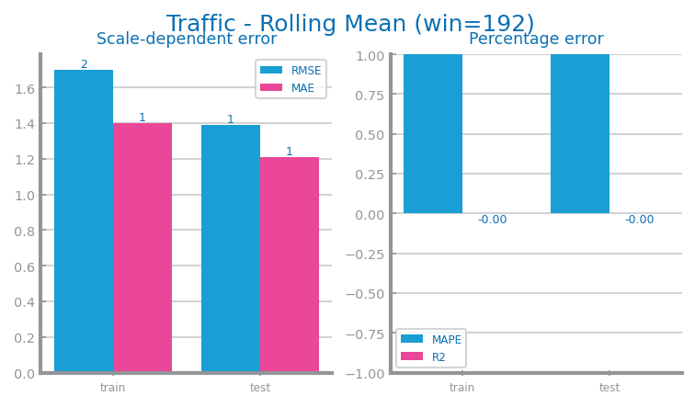
Figure 107 Forecasting results obtained with the best parameterisation of rolling mean algorithm, over time series 2

ARIMA Model
D1: The ARIMA parameters study appeared to be somewhat erratic, but either way the evaluation results represents an accurate model on this series.
D2: For this dataset, d = 1 and 2 show awful results and thus obviously choosing d = 0. Furthermore, we choose p = 3 and q = 7 since it shows the best results for our measure. This is a good model since our scale dependent errors and less than 1.
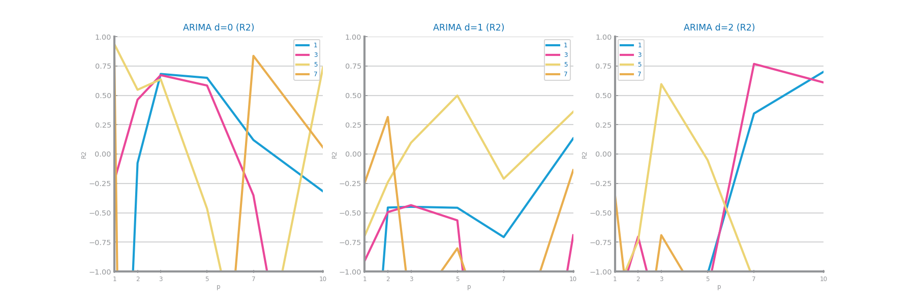
Figure 108 Forecasting study over different parameterisations of the ARIMA algorithm over time series 1
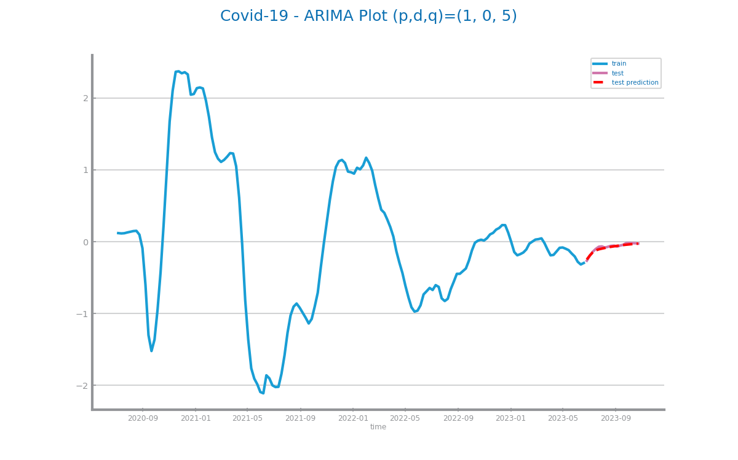
Figure 109 Forecasting plots obtained with the best parameterisation of ARIMA algorithm, over time series 1
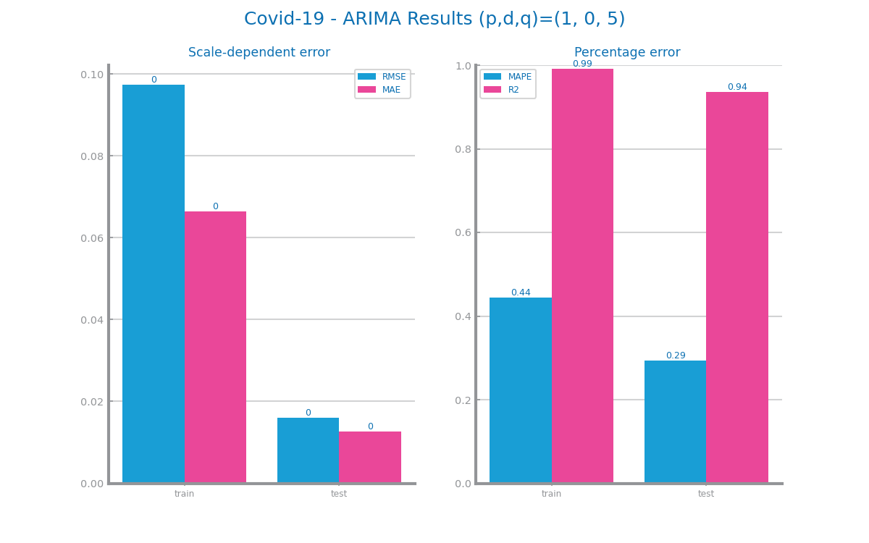
Figure 110 Forecasting results obtained with the best parameterisation of ARIMA algorithm, over time series 1
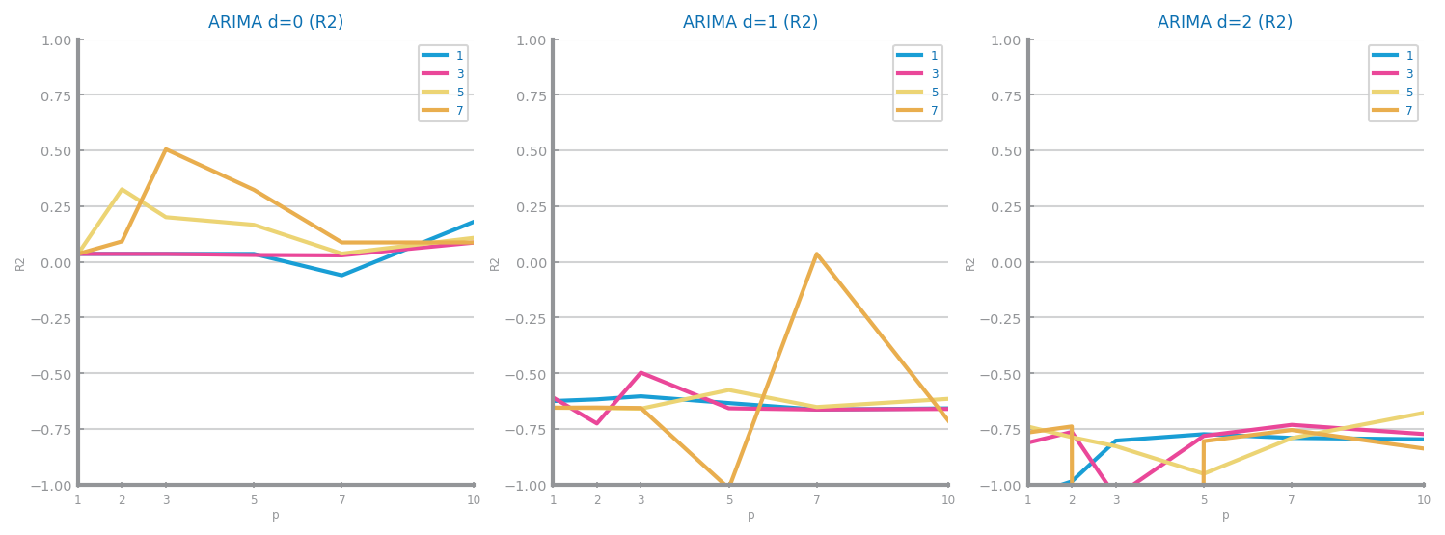
Figure 111 Forecasting study over different parameterisations of the ARIMA algorithm over time series 2
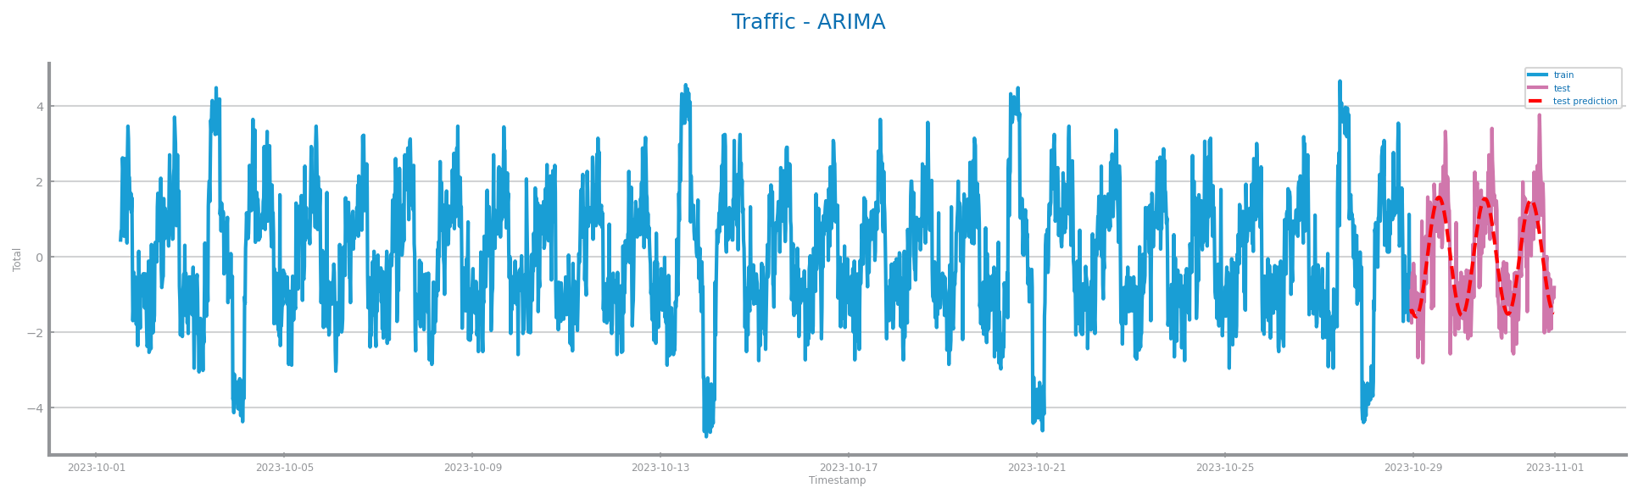
Figure 112 Forecasting plots obtained with the best parameterisation of ARIMA algorithm, over time series 2
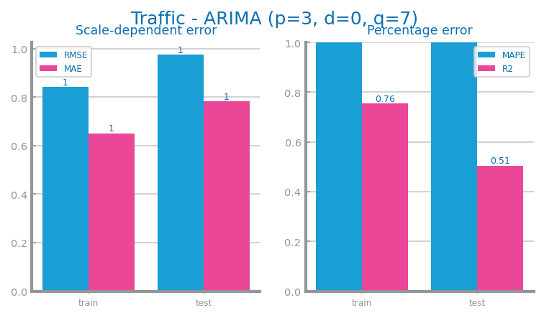
Figure 113 Forecasting results obtained with the best parameterisation of ARIMA algorithm, over time series 2

LSTMs Model
D1: There is a clear preference for lower sequence lengths and hidden units. The results ended up being like ARIMA’s.
D2: All results for the different lengths are similar but we get better results for our measure for length = 4 with hidden = 25 and epochs = 2100. For these values, the scale dependent error reaches around 0.8 and thus having good results and being a good model.
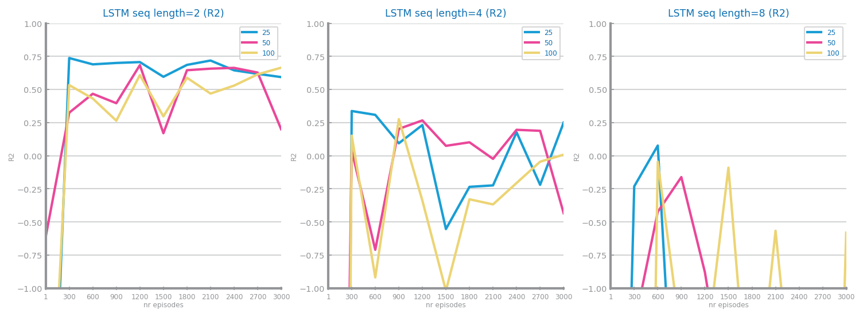
Figure 114 Forecasting study over different parameterisations of LSTMs over time series 1
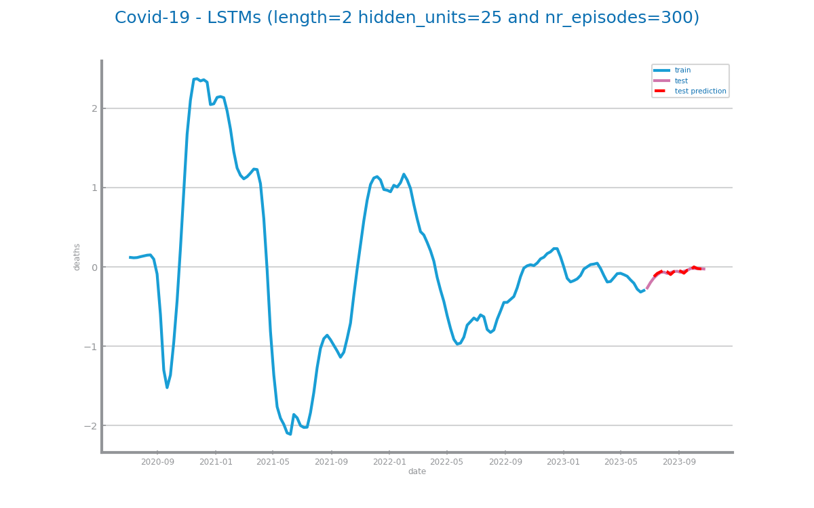
Figure 115 Forecasting plots obtained with the best parameterisation of LSTMs, over time series 1
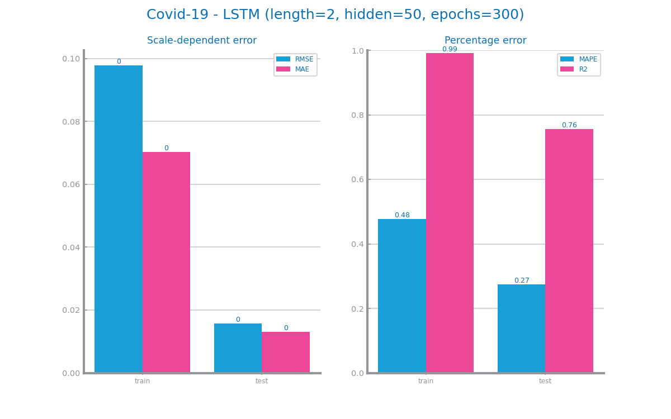
Figure 116 Forecasting results obtained with the best parameterisation of LSTMs, over time series 1
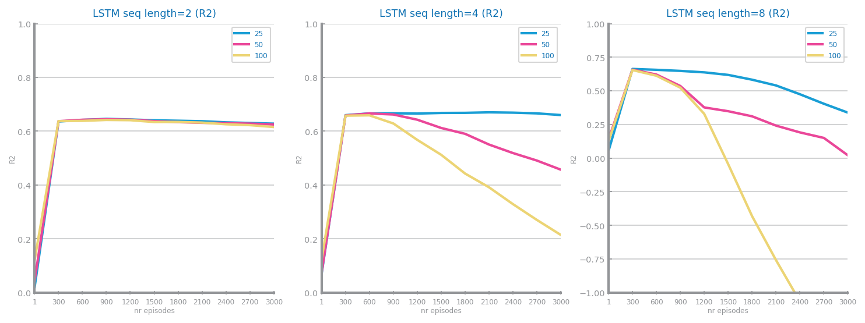
Figure 117 Forecasting study over different parameterisations of the LSTMs over time series 2
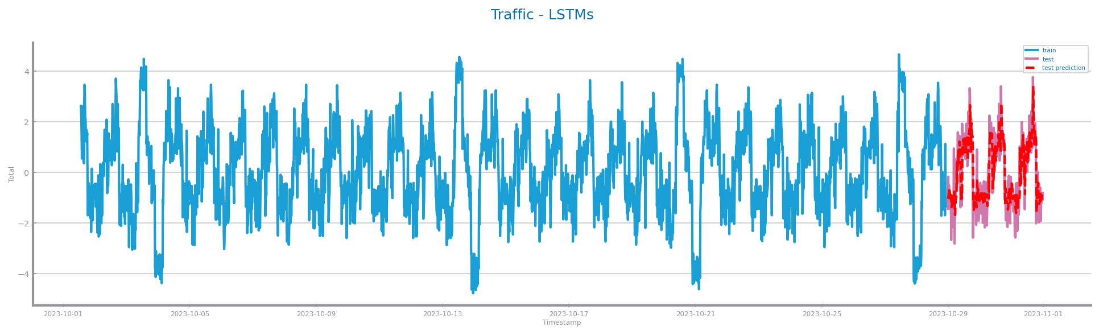
Figure 118 Forecasting plots obtained with the best parameterisation of LSTMs, over time series 2
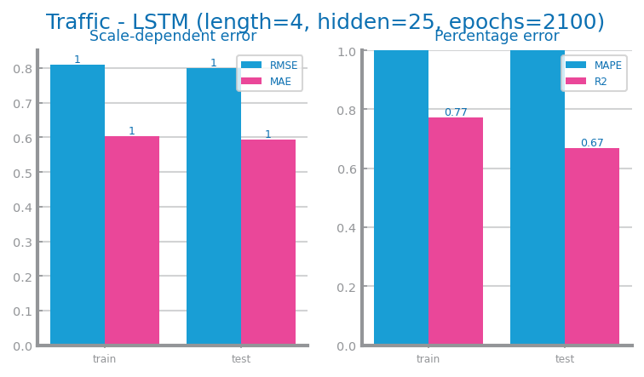
Figure 119 Forecasting results obtained with the best parameterisation of LSTMs, over time series 2

Critical Analysis
D1: Due to its smooth and trendy shape, there was little to worse change when aggregating and smoothing the series. Also, the dataset presented a close ratio between seasonality and randomness/residual component (i.e. in the same order of magnitude) leading it to be somewhat dependent on the differentiation.
From a top-down view, all models have their strongness’s and weaknesses, but the one that showed the best fit for the context in study was the Persistence Model, due to its versatility to make next point predictions as well a great long-term prediction. There is also an honourable mention to the Rolling Mean Model that could do a better job that the Persistence at long term predictions.
D2: After doing the data profiling step we can reach the conclusions that 15 minutes will be our best granularity and that this series is stationary. On average, all models are at least decent for our dataset but with clear stand outs, with these being LSTM and Persistence but for opposite reasons. The Persistence model stands out by being the worst model for our dataset and that could be because our data has complex patterns and/or is not linear and this model is not effective at dealing with series with these characteristics. The Rolling Mean model also fails in that aspect but not to the same degree. LSTM stands out, by being the model that suits our chosen series the best since opposed to the Persistence model, LSTM is good at adapting to changing patterns in a series due to being a more sophisticated model.

