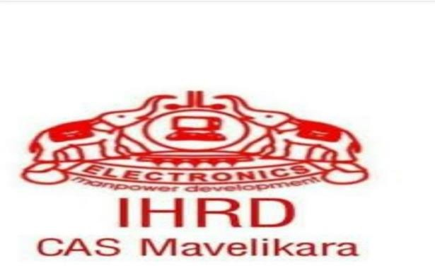

College of Applied Science, Mavelikara
Under IHRD, Govt. Of Kerala Affiliated to University of Kerala
International Collaboration with Shree Swaminarayan Academy, Kenya
Book Review of The gifts of imperfection,
Organised by IQAC Cell

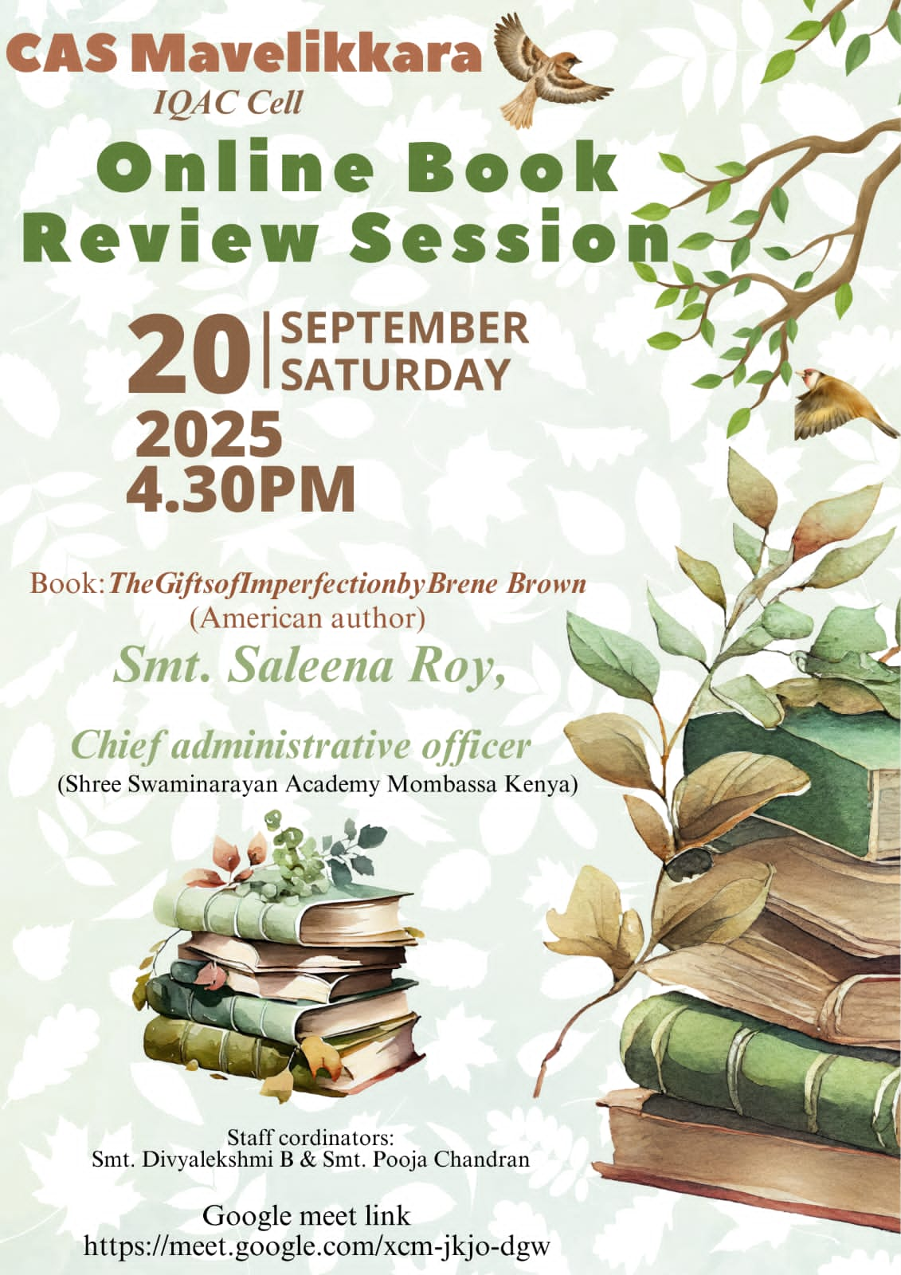
REPORT OF THE BOOK REVIEW BY Ms. SELEENA ROY
An International Collaboration with Shree Swaminarayan Academy, Kenya

Date and Time: 20, September, 2025, Saturday at 4.30 pm
Medium: Google Meet

Report
The book review was an international collaboration with an educational institution in Kenya. The chief guest Ms. Seleena Roy, Chief Administrator of Shree Swaminarayan Academy, discussed the book provided the students with insight into a healthy living and thought-provoking ideas for daily life. The program began with a welcome speech by Divyalekshmi B, Assistant Professor in English. Asst. Prof. Pooja Chandran moderated the session and introduced the chief guest to the audience. The Gifts of Imperfection by American author, Brene Brown was the book chosen for the talk.
During the talk, Ms. Seleena Roy emphasised the importance of living a healthy and content life. The interactive session that followed enabled an effective interaction of the speaker with the students. Students could clarify their doubts regarding the challenges in life. The talk concluded with a vote of thanks by Asst. Prof. Divyalekshmi B.

Closing Remarks: Pooja Chandran, Assistant Professor in English, CAS, Mavelikkara, provided the closing remarks, summarizing the key points of the event.

Organizers:
The Program was organized by the IQAC Cell of College of Applied Science

Participants:

Number of Participants: 48
Types of Participants: UG Students and Faculty members

Acknowledgement :

We extend our heartfelt thanks to Dr. Aysha V, the principal of CAS, Mavelikara for guiding us to cordinating the programme. We also extend gratitude to the Vice Principal, Latha G Nair and the IQAC Cell

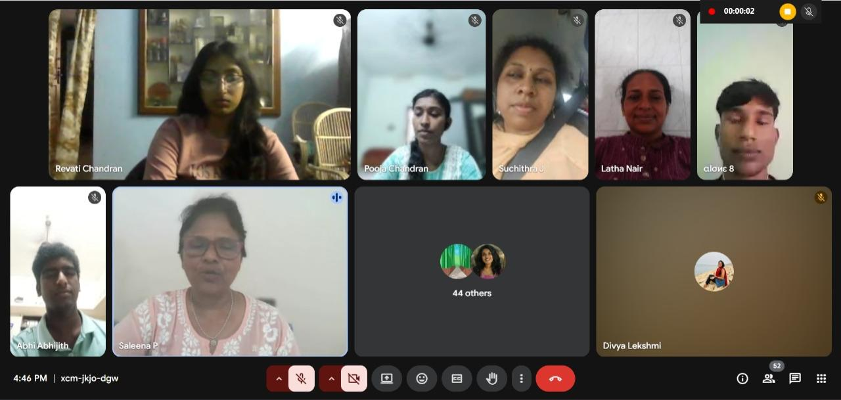

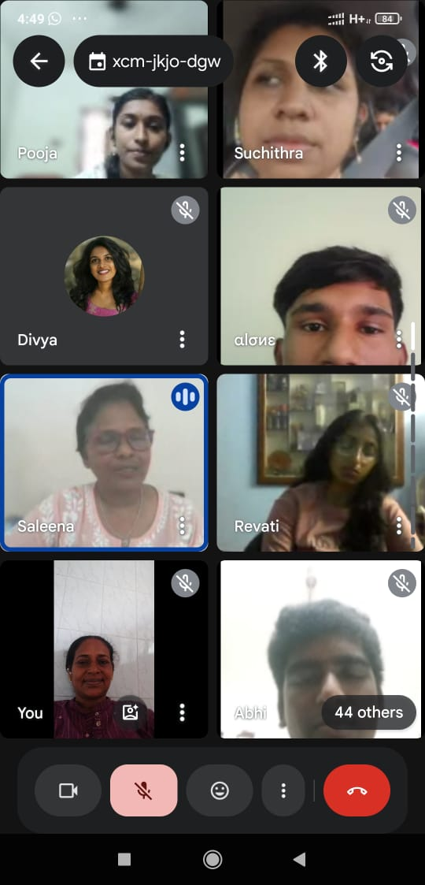

Report Submitted by ,

Pooja Chandran
Assistant Professor in English

Divyalekshmi B
Assistant Professor in English

