John Rudolph

JAR

CS1350

program #2

Stacks and Queues

due date: 10/14/2020

CS1350 Programming Project 1 Fall 2020

Due October 14, 2020 Class Time Mansfield, J

Design, test, implement and test a C++ program that uses an array of integers when implementing both a Stack and a Queue ADT. Then use your linked list to implement these two data structures (Queue and Stack) with integers.

You should plan this program well. You are creating an implementation of a stack – using both an array and a linked list. That is one program. Then you are creating an implementation of a queue, again using an array and a linked list.

All stacks have the same properties and the same required functions. All queues have the same properties and the same required functions.

Make sure to include all of your documentation for:

a) planning – algorithms

b) test and evaluation design – a plan to test each part of your program, along with the test data that will be used and how you will determine if test passed or failed

c) reflection – separate document, example available (25% of grade)

**Documentation – submit in appropriate location on BB:**

Turn in all required documentation:

• Cover page

• Copy of assignment

• Design documents – including all diagrams, algorithms, testing information, etc.

• Reflection

**Code – submit in appropriate location on BB:**

* One compressed folder:
* named yourinits.prog1 – use your initials.prog1
* all code and input/output files need to be in this folder
* all files need to have comments at the top:
  + //your name
  + //program name and portion of the program this file covers
  + //due date of the program
* all files need to have appropriate names, I recommend xyz.stack.h; xyz.queue.h; xyz.stackImp.cpp etc.

Due Date: 10/14/20

Algorithm:

Use this area to put your algorithm

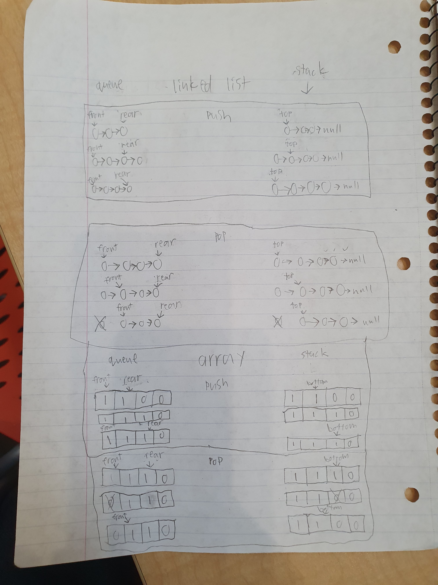

I will test all stacks and queues by creating a test function that will push, pop, and print each of lists.

Project Summary:

We were tasked to create datatypes implementing stacks and queues, using both a linked list and an array.

During this project I learned the correct terminology for pointers in stacks and queues, and how to sketch the algorithms of stacks and queues. I also learned how to use multiple files in C++.

Challenges:

The part of the project I found most challenging was the documentation. The code part was no too bad. I don’t normally plan before coding unless it’s a large project, so to force myself to plan out the tiny details was quite the challenge.

Solutions (Mitigation):

I learned how to do proper documentation and how to include multiple files with different header files. Most of the coding went well with minimal problems. (usually me misspelling stuff)