John Rudolph

JAR

CS1350

Project #3

Binary Search Tree

due date: 11/20/2020

CS1350 Programming Project 3 - BST Fall 2020 Due November 20, 2020 Mansfield, J

Design, test, implement and test a C++ program (using classes) that uses a linked list to create a Binary Search Tree of integers.

You will have an insert function along with the three traversals: inorder, preorder, postorder.

You should plan this program well. Include in your planning your testing methods for each required function – on both implementations.

Make sure to include all of your documentation for: a) planning; b) test and evaluation design; c) reflection.

Turn in all required documentation, to appropriate location on blackboard, one PDF called xyz.prog3.pdf:

• Cover page

• Copy of assignment

• Design documents – including all uml diagrams; testing design and any additional algorithms

• Reflection

Additionally, drop tarred and/or gzipped file in appropriate location on blackboard, the compressed file needs to be xyz.prog3.mmm where mmm is the extension your compression program assigns. NOTE: uncompressed folder MUST be xya.prog3

Due Date: 11/20/20

A binary search tree is a special implementation of a binary tree in which the first element inserted becomes the root, each subsequent element is compared to the root and inserted to the left if the element is less than the root, or right if the element is greater that the root.

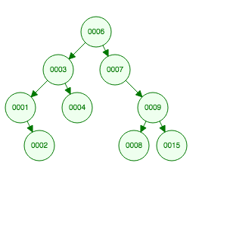

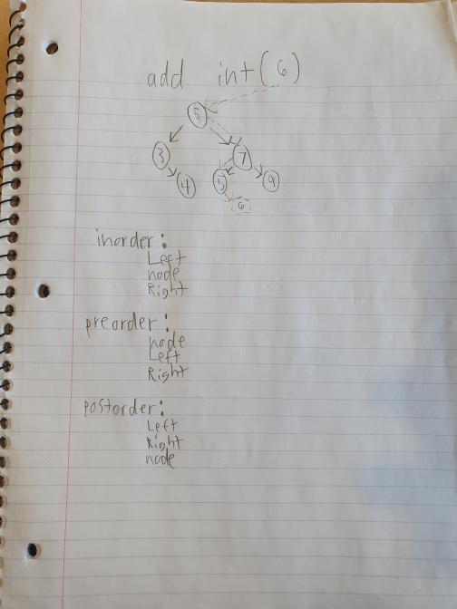

I will test my functions by filling my binary search tree with valid data and traversing the tree using inorder, preorder, and postorder algorithms.

Project Summary:

We were tasked to create a binary search tree and traversing it using inorder, preorder, and postorder algorithms.

Challenges:

I did not want to do the documentation.

Solutions (Mitigation):

I finally did my documentation.