Game Design Document

Fill up the following document

1. Write the title of your project.

* The title of my project is “Pacman 2.0”

1. What is the goal of the game?

* The goal of the game is to eat all the yellow dots that will be present throughout the maze.

1. Write a brief story of your game.

* In this game,there is a mze in which there are many yellow dots which is spread all around the maze.The playing character(Pacman) has to eat and finish before he loses the three lives given to him.There will be many power pallets so that it not difficult for the player to win the game but, to stop the player from winning, there will be 4 different ghosts who will be chasing the player and trying to eat the pacman.As soon as all the yellow dots are eaten, the player will win the game or if he/she loses all the lives,the game is over.

1. Which are the playing characters of this game?

* Playing characters are the ones who respond to the user based on the input from the user.
* Cars, monkeys, dinos, wizards, etc., are the playing characters in the game.

|  |  |  |
| --- | --- | --- |
| Number | Character Name | What can this character do? |
| 1 | Pacman | Can eat the ghost after eating the power pallets and has to finish all the yellow dots which is spread all around the maze. |
| 2 |  |  |
| 3 |  |  |
| 4 |  |  |
| 5 |  |  |
| 6 |  |  |
| 7 |  |  |
| 8 |  |  |

1. Which are the Non-Playing Characters of this game?

* Non-Playing characters are the ones that don't have an action or behavior when the user interacts with the game.
* Hurdles, stones, bananas, coins, etc., are non-playing characters in the game.

|  |  |  |
| --- | --- | --- |
| Number | Character Name | What can this character do? |
| 1 | Blue Ghost | Can eat the pacman and chase him |
| 2 | Pink Ghost | Can eat the pacman and chase him |
| 3 | Red Ghost | Can eat the pacman and chase him |
| 4 | YellowGhost | Can eat the pacman and chase him |
| 5 |  |  |
| 6 |  |  |
| 7 |  |  |
| 8 |  |  |

Draw your imagination of this game. What does this game look like?

* Draw the game either on your computer or on paper.
* Add images of the game scenes to show each of the playing and non-playing characters at least once.
* 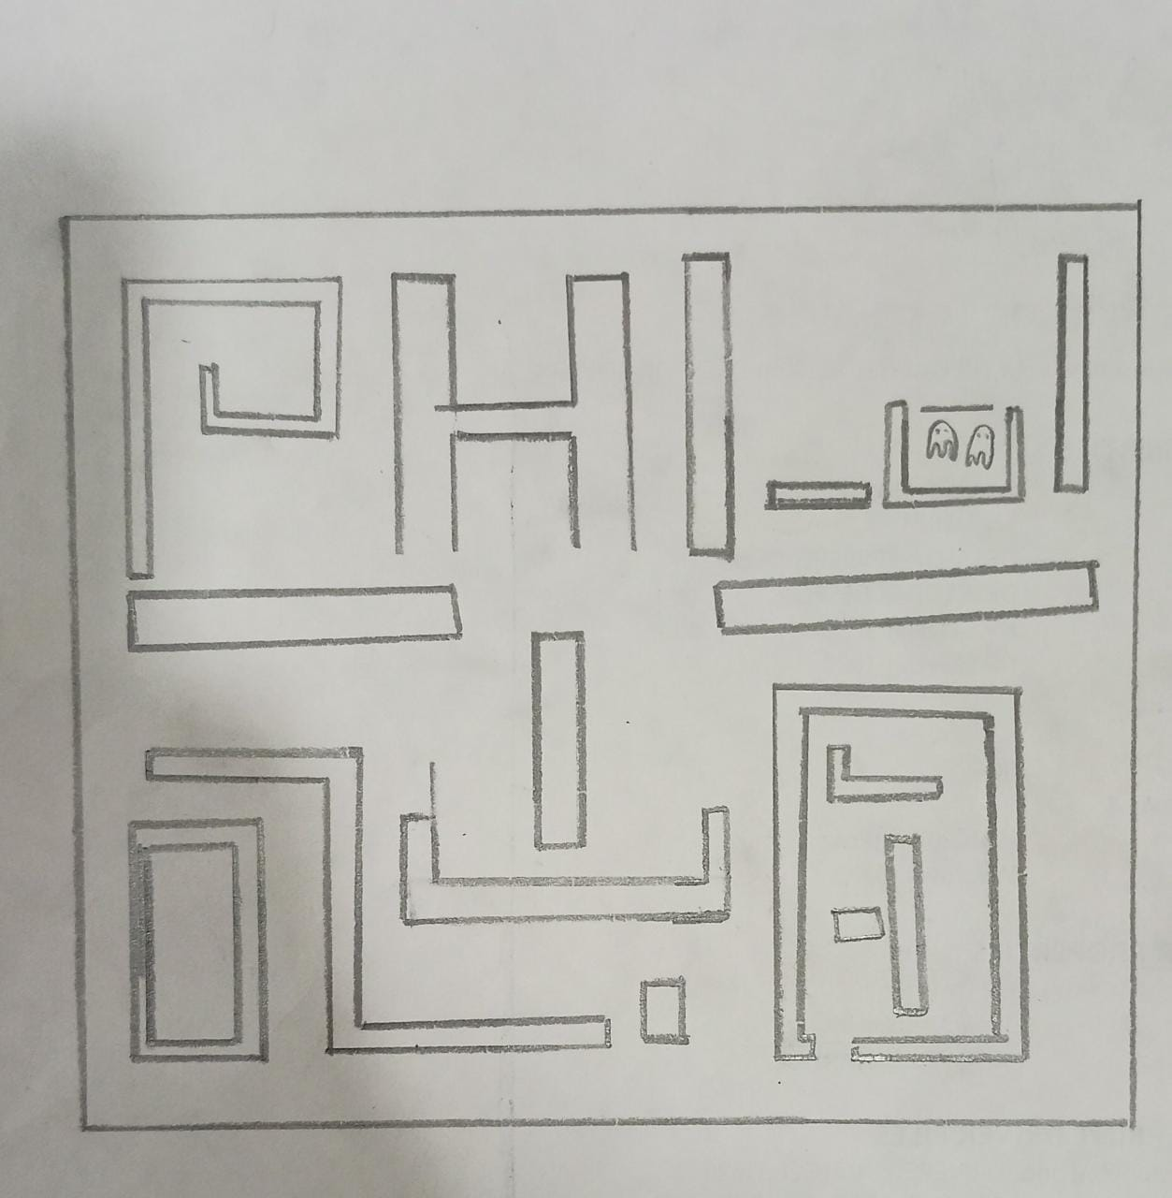

This is the maze which i have planned.

How do you plan to make your game engaging?

* In the game,there will be 4 power pallets which will hep the player from 15-20 seconds but the ghosts make make it a little hard for the player also.