Lab 1: Version Control using Git & GitHub

Files Setup
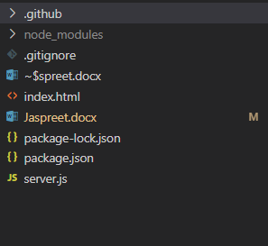
- server.js – Runs the Node.js Express server that serves web pages and handles app logic.
- index.html – Frontend page displayed to users in the browser.
- package.json – Stores app metadata, dependencies, and scripts for Node.js project management.

Uploading Files on GitHub

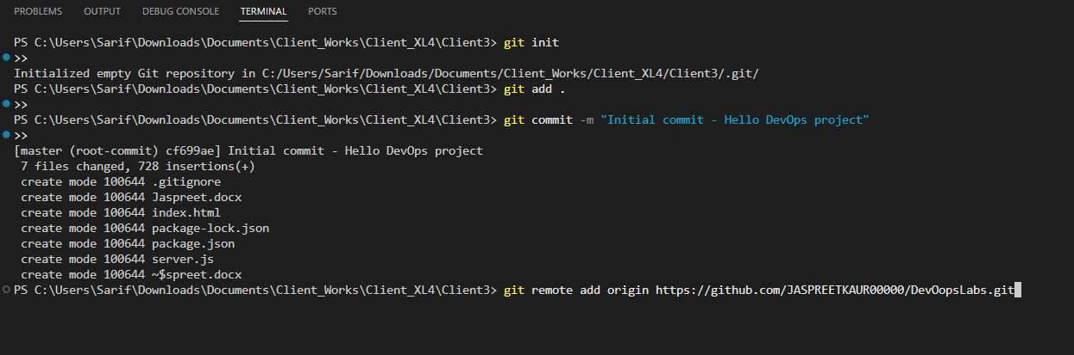

Verifying GitHub

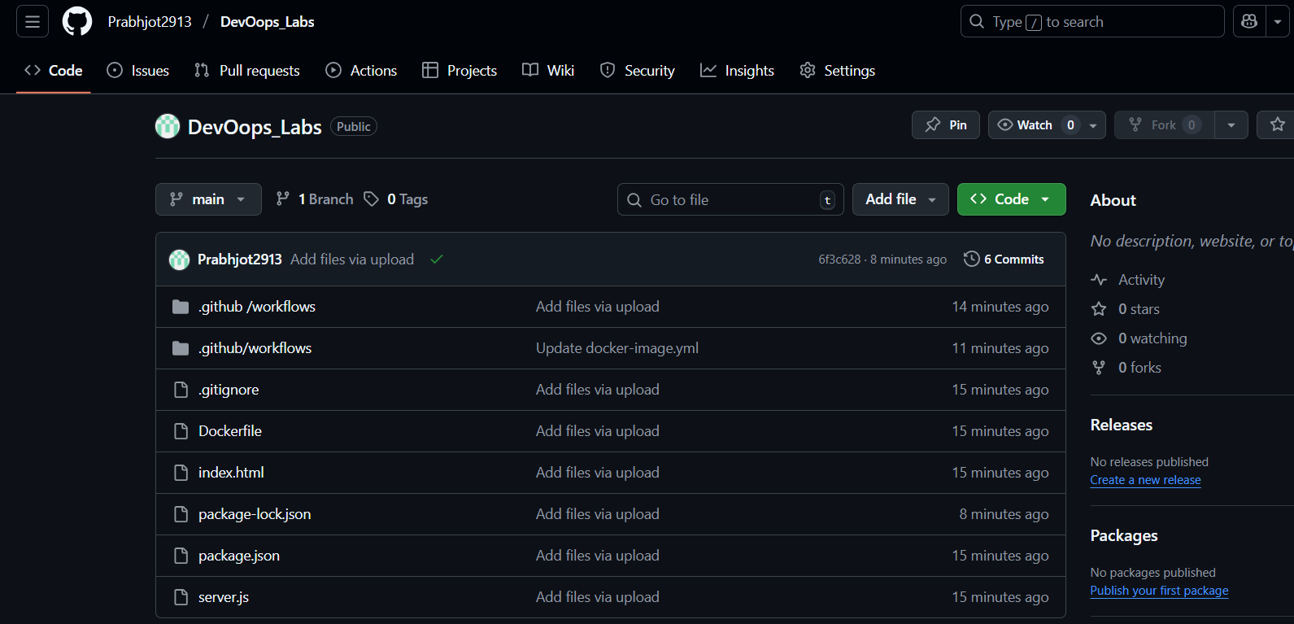

Package.json for Version Control

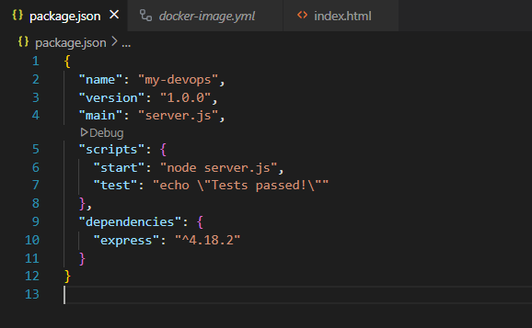

Lab 2: Planning using Trello
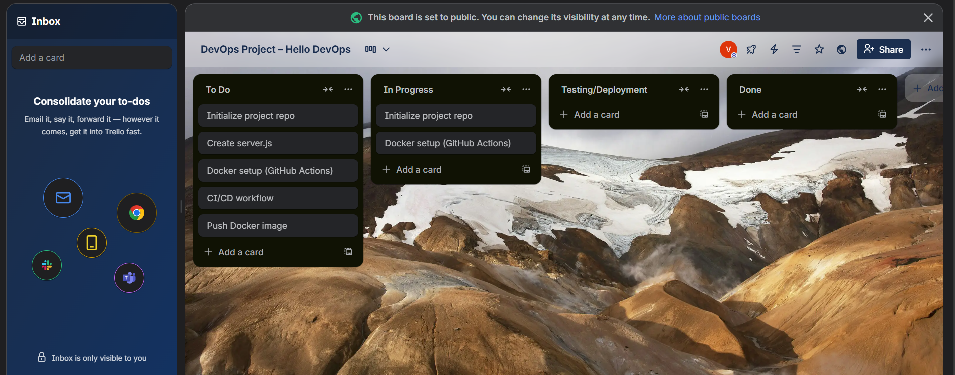

To Do:
- Initialize project repo
- Create server.js
- Docker setup
- CI/CD workflow

In Progress:
- Initialize project repo
- Docker setup

Lab 6: Containerisation using Docker

Setting Up Docker File
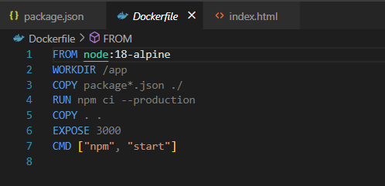

Docker Image yml set up

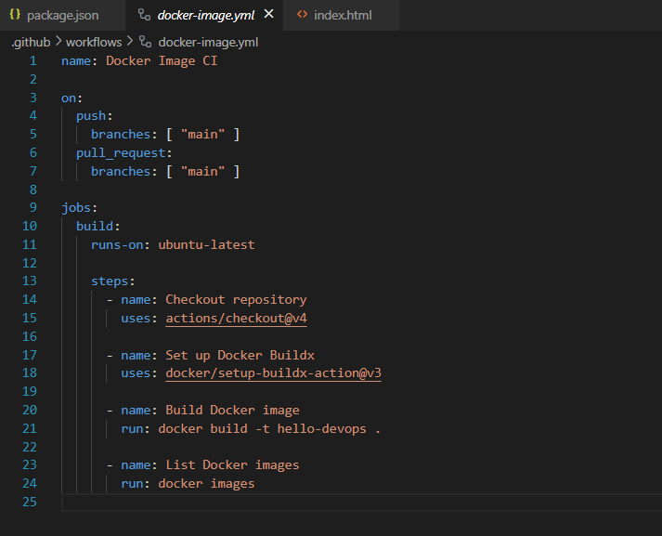

Docker Image Building

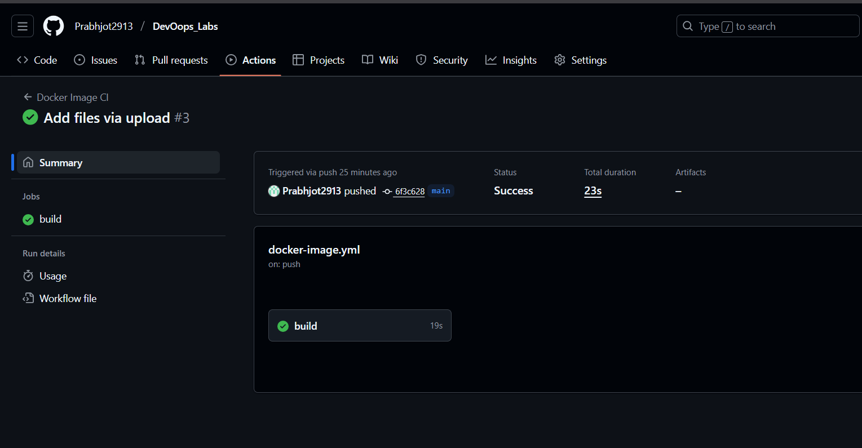

LAB 7: Automating Application Deployment using a CI/CD Pipeline (using Render/Vercel/Docker/PythonAnywhere)

Connecting GitHub with Render with CI/CD

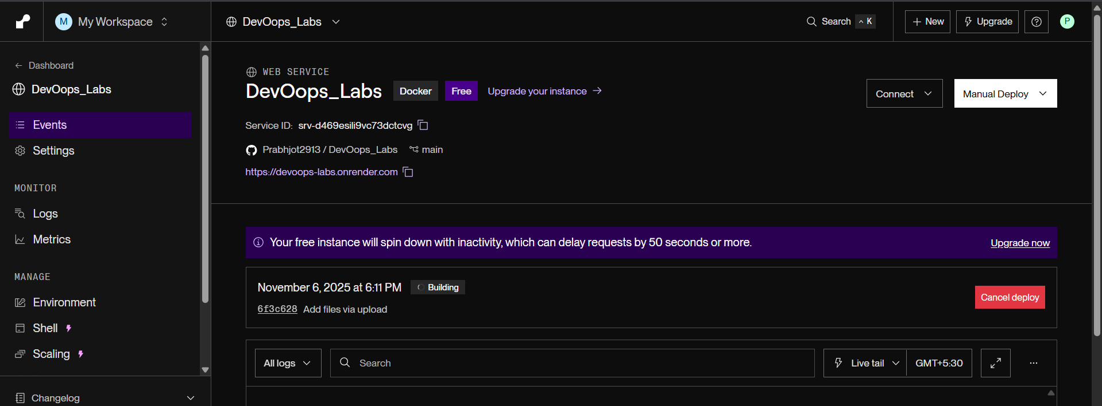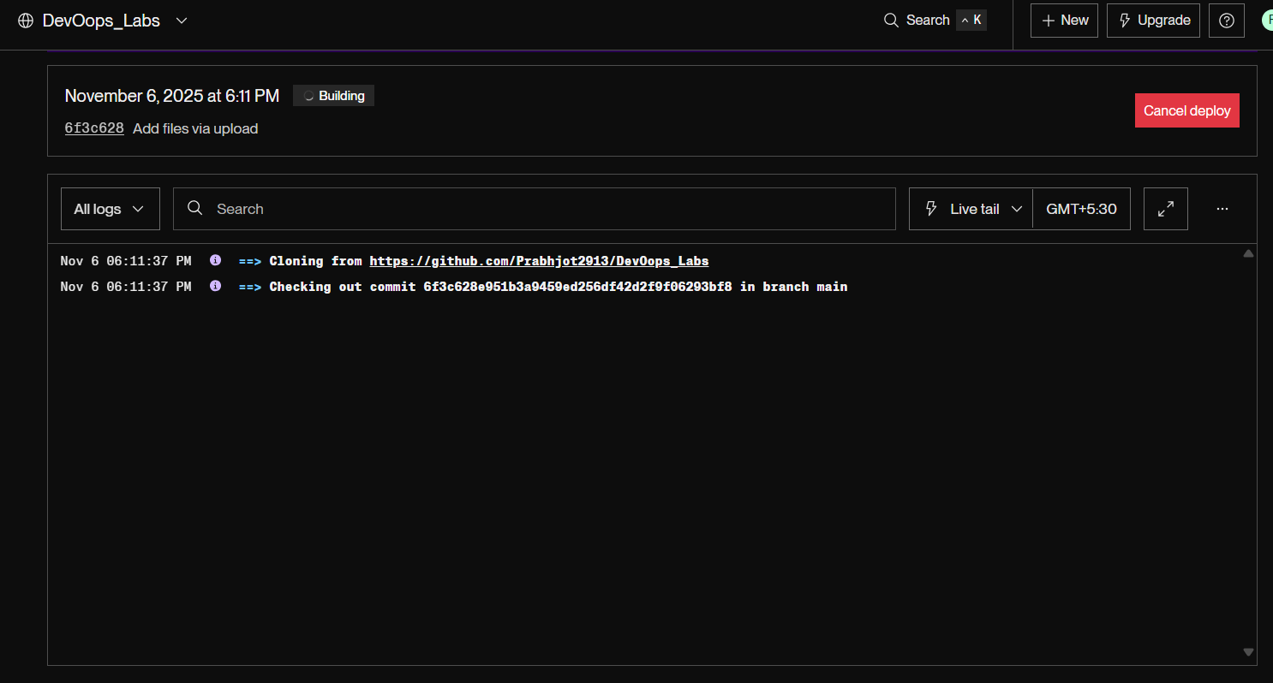

Deploying In Progress

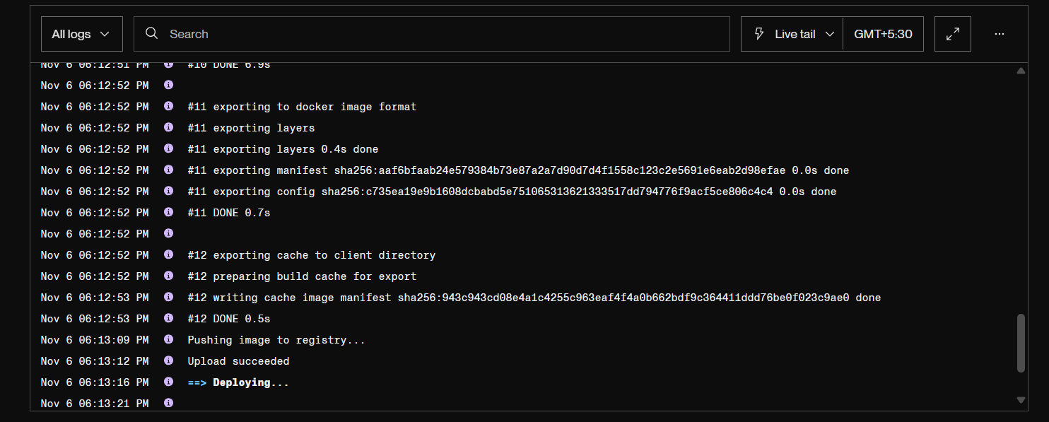

Deployment Successfullye completed

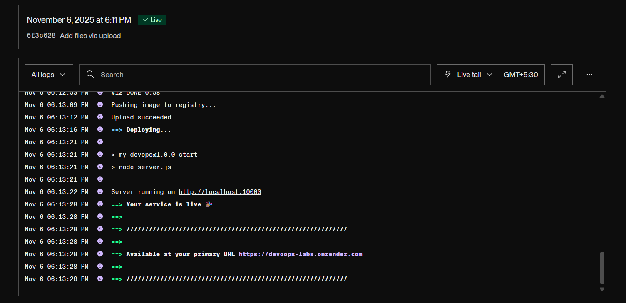

Accessing using https://devoops-labs.onrender.com/

