Gym Management System - Final Report
Course: ICS321
Submission Date: May 7, 2026
Team Members:
Jassim AlHumaid
Amjad Alsadiq
Firas Almashama

Table of Contents
Gym Management System - Final Report 1
1. Introduction 1
2. Objectives 2
3. System Scope 2
4. Conceptual Design - ER Diagram 3
5. Logical Design - Relational Tables Model 4
6. Integrity Constraints 7
7. Implementation 8
8. Sample Queries 9
9. User Interface 12
10. Conclusion and Future Work 12
11. Appendix A - Full Schema Source 13

1. Introduction
The day-to-day operations of a modern gym involve many moving parts - registering members, scheduling sessions, managing trainer assignments, handling subscriptions and payments, and tracking attendance. When these activities are managed manually or through disconnected spreadsheets, data quickly becomes inconsistent, redundant, and difficult to maintain. Staff members lose time reconciling records, members face poor service, and management lacks the reliable data needed to make informed decisions.
This project proposes a Gym Membership and Training Management System, a centralized data-centric application built on a relational database. The system unifies the gym’s core operations - user accounts, members, trainers, plans, subscriptions, payments, sessions, bookings, and attendance - into a single source of truth. Staff and administrators can register members, schedule sessions, approve subscriptions, and track payments through a unified interface, while members and trainers each have their own role-specific views.
The deliverable is a complete full-stack web application with a relational MySQL/MariaDB backend, a TypeScript Express API server, and a React-based front-end with dedicated dashboards for administrators, trainers, and members.

2. Objectives
The primary objectives of the Gym Management System are:
- Design a structured relational database that captures all core gym operations without redundancy
- Enforce data consistency and integrity through primary keys, foreign keys, unique constraints, and CHECK constraints
- Provide efficient tracking of members, trainers, sessions, subscriptions, and payments
- Simplify subscription and payment workflows for staff
- Offer role-based access so that members, trainers, and administrators each see only what is relevant to them
- Deliver a scalable foundation that can accommodate future features such as reporting, analytics, and external integrations

3. System Scope
The system supports the following functional areas:
- User management. A unified user table stores authentication credentials and profile information for all roles. The role of each user (administrator, trainer, or member) is determined by the presence of a row in the corresponding subtype table (staff, trainer, member).
- Member management. Member-specific attributes such as gender and join date are recorded, and member profiles are linked to user accounts.
- Trainer management. Each trainer is associated with a specialty and a hire date.
- Membership plans and subscriptions. Administrators define a catalog of membership plans (monthly, quarterly, annual, student, family, etc.). Members request subscriptions to these plans, and administrators approve or cancel them.
- Session scheduling. Trainers schedule sessions with a title, type, date, time range, and capacity. Sessions move through the states Scheduled, Completed, and Cancelled.
- Booking system. Members book seats in scheduled sessions, with the database enforcing that no member can book the same session twice.
- Attendance tracking. Trainers mark each booking as Present, Absent, or Late. Each booking can have at most one attendance record.
- Payment management. Each subscription can be paid for through one or more payment records, supporting installments and re-attempts after a failed transaction.
The system does not currently include features such as financial reporting dashboards, equipment inventory, locker assignment, or external payment-gateway integration. These are considered out of scope for the present iteration but are addressed in the Future Work section.

4. Conceptual Design - ER Diagram
The Entity-Relationship (ER) diagram in Figure 1 shows the entities, attributes, and relationships of the system at the conceptual level.
Figure 1: Gym Management System - Conceptual ER Diagram
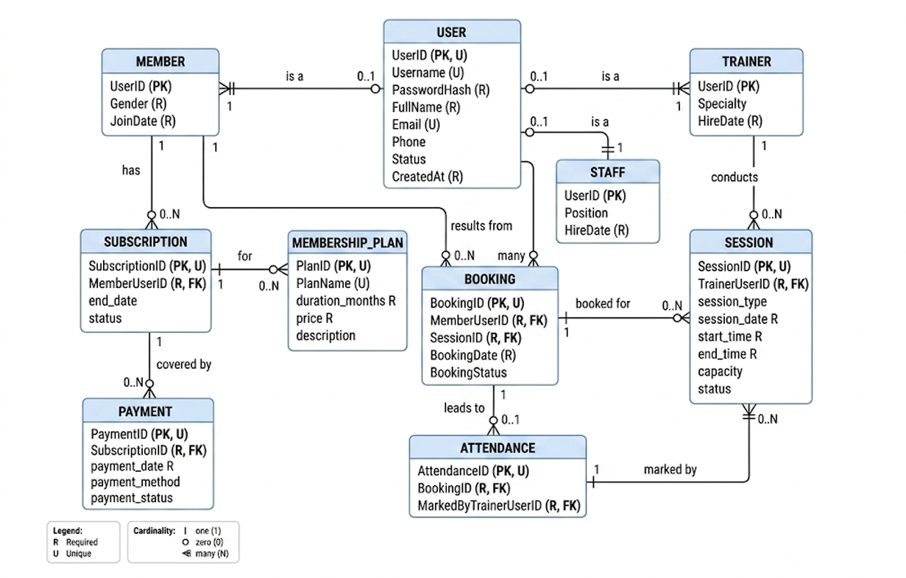
Gym Management System - Conceptual ER Diagram

4.1 Entities
The system contains nine entities:
- USER - Stores authentication credentials and shared profile information for all participants in the system.
- MEMBER - A subtype of USER that captures member-specific information such as gender and join date.
- TRAINER - A subtype of USER for trainers, with their specialty and hire date.
- MEMBERSHIPPLAN - The catalog of subscription plans available for members to purchase.
- SUBSCRIPTION - A member’s enrollment in a particular plan, with a start date, end date, and lifecycle status.
- PAYMENT - A financial transaction associated with a subscription, supporting multiple payments per subscription for installments and retries.
- SESSION - A scheduled training session conducted by a trainer at a given date, time, and capacity.
- BOOKING - A reservation by a member for a particular session.
- ATTENDANCE - A trainer’s record of whether a member who booked a session was present, absent, or late.

4.2 Key Relationships
- A USER is a MEMBER or TRAINER (subtype relationship; mutually exclusive in practice).
- A MEMBER has zero or many SUBSCRIPTIONs.
- A MEMBERSHIPPLAN defines zero or many SUBSCRIPTIONs.
- A SUBSCRIPTION is covered by zero or many PAYMENTs.
- A TRAINER conducts zero or many SESSIONs.
- A MEMBER makes zero or many BOOKINGs, and a SESSION is booked for by zero or many BOOKINGs.
- A BOOKING results in zero or one ATTENDANCE record (a 1:1 relationship enforced by a UNIQUE constraint on BookingID in the attendance table).
- A TRAINER marks zero or many ATTENDANCE records.

4.3 Notation
The diagram uses crow’s-foot notation for cardinality. Each attribute is annotated with R if it is required (NOT NULL) and U if it is unique. The bullet (●) marks the primary key.

5. Logical Design - Relational Tables Model
The conceptual ER model from Section 4 maps directly onto a set of relational tables. Figure 2 shows the relational tables model, where each box represents a database table, PKs are marked with a bullet (●), R indicates required (NOT NULL) columns, U indicates unique columns, and the arrows show foreign key references from the FK table to the referenced PK table.
Figure 2: Gym Management System - Relational Tables Model
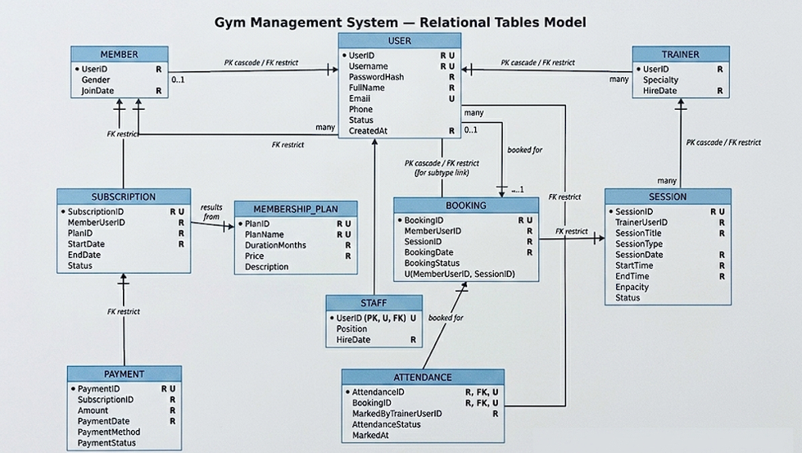
Gym Management System - Relational Tables Model
The conceptual model maps onto nine relational tables. Each subtype table (member, trainer) uses the corresponding UserID from the user table as both its primary key and a foreign key, enforcing that the subtype cannot exist without its parent user.

5.1 Table Definitions
Table | Purpose | Primary Key | Notable Foreign Keys
user | Authentication and shared profile data | UserID | -
member | Member-specific profile | UserID | UserID → user(UserID)
trainer | Trainer-specific profile | UserID | UserID → user(UserID)
membershipplan | Catalog of plans | PlanID | -
subscription | A member’s enrollment in a plan | SubscriptionID | MemberUserID → member, PlanID → membershipplan
payment | A financial transaction for a subscription | PaymentID | SubscriptionID → subscription
session | A scheduled training session | SessionID | TrainerUserID → trainer
booking | A member’s reservation in a session | BookingID | MemberUserID → member, SessionID → session
attendance | Trainer-marked attendance for a booking | AttendanceID | BookingID → booking, MarkedByTrainerUserID → trainer

5.2 Subtype Modeling
The user table holds attributes common to every account: username, password hash, full name, contact details, status, and creation timestamp. Two subtype tables - member and trainer - each reference UserID as both their primary key and a foreign key into user. This ensures that:
- A subtype row cannot exist without its parent user
- Deleting a user automatically removes the associated subtype row (ON DELETE CASCADE)
- A user’s role is determined by which subtype table contains a matching row
This is a cleaner alternative to storing the role as a single column on the user table because it allows each subtype to have its own role-specific attributes (Specialty, HireDate) while keeping the common columns in one place.

5.3 Multi-Payment Subscriptions
The payment table allows a single subscription to have multiple payment records. This supports two real-world scenarios:
- Installments. A high-value annual subscription can be paid in two or more installments rather than as one lump sum.
- Retries. If a payment attempt fails (for example, a card decline), a follow-up payment record can be inserted with status Paid, Pending, or Failed without losing the history of the failed attempt.

5.4 Booking-Centric Attendance
Attendance is linked to a booking rather than directly to a member and a session. This design choice enforces the business rule that a member can only have attendance recorded for sessions they actually booked. The UNIQUE constraint on BookingID in the attendance table further guarantees that a booking has at most one attendance record.

Implementation note: The actual database also contains a small staff table (structure: UserID PK/FK, Position, HireDate) used to identify administrator accounts. This table is not shown in the diagrams above because it is an implementation detail added to support admin authentication, rather than a core business entity. It follows the same subtype pattern as member and trainer.

6. Integrity Constraints
The schema applies multiple categories of integrity constraint to enforce data correctness at the database level.

6.1 Primary Key Constraints
Every table has a primary key. Surrogate auto-increment integers (UserID, SubscriptionID, etc.) are used wherever a meaningful natural key does not exist.

6.2 Unique Constraints
Table | Unique Column(s) | Purpose
user | Username | Each username must be unique system-wide
user | Email | Each email address can be used by at most one user
membershipplan | PlanName | Plan names must be distinct
booking | (MemberUserID, SessionID) | A member cannot book the same session twice
attendance | BookingID | Each booking has at most one attendance record

6.3 Foreign Key Constraints
Foreign keys enforce referential integrity between tables. The schema uses ON UPDATE CASCADE on every foreign key (so that primary-key changes propagate), and ON DELETE CASCADE on the subtype tables (so that deleting a user automatically removes associated profiles).

6.4 CHECK Constraints
CHECK constraints enforce business rules and value-domain restrictions:
Constraint | Rule
chk_user_status | user.Status must be Active, Inactive, or Suspended
chk_subscription_status | subscription.Status must be Pending, Active, or Cancelled
chk_payment_status | payment.PaymentStatus must be Pending, Paid, or Failed
chk_session_status | session.Status must be Scheduled, Completed, or Cancelled
chk_booking_status | booking.BookingStatus must be Confirmed, Booked, or Cancelled
chk_attendance_status | attendance.AttendanceStatus must be Present, Absent, or Late
chk_membershipplan_duration | membershipplan.DurationMonths must be greater than 0
chk_membershipplan_price | membershipplan.Price must be greater than 0
chk_payment_amount | payment.Amount must be greater than 0
chk_session_capacity | session.Capacity must be greater than 0
chk_session_time_order | session.EndTime must be after session.StartTime

6.5 NOT NULL Constraints
Every required field is declared NOT NULL, including all primary keys, all foreign keys, and key business attributes such as full name, password hash, plan name, payment amount, and session date and time.

7. Implementation

7.1 Technology Stack
Layer | Technology
Database | MariaDB 10.4 (via XAMPP)
Database tools | phpMyAdmin, HeidiSQL
Backend | Node.js, Express 4, TypeScript, tsx
Authentication | JSON Web Tokens (JWT), bcrypt password hashing
Frontend | React 19, TypeScript, Vite 6, React Router 7
Styling | Custom CSS
Testing | Vitest + Supertest — 69 tests across 7 test files

7.2 Database Setup
The schema is defined in database/schema.sql and contains all CREATE TABLE statements, primary keys, foreign keys, and CHECK constraints. Sample data is provided in seed_data.sql. Both files are imported through phpMyAdmin’s Import tab.
After import, the following counts confirm a successful load:
Table | Row Count
user | 17
member | 12
trainer | 4
membershipplan | 5
subscription | 14
payment | 16
session | 12
booking | 25
attendance | 13
[Insert screenshot: phpMyAdmin showing all 9 tables in gym_management database]
[Insert screenshot: count verification query result]

7.3 Backend Architecture
The Express server exposes a REST API under the /api prefix. Routes are organized by resource:
- /api/auth - login and registration
- /api/dashboard - admin metrics
- /api/users, /api/members, /api/trainers - user-management endpoints
- /api/plans - membership plan CRUD
- /api/subscriptions - subscription request, approval, and cancellation
- /api/payments - payment listing
- /api/sessions - session scheduling
- /api/bookings - booking creation and cancellation
- /api/attendance - attendance marking by trainers
Authentication is handled by issuing a signed JWT on successful login. The JWT carries the user’s role (derived from which subtype table contains the matching row), and route middleware enforces role-based access control.

7.4 Frontend Architecture
The React frontend has three role-specific dashboards:
- AdminDashboard - system-wide metrics, plan management, member and trainer listings, subscription approvals, payment overview, and session management.
- TrainerDashboard - sessions conducted by the logged-in trainer and an attendance-marking interface for each session.
- MemberDashboard - the member’s subscriptions, payments, available sessions to book, and existing bookings.
A shared LoginPage and LandingPage handle unauthenticated users, with React Router redirecting users to the correct dashboard based on their role after login.

8. Sample Queries
This section presents representative SQL queries that power the application. Each query is annotated with its purpose.

8.1 Login (Role-Aware)
This query fetches a user by username and derives the role from the presence of rows in the subtype tables. The LEFT JOIN to all three subtype tables allows a single round-trip to determine identity and role.
SELECT u.UserID AS user_id,
u.Username AS username,
u.PasswordHash AS password_hash,
u.FullName AS full_name,
u.Email AS email,
LOWER(u.Status) AS status,
CASE
WHEN st.UserID IS NOT NULL THEN 'admin'
WHEN t.UserID IS NOT NULL THEN 'trainer'
WHEN m.UserID IS NOT NULL THEN 'member'
END AS role,
m.UserID AS member_id,
t.UserID AS trainer_id
FROM `user` u
LEFT JOIN staff st ON st.UserID = u.UserID
LEFT JOIN trainer t ON t.UserID = u.UserID
LEFT JOIN member m ON m.UserID = u.UserID
WHERE u.Username = ?
LIMIT 1

8.2 Admin Dashboard Counts
The administrator dashboard issues a series of COUNT(*) queries to populate top-level metrics. A representative subset:
SELECT COUNT(*) AS count
FROM `user` u
JOIN member m ON m.UserID = u.UserID
WHERE u.Status = 'Active';
SELECT COUNT(*) AS count
FROM subscription
WHERE Status = 'Active';
SELECT COUNT(*) AS count
FROM `session`
WHERE Status = 'Scheduled';

8.3 Subscription Workflow - Request, Approve, Cancel
A member requests a new subscription:
INSERT INTO subscription (MemberUserID, PlanID, StartDate, EndDate, Status)
VALUES (?, ?, ?, ?, 'Pending');
When an administrator approves a pending subscription, the application creates a pending payment record for the plan price. The subscription remains Pending until an administrator marks that payment Paid, at which point the subscription activates and any other active subscriptions for the same member are cancelled:
-- Admin approves: creates a pending payment
INSERT INTO payment (SubscriptionID, Amount, PaymentDate, PaymentMethod, PaymentStatus)
VALUES (?, ?, CURDATE(), NULL, 'Pending');
-- Admin marks payment paid: cancels other active subs
UPDATE subscription
SET Status = 'Cancelled'
WHERE MemberUserID = ? AND SubscriptionID <> ? AND Status = 'Active';
-- Admin marks payment paid: activates the pending sub
UPDATE subscription
SET Status = 'Active'
WHERE SubscriptionID = ? AND Status = 'Pending';

UPDATE subscription SET Status = 'Cancelled' WHERE SubscriptionID = ?

An administrator can cancel a subscription directly:

8.4 Sessions With Booked-Count
The session listing includes a derived booked_count column showing how many active bookings each session has. This uses a correlated subquery with a LEFT JOIN:
SELECT s.SessionID AS session_id,
s.TrainerUserID AS trainer_id,
s.SessionTitle AS session_title,
s.SessionType AS session_type,
s.SessionDate AS session_date,
s.StartTime AS start_time,
s.EndTime AS end_time,
s.Capacity AS capacity,
LOWER(s.Status) AS status,
u.FullName AS trainer_name,
t.Specialty AS trainer_specialty,
COALESCE(booked.booked_count, 0) AS booked_count
FROM `session` s
JOIN trainer t ON t.UserID = s.TrainerUserID
JOIN `user` u ON u.UserID = t.UserID
LEFT JOIN (
SELECT SessionID, COUNT(*) AS booked_count
FROM booking
WHERE BookingStatus IN ('Confirmed', 'Booked')
GROUP BY SessionID
) booked ON booked.SessionID = s.SessionID
WHERE s.Status = 'Scheduled'
ORDER BY s.SessionDate, s.StartTime

8.5 Trainer Attendance View
For each session a trainer is conducting, this query lists the booked members and any existing attendance record:
SELECT b.MemberUserID AS member_id,
u.FullName AS member_name,
u.Email AS member_email,
a.AttendanceID AS attendance_id,
LOWER(a.AttendanceStatus) AS attendance_status,
a.MarkedByTrainerUserID AS marked_by_trainer_id,
a.MarkedAt AS marked_at
FROM booking b
JOIN member m ON m.UserID = b.MemberUserID
JOIN `user` u ON u.UserID = m.UserID
LEFT JOIN attendance a ON a.BookingID = b.BookingID
WHERE b.SessionID = ? AND b.BookingStatus IN ('Confirmed', 'Booked')
ORDER BY u.FullName

8.6 Marking Attendance (Idempotent)
The attendance-marking endpoint uses an INSERT … ON DUPLICATE KEY UPDATE pattern to support both initial marking and subsequent corrections:
INSERT INTO attendance (BookingID, MarkedByTrainerUserID, AttendanceStatus, MarkedAt)
VALUES (?, ?, ?, NOW())
ON DUPLICATE KEY UPDATE
MarkedByTrainerUserID = VALUES(MarkedByTrainerUserID),
AttendanceStatus = VALUES(AttendanceStatus),
MarkedAt = NOW();
The UNIQUE constraint on BookingID makes this safe and predictable.

9. User Interface
The application provides three role-specific dashboards. Screenshots of each are shown below.
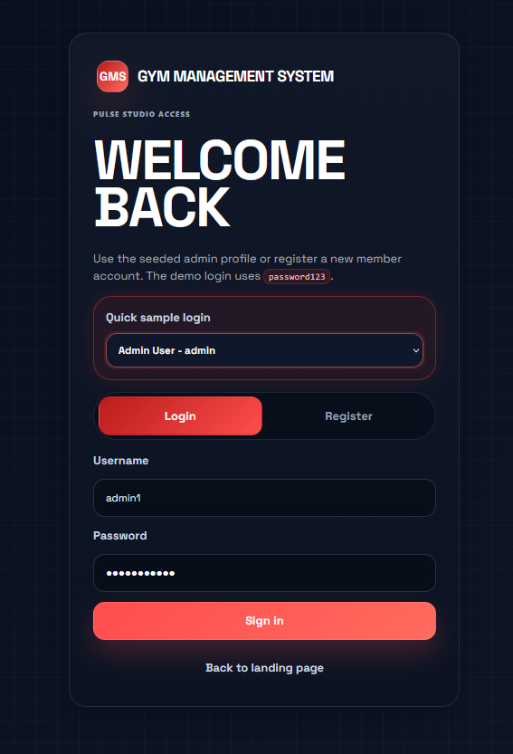
Login page

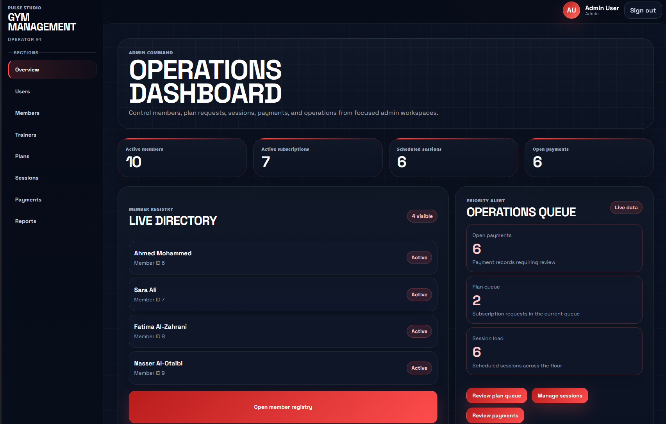

Admin dashboard
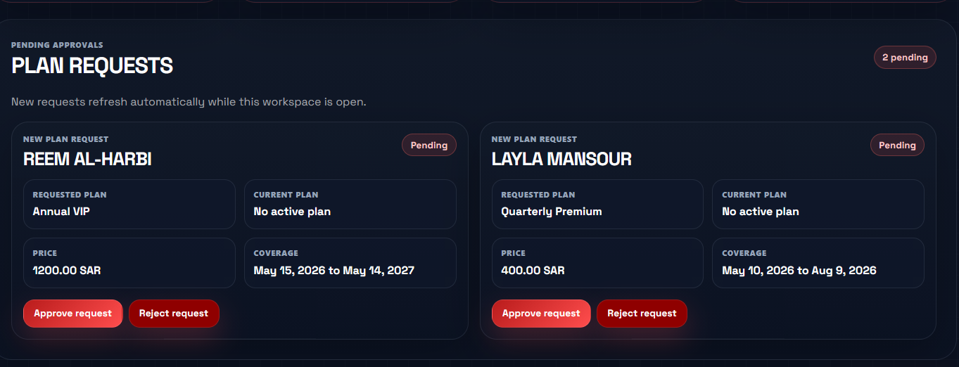

Admin subscription approval view
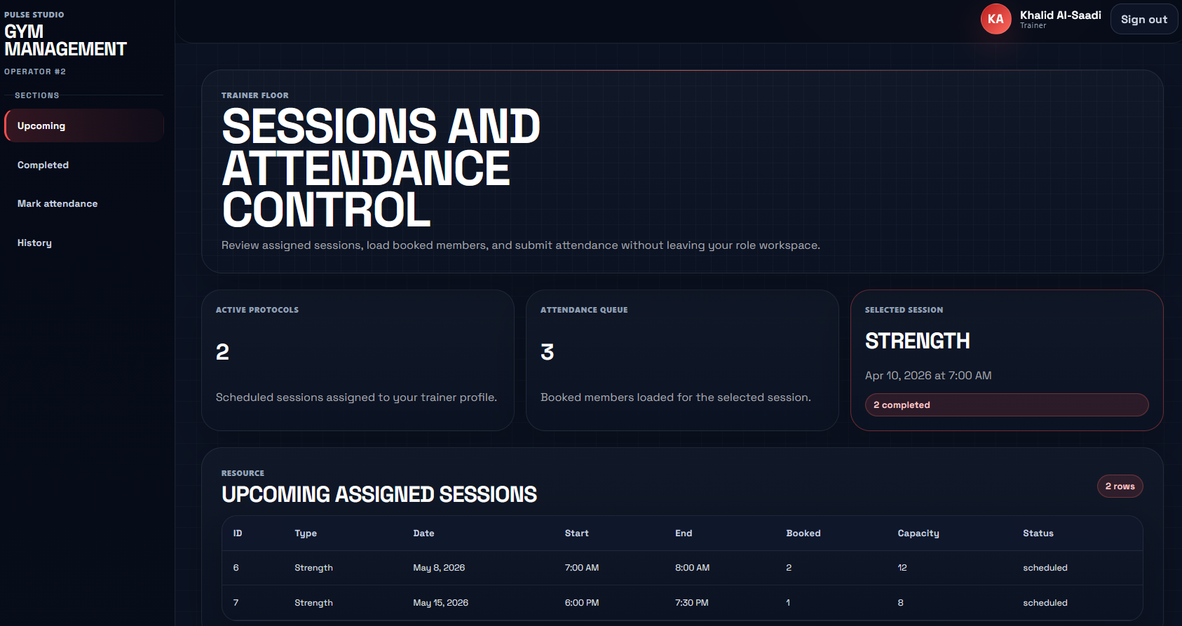

Trainer dashboard
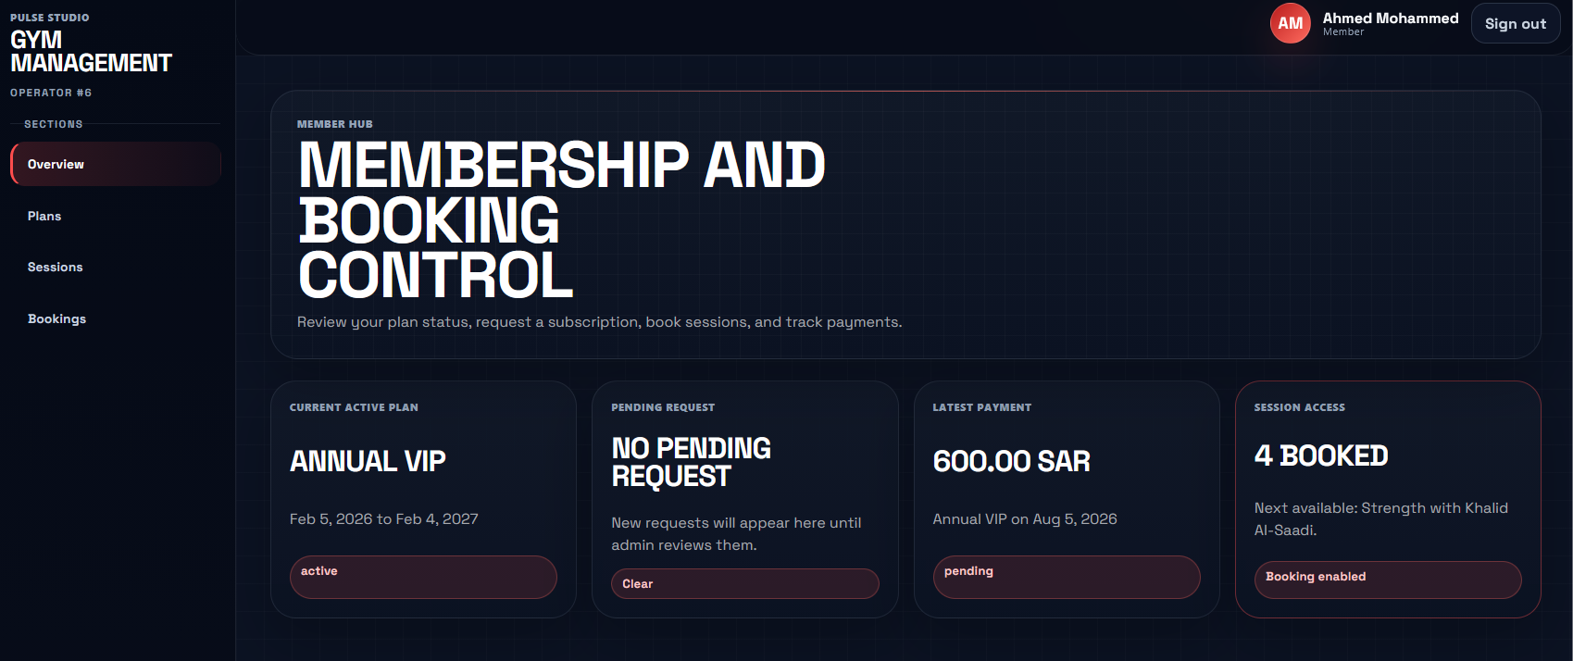

Member dashboard

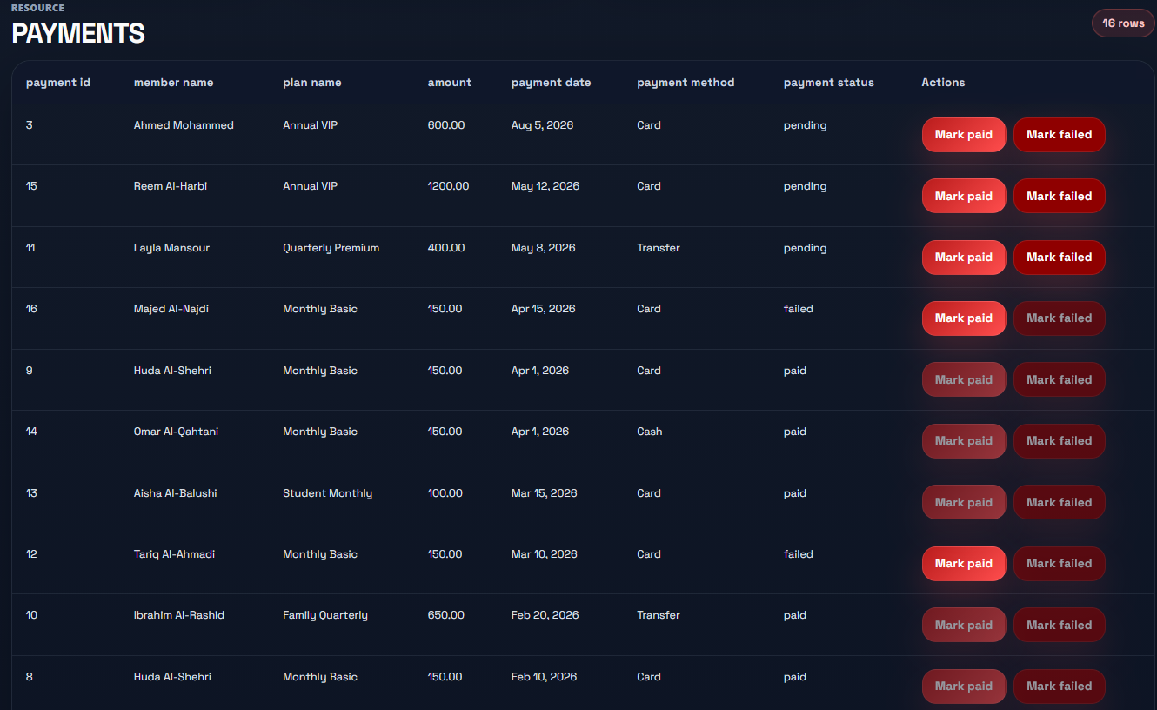

Payment management
Each interface respects the user’s role: members can only view and act on their own data, trainers can only mark attendance for sessions they conduct, and administrators have full visibility and management privileges.

10. Conclusion and Future Work
This project delivers a complete, working Gym Management System backed by a normalized relational database. The schema cleanly captures the core gym operations through ten interrelated tables and applies a comprehensive set of integrity constraints - primary keys, unique keys, foreign keys, and CHECK constraints - to ensure that the data remains consistent regardless of how it is accessed.
The system demonstrates a number of non-trivial design decisions: subtype tables for distinguishing roles, multi-payment subscriptions for installment support, booking-centric attendance for enforcing the booking-attendance relationship, and a CASE-based role derivation in the login query that avoids storing redundant role data.

10.1 Future Work
Possible extensions to the system include:
- Reporting and analytics. Dashboards showing revenue trends, attendance rates, and trainer utilization.
- Equipment and locker management. Additional tables for gym equipment inventory and locker assignments.
- External payment integration. Linking the payment table to a real payment-gateway API such as Stripe or PayTabs.
- Notifications. Email or SMS reminders for upcoming sessions and expiring subscriptions.
- Mobile application. A native iOS/Android client that consumes the same REST API.
- Audit logging. A separate audit_log table tracking all sensitive operations (subscription approvals, payment status changes, attendance marking) for compliance.

10.2 Lessons Learned
Building this system required careful coordination between the conceptual ER model, the relational schema, and the application code. Small inconsistencies between layers - a column missing from the ER diagram, a CHECK constraint not reflected in the application’s input validation - could have caused integration friction late in the project. The team’s approach of treating the schema as the source of truth, and regenerating the ER diagram and front-end forms from it, kept the three layers aligned throughout development.

11. Appendix A - Full Schema Source
The complete schema is provided in database/schema.sql. A condensed listing of each CREATE TABLE statement follows.
CREATE DATABASE `gym_management`;
USE `gym_management`;
-- 1. User Table (Base Table)
CREATE TABLE IF NOT EXISTS `user` (
`UserID` int NOT NULL AUTO_INCREMENT,
`Username` varchar(50) NOT NULL,
`PasswordHash` varchar(255) NOT NULL,
`FullName` varchar(100) NOT NULL,
`Email` varchar(100) DEFAULT NULL,
`Phone` varchar(20) DEFAULT NULL,
`Status` varchar(20) NOT NULL DEFAULT 'Active',
`CreatedAt` datetime NOT NULL,
PRIMARY KEY (`UserID`),
UNIQUE KEY `Username` (`Username`),
UNIQUE KEY `Email` (`Email`),
CONSTRAINT `chk_user_status` CHECK (`Status` in ('Active', 'Inactive', 'Suspended'))
);
-- 2. Staff Table (UserID is the Primary Key)
CREATE TABLE IF NOT EXISTS `staff` (
`UserID` int NOT NULL,
`Position` varchar(100) DEFAULT 'Admin',
`HireDate` date NOT NULL,
PRIMARY KEY (`UserID`),
CONSTRAINT `fk_staff_user` FOREIGN KEY (`UserID`) REFERENCES `user` (`UserID`) ON DELETE CASCADE ON UPDATE CASCADE
);
-- 3. Trainer Table (UserID is the Primary Key)
CREATE TABLE IF NOT EXISTS `trainer` (
`UserID` int NOT NULL,
`Specialty` varchar(100) DEFAULT NULL,
`HireDate` date NOT NULL,
PRIMARY KEY (`UserID`),
CONSTRAINT `fk_trainer_user` FOREIGN KEY (`UserID`) REFERENCES `user` (`UserID`) ON DELETE CASCADE ON UPDATE CASCADE
);
-- 4. Member Table (UserID is the Primary Key)
CREATE TABLE IF NOT EXISTS `member` (
`UserID` int NOT NULL,
`Gender` varchar(20) NOT NULL,
`JoinDate` date NOT NULL,
PRIMARY KEY (`UserID`),
CONSTRAINT `fk_member_user` FOREIGN KEY (`UserID`) REFERENCES `user` (`UserID`) ON DELETE CASCADE ON UPDATE CASCADE,
CONSTRAINT `chk_member_gender` CHECK (`Gender` in ('Male', 'Female'))
);
-- 5. Membership Plans
CREATE TABLE IF NOT EXISTS `membershipplan` (
`PlanID` int NOT NULL AUTO_INCREMENT,
`PlanName` varchar(100) NOT NULL,
`DurationMonths` int NOT NULL,
`Price` decimal(10, 2) NOT NULL,
`Description` varchar(255) DEFAULT NULL,
PRIMARY KEY (`PlanID`),
UNIQUE KEY `PlanName` (`PlanName`),
CONSTRAINT `chk_membershipplan_duration` CHECK (`DurationMonths` > 0),
CONSTRAINT `chk_membershipplan_price` CHECK (`Price` > 0)
);
-- 6. Subscriptions
CREATE TABLE IF NOT EXISTS `subscription` (
`SubscriptionID` int NOT NULL AUTO_INCREMENT,
`MemberUserID` int NOT NULL,
`PlanID` int NOT NULL,
`StartDate` date NOT NULL,
`EndDate` date DEFAULT NULL,
`Status` varchar(20) NOT NULL DEFAULT 'Pending',
PRIMARY KEY (`SubscriptionID`),
CONSTRAINT `fk_subscription_member` FOREIGN KEY (`MemberUserID`) REFERENCES `member` (`UserID`) ON UPDATE CASCADE,
CONSTRAINT `fk_subscription_plan` FOREIGN KEY (`PlanID`) REFERENCES `membershipplan` (`PlanID`) ON UPDATE CASCADE,
CONSTRAINT `chk_subscription_status` CHECK (`Status` in ('Pending', 'Active', 'Cancelled'))
);
-- 7. Payments
CREATE TABLE IF NOT EXISTS `payment` (
`PaymentID` int NOT NULL AUTO_INCREMENT,
`SubscriptionID` int NOT NULL,
`Amount` decimal(10, 2) NOT NULL,
`PaymentDate` date NOT NULL,
`PaymentMethod` varchar(50) DEFAULT NULL,
`PaymentStatus` varchar(20) NOT NULL DEFAULT 'Pending',
PRIMARY KEY (`PaymentID`),
CONSTRAINT `fk_payment_subscription` FOREIGN KEY (`SubscriptionID`) REFERENCES `subscription` (`SubscriptionID`) ON UPDATE CASCADE,
CONSTRAINT `chk_payment_amount` CHECK (`Amount` > 0),
CONSTRAINT `chk_payment_status` CHECK (`PaymentStatus` in ('Pending', 'Paid', 'Failed'))
);
-- 8. Training Sessions
CREATE TABLE IF NOT EXISTS `session` (
`SessionID` int NOT NULL AUTO_INCREMENT,
`TrainerUserID` int NOT NULL,
`SessionTitle` varchar(100) NOT NULL,
`SessionType` varchar(50) DEFAULT NULL,
`SessionDate` date NOT NULL,
`StartTime` time NOT NULL,
`EndTime` time NOT NULL,
`Capacity` int DEFAULT NULL,
`Status` varchar(20) NOT NULL DEFAULT 'Scheduled',
PRIMARY KEY (`SessionID`),
CONSTRAINT `fk_session_trainer` FOREIGN KEY (`TrainerUserID`) REFERENCES `trainer` (`UserID`) ON UPDATE CASCADE,
CONSTRAINT `chk_session_capacity` CHECK (`Capacity` > 0),
CONSTRAINT `chk_session_status` CHECK (`Status` in ('Scheduled', 'Completed', 'Cancelled')),
CONSTRAINT `chk_session_time_order` CHECK (`EndTime` > `StartTime`)
);
-- 9. Bookings
CREATE TABLE IF NOT EXISTS `booking` (
`BookingID` int NOT NULL AUTO_INCREMENT,
`MemberUserID` int NOT NULL,
`SessionID` int NOT NULL,
`BookingDate` date NOT NULL,
`BookingStatus` varchar(20) NOT NULL DEFAULT 'Confirmed',
PRIMARY KEY (`BookingID`),
UNIQUE KEY `uq_booking_member_session` (`MemberUserID`, `SessionID`),
CONSTRAINT `fk_booking_member` FOREIGN KEY (`MemberUserID`) REFERENCES `member` (`UserID`) ON UPDATE CASCADE,
CONSTRAINT `fk_booking_session` FOREIGN KEY (`SessionID`) REFERENCES `session` (`SessionID`) ON UPDATE CASCADE,
CONSTRAINT `chk_booking_status` CHECK (`BookingStatus` in ('Confirmed', 'Booked', 'Cancelled'))
);
-- 10. Attendance
CREATE TABLE IF NOT EXISTS `attendance` (
`AttendanceID` int NOT NULL AUTO_INCREMENT,
`BookingID` int NOT NULL,
`MarkedByTrainerUserID` int NOT NULL,
`AttendanceStatus` varchar(20) NOT NULL,
`MarkedAt` datetime DEFAULT NULL,
PRIMARY KEY (`AttendanceID`),
UNIQUE KEY `uq_attendance_booking` (`BookingID`),
CONSTRAINT `fk_attendance_booking` FOREIGN KEY (`BookingID`) REFERENCES `booking` (`BookingID`) ON UPDATE CASCADE,
CONSTRAINT `fk_attendance_trainer` FOREIGN KEY (`MarkedByTrainerUserID`) REFERENCES `trainer` (`UserID`) ON UPDATE CASCADE,
CONSTRAINT `chk_attendance_status` CHECK (`AttendanceStatus` in ('Present', 'Absent', 'Late'))
);

