IST 1025: INTRODUCTION TO PROGRAMMING

MID-SEMESTER EXAM

**24th June 2021, 9:00 – 11:00 (2 hours)**

**Instructions Total Marks: 30**

1. Answer Question One on Blackboard.
2. Answer Questions Two and Three in this document and submit in **PDF**.
3. Paste screenshots of your programs and output in the spaces indicated.

**Question One [14 Marks]**

This question will be done as a test on Blackboard.

**Question Two [8 Marks]**

1. Refer to the program below and write down the elements listed below it as found in the program. [5 Marks]

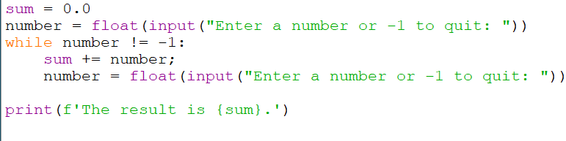

1. An f-string:
2. A sentinel:
3. A string literal:
4. A keyword:
5. An accumulator:
6. A variable:
7. An identifier:
8. An assignment:
9. A conditional expression:
10. A type conversion:
11. Write a **for loop** to add together the numbers 3, 5, 7, 9, 11. (Do not use a list.) [3 Marks]

PASTE YOUR SCREENSHOTS OF THE PROGRAM AND OUTPUT HERE

**Question Three [8 Marks]**

Write a program that takes a sentence from the user and prints out the following information about it.

1. The number of letters in the sentence [1 Mark]
2. The number of words in the sentence [2 Marks]
3. An uppercase version of the sentence [1 Mark]
4. A lowercase version of the sentence [1 Mark]
5. The number of times the letter ‘e’ or ‘E’ appears in the string [3 Marks]

PASTE YOUR SCREENSHOTS OF THE PROGRAM AND OUTPUT HERE