IST 1025: INTRODUCTION TO PROGRAMMING

MID-SEMESTER EXAM

**24th June 2021, 9:00 – 11:00 (2 hours)**

**Instructions Total Marks: 30**

1. Answer Question One on Blackboard.
2. Answer Questions Two and Three in this document and submit in **PDF**.
3. Paste screenshots of your programs and output in the spaces indicated.

**Question One [14 Marks]**

This question will be done as a test on Blackboard.

**Question Two [8 Marks]**

1. Refer to the program below and write down the elements listed below it as found in the program. [5 Marks]

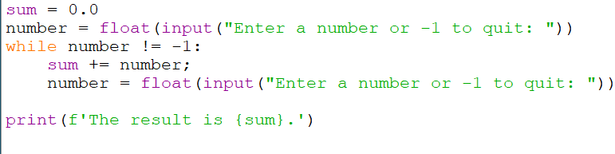

1. An f-string:

Print (f ‘the result is {sum} . ‘)

1. A sentinel:

-1

1. A string literal:

number = float(input(“Enter a number 0r -1 to quit: ”))

1. A keyword:

While

1. An accumulator:

number

1. A variable:

Sum, number

1. An identifier:   
   sum
2. An assignment:

Sum+=number

1. A conditional expression:

Number !=-1

1. A type conversion:

Printf (f’ the result is {sum} . ‘)