SMART-SECURE WATER

LEAKAGE DETECTION
&
MANAGEMENT SYSTEM

Overview
This project presents a smart system to detect water leakage, monitor tank level, detect abnormal flow rate, and provide Bluetooth password-based tank access control.

Objectives
- Detect pipeline leakage using IR sensor.
- Monitor tank level using ultrasonic sensor.
- Detect abnormal water flow using flow sensor.
- Send alerts through Bluetooth.
- Allow tank access only with password authentication.

Core Components
- Arduino UNO/Nano
- IR Sensor
- Ultrasonic Sensor (HC-SR04)
- Flow Sensor
- HC-05 Bluetooth Module
- Relay / Solenoid Valve
- Buzzer / LED

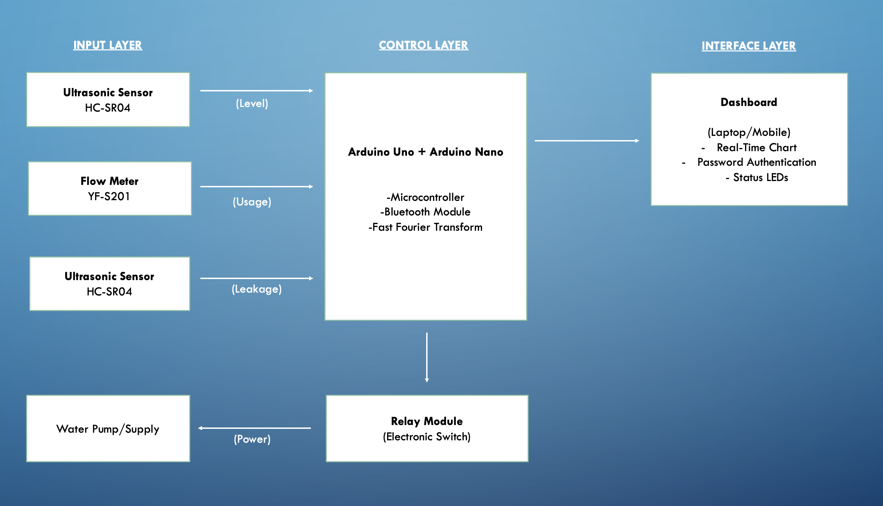

Working Principle
- Leak detection is done using IR sensor and FFT.
- Tank level is measured using ultrasonic sensor.
- Flow sensor monitors real-time flow rate.
- Converting Pulses to Flow Rate
Every 200 milliseconds:
flowRate = pulseCount / 7.5;
This converts pulse frequency into Liters per Minute (L/min).
- The system collects flow rate samples over time, converts them to frequency domain using FFT, measures how much of the signal is steady (DC), and determines whether the water flow pattern matches leakage characteristics.
- Behavior During Normal Water Usage
- dcRatio = LOW
- Behavior During Leakage
- dcRatio = HIGH
- dcEnergy = vReal[0]
totalEnergy = sum of all frequency magnitudes
dcRatio = dcEnergy / totalEnergy
- Leak Detection Logic
If:
meanFlow > 0.2 L/min
AND
dcRatio > 0.7
Then:
Leak detected
Valve closes
Buzzer turnS ON
- If flow exceeds threshold, Bluetooth alert is sent.
- Tank valve opens only after correct password is received via Bluetooth.
- “Hagen-Poiseuille Law” is used when the fluid is moving and you need to account for viscosity and friction,

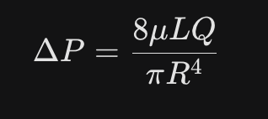

- ΔP: Pressure difference between the two ends (Pa)
- μ(mu): Dynamic viscosity of the fluid (Pa.s)
- L: Length of the pipe (m)
- Q: Volumetric flow rate (m^3/s)
- R: Radius of the pipe (m)

Features
- Real-time leak detection
- Tank level monitoring
- Abnormal flow detection
- Bluetooth alert system
- Password-protected tank access

Conclusion
This system provides intelligent and secure water management by integrating sensors, flow monitoring, and Bluetooth-based authentication.

Future Scope
- Consumption Forecasting: Analysing data to predict how much water a building will need the next day, allowing for optimized tank filling during off-peak electricity hours.
- Automated Billing: Creating unique "Water Wallets" for residents. Users could "pre-pay" for 1000L of water; once the flow sensor counts that much, the system automatically closes their specific supply line until they top up.
- Water Quality Sensing: Adding pH, Turbidity, and TDS (Total Dissolved Solids) sensors. The dashboard wouldn't just tell you how much water you have, but also if it is safe to drink.
- Acoustic Leak Detection: Using specialized microphones to detect the "hiss" of underground pipe leaks that flow sensors might miss.

